**REGISTRATION FORM FOR YOUR DREAM JOB**

**NAME:Montemayor, Charles**

**SECTION:UCOS 3-1**

**INSTRUCTIONS.**

* In case “MySQL has stopped working” is observed, please refer to the link given below.
* <https://docs.google.com/document/d/1_IyDLiGfhiDxisWDK6qH4BacsZPKpvgybjHtN7IBkyA/edit?usp=sharing>
* The goal for this activity is to create a registration system with **Create Read Update Delete (CRUD)** features using **PDO methods**. You can follow the same folder structure as specified from the lectures.
* The table should have a minimum of **EIGHT COLUMNS** to store (including the primary key and date added column).
* For example, from our lecture, it was mentioned that a student can store firstName, lastName, religion, and yearLevel. Do the **SAME THING** for your dream **PROFESSION**. It can be a registration system for either a software engineer, network administrator, database administrator.
* Submit a Google Drive link of your screen recorded presentation where you use the system in creating a record, updating a record, and deletion of a record. Please don’t forget to upload the project to GitHub.
* **PASTE A SCREENSHOT BELOW OF SQL CODE USED TO CREATE THE TABLE**

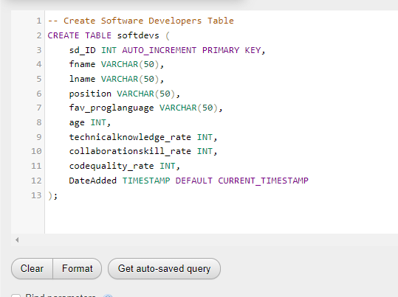

* **PASTE A SCREENSHOT BELOW OF THE FOLDER STRUCTURE YOU USED FOR THE PROJECT.**

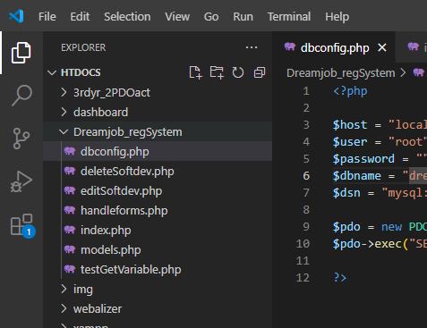

Note: I didn’t create separate folder for the dbconfig, handleforms and models.php file, so that there is no need to allocate specifically the location on the file once we need to put it on the require_once function and header(). It is more convenient and less complex since the code were working on doesn’t have that much file to be organize or to segregate files by folder.

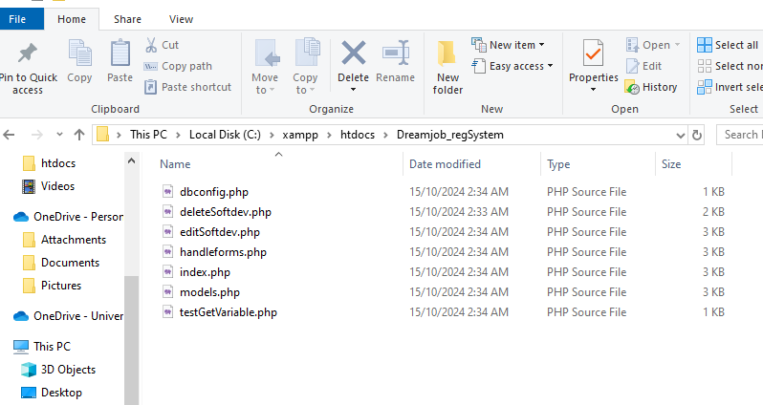

* **PASTE GOOGLE DRIVE LINK BELOW SHOWING A VIDEO-RECORDED PRESENTATION OF INSERTION, DELETION, AND UPDATING OF RECORDS BEING MADE IN THE SYSTEM**

<https://drive.google.com/drive/folders/15u23lmA4hatcA702kBTf-gZZFLm5rG0-?usp=sharing>

* **PASTE GITHUB LINK OF THE PROJECT BELOW**

<https://github.com/foshoo0/3rdyr_dreamjob_regsystem/tree/main>

* **PROGRESS REPORT (3-5 ENTIRE SCREEN SCREENSHOTS OF WHAT YOU DID SO FAR (October 9, 2024))**
* 
 