ECE 3304 – Project 3

Rafael Perales R#11458275

Tanveer Salim

May 3, 2020

**Part A Observations:**

For this project, the plot of the DFT of x1[n] was considered, where $x_{1}\left[n\right]= e^{j2πn{30}/{100}}+ e^{j2πn{33}/{100}}$ and by using 10 samples (0 ≤ n ≤ 9).

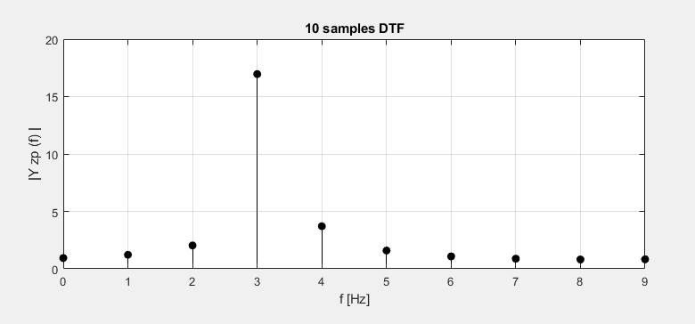

From this we can determine that not enough samples are given in order to differentiate the exponentials. In order to properly show the graph of the DFT more sample might be needed in order to properly display it.

**Part B Observations:**

For part b of the project we use zero-pad of the first signal. This uses a 500-point DFT where it uses the first’s part of 10 samples and zeroes the other 490 samples. This is in order to improve the speed and resolution of the signal that is produced by the DFT.

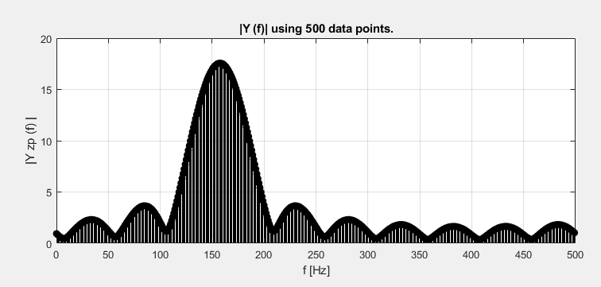

As shown in the plot above both exponentials are clearly defined since the graph is sampled more finely.