ECE 3304 – Project 1

Rafael Perales R#11458275

Tanveer Salim

May 2,2020

**Part 1:**

**Part 1 Observations:**

The processing of the discrete-time signals is done by discrete-time systems which are represented by functions. This is done by taking an input for the system to create an output out of the input. For the first the problem the discrete time following discrete time function f[n] is used.

$$f\left[n\right]= e^{{-n}/5}\cos\left({πn}/5\right)u[n]$$

Part 1 A:

The function above was generated using anonymous functions since *inline* did not work correctly. *Stem* command used in order to plot across the range of ( -10 <= n <= 10).

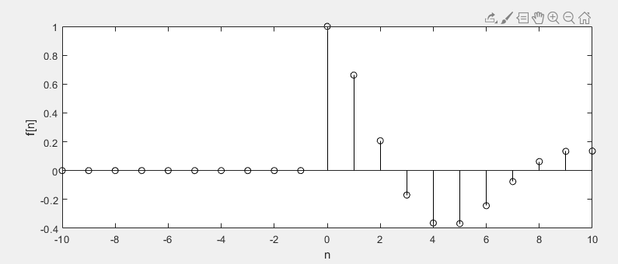

Part 1 B:

Using the previous function, we multiplied it by -2 in order to get the following result. This caused the plot to be reflected over the y-axis due to negative number. One other thing that changed was that the function shrunk due to it being multiplied by 2.

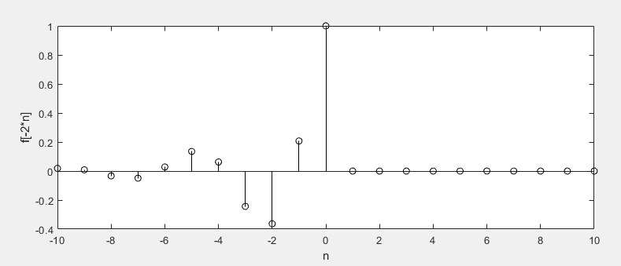

Part 1 C:

The last change done to graph was f[-2n+1] which in this case translated the function by 1 unit to the left.

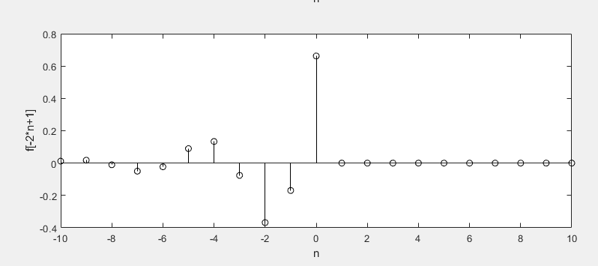

**Part 1 Conclusion:**

For the discrete-time functions described above you can modify it at any point when plotting it. This is allowed once the function is created and edited when calling the stem command.

**Part 2 Observations:**

For part 2, the filter command is used. It uses the coefficients of both the input and output in order to create the impulse response across a range for the system.

Part 2 A:

For the following observation, the following impulse response h[n] was considered.

y[n] – y[n-1] + y[n-2] = x[n].

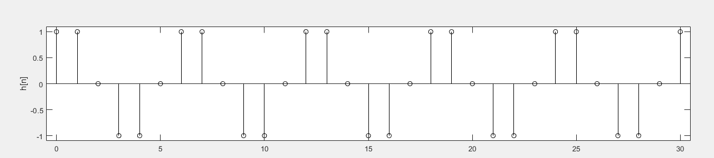

The figure is shown within the range of (0<=n<=30). Based on the plot it can be said that the system is not BIBO stable. This due to the periodic signal not being summable or being finite.

Part 2 B:

The plot below shows the zero state response y[n] for input $x\left[n\right]= \cos\left({2πn}/6\right)u[n]$ with range (0 <= n <= 30).

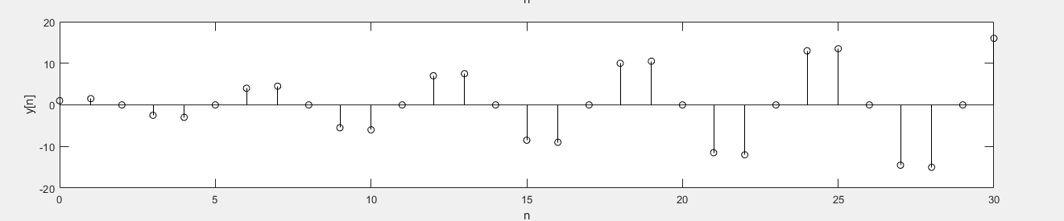

For the following impulse response equation y[n] – y[n-1] + y[n-2] = x[n] it can be rewritten as y[n+2] – y[n+1] + y[n] = x[n+2] due to $x\left[n\right]= \cos\left({2πn}/6\right)u[n]$. The characteristic equation becomes ${(E}^{2}-E+1)$ y[n]=0. In order to determine its roots the quadratic equation is needed in order to determine them, which in turn determines that the roots are $γ=e^{±jπ/3}$.Due to this it is BIBO unstable and asymptotically unstable.

Part 2 C:

For the next plot, the initial conditions, y[-1] = 1 and y[-2] = 2, are given for y0[n]. The given range is still the same at (0 <= n <= 30).

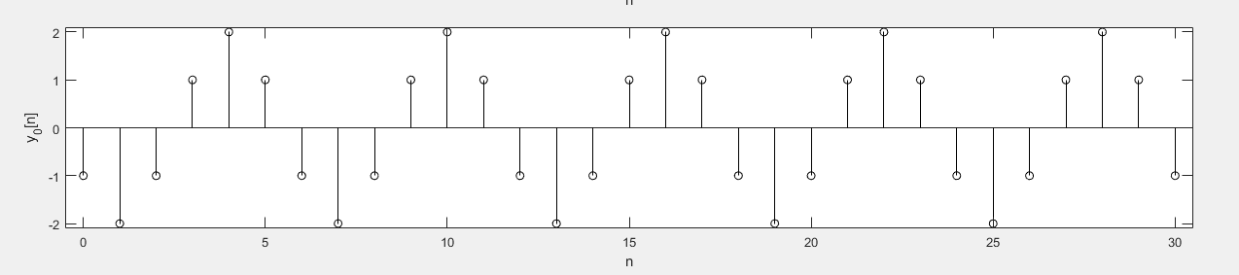

In th is signal the filtic command was used. This command finds the conditions for the delays in the input response. This function effectively performs a reverse difference to obtain the delay states.

**Part 3 Observations:**

This part deals with convolution using an impulse response and a input. For the impulse response the equations is $h\left[n\right]= \left\{\cos\left({πn}/3\right)+ \frac{1}{\sqrt{3}} \sin\left({πn}/3\right)\right\}u[n]$. For the input of the system it is $x\left[n\right]= \cos\left({2πn}/6\right)u[n]$. Below the following zero state response y[n] can be observed as the convolution between x[n] and h[n] over the range (0 <= n <= 30).

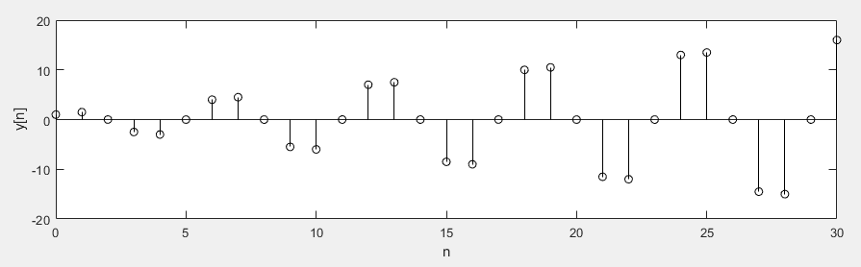

This signal is like Part 2B which also has the same input $x\left[n\right]= \cos\left({2πn}/6\right)u[n]$. From this we can determine BIBO unstable and asymptotically unstable.

**Part 2 and 3 Conclusion:**

From this we can determine that the filter and filtic are both used in their own way to determine evaluations on impulse responses. For filter it can be used to evaluate a system response of a differential equation. For filtic it can be used when an impulse response has initial conditions.

**Part 2:**

**Problem 3.M-3:**

**a.**

rxy[k] and ryx[k] in terms of convolution.

$$r_{xy}\left[k\right]=\sum_{n=-∞}^{∞}{x\left[n\right]y[n-k]}$$

If we let m=n-k, we get

$$r_{xy}\left[k\right]=\sum_{m=-∞}^{∞}{y\left[m\right]x[k+m]}$$

And take the convolution

$$h_{xy}\left[k\right]=\sum_{m=-∞}^{∞}{y\left[m\right]x[k-m]}$$

$$h_{x(-y)}\left[k\right]=\sum_{m=-∞}^{∞}{y\left[-m\right]x[k-m]}$$

We can say that

$$h_{x(-y)}\left[k\right]=\sum_{n=-∞}^{∞}{y\left[n\right]x\left[k+m\right]=}r_{xy}[k]$$

This means that

$$r_{xy}\left[k\right]=\sum_{m=-∞}^{∞}{y\left[m\right]x[k+m]}$$

$$r_{yx}\left[k\right]=\sum_{m=-∞}^{∞}{y\left[m\right]x[m-k]}$$

&

**b.**

As it observed above equations $r_{xy}\left[k\right]≠r_{yx}\left[k\right]$. It is true however that $r_{yx}\left[k\right]=r_{yx}\left[-k\right]$. This means that cross-correlation does indicate similarity between signals. This means when shift k aligns two similar signals they will constructively interact and $r_{xy}\left[k\right]$ will become larger. This means that both are negative and equal leading to a maximum positive value.

**c.**

To understand convolution and cross-correlation, the inputs x[n] = u[n − 5] − u[n − 10] over (0≤n = nx ≤ 20) and y[n] = u[−n − 15] − u[−n − 10] + δ[n − 2] over (−20 ≤ n = ny ≤ 10) were taken. Next the results for $r_{xy}\left[k\right]$ were plotted as a function of shifted k. The first plot represents x[n] shown below.

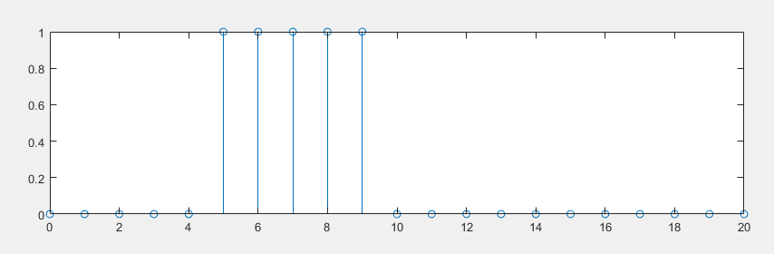

The plot of y[n] = u [−n − 15] − u [−n − 10] + δ [n − 2] over (−20 ≤ n = ny ≤ 10) is shown below.

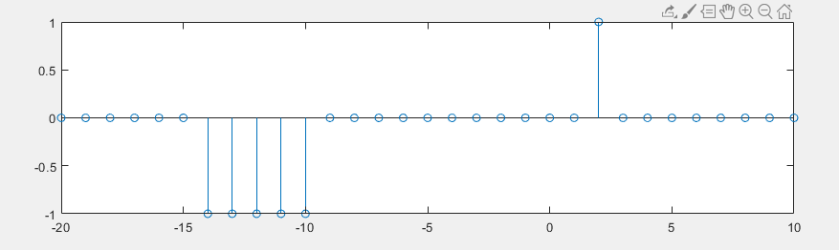

Finally, for the plot of $r_{xy}\left[k\right]$ was plotted as a function of the shift vector k.

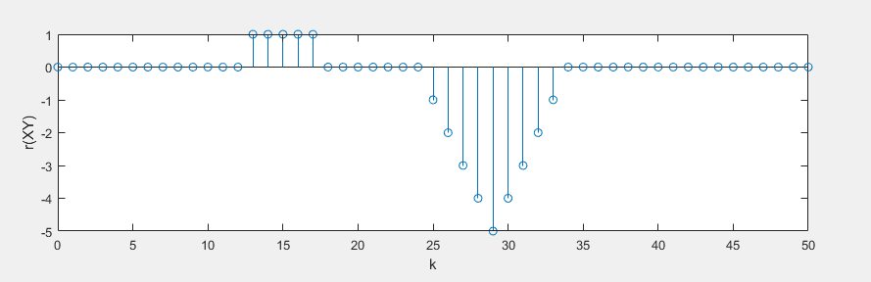

Based on the graph shown above of rxy, we can say that 5 is the largest magnitude at k=19. This is to both x[n] and y[n] being similar, due to x[n] starting n=5 and y[n] starting at

n= -14 both with pulse with of 5. This n turn leads to a shift of k=19 which in turn leads to a large value produced shown in the graph above.