Tanveer Salim

Rafael Perales

ECE 3304

Project 3 (due on Friday, May 1st)

Total Marks: 100 (Up to two students)

Class,

*Instructions: please prepare a zip file containing both the report and matlab files of project. The submitted file should have a name containing students last name and R number. In case of two students working on the project, the submitted zip file should be named with last names of both the students.*

Project:

Consider a complex signal composed of two closely spaced complex exponentials : $x_{1}\left[n\right]=e^{j2πn{30}/{100}}+e^{j2πn{33}/{100}}$. For each of the following cases, plot the length-N DFT magnitude as a function of frequency fr, where fr = r/N.

1. Compute and plot the DFT of x1[n] using 10 samples (0 ≤ n ≤ 9). From the plot, can both exponentials be identified? Explain.
2. Zero – pad the signal from part (a) with 490 zeros and then compute and plot the 500-point DFT. Does this improve the picture of DFT? (Please refer to section 8.5 of the reference book for details of zero-padding).
3. Compute and plot the DFT of x1[n] using 100 samples (0 ≤ n ≤ 99). From the plot, can both the exponentials be identified? Explain.

Yes, both exponentials are definitely visible in the plot graph. Below is a snapshot photo of the DFT graph:

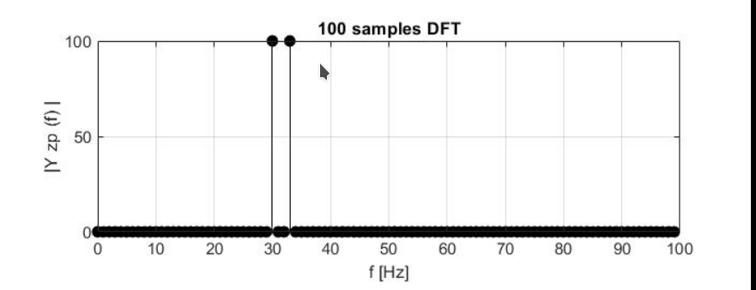

We can see the exponential plot for e^{2 \* \pi \* n \* 30/100} on the left and we can see the exponential plot for e^{2 \* \pi \* n \* 33/100} on the right.

1. Zero-pad the signal from part (c) with 400 zeros and then compute and plot the 500-point DFT. Does this improve the picture of the DFT? Explain.

Below is a snapshot of the Zero-pad plot:

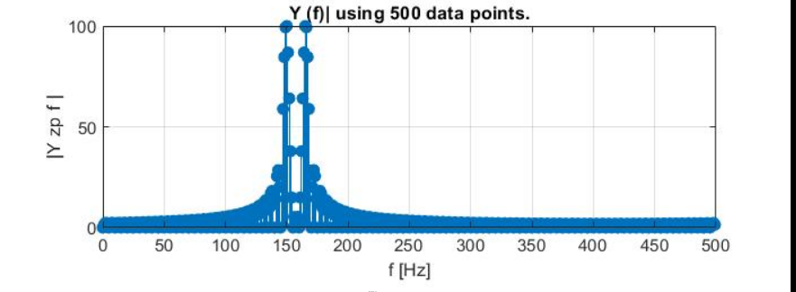

No, no it does not. The peaks in the graph shown in part (c) were sharper than that shown in the zero-padded image.