**Component Guide** -- **Pocket Science Lab**

Resistors

100 Ω

220 Ω

560 Ω

1 kΩ

2.2 kΩ

5.1 kΩ

10 kΩ

100 kΩ

180 kΩ

Transistors

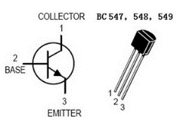

BC547, BC548

Capacitors



Polarized

Unpolarized

LED

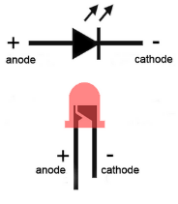

Diode

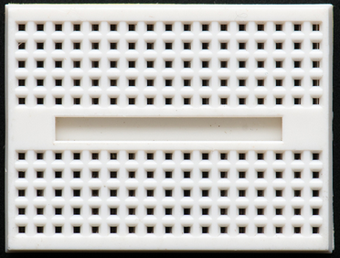

Breadboard

Every 5 holes are internally connected in the direction marked in RED

LDR

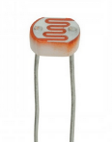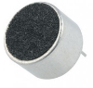

Microphone

Internet Resources

Official Web Page: - <https://pslab.fossasia.org/>

Pinout Diagram: - <https://github.com/fossasia/pslab-hardware/blob/master/PSLab_Pinout.pdf>

Hardware Repository: - <https://github.com/fossasia/pslab-hardware>

Android Repository: - <https://github.com/fossasia/pslab-android>

Desktop App Repository: - <https://github.com/fossasia/pslab-desktop-apps>

App on Google Play: - **Pocket Science Lab**

Instructions to install desktop app: - <https://github.com/fossasia/pslab-desktop-apps/#install-using-the-installersh-script>

**Component Guide** -- **Pocket Science Lab**

Resistors

100 Ω

220 Ω

560 Ω

1 kΩ

2.2 kΩ

5.1 kΩ

10 kΩ

100 kΩ

180 kΩ

Transistors



BC547, BC548

Capacitors



Polarized

Unpolarized

LED



Diode



Breadboard

Every 5 holes are internally connected in the direction marked in RED

LDR



Microphone

Internet Resources

Official Web Page: - <https://pslab.fossasia.org/>

Pinout Diagram: - <https://github.com/fossasia/pslab-hardware/blob/master/PSLab_Pinout.pdf>

Hardware Repository: - <https://github.com/fossasia/pslab-hardware>

Android Repository: - <https://github.com/fossasia/pslab-android>

Desktop App Repository: - <https://github.com/fossasia/pslab-desktop-apps>

App on Google Play: - **Pocket Science Lab**

Instructions to install desktop app: - <https://github.com/fossasia/pslab-desktop-apps/#install-using-the-installersh-script>