Kit Guide – Pocket Science Lab
Resistors |  |  |  |  | Capacitors |  |  |  |  |  | LED
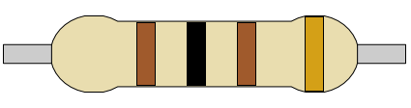 |  | 100 Ω |  |  | 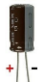  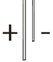 |   Polarised |  |  |  |  | 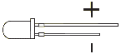 | 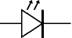
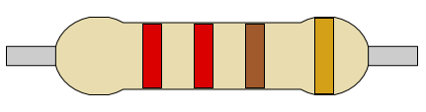 |  | 220 Ω
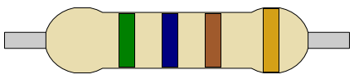 |  | 560 Ω |  |  | 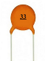 |   Unpolarised |  |  |  |  | LDR
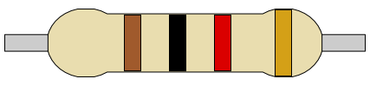 |  | 1K Ω |  |  |  |  |  |  |  |  | 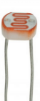 | 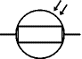
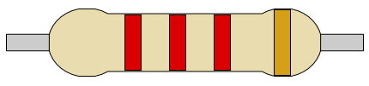 |  | 2.2K Ω |  |  | Diode |  |  |  |  |  | Transistors
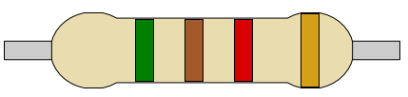 |  | 5.1K Ω |  |  |   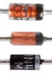  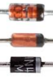 | 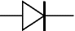 |  |  |  |  | 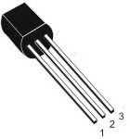 | NPN  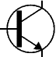
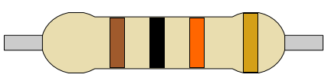 |  | 10K Ω
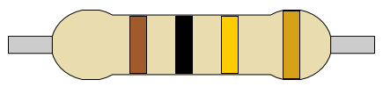 |  | 100K Ω |  |  | Temperature |  |  |  |  |  |  | PNP  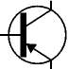
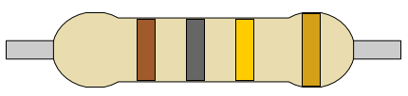 |  | 180K Ω |  |  | 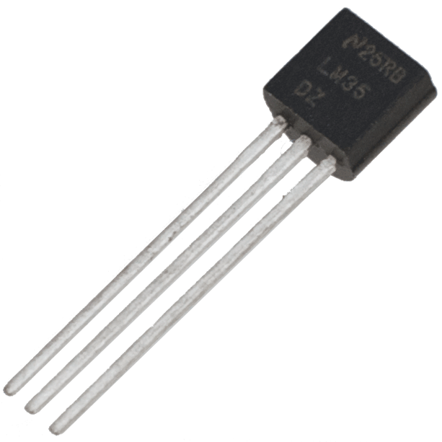  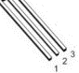 |  | LM-35  - VCC  - Analog Out  - Ground
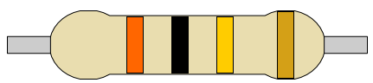 |  | 300K Ω |  |  |  |  |  |  |  |  | Moisture/Rain
Microphone |  |  |  |  | Magnetic |  |  |  |  |  | 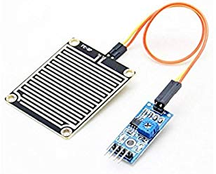 |  | FR-04  - VCC  - Ground  - Digital Out  - Analog Out
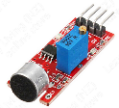 | KY-037  - Digital Out  - V+  - Ground  - Analog Out |  |  |  | 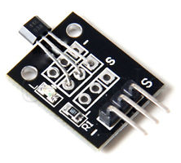 |  | KY-003  - Ground  - 5V  - Signal
Gas
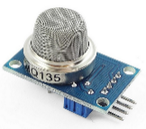 |  | MQ135  - VCC  - Ground  - Digital Out  - Analog Out |  |  | More Information  Official Web Page: - https://pslab.io  Google Play: PSLab F-Droid: PSLab  
Breadboard |  |  |  |  |  |  |  |  |  | Jumper Wires
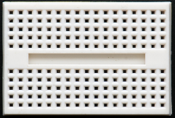 |  |  | Every 5 holes are internally connected in the direction marked in RED |  |  |  |  |  |  | 