**Reformed Druid Contact Information**

Updated 7/4/2014

Note of Caution: Each Grove is considered a separate entity, whose words and deeds reflect upon themselves alone. There is no implied endorsement for any of the groves that are listed here. It is only a list, and you should approach the aid of strangers with requisite caution in your spiritual quest. The unofficial handout, <http://www.rdna.info/uwp.doc> has a large section on ways to evaluate a grove's "quality" level. If you think a grove has fallen off the rocker or is abusive, I'd be interested to hear them, although there might be little I can do about it. Write to [mikerdna@hotmail.com](mailto:mikerdna@hotmail.com) or Facebook message to **mike.thefool**

For the sake of finding other groves, we’re putting them on the map, too. ADF, OBOD, Keltria, MOCC, AODA, RDNA, RDG are the largest groups in North America. None of them are jealous, and usually don’t mind attending each other’s services. If you are far away from any existing Druid groves, just go online and talk to real live Druids, better than nothing. Here are a few Reformed Druid online groups:

RDNA Facebook Group <http://www.facebook.com/groups/2455316244/>

RDG Facebook Group <http://www.facebook.com/groups/reforned.druids/>

Further RDG Grove Contacts available at <http://www.reformed-druids.org/?q=node/38>

**ADF Groves for updates since March, see <https://www.adf.org/groups/groves/index.html>**

**OBOD Groves** [**http://www.druidry.org/community/groups-groves/groves/groves-usa-and-canada**](http://www.druidry.org/community/groups-groves/groves/groves-usa-and-canada)

**Another great website for locating groves <http://danaan.net/druid-cat/finding-druids/>**

[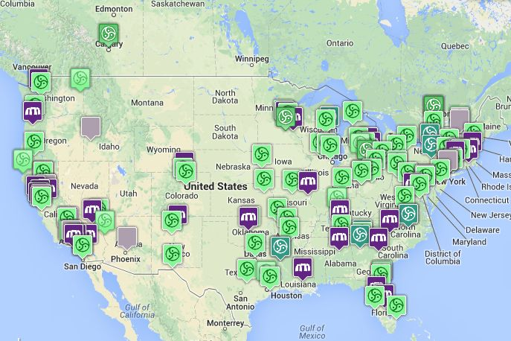](http://www.google.com/url?sa=i&rct=j&q=&esrc=s&source=images&cd=&cad=rja&uact=8&docid=4mFAsmgmJJvvbM&tbnid=HyC6mj3ndAjtVM:&ved=0CAUQjRw&url=http://danaan.net/druid-cat/finding-druids/&ei=TESwU7OkKc2qyATj5oDoDA&psig=AFQjCNH845cE_0Oa0VQ-f9sPdife-hfhsw&ust=1404147116988313)

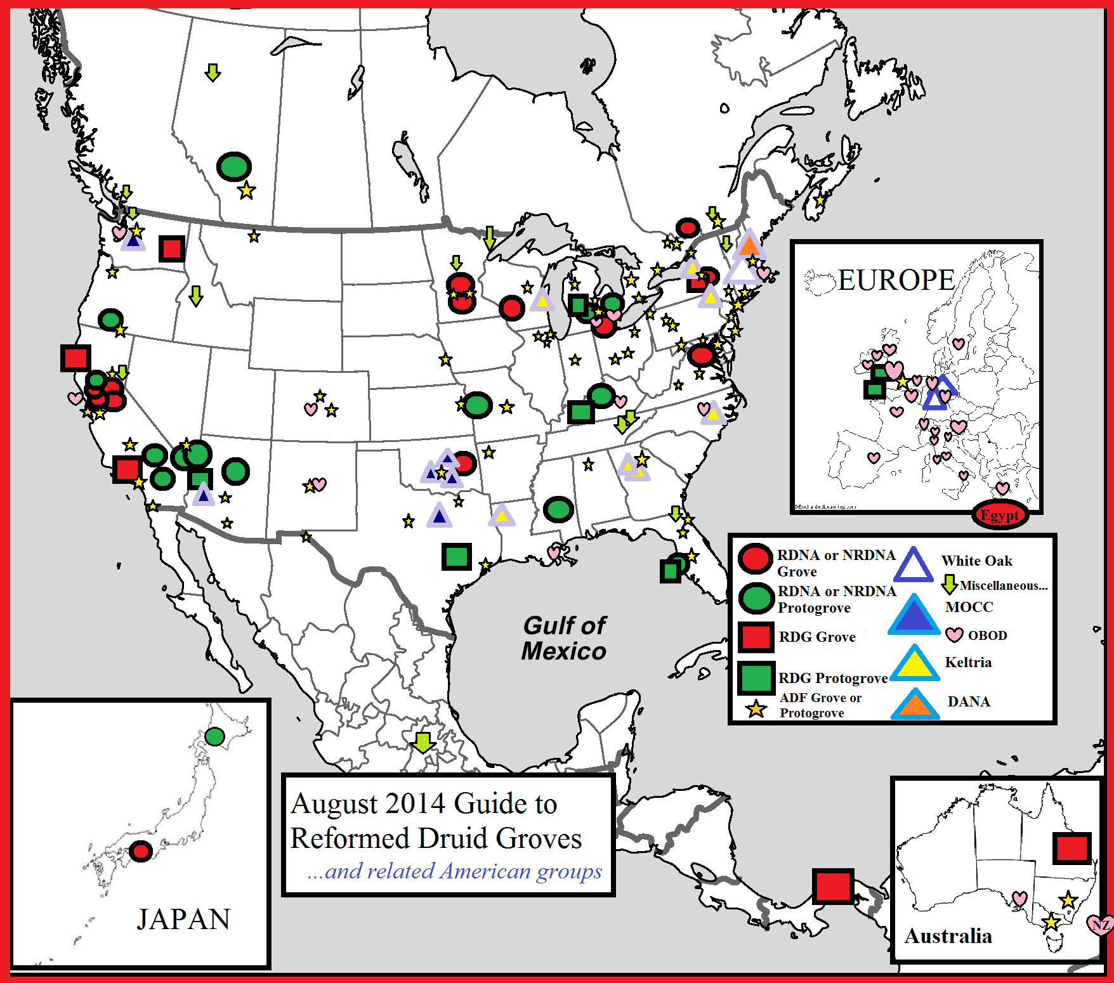

This map only represents groups that I follow.

There may be lots of solitaries, seasonal festivals, or smaller organizations operating within these area that I just don’t know about yet.

|  |  |  |  |  |
| --- | --- | --- | --- | --- |
| **Keywords** | **Grove Name (Location)** | **Founded** | **Membership** | **Contact** |
| RDNA | Carleton Grove  (Northfield, MN) | 1963 | 6 | Anna Smith [smitha@carleton.edu](mailto:smitha@carleton.edu)  Or you can also contact John at [www.facebook.com/brojoghost](http://www.facebook.com/brojoghost)  Updated 2/10/2013  Updated 6/28/2014 |
| New RDNA | Hazel Nut Grove  (Bay Area) | 1977 | 15 | Stephen Abbott  and Tegwedd  Po box 6775, San Jose, CA  [tezra dot reitan @ gmail dot com](mailto:tezra.reitan@gmail.com)  Updated 6/28/2014  [abbotts_inn@yahoo.com](mailto:abbots_inn@yahoo.com) |
| NRDNA | Tuatha de Dannan Grove  (Hayward, CA) | July 1992 | 5 | Jeffrey Sommer [j.r.sommer861@gmail.com](mailto:j.r.sommer861@gmail.com)  updated 2/8/2013  Updated 6/28/2104 |
| Reformed Druids of North Asia | Shikoku Grove  (Japan) | 1997 | 2 | SOMEWHAT ACTIVE  Updated 2/8/2013  Updated 6/28/2014  If you wish to meet Ikari, contact [Mikerdna@hotmail.com](mailto:Mikerdna@hotmail.com) |
| New RDNA | Duir de Danu Grove  Silicon Valley, CA | 1999 | 7 | [tezra@earthlink.net](mailto:tezra@earthlink.net)  Updated 9/14/08  <http://www.facebook.com/tegwedd7>  Updated 2/8/2013 |
| RDNA | Monument Grove  Washington, DC | Sept. 2000 | 3 | Mike Scharding  [mikerdna@hotmail.com](mailto:mikerdna@hotmail.com)  [www.facebook.com/mike.thefool](http://www.facebook.com/mike.thefool)  Updated 2/8/2013  Updated 6/28/2014 |
| RDG | Cylch Cerddwyr  Rhwng Y Bydoedd Grove  (Eureka, CA)  <http://reformed-druids.org/?q=node/13> and  <http://eureka.reformed-druids.org/>  RDG mother grove  <http://www.reformed-druids.org/> | RDNA affiliation first in  7/2001 | 7 | Ceridwen Seren-Ddaear  [Use Form](http://www.reformed-druids.org/?q=node/13) to contact or  <http://eureka.reformed-druids.org/contact.htm>  Updated 2/4/2013  Updated 6/28/2014 |
| RDNA | White Rabbit Grove  [http://helgaleena.wordpress.com](http://helgaleena.wordpress.com/) Blog  Western Wisconsin | Nov 2001 | a few | [healingline at gmail.com](mailto:healingline@gmail.com)  <http://www.facebook.com/helgaleena.healingline>  608-255-0504 for "The Healing Line" Updated 2/8/2013  Updated 6/28/2014 |
| New RDNA | Poison Oak Grove  <http://rdnapoisonoakgrove.tripod.com/> Out of date.  Canyon, CA | May 2002 | 3 | Somewhat active  Stacey Weinberger  <http://www.facebook.com/stacey.j.weinberger>  Updated 2/8/2013  Updated 6/28/2014 |
| RDNA | Sunset Grove  (Vacaville, CA)  **P**r**o**t**o**g**r**o**v**e | Feb 2004 | 3 | [center_stone@hotmail.com](mailto:center_stone@hotmail.com%20)  Oriana Lewyllan  Grove is rebooting soon  Updated 2/8/2013 |
| New RDNA | Grove of the Golden Valley  (formerly Sierra Madrone Grove)  <https://www.facebook.com/groups/127222536601/>  Updated 6/28/2014  Sacramento, CA | Oct 2004 | 4 | [seanthedruid@yahoo.com](mailto:seanthedruid@yahoo.com)  updated 1/24/2011  updated 6/28/2014  <http://www.facebook.com/sean.thedruid> Updated 2/8/2013  Updated 6/28/2014 |
| RDNA  ADF | Clan of the Triplehorses  [Triplehorses Facebook](http://www.facebook.com/Aigeann)  Updated 2/8/2013  <http://triplehorses.weebly.com/index.html> Updated 2/8/2013  Updated 6/28/2014  (Medford, OR)  **P**r**o**t**o**g**r**o**v**e | May 2004 | 8 | Wolfsong [triplehorses@gmail.com](mailto:triplehorses@gmail.com)  Updated 2/8/2013  Updated 6/28/2014 |
| RDNA | Rose Rock Grove  (Moore, OK) | Oct 2004 | 4 | [ms.dariana@gmail.com](mailto:ms.dariana@gmail.com)  Lydia  Updated 3/08/2013  Updated 6/28/2014 |
| RDNA, BDO, TDN | Awen Grove  <http://awencanada.com/>  Updated 2/8/2013  Updated 6/29/2014  (Alberta, Canada) | May 2005 | 10 | [athelia143@gmail.com](mailto:athelia143@gmail.com)  Updated 1/24/2011  Updated 6/29/2014  <http://www.facebook.com/athelia.nihtscada> Updated 2/8/2013  Updated 6/29/2014 |
| RDNA  Christian | Nine Oaks & Mystic Well  (Las Vegas, NV)  **P**r**o**t**o**g**r**o**v**e | Sept 2005  C. 1996 | 9 | [Nineoaksmysticwell@gmail.com](mailto:Nineoaksmysticwell@gmail.com)  Updated 6/28/2014  We also refer you to <http://www.facebook.com/briddana.dragonwillow> |
| RDNA | Grove of the Order of the Mists  (Winslow, AZ)  **P**r**o**t**o**g**r**o**v**e | Sept 2005 | 3 | <http://www.facebook.com/tully.reill> Updated March 2013  Updated June 23, 2014 |
| RDNA | Sprit of the Earth Mother Grove  (aka Port Huron Protogrove)  (Port Huron, MI)  **P**r**o**t**o**g**r**o**v**e | April 2006 | 4 | Kirk Hofer  [kirkhofer@yahoo.com](mailto:kirkhofer@yahoo.com)  Updated March 2013  Updated June 2014 |
| RDNA | Blackthorn Grove  (Louisville, KY)  **P**r**o**t**o**g**r**o**v**e | Aug 2006 (1994) | 5 | [blackthorngrove@earthlink.net](mailto:blackthorngrove@earthlink.net)  updated 8/11/06  Updated 9/14/08  Updated August 2011  Updated March 2013  Updated July 2014 |
| RDNA | Golden Bough Protogrove  Joshua Tree, CA | Sept 2008 | 6 | Rusty Mon  <http://www.facebook.com/rustymon>  Updated 2/8/2013  Updated 6/28/2014 |
| RDNA | [Koad Grove](http://koadprotogroverdna.weebly.com/)  [Dalon Ap Landu Shrine](http://nshrine.com/shrine/Dalon_ap_Landu)  Detroit, Michigan  Updated 6/29/2014 | Sept 2008 | a few | Phagos  <http://www.facebook.com/jon.drum>  Updated 2/8/2013  Updated 6/29/2014 |
| RDNA | [Desert Willow Grove](http://www.facebook.com/pages/Earth-Spirit-NTC/112065562169255?ref=mf&v=wall) (uses the NTC site)  Fort Irwin, CA  **P**r**o**t**o**g**r**o**v**e  Updated 6/29/2014 | Sept 2008 | 5-15 | Saher de Wahull NatureNTC@gmail.com  Updated 2/8/2013  Updated 6/29/2014 |
| RDG | Grove of The Ravens Wood  (Middleburg, FL)  <http://reformed-druids.org/?q=node/41>  Updated 6/28/2014 | 2008 | 6 | John Penda Harling  [Use Form](http://www.reformed-druids.org/?q=node/41) to contact  Updated 2/4/2013 |
| RDNA  Neopagan | Three Stones Grove  (Las Vegas, NV)  **P**r**o**t**o**g**r**o**v**e | July 2010  C. 1996 | 9 | Finneagas [three.stones.protogrove @gmail.com](mailto:three.stones.protogrove@gmail.com)  Updated 2/2013  Update 6/28/2014 |
| RDG | Rabbit In The Moon Grove[****http://ritmg.info****](http://ritmg.info)(Agoura Hills, CA)Updated 6/28/2014 | 2010 | 3 | Mike Talvola at <http://reformed-druids.org/?q=node/3> or you can  [Use Form](http://www.reformed-druids.org/?q=node/3) to contact  Updated 2/4/2013  Updated 6/28/2014 |
| RDNA | Raven's Cry Grove  Clairiere du Corbeau Grove  Border of Ontario and Quebec  Just north of Ottawa  <http://www.facebook.com/groups/5127134685/>  Updated 6/28/2014  <http://druidaefigulus.weebly.com/> NEW BLOG  6/28/2014 | Oct 2010 | 7 | Sebastien Beaudoin  <http://www.facebook.com/sebastien.beaudoin.50>  Updated 2/10/2013  Updated 6/28/2014 |
| RDG | Druids of Tuatha De Danaan Protogrove,  Central City, KY | 2012? | 3 | [**https://app.box.com/s/f65kj0ik9b4qkgq3o878**](https://app.box.com/s/f65kj0ik9b4qkgq3o878)  or <http://reformed-druids.org/?q=node/101>  Updated 6/28/2014 |
| RDNA and RDG | All Worlds Grove  Rochester, NY  Updated 2/10/2013 | May 2012 | 3 | Somewhat Active  Cid Phoenix <http://www.facebook.com/endlessbard> Updated 2/10/2013 |
| RDNA | Oakdale **Grove**  <https://www.facebook.com/OakdaleGrove>  Updated 6/28/2014  Twincities, MN | Sept 2012 | 4 | John Martens  <http://www.facebook.com/brojoghost>  Updated 2/10/2013  Updated 6/28/2014 |
| RDG | Circle of Flowing Truth  <http://www.facebook.com/CircleofFlowingTruth>  Updated 2/8/2013  Updated 6/28/2014  (Bullhead City AZ)  Proto-Grove | 2012 | 3 | JCarlier II  <http://reformed-druids.org/?q=node/39> or use  [Use Form](http://www.reformed-druids.org/?q=node/39) to contact  Updated 2/4/2013  Updated 6/28/2014 |
| RDG | Earrach Dreollin Reformed  <https://www.facebook.com/groups/edrdc/>  Updated 6/28/2014  Druid Proto-Grove  (Spring City TX) | 2012 | 5 | <http://reformed-druids.org/?q=node/83>  Updated 2/4/2013  Updated 6/28/2014 |
| RDG | Teulu'r Coedwig  (Swansea, Wales)  Protogrove | 2012 | 6 | Colin Donnan  <http://reformed-druids.org/?q=node/42> or use  [Use Form](http://www.reformed-druids.org/?q=node/42) to contact  Updated 2/4/2013  Updated 6/28/2014 |
| RDG | Polaris Grove  <http://reformed-druids.org/?q=node/40>  updated 6/28/2014  (Spokane, WA) | 2012 | 3 | Wayne Stewart  [Use Form](http://www.reformed-druids.org/?q=node/40) to contact  Updated 2/4/2013 |
| RDG/RDNA | Whispering Winds through the Willows Protogrove  <https://www.facebook.com/groups/WhisperingwindsinWillows/>  Updatd 6/28/2014 Public  [**http://whisperingwinds.spruz.com/**](http://whisperingwinds.spruz.com/)  Updated 2/8/2013  Grove members only  Updated 6/28/2014  (Jackson MI) | 2013 | 3 | Michael Johnson  [Use Form](http://www.reformed-druids.org/?q=node/93) to contact  Updated 2/4/2013  Updated 6/28/2014 |
| RDNA/RDG | Ghost Orchid Protogrove, (Fort Myers, Florida)  Proto-Grove | July 2013 | 5 | <http://www.facebook.com/vivian.tanis> Updated 8/15/2013  Updated 6/28/2014 |
| RDG | Nemeton Imbas Grove (Panama) | July 2013 | 3 | Rafael Severino <http://www.facebook.com/Lugdag>  Updated 6/28/2014 |
| RDNA | Wilding Protogrove  Mississippi  Protogrove | March 2014 | 3 | [toriymagee@yahoo.com](mailto:toriymagee@yahoo.com)  Updated 3/28/2014 |
| RDG | **Druid Clan of Celliwig  *(Proto-Grove)*** [http://cornwallschoolofmysteries.co.uk/druid-clan-of-celliwig/](http://ritmg.info/) Cornwall, United Kingdom | 2013 | 6 | <http://reformed-druids.org/?q=node/118>  Updated 6/28/2014 |
| RDG | LLanoz Grove  Queensland, Australia | 2013 | 6 | <http://reformed-druids.org/?q=node/108>  Updated 6/28/2014 |
| RDNA | Dogwood Proto-Grove  <https://www.facebook.com/groups/309848779167341/>  Updated 6/28/2014  (Kansas City, Missouri)  (formerly in Virginia)  Proto-Grove | May 2014 | 3 | [Tony.Dunsworth@gmail.com](mailto:Tony.Dunsworth@gmail.com) and [Ellen.Dunsworth@gmail.com](mailto:Ellen.Dunsworth@gmail.com)  Updated 6/28/2014 |
| RDNA | Papyrus Grove (Egypt) | Jan 2014 | 2.5 | [mikerdna@hotmail.com](mailto:mikerdna@hotmail.com)  Updated 6/28/2014 |

**Various Other Organizations Somehow Related to the Reform**

|  |  |  |  |  |
| --- | --- | --- | --- | --- |
| Group Title | Grove Name (Location) | Founded | Membership | Contact |
| [Missionary Order of the Celtic Cross](http://www.facebook.com/groups/144381945622403/)  Updated 2/10/2013 | MOCC Muskogee OK Convocationry  MOCC Tulsa OK Convocationry  MOCC Seminole OK Convocationry  MOCC Bullhead City Convocationry (Arizona).  MOCC Seattle Convocationry is rebuilding,  Rumors of MOCC groups in Arlington, TX and in Utah. | 1994 | 50 | Thomas Harris  <http://www.facebook.com/thomasleeharrisjr> Updated 2/13/2013  Updated 6/28/2014 |
| Order of White Oaks | [Order of White Oaks](http://www.whiteoakdruids.org)  <https://www.facebook.com/groups/whiteoakdruids/>  (3 in USA)  2 in Germany  Also there is a private teaching group:  Tribe of the Oak  <http://tribeoftheoak.com/>  Updated 6/28/2014 | Mid 1990s | Dozens | [www.whiteoakdruids.org](http://www.whiteoakdruids.org)  [membership@whiteoakdruids.org](mailto:membership@whiteoakdruids.org)  Updated 9/20/05  Updated 2/13/2013  Updated 6/28/2014 |
| American  Gwyddon | Nemeton Gwynedd  (Oroville, CA) | 1998? | 7 | INACTIVE CURRENTLY  Rhiannon Hawk <http://www.facebook.com/rhiannon.hawk>  Updated 6/28/2014 |
| Druid Association of North America (DANA) | Grove of the Golden Leaves  [www.facebook.com/GroveoftheGoldenLeaves](http://www.facebook.com/GroveoftheGoldenLeaves)  Updated 6/28/2014 | 2000 | 5 | <http://www.facebook.com/domi.obrien>  Updatd 6/28/2014 |
| Henge of Keltria | **Chartered Keltrian Groves**  **New York** - **Syracuse Area**  Garrán an Eich Órbhuí (Grove of the Golden Horse)  Grove Leader: Topaz Owl - [E-Mail](http://www.keltria.org/Blog1/contact-us/) [Biography](http://www.keltria.org/biographies/topazowl.htm)  **Keltrian Study Groups**  **Georgia** - **Atlanta**  [GryphonSong Clan](http://www.gryphonsongclan.com/) Contact - [Eibhlean/Melody](mailto:piperpettus@yahoo.com) or[Aracos Arendel/Hawk](mailto:glwages@bellsouth.net)  **Louisiana** - **Shrevport**.  Red River Grove (Study Group) - Contact [Sandy](http://www.keltria.org/Blog1/contact-us/)  **New York** - **Binghamton**.  White Cat Grove (Study Group) - Contact [Jenne](http://www.keltria.org/Blog1/contact-us/).  **North Carolina** - **Raleigh**.  White Oak Study Group - Contact [Ailim](http://www.keltria.org/Blog1/contact-us/)  **Wisconsin**- **Green Bay**.  [Celtic Earth Haven](http://www.myspace.com/celticearthhaven) (Study Group) - Contact[Naomi](http://www.keltria.org/Blog1/contact-us/).  **Autonomous HK Groves**  **Georgia** - Cumming (Atlanta)  Oldes Stone Grove <http://oldestonegrove.tripod.com/> | 1986 |  | <http://www.keltria.org/contact.htm>  Updated 6/28/2014 |