Simple Design Breakdown
To give our blimp full mobility we decided to mount the motors on rotating servos, this allows us to point the motor in whatever direction we need to move. This can be seen in the image below.

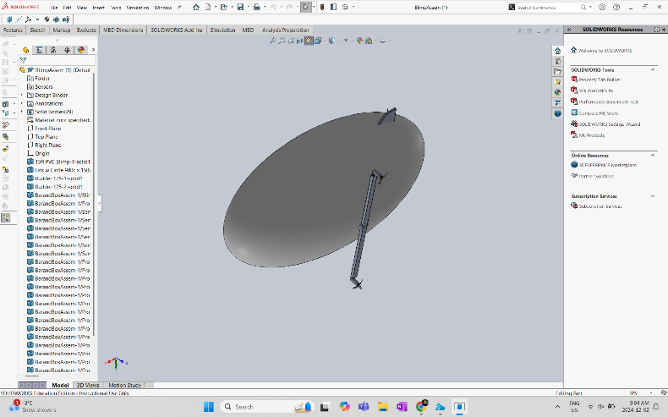
For instance then the blimp needs to go up both motors will be tilted to operate the way a helicopter does, and then to go forward they will be tilted to act like a plane. A very similar solution was used on the V22 Osprey military aircraft, this can be seen briefly in the image below.
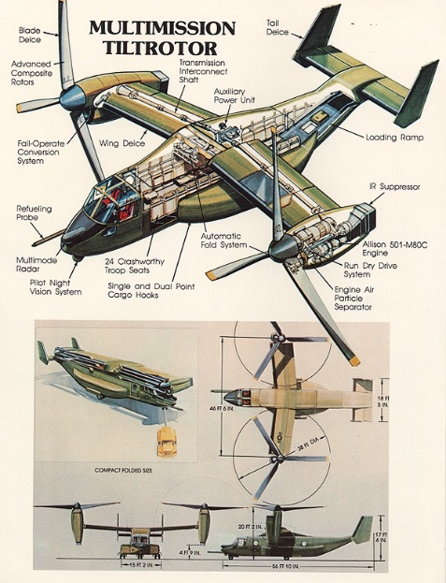
For additional stability and control, we also decided to implement flaps on the back of the blimp. These can be used while the blimp in the forward motion to help change the pitch and direction of the blimp without effecting the operation of the motors. These flaps can be seen in the image below.



