LiftHub — Design Document
AiLab Intern Pre-Assignment · Phase 2 · v1.1, revised after Review Checkpoint 2
Author: Foster Brown · July 2026
Builds on Requirements v1.1, which incorporates the Checkpoint 1 revisions: plan persistence, the Q&A deletion policy, and role snapshots on posts.

1. Scope
This document covers the five Phase 2 deliverables: database design, role & permission design, RLS policy design, API design, and directory structure. All SQL in this document is the intended content of the first migration files; it will be committed to supabase/migrations rather than applied by hand, so the schema and its security rules are reviewable in the repository.

2. Database Design
Four application tables sit alongside Supabase's managed auth.users. Relationships and fields:
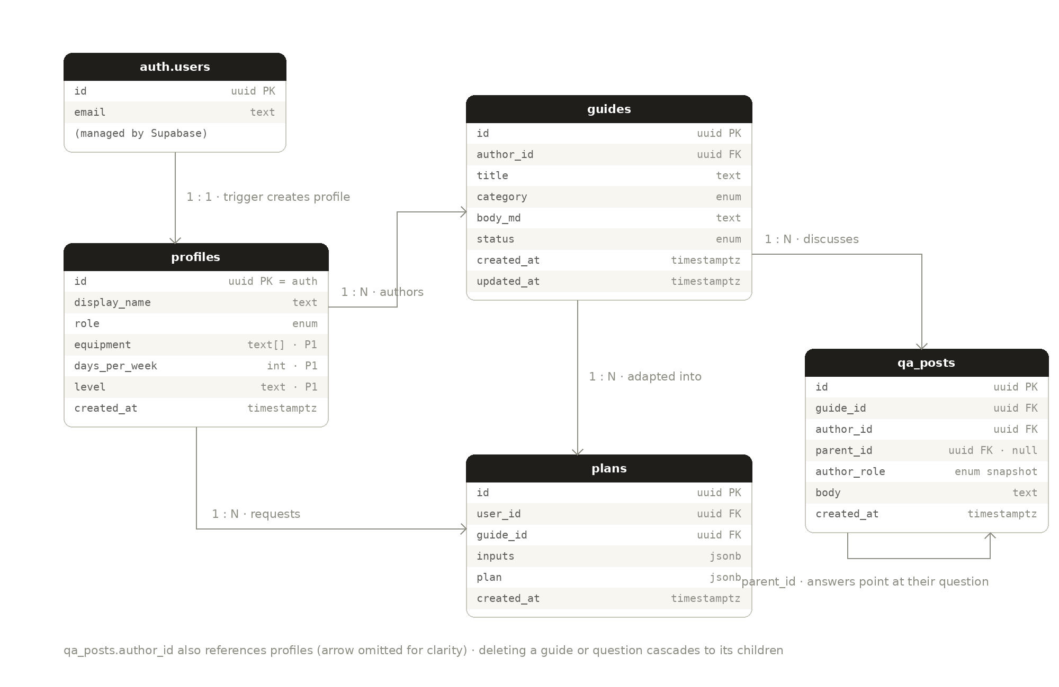
Design notes, table by table:
- profiles is created by a trigger when a row appears in auth.users, so every account has exactly one profile and the default role (member) is assigned in the database, not in application code. The three preference columns are nullable and only used by the P1 pre-fill feature.
- guides carries the ownership model: author_id drives both the trainer-edits-own-guides rule and the dashboard query. Status is a two-value enum; publishing is an update, not a copy.
- qa_posts holds questions and answers in one table: parent_id null means question, set means answer, and on delete cascade implements the moderation decision that removing a question removes its answers. author_role is the badge snapshot, stamped by a security definer trigger so the client can never claim a badge it doesn't have.
- plans is append-only and does three jobs: the newest row per (user, guide) is what the UI shows, the count of a user's rows today is the rate limit, and the full set is an audit trail of model output. The two composite indexes serve exactly those two read patterns.

2.1 Schema (migration 0001)
-- Enums
create type user_role as enum ('member','trainer','admin');
create type guide_category as enum ('programs','nutrition','gym_picks','recovery');
create type guide_status as enum ('draft','published');

-- Tables
create table profiles (
id uuid primary key references auth.users(id) on delete cascade,
display_name text not null default '',
role user_role not null default 'member',
equipment text[], -- P1: personalize pre-fill
days_per_week int, -- P1
level text, -- P1
created_at timestamptz not null default now()
);

create table guides (
id uuid primary key default gen_random_uuid(),
author_id uuid not null references profiles(id) on delete cascade,
title text not null,
category guide_category not null,
body_md text not null default '',
status guide_status not null default 'draft',
created_at timestamptz not null default now(),
updated_at timestamptz not null default now()
);

create table qa_posts (
id uuid primary key default gen_random_uuid(),
guide_id uuid not null references guides(id) on delete cascade,
author_id uuid not null references profiles(id) on delete cascade,
parent_id uuid references qa_posts(id) on delete cascade, -- null = question
author_role user_role not null, -- badge snapshot, set by trigger
body text not null,
created_at timestamptz not null default now()
);

create table plans (
id uuid primary key default gen_random_uuid(),
user_id uuid not null references profiles(id) on delete cascade,
guide_id uuid not null references guides(id) on delete cascade,
inputs jsonb not null, -- {equipment, days_per_week, level}
plan jsonb not null, -- validated model output
created_at timestamptz not null default now()
);

-- Indexes
create index on guides (status, category);
create index on qa_posts (guide_id, created_at);
create index on plans (user_id, created_at); -- rate limit count
create index on plans (user_id, guide_id, created_at desc); -- latest plan

2.2 Triggers (migration 0002)
-- Create a profile automatically on sign-up
create function public.handle_new_user() returns trigger
language plpgsql security definer set search_path = public as $$
begin
insert into profiles (id, display_name)
values (new.id, coalesce(new.raw_user_meta_data->>'display_name', ''));
return new;
end $$;

create trigger on_auth_user_created
after insert on auth.users
for each row execute function public.handle_new_user();

-- Stamp author identity and role on Q&A posts server-side,
-- so a client can never fake a trainer badge
create function public.stamp_author_role() returns trigger
language plpgsql security definer set search_path = public as $$
begin
new.author_id := auth.uid();
new.author_role := (select role from profiles where id = auth.uid());
return new;
end $$;

create trigger qa_stamp
before insert on qa_posts
for each row execute function public.stamp_author_role();

-- Keep guides.updated_at honest
create function public.touch_updated_at() returns trigger
language plpgsql as $$
begin new.updated_at := now(); return new; end $$;

create trigger guides_touch
before update on guides
for each row execute function public.touch_updated_at();

-- Enforce the flat Q&A thread at the database level (Checkpoint 2
-- recommendation): an answer's parent must be a root question,
-- and it must live on the same guide as that question.
create function public.check_flat_thread() returns trigger
language plpgsql as $$
declare parent_rec qa_posts;
begin
if new.parent_id is not null then
select * into parent_rec from qa_posts where id = new.parent_id;
if parent_rec.parent_id is not null then
raise exception 'answers cannot have replies';
end if;
if parent_rec.guide_id <> new.guide_id then
raise exception 'answer must belong to the question''s guide';
end if;
end if;
return new;
end $$;

create trigger qa_flat
before insert on qa_posts
for each row execute function public.check_flat_thread();

3. Role & Permission Design
Three roles — member (default at sign-up), trainer (verified by an admin), admin. Permissions are enforced in three layers: UI hides what you can't use, middleware blocks routes you can't visit, and RLS refuses at the database whatever the first two layers miss. Only RLS is a security boundary; the other two are UX. The matrices below are the single source of truth that both the middleware and the policies in §4 implement.

3.1 Table permissions
Table | Select | Insert | Update | Delete
profiles | any signed-in user (names for authorship) | sign-up trigger only | own row; role column revoked | admin
guides | published, or own, or admin | trainer/admin, author must be self | owner or admin | owner or admin
qa_posts | anyone who can see the guide | signed-in, on published guides | nobody (no edits in v1) | author or admin
plans | own rows only | server only (service role) | nobody | nobody

3.2 Route access
Route | Access | Enforced by
/login, /signup | public | —
/ (browse) | signed-in | middleware (session)
/guides/[id] | signed-in; drafts resolve only for owner/admin | middleware + guides_select RLS
/dashboard | trainer, admin | middleware (role) + RLS
/guides/new, /guides/[id]/edit | trainer, admin; ownership on save | middleware (role) + guides_update RLS
/admin/users | admin | middleware (role) + set_user_role check
/profile | signed-in | middleware (session)
/api/personalize | signed-in, under daily cap | route handler + plans count

3.3 Middleware role resolution (added after Checkpoint 2)
Middleware reads the caller's role with a profiles query per gated request, via the @supabase/ssr server client (option B from the review). The deciding factor is freshness: promoting a member to trainer is this app's central role-management moment, and it must take effect on the user's next request — not their next sign-in. A JWT custom claim would leave a just-promoted trainer locked out of /dashboard until their token refreshes, which is precisely the flow the demo will show. The cost is one indexed primary-key lookup on profiles, paid only on gated routes.
// middleware.ts (sketch) - Edge runtime, @supabase/ssr
const supabase = createServerClient(url, anonKey, { cookies });
const { data: { user } } = await supabase.auth.getUser();
if (!user) return NextResponse.redirect(new URL('/login', req.url));

if (needsRole(pathname)) {
const { data: p } = await supabase
.from('profiles').select('role').eq('id', user.id).single();
if (!allowed(pathname, p?.role)) {
return NextResponse.redirect(new URL('/', req.url));
}
}
The JWT custom-claim approach (custom_access_token hook) is documented as the scaling path: if per-request lookups ever became a cost worth removing, embedding the role as a claim plus a forced token refresh inside set_user_role would recover freshness. Not needed at v1 scale.

4. RLS Policy Design
Two traps shape this design. First, recursion: policies need the caller's role, but a policy on profiles that queries profiles re-triggers itself — so role lookup goes through a security definer function that runs outside RLS. Second, column protection: RLS rules are per-row, not per-column, so nothing in a row policy alone stops a user updating their own role field. The role column is revoked from the authenticated Postgres role entirely, and promotion happens only through set_user_role, which checks the caller is an admin. Migration 0003:
alter table profiles enable row level security;
alter table guides enable row level security;
alter table qa_posts enable row level security;
alter table plans enable row level security;

-- Role lookup without recursion: a policy on profiles that queries
-- profiles re-triggers itself. security definer runs outside RLS.
create function public.my_role() returns user_role
language sql stable security definer set search_path = public as $$
select role from profiles where id = auth.uid();
$$;

-- profiles ---------------------------------------------------------
create policy profiles_select on profiles for select
using (auth.uid() is not null);
create policy profiles_update on profiles for update
using (id = auth.uid()) with check (id = auth.uid());
create policy profiles_delete on profiles for delete
using (my_role() = 'admin');

-- RLS is per-row, not per-column: take role out of reach entirely,
-- and change it only through an admin-checked function.
revoke update (role) on public.profiles from authenticated;

create function public.set_user_role(target uuid, new_role user_role)
returns void language plpgsql security definer set search_path = public as $$
begin
if my_role() <> 'admin' then
raise exception 'admins only';
end if;
update profiles set role = new_role where id = target;
end $$;

-- guides -----------------------------------------------------------
create policy guides_select on guides for select
using (status = 'published' or author_id = auth.uid() or my_role() = 'admin');
create policy guides_insert on guides for insert
with check (my_role() in ('trainer','admin') and author_id = auth.uid());
create policy guides_update on guides for update
using (author_id = auth.uid() or my_role() = 'admin');
create policy guides_delete on guides for delete
using (author_id = auth.uid() or my_role() = 'admin');

-- qa_posts ---------------------------------------------------------
create policy qa_select on qa_posts for select using (
exists (select 1 from guides g where g.id = guide_id
and (g.status = 'published' or g.author_id = auth.uid()
or my_role() = 'admin'))
);
create policy qa_insert on qa_posts for insert with check (
auth.uid() is not null and
exists (select 1 from guides g where g.id = guide_id
and g.status = 'published')
);
create policy qa_delete on qa_posts for delete
using (author_id = auth.uid() or my_role() = 'admin');
-- no update policy: posts are immutable in v1 (delete and repost)

-- plans ------------------------------------------------------------
create policy plans_select on plans for select
using (user_id = auth.uid());
-- no insert policy for clients: rows are written only by the server
-- route using the service role, after the rate-limit check

5. API Design
The API surface is deliberately small. Because RLS is the authorization layer, ordinary reads and writes go directly through the Supabase client from pages and components — wrapping every table in REST endpoints would duplicate rules the database already enforces. Two custom surfaces exist.

5.1 POST /api/personalize
The only route handler. Server-side because it holds the Anthropic API key, enforces the rate limit, and validates model output before anything reaches the client.
POST /api/personalize
{
"guideId": "9f2c…",
"equipment": ["dumbbells", "bench"],
"daysPerWeek": 3,
"level": "beginner"
}

200 OK
{
"planId": "41ab…",
"plan": {
"days": [
{ "day": 1, "focus": "Push",
"exercises": [
{ "name": "Dumbbell bench press", "sets": 4,
"reps": "8-10", "note": "swapped from barbell" }
] }
],
"notes": ["Kept the push/pull structure",
"General guidance only - not medical advice"]
}
}

Server flow: (1) resolve the session — 401 if absent; (2) count today's plans rows for the user — 429 if at the daily cap (proposed: 10); (3) fetch the guide using the caller's own Supabase token, so drafts 404 for members automatically via guides_select; (4) prompt the model with the guide body, the member's constraints, and the §7 safety instructions from the requirements doc; (5) validate the response against the zod schema in lib/plan-schema.ts — 502 with a retry hint if malformed; (6) insert the plans row with the service client; (7) return plan and planId. The latest saved plan is read back by the guide page with an ordinary client select under plans_select — no endpoint needed.

5.2 Role changes
The admin panel calls supabase.rpc('set_user_role', { target, new_role }). Keeping this in the database (rather than a route handler) means the admin check and the write are one atomic, reviewable function — and the audit-log bonus item becomes a one-line trigger on profiles later.

6. Directory Structure
app/
├ (auth)/login/page.tsx · signup/page.tsx
├ page.tsx browse
├ guides/[id]/page.tsx detail + personalize + Q&A
├ guides/new/page.tsx · guides/[id]/edit/page.tsx
├ dashboard/page.tsx
├ admin/users/page.tsx
├ profile/page.tsx
└ api/personalize/route.ts the one custom endpoint
components/ shared UI (cards, badges, plan cards)
lib/supabase/client.ts · server.ts
lib/ai.ts prompt + Anthropic call
lib/plan-schema.ts zod schema for plan JSON
middleware.ts session + role gate for gated routes
supabase/migrations/ schema, triggers, RLS as committed SQL

Routes map one-to-one onto the seven screens from the requirements document. middleware.ts matches the gated routes, checks the session cookie, and reads the caller's role for /dashboard, /admin, and the editor routes; RLS remains the backstop if middleware is ever bypassed.

7. Checkpoint 2 Outcomes
- Rate limit confirmed at 10 personalizations per user per day.
- Plan JSON shape (§5.1) confirmed for implementation.
- Middleware role resolution decided and documented in §3.3: profiles query per gated request, JWT claim noted as the scaling path.
- Per reviewer recommendation, the flat Q&A structure is now enforced at the database level: the qa_flat trigger rejects replies-to-replies and cross-guide answers (§2.2).
- Remaining: reconcile this document against the per-phase task breakdown once received.

