**Subject:** Geometry

**Topic:** Shapes.

**Description:** This example lesson offers an activity for the geometry in order to distinguish different shapes like the parallelogram, square, trapezoid and rectangle. The activity uses machine learning to strengthen the learning of the learners, as well as other soft skills such as critical thinking, communication and argumentation skills, among others.

**Age(s):** 5th - 12th class

**Time:** 1h or 2h (depending on if using pre-uploaded image set or if learners have to create it on their own)

**Goals:**

* Learn to distinguish base on its characteristics, parallelogram, square, trapezoid and rectangle.

**Competences:**

* Understand different shapes and characteristics.
* Be able to identify their main characteristics
* Promote critical thinking when using AI in the classification of the respective capitals

**Situation before:** This class is a generic one and does not require any particular knowledge besides being able to work with a computer.

**Type of instruction, organisation:** Indirect instruction where students work in groups and discuss and solve problems guided by the teacher.

**Tool used:** LearningML, in particular its Image functionality: <https://learningml.org/editor/model/image>

**Required technical infrastructure:** Good network connection is required if you ask students to upload images

**Intro:**

**Rectangle**



The definition of rectangle is given as: a plane shape with four sides. It is a 4 sided polygon with opposite sides parallel to each other. As per definition of rectangle, this figure has four angles. So, one of the properties of rectangle is that all the angles in a rectangle are 90°.Another important one of the properties of rectangle is that the adjacent angles are supplementary. The diagonals of the rectangle are also congruent to each other and they bisect each other at their point of intersection. A rectangle can also be called a quadrilateral as it has 4 sides, but not all quadrilaterals fit the definition of rectangle.

**Square**



Square is a quadrilateral in which all the sides have equal length and all the four corners are at right angles. (A square also fits into the definition of rectangle). Based on the definition of square, we can understand the following properties.

* The opposite sides are parallel, with all sides being equal.
* A square has four lines of symmetry.
* The order of rotational symmetry is 4.
* The diagonals bisect each other at 90° or right angles. This is one of the properties of square that make it different from rectangles.
* Opposite sides are equal and parallel.
* All angles are equal to 90° and any two adjacent angles add up to 180°.
* The diagonals are equal and bisect the angles
* Each diagonal divides the square into two congruent isosceles right-angled triangles.

**Parallelogram**

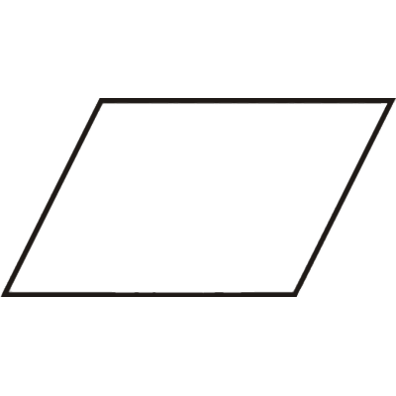

A parallelogram is a two-dimensional geometrical shape, whose sides are parallel to each other. It is a type of polygon having four sides (also called quadrilateral), where the pair of parallel sides are equal in length. The Sum of adjacent angles of a parallelogram is equal to 180 degrees. In geometry, you must have learned about many 2D shapes and sizes such as circle, square, rectangle, rhombus, etc. All of these shapes have a different set of properties. Also, the area and perimeter formulas of these shapes vary from each other and are used to solve many problems.

**Trapezoid**

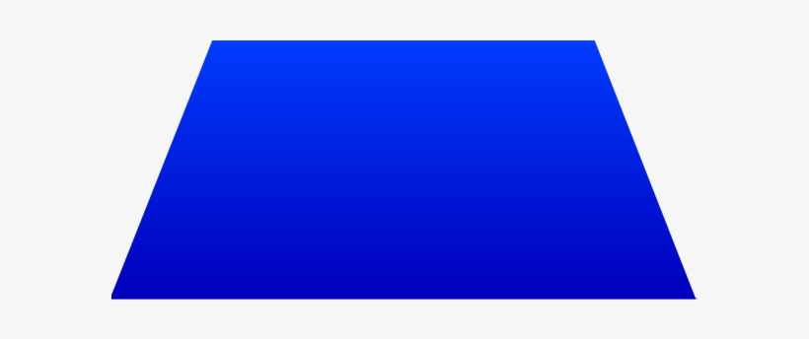

A trapezoid is also known as a trapezium is a four-sided polygon or a quadrilateral. It has one set of opposite sides which are parallel and a set of non-parallel sides. The parallel sides are known as the bases and the non-parallel sides are known as the legs of the trapezoid.

**Teacher guide:**

Step 1: Gather pictures from parallelograms, squares, trapezoids and rectangles (5 minutes / 30 minutes)

1. Use a pre-stored LearningML environment where 3 pictures from each of the shape have been stored. (5 minute)
2. Ask students to locate over the Internet 3-10 images from each shape. The Google Image Search engine can be of great help for this task. (30 minutes)

All images should be uploaded to LearningML, having at the end of this step three classifications, one for each of the shapes.

Step 2: Let the model learn (15 minutes)

In this step, LearningML learns to classify images, based on the input provided in Step 1. At this point it is a good opportunity to present the most important concepts of the different shapes. Learners should already be aware of the most significant differences, based on the pictures from Step 1. The most important concepts and keywords should be presented at this stage.

Step 3: Test & discuss (30-60 minutes)

* Ask learners to upload pictures of columns from the Internet and upload them to see the results. Alternative: We provide a set of images which can be used.
* For each uploaded picture, learners should answer following questions:
  + Are the results correct? (i.e., is the most probable shape the one you think it is?)
  + Why are the results not 100%?
  + If the result is not correct, what do you think is the reason for it?
  + What are the most relevant way in your opinion to identify each shape?
* Ask learners to upload a picture of a Table and to use it as test image.
  + Are the results correct?
  + Why are the results not 100%?
  + What type is it?
  + What’s the most significant detail to identify its type?
  + If the result is not correct, what do you think is the reason for it?
  + Could you explain the reason for the limitations of AI in this case?