**2015 - 2016**

**Oakland SEL Briefing Notes**

*“NoVo Foundation believes that Social and Emotional Learning (SEL),*

*brought to scale, can and will play a significant role in shifting our*

*culture of systemic inequality and violence toward a new ethos that*

*values and prioritizes collaboration and partnership.”*

**OUSD’s Equity-Centered Social and Emotional Learning Definition**

Social and emotional learning (SEL) is a process through which children and adults develop the fundamental skills for life effectiveness. These are the skills we all need to handle ourselves, our relationships, and our work effectively and ethically. **In OUSD, we believe that strengthening our social skills and competencies enhances our ability to connect across race, class, culture, language, gender identity, sexual orientation, learning needs and age. \***

**\*** *The bold text was added to the CASEL definition by the OUSD SEL Design Team in 2013 and is inspiring other districts to reexamine their definition of SEL using an equity lens.*

**Guiding Questions for Expanding and Sustaining Social and Emotional Learning in OUSD**

**Instruction:**  How will we ensure that every student experiences explicit, rigorous and culturally responsive instruction that builds their knowledge and skills of SEL?

**Integration:** How will we integrate our OUSD SEL Standards into instructional and leadership practices across academic content and district departments while providing multiple opportunities for practicing SEL skills?

**Culture and Climate:** How will we build and sustain partnerships that intentionally build a positive climate and culture for all members of our learning community (classrooms, schools, district)?

**OUSD Theory of Change: Social and Emotional Learning**

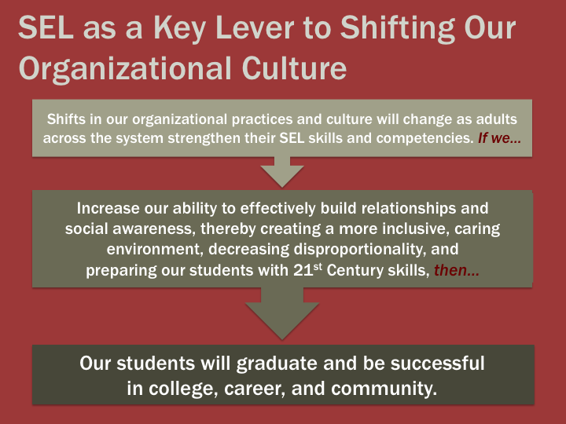

**Social and Emotional Learning in OUSD**

**Grounded in Leadership:**

* [**Board Policy**](https://drive.google.com/file/d/0B2DcKbJpERRRc1pzTUNtSFNnQjQ/view?usp=sharing) on Social and Emotional Learning (first in the nation, 2013)
* OUSD creates [**Social and Emotional Learning Standards**](https://drive.google.com/file/d/0B2DcKbJpERRRQmYzV0NqQUU3MFQ0SnVGbzlWNmhldUxENE5R/view?usp=sharing) for students and adults, “from the classroom to the boardroom.” (2013)
* OUSD Social and Emotional Learning Standards are now an essential part of the district's entire **system of performance frameworks** for:
  + Students ([Graduate Profile](http://www.ousd.org/cms/lib07/CA01001176/Centricity/Domain/2884/Graduate%20Profile%20gl%20edit%2011.15%20copy.pdf), [Elementary Report Card](https://drive.google.com/file/d/0B2DcKbJpERRRbW9FTmkxeUIzMVU/view?usp=sharing))
  + Teachers: Teacher Growth and Development System ([TGDS](http://www.ousd.org/Domain/3288))
  + Principals: Leadership Growth and Development System ([LGDS](http://www.ousd.org/Domain/3423))
  + Schools: School Performance Framework ([SPF](http://qualitycommunityschools.weebly.com/school-performance-framework.html))
  + Superintendent ([Superintendent’s Work Plan #2](http://www.ousd.org/cms/lib07/CA01001176/Centricity/Domain/10/2015-2016%20Work%20Plan%20-%20Superintendent%20of%20Schools.pdf))

**In the Classroom:**

* **Elementary Schools:** CASEL Select curricula: *Caring School Community* in 16 schools (current grant funding sunsets this year); *Second Step* in three sites; and *MindUP* in one site. Complementary programs such as *Toolbox*, *Roots of Empathy*, *Welcoming Schools*, *Not In Our Schools* and *Transformative Life Skills* are selected by and paid for by individual sites.
* **Middle Schools:** Initial planning year with Engaging Schools Advisory model.
* **High Schools:** Integrating SEL into Linked Learning structures and practices where SEL is explicitly taught, modeled and infused throughout the Four Pillars of Linked Learning. This year we are partnering with Pathway Coaches to offer SEL targeted professional learning at HS sites. We are also piloting research based SEL practices in partnership with Engaging Schools within two Pathways at Skyline HS.

**Supported with External Partnerships:**

* **[CASEL](http://www.casel.org/)** (Collaborative for Social and Emotional Learning)

* **[NoVo Foundation](http://novofoundation.org/)**

* **[Education First](http://education-first.com/)**

* **[S.D. Bechtel Jr. Foundation](http://sdbjrfoundation.org/)**

* **[Mills Teacher Scholars](http://millsscholars.org/)** (Mills College)

* **[Engaging Schools](http://engagingschools.org/)**

* **[Center for the Collaborative Classroom](https://www.collaborativeclassroom.org/)**

**Collaborating with District Partners:**

* **Leadership Development: SEL** explicitly embedded in monthly Principal and Assistant Principal professional learning.
* **Elementary Network 1: SEL Learning Hub Network:** Four elementary SEL Learning Hub Schools (Emerson, Lincoln, Crocker Highlands and Joaquin Miller.)
* **Elementary Networks 2 & 3:** Supporting Caring School Community implementation.
* **Middle School Network:** Advisory Planning Team with Engaging Schools
* **High School Network ~ Linked Learning Office for High School Improvement:** Pathway Coach capacity building, Pathway Teacher professional learning and partnership around professional learning with Director for Linked Learning Alliance & Educating for Careers
* **English Language Learners & Multilingual Achievement (ELLMA):** Planning for Newcomer Teachers’ professional learning; ELL focal students as part of the Mills Teacher Scholars
* **Classified:** Attendance Clerk monthly professional learning on SEL Standards
* **Community Schools & Student Services:** Restorative Justice co-facilitating professional learning, Community School Managers professional learning, Family Engagement parent leadership professional learning
* **SEL Steering Committee:** New working group called together by Superintendent Wilson to plan next three years of SEL implementation.

**Social and Emotional Learning Communication in OUSD**

* **[CONNECT: The SEL Information X-Change](http://us8.campaign-archive2.com/?u=88e81fd83437939b2d14a2ae5&id=a374270cd5&e=fb9ff0f5dd)**

* **[SEL Standards Posters](https://drive.google.com/open?id=0B2DcKbJpERRRNWdxeFZuTUhDY1E)**

* **[SEL Website](http://ousdsel.org/)**

**Office of Social and Emotional Learning Team**

* **[Kristina Tank-Crestetto, Director](https://docs.google.com/a/ousd.k12.ca.us/document/d/1x3qxLTnCXWnJoffGCLEi8PHxl8kI5W8JpQ5Tk-e8aOI/edit?usp=sharing)** (currently on leave)

* **[Mary Hurley, Coordinator](https://docs.google.com/a/ousd.k12.ca.us/document/d/1fdcDa84D2TeJgYpzfmWcfA3STij6lz1BKRBz1MRf-eM/edit?usp=sharing)**

* **[Sonny Kim, Program Manager](https://docs.google.com/a/ousd.k12.ca.us/document/d/1omr2MPb9z5FnPtYQ7x66EYM_JljMuj2bClYL2Cdk7xE/edit?usp=sharing)**

* **[Meena Srinivasan, Program Manager](https://docs.google.com/a/ousd.k12.ca.us/document/d/1IuTMQz6CgBxle_Tza4DzPp964tpcsczrgucLaNcv06Q/edit?usp=sharing)**

**OUSD CASEL Consultants**

* **[Chris Hiroshima](http://www.casel.org/people/christine-hiroshima/)**

* **[Ann McKay Bryson](http://www.casel.org/people/ann-mckay-bryson/)**