Seattle University: Center for Community Engagement

Senior Data and Evaluation Analyst Interview

Prepared by: James Lamar Foster

# Youth Initiative Zone Students

# Youth Initiative Zone Student Demographics

Bilingual Students

|  |  |  |
| --- | --- | --- |
| Group | n | Percent Bilingual |
| Non-SUYI | 209 | 31.9 |
| SUYI | 86 | 38.0 |

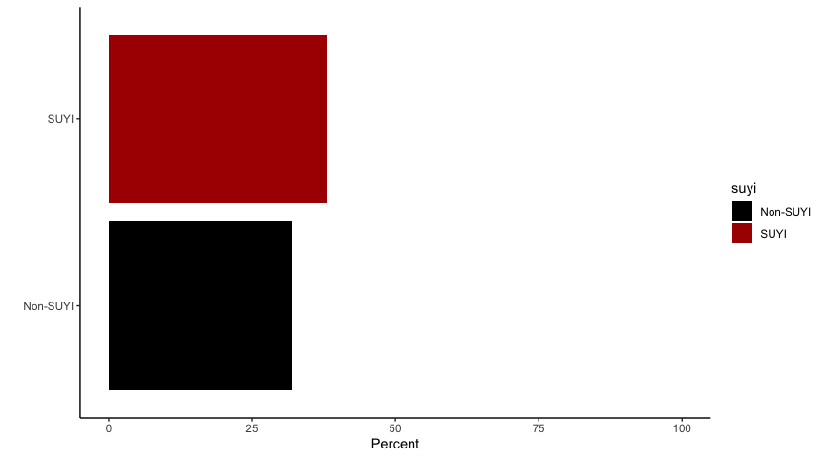

Students Experiencing Homelessness

|  |  |  |
| --- | --- | --- |
| Group | n | Percent Homeless |
| Non-SUYI | 52 | 7.94 |
| SUYI | 8 | 3.54 |

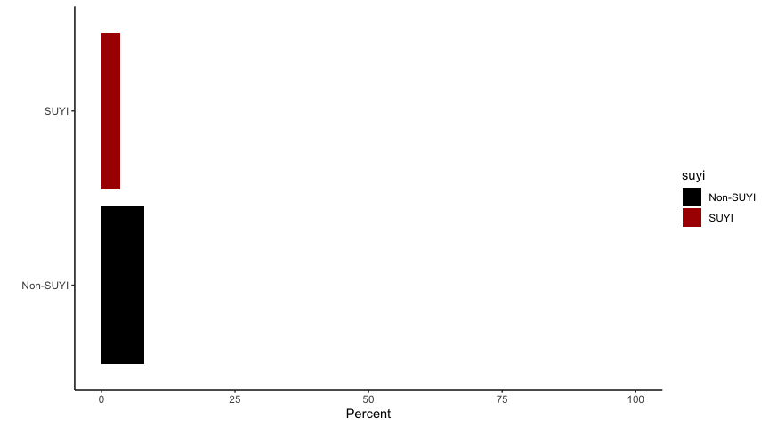

Student’s Primary Language

|  |  |
| --- | --- |
| Primary Language | n |
| English | 359 |
| Somali | 126 |
| Spanish | 105 |
| Vietnamese | 90 |
| Cantonese | 74 |
| Oromo (Ethiopia) | 30 |
| Amharic | 21 |
| Toishanese | 21 |
| Tigrinya (Tigrigna) | 13 |
| Mandarin | 12 |
| Tagalog | 8 |
| Mandingo | 4 |

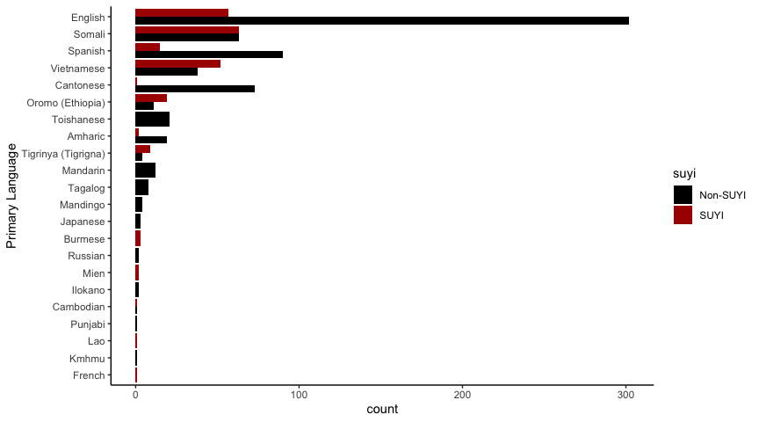

# RIT Scores

Fall Math Scores?

|  |  |  |  |
| --- | --- | --- | --- |
| Group | Mean | Std. Err. | t-test |
| Non-SUYI | 200 | 1.52 | n.s. |
| SUYI | 198 | 2.06 | n.s. |

