ELM-227 CIRCUIT THEORY – II 03.05.2023
Project

Student No : Y111111ZX
210102002808
Y = 2
Z = 0
X = 8

Name SURNAME: Fouad Aladhami
Questions:
(With bold font the questions have been modified according to my Student no)

The source $V\left(t\right)=230∠0°$feeds three parallel Loads. For the loads below
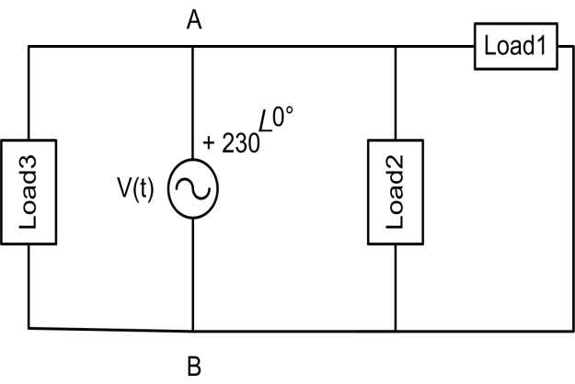
Figure 1: Circuit for project
Load 1 : S=2X kVA, PF=0.6X inductive, X is the last digit of your student number.
Load 1 : S=28 kVA, PF=0.68 inductive, 8 is the last digit of your student number.
Load 2 :P=5 kW, PF=0.8Y capacitive, Y is the first digit of your student number.
Load 2 :P=5 kW, PF=0.82 capacitive, 2 is the first digit of your student number.
Load 3 :P=1Z kW, PF=1 utility, Z is the second to last digit of your student number
Load 3 :P=10 kW, PF=1 utility, 0 is the second to last digit of your student number

a) Calculate the condansator value to set the power factor at 0.95. (Freq.=50 Hz).
b) In order to compensate the reactive power completely, determine the condansator value.
c) Find the current value drawn by the source before (I_{old}) and after (I_{new}) Find the current value before the compensation.
d) Calculate each condansator value for the PF=0.70 up to PF=1 with the step of 0.01. Obtain surface plot. In surface plot X-axis contains PF values, Y axis contains C values and Z axis contains current values drawn by the source. You can use programming skills. For example you can use Matlab for script and figures.
e) Model the Figure 1 in Matlab Simulink. Create two cases which are before compensation (initial case) and after compensation. You can use constant impedance model for loads.

a)

b)

c)

d) To solve the problem I write Matlab code as follow :
Vs = 230;
f = 50;
w = 2.*pi.*f;
%load1
pf1 = 0.68;%inductive
fi1 = acosd(pf1);%derece cinsinden açı değeri
S1 = 28000;
S1vector = S1 .* exp(fi1.*1i.* (pi ./ 180));
P1 = real(S1vector);
Q1 = imag(S1vector);
%load2
pf2 = 0.82;%Capacitive
fi2 = -acosd(pf2);%derece cinsinden açı değeri
P2 = 5000;
S2 = P2./pf2;
S2vector = S2 .* exp(fi2.*1i.* (pi ./ 180));
Q2 = imag(S2vector);
%load3
pf3 = 1 ;
fi3 = acosd(pf3);%derece cinsinden açı değeri
P3 = 10000;
S3 = P3./pf3;
S3vector = S3 .* exp(fi3.*1i.* (pi ./ 180));
Q3 = imag(S3vector);
%Total
PT = P1 + P2 + P3 ;
QT = Q1 + Q2 + Q3 ;
STvector = PT + 1i*QT;
ST = abs(STvector);
pfT = PT./ST;
%Compenzation
pfn = 0.7 : 0.01 : 1;
Qaf = PT.*tand(acosd(pfn));
Qc = QT - Qaf;
Xc = Vs.^2 ./ Qc;
C = 1./(100.*pi.*Xc);
Snvector = PT + 1i.*Qaf;
Sn = abs(Snvector);
Is = Sn./Vs;
plot3(pfn, C, Is)
xlabel("Power factor")
ylabel("Capacitor needed for power factor correction","Rotation",-30,"HorizontalAlignment","right")
zlabel("Current drawn by the source")
figure
mdl = scatteredInterpolant(pfn(:), C(:), Is(:));
[xg, yg] = meshgrid(unique(pfn), unique(C));
zg = mdl(xg, yg);

surf( xg,yg,zg)

xlabel("Power factor")
ylabel("Capacitor needed for power factor correction","Rotation",-30,"HorizontalAlignment","right")
zlabel("Current drawn by the source")

This code give me the graph below:
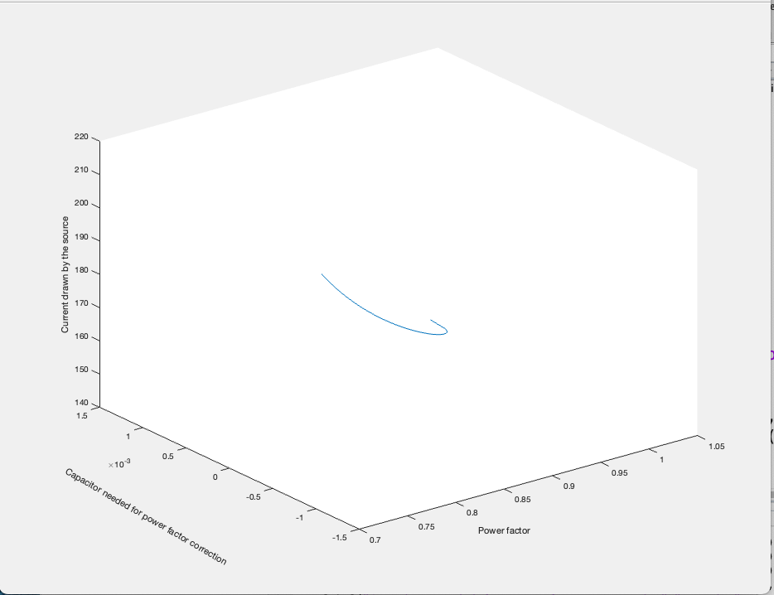
In this graph, when attempting to make changes in the power factor for our specific circuit, it shows which capacitance should be connected and how it affects the current value, whether it increases or decreases.
When attempting to create a surface plot, it is impossible to do it solely based on the instructions provided in the question, which states to only vary the power factor and find the compensating capacitance and current. This is because to obtain a surface plot, it is necessary to vary multiple parameters. One approach involves keeping the power factor constant while changing the capacitance and current. Another approach involves keeping the capacitance constant while varying the power factor and current. Similarly, keeping the current constant while varying the capacitance and power factor would be another approach. All these combinations need to be explored to scan the entire parameter space and generate a surface plot.
This exploration provides a general characteristic regarding current, capacitance, and power factor based on the voltage source mentioned in the question (It is independent of the loads in the circuit and aims to provide an overall understanding.).

To achieve this, the scatteredInterpolant function was used. The scatteredInterpolant function performs interpolation in scattered data, which means it estimates values for points that are not explicitly provided in the data set. It creates a mathematical representation of the data based on the given points, allowing for the estimation of values at other points within the parameter space.
By using the scatteredInterpolant function, missing values or points in the parameter space can be obtained by interpolating between the existing data points. This interpolation process helps create a complete representation of the surface, enabling the visualization and analysis of the circuit characteristics for various combinations of power factor, capacitance, and current values.

E) In the Multisim environment, to model the circuit before and after compensation, the Constant Power Load model from the Simscape library was utilized. This model allows specifying both the active and reactive power values for the loads, thereby representing the loads in the circuit accurately. For power factor correction, the identified capacitance value was added to the circuit as "Correction Capacitance." The currents in these circuits were measured using a current sensor and observed by connecting them to a scope.
This approach facilitates the modeling of the circuit in Multisim, incorporating the Constant Power Load model to represent the loads with active and reactive power values, as well as implementing power factor correction by introducing the appropriate capacitance. The currents in the circuits were then measured using a current sensor and observed using a scope for further analysis.
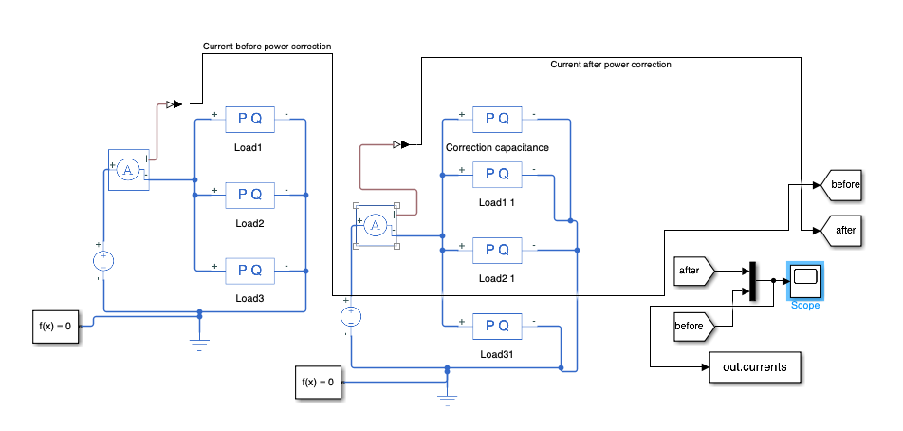

Current for 0.2 second:
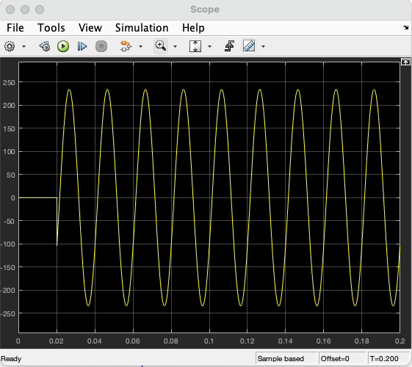

The peak value is found as 234.4
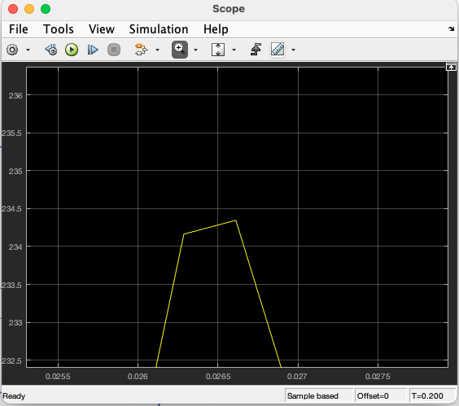
Based on the provided calculation, the RMS (Root Mean Square) value of 234.4, divided by the square root of 2 (√2), indeed equals approximately 165.74. This result is consistent with calculation.
Afterwards, two sinusoidal waves were superimposed and plotted as follows:
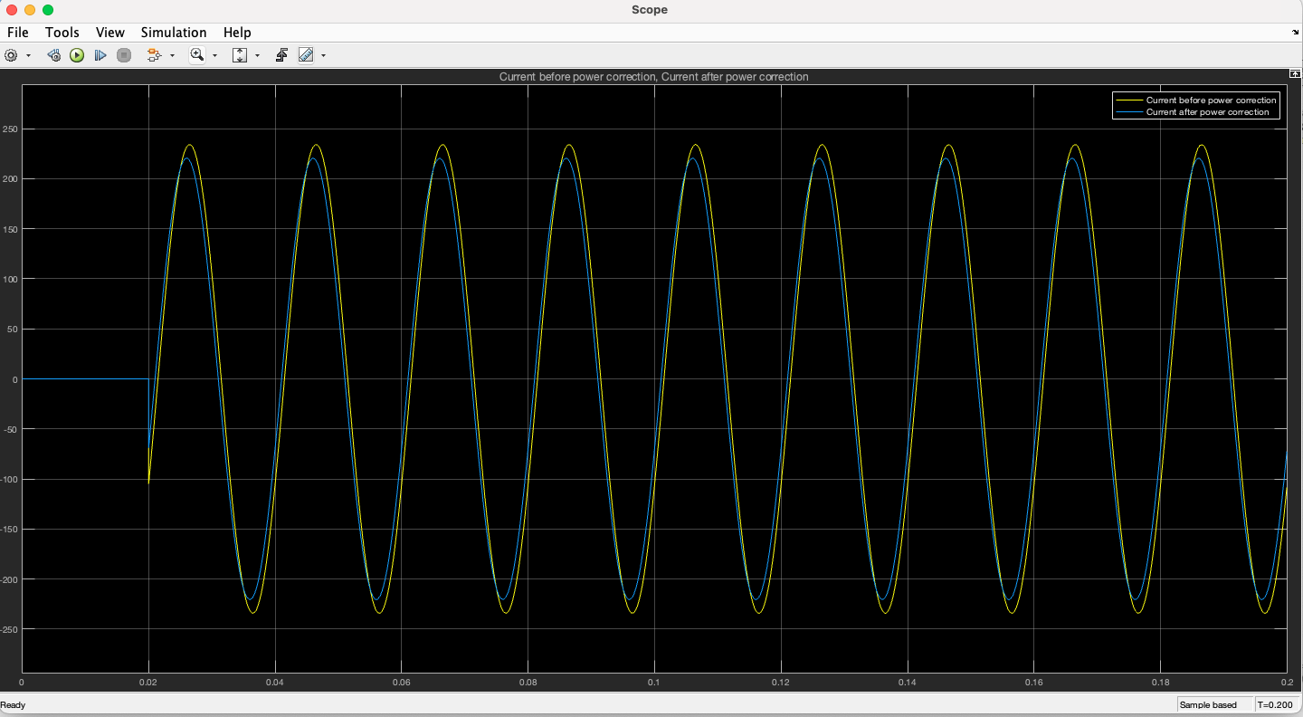
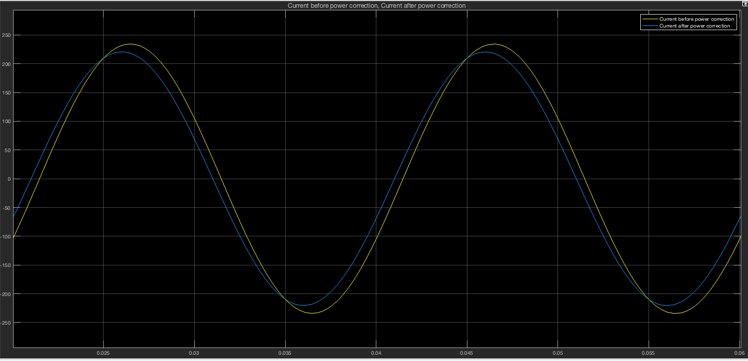

The data was captured as shown below with the "after" and "before" blocks, and it was imported into the MATLAB workspace using a multiplexer (mux).
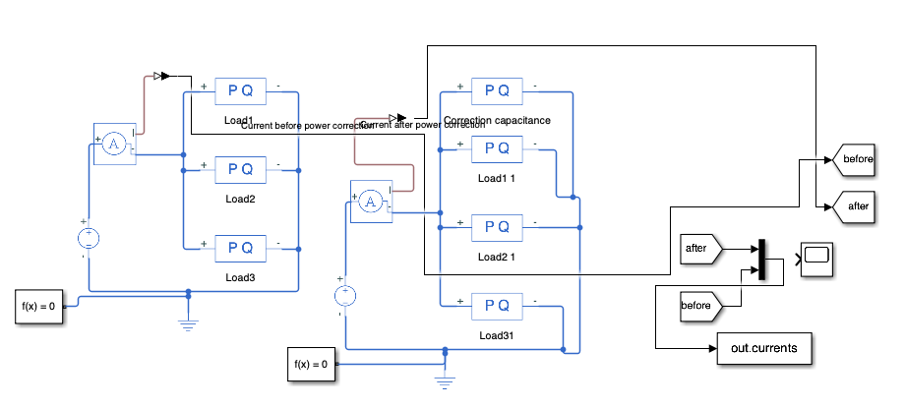
The data was obtained in the form of an array data type, and the following lines of code were used to plot the acquired data.
time = out.tout;
current_before = out.currents(:,1);
current_after = out.currents(:,2);
legend()
plot(time,current_before)
hold on
plot(time,current_after)
legend('Current before compenzation','Current after compenzation',...
'FontSize',12)
xlabel('Time', 'FontSize',14)
ylabel('Amplitude of currents','FontSize',14)

The provided code generates a plot comparing the amplitude of two sets of current data, "current_before"(Current before compenzation) and "current_after"(Current after compenzation) over time. It extracts the time values and current data from the given arrays and plots them using the "plot" function. The plot includes a legend with labels for the two data series and has x-axis and y-axis labels for time and current amplitude, respectively. Overall, the code visualizes the change in current amplitude before and after compensation.
The graph obtained as the output of this code is shown below.

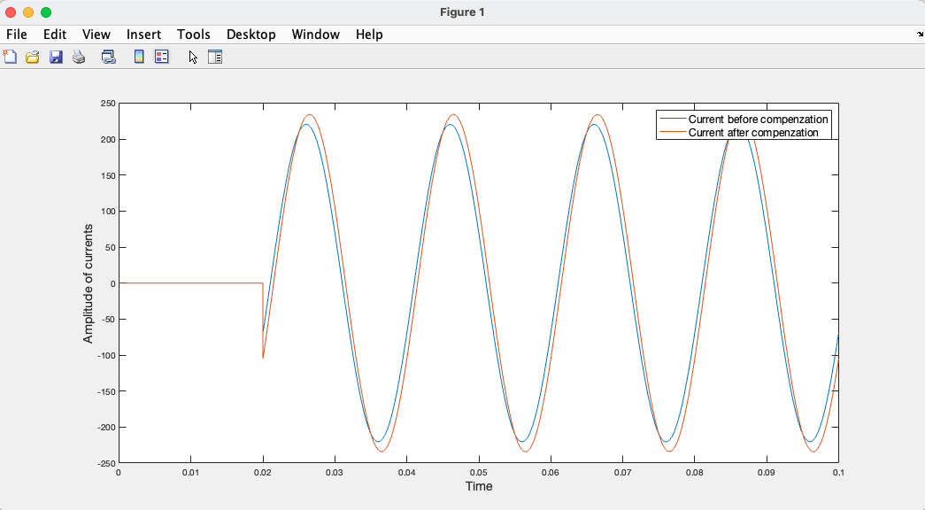
From this graph, a clear decrease in the amplitude of the current after compensation can be observed.

