

GEBZE TECHNICAL UNIVERSITY

ELECTRONICS ENGINEERING

Lab 3 experiment report

1 | Ad Soyad | Süleyman Melih Güneş
1 | Numara | 200102002069
2 | Ad Soyad | Fouad Aladhami
2 | Numara | 210102002808

İçindekiler Tablosu
1 Diode Action 2
1.1 Ideal Rectification 2
1.2 Rectifier Filtering 4
2 Diode Conduction – The forward Drop 6
2.1 Basic Measurements 6
2.2 Forward Conduction Modelling –Finding a Large Signal Model: 7
2.3 Forward Conduction modelling – Find a Small Signal Model: 8

Diode Action

Ideal Rectification

a)
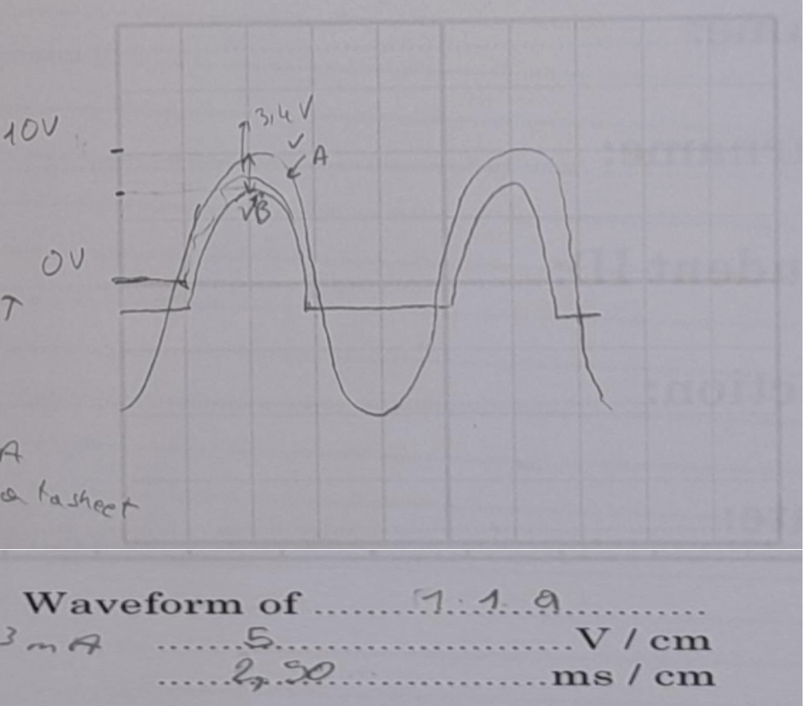
Figure 1: Sinusoidal-Waveforms of First Circuit (Half wave rectifier)
As shown in Figure 1 when the positive voltage falls on the diode, the diode operates and transmits the signal output. Otherwise, it will block the signal. There is a voltage drop due to the internal structure of the diode.

b)
V_{D@10V peak} | V_{D@1V peak}
0.698 | 0.612
Table 1:The estimated voltage drops (V_{D}) at the Peak of the Output for 20Vpp and 2Vpp
In Table 1, V_{D} is calculated using the exponential model of diode and the data provided in datasheet. Refer to datasheet V_{D} = 0.7 V @ 10 mA. Using the exponential model:

$$V_{2}=V_{1}+ V_{T} ln\left(\frac{I_{2}}{I_{1}}\right)$$
When I₁ = 10mA for V₁ = 0.7 V, and I₂ is the calculated current referred to V₁.

c)
 | When V_{b} begins rising | When V_{b} is 1⁄2 diode drop
t(ms) | 100us | 1.2ms
Table 2: Time measurement

d)
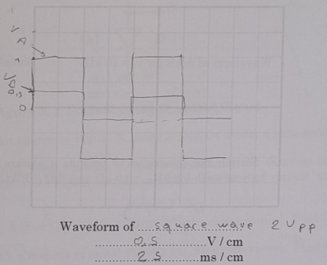
Figure 2: The reaction of the circuit to square wave
In figure 2, for square wave input, the diode rectify the signal and filter the negative part.

Rectifier Filtering
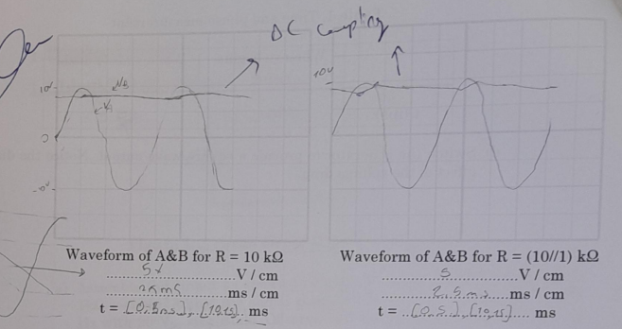
a,b)
Figure 3: Waveform of A & B for R=10 kΩ and Waveform of A & B for R=(10//1) kΩ

Using DC coupling mode of oscilloscope the input and output signal is obtained as shown in Figure 3. The smaller resistor draws more current, so the capacitor discharges faster, and the bias between the two peaks increases. So, for R = (10//1)Kohm the capacitor discharges faster than when R = 10Kohm.

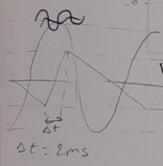
Figure 4: AC sweep for a
As shown in Figure 4, the ac sweep oscilloscope mode is used. In this mode the dc component of the signal is filtered, and the ac portion is shown. So using cursor in the oscilloscope the time of charging of capacitor is measured.
c)
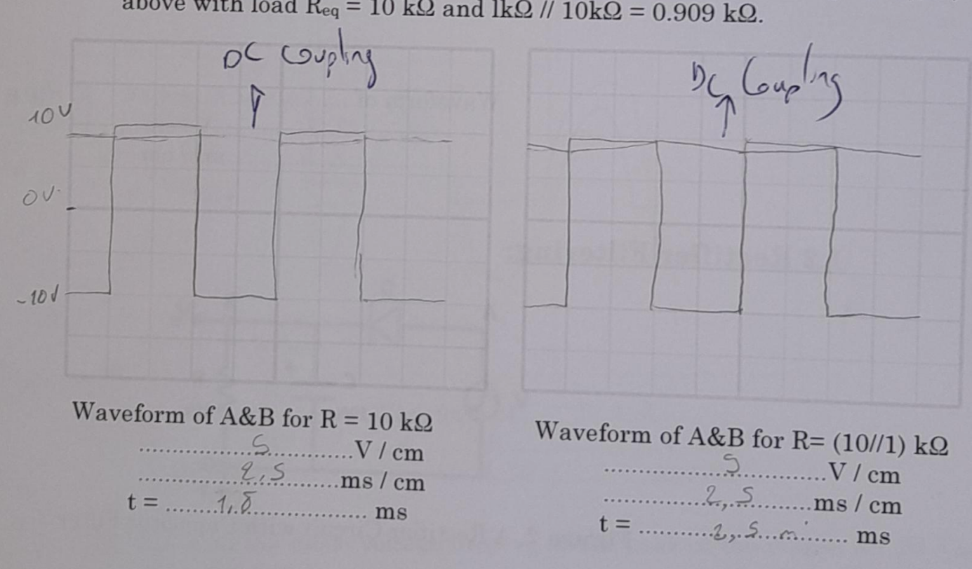
Figure 5: DC coupling for c

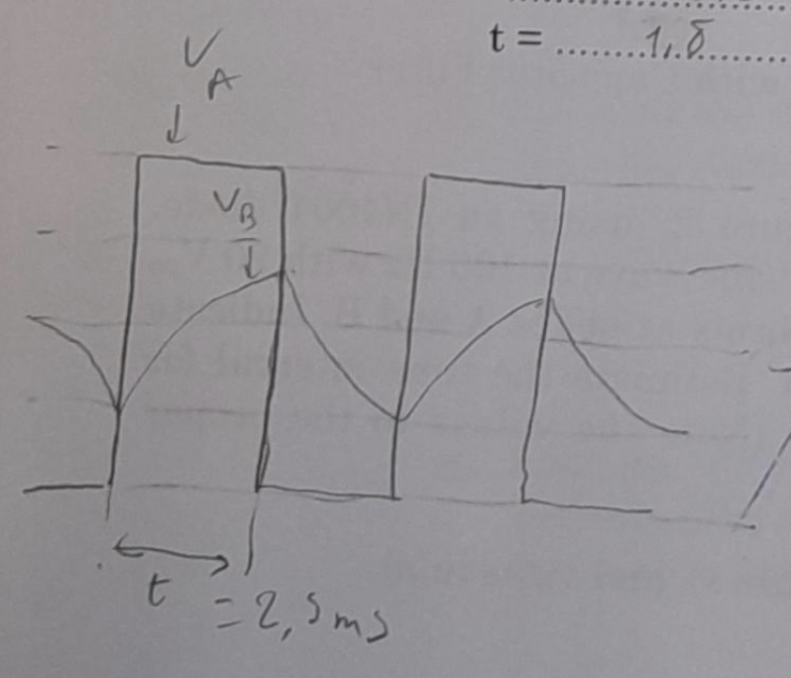
Figure 6: AC sweap of the first circuit in c
First the measurement done in in DC coupling mode as shown in Figure 5. And a voltage drop caused by the diode is clearly visible. Then AC coupling is used as shown in Figure 6 to measure the time of charging the capacitor and its equal to time of diode work in forward direction.

Diode Conduction – The forward Drop

Basic Measurements

 | R = 1 k𝜴 Single Diode | R = (1//1) k𝜴 Single Diode | R = (1//1) k𝜴 Two Diodes Shunted
𝑽𝑩(= 𝑽𝑫) | 0.689 V | 0.72 V | 0.69 V
𝒊𝑫(calculated) | 9.311mA | 9.28mA | 9.31 mA
Table 3:Voltage Measurement and Current
a) When a voltage of 10V is given from the source, the diode current is calculated as 9.311mA from Ohm's law.
b) Adding 1k resistor in parallel to R, the current changed and 9.28 mA went down
c) When we added another diode in parallel to the first diode, its current became 9.31mA.

Forward Conduction Modelling –Finding a Large Signal Model:

IN4004 |  | R = 1 k𝜴 | R = 10 k𝜴 | R = 100 k𝜴 | R = 1 M𝜴
𝑽𝑫𝑫 = 10 V | 𝑽𝑫 (meas.) | 0.689 V | 0.578V | 0.47 V | 0.278 V
𝑽𝑫𝑫 = 10 V | 𝒊𝑫(calc.) | 9.311 mA | 0.942 mA | 0.0953mA | 9.72 𝝁A
𝑽𝑫𝑫 = 10.7 V | 𝑽𝑫 (meas.) | 0.69 V | 0.58 V | 0.477 V | 0.26 V
𝑽𝑫𝑫 = 10.7 V | 𝒊𝑫(calc.) | 9.310mA | 0.942 mA | 0.0952mA | 9.74 𝝁A
Table 4: Voltage Measurements and Current Estimates for IN4004 (Large Signal Model)

a) As shown in Table 4 when the resistors were increased 10 times, the current decreased exponentially. It was noted on the graph. For better observation, V=10.7 volts was adjusted and the same operations were repeated.

b) The circuit circuit set up in Ltspice as shown in Figure

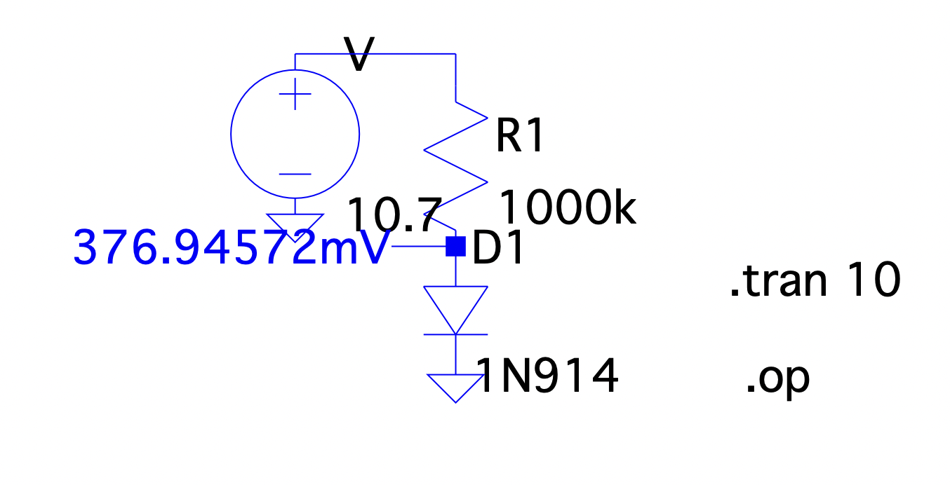
Figure 7: Ltspice circuit for Voltage Measurements and Current Estimates for IN914 (Large Signal Model)

IN914 |  | R = 1 kΩ | R = 10 kΩ | R = 100 kΩ | R = 1 MΩ
VDD =10V | VD (meas.) mV | 690.5 | 582.0 | 477.7 | 373.8
VDD =10V | ID (calc.) mA | 9.31 | 0.94 | 0.095 | 0.0096
VDD = 10.7 V | VD (meas.)mV | 694.2 | 585.3 | 480.9 | 376.9
VDD = 10.7 V | ID (calc.) mA | 9.30 | 0.94 | 0.095 | 0.0096
Table 5: Voltage Measurements and Current Estimates for IN914 (Large Signal Model )

Forward Conduction modelling – Find a Small Signal Model:
Aynı işlemi yapacaksın değerim yanlış olabilir şıklarda istenilen adımları izleyebilirsin
- Using ltspice as shown in Figure 8 an IN914 diode is connected to V+ =10 V and R =1 kohm and V_{D} is measured.

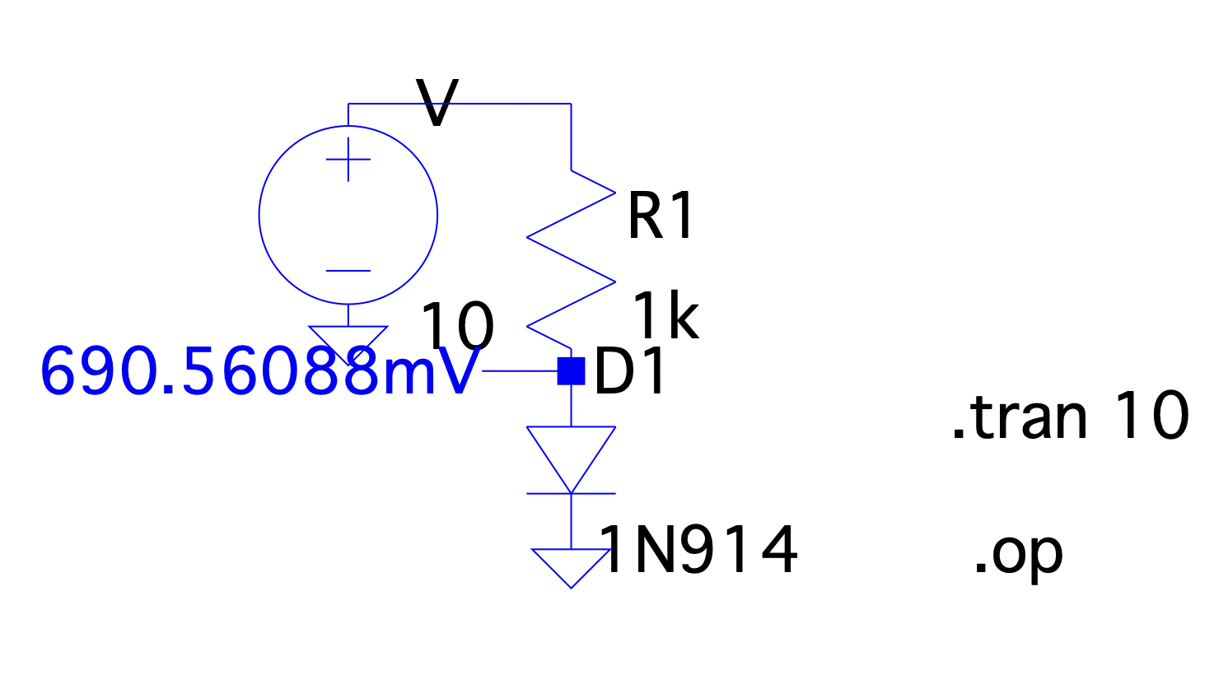
Figure 8:LTspice V_{D} measurement for IN914
- From A we can calculate rd with ohm law, $rd =\frac{VD}{ID}$ when $ID =\frac{VS – VD}{R1}$ when VS is the source voltage and VD the diode voltage. Let’s call this values rd old and ID old. We find $IR1 = \frac{VS – VD}{R1}$ , $IR2=\frac{VD}{R2}$ And $IR2= IR-ID$ so IDnew = IR-IR2 using this formula find IDnew and divide by VD new to obtain rd.
We have repeat the same thing for c and d.

 | R = 1kohm |  |  | R = 100kohm
 | VD with no R  shunting | VD with R  shunting | rD  @~10 mA | VD with no R  shunting | VD with R  shunting | rD  @~0.1 mA
IN4004
IN914
Figure 9: Voltage Measurements and r_{D} Estimates for IN914 and IN4004 (Small Signal Model)

