ELEC361 MATLAB PROJECT

LARGE CARRIER MODULATION AND
ENVELOP DETECTION

Name: Fouad Aladhami
ID: 210102002808

1 Plot m(t), x(t), z(t) and y(t) 3
1.1 Analytic solution 3
1.2 Plot of m(t), c(t), x(t), z(t), y(t) in MATLAB 6
1.3 MATLAB code 7
2 Find and plot M(f), X(f), Z(f), Y(f) 9
2.1 Analytic solutions and plots 9
2.2 FFT with MATLAB and signal plots 11
2.3 MATLAB code 12
3 Envelope detection 14
3.1 With envelope built in MATLAB function 14
3.2 With envelope detector circuit 15
3.2.1 Analytic solution and expression 15
3.2.2 MATALB results 17
3.2.3 MATLAB code 19

Plot m(t), x(t), z(t) and y(t)

Analytic solution
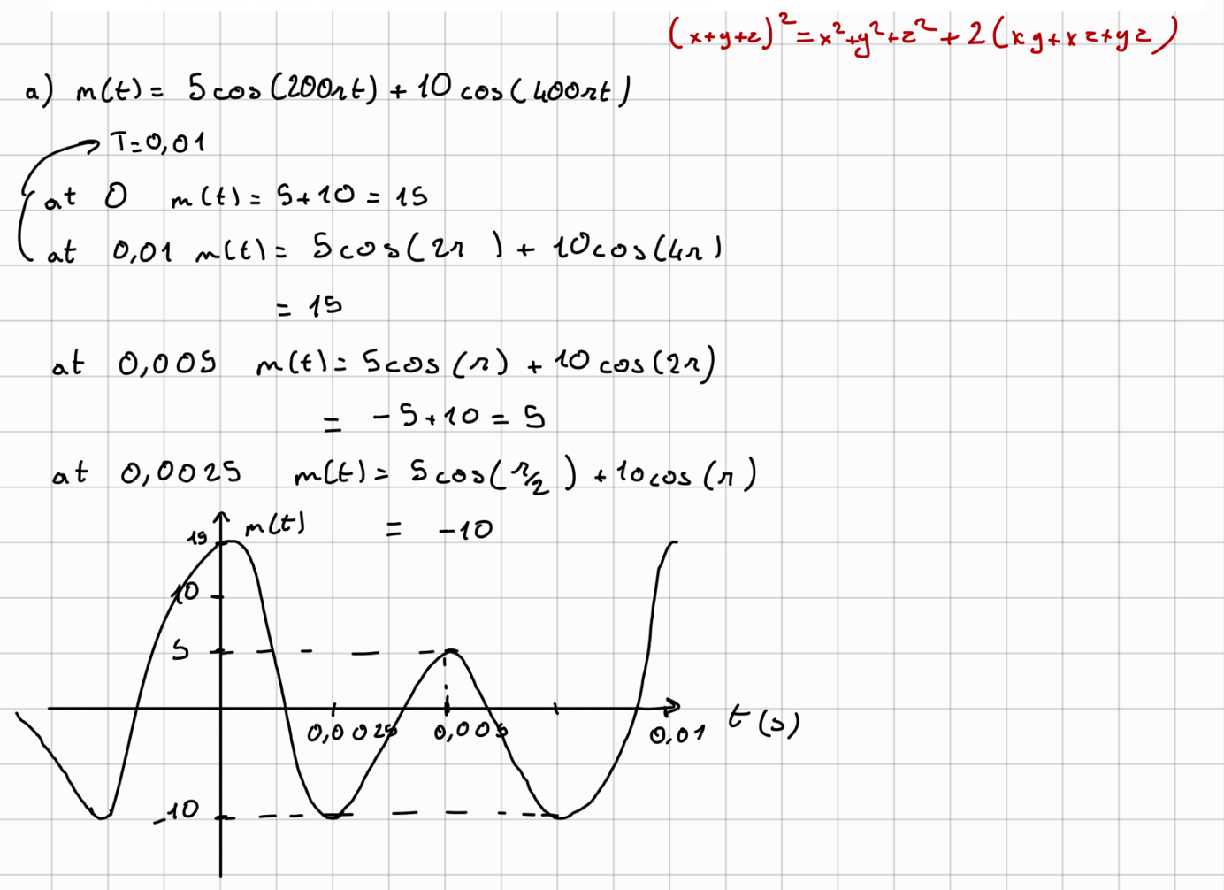
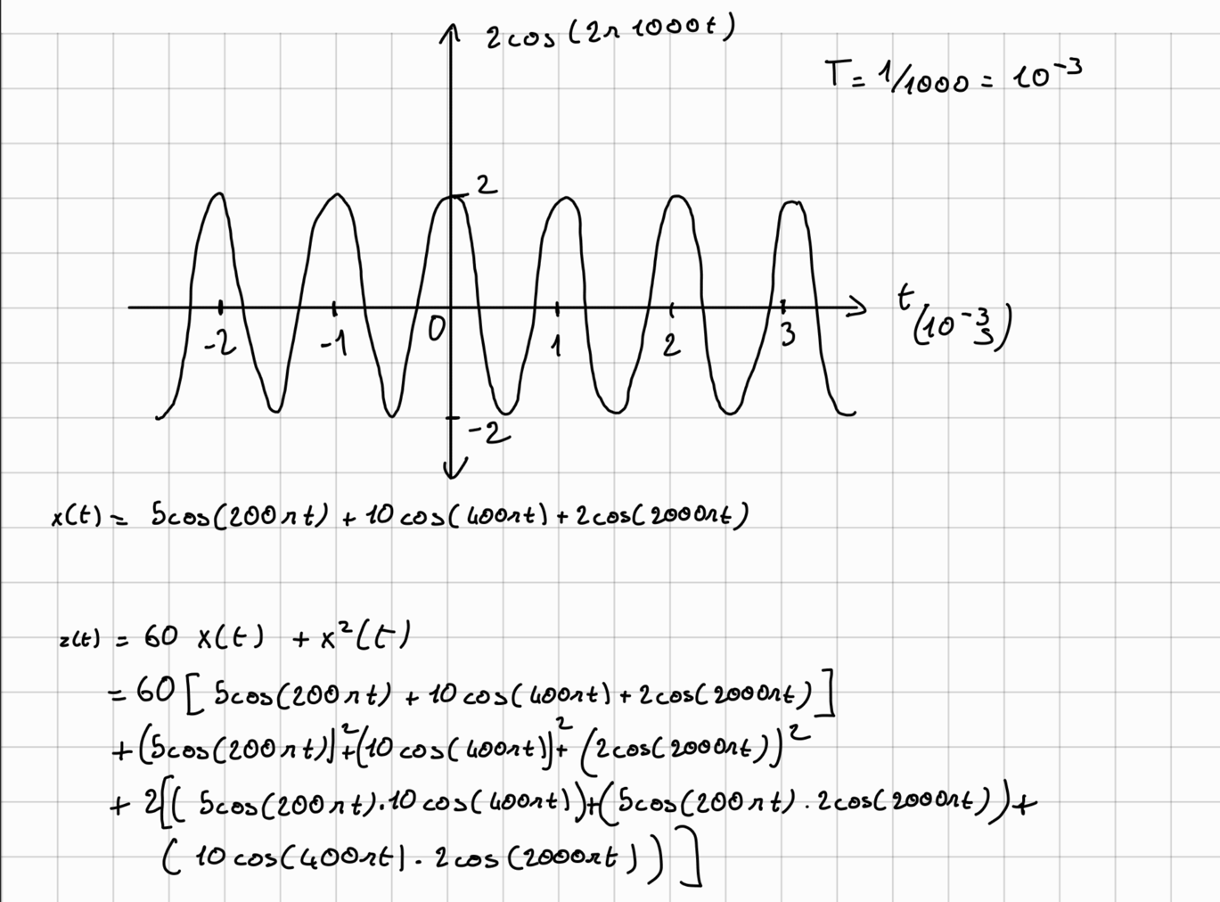
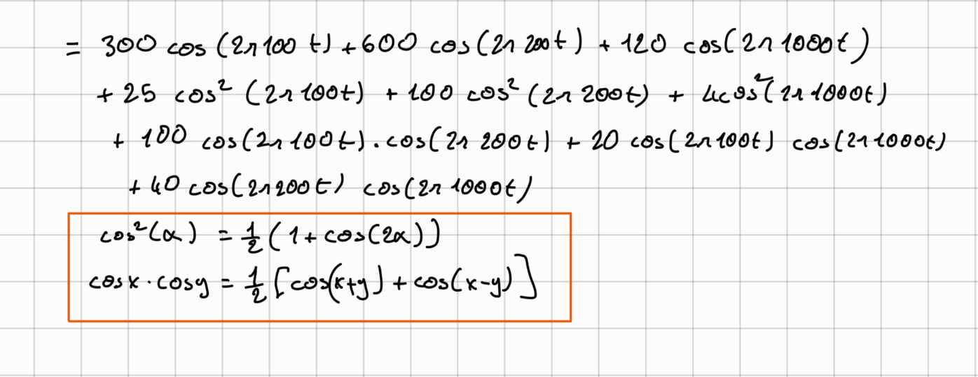
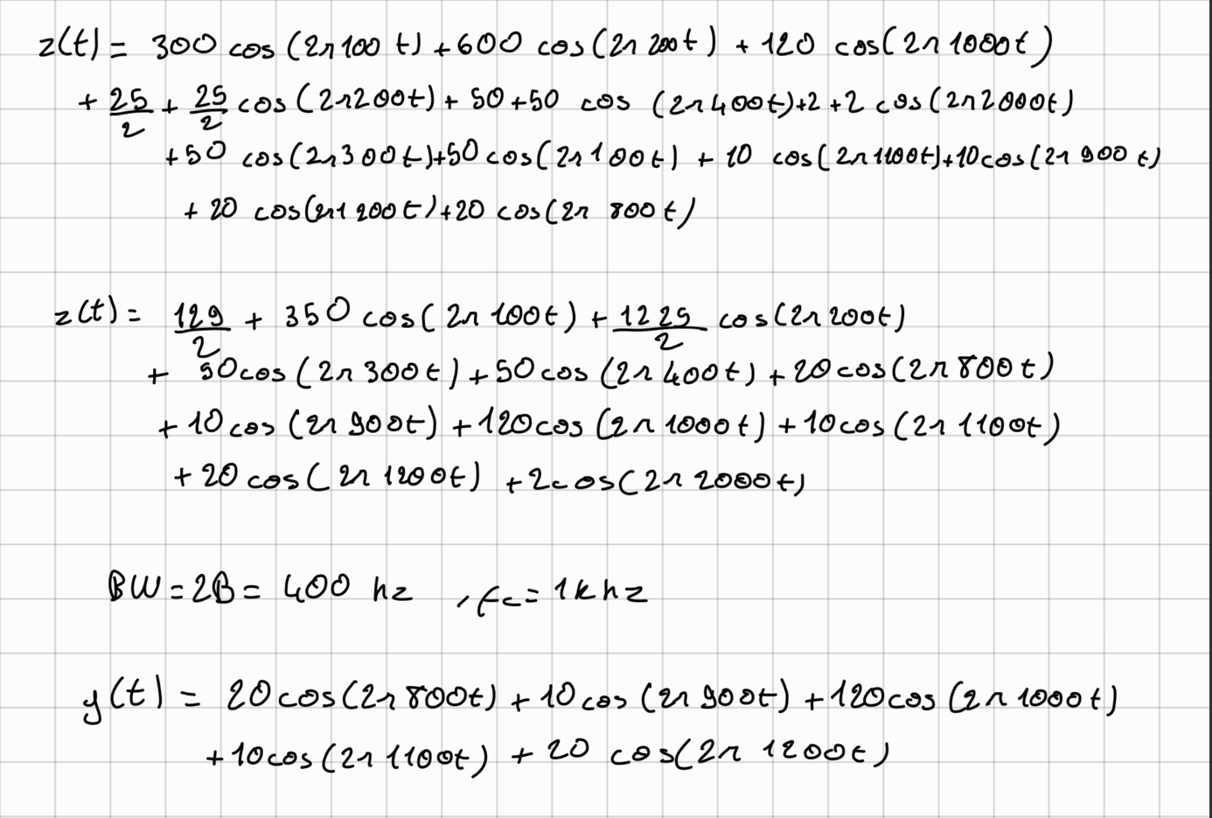

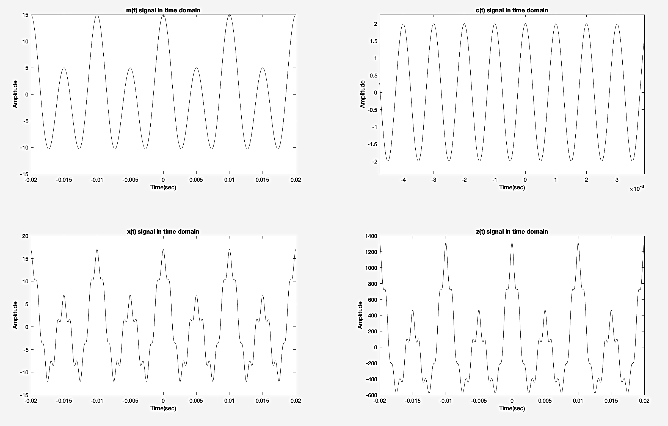
Plot of m(t), c(t), x(t), z(t), y(t) in MATLAB
Figure 1: m(t), x(t), z(t) and y(t) signals in time domain
The signals defined in MATLAB than plotted as shown in Figure 1. Here c(t) signal is defined as the following:
$$c\left(t\right)=2cos⁡(2000πt)$$
m(t) and c(t) signal plots are the same in analytic solution. x(t), z(t),y(t) are also compatible with the equations funded in the analytic solution. y(t) signal is plotted in Figure 2. To obtain y(t), z(t) signal is filtered by a band pass filter of Bandwidth 400Hz and center frequency 1KHz.
To make this filtering, the Fourier transform of z(t) signal is token using FFT, then this signal is multiplied in frequency domain with the Transfer function H(f) of Bandwidth filter. Because the gain of the filter is 1:
$$H(f) = \left\{\begin{aligned}1 , 800≤f≤1200 \\ 0 , other \end{aligned}\right.$$
And
$$Y\left(f\right)=Z\left(f\right) . H(f)$$

By using IFFT (Inverse Fast Fourier Transform) y(t) signal is obtained.

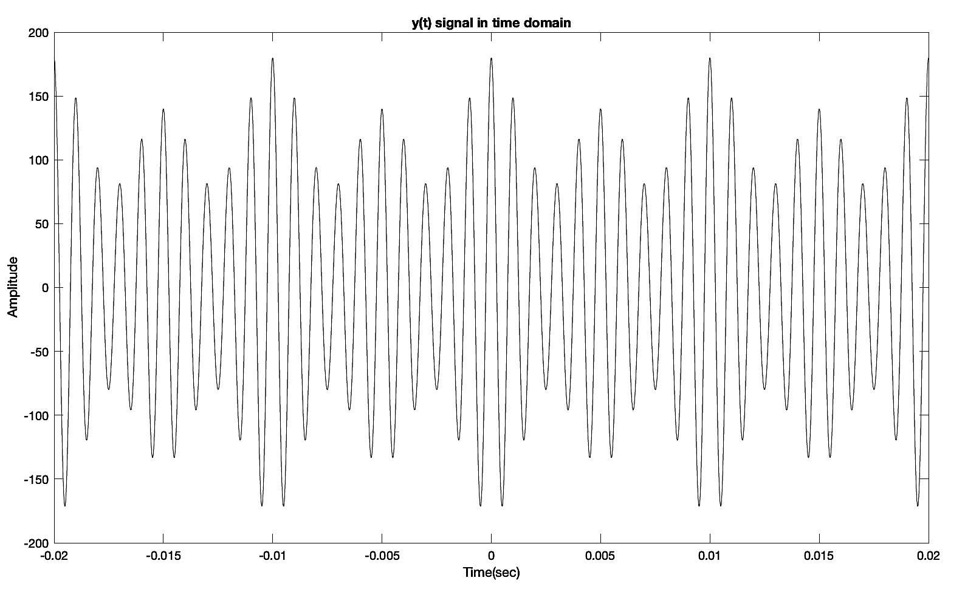
Figure 2: y(t) in time domain

MATLAB code

To draw the functions in time domain the following code was written.

%%
% Define system function
m = @(t) 5.*cos(200.*pi.*t) + 10.*cos(400.*pi.*t);
c = @(t) 2.*cos(2000.*pi.*t);
x = @(t) (m(t) + c(t));
z = @(t) (60*x(t) + x(t).^2);
Ts = 0.00001; %determination of the sample coefficient
%Define the time vector for simulating the signal in time
time = -10:Ts:10-Ts;
%%
%Calculations
mt = m(time);
et = c(time);
xt = x(time);
zt = z(time);

%%
%Plot the signals in time domian
figure
grid on;
subplot (2,2,1);
plot(time, mt)
title('m(t) signal in time domain')
xlim([-0.02,0.02])
xlabel('Time(sec)')
ylabel('Amplitude')

subplot (2,2,2);
plot(time, et)
xlim([-0.02,0.02])
title('c(t) signal in time domain')
xlabel('Time(sec)')
ylabel('Amplitude')

subplot (2,2,3);
plot(time, xt)
xlim([-0.02,0.02])
title('x(t) signal in time domain')
xlabel('Time(sec)')
ylabel('Amplitude')

subplot (2,2,4);
plot(time, zt)
xlim([-0.02,0.02])
title('z(t) signal in time domain')
xlabel('Time(sec)')
ylabel('Amplitude')

To find y(t), the method explained in 1.2 section is used. The Bandwidth filter implemented as following. The functions take a signal xf in frequency domain an f array, the frequency sampling constant fs, the center frequency of the filter fc, and the bandwidth of the filter bw. And the function returns the filtered signal in time domain yt, and frequency domain yf.

%%
function [yt,yf] = bandwidthFilterFrequencyDomain(xf,f,fs,fc,bw)
% Compute the magnitude response of the filter
H = zeros(size(f));
for i = 1:length(f)
if abs(f(i)) >= fc - bw/2 && abs(f(i)) <= fc + bw/2
H(i) = 1;
else
H(i) = 0;
end
end
% Apply the filter to the frequency domain signal
yf = xf .* H;
% Obtain the time-domain signal using the inverse Fourier transform
yt = ifft(ifftshift(yf)).*fs;

end

Than to the function is used as following.
zf = fft(zt)* Ts;
figure
n = length(zt);
fshift = (-n/2:n/2-1)*(fs/n);
zfshift = fftshift(zf);
plot(fshift,abs(zfshift))
xlim([-2000,2000])
title('Z(f)')
xlabel('Frequency (Hz)')
ylabel('Magnitude')

fc = 1000;
bw = 400;
[yt,yfshift] = bandwidthFilterFrequencyDomain(zfshift,fshift,fs,fc,bw);
figure
plot(fshift,abs(yfshift))
xlim([-2000,2000])
title('Y(f)')
xlabel('Frequency (Hz)')
ylabel('Magnitude')

%%
figure
yt = real(yt);
plot(time,yt )
title('y(t) signal in time domain')
xlim([-0.02,0.02])
xlabel('Time(sec)')
ylabel('Amplitude')

Find and plot M(f), X(f), Z(f), Y(f)

Analytic solutions and plots
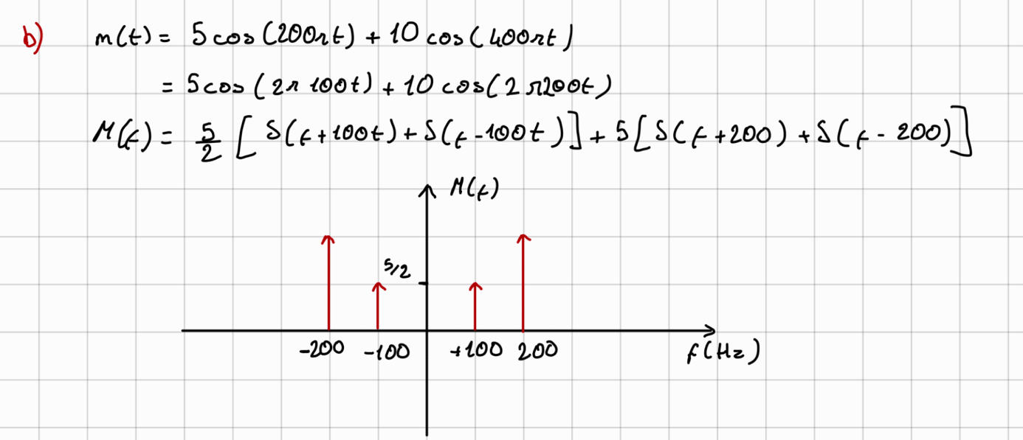

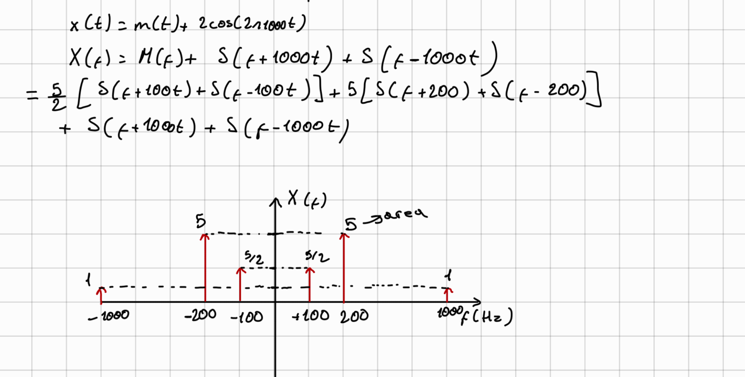
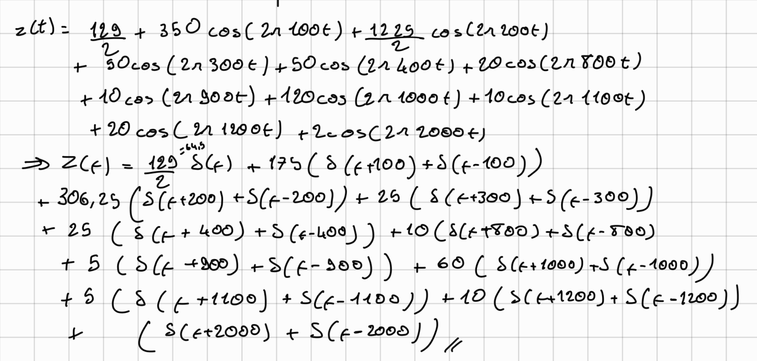
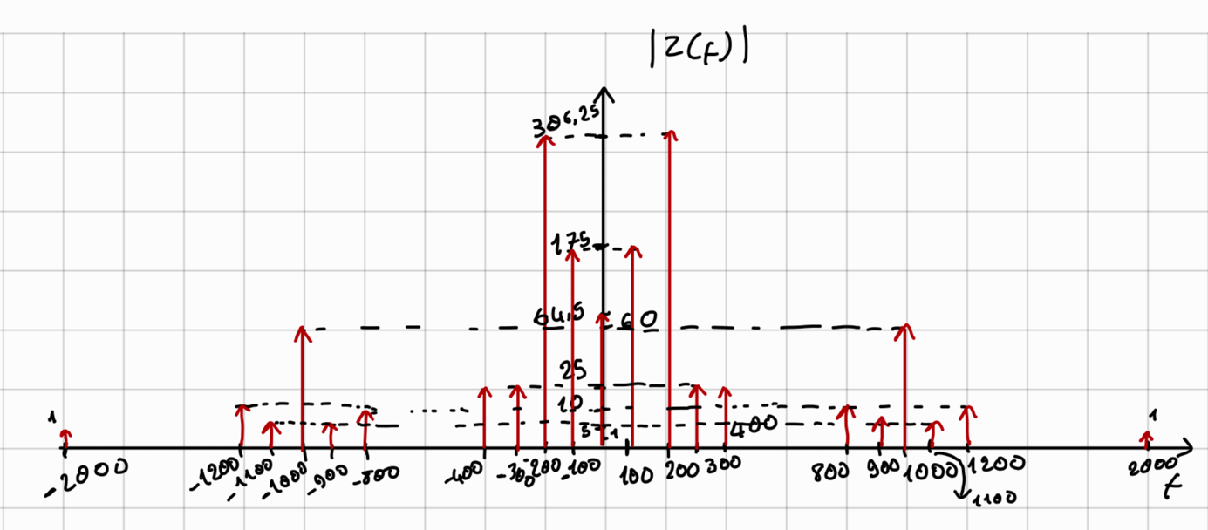

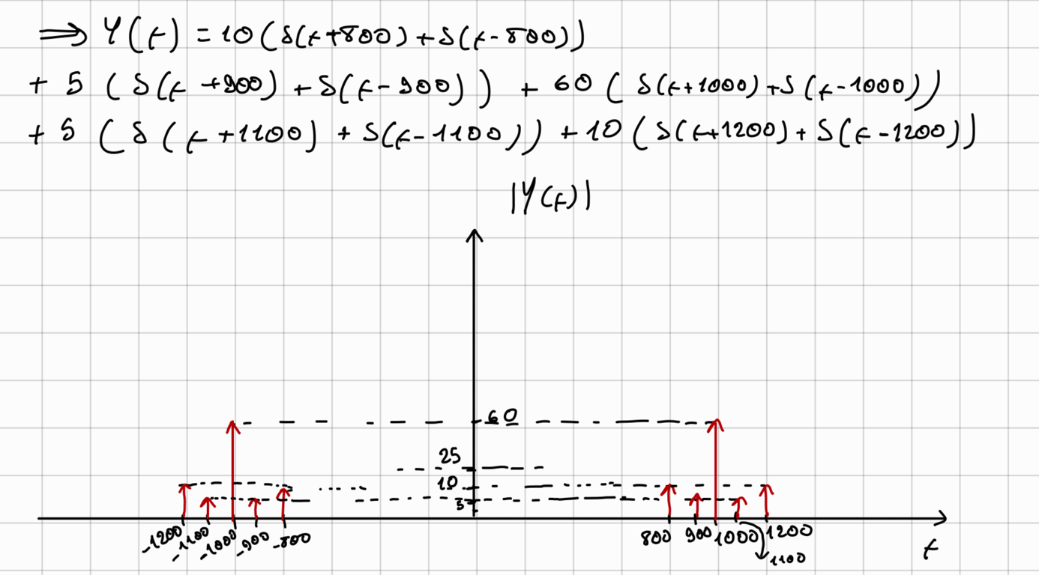

FFT with MATLAB and signal plots

To take the Fourier transform in MATLAB FFT (fast Fourier transform) is used. The signals obtained, are plotted as shown in Figure 3.

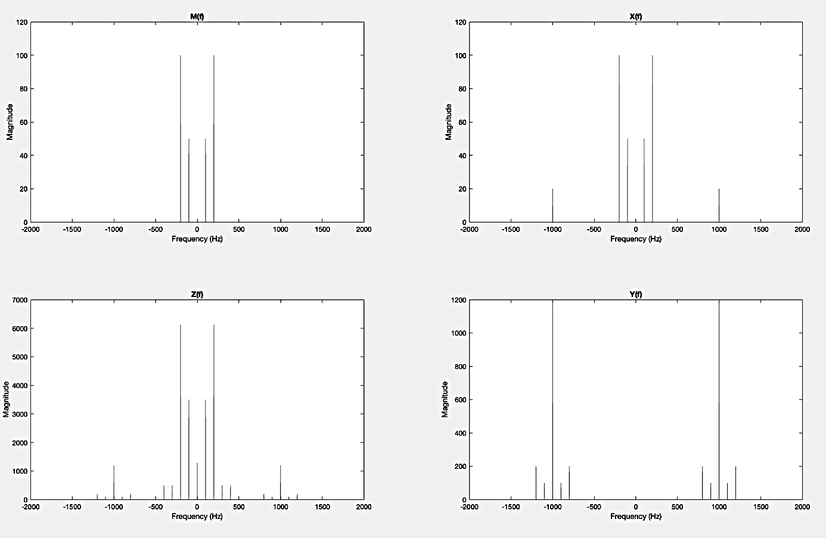
Figure 3: The fourier transform (FFT) of m(t), x(t), z(t), y(t)
A close look at the signal around 100 hz shows that the signal area is

$$50*\frac{100.05- 99.95 }{2}=\frac{5}{2}$$
This equal to the area of the dirac at 100hz found in the analytic solution.

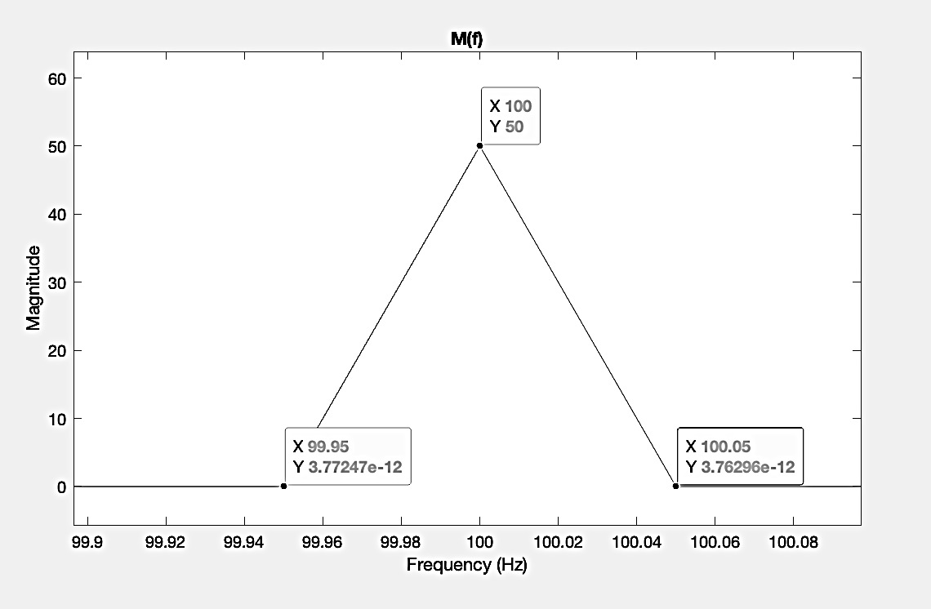
Figure 4: Dirac at 100hz in m(t) signal
And it’s clearly seen that the signals is the same with the signals funded in the analytic solution.

MATLAB code
First the signals obtained in time domain, that by using fft and fft shift the signals obtained in frequency domain. The code is as following.

%% a section code
% Define system function
m = @(t) 5.*cos(200.*pi.*t) + 10.*cos(400.*pi.*t);
c = @(t) 2.*cos(2000.*pi.*t);
x = @(t) (m(t) + c(t));
z = @(t) (60*x(t) + x(t).^2);
Ts = 0.00001; %determination of the sample coefficient
%define the time vector for simulating the signal in time
time = -10:Ts:10-Ts;
%%
%Calculations
mt = m(time);
et = c(time);
xt = x(time);
zt = z(time);

%%
%Plot the signals in time domian
figure
grid on;
subplot (2,2,1);
plot(time, mt)
title('m(t) signal in time domain')
xlim([-0.02,0.02])
xlabel('Time(sec)')
ylabel('Amplitude')

subplot (2,2,2);
plot(time, et)
xlim([-0.02,0.02])
title('c(t) signal in time domain')
xlabel('Time(sec)')
ylabel('Amplitude')

subplot (2,2,3);
plot(time, xt)
xlim([-0.02,0.02])
title('x(t) signal in time domain')
xlabel('Time(sec)')
ylabel('Amplitude')

subplot (2,2,4);
plot(time, zt)
xlim([-0.02,0.02])
title('z(t) signal in time domain')
xlabel('Time(sec)')
ylabel('Amplitude')

%%
%%Take fourier transform using fft
mf = fft(mt)* Ts;%take the fourşer transform using fft
fs = 1/Ts;
figure
subplot(2,2,1)
n = length(mt);
%take the shift of the spectra of the fourier transform
fshift = (-n/2:n/2-1)*(fs/n);
mfshift = fftshift(mf);
plot(fshift,abs(mfshift))
xlim([-2000,2000])%limit the frequency x axis
% between -2000 and 2000 for best view
title('M(f)')
xlabel('Frequency (Hz)')
ylabel('Magnitude')

xf = fft(xt)* Ts;
subplot(2,2,2)
n = length(xt);
fshift = (-n/2:n/2-1)*(fs/n);
xfshift = fftshift(xf);
plot(fshift,abs(xfshift))
xlim([-2000,2000])
title('X(f)')
xlabel('Frequency (Hz)')
ylabel('Magnitude')

zf = fft(zt)* Ts;
subplot(2,2,3)
n = length(zt);
fshift = (-n/2:n/2-1)*(fs/n);
zfshift = fftshift(zf);
plot(fshift,abs(zfshift))
xlim([-2000,2000])
title('Z(f)')
xlabel('Frequency (Hz)')
ylabel('Magnitude')

%%
fc = 1000;
bw = 400;
[yt,yfshift] = bandwidthFilterFrequencyDomain(zfshift,fshift,fs,fc,bw);
subplot(2,2,4)
plot(fshift,abs(yfshift))
xlim([-2000,2000])
title('Y(f)')
xlabel('Frequency (Hz)')
ylabel('Magnitude')

%%
figure
yt = real(yt);
plot(time,yt )
title('y(t) signal in time domain')
xlim([-0.02,0.02])
xlabel('Time(sec)')
ylabel('Amplitude')

Envelope detection

With envelope built in MATLAB function

Using the envelope command of MATLAB, the envelope is obtained as shown in figure 5. The following code has been added in addition to the code in the previous problems to obtain it.

%%
figure
plot(time, yt)
hold on
[dtup , dtlow] = envelope(yt,100, 'peak');
plot(time,dtup)
plot(time,-dtup)
xlim([-0.02,0.02])
title('y(t), d(t) up, and d(t) down signal in time domain')
xlabel('Time(sec)')
ylabel('Amplitude')
hold off

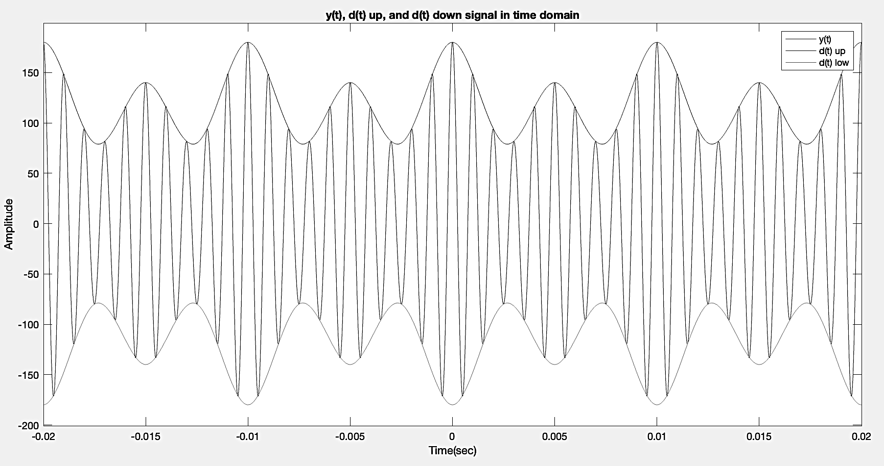
Figure 5: Envelope detection with matlab envelope function

With envelope detector circuit

Analytic solution and expression
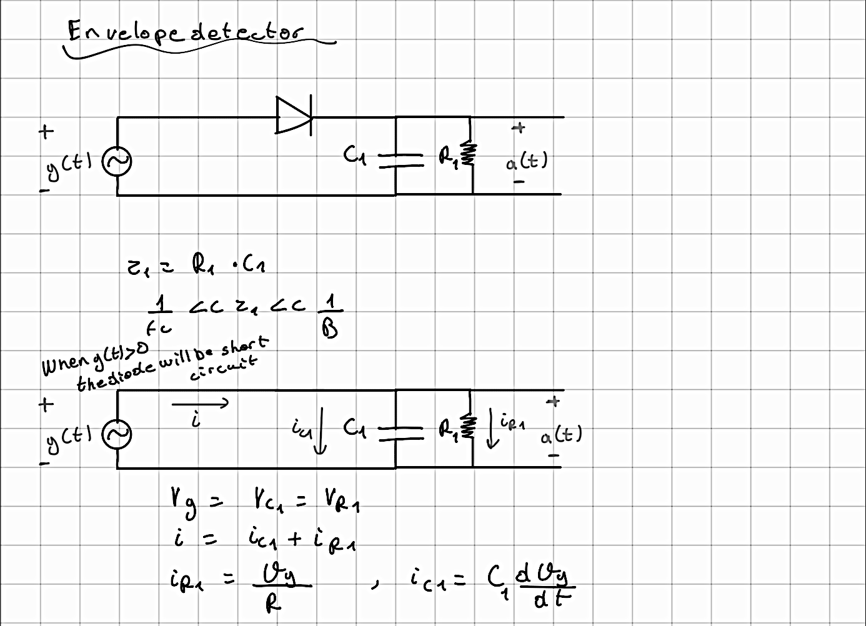
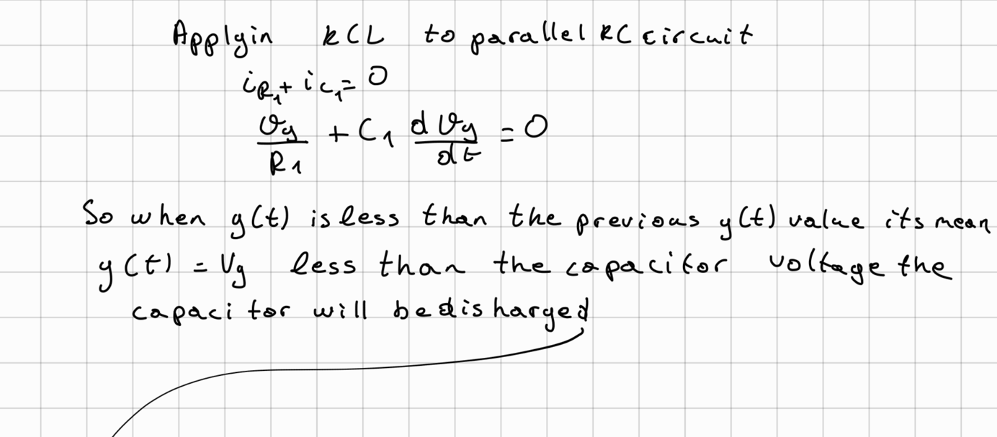
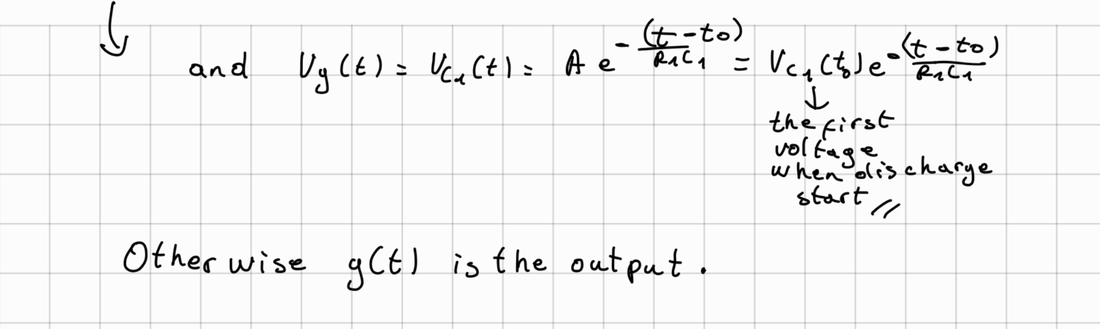
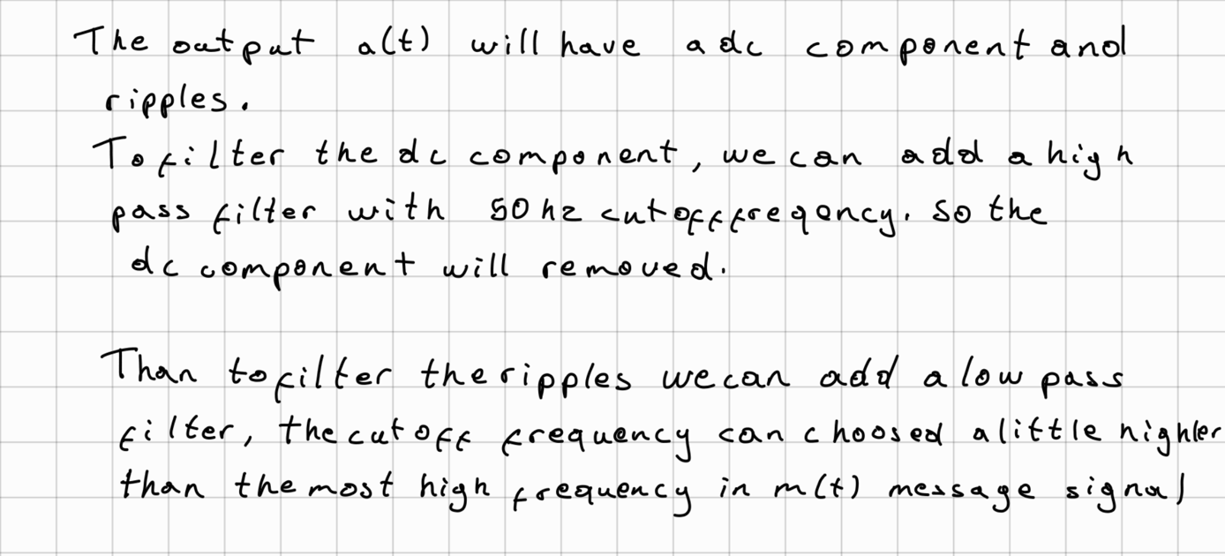
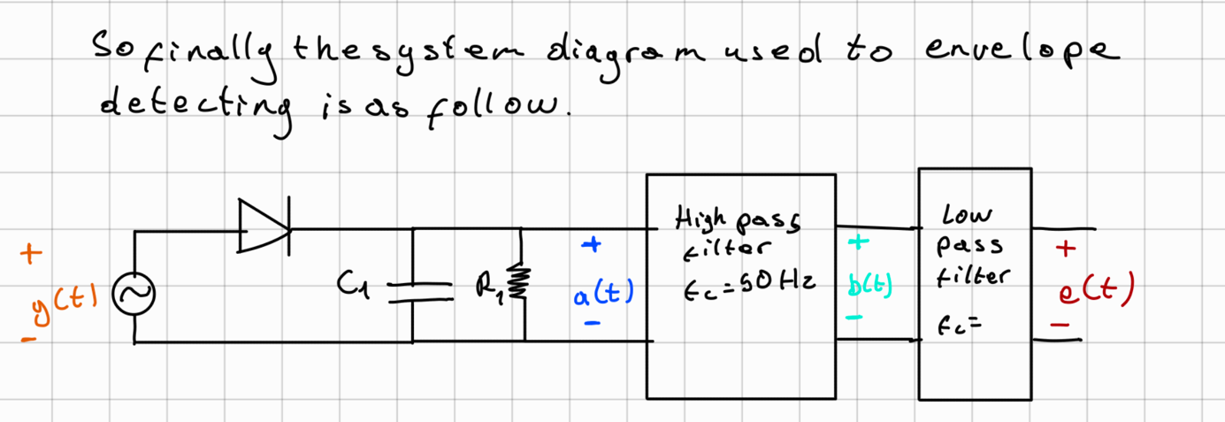

MATALB results
To detect the envelop first the diode, R1, C1 circuit is equations is implemented to MATLAB. The signal obtained is called a(t) signal as shown at section 3.2.1. Then a(t) signal is filtered by using a high pass filter with cut-off frequency fc = 50 Hz to filter the dc component of the signal and the signal obtained is called b(t). After that to remove the ripples, the signal is filtered by a low pass filter with cutoff frequency 200 Hz, its equal to the higher frequency in m(t) message signal.

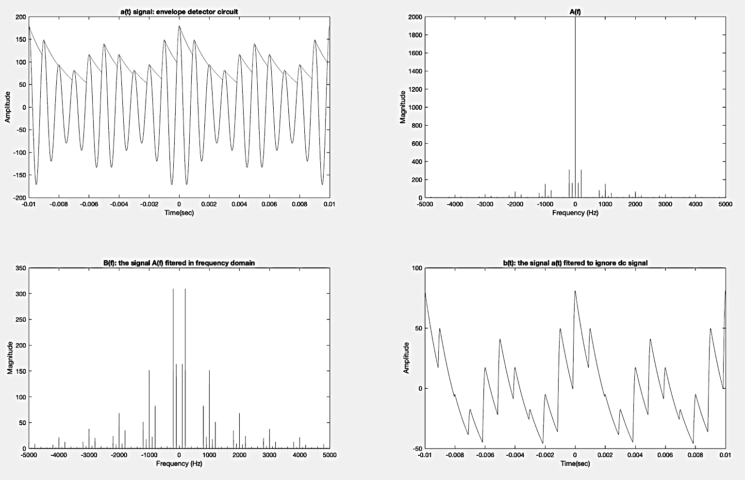
Figure 6: a(t) signal is the envelop detected with the detector in the first step, b(t) is a(t) filtered from dc component

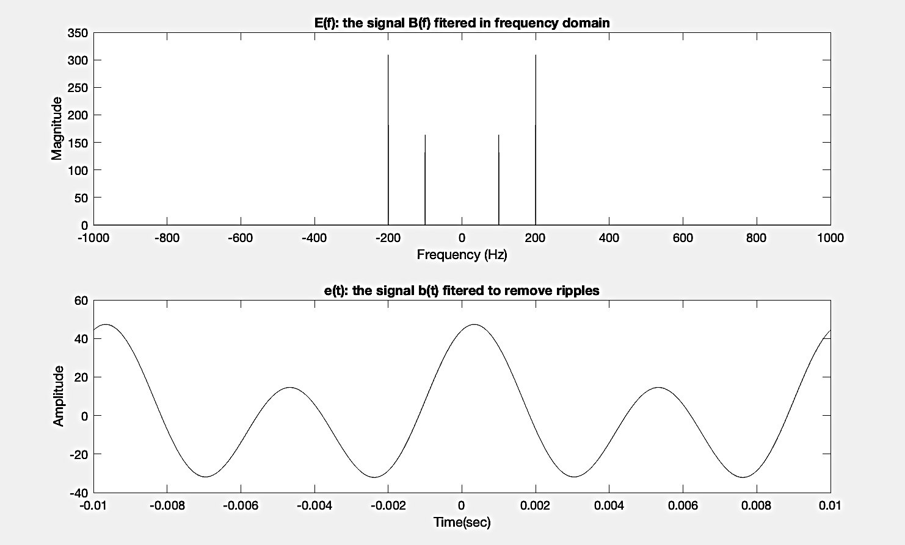
Figure 7: e(t) signal plot

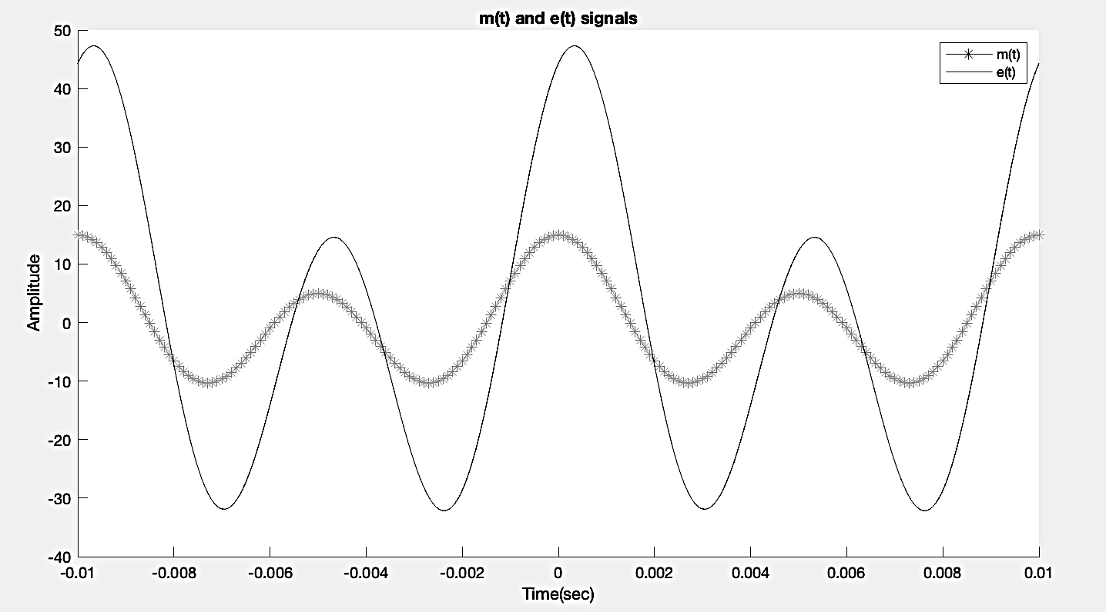
Figure 8: m(t) and e(t) signals plotted.

MATLAB code
To detect the envelop, in the first stage the following function is implemented to MATLAB.
function [at] = envelope_detector(time,yt,C1,R1)
at = zeros(size(yt));
at(1)= yt(1);
i0 = 1;
for i = 2:length(time)
if yt(i)>0 && yt(i)>at(i-1)
if yt(i) >= yt(i- 1)
at(i) = yt(i);
i0 = i;
else
at(i) = yt(i0).* exp(-(time(i)- time(i0))/(R1.*C1));
end
else
at(i) = yt(i0).* exp(-(time(i)- time(i0))/(R1.*C1));
end
end

end

Than for filter stages, a lowpass and high pass filters are implemented as following.

%%
function [bt,bf] = highPassFilterFrequencyDomain(af,f,fs,fc)
% Compute the magnitude response of the filter
H = zeros(size(f));
for i = 1:length(f)
if abs(f(i)) >= fc
H(i) = 1;
else
H(i) = 0;
end
end
% Apply the filter to the frequency domain signal
bf = af .* H;
% Obtain the time-domain signal using the inverse Fourier transform
bt = ifft(ifftshift(bf)).*fs;

end
%%
function [et,ef] = lowPassFilterFrequencyDomain(bf,f,fs,fc)
% Compute the magnitude response of the filter
H = zeros(size(f));
for i = 1:length(f)
if abs(f(i)) <= fc
H(i) = 1;
else
H(i) = 0;
end
end
% Apply the filter to the frequency domain signal
ef = bf .* H;
% Obtain the time-domain signal using the inverse Fourier transform
et = ifft(ifftshift(ef)).*fs;

end

Than using the functions the following code is added to the last problems.
figure

subplot(2,2,1)
plot(time, yt)
hold on
C1 = 100*10^-9;
R1 = 20*10^3;
at = envelope_detector(time,yt,C1,R1);
plot(time, at)
title('a(t) signal: envelope detector circuit')
xlabel('Time(sec)')
ylabel('Amplitude')
xlim([-0.01,0.01])
%calculate the fourier transform of a(t)
% than add high pass filter for ignore the dc signal
af = fft(at)* Ts;

subplot(2,2,2)
n = length(at);
fshift = (-n/2:n/2-1)*(fs/n);
afshift = fftshift(af);
plot(fshift,abs(afshift))
xlim([-5000,5000])
title('A(f)')
xlabel('Frequency (Hz)')
ylabel('Magnitude')

subplot(2,2,3)
fc = 50;
[bt,bf] = highPassFilterFrequencyDomain(afshift,fshift,fs,fc);
plot(fshift,abs(bf))
xlim([-5000,5000])
title('B(f): the signal A(f) fitered in frequency domain')
xlabel('Frequency (Hz)')
ylabel('Magnitude')
subplot(2,2,4)
plot(time,bt)
xlim([-0.01,0.01])
title('b(t): the signal a(t) fitered to ignore dc signal')
xlabel('Time(sec)')
ylabel('Amplitude')

%%
figure
%to filter the ripples, a low pass filter is used
% because ripples have high frequency
fc = 200;
[et,ef] = lowPassFilterFrequencyDomain(bf,fshift,fs,fc);
subplot(2,1,1)
plot(fshift,abs(ef))
xlim([-1000,1000])
title('E(f): the signal B(f) fitered in frequency domain')
xlabel('Frequency (Hz)')
ylabel('Magnitude')
subplot(2,1,2)
plot(time,et)
xlim([-0.01,0.01])
title('e(t): the signal b(t) fitered to remove ripples')
xlabel('Time(sec)')
ylabel('Amplitude')

%%
%Lets plot m(t) and e(t)
%%figure
hold on
plot(time,mt,"Marker","*",MarkerIndices=1:10:length(mt))
plot(time,et)
xlim([-0.01,0.01])
title('m(t) and e(t) signals')
legend('m(t)','e(t)')
xlabel('Time(sec)')
ylabel('Amplitude')

