ELEC361 MATLAB PROJECT2

FM Modulation and Demodulation

Name: Fouad Aladhami
ID: 210102002808

1 Analytic solutions 3
2 MATLAB solutions 7
2.1 Plot of m(t) signal. M(f) signal and the plot of the magnitude spectrum. 7
2.2 Obtain fi(t) and plot it, and their magnitude spectrum. 8
2.3 y(t) signal in time domain and |Y(f)| the magnitude spectrum of y(t). 9
2.4 The time domain signals and their magnitude spectrum at each step of demodulator. 11
3 MATLAB VS Analytic solution 17
4 MATLAB CODE 19

Analytic solutions
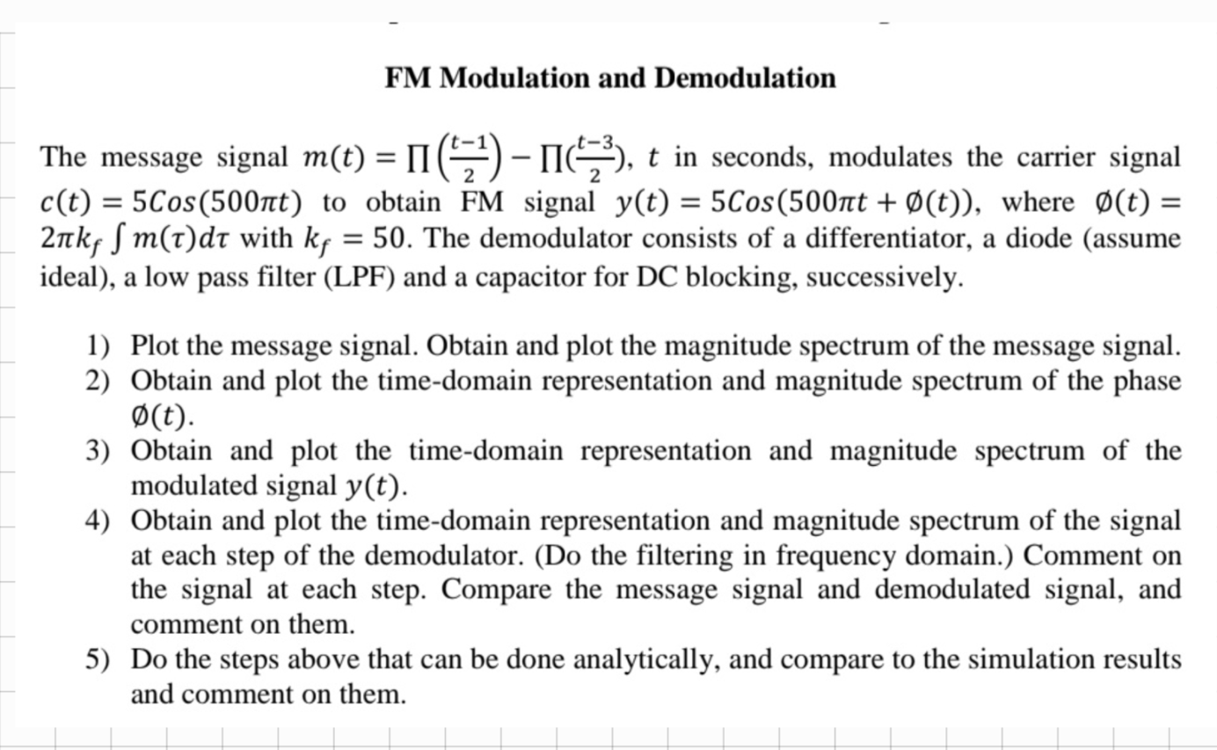
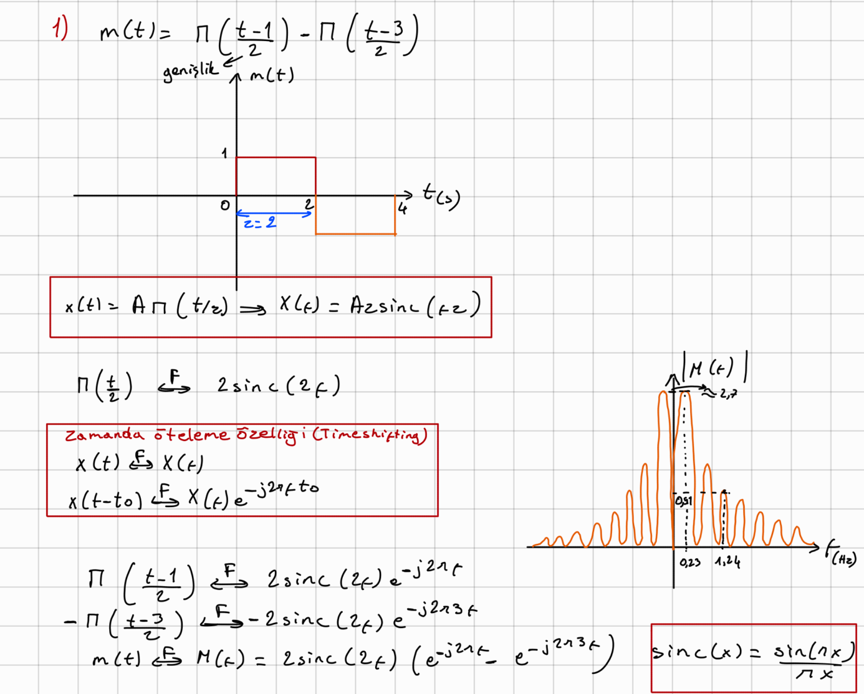

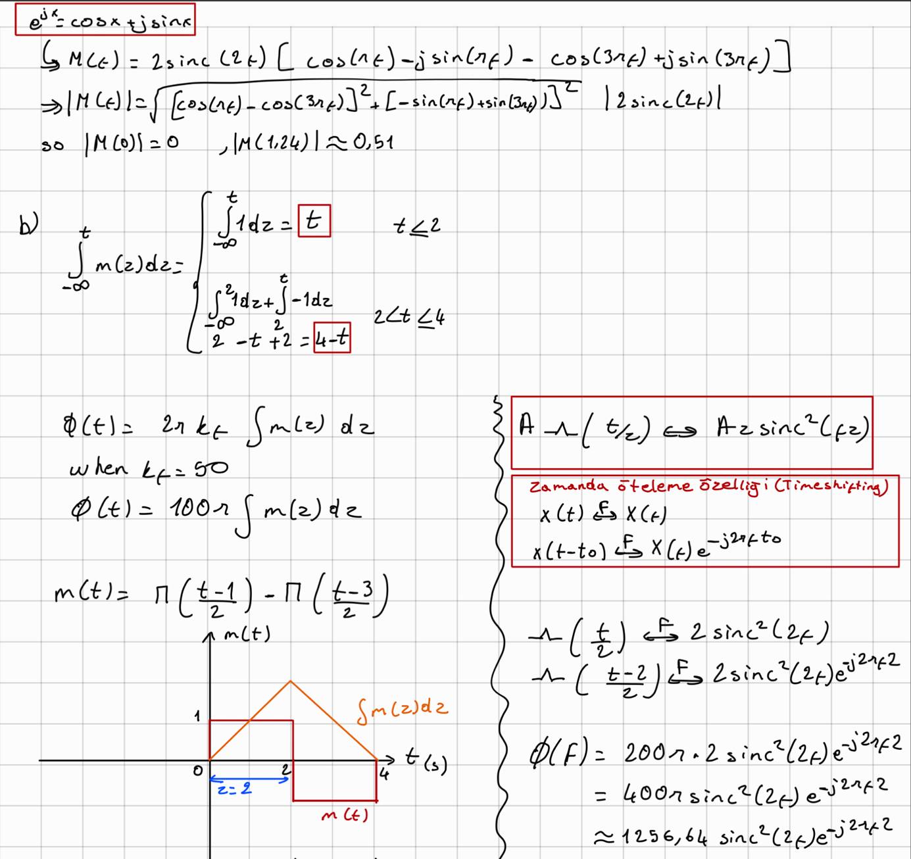
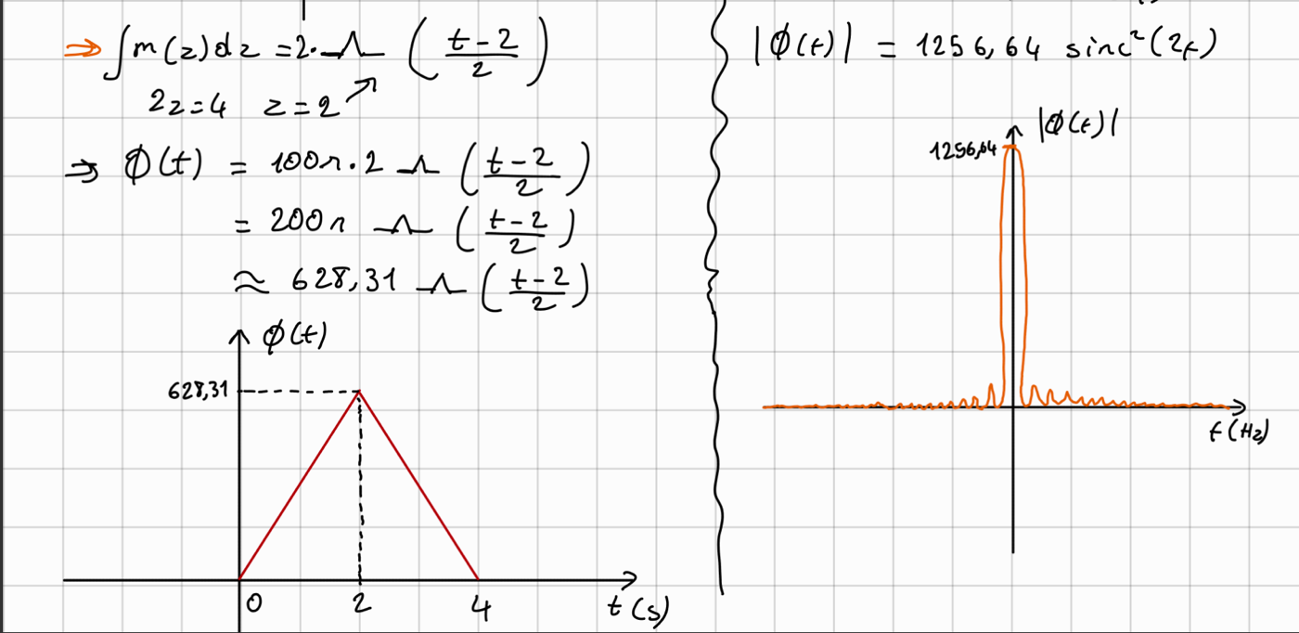

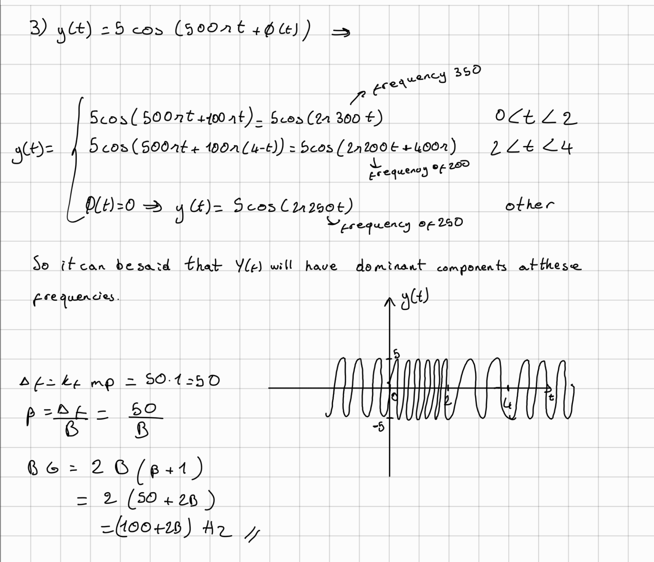
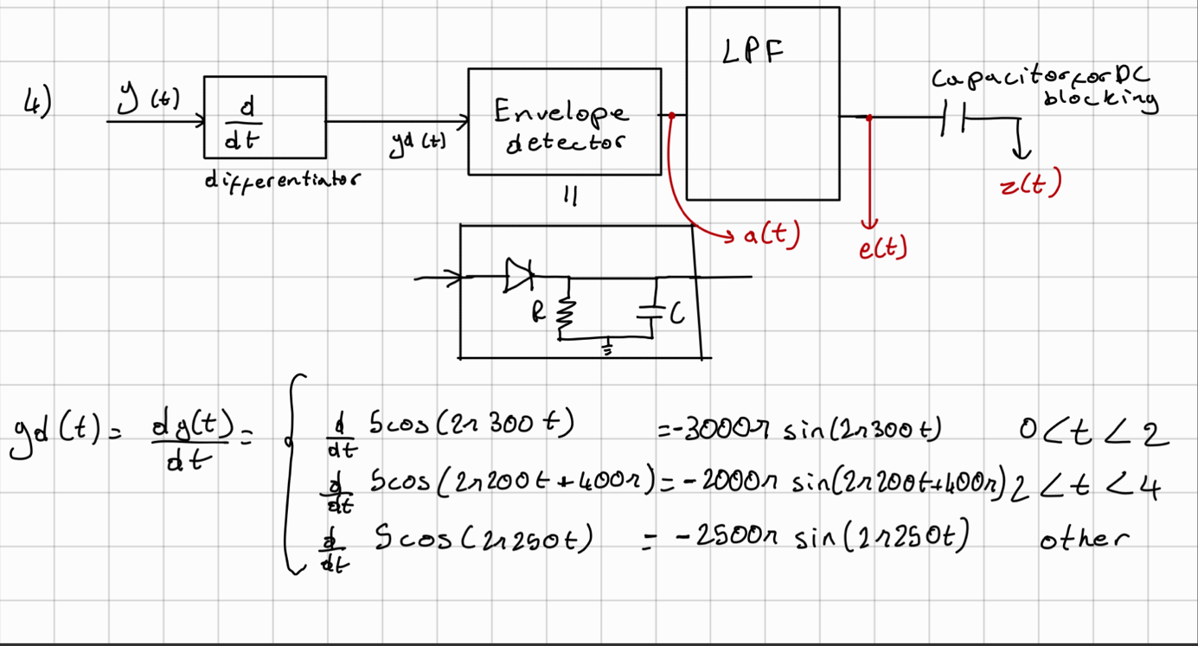
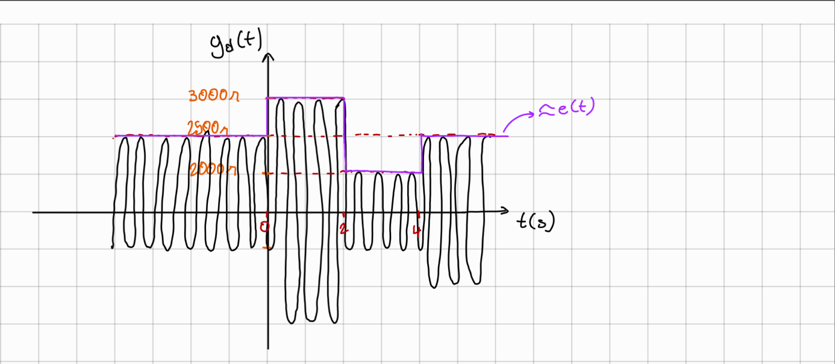

MATLAB solutions

Plot of m(t) signal. M(f) signal and the plot of the magnitude spectrum.
m(t) signal Plotted in MATLAB in time domain as shown in Figure 1 and by using FFT the magnitude spectrum of m(t) obtained and plotted in Figure2.

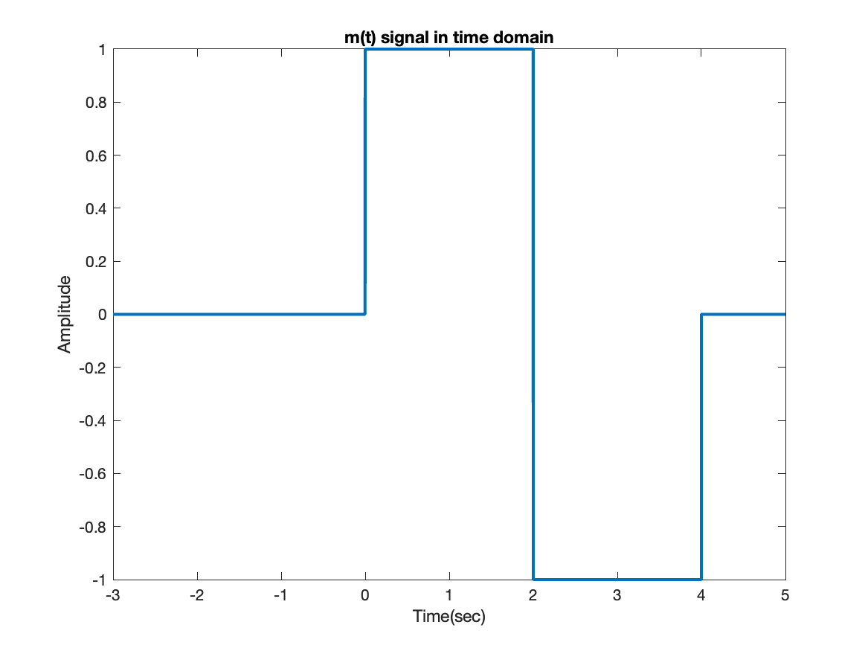
Figure 1: m(t) signal plot in time domain.
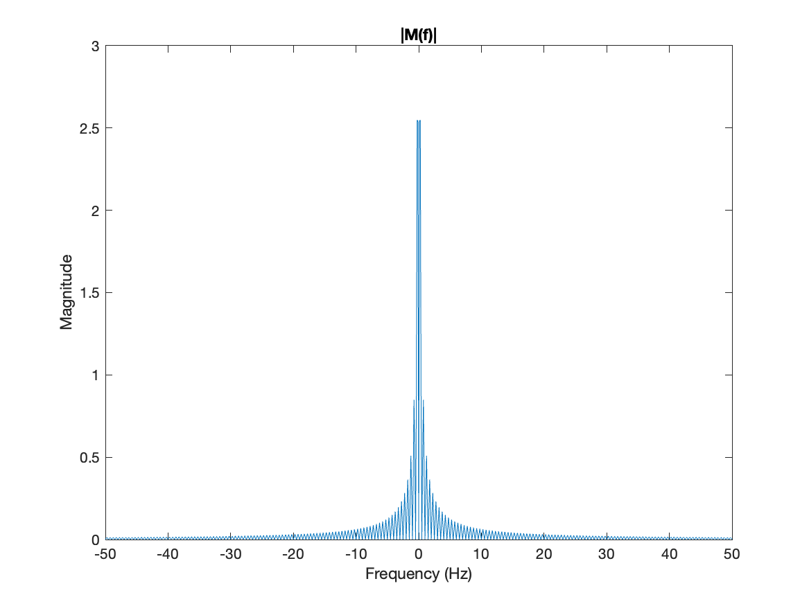
Figure 2: |M(f)| plot the magnitude spectrum of m(t) signal.

Obtain fi(t) and plot it, and their magnitude spectrum.
By integrating the signal m(t) in section 2.1, and scale it with 2*pi*kf = 100 pi the signal fi(t) obtained and plotted in Figure 3. Using FFT the magnitude spectrum of fi(t), |Fi(f)| is obtained and plotted in Figure4. To integrate m(t) signal Least squares integration method is used to integrate faster the integral command of MATLAB. And it’s okay because the m(t) signal is simple.
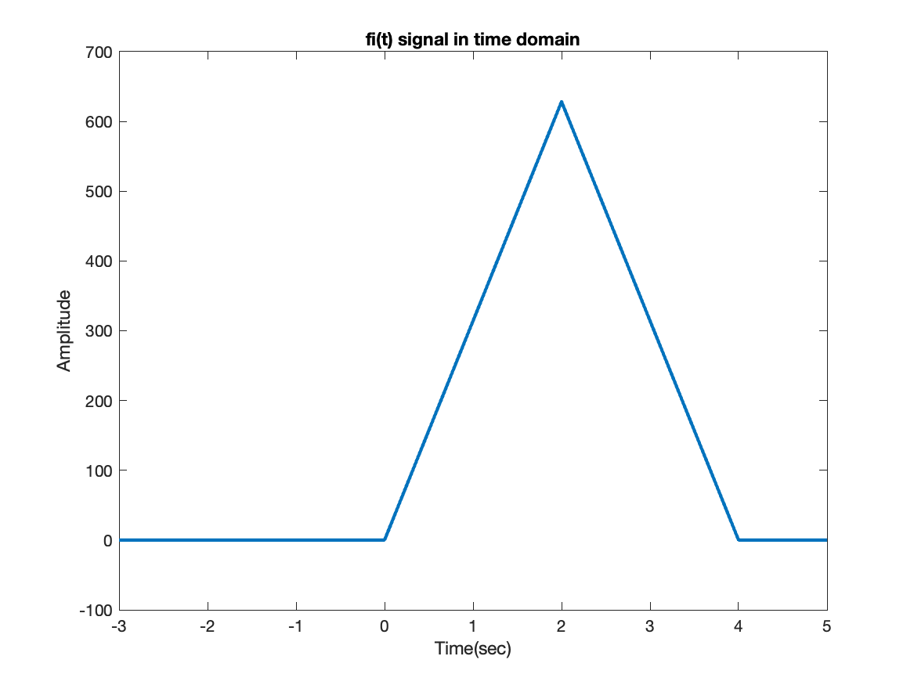
Figure 3: fi(t) signal plot in time domain.
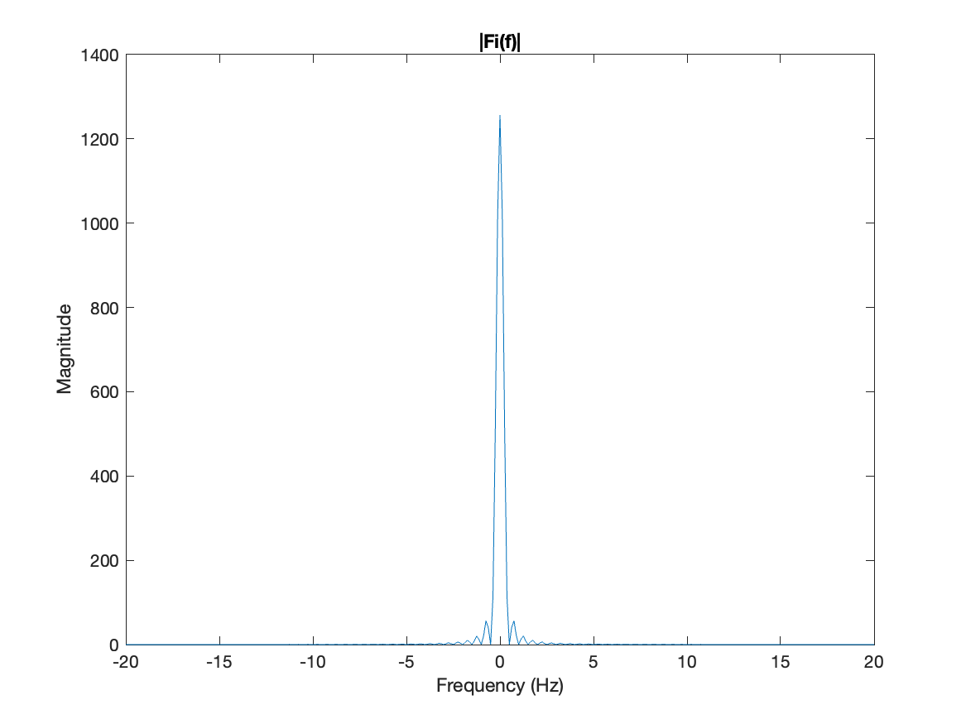
Figure 4: |Fi(f)| plot the fi(t) spectrum magnitude plot.

y(t) signal in time domain and |Y(f)| the magnitude spectrum of y(t).
By putting the phase fi(t) inside the carrier, as 5*cos(2*250*pi + fi(t)) the y(t) signal is obtained and plotted in Figure 5.
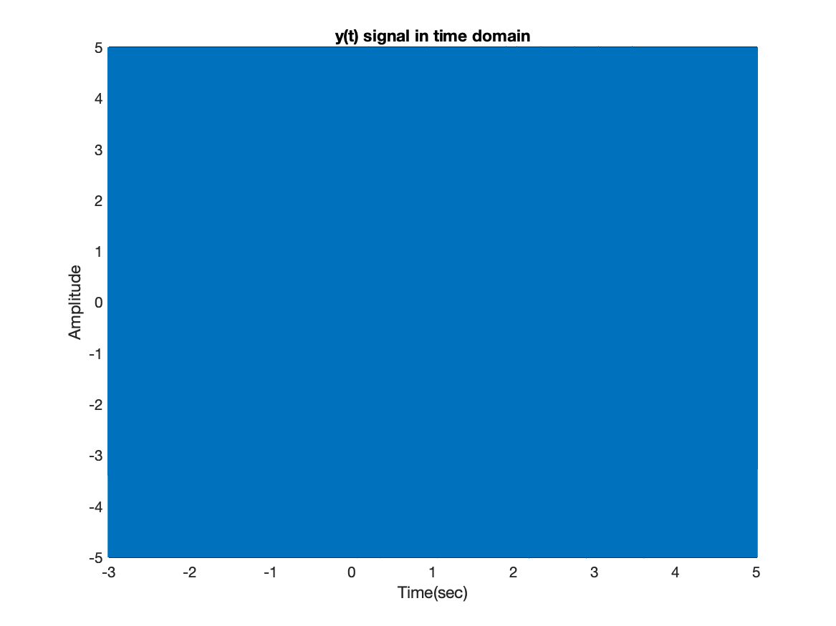
Figure 5: y(t) signal plot in time domain
When y(t) plotted between 3.95 – 4.05 and 1.95 - 2.05 as shown in Figure 6 and Figure 7 , the change in frequency of the signal at the transition points is clearly visible as shown in the analytic section.
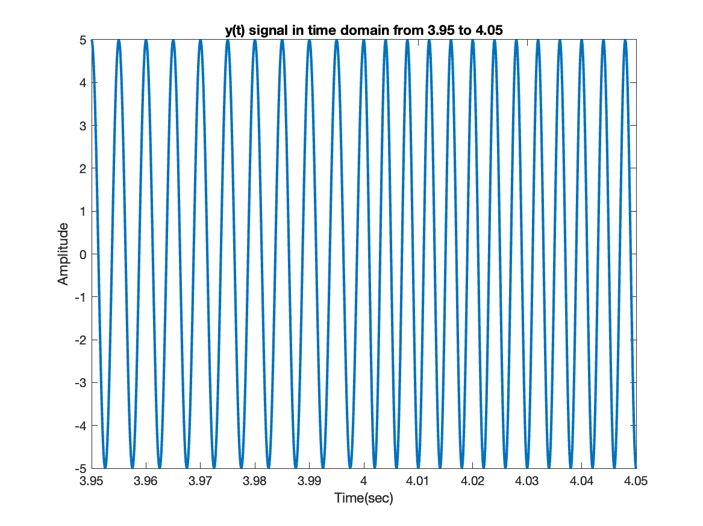
Figure 6: y(t) signal plot in time domain from 3.95 to 4.05
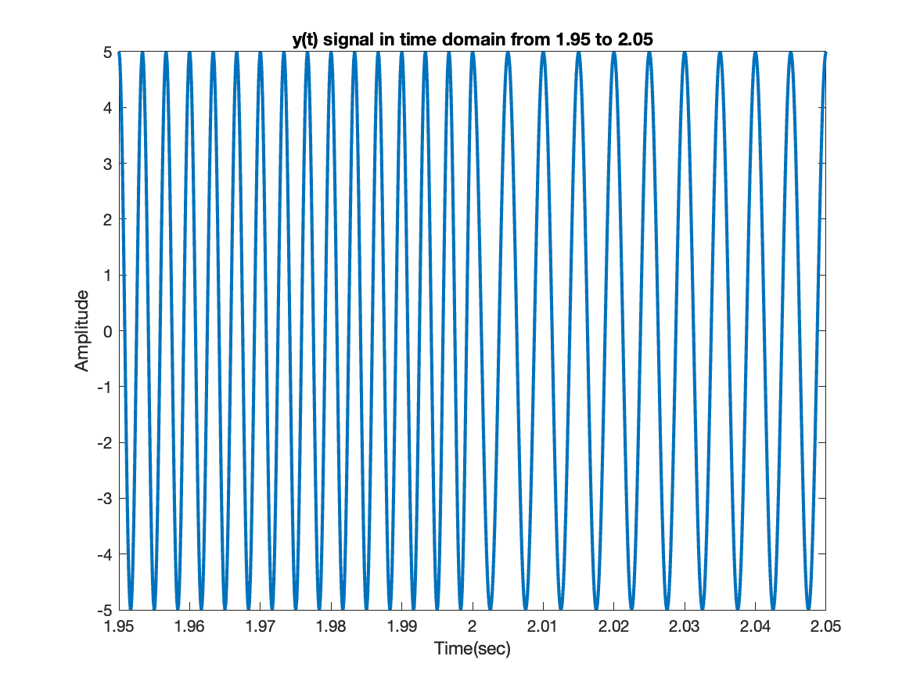
Figure 7: y(t) signal plot in time domain from 1.95 to 2.05
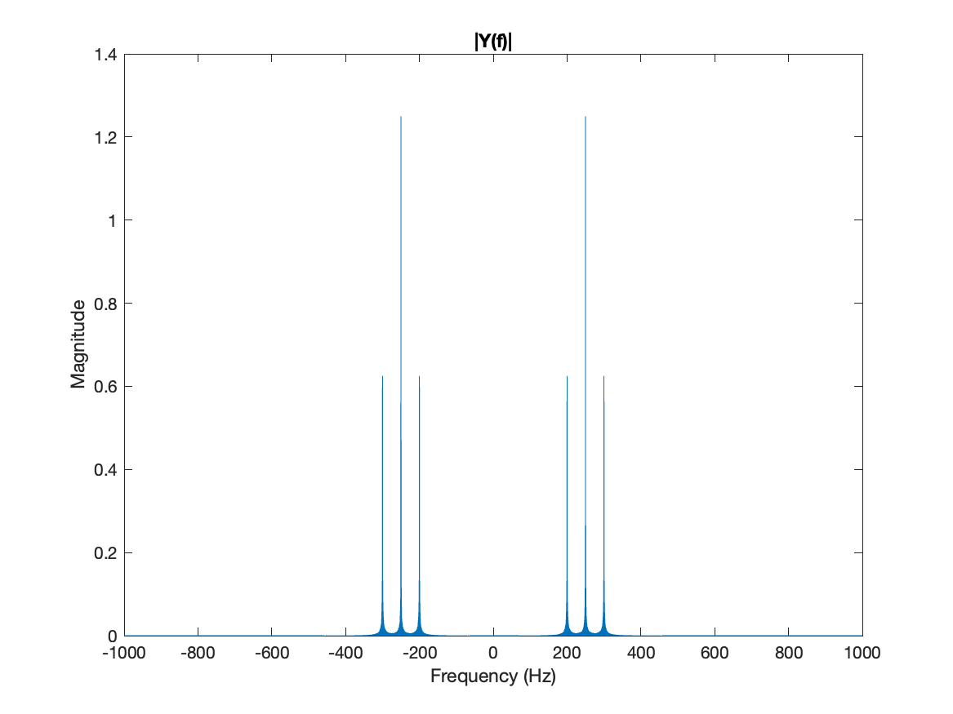
Figure 8: |Y(f)| the y(t) signal magnitude spectrum
The Magnitude spectrum of signal y(t) is obtained in Figure 8 and It is clearly seen that it has dominant components at frequencies 250, 200 and 300.

The time domain signals and their magnitude spectrum at each step of demodulator.
The derivative of the signal y(t) is obtained by using MATLAB diff function and it’s called yd(t).
The signal is plotted in time domain as shown in Figure 9. The magnitude spectrum of yd(t) is obtained using FFT and plotted in Figure 10.
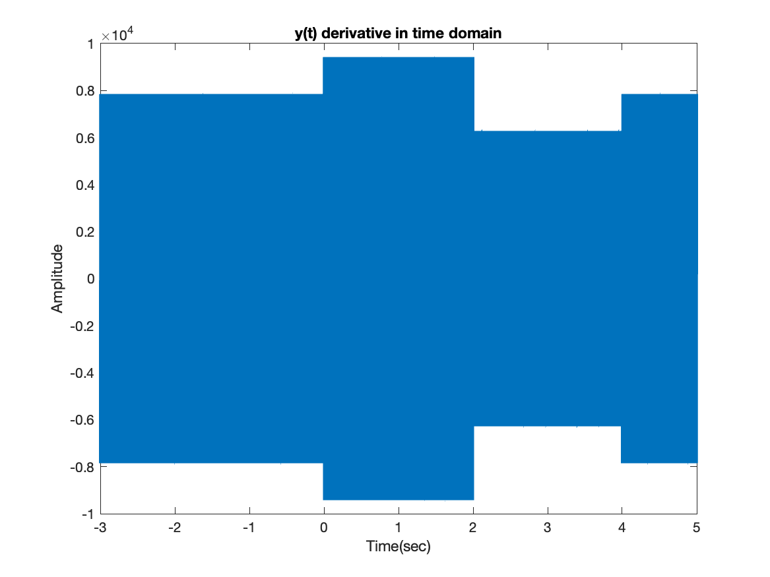
Figure 9: y(t) derivative plot in time domain
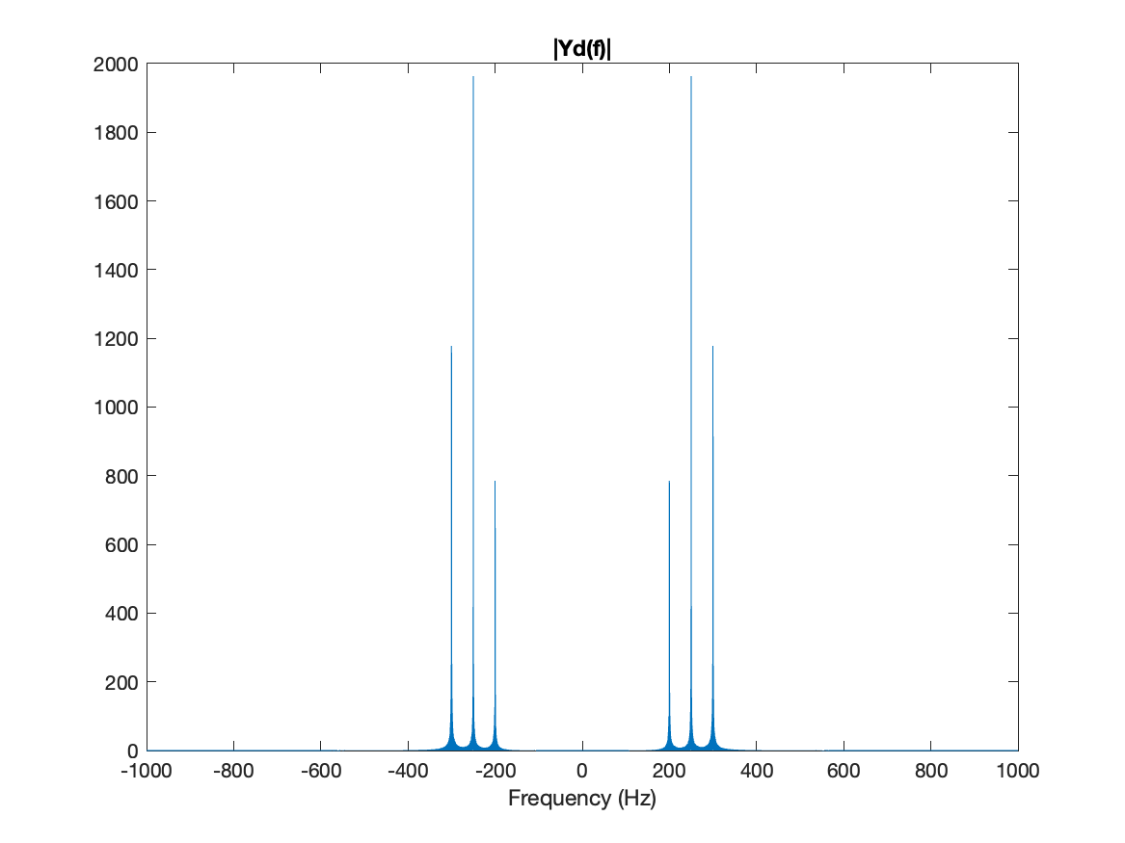
Figure 10: |Yd(f)| the y(t) derivative magnitude spectrum
The signal yd(t) passed by the envelops detector and a(t) signal obtained. Resistor and Capacitor values is chosen as R= 100kohm and C= 1uF. The a(t) signal is plotted in Figure 11 And the magnitude spectrum of a(t) is obtained and plotted in figure 12.
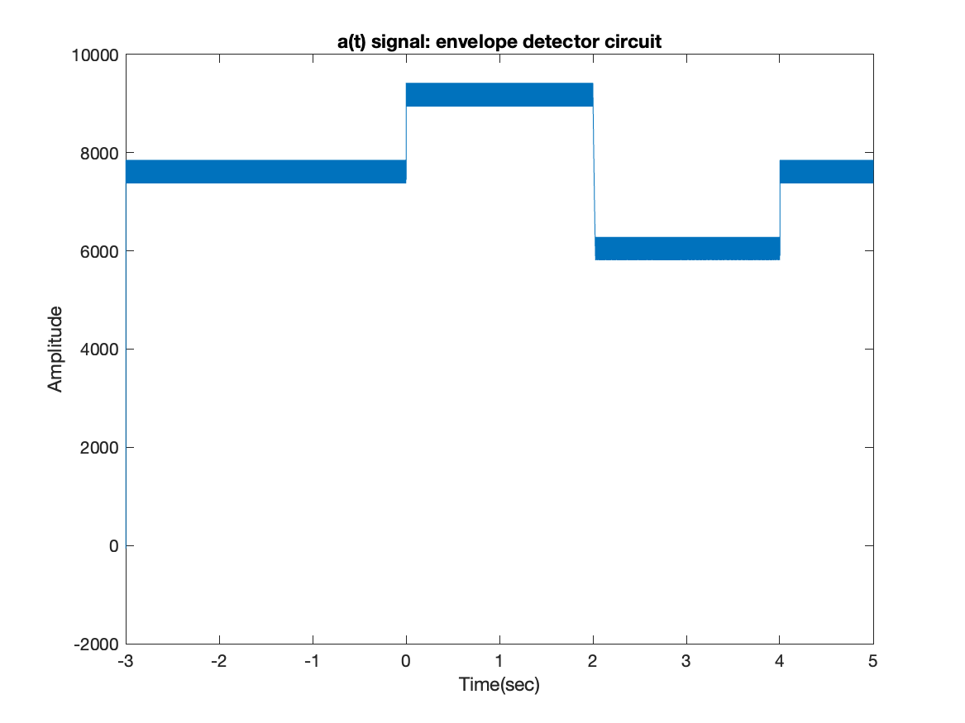
Figure 11: a(t) signal plot in time domain the output of the envelope detector
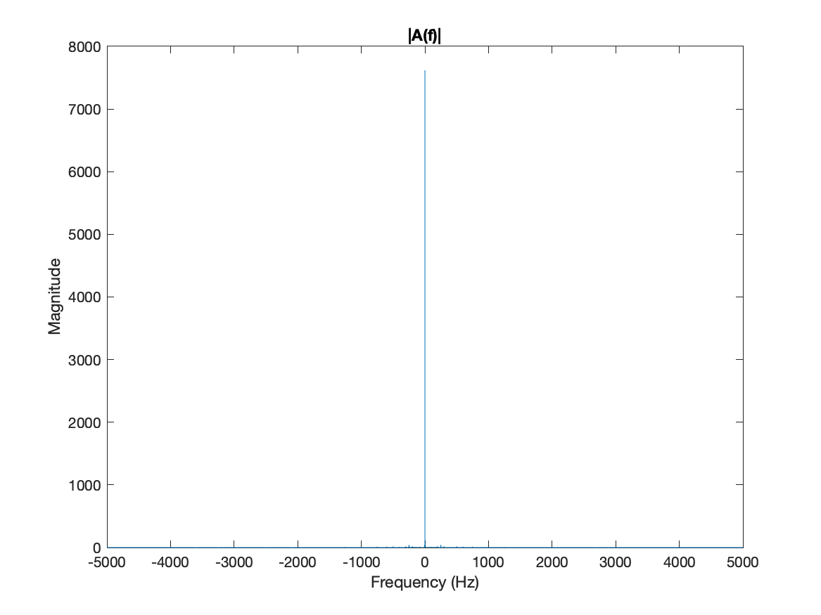
Figure 12: |A(f)| plot the magnitude spectrum of a(t)
To Filter the ripples at high frequency the signal a(t) is passed by a low pass filter and this signal is called e(t). First the spectrum of it is obtained after is passed by a filter in the frequency domain than the signal e(t) is obtained by using IFFT as shown in Figure 13 and Figure 14.
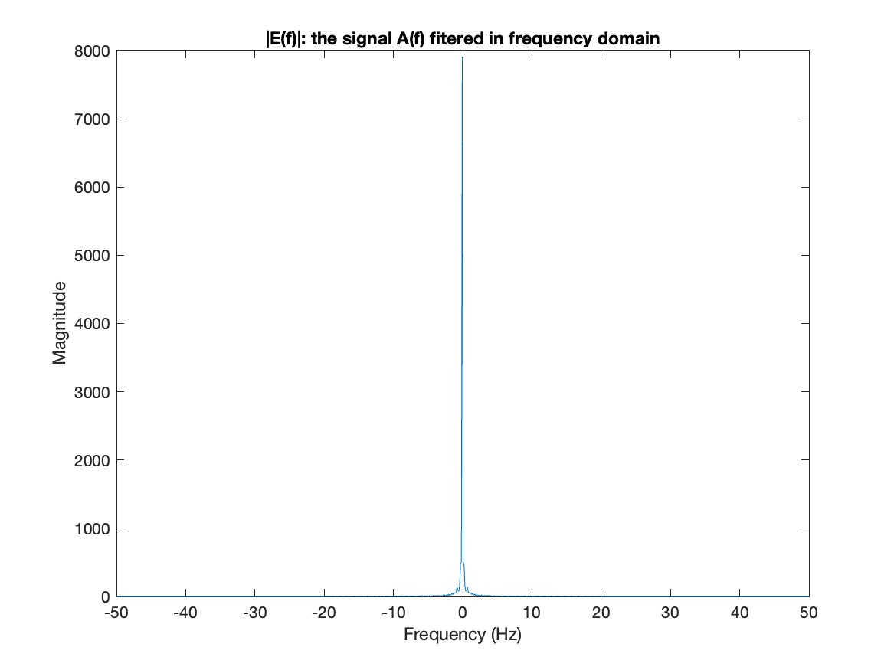
Figure 13:|E(f)|: the signal A(f) filtered in frequency domain
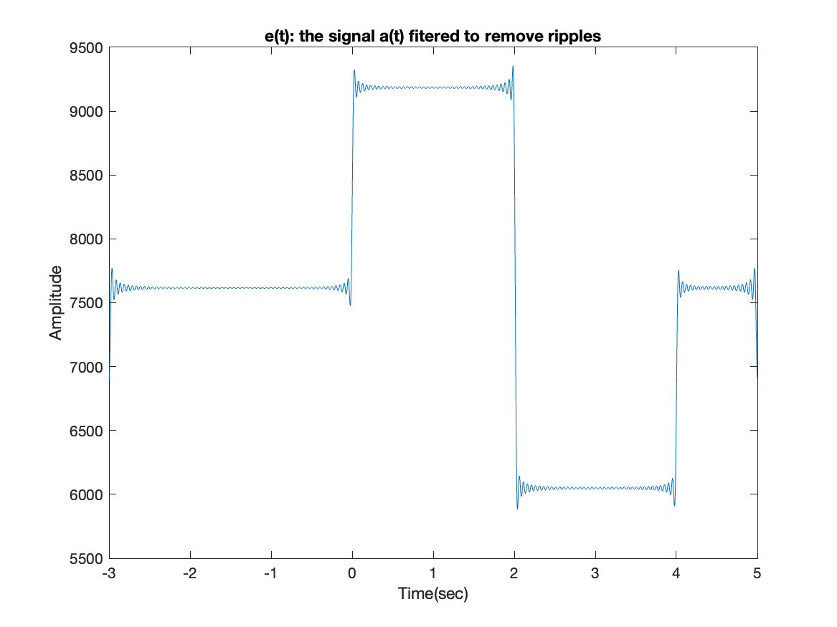
Figure 14:e(t) plot, the signal a(t) fitered to remove ripples
The signal e(t) is normalized by Ac*2*pi*kf to obtain the amplitude of the message as the same of m(t). en(t) signal is plotted as Figure 15.
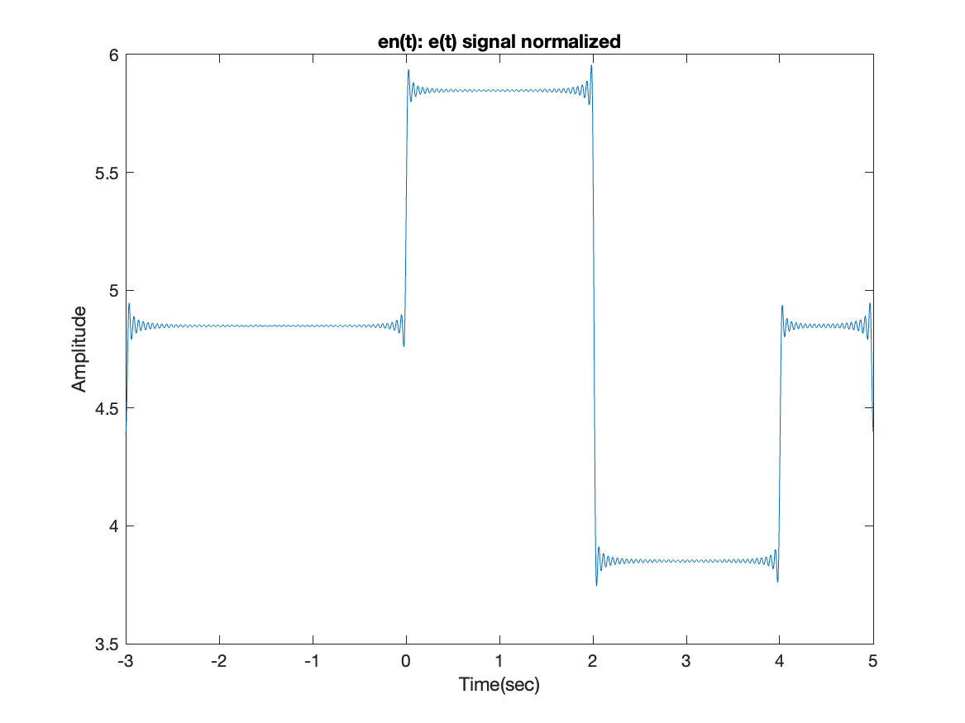
Figure 15: en(t) plot the e(t) signal normalized.
The m(t) and en(t) signals is plotted together as shown in Figure 16. A DC component is briefly seen in en(t) signal to ignore the DC component a Capacitor is used, and the signal passed by the DC blocking capacitor is called z(t) and it’s plotted as shown as Figure 17. The magnitude spectrum of z(t) is obtained and plotted as shown in Figure 18.
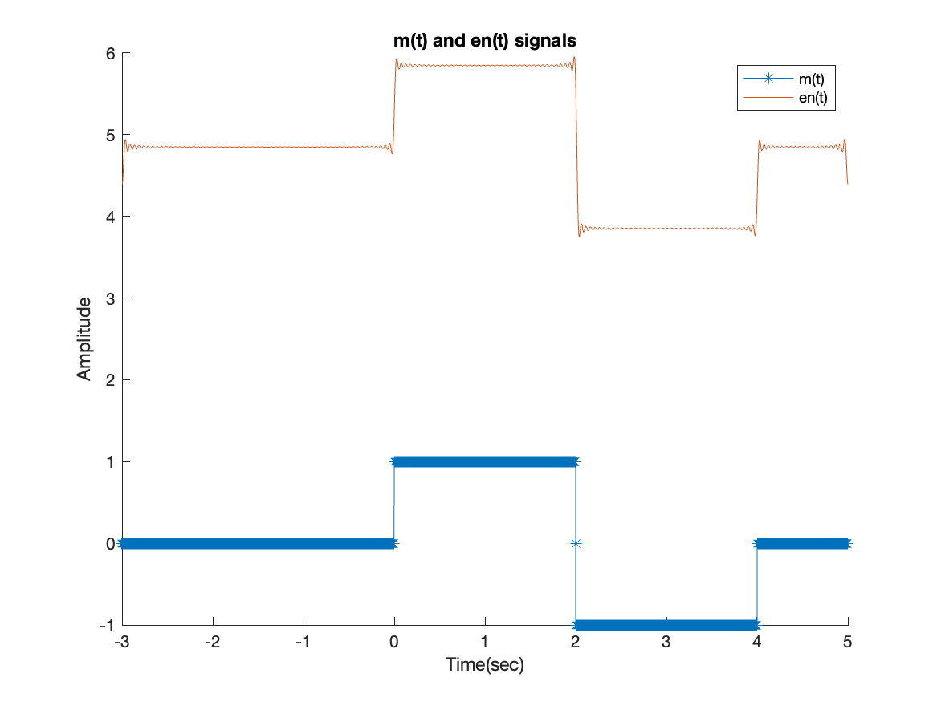
Figure 16: en(t) and m(t) signals plotted together.
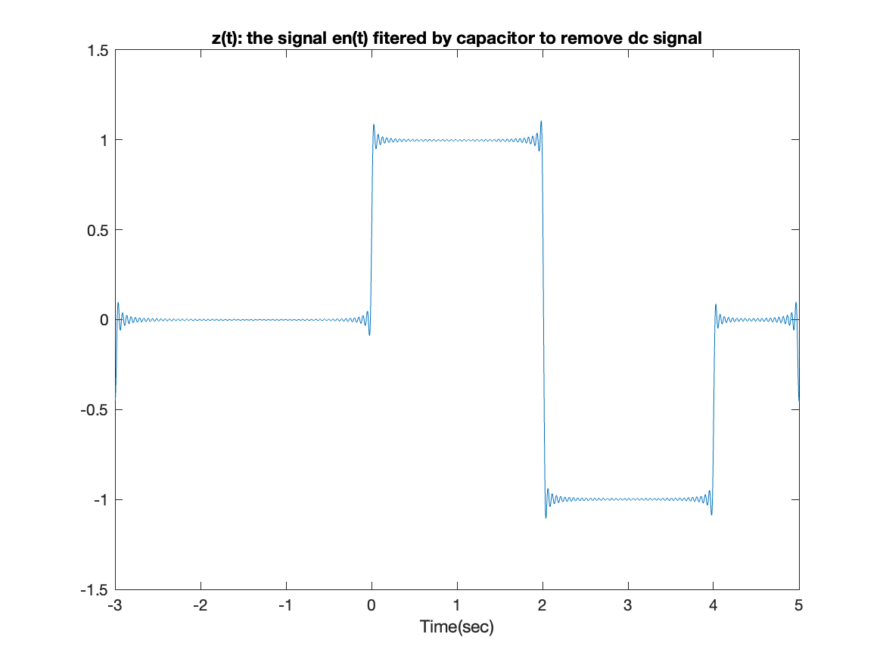
Figure 17: z(t) signal plot the signal en(t) after dc blocking capacitor
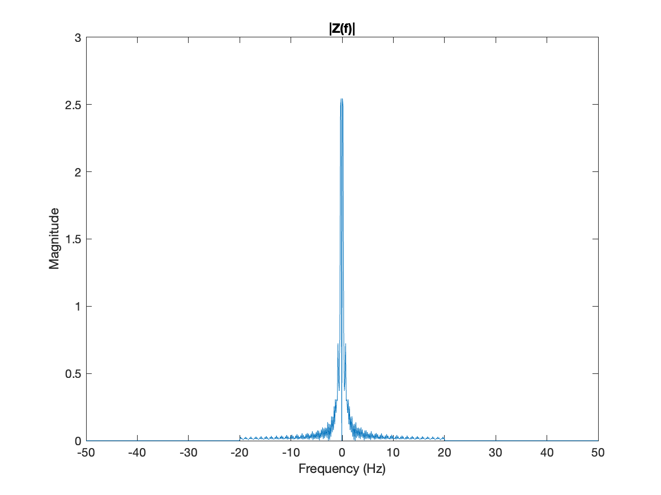
Figure 18: |Z(f)| plot
The m(t) and z(t) plotted together as shown in figure 19 and they appear to overlap. But z(t) signal have some noise at the transition points.
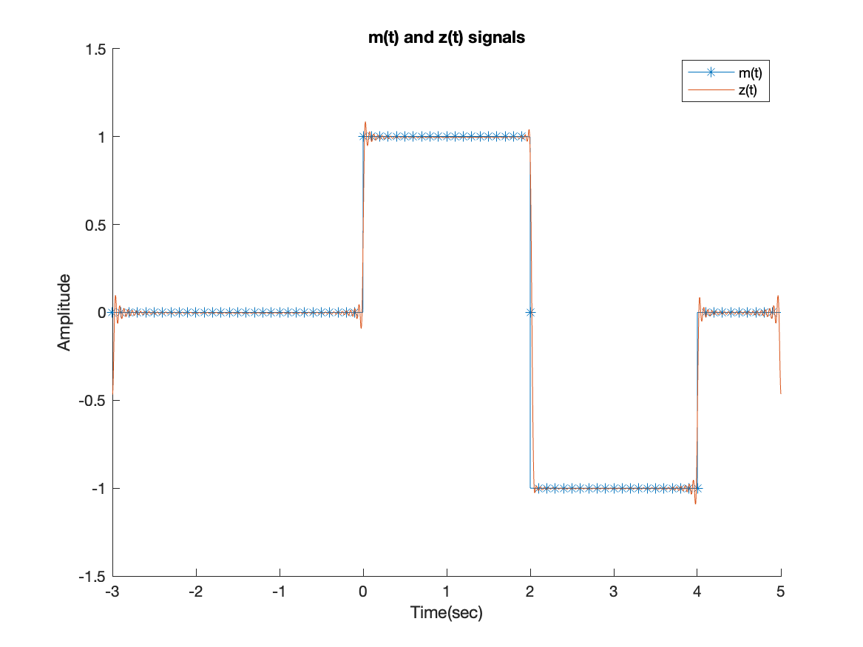
Figure 19: m(t) and z(t) signals plotted together.

MATLAB VS Analytic solution
As shown below m(t) signal and |M(f)| obtained in the analytic and MATLAB and results are consistent.
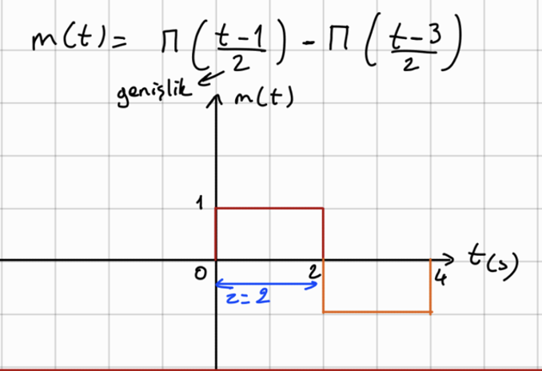

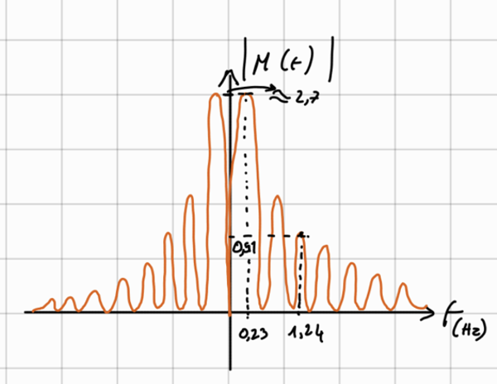

Then fi(t) and |Fi(f)| obtained as below by integrating m(t) and scale it with 2*pi*kf. And results are consistent.
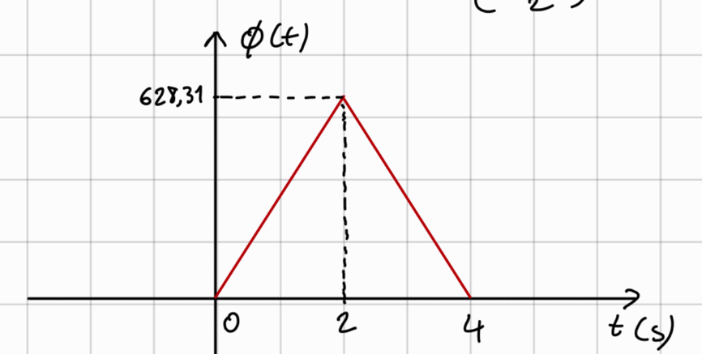

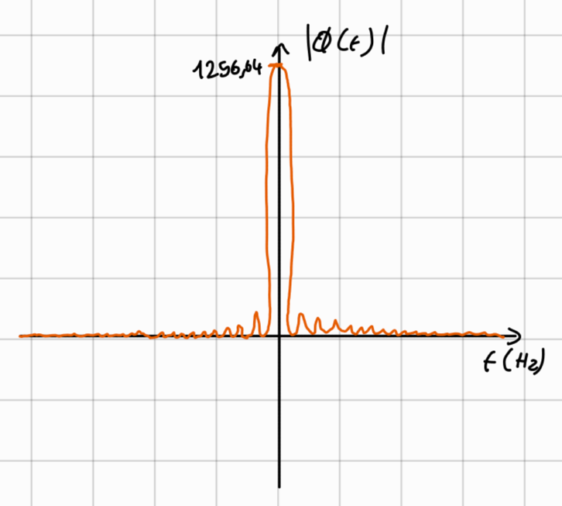

y(t) signal and its magnitude spectrum are obtained and plotted. And results are consistent in Analytic and MATLAB. (The y(t) signal is drawn notationally in analytics to clearly show the frequency change at transition points.)
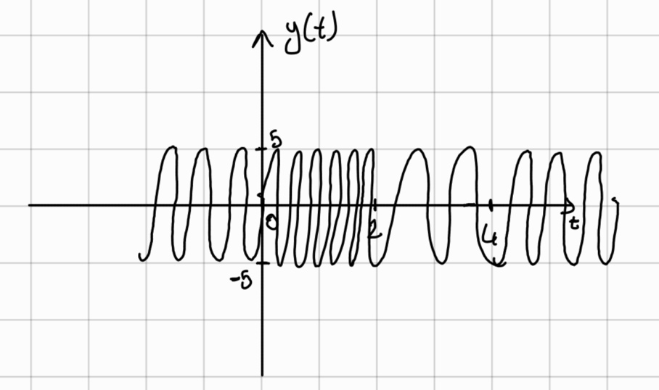

The derivative of y(t) is obtained as following the amplitude founded in analytic between 0 and 2 is 3000*pi = 9424.78 = 0.942478 * 10^-4 and it’s the same as found in MATLAB.
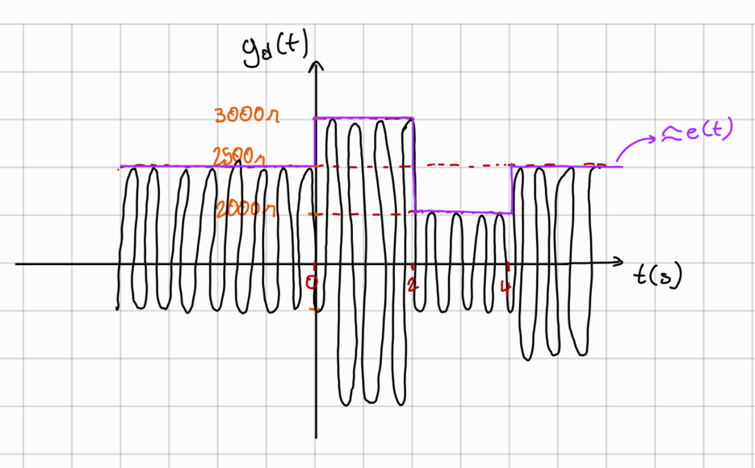

In this section, the comparison of important signals is mentioned, and other signals are given in more detail in the 1st and 2nd sections.

MATLAB CODE
save_path = 'figures/';
mkdir(save_path)
%%
fig_counter = 1;
%%
Ts = 0.00001; %determination of the sample coefficient
%define the time vector for simulating the signal in time
Tlow = -3;
time = Tlow:Ts:5-Ts;
%define the m(t) signal
m = @(t) square_wave((t - 1)./2 ) - square_wave((t - 3)./2 );
%%
%Calculations
mt = m(time);
%%
%plot m(t) in the time domian
figure Name 'm(t) in time domain'
grid on;
plot(time, mt,"LineWidth",2)
title('m(t) signal in time domain')
xlabel('Time(sec)')
ylabel('Amplitude')
saveas(gcf,append(save_path,string(fig_counter),'- m(t) in time domain'),'png')
fig_counter=fig_counter+ 1;
%%
%%Take fourier transform using fft
fs = 1/Ts;
mf = fft(mt)/fs;%take the fourier transform using fft
figure Name 'M(f)'
n = length(mt);
%take the shift of the spectra of the fourier transform
fshift = (-n/2:n/2-1)*(fs/n);
mfshift = fftshift(mf);
plot(fshift,abs(mfshift))
xlim([-50,50])%limit the frequency x axis
% between -50 and 50 for best view
title('|M(f)|')
xlabel('Frequency (Hz)')
ylabel('Magnitude')
saveas(gcf,append(save_path,string(fig_counter),'- M(f)'),'png')
fig_counter=fig_counter+ 1;

%%
kf = 50;
%fi = @(t) 2*pi*kf.*integral(m,-1,t);

fit = zeros(size(time));
for i = 2:length(time)
fit(i) = fit(i-1) + (2*pi*kf*mt(i) *Ts);
end
Ac =5;
yt = Ac.*(cos(500*pi.*time+ fit));

%%
figure Name 'fi(t) in time domain'
plot(time, fit,"LineWidth",2)
title('fi(t) signal in time domain')
%xlim([-0.01,0.01])
xlabel('Time(sec)')
ylabel('Amplitude')
saveas(gcf,append(save_path,string(fig_counter),'- fi(t) in time domain'),'png')
fig_counter=fig_counter+ 1;

%%
%%Take fourier transform using fft
fs = 1/Ts;
yf = fft(fit)/fs;%take the fourşer transform using fft
figure Name 'Fi(f)'
n = length(fit);
%take the shift of the spectra of the fourier transform
fshift = (-n/2:n/2-1)*(fs/n);
fifshift = fftshift(yf);
plot(fshift,abs(fifshift))
xlim([-20,20])%limit the frequency x axis
% between -10 and 10 for best view
title('|Fi(f)|')
xlabel('Frequency (Hz)')
ylabel('Magnitude')
saveas(gcf,append(save_path,string(fig_counter),'- Fi(f)'),'png')
fig_counter=fig_counter+ 1;

%%
figure Name 'y(t) in time domian'
plot(time, yt,"LineWidth",2)
title('y(t) signal in time domain')
%xlim([-0.01,0.01])
xlabel('Time(sec)')
ylabel('Amplitude')
saveas(gcf,append(save_path,string(fig_counter),'- y(t) signal in time domain'),'png')
fig_counter=fig_counter+ 1;
%%
figure Name 'y(t) in time domian from 3.95 to 4.05'
plot(time, yt,"LineWidth",2)
title('y(t) signal in time domain from 3.95 to 4.05')
xlim([3.95,4.05])
xlabel('Time(sec)')
ylabel('Amplitude')
saveas(gcf,append(save_path,string(fig_counter),'- y(t) in time domian from 3.95 to 4.05'),'png')
fig_counter=fig_counter+ 1;
%%
figure Name 'y(t) in time domian from 1.95 to 2.05'
plot(time, yt,"LineWidth",2)
title('y(t) signal in time domain from 1.95 to 2.05')
xlim([1.95,2.05])
xlabel('Time(sec)')
ylabel('Amplitude')
saveas(gcf,append(save_path,string(fig_counter),'- y(t) in time domian from 1.95 to 2.05'),'png')
fig_counter=fig_counter+ 1;

%%
%%Take fourier transform using fft
yf = fft(yt)/length(yt);%take the fourşer transform using fft
fs = 1/Ts;
figure Name 'Y(f)'
n = length(yt);
%take the shift of the spectra of the fourier transform
fshift = (-n/2:n/2-1)*(fs/n);
yfshift = fftshift(yf);
plot(fshift,abs(yfshift))
xlim([-1000,1000])%limit the frequency x axis
% between -10 and 10 for best view
title('|Y(f)|')
xlabel('Frequency (Hz)')
ylabel('Magnitude')
saveas(gcf,append(save_path,string(fig_counter),'- Y(f)'),'png')
fig_counter=fig_counter+ 1;
%%
%Take the derivative of the y(t) signal and plot in time domain
ydt = diff(yt)/Ts;
figure Name 'y(t) derivative yd(t) in time domain'
plot(time(1:end-1), ydt,"LineWidth",2)
title('y(t) derivative in time domain')
%xlim([-0.01,0.01])
xlabel('Time(sec)')
ylabel('Amplitude')
saveas(gcf,append(save_path,string(fig_counter),'- y(t) derivative yd(t) in time domain'),'png')
fig_counter=fig_counter+ 1;
%%
%Take fourier transform using fft and plot in frequency domain
ytdf = fft(ydt)/length(ydt);%take the fourşer transform using fft
fs = 1/Ts;
figure Name '|Yd(f)| '
n = length(ydt);
%take the shift of the spectra of the fourier transform
fshift = (-n/2:n/2-1)*(fs/n);
ytdfshift = fftshift(ytdf);
plot(fshift,abs(ytdfshift))
xlim([-1000,1000])%limit the frequency x axis
% between -10 and 10 for best view
title('|Yd(f)|')
xlabel('Frequency (Hz)')
saveas(gcf,append(save_path,string(fig_counter),'- |Yd(f)|'),'png')
fig_counter=fig_counter+ 1;

%%
sinc = @(x) sin(pi.*x)./(pi.*x);
%%
fshift = -100:0.001:100;
figure Name 'M(f) from analitic solution'
mfanalitic = (2.*sinc(2.*fshift)).*(exp(-1i*2*pi.*fshift)-exp(-1i*2*pi*3.*fshift));
plot(fshift,abs(mfanalitic))
xlim([-50,50])%limit the frequency x axis
title('|M(f)| from analitic')
xlabel('Frequency (Hz)')
ylabel('Magnitude')
%saveas(gcf,append(save_path,string(fig_counter),'- |M(f)| from analitic'),'png')
%fig_counter=fig_counter+ 1;

%%
C1 = 1000*10^-9;
R1 = 100*10^3;

%%
at = envelope_detector(time(1:end-1),ydt,C1,R1);
figure Name 'a(t)'
plot(time(1:end-1), at)
title('a(t) signal: envelope detector circuit')
xlabel('Time(sec)')
ylabel('Amplitude')
saveas(gcf,append(save_path,string(fig_counter),'- a(t) signal: envelope detector circuit'),'png')
fig_counter=fig_counter+ 1;
%%
%calculate the fourier transform of a(t)
af = fft(at)/length(at);
figure Name '|A(f)|'
n = length(at);
fshift = (-n/2:n/2-1)*(fs/n);
afshift = fftshift(af);
plot(fshift,abs(afshift))
xlim([-5000,5000])
title('|A(f)|')
xlabel('Frequency (Hz)')
ylabel('Magnitude')
saveas(gcf,append(save_path,string(fig_counter),'- |A(f)|'),'png')
fig_counter=fig_counter+ 1;
%%
figure Name '|E(f)|'
%to filter the ripples, a low pass filter is used
% because ripples have high frequency
fc = 20;
[et,ef] = lowPassFilterFrequencyDomain(afshift,fshift,fs,fc);
plot(fshift,abs(ef))
xlim([-50,50])
title('|E(f)|: the signal A(f) fitered in frequency domain')
xlabel('Frequency (Hz)')
ylabel('Magnitude')
saveas(gcf,append(save_path,string(fig_counter),'- |E(f)|'),'png')
fig_counter=fig_counter+ 1;
%%
figure Name 'e(t)'
plot(time(1:end-1),et)
title('e(t): the signal a(t) fitered to remove ripples')
xlabel('Time(sec)')
ylabel('Amplitude')
saveas(gcf,append(save_path,string(fig_counter),'- e(t): the signal b(t) fitered to remove ripples'),'png')
fig_counter=fig_counter+ 1;
%%
figure Name 'en(t)'
ent = et./(2*pi*kf*Ac);
plot(time(1:end-1),ent)
title('en(t): e(t) signal normalized')
xlabel('Time(sec)')
ylabel('Amplitude')
saveas(gcf,append(save_path,string(fig_counter),'- en(t): e(t) signal normalized'),'png')
fig_counter=fig_counter+ 1;

%%
%Lets plot m(t) and e(t)

figure Name 'm(t) and en(t) signals'
hold on
plot(time,mt,"Marker","*",MarkerIndices=1:10:length(mt))
plot(time(1:end-1),ent)
title('m(t) and en(t) signals')
legend('m(t)','en(t)')
xlabel('Time(sec)')
ylabel('Amplitude')
saveas(gcf,append(save_path,string(fig_counter),'- m(t) and en(t) signals'),'png')
fig_counter=fig_counter+ 1;
%%
%filter the dc signal of e(t)
zt = filterDC(ent);
figure Name 'z(t)'
plot(time(1:end-1),zt)
title('z(t): the signal en(t) fitered by capacitor to remove dc signal')
xlabel('Time(sec)')
saveas(gcf,append(save_path,string(fig_counter),'- z(t): the signal en(t) fitered'),'png')
fig_counter=fig_counter+ 1;
%%
%calculate the fourier transform of z(t)
zf = fft(zt)/fs;
figure Name '|Z(f)|'
n = length(zt);
fshift = (-n/2:n/2-1)*(fs/n);
zfshift = fftshift(zf);
plot(fshift,abs(zfshift))
xlim([-50,50])
title('|Z(f)|')
xlabel('Frequency (Hz)')
ylabel('Magnitude')
saveas(gcf,append(save_path,string(fig_counter),'- |Z(f)|'),'png')
fig_counter=fig_counter+ 1;

%%
figure Name 'm(t) and z(t)'
hold on
plot(time,mt,"Marker","*",MarkerIndices=1:10000:length(mt))
plot(time(1:end-1),zt)
title('m(t) and z(t) signals')
legend('m(t)','z(t)')
xlabel('Time(sec)')
ylabel('Amplitude')
saveas(gcf,append(save_path,string(fig_counter),'- m(t) and z(t) signals'),'png')
fig_counter=fig_counter+ 1;

%%
function [at] = envelope_detector(time,yt,C1,R1)
at = zeros(size(yt));
at(1)= yt(1);
i0 = 1;
for i = 2:length(time)
if yt(i)>0 && yt(i)>at(i-1)
if yt(i) >= yt(i- 1)
at(i) = yt(i);
i0 = i;
else
at(i) = yt(i0).* exp(-(time(i)- time(i0))/(R1.*C1));
end
else
at(i) = yt(i0).* exp(-(time(i)- time(i0))/(R1.*C1));
end
end

end

%%
function [et,ef] = lowPassFilterFrequencyDomain(bf,f,fs,fc)
% Compute the magnitude response of the filter
H = zeros(size(f));
for i = 1:length(f)
if abs(f(i)) <= fc
H(i) = 1;
else
H(i) = 0;
end
end
% Apply the filter to the frequency domain signal
ef = bf .* H;
% Obtain the time-domain signal using the inverse Fourier transform
et = ifft(ifftshift(ef)).*length(bf);
end
%%

function [yt] = square_wave(xt)
% return a square wave with amplitude equal to 1 and width 1
yt = zeros(size(xt));
for i = 1:length(xt)
if abs(xt(i)) >= -1/2 && abs(xt(i)) <= 1/2
yt(i) = 1;
else
yt(i) = 0;
end
end
end

%%
% function to filter DC signal of e(t) signal by taking the average
% of the signal and subtracting it from the signal

function [zt] = filterDC(et)
zt = et - mean(et);
end

