Pulse Width Modulation is a technique used to encode information in the duration of a pulse signal. By changing the duty cycle of the PWM signal LED brightness can be changed.

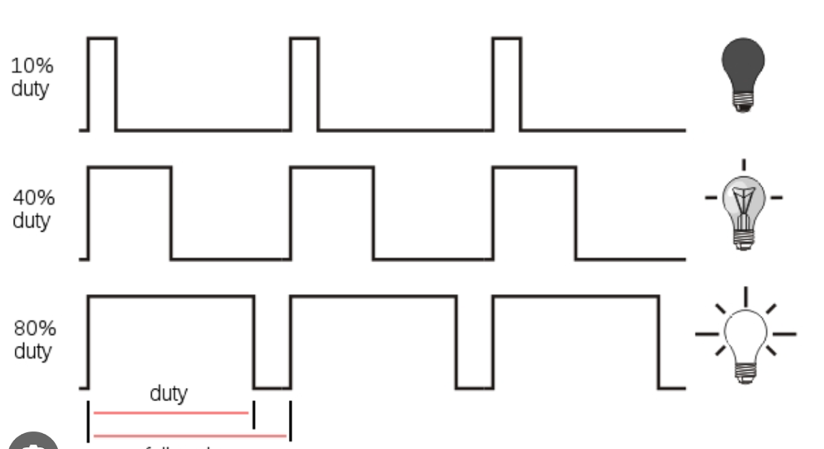
Figure 1: Duty cycle led brightness relationship.

PWM involves rapidly toggling a digital signal between high and low states. The frequency of the PWM signal can calculated by the above formula:

$$PWM frequency= \frac{APB clock frequency}{ARR*\left(PSC+1\right)}$$

To set the PWM frequency to 1 Khz, because the clock is default 16Mhz, PSC register value is set as 15, and ARR register value as 1000. To set the duty cycle the CCR register value can changed. The duty cycle percentage can be calculated by the above formula:

$$Duty Cycle=\frac{CCR}{ARR}*100 \%$$

So as an example, to set duty cycle to 40% CCR value must be equal to 400.
TIM2 is used to generate the PWM signal, and the interrupt is activated. In the interrupt the duty cycle of the PWM signal is updated. By using the Systick timer a counter is increased and decreased. The counter is set as PWM duty cycle in the TIM2 interrupt. So, every 1ms the counter increase by 1, this is equal to 0.1% of duty cycle.

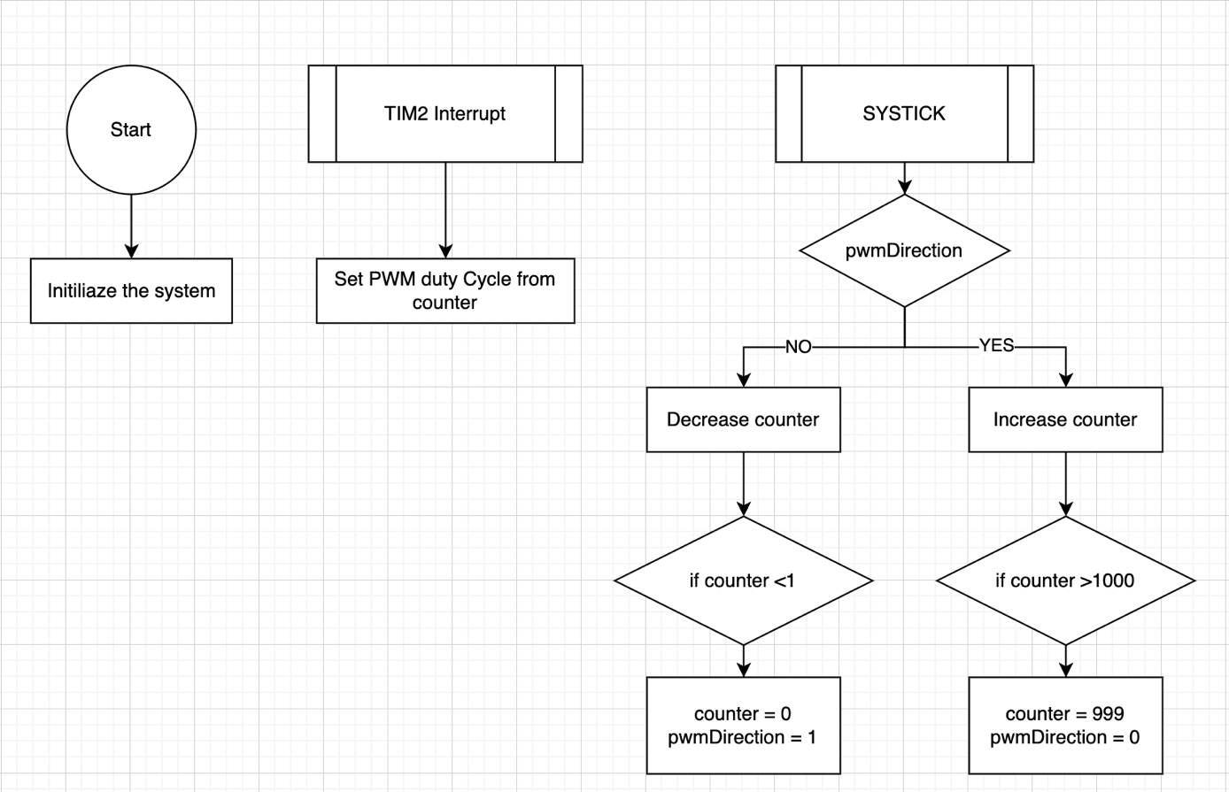
Figure 2: Flowchart of problem 2
/*
* main.c
*/
#include "main.h"

void Init_Systick(uint32_t tick);
void increase_tick(void);
void TIM2_IRQHandler(void);
void SetDutyCycle(uint16_t dutyCycle);
void StartPWM(void);
void StopPWM(void);
void SysTick_Handler(void);
void init_pwm2(void);

// variables
uint64_t tick;
uint8_t seconds;
uint16_t counter = 0;
uint8_t pwmDirection = 1; // 1 for increase, 0 for decrease

// defines
#define SYSTICK_FREQ 16000 // Khz
int main(void)
{

Init_Systick(SYSTICK_FREQ);
init_pwm2();
SetDutyCycle(0);
StartPWM();

while (1)
{
}

return 0;
}

void TIM2_IRQHandler(void)
{
// update duty
SetDutyCycle(counter);
// Clear update status register
TIM2->SR &= ~(1U << 0);
}

/**
* Setup PWM output for
* TIM2 CH2 on PB3
*/
void init_pwm2(void)
{

// Setup GPIO
//

// Enable GPIOB clock
RCC->IOPENR |= (1U << 1);
// Enable TIM2 clock
RCC->APBENR1 |= RCC_APBENR1_TIM2EN;

// Set alternate function to 2
// 3 comes from PB3
GPIOB->AFR[0] |= (2U << 4 * 3);
// Select AF from Moder
GPIOB->MODER &= ~(3U << 2 * 3);
GPIOB->MODER |= (2U << 2 * 3);

// zero out the control register just in case
TIM2->CR1 = 0;

// Select PWM Mode 1
TIM2->CCMR1 |= (6U << 12);
// Preload Enable
TIM2->CCMR1 |= TIM_CCMR1_OC2PE;

// Capture compare ch2 enable
TIM2->CCER |= TIM_CCER_CC2E;

// zero out counter
TIM2->CNT = 0;
// 1 ms interrupt
//CLOCK/((PSC+1)* ARR)
TIM2->PSC = 15;
TIM2->ARR = 1000;

// zero out duty
TIM2->CCR2 = 0;

// Update interrupt enable
TIM2->DIER |= (1 << 0);

// TIM1 Enable
// TIM2->CR1 |= TIM_CR1_CEN;

NVIC_SetPriority(TIM2_IRQn, 1);
NVIC_EnableIRQ(TIM2_IRQn);
}
void StartPWM(void)
{
// Enable the timer
TIM2->CR1 |= TIM_CR1_CEN;
}

void StopPWM(void)
{
// Disable the timer
TIM2->CR1 &= ~TIM_CR1_CEN;
}
void SetDutyCycle(uint16_t dutyCycle)
{
// Ensure duty cycle is within bounds

// Set the duty cycle by updating the CCR2 register
TIM2->CCR2 = dutyCycle;
TIM2->CCR1 = dutyCycle;
}
void increase_tick(void)
{
tick++;
}
void Init_Systick(uint32_t tick)
{
SysTick->LOAD = tick; // Count down from 999 to 0
SysTick->VAL = 0; // Clear current value
SysTick->CTRL = 0x7; // Enable Systick, exception,and use processor clock
}
/**
* @brief This function handles System tick timer.
*/
void SysTick_Handler(void)
{
increase_tick();
if (pwmDirection)
{
counter++;
if (counter > 1000)
{
counter = 999;
pwmDirection = 0;
}
}
else
{
counter--;
if (counter < 1)
{
counter = 0;
pwmDirection = 1;
}
}

}

