GEBZE TECHNICAL UNIVERSITY
ELECTRONICS ENGINEERING DEPARTMENT

ELM 366 COMMUNICATIONS LABORATORY
REPORT 5

EXPERIMENT 5: ASK and FSK Modulation

Prepared by: Fouad Aladhami
Student Number: 210102002808
Team and Group Number: Team 4
Team Mates: Esra Kirman, Büşra Ülker

Date of the experiment: 23.04.2024

Introduction

Theorical Background

Amplitude Shift Keying Modulation and Demodulation

Frequency Shift Keying Modulation and Demodulation

Experiement

Generating an ASK signal

The power of the TETRA-BB and ELVIS platforms was turned on, and the ELVIS platform was connected to the PC via USB. The control mode of TETRA-BB was set to PC. The TETRA-BB soft front panel (SFP) software was run. To generate an ASK signal the required connections were made as shown in the Figure 2. The frequency of the sinus tone signal was set to 2 kHz, and the oscilloscope panel settings were adjusted as follows: Channel 0 Voltage Range: 1V/div, Channel 1 Voltage Range: 2V/div, Horizontal Time base: 1ms/div, Trigger: Digital, TRIG Source, Level: 0V, Horizontal Position (%): 50, Probe Attenuation: 1x.

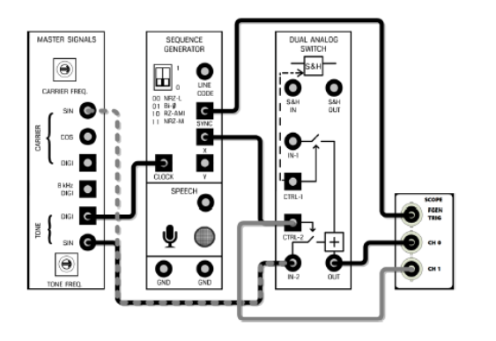
Figure 2: Block diagram of Generating ASK signal

ASK MODULATION

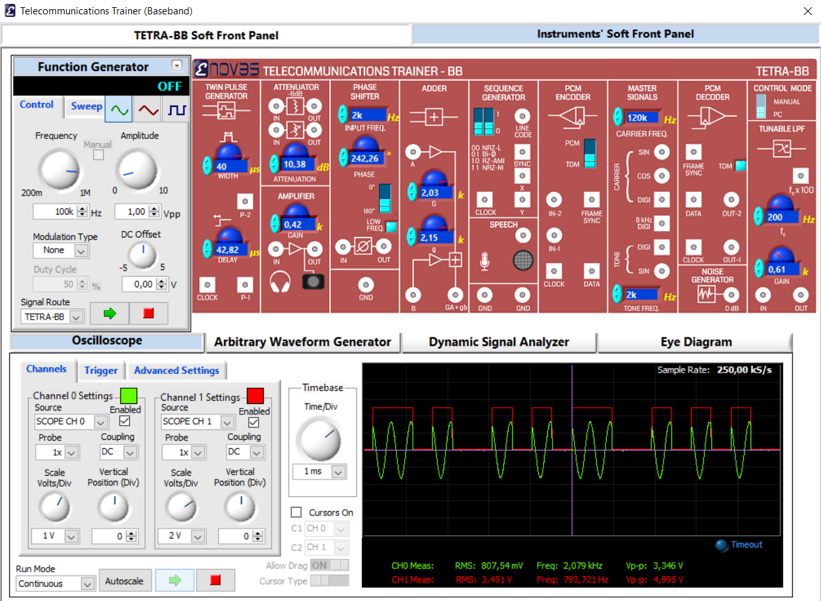
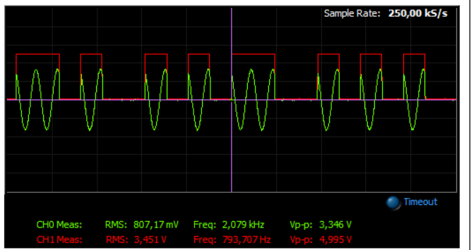
Carrier sinyale alındı 100k

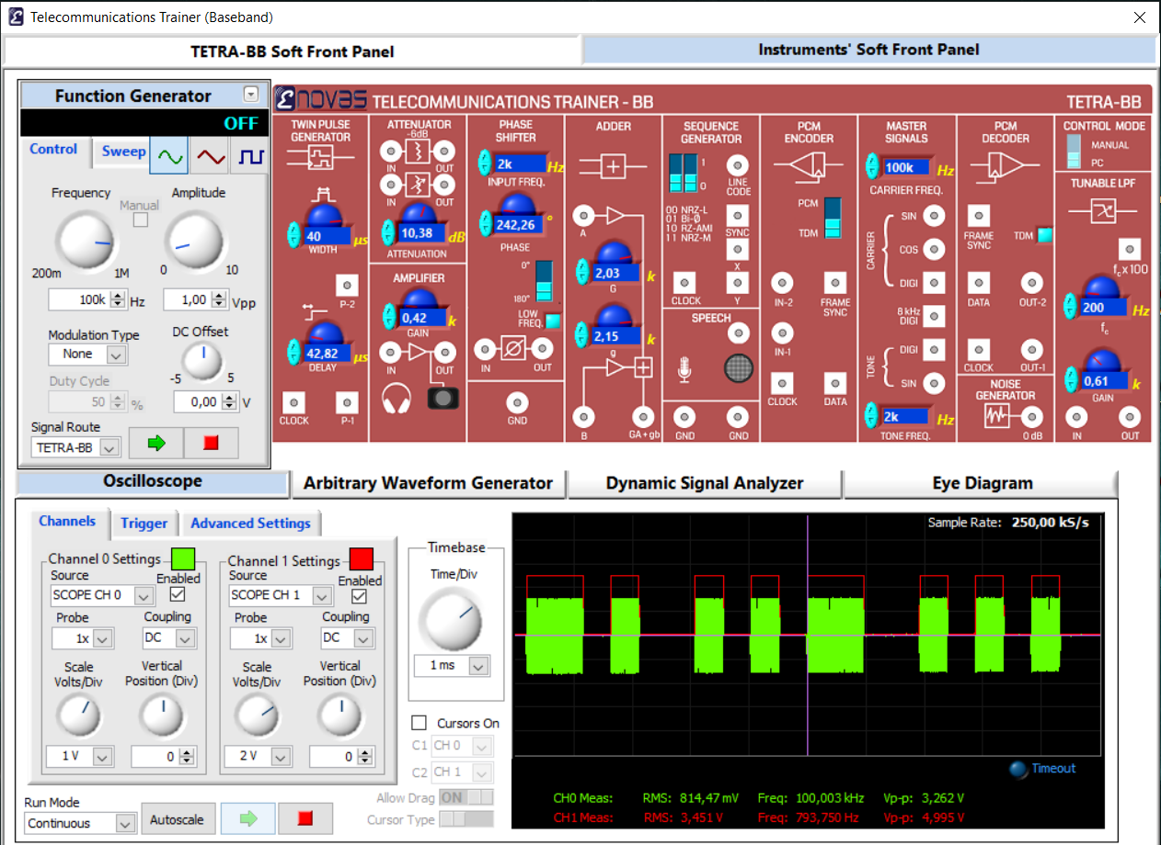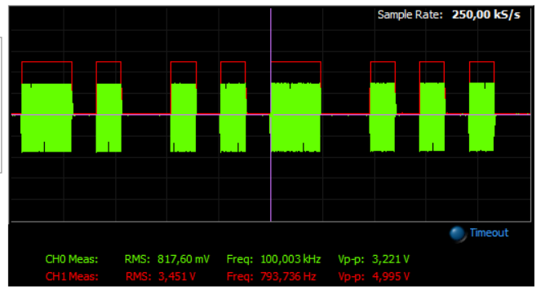
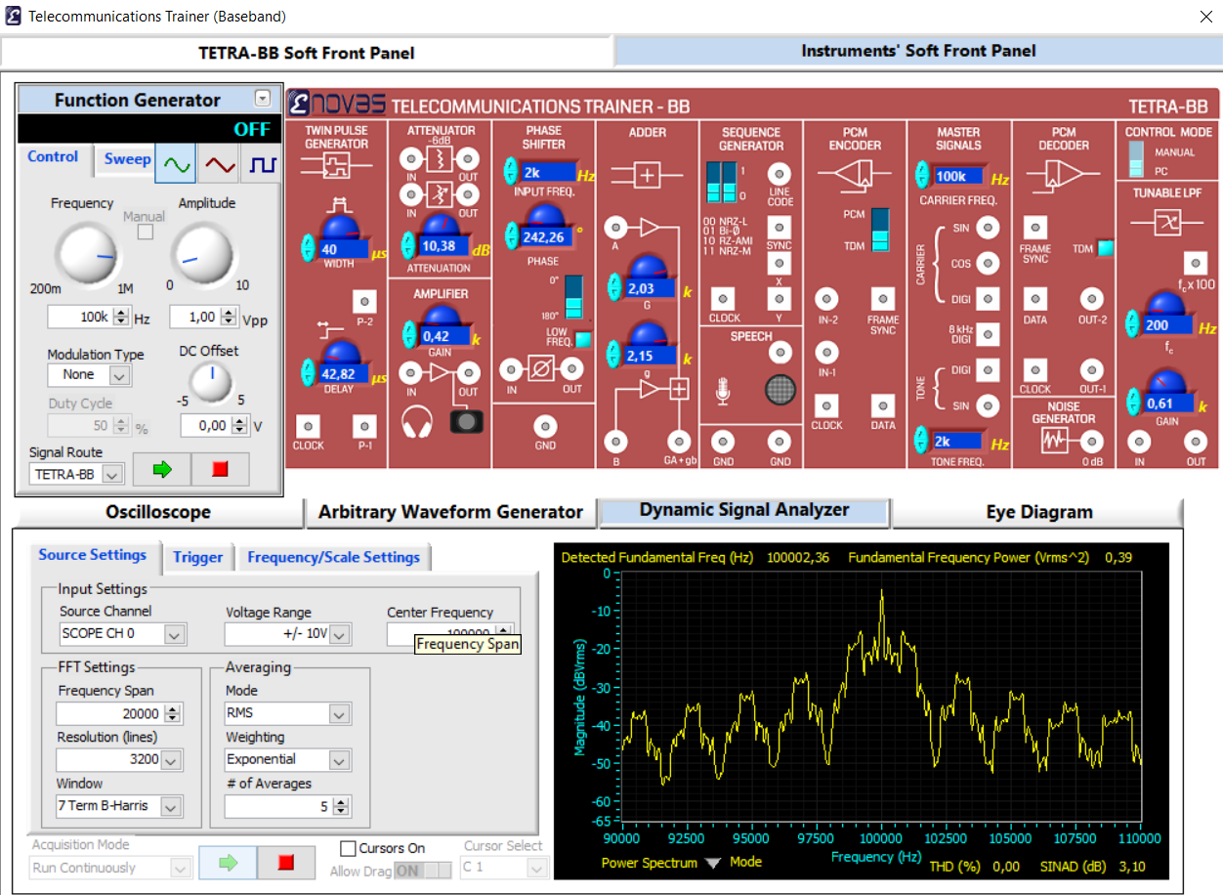
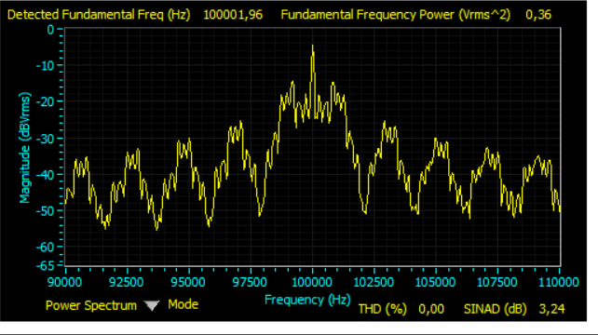

Range 200k yapıldı:
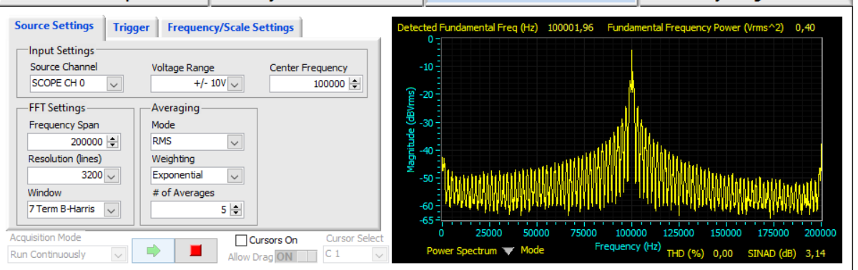
DEMOD
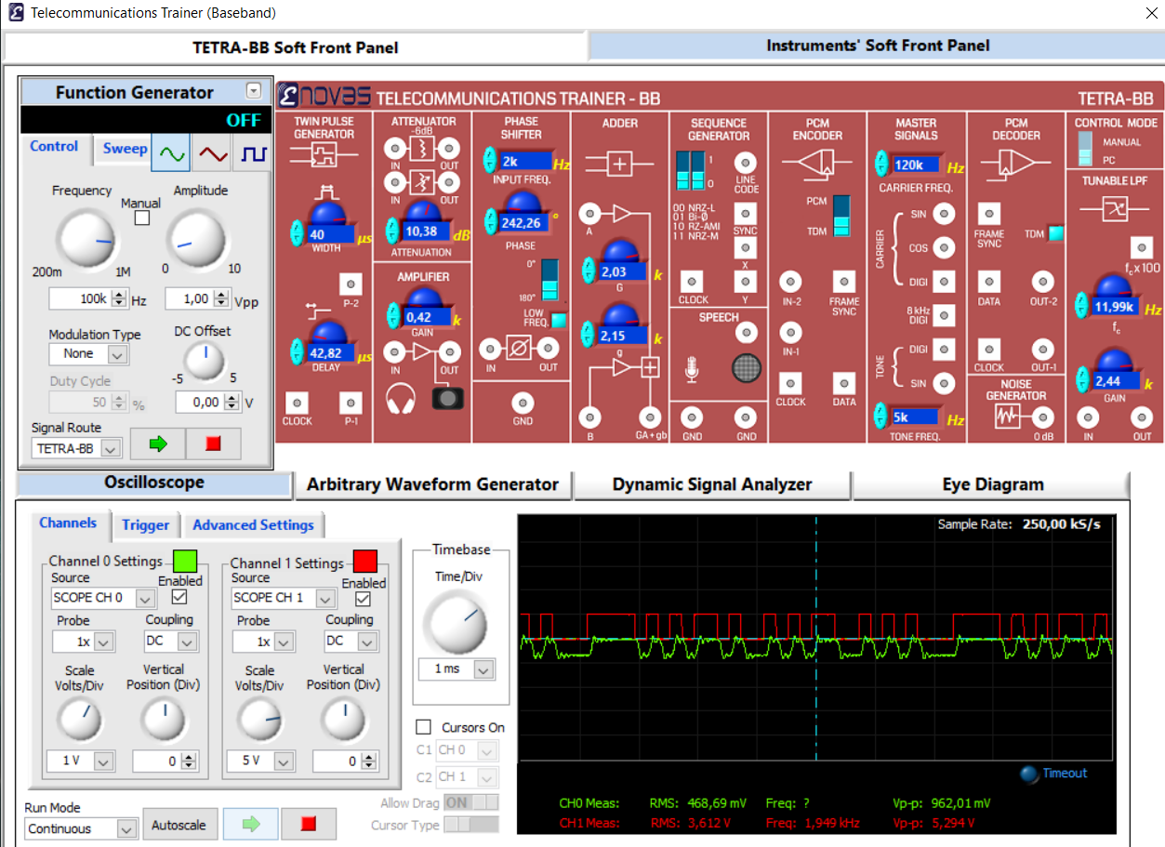
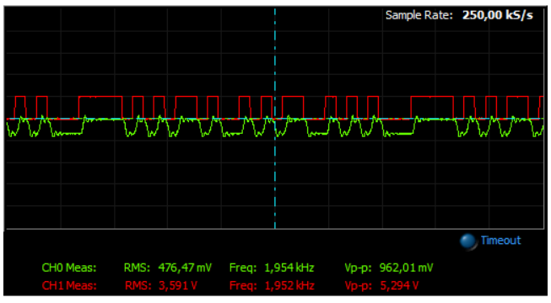
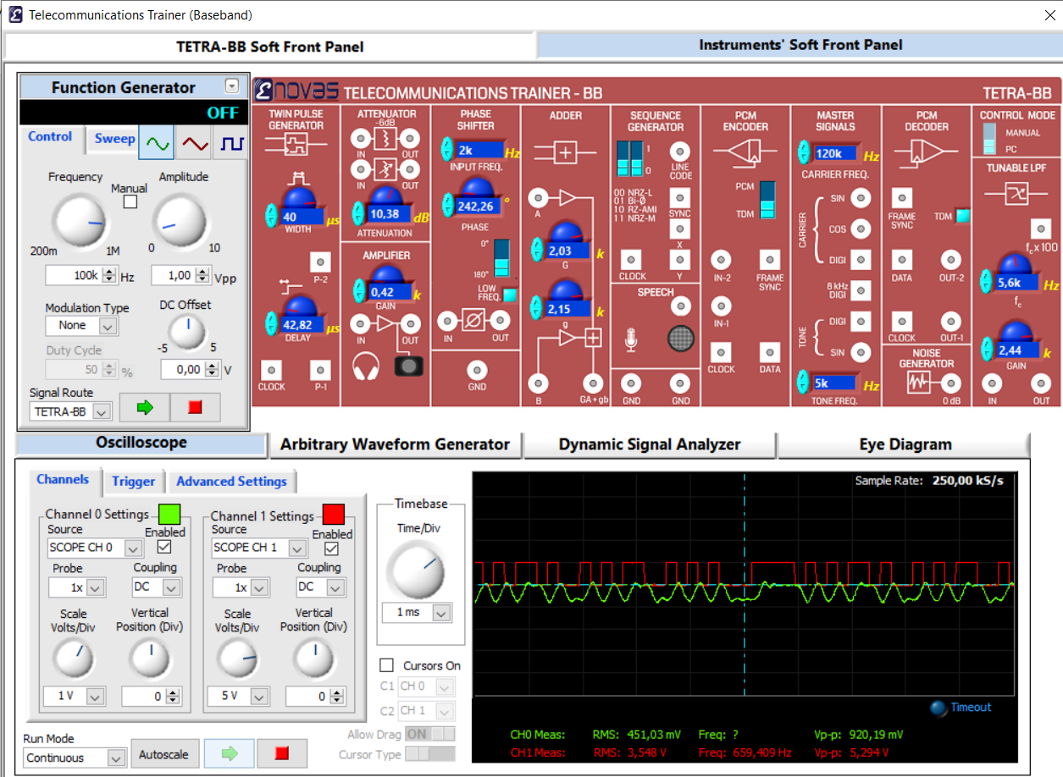

-1V DC verildi.
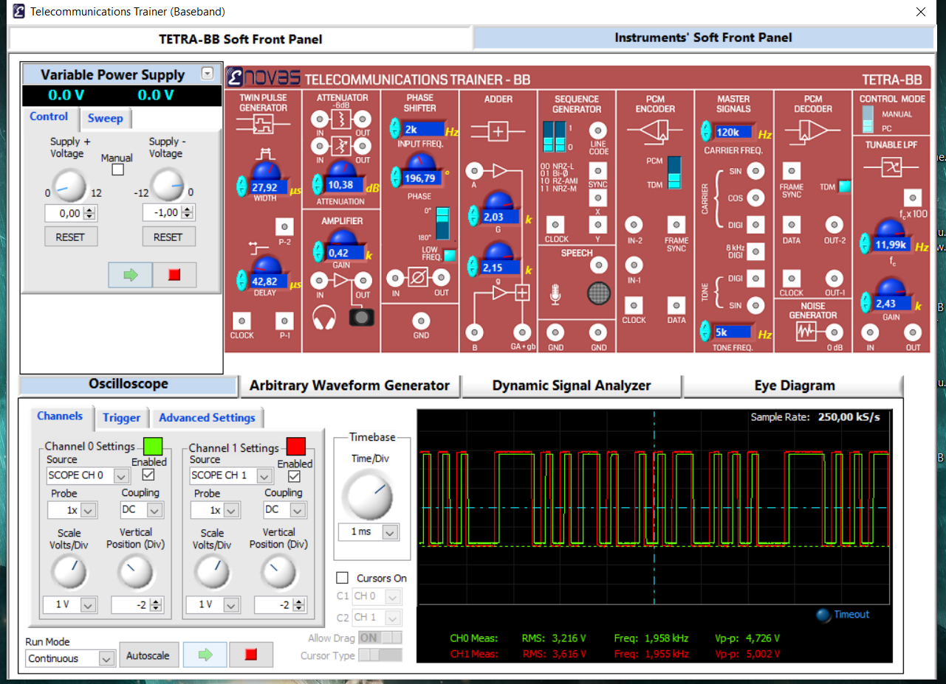
FSK MODULATION
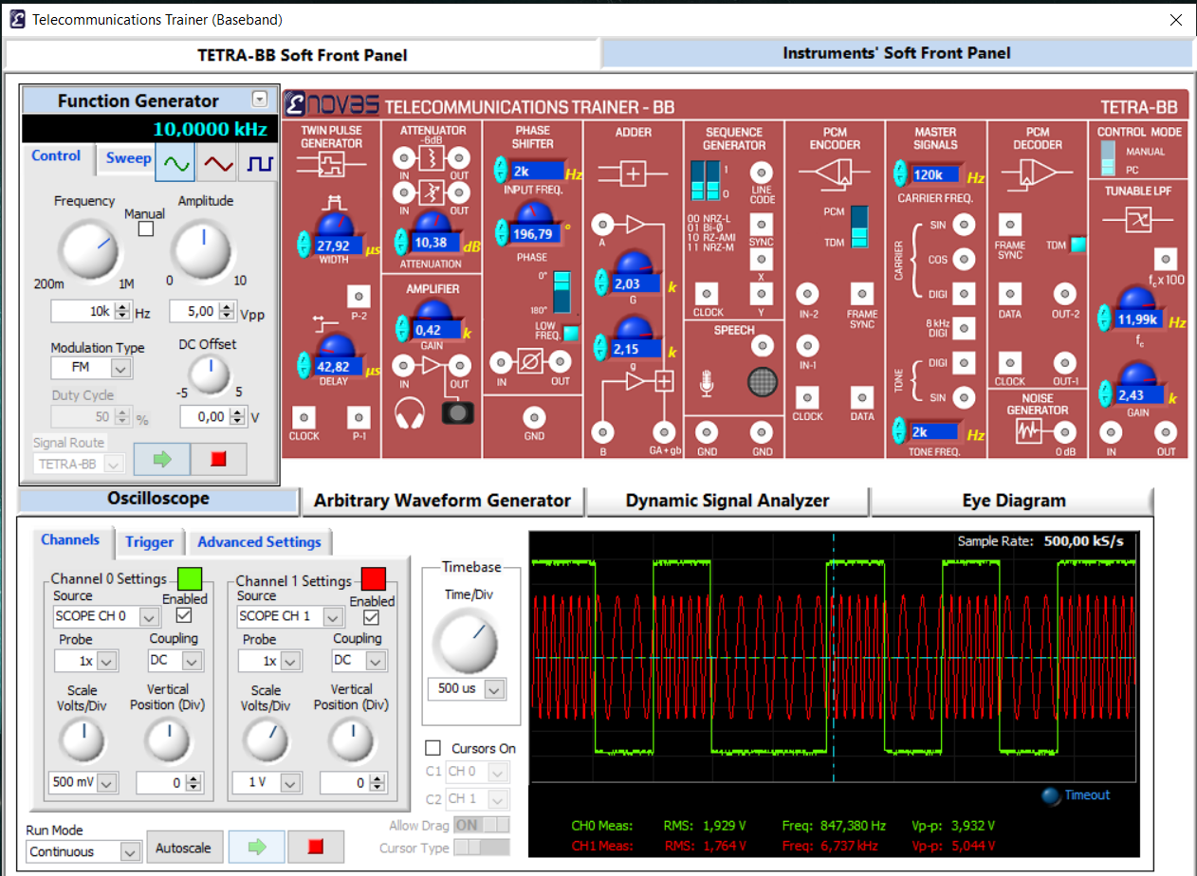
CHANNEL 0
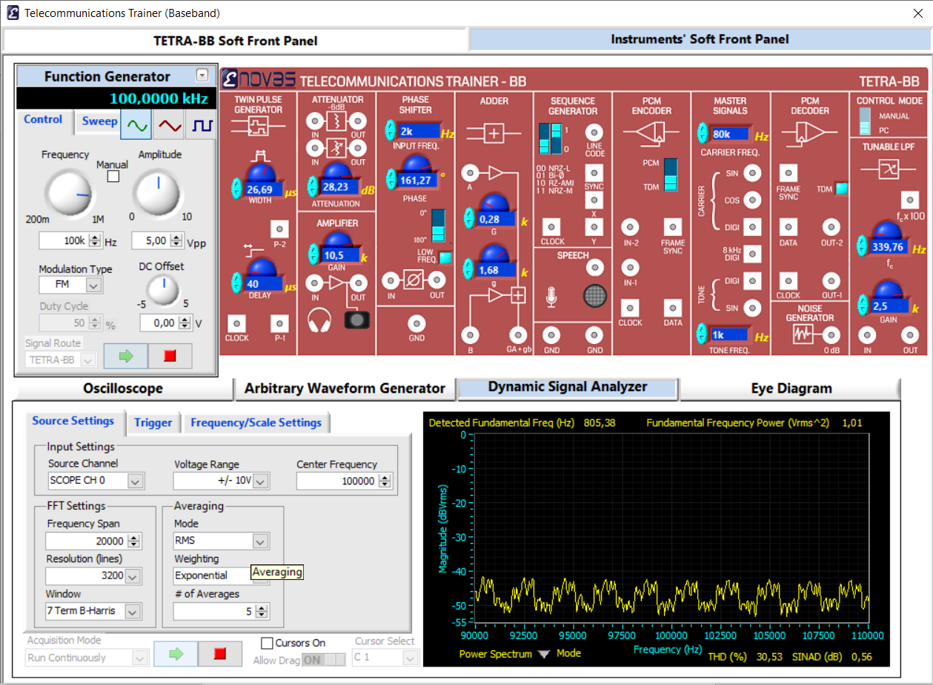
CHANNEL1
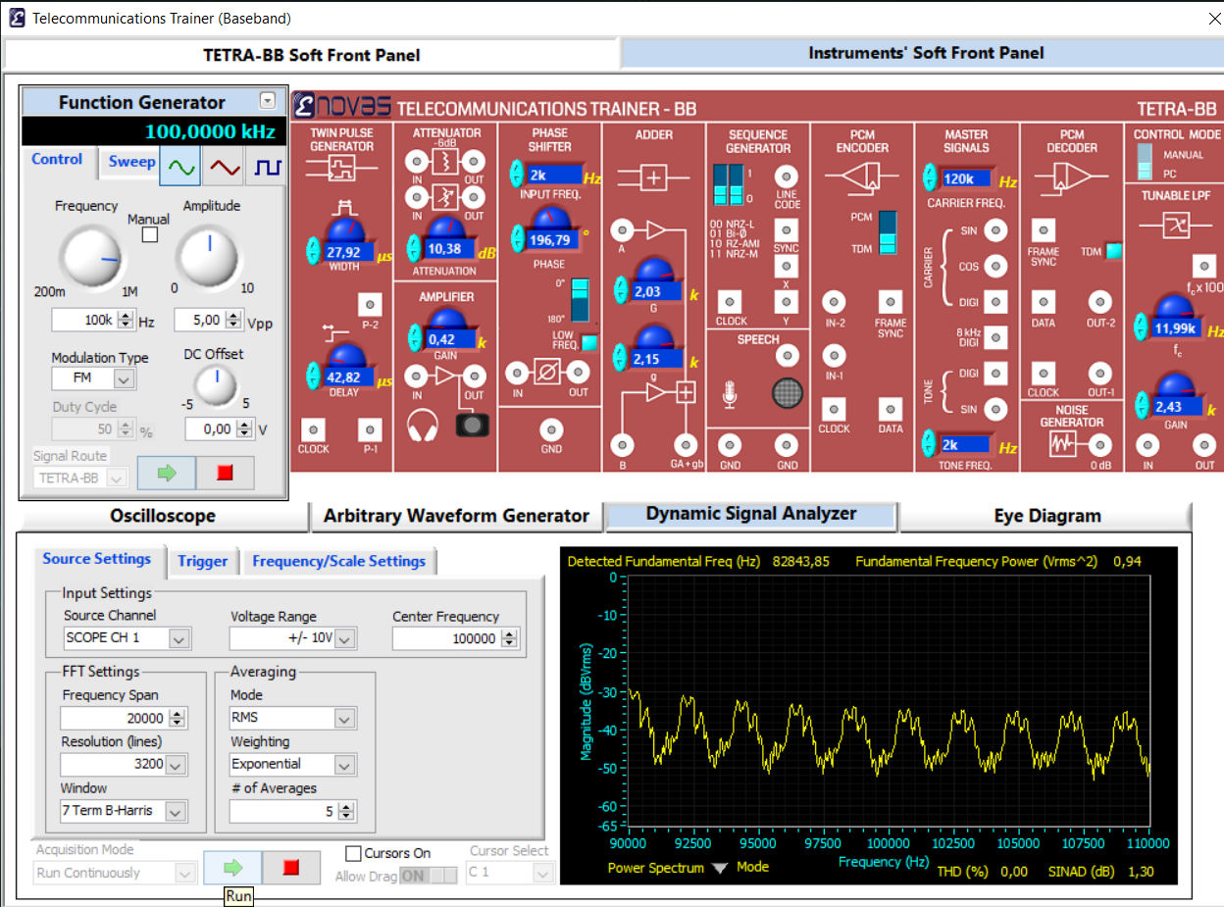
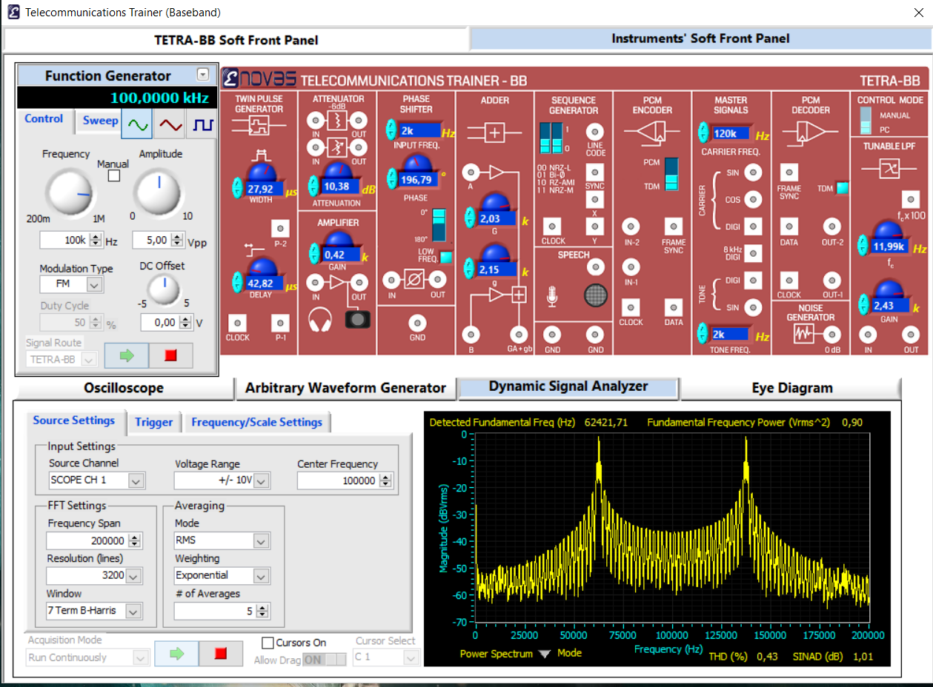
DEMOD FSK

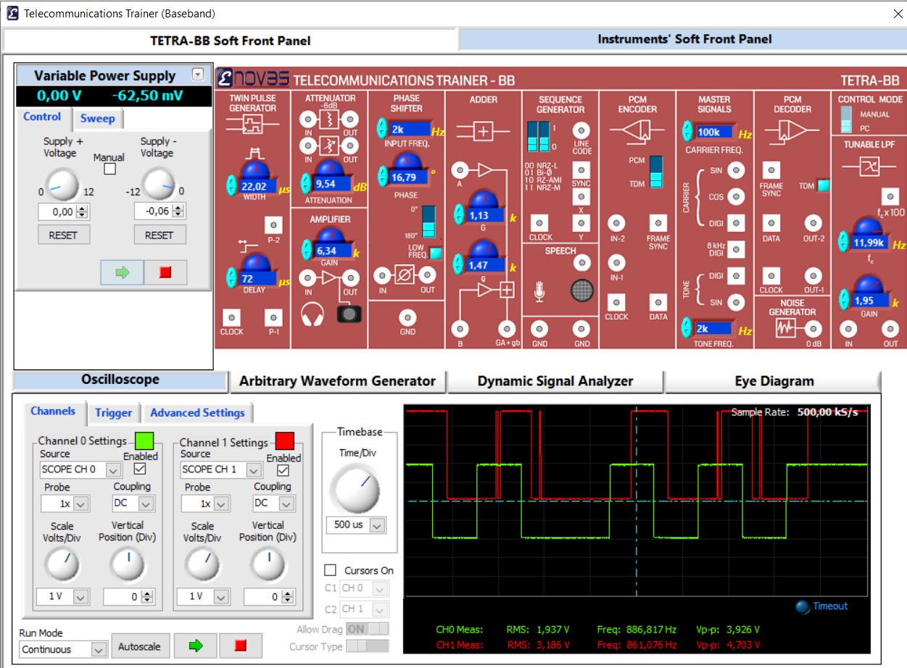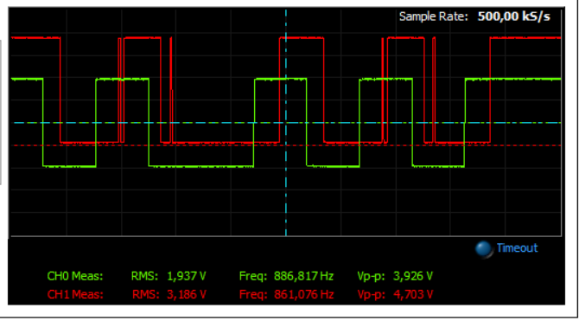
Refle in yerini değiştirince:
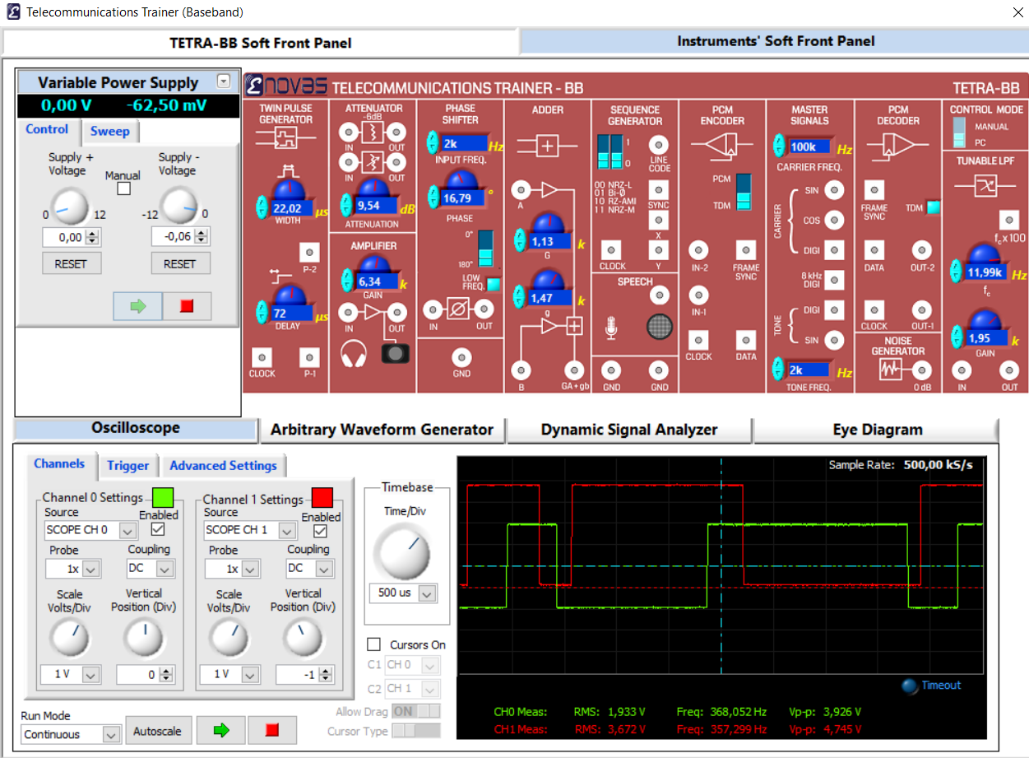
Diğer comparator kullanıldı
