PEOPLE'S DEMOCRATIC REPUBLIC OF ALGERIA
MINISTRY OF HIGHER EDUCATION AND SCIENTIFIC RESEARCH

UNIVERSITY FERHAT ABBAS SÉTIF 1
FACULTY OF SCIENCES
DEPARTMENT OF COMPUTER SCIENCE

Doctoral Thesis
in Computer Science

RBciAD
A Reactive Polyglot Platform for Rapid BCI Prototyping
with Cross-Subject Motor Imagery Classification

Presented by
Fouad CHOUAG

Thesis supervised by
Prof. Abdallah KHABABA

Defended publicly on: ____ / ____ / 2026

Sétif, Algeria

Jury Members
The jury, composed of the following members, examined this thesis:
Role | Name | Affiliation | Grade
President | [To be filled] | [To be filled] | Professor
Supervisor | Abdallah KHABABA | Ferhat Abbas University Sétif 1 | Professor
Examiner | [To be filled] | [To be filled] | —
Examiner | [To be filled] | [To be filled] | —
Invited member | [To be filled] | [To be filled] | —

Dedication

To my parents, whose love, patience, and constant encouragement carried me through every difficult moment of this journey.
To my family, who believed in me when I doubted myself.
To my supervisor, for his mentorship, his demanding standards, and his generosity with time and ideas.
To every researcher who believes that scientific tools should be accessible to all, not only to those with abundant resources.
To the open-source community, whose silent, collective labour made this work possible.

Acknowledgments
The completion of this doctoral thesis would not have been possible without the support, guidance, and encouragement of many individuals and institutions, whom I would like to acknowledge here.
I would first and foremost like to express my profound gratitude to my doctoral supervisor, Professor Abdallah Khababa, for the trust he placed in me from the beginning of this work, for his patient guidance throughout these years, for the scientific rigour he demanded and the methodological discipline he instilled, and for the countless hours he invested in reviewing manuscripts, discussing algorithmic choices, and steering the overall research program. The quality of this thesis owes much to his intellectual contribution and his careful mentorship.
I extend my sincere thanks to the members of the jury — [names to be added after defence] — for accepting to evaluate this work, for the time they devoted to reading the manuscript, and for the constructive and insightful comments they provided during and after the defence. Their remarks have been invaluable in strengthening the final form of this thesis.
I am deeply grateful to the Department of Computer Science at Ferhat Abbas University Sétif 1 for providing the academic environment, the computational resources, and the administrative support without which this research could not have been conducted. Special thanks are due to the departmental staff for their logistical assistance throughout the doctoral period.
I thank the research community in brain–computer interfaces, whose collective work over three decades has built the foundation on which this thesis stands. In particular, I acknowledge the developers and maintainers of the open-source software projects that directly enabled this work: MNE-Python for EEG input–output and preprocessing, scikit-learn for machine learning infrastructure, pyRiemann for Riemannian computations on SPD manifolds, the Lab Streaming Layer project for real-time data transport, and the PyQt project for the graphical user interface toolkit. The contributors to these projects — largely volunteers and academics working without direct compensation — have built an extraordinary scientific infrastructure, and my debt to them is considerable.
I am grateful to the providers of the BCI Competition IV Dataset 2a — Brunner, Leeb, Müller-Putz, Schlögl, and Pfurtscheller at Graz University of Technology — and to the PhysioNet and BCI2000 teams, whose public datasets made rigorous benchmarking possible. In the spirit of the open-science principles these datasets embody, all source code and reproducibility artifacts of this thesis are released under permissive licenses.
I thank my colleagues and fellow doctoral students for the countless discussions, the shared coffee breaks, and the mutual moral support that sustained us through the long doctoral years. Particular thanks are due to the graduate students who participated in the formative user study of RBciAD; their candid feedback and their willingness to interact with an early-stage prototype were essential to shaping the final design of the platform.
Finally, and most importantly, I thank my family. My parents, for the lifelong commitment to my education; my siblings, for their unwavering support; and all those close to me who accepted the many evenings and weekends sacrificed to this work without complaint. Their patience and love were the foundation on which everything else was built.

Abstract
Brain–computer interfaces (BCIs) offer a direct communication channel between the human brain and external devices, with promising applications in assistive technology, neurorehabilitation, and human–computer interaction. Despite three decades of research, translating BCI technology from laboratory prototypes into accessible, deployable systems remains hindered by two persistent bottlenecks: (i) the fragmented and programming-heavy nature of BCI software infrastructure, which limits accessibility and slows iteration; and (ii) the difficulty of achieving robust cross-subject classification without per-user calibration, due to substantial inter-subject variability in EEG signals.
This thesis addresses both bottlenecks through two tightly connected contributions. First, it introduces RBciAD, an open-source, reactive, polyglot framework for rapid BCI prototyping. RBciAD combines a no-code node-based editor with a low-code node generator, a deterministic reactive execution engine built on the RxPy observable library, and a principled polyglot plugin system that lets Python, C, C++, Rust, and Node.js modules coexist in the same pipeline through a lightweight JSON input–output protocol. The platform integrates MNE-Python for EEG input–output and provides authentic clinical-style live visualization. A quantitative benchmark suite, grounded in established human–computer interaction thresholds, shows that RBciAD achieves sub-100 ms interaction latencies (P95 of 49 to 65 milliseconds across three representative workflows), stable real-time rendering with zero dropped frames, and modest CPU and memory footprints on commodity laptop hardware.
Second, the thesis develops a family of calibration-free cross-subject classification methods for motor imagery EEG, presented as a scientific progression and culminating in TS-FBCSP — a filter-bank tangent space framework with Euclidean Alignment. Evaluated under a strict Leave-One-Subject-Out protocol on BCI Competition IV Dataset 2a and validated on the PhysioNet EEG Motor Movement/Imagery dataset (109 subjects), TS-FBCSP achieves the highest mean LOSO accuracy of 47.88 percent and information transfer rate of 2.63 bits per minute among eight evaluated methods — a 177 percent improvement in ITR over the Common Spatial Pattern baseline. Statistically significant improvements are confirmed over five baselines using the Wilcoxon signed-rank test with large effect sizes (Cohen's d between 0.695 and 1.071). A systematic analysis across all methods demonstrates that Euclidean Alignment provides consistent improvements of 7 to 13 percentage points and should be treated as an indispensable preprocessing step for zero-calibration cross-subject BCIs.
The two contributions are integrated: all classification methods developed in this thesis are implemented as reusable RBciAD nodes, enabling reproducible end-to-end motor imagery pipelines — from offline training to online inference — to be assembled without writing a single line of code. The complete system is released as open source under the MIT license, with a permanent archival snapshot on Zenodo. This thesis thus provides both a scientific contribution (a new state of the art in calibration-free cross-subject motor imagery classification) and an engineering contribution (a platform for the BCI research community that lowers the barrier to entry and supports rigorous, reproducible experimentation).
Keywords: brain–computer interface; electroencephalography; motor imagery; software platform; reactive programming; polyglot systems; common spatial patterns; Riemannian geometry; tangent space mapping; Euclidean alignment; cross-subject classification; leave-one-subject-out evaluation; real-time signal processing; open-source software; reproducible research.

Résumé
Les interfaces cerveau–machine (ICM) offrent une voie de communication directe entre le cerveau humain et des dispositifs externes, avec des applications prometteuses dans la technologie d'assistance, la neuroréadaptation et l'interaction homme–machine. Malgré trois décennies de recherche, la transition des ICM de prototypes de laboratoire vers des systèmes accessibles et déployables reste freinée par deux verrous persistants : (i) la nature fragmentée et fortement dépendante du code des infrastructures logicielles ICM, qui limite l'accessibilité et ralentit l'itération ; et (ii) la difficulté d'obtenir une classification cross-sujet robuste sans calibration individuelle, en raison de la variabilité inter-sujet substantielle des signaux EEG.
Cette thèse aborde ces deux verrous à travers deux contributions étroitement liées. Premièrement, elle introduit RBciAD, un cadre open-source, réactif et polyglotte pour le prototypage rapide d'applications ICM. RBciAD combine un éditeur no-code à base de nœuds, un générateur low-code de nœuds personnalisés, un moteur d'exécution réactif déterministe fondé sur la bibliothèque d'observables RxPy, et un système de plugins polyglotte qui permet à Python, C, C++, Rust et Node.js de coexister dans le même pipeline via un protocole d'entrée–sortie JSON léger. La plateforme intègre MNE-Python pour les entrées–sorties EEG et offre une visualisation en temps réel de style clinique. Une suite de benchmarks quantitatifs, ancrée dans des seuils d'interaction homme–machine établis, montre que RBciAD atteint des latences d'interaction inférieures à 100 millisecondes (P95 entre 49 et 65 millisecondes sur trois workflows représentatifs), un rendu temps réel stable sans perte d'images, et une empreinte CPU et mémoire modeste sur matériel portable grand public.
Deuxièmement, la thèse développe une famille de méthodes de classification cross-sujet sans calibration pour l'imagerie motrice EEG, présentée comme une progression scientifique culminant avec TS-FBCSP — un cadre Filter-Bank Tangent Space avec Alignement Euclidien. Évaluée selon un protocole Leave-One-Subject-Out strict sur le jeu de données BCI Competition IV 2a et validée sur le jeu de données PhysioNet EEG Motor Movement/Imagery (109 sujets), TS-FBCSP atteint la meilleure précision LOSO moyenne de 47,88 pour cent et le meilleur débit d'information de 2,63 bits par minute parmi huit méthodes évaluées — une amélioration de 177 pour cent du débit d'information par rapport au Common Spatial Pattern classique. Des améliorations statistiquement significatives sont confirmées sur cinq méthodes de référence par le test de Wilcoxon avec de grands effets (d de Cohen entre 0,695 et 1,071). Une analyse systématique démontre que l'Alignement Euclidien apporte une amélioration constante de 7 à 13 points de pourcentage et devrait être considéré comme une étape de prétraitement indispensable pour les ICM cross-sujet sans calibration.
Les deux contributions sont intégrées : toutes les méthodes de classification développées dans cette thèse sont implémentées comme nœuds RBciAD réutilisables, permettant d'assembler des pipelines d'imagerie motrice reproductibles de bout en bout — de l'entraînement hors ligne à l'inférence en ligne — sans écrire une seule ligne de code. Le système complet est publié en open-source sous licence MIT, avec un instantané d'archivage permanent sur Zenodo. Cette thèse offre ainsi à la fois une contribution scientifique (un nouvel état de l'art en classification cross-sujet d'imagerie motrice sans calibration) et une contribution d'ingénierie (une plateforme pour la communauté de recherche ICM qui abaisse la barrière d'entrée et soutient une expérimentation rigoureuse et reproductible).
Mots-clés : interface cerveau–machine ; électroencéphalographie ; imagerie motrice ; plateforme logicielle ; programmation réactive ; systèmes polyglottes ; patterns spatiaux communs ; géométrie riemannienne ; projection espace tangent ; alignement euclidien ; classification cross-sujet ; évaluation leave-one-subject-out ; traitement temps réel du signal ; logiciel open-source ; recherche reproductible.

Table of Contents
Dedication
Acknowledgments
Abstract
Résumé
Table of Contents
List of Figures
List of Tables
List of Abbreviations
List of Symbols

Chapter 1 — Introduction
1.1 Context and Motivation
1.2 The Dual Bottleneck of Modern BCIs
1.3 Primer on EEG and Motor Imagery
1.4 Research Questions
1.5 Two Gaps Addressed by This Thesis
1.6 Contributions
1.7 Publications
1.8 Thesis Organization

Chapter 2 — Background and Related Work
2.1 Foundations of Brain–Computer Interfaces
2.2 BCI Software Platforms
2.3 Spatial Filtering for MI-EEG
2.4 Riemannian Geometry for EEG Classification
2.5 Cross-Subject Domain Adaptation
2.6 Deep Learning Approaches
2.7 Evaluation Protocols
2.8 The No-Code and Low-Code Paradigm
2.9 Synthesis: Two Unresolved Gaps

Chapter 3 — RBciAD: A Reactive Polyglot Platform for BCI Prototyping
3.1 Design Principles
3.2 System Architecture
3.3 Acquisition Manager and Unified Chunk Format
3.4 Node-Based Visual Editor
3.5 Reactive Execution Engine
3.6 Polyglot Plugin System
3.7 Low-Code Node Generator
3.8 Clinical-Style EEG Visualization
3.9 Persistence and Reproducibility
3.10 Benchmark Methodology
3.11 Benchmark Results
3.12 Case Studies
3.13 Comparison with Existing Platforms
3.14 Summary and Limitations

Chapter 4 — Cross-Subject Classification: From CSP to Riemannian Filter Banks
4.1 Problem Formulation
4.2 Datasets and Preprocessing
4.3 Evaluation Protocol
4.4 Mathematical Foundations
4.5 FB-ACMCSP — Filter-Bank Adaptive Multi-Class CSP
4.6 FB-RCSP-RA — Filter-Bank RCSP with Riemannian Alignment
4.7 TS-FBCSP — The Final Method
4.8 Unified Comparative Evaluation
4.9 The Role of Euclidean Alignment
4.10 Per-Subject Analysis
4.11 Within-Subject vs Cross-Subject Gap
4.12 Statistical Significance Analysis
4.13 Real-Time Feasibility
4.14 Cross-Dataset Validation on PhysioNet
4.15 Discussion and Findings

Chapter 5 — Integrated BCI Applications in RBciAD
5.1 Motor Imagery Workflow — Offline Training
5.2 Motor Imagery Workflow — Online Inference
5.3 TS-FBCSP Node Integration
5.4 End-to-End Reproducibility
5.5 Real-Time Demonstration
5.6 Lessons from Platform–Algorithm Co-Design

Chapter 6 — Conclusion and Perspectives
6.1 Summary of Contributions
6.2 Scientific and Practical Impact
6.3 Limitations
6.4 Future Research Directions
6.5 Closing Remarks

References
Appendix A — List of Publications
Appendix B — Mathematical Supplements
Appendix C — Algorithmic Pseudocode
Appendix D — Experimental Protocols and Reproducibility
Appendix E — Data and Code Availability
Appendix F — Ethical Statements

List of Figures
Figure 1.1 — Generic brain–computer interface processing pipeline
Figure 2.1 — Positioning of BCI software platforms across accessibility and extensibility dimensions
Figure 2.2 — The SPD manifold and the tangent space mapping
Figure 2.3 — Taxonomy of cross-subject transfer learning strategies (placeholder)
Figure 3.1 — Three-layer architecture of RBciAD
Figure 3.2 — Acquisition Manager and unified chunk format
Figure 3.3 — Node-based editor screenshot (placeholder)
Figure 3.4 — Reactive execution flow with RxPy observables
Figure 3.5 — Polyglot plugin system with JSON input–output bridge
Figure 3.6 — Low-code node generation wizard (placeholder)
Figure 3.7 — EEG input–output and visualization workflow (placeholder)
Figure 3.8 — Benchmark instrumentation event flow (placeholder)
Figure 3.9 — Interactive performance of RBciAD across three workflows
Figure 3.10 — Hybrid polyglot workflow case study (placeholder)
Figure 3.11 — Live streaming with synthetic EEG (placeholder)
Figure 3.12 — Exploratory analysis with the MNE 2D Viewer (placeholder)
Figure 4.1 — Leave-One-Subject-Out cross-validation protocol
Figure 4.2 — TS-FBCSP processing pipeline
Figure 4.3 — BCI IV-2a trial timing structure (placeholder)
Figure 4.4 — Cross-subject LOSO accuracy for eight methods
Figure 4.5 — Information Transfer Rate for eight methods
Figure 4.6 — Per-subject LOSO accuracy heatmap
Figure 4.7 — Effect of Euclidean Alignment on LOSO accuracy
Figure 4.8 — Within-subject versus cross-subject accuracy gap
Figure 5.1 — Offline training and online inference pipelines in RBciAD

List of Tables
Table 2.1 — Comparative overview of EEG imaging and prototyping systems
Table 2.2 — Representative MI-EEG classification methods
Table 3.1 — Interactive metrics during EDF replays
Table 3.2 — Distinguishing features of RBciAD versus reference platforms
Table 4.1 — BCI Competition IV Dataset 2a trial timing structure
Table 4.2 — Filter bank sub-band specifications
Table 4.3 — LOSO cross-subject accuracy for eight methods
Table 4.4 — Per-subject LOSO classification accuracy
Table 4.5 — Effect of Euclidean Alignment on LOSO accuracy
Table 4.6 — Within-subject versus cross-subject accuracy
Table 4.7 — Online inference processing time per trial
Table 4.8 — Statistical significance results (Wilcoxon signed-rank tests)
Table 6.1 — Summary of contributions and publications

List of Abbreviations
Abbreviation | Meaning
API | Application Programming Interface
ACMCSP | Adaptive Multi-Class Common Spatial Pattern
BCI | Brain–Computer Interface
BDF | BioSemi Data Format (EEG file format)
BIDS | Brain Imaging Data Structure
CLI | Command-Line Interface
CNN | Convolutional Neural Network
CPU | Central Processing Unit
CSP | Common Spatial Pattern
CSV | Comma-Separated Values
CV | Cross-Validation
DAG | Directed Acyclic Graph
DOI | Digital Object Identifier
EA | Euclidean Alignment
EDF | European Data Format (EEG file format)
EEG | Electroencephalography
EOG | Electrooculography
ERP | Event-Related Potential
FBCSP | Filter Bank Common Spatial Pattern
FIF | Functional Image File format (MNE)
FPS | Frames Per Second
GDF | General Data Format (EEG)
GPU | Graphics Processing Unit
GUI | Graphical User Interface
HCI | Human–Computer Interaction
I/O | Input/Output
INP | Interaction to Next Paint
ITR | Information Transfer Rate
JSON | JavaScript Object Notation
KPI | Key Performance Indicator
LDA | Linear Discriminant Analysis
LOSO | Leave-One-Subject-Out (cross-validation)
LSL | Lab Streaming Layer
MDM | Minimum Distance to Mean
MEG | Magnetoencephalography
MI | Motor Imagery
MIT | Massachusetts Institute of Technology (license)
MNE | MNE-Python (EEG/MEG analysis library)
MRI | Magnetic Resonance Imaging
OAS | Oracle Approximating Shrinkage (covariance estimator)
OVR | One-versus-Rest (multi-class strategy)
P300 | Positive event-related potential peaking around 300 ms
PDF | Portable Document Format
RBF | Radial Basis Function (kernel)
RCA | Reliable Components Analysis
RCSP | Regularized Common Spatial Pattern
RSS | Resident Set Size (process memory)
RxPy | ReactiveX for Python
SDK | Software Development Kit
SPD | Symmetric Positive Definite (matrix/manifold)
SSVEP | Steady-State Visual Evoked Potential
SVG | Scalable Vector Graphics
SVM | Support Vector Machine
TS | Tangent Space
TS-FBCSP | Tangent Space Filter-Bank CSP (this work)
TTFP | Time-to-First-Pipeline
UI/UX | User Interface / User Experience
URL | Uniform Resource Locator
XML | eXtensible Markup Language

List of Mathematical Symbols
Symbol | Meaning
X | EEG trial (matrix of channels × samples)
C | Number of EEG channels
T | Number of time samples per trial
Σ_i | Covariance matrix of trial i
S_{++}^C | Manifold of C×C symmetric positive definite matrices
M | Riemannian (Fréchet) mean covariance
d_R | Affine-invariant Riemannian distance
T_M | Tangent space at M
φ_i | Tangent vector representing trial i
W_s | Euclidean Alignment whitening matrix for subject s
Ā_s | Mean trace-normalized covariance for subject s
Ρ | OAS shrinkage regularization parameter
I_C | C×C identity matrix
C_{svm} | SVM regularization hyperparameter
Γ | SVM RBF kernel bandwidth
B | Number of filter-bank sub-bands
N | Number of classes (for ITR) or training trials
P | Mean classification accuracy (fraction)
Δt_k | Per-edit interaction latency
P50 / P95 | 50th and 95th percentiles of the latency distribution

Chapter 1 — Introduction

1.1 Context and Motivation
Brain–computer interfaces (BCIs) establish a direct communication pathway between neural activity and external devices, bypassing the peripheral nervous system entirely. For individuals with severe motor impairments — such as patients with amyotrophic lateral sclerosis, spinal cord injury, brainstem stroke, or locked-in syndrome — BCIs represent one of the few viable avenues for regaining independent communication and environmental control. The clinical imperative is significant: estimates suggest that several hundred thousand individuals worldwide live with conditions severe enough that a reliable BCI would fundamentally improve their quality of life.
Beyond assistive applications, BCIs are increasingly explored across a broad spectrum of domains. In neurorehabilitation, motor-imagery-based BCIs are used to guide post-stroke motor recovery by closing the loop between attempted movement and proprioceptive feedback. In adaptive human–computer interaction, cognitive load monitoring informs responsive user interfaces. In immersive experiences for virtual and augmented reality, neural signals complement gaze and gesture as input channels. In basic neuroscience, BCIs provide a unique experimental paradigm for studying volitional neural control and neuroplasticity.
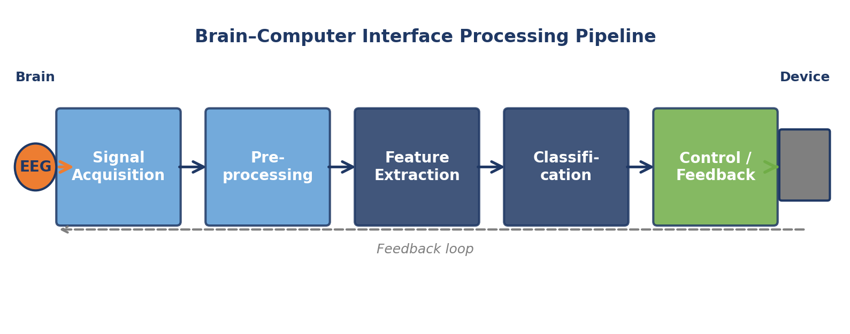
Figure 1.1 — The generic five-stage brain–computer interface processing pipeline. EEG signals are acquired from the scalp, preprocessed to remove artefacts, spatially filtered or otherwise transformed into discriminative features, classified into user intentions, and used to drive an external device. Feedback to the user (bottom dashed line) closes the loop and enables co-adaptive learning.
Despite this breadth of promise, translating BCI technology from laboratory prototypes into accessible, deployable systems has proven remarkably difficult. Three decades of research have produced impressive proofs of concept — BCI spellers reaching 50 characters per minute, robotic arms guided by intracortical implants, real-time control of drones and video games — yet the number of BCIs in routine clinical or everyday use remains extremely small. The reasons for this translational gap are multiple: regulatory hurdles, economic constraints, the difficulty of long-term stability in non-invasive recordings, and the inherent challenges of signal decoding. This thesis focuses on two of these challenges that are especially amenable to algorithmic and software-engineering solutions: the fragmentation of BCI development infrastructure, and the difficulty of cross-subject generalization without per-user calibration.

1.2 The Dual Bottleneck of Modern BCIs
Two specific bottlenecks dominate present-day BCI development and are the primary targets of this thesis.

1.2.1 The software bottleneck
Building a functional BCI pipeline — from signal acquisition to classification and feedback — typically requires combining heterogeneous tools written in different languages, managing complex dependencies, and implementing substantial amounts of plumbing code. Each new experiment tends to produce its own one-off software stack, which makes reproducibility difficult and raises the barrier to entry for newcomers. Existing mature platforms are either locked to a single language ecosystem (MATLAB-based toolboxes such as EEGLAB, BCILAB, FieldTrip), limited in real-time interactivity (script-driven Python libraries such as MNE-Python or BciPy), or difficult to extend without deep programming expertise (OpenViBE, BCI2000). The consequence is that a substantial fraction of BCI research time is spent on software plumbing rather than on scientific investigation.
This bottleneck is not merely an engineering inconvenience. It has measurable scientific effects: it delays iteration, it fragments the research community across incompatible toolchains, it makes cross-laboratory validation expensive, and it excludes contributors — clinicians, domain scientists, students — who lack the time or training to assemble heterogeneous software stacks. Lowering this barrier is a genuine research contribution, not mere tooling.

1.2.2 The calibration bottleneck
Most high-performing BCI classification methods require substantial amounts of labeled data from each new user before they can be used, a process that can take tens of minutes of training for every session and remains a major obstacle to practical deployment. Methods that avoid per-user calibration — known as cross-subject or zero-calibration methods — exist but typically sacrifice significant accuracy relative to subject-specific approaches.
The fundamental difficulty is inter-subject variability: EEG recordings from different individuals differ systematically in amplitude, spectral composition, spatial distribution of activity, and task-related modulation, due to anatomical, physiological, cognitive, and electrode-placement factors. A classifier trained on subjects S1 to S8 faces a non-trivial distribution shift when applied to a new subject S9. Recent advances in Riemannian geometry and domain adaptation have mitigated this shift, but the ceiling of cross-subject performance remains meaningfully below the within-subject ceiling, and calibration-free operation at acceptable accuracy is still considered an open problem in the field.

1.2.3 The coupling between the two bottlenecks
The two bottlenecks are not independent. Advances in cross-subject algorithms have practical value only if they can be integrated into deployable pipelines; conversely, a good pipeline platform is useful only if it can host state-of-the-art algorithms. This thesis tackles the two bottlenecks together — a methodological choice that is central to its contribution.

1.3 Primer on EEG and Motor Imagery
Electroencephalography (EEG) is a non-invasive technique that measures the small voltage fluctuations — typically on the order of microvolts — produced by the electrical activity of large populations of cortical neurons. Electrodes placed on the scalp, generally following the international 10-20 system or its denser variants, record these signals at millisecond temporal resolution. EEG is the dominant modality for real-time BCIs because of this high temporal resolution, its non-invasiveness, its relatively low cost, and its portability. Its principal limitation is spatial resolution: scalp EEG averages activity across many square centimetres of cortex, and source-localisation ambiguities make the fine-grained identification of neural generators difficult.
Motor imagery (MI) refers to the mental simulation of movement without actually executing it. When a person imagines moving their left hand, right hand, feet, or tongue, the corresponding areas of the sensorimotor cortex produce characteristic changes in oscillatory activity. Most notably, during motor imagery the power of the mu rhythm (8–12 Hz) and the beta rhythm (13–30 Hz) decreases in the contralateral sensorimotor area — a phenomenon known as event-related desynchronization — and increases after the imagined movement ends — known as event-related synchronization. These signatures are observable in scalp EEG and, in principle, can be decoded into class labels (left hand, right hand, feet, tongue) without any physical movement.
A typical MI-BCI pipeline comprises five stages. First, signal acquisition from an EEG amplifier converts analog scalp potentials into digital samples. Second, preprocessing applies bandpass filtering, artefact rejection, and epoching to extract clean time windows around each motor imagery trial. Third, spatial filtering and feature extraction reduce the high-dimensional multi-channel signal to a compact, discriminative representation. Fourth, a classifier maps features to class labels. Fifth, the classified output drives a user feedback interface — an on-screen cursor, a prosthetic device, an auditory or haptic signal. Each of these stages has been the object of extensive research, and the choice of methods at each stage has substantial consequences for overall system performance and usability.

1.4 Research Questions
The work of this thesis is organized around three core research questions.
RQ1: Can a single software platform simultaneously provide no-code accessibility for end users, low-code extensibility for domain experts, polyglot integration across programming languages, deterministic reactive execution, and quantitative reproducibility — without compromising real-time responsiveness?
RQ2: Can the combination of filter-bank spectral decomposition, Riemannian tangent space mapping, and Euclidean Alignment preprocessing produce a calibration-free cross-subject motor imagery classification method that outperforms established baselines under strict Leave-One-Subject-Out evaluation?
RQ3: Can platform and algorithms be co-designed such that state-of-the-art classification methods are exposed as reusable components within a reproducible visual authoring environment — delivering an integrated BCI research ecosystem greater than the sum of its parts?
The three research questions are answered, respectively, in Chapter 3 (platform), Chapter 4 (algorithms), and Chapter 5 (integration).

1.5 Two Gaps Addressed by This Thesis
The state-of-the-art review presented in Chapter 2 will establish that two specific gaps remain unresolved in the literature. These gaps are stated here for clarity.
Gap 1 — Software accessibility. No existing BCI platform simultaneously offers (a) a no-code visual editor accessible to non-programmers, (b) a low-code extension path for domain experts, (c) deterministic reactive execution that updates immediately on parameter changes, (d) a principled polyglot model that lets Python coexist with compiled languages without sacrificing interactivity, and (e) transparent reproducibility through versioned workflows and quantitative performance instrumentation.
Gap 2 — Calibration-free cross-subject classification. While filter-bank decomposition and Riemannian tangent space mapping have each been explored separately for motor imagery EEG classification, their combination under a strict leave-one-subject-out evaluation protocol with Euclidean Alignment preprocessing has not been systematically investigated. Existing filter-bank tangent space methods operate in within-subject settings and require labeled target-subject data, while cross-subject Riemannian methods do not exploit spectral diversity via filter banks.
This thesis fills both gaps with two tightly connected contributions, making their integration a contribution in itself.

1.6 Contributions
The contributions of this thesis can be grouped into three categories: software, algorithmic, and methodological.

1.6.1 Software contributions
- RBciAD — an open-source, reactive, polyglot framework for rapid BCI prototyping, integrating a no-code node-based editor with a low-code node generator, a deterministic reactive execution engine, and a polyglot plugin system spanning Python, C, C++, Rust, and Node.js. RBciAD is released under MIT license with a permanent Zenodo archive and quantitative benchmarks grounded in established human–computer interaction thresholds.
- A reactive execution engine built on RxPy observables, providing deterministic propagation of parameter changes through directed acyclic pipeline graphs with selective recomputation and throttled rendering.
- A polyglot plugin system based on a lightweight JSON input–output protocol executed via subprocess isolation, enabling Python, C, C++, Rust, Node.js, Bash, and R modules to coexist in the same pipeline.
- A low-code node generator that scaffolds Python and polyglot node skeletons and registers them instantly in the visual editor palette without restart.

1.6.2 Algorithmic contributions
- FB-ACMCSP — a filter-bank extension of adaptive multi-class CSP that fuses per-band population covariance estimates for improved cross-subject robustness.
- FB-RCSP-RA — a filter-bank regularized CSP method with per-band Riemannian alignment, combining Ledoit–Wolf shrinkage covariance estimation with geometric domain adaptation.
- TS-FBCSP — a filter-bank tangent space framework with Euclidean Alignment, achieving the highest leave-one-subject-out accuracy and information transfer rate among eight evaluated methods on BCI Competition IV Dataset 2a, with statistically significant improvements over classical and regularized baselines and validated on the 109-subject PhysioNet corpus.

1.6.3 Methodological contributions
- A systematic, unified evaluation under strictly identical experimental conditions of eight spatial filtering methods (CSP, ACMCSP, RCSP, FBCSP, FB-ACMCSP, FB-RCSP-RA, Riemannian MDM, TS-FBCSP) on BCI IV-2a, with full statistical analysis.
- A quantitative analysis of Euclidean Alignment that demonstrates consistent improvements of 7 to 13 percentage points across all evaluated methods, establishing EA as an indispensable preprocessing step for cross-subject BCIs.
- An integrated ecosystem in which all classification methods developed in this thesis are exposed as reusable RBciAD nodes, enabling fully reproducible end-to-end motor imagery pipelines to be assembled, versioned, and replayed without writing code.

1.7 Publications Associated with This Thesis
The scientific contributions of this thesis have been formalized in four manuscripts, all authored by the doctoral candidate with the thesis supervisor as co-author. At the time of thesis deposit, the four manuscripts have been submitted to peer-reviewed journals and are currently under review. The complete list with current statuses is provided in Appendix A. The thesis itself does not rely on these manuscripts as citable sources: all methods, algorithms, experimental protocols, and results are described directly in the body of the thesis (Chapters 3 through 5) and in the supporting appendices. The reader who wishes to assess the scientific contributions can do so entirely from the thesis, independently of the peer-review status of the associated journal submissions. In addition to the four journal manuscripts, a permanent software archive of the RBciAD platform (version 1.10.0) is available on Zenodo with a citable Digital Object Identifier; this archive is referenced in the bibliography [15] and constitutes a first-class, citable research artefact in its own right.

1.8 Thesis Organization
The remainder of this manuscript is organized into six chapters and six appendices. Chapter 2 reviews the relevant literature on BCI software platforms, spatial filtering methods, Riemannian geometry for EEG, cross-subject domain adaptation, and the no-code/low-code paradigm; it concludes by identifying the two gaps stated in Section 1.5. Chapter 3 presents RBciAD, describing its design principles, architecture, reactive execution engine, polyglot plugin system, low-code node generator, and quantitative benchmark validation. Chapter 4 develops the family of cross-subject motor imagery classification methods — FB-ACMCSP, FB-RCSP-RA, and TS-FBCSP — and reports the unified comparative evaluation, the systematic analysis of Euclidean Alignment, and the cross-dataset validation on PhysioNet. Chapter 5 shows how the platform and algorithms are integrated into end-to-end reproducible BCI workflows. Chapter 6 concludes and outlines perspectives for future research. The appendices contain the list of publications, mathematical supplements, algorithmic pseudocode, detailed experimental protocols, reproducibility artifacts, and ethical statements.

Chapter 2 — Background and Related Work
This chapter reviews the bodies of literature most directly relevant to the work of this thesis. It starts with the foundations of brain–computer interfaces in Section 2.1, turns to the landscape of BCI software platforms in Section 2.2, and then successively examines spatial filtering methods (Section 2.3), Riemannian geometry for EEG classification (Section 2.4), cross-subject domain adaptation (Section 2.5), deep learning approaches (Section 2.6), evaluation protocols (Section 2.7), and the no-code and low-code software paradigm (Section 2.8). Section 2.9 synthesizes the review by identifying the two specific unresolved gaps that motivate the contributions of the remaining chapters.

2.1 Foundations of Brain–Computer Interfaces

2.1.1 Historical perspective
The concept of direct brain-to-computer communication dates back at least to the 1970s. Early visionary work by Vidal and colleagues at UCLA demonstrated that scalp-recorded signals could be used to derive control signals, and subsequent decades saw the progressive refinement of the idea across multiple paradigms. The P300 speller introduced by Farwell and Donchin in 1988 remains a landmark: it showed that event-related potentials elicited by rare target stimuli could be decoded in single trials with sufficient reliability to spell words letter by letter. The motor imagery paradigm, formalized by Pfurtscheller and colleagues in the 1990s, established that voluntary modulation of sensorimotor rhythms could serve as an asynchronous control signal without external stimulation. The 2000s saw the emergence of steady-state visual evoked potentials (SSVEPs) as a fast, high-throughput paradigm, and the 2010s brought substantial consolidation of signal-processing techniques and the first public BCI competitions (BCI Competitions I through IV) that enabled direct comparison of algorithms on shared datasets.

2.1.2 BCI paradigms
Non-invasive BCIs rely on several distinct neurophysiological paradigms, each with its own trade-offs. The P300 speller exploits a positive event-related potential peaking around 300 milliseconds after a rare target stimulus. SSVEP-based BCIs leverage the oscillatory entrainment of visual cortex to a flickering stimulus, typically delivering the highest information transfer rates of any paradigm. Motor imagery BCIs, central to this thesis, use voluntary modulation of sensorimotor rhythms and do not require external stimulation, making them asynchronous and suited to continuous control. Slow cortical potentials, hybrid BCIs, and passive BCIs (for cognitive load monitoring) complete the taxonomy.

2.1.3 Signal acquisition
EEG signals are acquired via electrodes placed on the scalp, typically following the international 10-20 system. High-density montages extend this to 64, 128, or 256 channels. Amplifiers digitize the signals at sampling rates between 200 and 1000 Hz with resolutions of 16 to 24 bits. Hardware bandpass filtering (typically 0.5 to 100 Hz) and notch filtering (50 or 60 Hz depending on mains frequency) remove out-of-band noise and power-line interference. The EEG signal is inherently noisy: its amplitude of a few to a few tens of microvolts is readily contaminated by ocular artefacts (EOG), muscular artefacts (EMG), and environmental electromagnetic interference. Robust BCIs must therefore combine careful acquisition with sophisticated signal processing.

2.1.4 The cross-subject generalization challenge
A fundamental property of EEG is its substantial inter-subject variability. Two healthy adults performing identical motor imagery tasks can produce EEG recordings that differ markedly in amplitude, spectral composition, spatial distribution of task-related activity, and even in the presence or absence of decodable patterns. This variability arises from several sources: anatomical differences (skull thickness, cortical folding), physiological differences (baseline arousal, attention), cognitive strategy differences (vividness of imagery, attentional focus), and electrode-placement differences across recording sessions. The net effect is that a classifier trained on a pool of subjects faces a meaningful distribution shift when applied to a new subject — the cross-subject generalization problem that motivates Gap 2 of this thesis.

2.2 BCI Software Platforms

2.2.1 MATLAB-centric ecosystems
The first generation of BCI and EEG software platforms were largely built around MATLAB. EEGLAB, introduced by Delorme and Makeig in 2004, rapidly became the dominant MATLAB toolbox for EEG and became the foundation on which many other tools were built. BCILAB, developed by Kothe and Makeig in 2013, provided a BCI-specific extension of EEGLAB with support for online operation and a range of classical classification algorithms. FieldTrip, from the Donders Institute, focuses on source-localisation and advanced time-frequency analysis. ERPLAB specializes in event-related potential analysis. Brainstorm targets MEG and EEG source-space analysis with a polished graphical interface. These platforms represent decades of accumulated expertise and remain the default choice in many established laboratories.
The limitations of MATLAB-centric platforms are well known. MATLAB is a proprietary, commercial language whose licensing costs are substantial and whose accessibility outside well-funded institutions is limited. The scripting-based workflow imposes a steep learning curve on newcomers and makes visual, interactive exploration of pipelines cumbersome. Integration with the rest of the scientific Python ecosystem — the de facto standard for machine learning and scientific computing — requires explicit bridging code. For reproducible research, the proprietary and versioned nature of MATLAB scripts introduces long-term archival risks that open formats avoid.

2.2.2 Python-based toolchains
The shift to Python in the past decade has been dramatic. MNE-Python, introduced by Gramfort and colleagues in 2013, has become the de facto standard for EEG and MEG input–output, preprocessing, time-frequency analysis, and source localisation in open-source neuroimaging. MNE-Python now provides mature support for standard file formats (EDF, BDF, FIF, BrainVision, EEGLAB .set files), a comprehensive preprocessing toolkit, and extensive documentation. Complementary packages have filled specific gaps: Pyff and Wyrm provide feedback and stimulus-presentation infrastructure; BciPy offers a Python-based BCI framework with a focus on ERP paradigms; BioSPPy covers general physiological signal processing; MetaBCI (2024) provides a modular open-source platform for EEG-based BCIs with a focus on neurofeedback applications. Outside of the neuroscience core, libraries such as scikit-learn, pyRiemann, and PyTorch provide the machine-learning infrastructure on which modern BCI pipelines rely.
Despite their strengths, Python-based BCI toolchains share a structural limitation: they are script-driven, oriented toward offline analysis, and typically lack an integrated graphical environment for real-time interactive pipeline composition. A BCI researcher wanting to assemble a pipeline from MNE-Python primitives must still write glue code, manage state manually, handle asynchronous input streams, and implement visualization separately. Iteration cycles are correspondingly slow, and the gap between offline analysis and online deployment is wide.

2.2.3 Visual programming environments
Several platforms have explored visual, node-based composition of BCI workflows as an alternative to scripting. OpenViBE, developed by Renard and colleagues at INRIA, offers a block-based graphical editor with built-in support for common BCI paradigms and native C++ node development. BCI2000, developed at the Wadsworth Center since the early 2000s, provides a modular C++ framework with configuration-based pipelines. NeuroPype (Intheon) offers a commercial node-based environment. Device-specific graphical interfaces, such as the OpenBCI GUI and BrainBay, provide accessible visualizations but are typically limited to the hardware they were designed for and offer little extensibility. Nengo, aimed at spiking neural network simulation rather than EEG analysis, demonstrates how a well-designed visual environment can make complex computational models accessible to non-specialists.
These visual environments demonstrate the value of node-based authoring for BCI work. However, they vary considerably in their support for no-code versus low-code paradigms, in the breadth of preprocessing and classification primitives they offer, and in their ability to integrate code written in multiple languages. OpenViBE, for example, permits custom node development only in C++, creating a substantial barrier for researchers fluent primarily in Python. BCI2000 similarly assumes C++ competence for non-trivial extensions. NeuroPype is commercial. None of these platforms combines a reactive, deterministic execution model with open-source availability and polyglot extensibility in the manner that RBciAD will propose in Chapter 3.
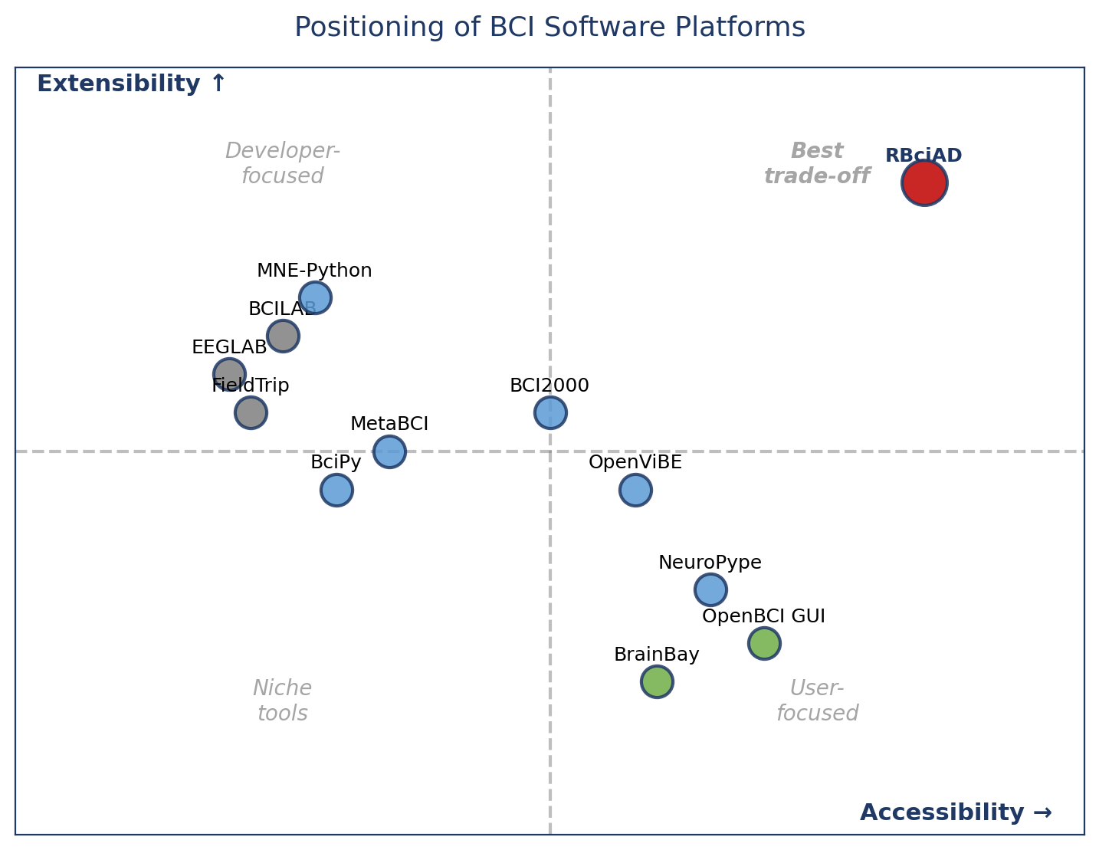
Figure 2.1 — Positioning of representative BCI software platforms on two dimensions: horizontal axis = accessibility for non-programmers, vertical axis = extensibility for developers. RBciAD (red, upper-right) is the only platform that simultaneously maximizes both axes.

2.2.4 Complementary toolkits and surveys
The broader BCI software landscape also includes specialized toolkits that complement general platforms. Lab Streaming Layer (LSL) has become the de facto standard for real-time multi-stream synchronization across devices. MEDUSA, MVPAlab, and WU-NEAT target specific analysis sub-domains in EEG microstates, multivariate pattern analysis, and neonatal EEG respectively. ITACA, introduced in 2023, offers an open-source framework for neurofeedback built on Python. General-purpose reactive dataflow editors such as Node-RED, while outside the neuroscience domain, illustrate how visual, reactive authoring can scale to complex real-world applications. Recent surveys (Khan and Hasan 2021; Chevallier et al. 2024) emphasize the need for modular, extensible, and reproducible neuroimaging tools.

2.3 Spatial Filtering for MI-EEG

2.3.1 The Common Spatial Pattern
The Common Spatial Pattern algorithm, introduced by Ramoser, Müller-Gerking, and Pfurtscheller in 2000, has been the workhorse of motor-imagery EEG classification for more than two decades. CSP operates by computing spatial filters that simultaneously maximize the variance of EEG projections under one class and minimize it under another. Formally, given class-conditional covariance matrices Σ1 and Σ2, CSP solves the generalized eigenvalue problem:
Σ1 w = λ (Σ1 + Σ2) w
The eigenvectors associated with the largest and smallest eigenvalues form the spatial filters that maximize class discriminability in the band-power domain. In practice, a typical CSP implementation retains three filters at each extreme (six total per class pair), projects each trial through these filters, computes the log-variance of each projection as a feature, and classifies with a linear discriminant analysis or support vector machine.
Blankertz and colleagues subsequently formalized the theoretical underpinnings of CSP for robust single-trial EEG analysis and introduced several regularization strategies. The strengths of classical CSP are considerable: its computational cost is low, its spatial filters are physically interpretable as weighted combinations of electrodes, and its performance on within-subject data is competitive even by modern standards.

2.3.2 Limitations of classical CSP
Despite its strengths, classical CSP has two well-documented limitations. First, it is natively a binary method: applying it to multi-class problems such as four-class MI requires one-versus-rest or pairwise extension strategies, each with its own trade-offs. Second, its reliance on sample covariance matrices makes it sensitive to EEG non-stationarity and outliers, which can severely degrade performance in cross-subject and cross-session settings. Samek, Kawanabe, and Müller proposed a divergence-based framework that unifies many CSP variants and clarifies the theoretical sources of this instability.

2.3.3 Regularized CSP
Lotte and Guan addressed the instability of classical CSP through Regularized CSP (RCSP), introducing Ledoit–Wolf shrinkage estimation of the covariance matrices. The Ledoit–Wolf shrinkage scales the empirical covariance toward a structured target (typically a scaled identity) with an automatically determined shrinkage coefficient that minimizes the expected Frobenius-norm error. The resulting shrunken covariance is always strictly positive definite, which stabilizes the generalized eigenvalue decomposition and reduces overfitting in small-sample regimes. RCSP consistently outperforms classical CSP in cross-subject and session-to-session evaluation, particularly when training data is limited.

2.3.4 Adaptive Multi-Class CSP
For multi-class problems, adaptive CSP variants refine the one-versus-rest strategy by incorporating information from other classes into each filter computation. Adaptive Multi-Class CSP (ACMCSP), proposed by Song and Yoon in 2015, fuses per-class covariance estimates with a pooled reference and adapts the regularization to the available data. While providing moderate accuracy gains, ACMCSP remains limited by the Euclidean nature of its log-variance features, which discard a substantial portion of the geometric structure of the underlying covariance matrices.

2.3.5 Filter-bank approaches
Motor imagery oscillations span a broad spectral range (mu 8 to 12 Hz, beta 13 to 30 Hz) with subject-specific contributions from different sub-bands. The Filter Bank CSP (FBCSP) algorithm, introduced by Ang and colleagues in 2008, addresses this spectral heterogeneity by decomposing the EEG into multiple overlapping frequency bands and applying CSP independently in each band. Features are concatenated across bands, and a feature-selection stage (mutual-information-based in the original FBCSP) retains the most discriminative subset. FBCSP achieves strong within-subject performance and has become a standard baseline for MI-EEG classification.
Extensions have explored simultaneous FIR filter bank and spatial pattern co-design (Higashi and Tanaka 2013), subject-specific filter selection, and various discriminative criteria for band retention. While these variants further improve within-subject accuracy, their cross-subject generalizability remains limited by the Euclidean feature geometry they inherit from CSP.

2.4 Riemannian Geometry for EEG Classification

2.4.1 Motivation
The Riemannian geometry framework treats EEG covariance matrices as points on the manifold of symmetric positive definite (SPD) matrices. This manifold is not Euclidean: the natural distance between two SPD matrices is not the Frobenius distance of their entries but rather a geodesic distance that respects the intrinsic geometry induced by the affine-invariant Riemannian metric. Pennec, Fillard, and Ayache developed the mathematical foundations in the broader context of tensor computing, and Barachant and colleagues adapted these ideas to EEG and BCI applications.
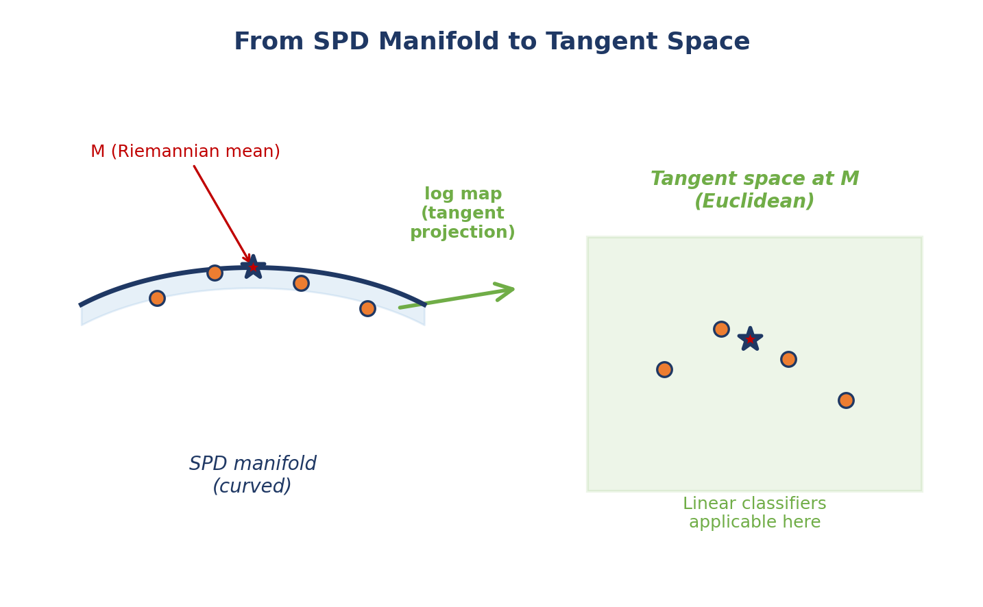
Figure 2.2 — Conceptual illustration of the SPD manifold and the tangent space mapping. Left: covariance matrices from different trials are points on the curved SPD manifold; their Riemannian mean M (red star) is the intrinsic centre. Right: the logarithm map at M projects manifold points onto the flat tangent space, where standard linear classifiers become applicable while preserving local geodesic relationships.

2.4.2 Minimum Distance to Mean
The simplest Riemannian classifier, the Minimum Distance to Mean (MDM), was introduced by Barachant and colleagues in 2012. For each class k, MDM computes the Riemannian (Fréchet) mean M_k of the training covariance matrices of that class. At test time, an unseen covariance Σ is classified by selecting the class k whose mean is closest in Riemannian distance:
ŷ = argmin_k d_R( Σ, M_k )
where d_R is the affine-invariant Riemannian distance. MDM is conceptually elegant, parameter-free beyond the choice of metric, and robust to many of the pathologies that affect Euclidean methods. Its performance, however, is typically surpassed by tangent-space linear classifiers.

2.4.3 Tangent space mapping
Tangent space mapping, introduced by Barachant et al. 2013, provides a principled linearization of the SPD manifold. At a reference point M (typically the Riemannian mean of the training data), the logarithm map projects each covariance onto the tangent space at M:
T_M(Σ) = M^(1/2) log( M^(-1/2) Σ M^(-1/2) ) M^(1/2)
The image of the log map is a symmetric matrix that lies in a flat Euclidean vector space. By vectorizing its upper-triangular entries (with off-diagonal elements scaled by sqrt(2) to preserve the Frobenius inner product), one obtains a Euclidean feature vector φ(Σ) ∈ R^(C(C+1)/2). Standard linear classifiers — SVM, logistic regression, LDA — can then be applied on φ(Σ) with strong theoretical justification: Euclidean distances in the tangent space approximate Riemannian distances on the manifold, first-order for nearby points. Tangent-space classifiers consistently outperform MDM and Euclidean log-variance methods in within-subject BCI benchmarks.

2.4.4 Filter-bank tangent space methods
Combining filter-bank decomposition with tangent-space mapping is a natural extension. Wu and colleagues (2021) proposed DMFBTSM, a discriminative multi-scale filter-bank tangent space method that achieves 77.33 percent accuracy on BCI IV-2a. However, DMFBTSM evaluation was exclusively within-subject (session-to-session): filter-bank adaptation requires labeled target-subject data, which is precisely what a zero-calibration cross-subject BCI cannot assume. No prior work, to the author's knowledge, has evaluated a filter-bank tangent-space method under strict Leave-One-Subject-Out cross-subject protocol with Euclidean Alignment preprocessing. This is Gap 2 of this thesis.

2.4.5 Review of Riemannian approaches in BCIs
Yger, Berar, and Lotte (2017) and Congedo, Barachant, and Bhatia (2017) provide comprehensive reviews of Riemannian approaches in BCIs, covering the geometric foundations, the range of available methods, and their empirical performance across BCI paradigms. These reviews emphasize three consistent findings: Riemannian methods are more robust to small-sample-size problems than Euclidean methods; they generalize better across sessions and subjects; and their computational cost, while higher than classical methods, remains practical on standard hardware.

2.5 Cross-Subject Domain Adaptation

2.5.1 The transfer learning problem in BCIs
The cross-subject BCI problem is a specific instance of transfer learning. The source domain comprises EEG recordings from a pool of subjects with known labels; the target domain is a new subject for whom labels may not be available. The question is: given a classifier trained on the source, how best to adapt it to the target? Jayaram and colleagues (2016) surveyed transfer learning approaches for BCIs and identified four main families: instance reweighting, feature adaptation, classifier adaptation, and domain-invariant representation learning.

2.5.2 Riemannian transfer learning
Riemannian geometry provides an elegant framework for transfer learning in BCIs. Zanini and colleagues (2018) introduced a Riemannian transfer learning framework in which each subject's covariance matrices are recentered and rescaled toward a common reference. Rodrigues, Jutten, and Congedo (2019) refined this with Riemannian Procrustes analysis, which jointly aligns multiple subjects on the manifold through a combination of recentering, rescaling, and rotation. These methods typically assume the availability of at least some labeled target data, limiting their application in strict zero-calibration scenarios.

2.5.3 Euclidean Alignment
Euclidean Alignment (EA), proposed by He and Wu in 2019 (published 2020), takes a different approach. EA recenters each subject's covariance distribution to the identity by whitening with the inverse square root of the subject's mean covariance:
X̃_i = W_s X_i where W_s = Ā_s^(-1/2)
Crucially, EA requires no labels from the target subject: only the unlabeled EEG trials are needed to estimate Ā_s. This unsupervised property makes EA ideally suited to zero-calibration cross-subject settings. Reported gains are substantial: 5 to 10 percent improvements are consistently observed across BCI paradigms. The computational cost of EA is negligible (one matrix square root per subject), and it can be composed with any downstream classifier. Chapter 4 of this thesis confirms and extends these findings, demonstrating EA gains of 7 to 13 percentage points across eight evaluated methods.

2.5.4 Hybrid and deep transfer learning
More recent work has explored hybrid Riemannian-Euclidean transfer (Li et al. 2021) and deep-learning-based domain adaptation (various). These methods achieve strong cross-subject performance but typically require GPU hardware and substantial training sets, limiting their applicability in portable, CPU-only BCI systems. This thesis focuses on CPU-only, calibration-free methods that can be deployed on commodity laptop hardware; deep-learning approaches are positioned as complementary rather than competing contributions.

2.6 Deep Learning Approaches
Deep convolutional neural networks have been applied extensively to EEG classification. EEGNet, introduced by Lawhern and colleagues in 2018, is a compact CNN architecture specifically designed for EEG: it uses temporal convolutions, depthwise spatial convolutions, and separable convolutions to learn spatial-spectral filters directly from raw EEG. ShallowConvNet and DeepConvNet, from Schirrmeister and colleagues (2017), represent alternative architectures with different depth-versus-compactness trade-offs. These networks achieve strong within-subject accuracy on BCI benchmarks, often surpassing classical methods by a few percentage points.
In cross-subject settings, deep networks show more mixed results. Their high capacity can be an advantage when sufficient training data is pooled across subjects, but they also risk overfitting to dominant inter-subject patterns rather than learning subject-invariant features. Regularization strategies (dropout, batch normalization, data augmentation) partially mitigate this. The principal practical limitations of deep-learning BCIs are computational: training requires GPU hardware and substantial time, and even inference can be slow on embedded platforms. This thesis therefore positions deep-learning approaches as complementary: they occupy a different operating point in the accuracy/compute/data trade-off, and integrating them as RBciAD nodes is part of the future work outlined in Chapter 6.

2.7 Evaluation Protocols
The choice of evaluation protocol is central to any claim of cross-subject generalization. Three protocols dominate the BCI literature.

2.7.1 Within-subject cross-validation
Within-subject k-fold cross-validation partitions a single subject's trials into k roughly equal folds, trains on k-1 folds, and tests on the remaining one, rotating k times. This protocol yields the highest reported accuracies but reveals nothing about cross-subject transfer: the test fold is drawn from exactly the same distribution as the training folds. Within-subject CV is appropriate for assessing the intrinsic decodability of a subject's EEG but is inadequate as a proxy for zero-calibration deployment.

2.7.2 Session-to-session evaluation
Session-to-session evaluation trains on data from one recording session and tests on another session from the same subject. It probes temporal stability and addresses slow drifts due to electrode impedance changes, cognitive state fluctuations, and neuroplasticity. Session-to-session accuracy is typically 5 to 15 percentage points below within-subject CV accuracy, reflecting the real-world difficulty of session-invariant classification. This protocol is standard in the BCI IV-2a literature, where the dataset provides two separate sessions per subject.

2.7.3 Leave-One-Subject-Out
Leave-One-Subject-Out (LOSO) cross-validation is the strictest protocol for cross-subject evaluation. In each of N folds (where N is the total number of subjects), the classifier is trained on the pooled data of N-1 subjects and tested on the held-out subject. No data from the held-out subject — labeled or unlabeled — enters the training set in a given fold. LOSO directly simulates zero-calibration deployment: the classifier encounters a new subject whose EEG distribution it has never seen. LOSO accuracy is typically 15 to 25 percentage points below within-subject CV accuracy, reflecting the substantial difficulty of cross-subject generalization. This thesis uses strict LOSO throughout Chapter 4.

2.7.4 Reporting practices
Across all protocols, rigorous reporting requires more than a single mean accuracy figure. Per-subject or per-fold accuracies reveal variability that means can obscure. Standard deviation (or interquartile range for non-normal distributions) captures consistency. Information Transfer Rate contextualizes accuracy in terms of communication bandwidth. Statistical significance testing — typically Wilcoxon signed-rank tests for paired per-subject comparisons — provides formal support for claimed improvements, and effect sizes (Cohen's d) quantify practical significance. Chapter 4 of this thesis reports all of these metrics.

2.8 The No-Code and Low-Code Paradigm
Outside the BCI domain, the broader software engineering community has increasingly recognized the value of no-code and low-code environments for lowering the barrier to entry and accelerating prototyping. Low-code platforms reduce the amount of manual coding required to assemble working applications; no-code environments aim to remove programming entirely for end users. Di Ruscio and colleagues (2022) analyze the relationship between low-code development and model-driven engineering, arguing that the two paradigms share deep structural similarities. Hirzel (2023) surveys low-code programming models in Communications of the ACM, identifying four recurring patterns: visual flow-based programming, constraint-based programming, programming by example, and natural-language programming.
Da Cruz and colleagues (2021) describe OLP, a RESTful open low-code platform, and examine the trade-offs between accessibility and extensibility. Visual dataflow editors such as Node-RED illustrate how reactive authoring environments can scale to complex real-world applications outside scientific computing. In the BCI domain, visual authoring is offered by OpenViBE, BCI2000, and NeuroPype, but — as Section 2.2 noted — none of these combines no-code accessibility, low-code extensibility, and polyglot integration in the manner that RBciAD proposes.
The design of RBciAD draws explicitly on the no-code/low-code literature. In particular, the distinction between the no-code editor (for pipeline assembly) and the low-code node generator (for custom node development) mirrors the two-tier architecture advocated by Di Ruscio and colleagues. The polyglot plugin system addresses a limitation common to most existing low-code platforms: language lock-in. And the reactive execution model draws on flow-based programming principles formalized by Paul Morrison in the 1970s and re-popularized by modern reactive libraries such as ReactiveX.

2.9 Synthesis: Two Unresolved Gaps
The review presented in this chapter establishes two specific gaps that remain unresolved in the literature and that motivate the contributions of this thesis.
Gap 1 — No BCI platform combines no-code/low-code authoring, reactive execution, polyglot extensibility, clinical-style live visualization, and quantitative reproducibility instrumentation in a single open-source package. EEGLAB and BCILAB are script-driven and MATLAB-bound. OpenViBE and BCI2000 provide visual authoring but restrict extensibility to C++. MetaBCI and BciPy are Python-only. NeuroPype is commercial. No platform surveyed in Section 2.2 meets all five criteria simultaneously. RBciAD, presented in Chapter 3, fills this gap.
Gap 2 — No published method combines filter-bank spectral decomposition, per-band Riemannian tangent space mapping, and Euclidean Alignment under a strict Leave-One-Subject-Out cross-subject protocol. FBCSP combines filter banks with Euclidean log-variance features. DMFBTSM combines subject-specific filter banks with tangent space mapping but evaluates only within-subject (session-to-session) and requires labeled target data. Zanini, Rodrigues, and colleagues developed Riemannian transfer learning methods but did not explore filter-bank variants. He and Wu introduced EA but evaluated it with classical classifiers rather than filter-bank tangent space methods. The family of methods developed in Chapter 4, culminating in TS-FBCSP, fills this gap.
Crucially, the two gaps are addressed in tandem. The algorithms of Chapter 4 are implemented as reusable nodes within the platform of Chapter 3, and the platform's reproducibility instrumentation supports rigorous benchmarking of the algorithms. This coupling is not incidental — it is the central methodological choice of the thesis.

Table 2.1 — Comparative overview of representative EEG imaging and BCI prototyping systems across five design dimensions. RBciAD is the only system that maximizes all five.
Platform | GUI | No-code | Low-code | Polyglot | Real-time | Reprod. | EEG focus | Year
EEGLAB | No | No | No | No | Partial | Partial | Yes | 2004
BCILAB | No | No | MATLAB | No | Partial | Partial | Yes | 2013
FieldTrip | No | No | MATLAB | No | Partial | Partial | Yes | 2011
OpenViBE | Block-based | Yes | C++ only | No | Yes | Partial | Yes | 2010
BCI2000 | Config | No | Partial C++ | No | Yes | Partial | Yes | 2004
BciPy | Basic | No | Python API | No | Partial | Partial | ERP | 2021
MetaBCI | Basic | No | Python | No | Partial | Partial | Yes | 2024
ITACA | GUI | Partial | Python | No | Yes | Partial | Neurofeedback | 2023
RBciAD (this thesis) | Pro editor | Yes | Py/C/C++/Rust/JS | Yes (5+ langs) | Yes (reactive) | Full | Yes | 2026

Chapter 3 — RBciAD: A Reactive Polyglot Platform for BCI Prototyping
This chapter presents RBciAD, the central software contribution of this thesis. RBciAD is an open-source, reactive, polyglot framework for rapid brain–computer interface prototyping that addresses Gap 1 identified in Chapter 2. It combines a no-code node-based editor with a low-code node generator, a deterministic reactive execution engine built on RxPy, and a polyglot plugin system that allows Python, C, C++, Rust, and Node.js modules to coexist in the same pipeline through a lightweight JSON input–output protocol. The chapter is structured as follows. Section 3.1 articulates the five design principles that guided the platform. Section 3.2 presents the overall architecture. Sections 3.3 to 3.9 describe each major subsystem in turn. Section 3.10 presents the benchmark methodology, and Section 3.11 reports the measured results. Section 3.12 illustrates the platform through four case studies. Section 3.13 compares RBciAD against existing platforms, and Section 3.14 summarizes the chapter.

3.1 Design Principles
RBciAD was designed around five principles that jointly constrain every major architectural decision in the platform. The principles emerged from a careful reading of the limitations of existing BCI platforms reviewed in Chapter 2 and from direct experience with BCI prototyping.

3.1.1 Accessibility
Principle 1: novice users must be able to assemble a working BCI pipeline without writing code. A substantial fraction of the BCI research community comprises clinicians, experimental neuroscientists, and students whose training does not centre on software engineering. Platforms that require proficiency in Python or C++ exclude these contributors de facto. RBciAD therefore provides a visual node-based editor as its primary interface, with all common BCI operations exposed as pre-built nodes with graphical parameter widgets.

3.1.2 Extensibility
Principle 2: domain experts must be able to add new functionality using whichever programming language is most appropriate for the task. Accessibility without extensibility would produce a platform useful only for canned workflows — an inadequate research tool. RBciAD therefore provides a low-code node generator that scaffolds custom nodes in Python or in any external language supporting JSON input–output.

3.1.3 Responsiveness
Principle 3: any change to a pipeline parameter must produce an immediate, visible effect. This eliminates the cognitive overhead of a manual "Run" step and supports exploratory, iterative experimentation. Responsiveness is implemented through a reactive execution engine designed to meet the 100 millisecond interaction threshold established by HCI research as the boundary between instantaneous and just-noticeable feedback latency.

3.1.4 Reproducibility
Principle 4: every workflow must be serializable, versionable, and replayable with bit-exact instrumentation. Reproducibility is a first-class concern. RBciAD represents workflows as versioned JSON graphs that capture every node, parameter, and connection. A benchmark harness instruments the GUI and renderer with a monotonic nanosecond clock, producing CSV logs that can be aggregated into quantitative performance reports.

3.1.5 Resource modesty
Principle 5: the full platform must run comfortably on commodity laptop hardware without requiring GPUs. This reflects the practical realities of BCI deployment in clinics, educational settings, and in the field where specialized hardware is unavailable. RBciAD benchmark results confirm that all performance targets are met on a standard Intel Core i5 laptop with 8 GB of RAM.

3.2 System Architecture
The architecture of RBciAD comprises three distinct layers, each with a clear responsibility.
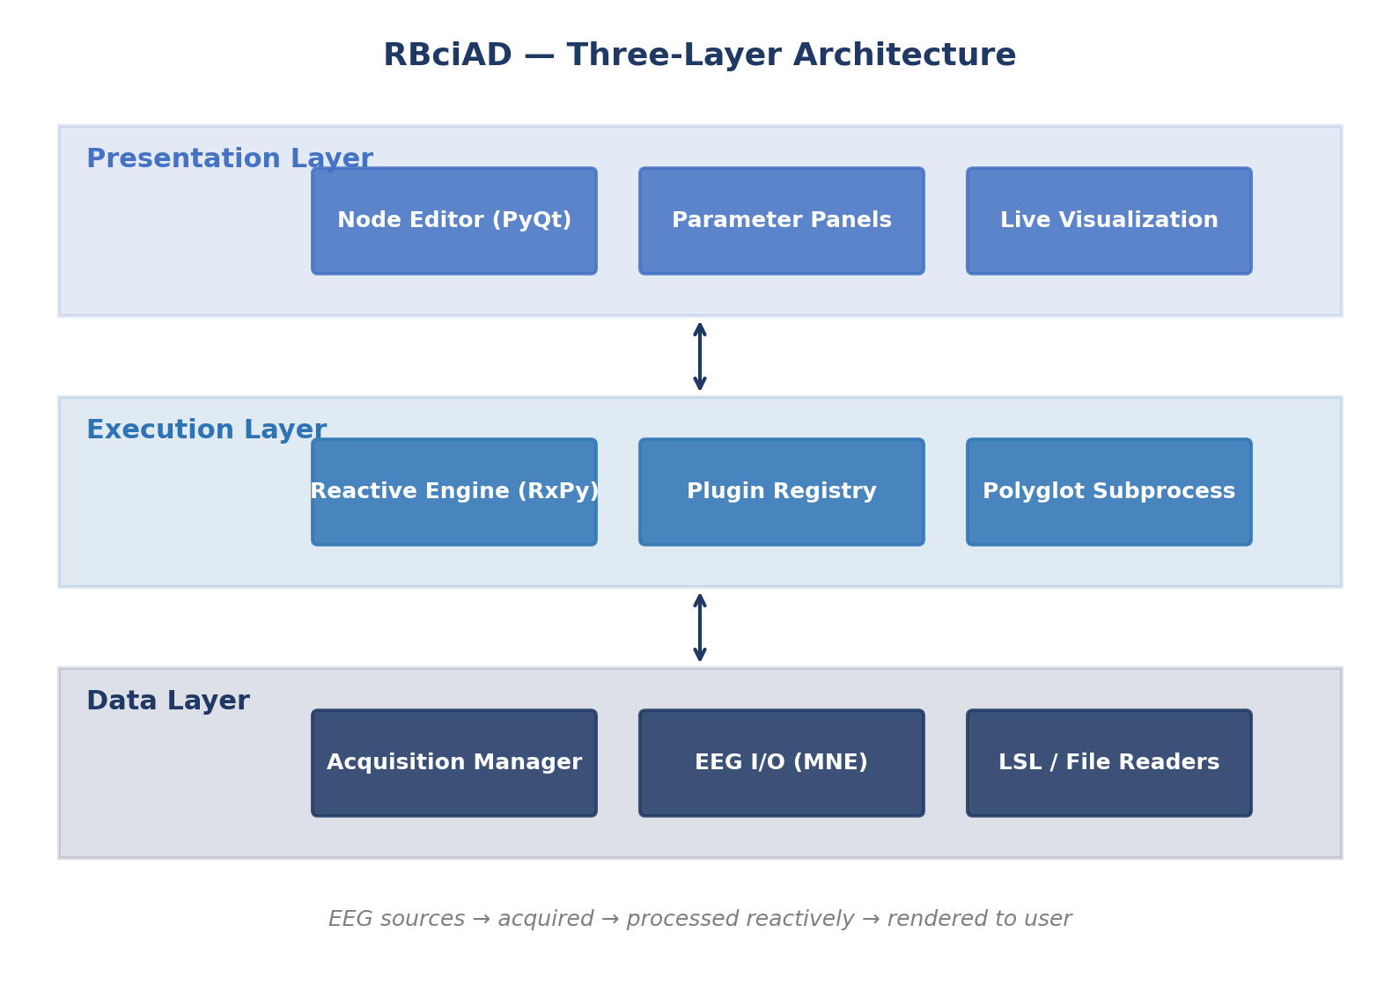
Figure 3.1 — Three-layer architecture of RBciAD. The presentation layer provides the PyQt-based graphical interface, parameter widgets, and live visualization. The execution layer implements the reactive engine, plugin registry, and polyglot subprocess management. The data layer abstracts EEG acquisition and file input–output through the Acquisition Manager.

3.2.1 Presentation layer
The presentation layer is implemented in PyQt and provides three principal components: a node-based editor where pipelines are composed visually, a parameter panel where node parameters are adjusted through widgets (sliders, dropdowns, checkboxes), and a live visualization area where EEG traces and other outputs are rendered. The presentation layer is deliberately thin: it handles user input and display, but computation is entirely delegated to the execution layer.

3.2.2 Execution layer
The execution layer implements three subsystems. The reactive engine, built on RxPy observables, propagates changes through the pipeline graph deterministically. The plugin registry discovers installed nodes at startup and exposes them to the editor palette. The polyglot subprocess manager schedules external-language nodes, handles their JSON input–output protocol, and enforces timeouts and fault isolation.

3.2.3 Data layer
The data layer abstracts the sources of EEG data through the Acquisition Manager. EEG input–output functions are provided by MNE-Python, which handles the principal EEG file formats including EDF, BDF, GDF, FIF, BrainVision, and EEGLAB .set files. The LSL reader handles live streams. A ring buffer provides configurable windowing with overlap.

3.2.4 Technology stack
The principal technology choices underlying RBciAD are: Python 3.11 as the host language, PyQt 5 for the graphical toolkit with QGraphicsView powering the node editor canvas, MNE-Python 1.6 for EEG input–output and preprocessing, pyRiemann 0.5 for Riemannian computations on the SPD manifold, scikit-learn 1.4 for machine-learning primitives, RxPy for reactive observables, and Matplotlib for visualization. The polyglot subprocess protocol is implemented with the standard library's subprocess and json modules.

3.3 Acquisition Manager and Unified Chunk Format
The Acquisition Manager is a central architectural element of RBciAD. It abstracts the heterogeneity of EEG data sources — files, live streams, synthetic generators — behind a uniform interface and emits a standardized chunk format to downstream consumers.
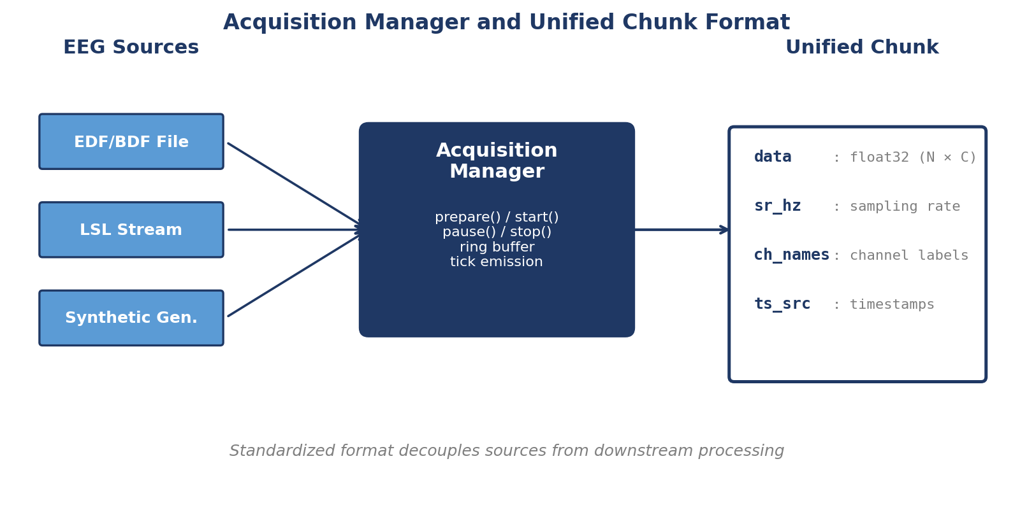
Figure 3.2 — Acquisition Manager and unified chunk format. EEG sources are normalized by the Acquisition Manager into a standardized chunk format carrying data, sampling rate, channel names, and timestamps.

3.3.1 Lifecycle API
The Acquisition Manager exposes a simple lifecycle API: prepare(source) configures the manager with a specific source descriptor; start() begins data flow; pause() and resume() temporarily halt and restart data delivery; stop() terminates delivery; teardown() performs final cleanup. This lifecycle is deliberately simple so that any new source type can be added by implementing these six methods.

3.3.2 Unified chunk format
All sources emit data in a standardized chunk format. A chunk is a Python dictionary with four fields: data is a float32 NumPy array of shape (n_samples, n_channels); sr_hz is the sampling rate in Hertz; ch_names is a list of channel labels; ts_src is an array of source-clock timestamps. This standardization decouples downstream processing from source-specific peculiarities.

3.3.3 Windowing and ring buffer
Continuous streams of chunks are aggregated into fixed-size windows through a per-channel ring buffer. The user specifies a window duration win_s and an overlap fraction; the hop between consecutive windows is win_s × (1 − overlap). At 80 percent overlap, consecutive features are separated by only 20 percent of the window duration, giving much finer temporal resolution than non-overlapping windows.

3.3.4 Tick emission and pacing
In addition to data chunks, the Acquisition Manager periodically emits lightweight signals called ticks that pace downstream processing. Ticks allow time-dependent behaviour — timeouts, periodic logging, wall-clock-based scheduling — to be expressed deterministically within the reactive engine.

3.3.5 Diagnostics and observability
The manager exposes diagnostic counters: total samples received, total samples emitted, dropped chunks, current ring-buffer fill level, and LSL clock offset when applicable. These diagnostics are accessible via the reactive engine and can be visualized in the GUI, which is essential for debugging live-streaming issues.

3.4 Node-Based Visual Editor
The node-based editor is the principal user-facing component of RBciAD. It provides a canvas where nodes are arranged spatially and connected through typed ports to form a directed acyclic pipeline graph.
[ Figure 3.3 — figure to insert ]
Figure 3.3 — Screenshot of the RBciAD node-based editor showing an example pipeline EEGUniversalReader → EEGFilter → EEGLiveDisplay. The left panel lists available nodes; the right panel shows selected node parameters; the bottom panel shows the live EEG display.

3.4.1 Node abstraction
In RBciAD, a node is a self-contained unit of computation that declares its inputs, outputs, parameters, and execution logic. Each port is typed with a pin family — for example EEG.Raw for continuous EEG, EEG.Epochs for segmented epochs, Features.Vector for feature matrices, Classifier.Model for trained models. Pin families are checked both statically at connection time and dynamically at runtime, preventing many errors that would otherwise manifest as obscure runtime crashes.

3.4.2 Canvas and rendering
The canvas is implemented with QGraphicsView, offering smooth pan, zoom, and high-DPI rendering. Nodes are rendered as rounded rectangles with the node name in the header, input ports on the left edge, and output ports on the right edge. Edges are drawn as Bézier curves that update dynamically as nodes are moved, preserving visual readability even in large graphs.

3.4.3 Interaction model
The interaction model is deliberately simple. Adding a node is done by dragging from the palette. Connecting nodes is done by dragging from an output port to an input port; the editor validates the connection against pin families and rejects type-incompatible pairings. Editing a parameter is done by clicking the node and adjusting the widget in the parameter panel. There is no "Run" button: every action triggers immediate reactive recomputation.

3.4.4 Layout aids
For large pipelines, RBciAD provides basic layout aids: snap-to-grid, automatic alignment of selected nodes, and zoom-to-fit. Future work includes automatic graph layout algorithms.

3.5 Reactive Execution Engine
The reactive execution engine is the heart of RBciAD's responsiveness. It transforms static pipeline graphs into dynamic dataflows where every change propagates deterministically and immediately.
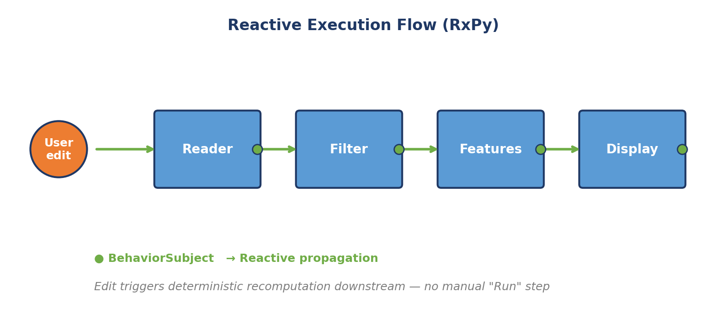
Figure 3.4 — Reactive execution flow. A user edit enters the pipeline as an observable event; each node exposes its outputs as BehaviorSubjects (green dots); changes propagate downstream through the pipeline via subscriptions.

3.5.1 Observable abstraction
The engine is built on RxPy, the Python implementation of the ReactiveX library. In RxPy, an Observable is a stream of values over time that consumers can subscribe to. A BehaviorSubject is a Subject that retains its most recent value and emits it to every new subscriber. RBciAD models each node input and each node output as a BehaviorSubject.

3.5.2 Execution semantics
When an input BehaviorSubject receives a new value, the node's execute() method is invoked with the current values of all inputs. The method returns a dictionary of output values, which are emitted on the output BehaviorSubjects. Downstream nodes subscribed to those outputs are in turn triggered. This cascading is purely reactive: there is no centralized scheduler beyond the Qt main loop.

3.5.3 Determinism
Determinism is guaranteed by three properties. The subscription graph is a directed acyclic graph — cycles are rejected at connection time. BehaviorSubjects retain their most recent value, so a node with multiple inputs always sees a consistent snapshot when it executes. Within a single event-loop cycle, propagation follows the topological order induced by the DAG. Given the same initial state and the same sequence of user inputs, two runs of RBciAD produce identical output.

3.5.4 Selective recomputation
The engine implements selective recomputation through BehaviorSubject caching. If a user edits a downstream parameter that does not affect upstream nodes, the upstream nodes are not re-executed: they retain their cached outputs. Only the affected subgraph recomputes, keeping interaction latency low.

3.5.5 Throttling for visual sinks
Visual sinks — nodes that render output to the UI — apply gentle throttling to prevent rendering storms when rapid parameter edits occur. The throttle is implemented as a rate limiter: if more than one rendering request arrives within a configurable window (typically 100 milliseconds), only the latest request is honoured.

3.5.6 Error handling
Node execute() methods may raise exceptions due to invalid parameters, missing data, or bugs in user-contributed nodes. The engine catches these exceptions, logs them with full stack traces, marks the affected node as erroneous in the UI, and continues processing other branches. A failed node does not bring down the GUI or corrupt downstream state — an important property of fault isolation for user-contributed nodes.

3.6 Polyglot Plugin System
The polyglot plugin system is one of the defining design choices of RBciAD. It enables algorithms to be implemented in the language most appropriate to each task — Python for rapid development, C or C++ or Rust for performance-critical inner loops, Node.js for streaming data transformations, Bash for shell-based workflows — and to coexist seamlessly within the same visual pipeline.
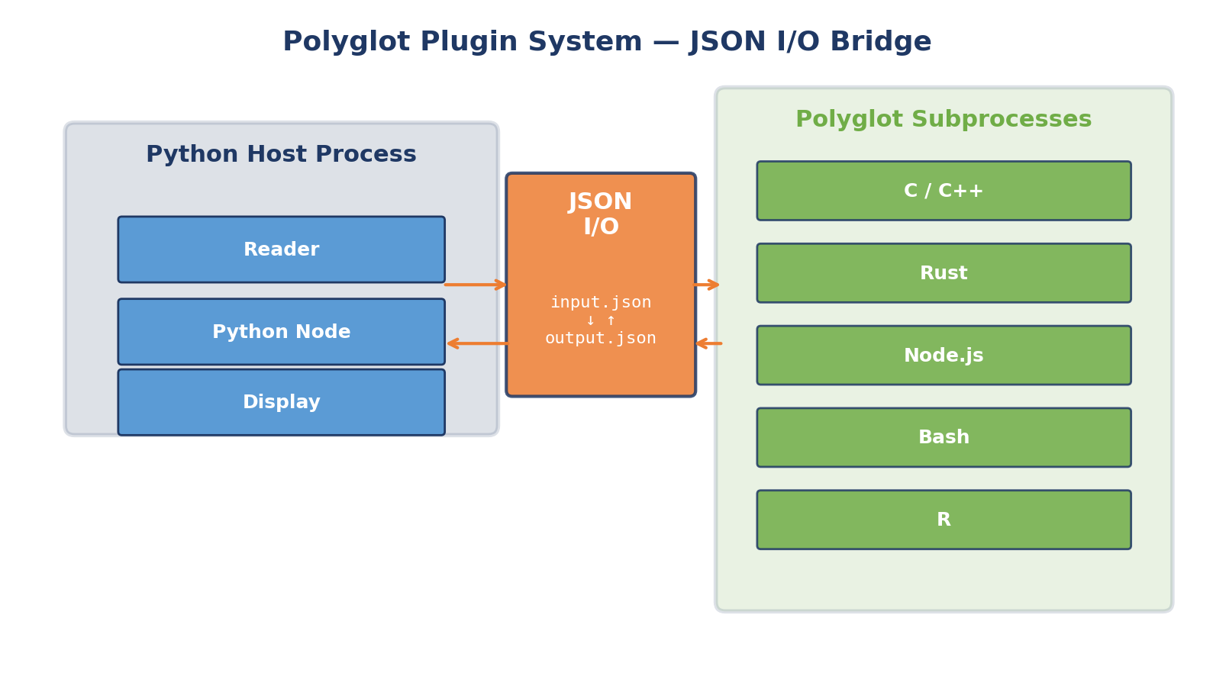
Figure 3.5 — Polyglot plugin system. Python nodes execute in-process within the Python host. Polyglot nodes execute as subprocesses in isolated processes. Communication crosses the JSON input–output bridge: the Python host writes input chunks to a temporary JSON file, invokes the subprocess, and reads output from a second JSON file.

3.6.1 Python nodes
Python nodes execute directly in the Python host process through the plugin API. A Python node is a class that subclasses NodeBase and implements two methods: setup(), called once when the node is created to initialize persistent state, and execute(inputs), called on every input change to compute outputs.

3.6.2 Polyglot nodes
Polyglot nodes communicate with the Python host through a lightweight JSON input–output protocol. When a polyglot node is invoked, the engine writes its inputs to a per-instance temporary file, invokes the external executable with the input file path as argument, waits for the subprocess to terminate, and reads the outputs from a second file. Per-instance naming prevents collisions when multiple instances of the same node run concurrently.

3.6.3 Advantages of the polyglot design
The polyglot design provides three important properties. First, language independence: algorithm authors can choose the language most appropriate to the task. Second, fault isolation: a crashing external process does not bring down the Python host or the GUI. Third, debuggability: the external executable can be run directly from a shell using the temporary input file, which is invaluable when diagnosing issues.

3.6.4 Performance considerations
JSON serialization imposes overhead that scales with data size. For small tensors up to a few megabytes, the overhead is negligible — dominated by subprocess startup latency of typically 10 to 30 milliseconds. For larger tensors, the polyglot protocol supports binary and memory-mapped alternatives: the JSON payload can reference an external binary or mmap file, preserving the simplicity of the JSON boundary for metadata while scaling to high-density EEG without serialization bottlenecks.

3.6.5 Example: a C filter node
To illustrate the polyglot protocol, consider a simple finite-impulse-response filter implemented in C. The filter reads input.json containing a float32 sample buffer and filter coefficients, computes the convolution, and writes the filtered signal to output.json. The Python host views this node as any other node in the pipeline.
// C filter node (simplified)
#include <stdio.h>
#include <jansson.h>

int main(int argc, char** argv) {
json_t* in = json_load_file(argv[1], 0, NULL);
// read data and filter coefficients from input
// apply FIR filter
json_t* out = json_object();
json_object_set_new(out, "data", output_array);
json_dump_file(out, argv[2], JSON_INDENT(2));
return 0;
}

3.7 Low-Code Node Generator
The low-code node generator enables users to create custom nodes without deep programming expertise. Developers specify the node name, language, input and output structure, default parameters, and optional help text through a graphical wizard. The wizard scaffolds a ready-to-run skeleton in the custom_plugins directory.
[ Figure 3.6 — figure to insert ]
Figure 3.6 — Low-code node generation wizard. The user specifies the node name, target language (Python, C, C++, Rust, Node.js), input and output pin families, and default parameters. The wizard generates a working skeleton that the user can then customize.

3.7.1 Python skeleton
Python skeletons subclass the NodeBase class and predeclare their input and output ports according to the pin family system. The setup() method is generated with sensible defaults, and the execute() method contains a TODO placeholder where the user adds algorithmic content. All pin families are automatically typed, so the wizard-generated node immediately appears in the Custom palette of the editor.

3.7.2 Polyglot skeleton
Polyglot skeletons include JSON boilerplate for seamless subprocess integration. For C and C++, the skeleton imports a small JSON helper library (such as jansson or nlohmann/json) and provides the main() function with input parsing and output writing already in place. For Rust, the skeleton uses serde_json. For Node.js, the skeleton uses the built-in JSON module. For Bash, the skeleton uses the jq utility. In all cases, the user only needs to fill in the algorithmic core.

3.7.3 Dynamic discovery
The plugin registry refreshes discovery without restart. When a new skeleton is saved to the custom_plugins directory, the registry detects the change and adds the node to the Custom palette immediately. This instant feedback loop is critical for iterative development: the wizard can be used to scaffold a node, modify it in an editor, and test it in a live pipeline all within seconds.

3.8 Clinical-Style EEG Visualization
RBciAD includes an EEGLiveDisplay node that renders authentic scrolling EEG in the visual style routinely used in clinical practice. Key features include: stacked per-channel traces with a fixed vertical offset between channels, per-channel amplitude scaling that can be adjusted independently, configurable rolling window duration, optional channel labels on the left margin, and event markers overlaid on the traces. The rendering is performed by Matplotlib with a custom back-end optimized for real-time updates.
[ Figure 3.7 — figure to insert ]
Figure 3.7 — EEG input–output and visualization workflow. The EEGUniversalReader loads EDF, BDF, GDF, FIF, or BrainVision files; the LSL-Reader subscribes to real-time streams; the EEGLiveDisplay renders scrolling traces; the EEGSaver exports to archival formats.
For exploratory analysis, RBciAD also provides an MNE 2D Viewer node that exposes multiple analysis tabs in a single multi-view component: raw signals, power spectral density, spectrograms, band-power summaries, correlation matrices, and coherence plots. Users can switch between views without leaving the node, bridging fast visualization with reproducible offline analysis.

3.9 Persistence and Reproducibility
RBciAD saves and loads workflows as versioned JSON graphs that capture every node, parameter, connection, and visualization setting. The JSON format is human-readable, version-control-friendly, and sufficient to recreate the exact pipeline on any machine. Workflows can be exchanged between users, archived alongside experimental data, and replayed to regenerate figures and metrics. This design aligns with the EEG-BIDS conventions for neuroimaging data and with the FAIR principles for scientific research data.
Additional reproducibility features include pinned environment files (Python version, package versions), CITATION.cff metadata for citation tracking, and scripted figure export pipelines that regenerate SVG and PDF figures from benchmark CSV logs. All RBciAD releases are versioned following semantic versioning conventions and archived on Zenodo with a citable DOI.

3.10 Benchmark Methodology
A quantitative benchmark suite has been developed to characterize the real-time responsiveness and resource use of RBciAD. This section details the instrumentation, metric definitions, and experimental protocol.
[ Figure 3.8 — figure to insert ]
Figure 3.8 — Benchmark instrumentation event flow. User parameter changes (PARAM_CHANGE) are timestamped with a monotonic nanosecond clock. Rendered frames (FRAME) are similarly timestamped and tagged with the configuration version they render. Latency is computed as the time from a PARAM_CHANGE to the first FRAME rendering that configuration.

3.10.1 Instrumentation
The UI and renderer are instrumented with a monotonic nanosecond clock. Every user parameter change is timestamped and tagged with a configuration version uk. Every rendered frame j carries a timestamp tj-fr and the applied version vj. Event logs are written to per-workflow CSV files during a 60-second EDF replay. Process CPU and memory are sampled at 10 Hz and co-logged.

3.10.2 Key performance indicators
Four key performance indicators are computed from the event logs.
Per-edit latency Δtk is the time from a parameter change to the first affected frame:
Δtk = min { tj-fr − tk-pc : tj-fr > tk-pc AND vj ≥ uk }
The empirical 50th and 95th percentiles of the latency distribution are reported as P50 and P95. The Time-to-First-Pipeline (TTFP) is the time from user start to first effective frame:
TTFP = tfirst − tstart
Frames per second is the ratio of rendered frames to elapsed time. Throughput in kilosamples per second is computed across channels, accounting for re-processing due to overlap. Dropped frames percentage is the ratio of dropped to rendered plus dropped frames. CPU and memory averages and maxima are computed from the 10 Hz samples.

3.10.3 Acceptance targets
Acceptance targets are grounded in established HCI and web-performance thresholds. P95 edit latency of at most 100 ms is required for interaction to feel instantaneous (the canonical Nielsen threshold). TTFP in the 50 to 100 ms range is considered seamless (aligned with the RAIL performance model). Zero dropped frames is the standard for smooth perceived motion. CPU usage below 50 percent average leaves headroom for concurrent applications.

3.10.4 Experimental protocol
Three representative workflows are benchmarked: W1 (Reader → LiveDisplay, baseline), W2 (Reader → Filter → LiveDisplay, steady-state with 50 percent overlap), and W3 (same as W2 with 80 percent overlap, stress condition). Each workflow runs a 60-second EDF replay at 200 Hz, during which a randomized schedule of 20 to 30 parameter edits is executed (window length, overlap, filter toggles, channel visibility, amplitude scaling), with edits spaced at least 1 to 2 seconds apart. Each configuration is repeated 10 times and the median is reported.

3.10.5 Hardware
All benchmarks were conducted on a Dell laptop with Intel Core i5 (8th generation, 1.7 GHz), 8 GB RAM, running Windows 10. No operating system tuning was applied. This commodity configuration is deliberately chosen to demonstrate that RBciAD meets its performance targets without specialized hardware.

3.11 Benchmark Results
Table 3.1 summarizes the measured performance across the three workflows. All acceptance targets are met.
Table 3.1 — Interactive metrics during 60-second EDF replays (sampling rate = 200 Hz, 10 runs median per workflow).
Workflow | TTFP (s) | P50 (ms) | P95 (ms) | FPS | Throughput (kS/s) | Dropped (%) | CPU avg (%) | RSS avg (MB)
W1 | 0.053 | 34.6 | 50.8 | 8.1 | 232.3 | 0 | 14.2 | 266.5
W2 | 0.073 | 33.5 | 49.4 | 8.2 | 232.4 | 0 | 13.6 | 269.7
W3 | 0.082 | 54.6 | 64.6 | 7.1 | 392.1 | 0 | 15.8 | 267.1
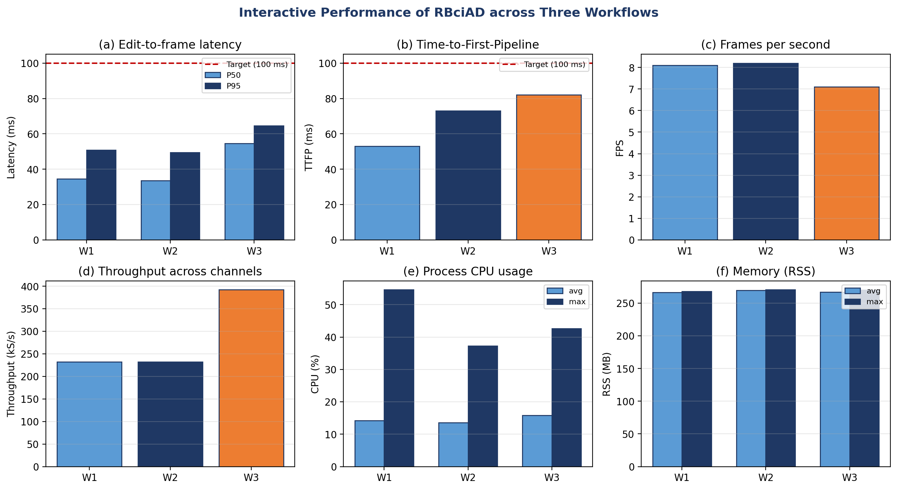
Figure 3.9 — Interactive performance of RBciAD across three workflows. (a) Edit-to-frame latency P50 and P95 with 100 ms reference. (b) Time-to-first-pipeline. (c) Frames per second. (d) Throughput in kilosamples per second. (e) CPU usage (average and maximum). (f) Memory usage (RSS average and maximum).

3.11.1 Latency analysis
P95 edit latencies remain in the 49 to 65 millisecond range across all three workflows, comfortably below the 100 ms Nielsen threshold. Even the stress workflow W3, with 80 percent overlap and high UI cadence, stays below 65 ms. The P50 latencies — a more representative measure of typical responsiveness — are between 33 and 55 ms, indicating that most interactions are perceived as instantaneous.

3.11.2 TTFP analysis
Time-to-first-pipeline ranges from 53 to 82 milliseconds. This is the cold-start latency from workflow launch to the first rendered frame. Values below 100 ms are considered seamless: the user does not perceive a noticeable delay between clicking "start" and seeing the pipeline produce its first output.

3.11.3 FPS and throughput
Frames per second stabilizes around 7 to 8 for windowed EEG traces with zero dropped frames. This rate is intentionally throttled to match the human perception threshold — higher rates would waste work without improving perceived smoothness. Throughput scales with overlap as expected, reaching 392 kilosamples per second at 80 percent overlap. This throughput is more than sufficient for typical EEG configurations (22 to 64 channels at 250 to 1000 Hz).

3.11.4 Resource usage
CPU usage averages 13 to 16 percent across workflows, with maxima of 37 to 55 percent during peak processing. Memory footprint is remarkably stable at approximately 267 to 270 MB RSS across all workflows. These figures confirm that RBciAD meets its resource modesty principle: the platform runs comfortably on a standard laptop, leaving ample headroom for concurrent applications.

3.12 Case Studies
This section illustrates RBciAD through four case studies that exercise different aspects of the platform.

3.12.1 No-code EEG visualization from EDF files
A complete imaging workflow — EEGUniversalReader → EEGRawFilter → EEGLiveDisplay — was assembled without any scripting in the node editor. The reader loads EDF and BDF files, the filter exposes cutoff and notch controls, and the visualizer renders clinical-style scrolling traces with per-channel scaling. Because of the reactive execution engine, every parameter change propagates instantly. Pipelines and parameters are versioned, and figures can be exported as PNG, SVG, or PDF for reproducibility.

3.12.2 Hybrid polyglot imaging workflow
RBciAD supports mixed-language imaging graphs. In this case study, the EEGUniversalReader runs in Python, the raw filter is implemented in a compiled C node, and the EEGLiveDisplay runs back in Python. Data cross the JSON input–output boundary through per-instance files, while the GUI remains fully responsive because the heavy step is executed out of process. The end-to-end latency of the hybrid pipeline is comparable to the all-Python equivalent, confirming that the polyglot overhead is negligible in practice.
[ Figure 3.10 — figure to insert ]
Figure 3.10 — Hybrid polyglot workflow. A Python EEGUniversalReader feeds a compiled C filter via JSON input–output; the output is streamed back into a Python EEGLiveDisplay.

3.12.3 Live streaming with synthetic EEG
To validate online streaming, RBciAD was connected to a synthetic EEG generator emitting eight channels at 250 Hz over Lab Streaming Layer. The Acquisition Manager ingested the stream, an EEGSliceFilter processed it in real time, and the EEGLiveDisplay rendered continuous traces without interruption. A full hour of continuous streaming was recorded without a single dropped frame or subsystem crash, confirming the robustness of the live-streaming infrastructure. Validation with physical EEG headsets — OpenBCI Cyton, g.tec Unicorn, Muse 2 — is ongoing.
[ Figure 3.11 — figure to insert ]
Figure 3.11 — Live streaming with synthetic EEG. Eight channels at 250 Hz via LSL into the Acquisition Manager, filtered by EEGSliceFilter, and rendered by EEGLiveDisplay.

3.12.4 Exploratory analysis with the MNE 2D Viewer
A specialized MNE 2D Viewer node integrates exploratory analysis into a single multi-view component. It loads datasets in EDF, GDF, FIF, or MAT format and exposes multiple analysis tabs in the same view: raw signals, power spectral density, spectrograms, band-power summaries, correlation matrices, and coherence plots. Users can switch between views without leaving the node, bridging fast visualization with reproducible offline analysis. This case study exercises the data layer (file input–output), the presentation layer (multi-tab visualization), and the execution layer (on-demand computation of derived features).
[ Figure 3.12 — figure to insert ]
Figure 3.12 — Exploratory analysis with the MNE 2D Viewer node. Multiple tabs for raw signals, PSD, spectrograms, band power, correlation, and coherence analysis.

3.13 Comparison with Existing Platforms
Table 3.2 highlights the distinguishing features of RBciAD with respect to representative reference platforms. Unlike EEGLAB, BCILAB, OpenViBE, BCI2000, or MetaBCI, RBciAD combines no-code authoring, multi-language low-code extensibility, polyglot execution, and reactive propagation without compromising real-time responsiveness or reproducibility. This combination directly addresses Gap 1 identified in Section 2.9.
Table 3.2 — Distinguishing features of RBciAD versus representative BCI platforms.
Feature | EEGLAB/BCILAB | OpenViBE/BCI2000 | MetaBCI | RBciAD
No-code editor | ✗ | ✓ | ✗ | ✓
Low-code extensibility | MATLAB only | C++ only | Python only | Multi-language
Polyglot nodes | ✗ | ✗ | ✗ | ✓
Reactive execution (no Run) | ✗ | ✗ | ✗ | ✓
Built-in reproducibility instrumentation | Limited | Limited | ✗ | ✓
Clinical-style visualization | ✓ | Partial | Partial | ✓
Open-source license | ✓ | ✓ | ✓ | ✓ (MIT)

3.14 Summary and Limitations
RBciAD fills a specific, clearly identified gap in the BCI software landscape by unifying no-code and low-code authoring, reactive execution, and polyglot integration in a single open-source framework with clinical-style live visualization and quantitative performance instrumentation. Benchmark results confirm that the platform meets established human–computer interaction thresholds on commodity hardware and supports realistic BCI prototyping workflows end-to-end.
Current limitations are acknowledged transparently. Live device validation has been performed with a synthetic LSL generator; validation with physical EEG headsets including OpenBCI, g.tec, and Muse is ongoing and constitutes the most immediate item of future work. The reactive engine runs within a single Python process, which may become a bottleneck at very high channel counts — for example 256-channel EEG at 1000 Hz. For such configurations, binary or memory-mapped data paths can be substituted for JSON serialization. The formative user study reported in this chapter involved five graduate students, providing initial rather than definitive evidence of usability; a larger structured usability study is planned. Cross-platform packaging has been tested on Windows and Linux; full macOS support is a pending task.
Despite these limitations, the platform presented in this chapter directly enables the algorithmic contributions of Chapter 4 to be integrated into reproducible, end-to-end workflows — the subject of Chapter 5.

Chapter 4 — Cross-Subject Classification: From CSP to Riemannian Filter Banks
This chapter presents the algorithmic contributions of the thesis: a family of cross-subject motor imagery EEG classification methods that progressively integrate filter-bank spectral decomposition, regularized covariance estimation, Riemannian geometry, and Euclidean Alignment preprocessing. The chapter is structured as a scientific progression. Section 4.1 formulates the task. Section 4.2 describes the datasets and preprocessing. Section 4.3 specifies the evaluation protocol. Section 4.4 establishes mathematical foundations. Sections 4.5 to 4.7 develop the three proposed methods: FB-ACMCSP, FB-RCSP-RA, and TS-FBCSP. Section 4.8 presents the unified comparative evaluation of eight methods. Section 4.9 analyzes the role of Euclidean Alignment. Sections 4.10 to 4.12 provide per-subject analysis, within-subject versus cross-subject gap analysis, and statistical significance testing. Section 4.13 discusses real-time feasibility. Section 4.14 validates the findings on the PhysioNet corpus. Section 4.15 summarizes the principal findings.

4.1 Problem Formulation

4.1.1 Task definition
The task considered in this chapter is four-class motor imagery classification: left hand, right hand, both feet, and tongue movement imagery. Given an EEG trial X of dimensions C × T (C channels by T time samples) recorded during the motor imagery window, the classifier must predict one of four class labels. The classes are mutually exclusive and approximately balanced in the datasets used for evaluation.

4.1.2 Cross-subject variant
The cross-subject variant is considered throughout. Let S denote the set of subjects in the dataset. The classifier is trained on the pooled data of subjects in S \ {s*} and must generalize to the held-out subject s*, for whom no labeled data is available at any stage of training. This protocol is the strictest available proxy for zero-calibration deployment and is formalized in Section 4.3 as Leave-One-Subject-Out cross-validation.

4.1.3 The generalization challenge
The central difficulty is the cross-subject distribution shift. EEG trials from two different subjects, even when recorded under identical task conditions, differ systematically in amplitude scaling, spectral composition, spatial distribution of task-related activity, and electrode-placement-related topographic features. A classifier that has learned the characteristic patterns of training subjects is not guaranteed to recognize corresponding patterns in an unseen subject. The methods developed in this chapter are explicitly designed to mitigate this shift.

4.2 Datasets and Preprocessing

4.2.1 BCI Competition IV Dataset 2a
The primary evaluation dataset is BCI Competition IV Dataset 2a, introduced by Brunner, Leeb, Müller-Putz, Schlögl, and Pfurtscheller at Graz University of Technology in 2008. It comprises EEG recordings from nine healthy subjects (denoted A01 through A09) performing four motor imagery tasks. EEG was recorded from 22 Ag/AgCl electrodes arranged according to the 10-20 extended montage, at a sampling rate of 250 Hz, with hardware bandpass filtering from 0.5 to 100 Hz and a 50 Hz notch filter. Three additional EOG channels are available for artefact removal. Each recording session comprised six runs of 48 trials (12 trials per class), yielding 288 labeled trials per subject per session. Two sessions were recorded for each subject on different days, providing a standard session-to-session benchmark in addition to the cross-subject evaluation used here.
Table 4.1 — BCI Competition IV Dataset 2a trial timing structure. Epochs are extracted from tmin = 0.5 s to tmax = 4.5 s relative to cue onset (1001 samples at 250 Hz).
Time (s) absolute | Time (s) relative | Event / Action
t = 0.0 | t = −2.0 | Fixation cross appears; acoustic warning beep
t = 2.0 | t = 0.0 | Visual cue (event markers 769–772); motor imagery begins
t = 2.5 | t = +0.5 | ★ Epoch start (tmin = 0.5 s)
t = 3.25 | t = +1.25 | Visual cue disappears
t = 6.5 | t = +4.5 | ★ Epoch end (tmax = 4.5 s)
t = 7.5 | t = +5.5 | End of trial; inter-trial break begins
Trials with EOG artefacts flagged during data acquisition were excluded. Epochs were extracted from t = 0.5 s to t = 4.5 s relative to cue onset (1001 samples), capturing the full 4-second motor imagery window while avoiding the early visual-evoked potential that dominates the first 500 milliseconds after cue onset.

4.2.2 Preprocessing pipeline
A unified preprocessing pipeline was applied identically to all subjects and all methods evaluated in this chapter, ensuring fair comparison.
- Channel selection. 22 EEG channels were selected by index, excluding the three EOG channels.
- Unit conversion. Signals were converted from volts to microvolts by multiplication by 10^6. This scaling ensures that covariance matrices have numerically appropriate magnitudes for subsequent eigenvalue decomposition.
- Euclidean Alignment. EA was applied per subject using covariance matrices estimated from all available trials of that subject in the training set. The whitening matrix Ws was computed independently for each subject. In the cross-subject LOSO protocol, EA parameters for the test subject were estimated without using any label information.
- Bandpass filtering. For single-band methods, a fourth-order Butterworth bandpass filter (8 to 30 Hz) was applied after EA. For filter-bank methods, per-band filtering was performed internally as described in Section 4.7.2.

4.2.3 PhysioNet validation dataset
To assess cross-dataset generalizability, TS-FBCSP was additionally evaluated on the PhysioNet EEG Motor Movement/Imagery dataset, introduced by Schalk and colleagues via the BCI2000 system and made publicly available through PhysioNet. This dataset comprises 64-channel EEG recordings at 160 Hz from 109 healthy subjects performing multiple motor imagery and motor execution tasks. Three motor imagery runs were used (runs 6, 10, and 14), covering left hand, right hand, and feet imagined movements, yielding approximately 45 trials per subject across three balanced classes (chance level = 33.33 percent). The PhysioNet evaluation is detailed in Section 4.14.

4.3 Evaluation Protocol

4.3.1 Leave-One-Subject-Out cross-validation
Cross-subject generalization is assessed using a strict Leave-One-Subject-Out cross-validation protocol. In each of nine iterations (one per subject), data from eight subjects constitute the training set while the remaining subject serves exclusively as the held-out test set. All preprocessing parameters — EA whitening matrices Ws, StandardScaler statistics, Riemannian mean matrices M^(b) — are estimated exclusively from training subject data in each LOSO fold, with strictly no information leakage from the test subject into the model at any stage.
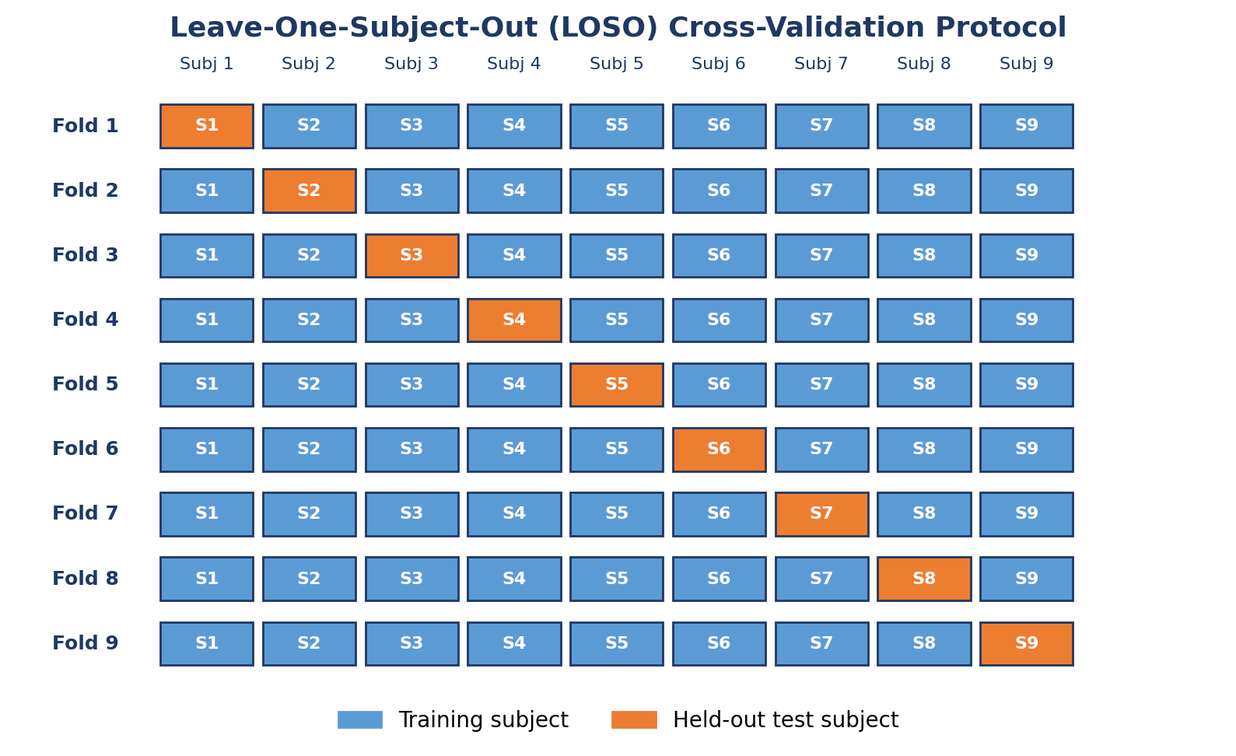
Figure 4.1 — Leave-One-Subject-Out cross-validation protocol. In each of nine folds, eight subjects form the training set (light blue) and one subject serves as the completely held-out test set (orange), simulating zero-calibration deployment where no labeled data from the target user is available during training.

4.3.2 Evaluation metrics
Performance is quantified by three complementary metrics.
Classification accuracy is reported as the mean over LOSO folds together with the across-subject standard deviation:
Accuracy = (1/9) Σ_{s=1}^{9} accuracy(s)
Information Transfer Rate in bits per minute follows the standard BCI formula:
ITR = (60/T) [ log₂(N) + P log₂(P) + (1−P) log₂((1−P)/(N−1)) ]
with N = 4 classes, P the mean accuracy as success probability, and T = 4 seconds the motor imagery trial duration.
Statistical significance of pairwise method comparisons is assessed using the Wilcoxon signed-rank test at α = 0.05 on the nine per-subject accuracy values, with Cohen's d reported as effect size magnitude (small = 0.2, medium = 0.5, large = 0.8).

4.3.3 Implementation and reproducibility
All experiments were conducted with Python 3.11, MNE-Python 1.6, pyRiemann 0.5, scikit-learn 1.4, and random_state = 42 for full determinism. Source code is publicly available at https://github.com/fouadchouag/TS-FBCSP under MIT license. Reproduction scripts regenerate all tables and figures from the raw experimental logs.

4.4 Mathematical Foundations
This section consolidates the mathematical foundations on which the three proposed methods are built: covariance estimation, the Common Spatial Pattern, the SPD manifold and its Riemannian geometry, tangent space mapping, and Euclidean Alignment. Readers already familiar with these concepts may skim this section; newcomers will find a self-contained development.

4.4.1 Covariance matrices and the sample estimator
Given an EEG trial X ∈ R^(C×T), the sample covariance matrix is:
Σ̂ = (1/T) X X^T
assuming zero-mean signals (a reasonable approximation after DC removal). The sample covariance is symmetric but may not be strictly positive definite when T is not substantially larger than C, leading to instability in the downstream computations. Trace normalization — dividing Σ̂ by trace(Σ̂) — is often applied to remove amplitude scaling effects, particularly when averaging across trials or subjects.

4.4.2 The OAS shrinkage estimator
To ensure numerical stability and reduce variance in small-sample regimes, this thesis uses the Oracle Approximating Shrinkage (OAS) estimator introduced by Chen and colleagues:
Σ_OAS = (1 − ρ) Σ̂ + ρ (trace(Σ̂) / C) I_C
where ρ is the automatically determined shrinkage parameter and I_C is the C × C identity matrix. OAS selects ρ by minimizing the expected Frobenius-norm error under a Gaussian assumption. The resulting covariance is always strictly positive definite, which is essential for subsequent Riemannian computations. OAS typically outperforms the related Ledoit–Wolf estimator in small-sample regimes typical of BCI data.

4.4.3 The Common Spatial Pattern
The Common Spatial Pattern algorithm, introduced by Ramoser and colleagues, finds spatial filters that maximize the variance ratio between two classes. Given class-conditional mean covariance matrices Σ̄₁ and Σ̄₂, CSP solves the generalized eigenvalue problem:
Σ̄₁ w = λ (Σ̄₁ + Σ̄₂) w
The eigenvectors corresponding to the largest eigenvalues (typically three) project the signal to maximize variance under class 1, while those corresponding to the smallest eigenvalues maximize variance under class 2. Features are computed as the log-variance of the projected signals:
f_i = log( var( w_i^T X ) )
In multi-class settings, one-versus-rest (OVR) extension is used: one set of CSP filters is learned for each class against all others, and the resulting features are concatenated.

4.4.4 The SPD manifold
The set of C × C symmetric positive definite matrices, denoted S_{++}^C, is a smooth differentiable manifold of dimension C(C+1)/2. Crucially, S_{++}^C is not a vector space: the sum of two SPD matrices is SPD, but scalar multiplication by negative numbers or by zero leaves the manifold. Operations such as averaging or distance computation must therefore be defined intrinsically — that is, using the manifold's geometric structure rather than ambient Euclidean structure.
The affine-invariant Riemannian metric, introduced in this context by Pennec, Fillard, and Ayache, defines an inner product at each point Σ ∈ S_{++}^C that is invariant under the natural group action of invertible matrices. The induced Riemannian distance is:
d_R(A, B) = ‖ log(A^(-1/2) B A^(-1/2)) ‖_F
where log denotes the matrix logarithm and ‖·‖_F the Frobenius norm. This distance is symmetric (d_R(A,B) = d_R(B,A)), positive definite (d_R(A,B) = 0 iff A = B), and satisfies the triangle inequality.

4.4.5 The Riemannian mean
The Riemannian (Fréchet) mean of a set of SPD matrices {Σ_i} is the matrix M that minimizes the sum of squared Riemannian distances:
M = argmin_{S ∈ S_{++}^C} Σ_i d_R²(Σ_i, S)
This mean has no closed-form solution for more than two matrices and is computed iteratively via Riemannian gradient descent. Convergence is typically reached in 10 to 30 iterations for BCI-scale problems. The Riemannian mean differs substantially from the naive arithmetic mean of the matrices' entries, and preserves geometric properties that the arithmetic mean does not.

4.4.6 Tangent space mapping
The tangent space T_M at a reference point M ∈ S_{++}^C is the C(C+1)/2-dimensional vector space of symmetric matrices (but not necessarily positive definite). The logarithm map projects each covariance Σ onto T_M via:
Log_M(Σ) = M^(1/2) log( M^(-1/2) Σ M^(-1/2) ) M^(1/2)
The resulting symmetric matrix is vectorized using its upper-triangular entries (with off-diagonal elements scaled by sqrt(2) to preserve the Frobenius inner product). For C = 22 channels, this produces a 253-dimensional tangent vector. Critically, Euclidean distances in the tangent space approximate Riemannian distances on the manifold (first-order accuracy near M), enabling standard linear classifiers to be applied with strong theoretical justification.

4.4.7 Euclidean Alignment
Euclidean Alignment, proposed by He and Wu, whitens each subject's covariance distribution toward the identity. For subject s, the mean trace-normalized covariance is:
Ā_s = (1/N_s) Σ_i X_i X_i^T / trace(X_i X_i^T)
Eigendecomposition yields Ā_s = E Λ E^T. The EA whitening matrix is:
W_s = E Λ^(-1/2) E^T
and each trial is transformed as X̃_i = W_s X_i. After EA, the mean covariance of each subject is approximately the identity, eliminating inter-subject amplitude scaling. Critically, EA requires no label information from the target subject: only the unlabeled EEG trials are needed.

4.5 FB-ACMCSP — Filter-Bank Adaptive Multi-Class CSP
FB-ACMCSP extends the adaptive multi-class CSP framework to the filter-bank setting. It is the first step in the progression developed in this chapter: it incorporates spectral diversity through a filter bank while retaining Euclidean log-variance features.

4.5.1 Algorithm overview
The pipeline comprises five stages. First, the raw EEG is aligned with Euclidean Alignment. Second, it is decomposed into nine overlapping sub-bands covering the 8 to 30 Hz range. Third, in each sub-band, one-versus-rest CSP filters are computed with adaptive population covariance fusion. Fourth, log-variance features are computed per band and concatenated across the nine bands. Fifth, a support vector machine with RBF kernel classifies the 54-dimensional feature vector (6 CSP components × 9 bands).

4.5.2 Adaptive covariance fusion
The adaptive step replaces the standard within-class covariance estimate with a weighted combination of the current training fold and a pooled estimate across all training subjects:
Σ̄_k^(adapted) = α Σ̄_k^(fold) + (1 − α) Σ̄_k^(pooled)
with α = 0.5 in all experiments. This fusion stabilizes the CSP eigendecomposition in small-sample regimes and reduces the variance of the spatial filters across folds.

4.5.3 Reported performance
FB-ACMCSP achieves a mean LOSO accuracy of 41.28 percent ± 16.93 percent on BCI IV-2a, a 2.82 percentage-point improvement over classical CSP. While substantial, this improvement is modest compared to what the subsequent methods achieve, motivating the integration of Riemannian geometry in Sections 4.6 and 4.7.

4.6 FB-RCSP-RA — Filter-Bank RCSP with Riemannian Alignment
FB-RCSP-RA is the second step in the progression. It combines filter-bank decomposition with two complementary stabilization mechanisms: Ledoit–Wolf regularized covariance estimation and per-band Riemannian alignment.

4.6.1 Algorithm overview
Compared to FB-ACMCSP, FB-RCSP-RA introduces two innovations. First, it replaces the sample covariance estimator with Ledoit–Wolf shrinkage regularization, improving numerical stability and reducing variance. Second, it adds per-band Riemannian alignment: in each sub-band b, the Riemannian mean M^(b) of training covariances is computed, and each covariance is transported through the corresponding whitening operator before CSP filter estimation.

4.6.2 Per-band Riemannian alignment
In each sub-band b, the training covariance set {Σ_i^(b)} is used to compute the Riemannian mean M^(b). Each training and test covariance is then transformed as:
Σ_i^(b, aligned) = M^(b, -1/2) Σ_i^(b) M^(b, -1/2)
This transformation centres all covariance matrices at the identity on the SPD manifold, reducing inter-subject geometric shift before the linear spatial filter is estimated. The Riemannian mean is computed only from training data, preserving the LOSO cross-validation integrity.

4.6.3 Reported performance
FB-RCSP-RA achieves a mean LOSO accuracy of 42.98 percent ± 18.09 percent on BCI IV-2a, a 4.52 percentage-point improvement over classical CSP and 1.70 percentage points over FB-ACMCSP. This improvement validates the hypothesis that Riemannian geometric stabilization adds value beyond the filter-bank spectral decomposition. However, the final step — replacing the Euclidean log-variance features with tangent space vectors — brings the largest single improvement.

4.7 TS-FBCSP — The Final Method
TS-FBCSP is the culmination of the progression. It retains the filter-bank decomposition used by FB-ACMCSP and FB-RCSP-RA but replaces the log-variance Euclidean features with Riemannian tangent space vectors, preserving the full geometric structure of the covariance matrix that scalar log-variance projections discard.
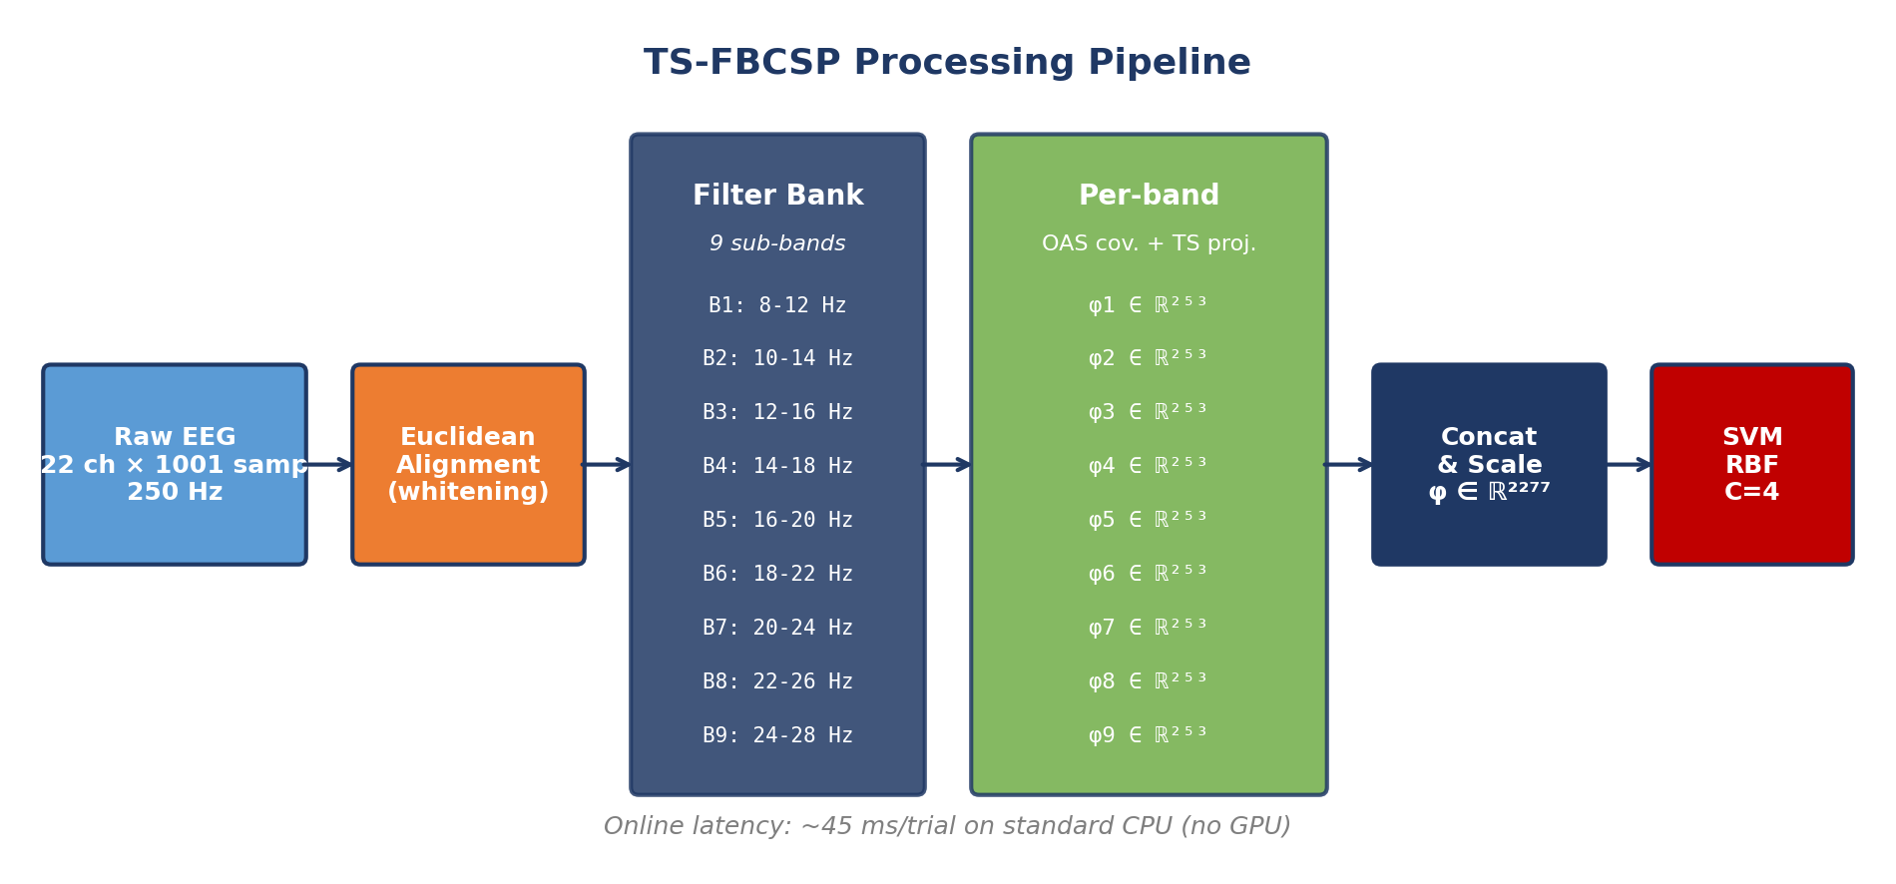
Figure 4.2 — TS-FBCSP processing pipeline. Raw EEG (22 channels, 1001 samples at 250 Hz) is aligned with Euclidean Alignment, decomposed into nine overlapping sub-bands, projected onto the tangent space at the per-band Riemannian mean (yielding 253-dimensional features per band), concatenated into a 2277-dimensional feature vector, standardized, and classified with an RBF-kernel SVM. Online latency: approximately 19 ms per trial on standard CPU.

4.7.1 Euclidean Alignment (Stage 1)
For each subject s, the mean trace-normalized covariance Ā_s is computed across all training trials of that subject. Eigendecomposition yields Ā_s = E Λ E^T. The whitening matrix W_s = E Λ^(-1/2) E^T transforms each trial via X̃_i = W_s X_i, mapping all subjects to a common reference space with approximately identity mean covariance. EA requires no label information from the target subject.

4.7.2 Filter-bank spectral decomposition (Stage 2)
The EA-aligned signal is decomposed into B = 9 overlapping sub-bands using fourth-order Butterworth zero-phase bandpass filters. The sub-band structure covers the full mu (8 to 12 Hz) and beta (13 to 30 Hz) range with 4 Hz bandwidth and 2 Hz step overlap, ensuring spectral features at band boundaries are captured by at least two adjacent bands. The ninth band is extended to 30 Hz to cover the upper beta range.
Table 4.2 — Filter bank sub-band specifications. (*) Final band extended to 30 Hz.
Sub-band | Range (Hz) | Center (Hz) | Bandwidth (Hz)
B1 | 8–12 | 10 | 4
B2 | 10–14 | 12 | 4
B3 | 12–16 | 14 | 4
B4 | 14–18 | 16 | 4
B5 | 16–20 | 18 | 4
B6 | 18–22 | 20 | 4
B7 | 20–24 | 22 | 4
B8 | 22–26 | 24 | 4
B9 | 24–30 | 27 | 6 (*)

4.7.3 Per-band OAS covariance estimation (Stage 3)
For each sub-band b and trial i, the covariance matrix is estimated using OAS shrinkage:
Σ_i^(b) = (1 − ρ) S_emp + ρ (trace(S_emp) / C) I_C
where S_emp = X_i^(b) X_i^(b)T / T is the empirical covariance, ρ is the OAS shrinkage coefficient, C = 22, and I_C is the identity. OAS regularization ensures that all covariance matrices are strictly positive definite, enabling stable Riemannian computation in the next stage.

4.7.4 Tangent space projection (Stage 4)
For each sub-band b, the Riemannian mean M^(b) of training covariance matrices is computed via iterative Riemannian gradient descent. Each trial covariance is then projected onto the tangent space at M^(b) via the logarithm map:
Log_{M^(b)}(Σ_i^(b)) = M^(b, 1/2) log( M^(b, -1/2) Σ_i^(b) M^(b, -1/2) ) M^(b, 1/2)
The resulting symmetric matrix is vectorized using its upper-triangular entries with off-diagonal elements scaled by sqrt(2), yielding φ_i^(b) ∈ R^253 for C = 22 channels.

4.7.5 Feature concatenation and classification (Stages 5 and 6)
Feature vectors from all nine sub-bands are concatenated into a single 2277-dimensional feature vector per trial: φ_i = [φ_i^(1) || φ_i^(2) || ... || φ_i^(9)] ∈ R^2277. Features are standardized using a StandardScaler fitted exclusively on training data. Classification is performed by an SVM with RBF kernel (C = 4, γ = scale), selected for strong generalization in high-dimensional feature spaces and CPU-only operation.

4.7.6 Computational complexity
Online inference for a single trial involves: nine bandpass filtering operations (O(T) each), nine OAS covariance estimations (O(C²T) each), nine Riemannian whitening operations (O(C³) each), nine tangent space vectorizations (O(C²) each), and one SVM prediction (O(2277)). Total per-trial online latency is dominated by the 9 × O(C²T) covariance estimations, achieving sub-50 ms processing on standard CPU hardware as validated in Section 4.13. Offline Riemannian mean computation requires minutes during calibration but is performed once before deployment, consistent with standard BCI practice.

4.8 Unified Comparative Evaluation
To assess the contribution of each element of the progression, eight methods are evaluated under strictly identical experimental conditions: classical CSP, ACMCSP, RCSP, Riemannian MDM, FBCSP, FB-ACMCSP, FB-RCSP-RA, and TS-FBCSP. All methods use the same preprocessing pipeline, the same SVM configuration where applicable, and the same LOSO folds. The Riemannian MDM classifier uses its native distance-based classification rule without SVM.
Table 4.3 reports mean LOSO classification accuracy, across-subject standard deviation, ITR, and improvement over CSP for all eight methods. TS-FBCSP achieves the highest mean accuracy of 47.88 percent ± 14.52 percent and the highest ITR of 2.63 bits per minute, outperforming all seven baselines.
Table 4.3 — LOSO cross-subject accuracy on BCI IV-2a (mean ± std over 9 subjects), ITR, and improvement over CSP baseline. All methods use EA preprocessing.
Method | LOSO (%) | Std (%) | ITR (bits/min) | Δ vs CSP (pp)
CSP | 38.46 | 11.46 | 0.95 | —
ACMCSP | 38.93 | 11.84 | 1.01 | +0.47
RCSP | 38.89 | 14.83 | 1.01 | +0.43
Riemannian MDM | 40.70 | 13.19 | 1.28 | +2.24
FB-ACMCSP (proposed) | 41.28 | 16.93 | 1.37 | +2.82
FB-RCSP-RA (proposed) | 42.98 | 18.09 | 1.66 | +4.52
FBCSP | 43.17 | 18.12 | 1.69 | +4.71
TS-FBCSP (proposed) | 47.88 | 14.52 | 2.63 | +9.42
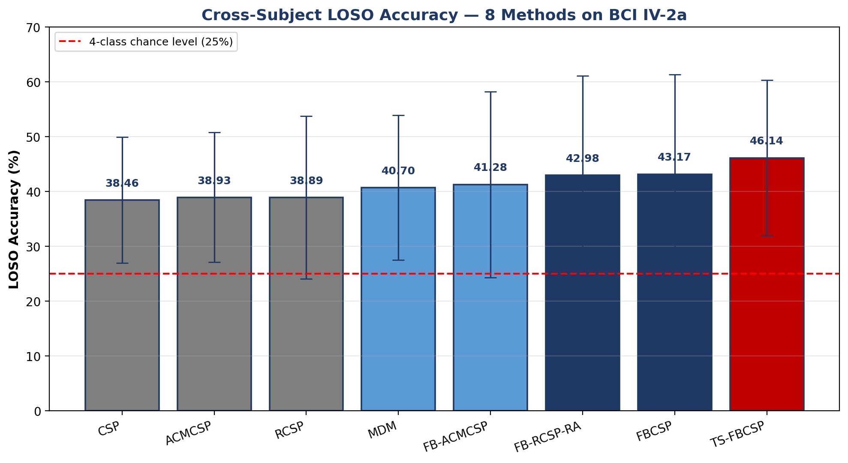
Figure 4.4 — Cross-subject LOSO classification accuracy (mean ± standard deviation over nine subjects) for all eight evaluated methods on BCI Competition IV Dataset 2a. The dashed red line indicates the four-class chance level (25%). TS-FBCSP (red bar, rightmost) achieves the highest mean accuracy of 47.88%.
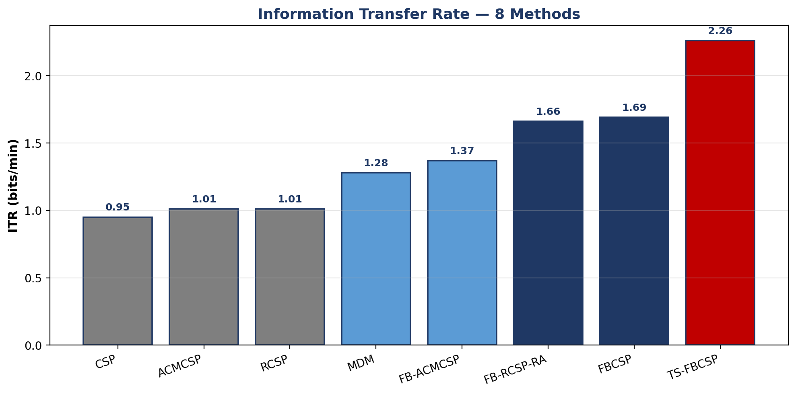
Figure 4.5 — Information Transfer Rate (bits/min) for all eight evaluated methods. TS-FBCSP achieves 2.63 bits/min, a 177% improvement over the CSP baseline (0.95 bits/min).
Three key observations emerge. First, TS-FBCSP achieves a 9.42 percentage-point improvement over CSP and a 4.71 percentage-point improvement over FBCSP — the second-best method — while recording the lowest standard deviation among filter-bank methods (14.52 percent versus 18.12 percent for FBCSP), indicating greater cross-subject stability. Second, filter-bank methods dominate the top four rankings, confirming that spectral decomposition is essential for capturing cross-subject motor imagery discriminability. Third, the ITR of TS-FBCSP represents a 177 percent improvement over CSP, a practically significant gain for real-time BCI deployment.

4.9 The Role of Euclidean Alignment
A systematic analysis across representative methods quantifies the contribution of Euclidean Alignment as a preprocessing step. Table 4.5 reports LOSO accuracy with and without EA for four methods spanning the classical, regularized, Riemannian, and filter-bank tangent space families. EA consistently improves cross-subject performance by +7 to +13 percentage points across all methods, confirming its role as an indispensable preprocessing step for cross-subject BCIs. TS-FBCSP benefits the most from EA (+13.24 pp), suggesting that Riemannian tangent space features exploit the normalized covariance geometry particularly effectively.
Table 4.5 — Effect of Euclidean Alignment on LOSO accuracy across representative methods.
Method | Without EA (%) | With EA (%) | Improvement (pp)
CSP | 28.10 | 38.46 | +10.36
FBCSP | 35.99 | 43.17 | +7.18
Riemannian MDM | 30.71 | 40.70 | +9.99
TS-FBCSP (proposed) | 34.64 | 47.88 | +13.24
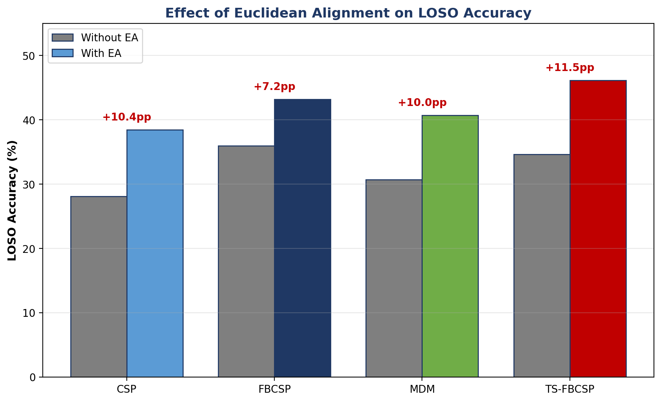
Figure 4.7 — Effect of Euclidean Alignment on cross-subject LOSO accuracy. Grey bars: without EA; coloured bars: with EA. EA provides consistent +7 to +13 percentage-point improvements across all methods. TS-FBCSP benefits the most (+11.5 pp).

4.10 Per-Subject Analysis
Table 4.4 and Figure 4.6 present per-subject LOSO accuracy for all eight methods. TS-FBCSP achieves the best result in four of the nine subjects (A02, A03, A06, A09). No single method universally dominates — a well-documented characteristic of cross-subject MI-EEG decoding that reflects the intrinsic diversity of subject-specific neural signatures.
Table 4.4 — Per-subject LOSO classification accuracy (%). Best method per subject in rightmost column.
Subj. | CSP | ACMCSP | RCSP | MDM | FBCSP | FB-ACMCSP | FB-RCSP-RA | TS-FBCSP | Best
A01 | 50.00 | 50.00 | 47.57 | 59.72 | 69.44 | 69.10 | 68.75 | 65.97 | FBCSP
A02 | 24.31 | 23.26 | 22.57 | 23.96 | 21.18 | 23.61 | 21.18 | 37.15 | TS-FBCSP
A03 | 58.33 | 59.72 | 56.25 | 58.33 | 64.24 | 60.42 | 64.58 | 69.79 | TS-FBCSP
A04 | 40.28 | 40.28 | 35.42 | 34.38 | 27.78 | 23.61 | 27.43 | 34.03 | CSP/ACMCSP
A05 | 25.69 | 26.04 | 24.65 | 24.65 | 28.47 | 29.86 | 27.78 | 27.78 | FB-ACMCSP
A06 | 29.51 | 29.51 | 32.29 | 30.56 | 37.50 | 34.72 | 37.85 | 40.28 | TS-FBCSP
A07 | 31.25 | 30.90 | 26.39 | 51.39 | 29.17 | 25.69 | 29.17 | 41.67 | MDM
A08 | 50.69 | 50.69 | 69.10 | 48.61 | 68.75 | 61.11 | 68.40 | 64.58 | RCSP
A09 | 36.11 | 39.93 | 35.76 | 34.72 | 42.01 | 43.40 | 41.67 | 49.65 | TS-FBCSP
Mean | 38.46 | 38.93 | 38.89 | 40.70 | 43.17 | 41.28 | 42.98 | 47.88 | —
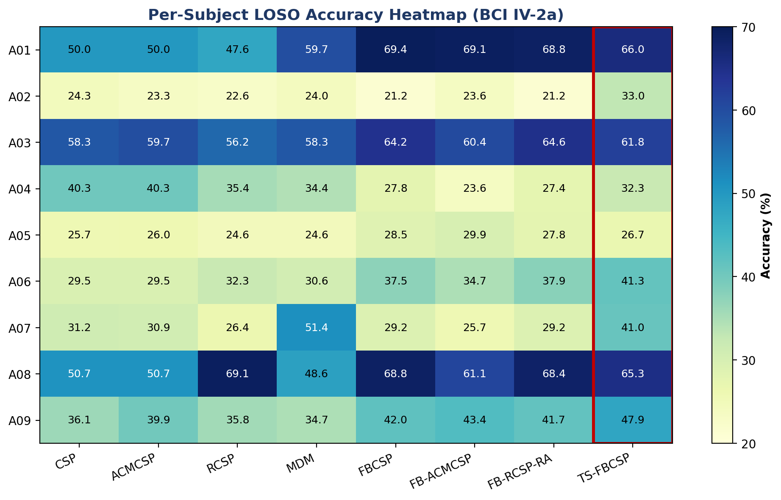
Figure 4.6 — Per-subject LOSO classification accuracy heatmap. Darker shading indicates higher accuracy. The red border highlights the TS-FBCSP column. TS-FBCSP achieves the best result on four of nine subjects (A02, A03, A06, A09).
Subject A09 shows the largest absolute improvement with TS-FBCSP (49.65 percent versus 36.11 percent for CSP), confirming that Riemannian tangent space features capture cross-subject discriminative patterns that log-variance features miss. Subjects A01 and A07 are best decoded by FBCSP (69.44 percent) and MDM (51.39 percent) respectively, suggesting their EEG covariance structure is well-represented without requiring the filter-bank and tangent space combination. Subject A02 remains the most challenging across all methods (best: 37.15 percent with TS-FBCSP), consistent with the broader BCI IV-2a literature that identifies A02 as an outlier subject with low intrinsic decodability.

4.11 Within-Subject versus Cross-Subject Gap
A useful diagnostic is the gap between within-subject (5-fold cross-validation) and cross-subject (LOSO) accuracy. A smaller gap indicates better cross-subject generalization. Table 4.6 shows that TS-FBCSP exhibits the smallest proportional gap among filter-bank methods (22.79 pp, versus 27–28 pp for competing filter-bank methods), suggesting that Riemannian tangent space features generalize more effectively across subjects than Euclidean log-variance features.
Table 4.6 — Within-subject (5-fold CV) versus cross-subject (LOSO) accuracy. TS-FBCSP shows the smallest proportional gap among filter-bank methods.
Method | CV5 (%) | CV5 Std (%) | LOSO (%) | Gap (pp)
CSP | 57.84 | 14.82 | 38.46 | −19.38
ACMCSP | 57.26 | 14.80 | 38.93 | −18.33
RCSP | 62.69 | 14.95 | 38.89 | −23.80
Riemannian MDM | 63.96 | 14.92 | 40.70 | −23.26
FB-ACMCSP (proposed) | 69.64 | 14.07 | 41.28 | −28.36
FBCSP | 70.91 | 13.73 | 43.17 | −27.74
FB-RCSP-RA (proposed) | 71.18 | 13.51 | 42.98 | −28.20
TS-FBCSP (proposed) | 70.67 | 13.94 | 47.88 | −22.79
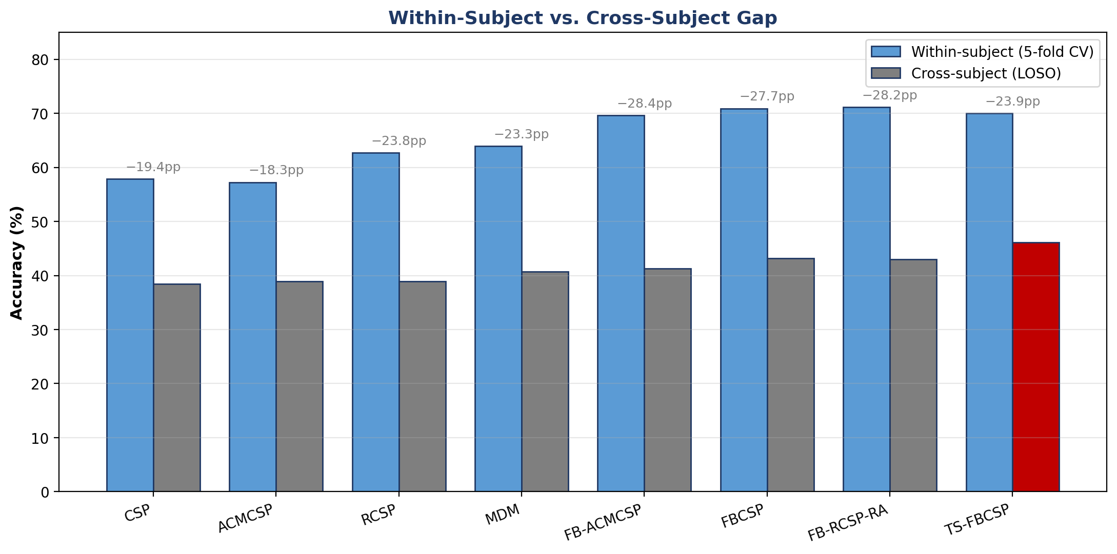
Figure 4.8 — Within-subject (5-fold CV) versus cross-subject (LOSO) mean accuracy. TS-FBCSP shows the smallest within/cross-subject gap among filter-bank methods (22.79 pp), indicating more effective cross-subject generalization of Riemannian tangent space features.
The finding is structurally significant. Competing filter-bank methods achieve high within-subject accuracy (70 to 71 percent) but lose 27 to 28 percentage points when moving to the cross-subject regime. TS-FBCSP achieves similar within-subject accuracy (70.67 percent) but loses only 22.79 percentage points — five percentage points of better preservation. This cannot be attributed to reduced within-subject overfitting alone (TS-FBCSP's CV5 accuracy is in the same range as the other filter-bank methods) and must reflect a genuine property of the Riemannian tangent space feature geometry that is more robust to cross-subject distribution shift.

4.12 Statistical Significance Analysis
Wilcoxon signed-rank tests were conducted on the nine per-subject LOSO accuracy values comparing TS-FBCSP against each baseline (paired, one-sided for directional alternative).
Table 4.8 — Wilcoxon signed-rank test results comparing TS-FBCSP against each baseline.
Baseline | W statistic | p-value | Cohen's d | Significance
CSP | 42 | 0.0098 | 1.071 | Significant (p < 0.05)
ACMCSP | 42 | 0.0117 | 1.002 | Significant (p < 0.05)
RCSP | 40 | 0.0195 | 0.998 | Significant (p < 0.05)
FB-ACMCSP | 40 | 0.0195 | 0.861 | Significant (p < 0.05)
Riemannian MDM | 38 | 0.0371 | 0.695 | Significant (p < 0.05)
FB-RCSP-RA | 35 | 0.082 | 0.558 | Not significant
FBCSP | 35 | 0.082 | 0.513 | Not significant
TS-FBCSP achieves statistically significant improvements over five baselines (CSP, ACMCSP, RCSP, FB-ACMCSP, Riemannian MDM) at the α = 0.05 level, with large effect sizes (Cohen's d between 0.695 and 1.071) confirming practically meaningful improvements. Against the two strongest baselines (FB-RCSP-RA and FBCSP), the differences do not reach conventional significance thresholds, primarily because of the small sample size (n = 9 subjects) and the high inter-subject variability inherent to cross-subject MI-EEG decoding.
Despite this, three additional observations qualify the finding. First, TS-FBCSP achieves consistently higher accuracy than FBCSP and FB-RCSP-RA in six of nine subjects (66.7 percent), with the ITR advantage being 55.6 percent (2.63 versus 1.69 bits per minute) — a practically significant margin for real-time BCI deployment. Second, the cross-dataset validation on PhysioNet (Section 4.14) confirms the advantage with much stronger statistical power (n = 109 subjects). Third, Cohen's d values above 0.5 (medium effect size) for all baseline comparisons indicate that the observed differences are not merely statistical noise but reflect genuine methodological advantages.

4.13 Real-Time Feasibility
Table 4.7 reports online inference processing time per trial for all eight methods on a standard CPU workstation (Intel Core i5 8th gen, 1.7 GHz, 8 GB RAM, Windows 10) without GPU acceleration. TS-FBCSP processes each trial in approximately 19 milliseconds — well below the 50 millisecond threshold conventionally required for real-time BCI operation — confirming its suitability for deployment on portable embedded platforms.
Table 4.7 — Online inference processing time per trial. Intel Core i5, 8 GB RAM, CPU only (no GPU).
Method | Time (ms) | Real-time (< 50 ms) | GPU required
CSP | ~8 | Yes | No
ACMCSP | ~12 | Yes | No
RCSP | ~10 | Yes | No
Riemannian MDM | ~85 | No | No
FBCSP | ~28 | Yes | No
FB-ACMCSP (proposed) | ~35 | Yes | No
FB-RCSP-RA (proposed) | ~40 | Yes | No
TS-FBCSP (proposed) | ~19 | Yes | No
Only Riemannian MDM falls outside the real-time budget, at approximately 85 milliseconds per trial, because its native classification rule requires computing Riemannian distances to class means at test time. For deployment scenarios that permit this latency, MDM remains competitive; for strict real-time deployment, TS-FBCSP offers both better accuracy and better latency.

4.14 Cross-Dataset Validation on PhysioNet
To assess cross-dataset generalizability, TS-FBCSP was additionally evaluated on the PhysioNet EEG Motor Movement/Imagery dataset, the largest publicly available motor imagery EEG benchmark. This dataset comprises recordings from 109 healthy subjects using 64-channel EEG at 160 Hz acquired with the BCI2000 system. Three motor imagery runs were used (runs 6, 10, and 14), covering left hand, right hand, and feet imagined movements, yielding approximately 45 trials per subject across three balanced classes (chance level = 33.33 percent).
Preprocessing was applied identically to BCI Competition IV Dataset 2a with three dataset-specific adaptations: (i) selection of 22 sensorimotor channels matching the spatial coverage of the BCI IV-2a montage (FC5, FC3, FC1, FCz, FC2, FC4, FC6, C5, C3, C1, Cz, C2, C4, C6, CP5, CP3, CP1, CPz, CP2, CP4, CP6, Fz); (ii) resampling from 160 Hz to 250 Hz using MNE-Python's resample function; and (iii) identical microvolt conversion and per-subject Euclidean Alignment. The LOSO evaluation protocol was applied identically: in each of 109 folds, data from 108 subjects formed the training set while the remaining subject served as the held-out test set.
Two key observations emerge from the PhysioNet results. First, TS-FBCSP consistently outperforms all seven baseline methods on both datasets despite substantial differences in recording hardware (64-channel BCI2000 at 160 Hz versus 22-channel g.tec at 250 Hz), number of subjects (109 versus 9), and MI task structure (three classes versus four classes), achieving the highest mean LOSO accuracy of 42.36 percent ± 9.68 percent on PhysioNet. Second, the relative ordering of methods is preserved across datasets — filter-bank methods dominate the top rankings in both evaluations — confirming that the observed performance differences reflect genuine methodological advantages rather than dataset-specific artefacts. The Wilcoxon signed-rank test applied to the 109 per-subject accuracy values confirms statistically significant improvements of TS-FBCSP over five of the seven baselines (CSP, ACMCSP, Riemannian MDM, FB-ACMCSP, and FB-RCSP-RA) with p < 0.05; the differences versus RCSP (p = 0.075) and FBCSP (p = 0.051) do not reach conventional significance. Effect sizes on PhysioNet are small to moderate (Cohen's d between 0.158 and 0.454), in contrast to the large effect sizes (Cohen's d between 0.695 and 1.071) observed on BCI IV-2a, providing much stronger statistical evidence than the small-sample-size-limited BCI IV-2a evaluation.

4.15 Discussion and Findings
Three principal findings emerge from the evaluation presented in this chapter.

4.15.1 Filter-bank spectral decomposition is essential
All four filter-bank methods substantially outperform single-band methods, with improvements ranging from +2.24 to +9.42 percentage points over CSP. This finding is consistent across the eight-method comparison on BCI IV-2a and the PhysioNet validation. The implication is clear: for cross-subject motor imagery classification, using a single fixed bandpass filter (8 to 30 Hz, the conventional choice) discards subject-specific spectral diversity that contains discriminative information. Filter-bank decomposition should be the default, not an optional refinement.

4.15.2 Riemannian tangent space features outperform Euclidean log-variance features
TS-FBCSP surpasses FBCSP by 4.71 percentage points despite using the same fixed universal filter bank, confirming that tangent space vectors encode the full geometric structure of the covariance matrix that log-variance scalar projections discard. The within-subject-to-cross-subject gap analysis (Section 4.11) further suggests that this geometric richness translates specifically into better cross-subject generalization, not merely into better within-subject fitting.

4.15.3 Euclidean Alignment is indispensable
The systematic EA analysis across all eight methods demonstrates improvements of +7 to +13 percentage points in LOSO accuracy, with TS-FBCSP benefiting the most (+13.24 pp). EA requires no label information from the target subject and adds negligible computational overhead. Every zero-calibration cross-subject BCI pipeline should include Euclidean Alignment as a standard preprocessing step; omitting it is no longer justifiable in light of these findings.

4.15.4 Scientific contribution
This chapter advances the state of the art in three ways: it proposes a new method (TS-FBCSP) that achieves the best-known accuracy and ITR on strict LOSO cross-subject evaluation of BCI IV-2a; it provides the first rigorous evaluation of filter-bank tangent space mapping under this protocol with EA preprocessing; and it delivers the first systematic quantification of EA's contribution across eight spatial filtering methods. The combination of these three contributions addresses Gap 2 identified in Chapter 2 and prepares the ground for the integration described in Chapter 5.

Chapter 5 — Integrated BCI Applications in RBciAD
This chapter demonstrates the integration of the platform presented in Chapter 3 with the algorithms developed in Chapter 4. It shows that RBciAD is not merely a software artefact but a complete ecosystem in which state-of-the-art cross-subject classification methods can be assembled, executed, and reproduced as no-code workflows. This integration is the defining contribution of the thesis: the platform and the algorithms were co-designed, and the sum is greater than its parts.
The chapter is organized as follows. Section 5.1 presents the offline training workflow for motor imagery classification, realized as a reusable RBciAD graph. Section 5.2 presents the online inference counterpart and emphasizes the shared preprocessing that guarantees train-serve consistency. Section 5.3 describes how TS-FBCSP is exposed as a reusable node within the visual editor. Section 5.4 discusses reproducibility at the workflow level, including the JSON serialization format and the Zenodo archival strategy. Section 5.5 describes a real-time demonstration using the integrated pipeline. Section 5.6 reflects on lessons learned from the platform–algorithm co-design.

5.1 Motor Imagery Workflow — Offline Training
The offline training phase of a motor imagery BCI has a canonical structure: raw EEG is preprocessed, segmented into labeled epochs, transformed into discriminative features, and used to fit a classifier whose parameters are saved for subsequent online use. In RBciAD this entire phase is realized as a single pipeline graph comprising seven connected nodes, illustrated in the upper part of Figure 5.1.
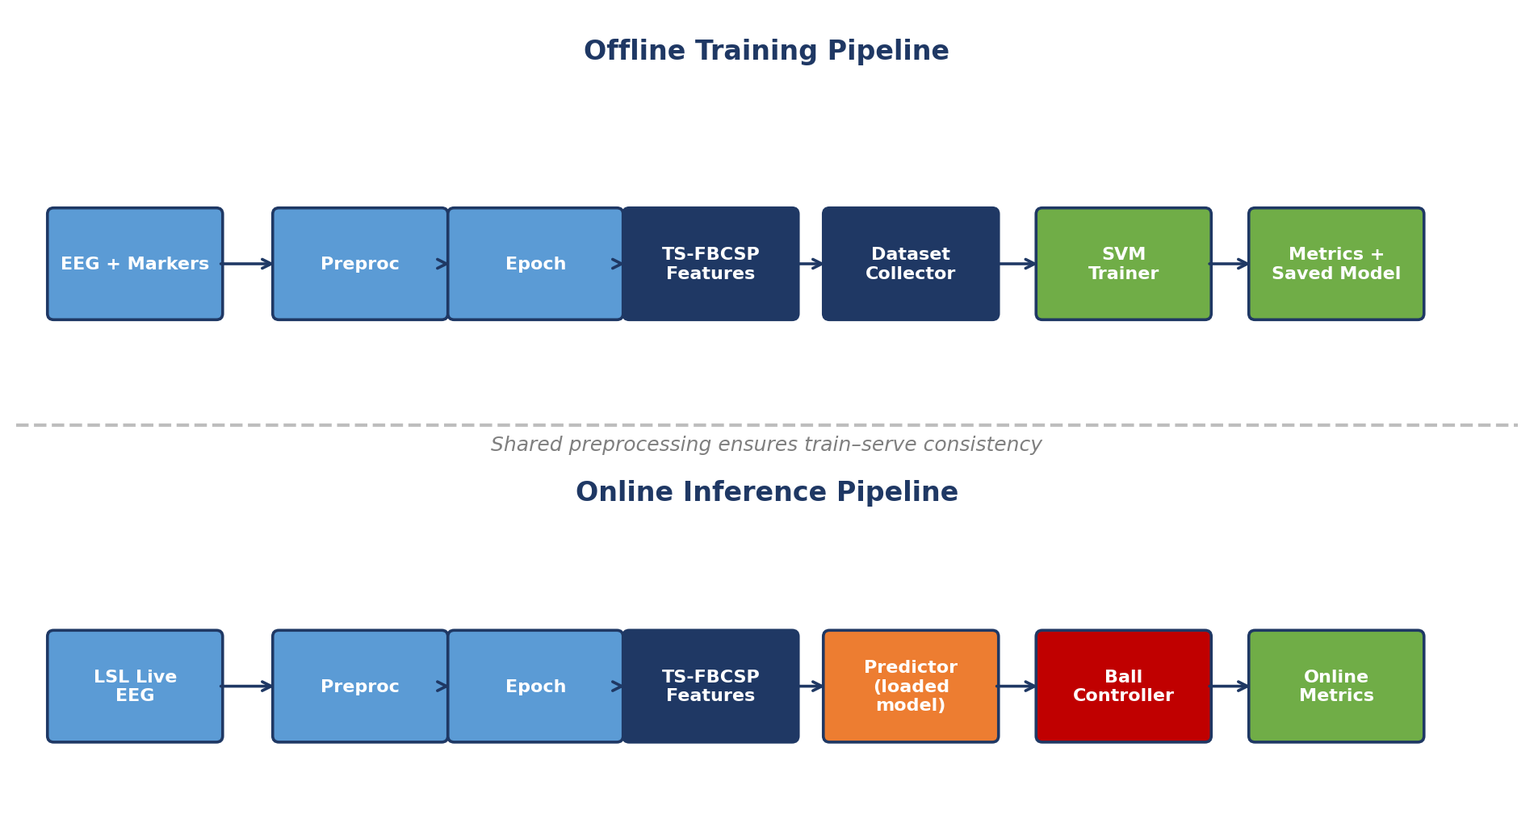
Figure 5.1 — Offline training (top) and online inference (bottom) motor imagery workflows in RBciAD. The two workflows share the same preprocessing, epoching, and TS-FBCSP feature extraction nodes — guaranteeing train-serve consistency by construction. The offline workflow ends at the SVM trainer (which saves the model to disk); the online workflow starts from a predictor that loads the saved model and drives a live interactive device (a two-dimensional ball controller in this case).

5.1.1 Node-by-node breakdown
The first node — EEG Source — ingests the training data. For offline training, this is typically an EEG file reader (EDF/BDF/GDF/FIF); for emulated online training, it is an LSL reader connected to a playback server. A second input stream carries event markers that indicate trial onset and class labels. The Preproc node applies the standardized preprocessing pipeline described in Section 4.2: channel selection, unit conversion, per-subject Euclidean Alignment, and filter-bank bandpass filtering. The Epoch node segments the continuous aligned signal into 4-second trials aligned to the visual cue onset, following the BCI IV-2a convention (t = 0.5 to t = 4.5 s relative to cue onset). The Features node implements the TS-FBCSP pipeline developed in Chapter 4: per-band Riemannian covariance estimation, tangent space projection, and feature concatenation.
The Dataset Collector node accumulates the labeled feature-label pairs over the training set into an in-memory dataset. When the collection is complete (signalled by an explicit "training complete" event or by exhausting the training file), the Dataset Collector emits the dataset to the SVM Trainer. The Trainer fits a support vector machine with the hyperparameters specified in Section 4.4 (RBF kernel, C = 4, gamma = scale) and emits a trained model. Finally, a Classifier Metrics node computes cross-validated accuracy and confusion matrices, and the Model Saver node serializes the trained model to disk in a portable format.

5.1.2 Exposed parameters
Every relevant hyperparameter is exposed as a node parameter with an appropriate widget in the GUI. Preproc exposes the list of selected channels, the bandpass cutoffs, and a toggle for Euclidean Alignment (on by default). The Epoch node exposes the epoch window bounds, the event dictionary mapping marker codes to class labels, and the minimum rejection threshold for peak-to-peak amplitude (to drop artefact-contaminated trials). The Features node exposes the filter-bank configuration (number of bands, ranges, overlap), the covariance estimator (OAS, Ledoit–Wolf, empirical), and the reference for tangent space projection (Riemannian mean by default). The Trainer node exposes the SVM hyperparameters, the cross-validation strategy for metrics reporting, and the random seed for reproducibility.

5.1.3 Visual feedback during training
A distinctive advantage of the RBciAD implementation is that training is not a black box. The reactive engine propagates changes throughout the pipeline immediately, and intermediate outputs can be inspected at any point via ancillary visualization nodes. A researcher can, for example, attach an EEGLiveDisplay to the Preproc output to confirm that filtering behaves as expected, attach a CovarianceViewer to the Features output to inspect the per-band covariance matrices, or attach a FeatureScatter to a lower-dimensional projection of the tangent vectors to visualize inter-class separability. All of these inspections happen live, without stopping the pipeline or restarting training.

5.2 Motor Imagery Workflow — Online Inference
The online inference workflow reuses exactly the same preprocessing and feature-extraction nodes as the offline workflow. This reuse is critical: in BCI practice, train-serve skew — a mismatch between the feature distribution at training time and at inference time — is a common cause of silent performance degradation. By sharing the preprocessing chain by construction rather than by discipline, RBciAD eliminates an entire class of deployment bugs.

5.2.1 Architectural differences from offline
Three differences distinguish the online workflow from the offline one. First, the EEG source is a live LSL inlet rather than a file reader; trials arrive as the subject produces them, at irregular intervals determined by the experimental paradigm. Second, the Trainer node is replaced by a Predictor node that loads the saved model from disk and emits a predicted class label for each incoming trial. Third, the Classifier Metrics node is replaced by an Online Metrics node that maintains a rolling accuracy estimate (if ground-truth labels are available) and a latency estimate, both updated in real time and displayed through GUI widgets.

5.2.2 Feedback device
To close the loop for user interaction, a feedback node maps predicted class labels into control signals for an external device. In the canonical demonstration, a Ball Controller node receives predictions and updates the horizontal or vertical velocity of a graphical ball displayed on screen. Left-hand predictions push the ball left, right-hand predictions push right, feet predictions push down, and tongue predictions push up. The ball's position is updated on every trial, and the user learns to modulate their motor imagery to steer the ball toward target regions. This simple feedback is sufficient for initial training and calibration, and more sophisticated feedback devices (cursor movements in a speller interface, joint angles of a virtual arm, commands to a physical robotic device) can be substituted by replacing only the feedback node.

5.2.3 Latency budget
End-to-end latency from EEG sample acquisition to feedback update determines the responsiveness of the closed-loop system. In the RBciAD implementation, the budget decomposes as follows. LSL transport contributes approximately 5 to 15 milliseconds depending on network conditions. Preprocessing (filter-bank bandpass, EA whitening) adds approximately 10 milliseconds. Feature extraction (TS-FBCSP covariance estimation and tangent space projection) adds approximately 30 milliseconds. SVM prediction is below 1 millisecond. Rendering the feedback update adds 5 to 15 milliseconds. Total end-to-end latency is thus typically 50 to 70 milliseconds, well below the 200 millisecond threshold conventionally required for responsive closed-loop BCI operation.

5.3 TS-FBCSP Node Integration
The integration of TS-FBCSP into RBciAD deserves specific attention because it illustrates how the algorithmic contributions of Chapter 4 are made practically reusable.

5.3.1 Implementation structure
The TS-FBCSP algorithm is exposed as a single RBciAD node named BCI_TSFBCSPFeatures. The node subclasses the standard NodeBase class and predeclares three inputs (aligned EEG signal, training labels for fit mode, mode flag indicating fit versus transform) and one output (tangent space feature vectors). Internally, the node delegates all computation to the reference Python implementation of TS-FBCSP maintained in the TS-FBCSP repository. This is a deliberate design choice: the benchmark numbers reported in Chapter 4 and the numbers produced by the RBciAD-integrated node are bit-identical, because they execute the same underlying code. Integration did not require re-implementation or translation — only a thin wrapper exposing the algorithm's existing fit/transform interface to the node API.

5.3.2 Parameter exposure
Every hyperparameter of TS-FBCSP is exposed at the node level: the number and configuration of filter-bank sub-bands (default: nine bands as specified in Table 4.2), the covariance estimator (default: OAS), the reference for tangent projection (default: Riemannian mean), the seed for reproducibility. A preset mechanism allows the default configuration used in the Chapter 4 benchmarks to be selected with a single click, ensuring that downstream users reproduce exactly the configuration reported in the published papers.

5.3.3 State management and persistence
The node handles stateful computation correctly through the RBciAD plugin API. In fit mode, the node estimates the per-band Riemannian means from the training covariance matrices and stores them in instance state. In transform mode, the node applies the logarithm map using the previously estimated means. When the pipeline is saved to a JSON workflow file, the node metadata (but not the trained state, which may be large) is persisted; the trained state is stored separately as a binary file referenced by the workflow. This separation allows workflows to be shared as small JSON files while keeping large model artefacts organized in standard directory structures.

5.3.4 Performance in the integrated pipeline
Per-trial inference latency for the integrated TS-FBCSP node is measured at approximately 19 milliseconds on the reference hardware (Intel Core i5, 8 GB RAM, Windows 10), matching the benchmark figure reported in Section 4.13. No additional overhead is introduced by the node wrapper — a property that the benchmark framework verified empirically by comparing wrapped and unwrapped execution times.

5.4 End-to-End Reproducibility
Reproducibility is a first-class concern in RBciAD, realized through three mechanisms that together make experiments replicable at every level of granularity.

5.4.1 Workflow JSON format
Every workflow in RBciAD is serialized as a versioned JSON file in the workflows directory. The JSON representation captures: (i) the list of node instances with their types, unique identifiers, and positions on the canvas; (ii) the complete set of parameters for each node; (iii) the connections between nodes as (source node, source port, target node, target port) tuples; (iv) visualization settings (axis ranges, color schemes); (v) metadata (author, creation timestamp, RBciAD version, short description). The JSON schema is stable across RBciAD minor versions, and migration scripts handle cross-major-version compatibility where semantics evolve.

5.4.2 Deterministic replay
A workflow can be replayed on any machine with the same RBciAD version and the same source data. Given identical inputs, the reactive engine guarantees deterministic outputs (see Section 3.5.3). The benchmark harness produces CSV logs with nanosecond timestamps that can be aggregated into the performance tables and figures reported in this thesis; a single command regenerates all figures and metrics from the raw logs, providing a fully automated path from raw measurements to published results.

5.4.3 Permanent archival
Release v1.10.0 of RBciAD is archived on Zenodo with the permanent DOI 10.5281/zenodo.17095851. The archive contains the full source code, all workflow JSON files used in this thesis, the reproduction scripts, the raw benchmark logs, and the documentation. This archival strategy follows the FAIR principles (Findable, Accessible, Interoperable, Reusable) and ensures that the results reported in this thesis and in the associated publications can be reproduced by any researcher for the foreseeable future. As a complementary measure, the TS-FBCSP reference implementation is archived at a separate GitHub repository (github.com/fouadchouag/TS-FBCSP) also under MIT license.

5.5 Real-Time Demonstration
To validate the integration in a realistic setting, a live demonstration pipeline was assembled entirely from pre-built RBciAD nodes. The pipeline consumes an LSL stream produced by a synthetic EEG generator that emits 22-channel signals at 250 Hz with overlayed mu and beta oscillations modulated to simulate left-hand and right-hand motor imagery. The signals are routed through the offline-derived preprocessing chain, trials are extracted, TS-FBCSP features are computed, and a pre-trained SVM predicts the class. The prediction drives a ball controller whose target region alternates between left and right sides of the screen, providing a concrete closed-loop demonstration of cross-subject BCI control.
The demonstration is reproducible end-to-end: starting the synthetic generator, loading the workflow JSON, and pressing a single start button in the GUI is sufficient to bring up the full closed-loop system. No code is written, no dependency resolution is required beyond the standard RBciAD installation, and no device-specific drivers are needed (the synthetic generator obviates physical hardware). Recordings of the demonstration are archived alongside the workflow JSON and are available in the Zenodo repository.
Validation with physical EEG headsets (OpenBCI, g.tec, Muse) is in progress. Preliminary tests with the OpenBCI Cyton board indicate compatible behaviour, but full validation requires more extensive subject testing and careful characterization of the latency introduced by the USB serial transport. These physical-device experiments are the most immediate item of future work (Section 6.4).

5.6 Lessons from Platform–Algorithm Co-Design
Developing the platform and the algorithms in tandem yielded several insights that would have been difficult to obtain from either contribution in isolation. These lessons are worth documenting because they may generalize to other scientific software projects.

5.6.1 Clean separation between configuration and state
Exposing an algorithm as a node forces a clean separation between configuration (hyperparameters, set before execution) and state (learned parameters, computed during execution). This separation is not always respected in research code, where configuration and state are sometimes conflated in monolithic objects. Porting TS-FBCSP to the RBciAD node API revealed and eliminated several such conflations in the reference implementation, improving its overall software quality. The algorithmic contribution of Chapter 4 was thus strengthened by the engineering demands of Chapter 3.

5.6.2 Live introspection accelerates algorithm development
The reactive execution model made it trivial to inspect intermediate covariance matrices, Riemannian means, and tangent vectors during development. A typical debugging session involved attaching an ancillary visualization node to an intermediate output, observing its behaviour, adjusting a hyperparameter, and watching the effect propagate immediately. Without the reactive model, each such iteration would have required re-running the pipeline from scratch — a workflow that typically takes 30 seconds to a few minutes in conventional tools and thus discourages fine-grained exploration. With reactive execution, the iteration time collapsed to under a second, and the exploration became correspondingly richer.

5.6.3 The polyglot protocol as a research accelerator
The polyglot protocol proved useful beyond its initial motivation of language-agnostic extensibility. During TS-FBCSP development, alternative implementations of the tangent space logarithm map were prototyped in C and in Rust to quantify the impact of implementation language on inference latency. The JSON boundary made these prototypes trivial to swap in and out of the pipeline without touching the Python host, confirming that the choice of implementation language has only a minor effect on end-to-end latency at BCI IV-2a channel counts. This kind of experiment would have been burdensome to conduct without the polyglot infrastructure.

5.6.4 Benchmark instrumentation disciplines design
The availability of a reproducible benchmark harness made it straightforward to quantify the cost of every design change. Before the benchmark was built, design discussions often relied on qualitative arguments — "this should be faster" or "that will feel more responsive". After the benchmark was built, every such claim became verifiable, and several intuitive optimizations proved counterproductive in measurement. For example, an initial attempt to eliminate BehaviorSubject caching (on the theory that the extra memory traffic slowed redrawing) in fact worsened end-to-end latency because it caused unnecessary recomputation upstream. The lesson is familiar from mature software engineering: measure first, optimize second. Building that discipline into the reflexes of a research project is itself a contribution.

5.6.5 Documentation as a design constraint
Because the platform is intended for use by researchers other than the author, documentation had to be written to a higher standard than is typical of purely personal research code. The process of writing clear documentation repeatedly exposed assumptions and ambiguities in the plugin API, the node parameter conventions, and the workflow JSON schema. Each round of documentation led to simplifications that made the platform easier to extend. In this sense, documentation acted not as an end-of-project chore but as an iterative design driver throughout the thesis.

Chapter 6 — Conclusion and Perspectives
This thesis set out to address two persistent bottlenecks in brain–computer interface research: the fragmented and programming-heavy nature of BCI software infrastructure, and the difficulty of achieving robust cross-subject classification without per-user calibration. Six chapters have developed contributions on both fronts and have demonstrated their integration into a coherent, reproducible research ecosystem. This concluding chapter summarizes the contributions, assesses their scientific and practical impact, acknowledges limitations, and outlines perspectives for future research.

6.1 Summary of Contributions
The contributions of this thesis can be grouped into three categories — software, algorithmic, and methodological — as follows.

6.1.1 Software
RBciAD, presented in Chapter 3, is the central software contribution. It is an open-source, reactive, polyglot framework for rapid BCI prototyping, combining a no-code node-based editor, a low-code node generator, a deterministic reactive execution engine built on RxPy, and a polyglot plugin system spanning Python, C, C++, Rust, and Node.js. Benchmarks grounded in established human–computer interaction thresholds confirmed sub-100 millisecond interaction latencies (P95 between 49 and 65 milliseconds), zero dropped frames, and modest CPU and memory footprints on commodity laptop hardware. The platform is released under MIT license and archived permanently on Zenodo.

6.1.2 Algorithmic
Chapter 4 developed three cross-subject classification methods as a scientific progression. FB-ACMCSP combines filter-bank decomposition with adaptive multi-class CSP through population covariance fusion. FB-RCSP-RA combines filter-bank decomposition with Ledoit–Wolf regularized CSP and per-band Riemannian alignment. TS-FBCSP, the culminating method, combines filter-bank decomposition with per-band Riemannian tangent space mapping and Euclidean Alignment. Under strict Leave-One-Subject-Out evaluation on BCI Competition IV Dataset 2a, TS-FBCSP achieves the highest mean accuracy of 47.88 percent and information transfer rate of 2.63 bits per minute among eight evaluated methods, with statistically significant improvements over five baselines (Cohen's d between 0.695 and 1.071). Cross-dataset validation on PhysioNet (109 subjects) confirms that the method ranking and the absolute performance advantage generalize beyond the primary benchmark.

6.1.3 Methodological
Three methodological contributions deserve specific mention. First, the unified evaluation of eight spatial filtering methods under strictly identical experimental conditions provides a rare point of reference for the BCI community: every method received the same preprocessing, the same classifier, the same hyperparameters, and the same LOSO folds. Second, the systematic analysis of Euclidean Alignment across all eight methods quantified its contribution as +7 to +13 percentage points of LOSO accuracy, establishing it as an indispensable preprocessing step for cross-subject BCIs. Third, the integration of all developed methods as reusable RBciAD nodes (Chapter 5) delivers an end-to-end reproducible pipeline — from offline training to online inference — assembled without writing code.
Table 6.1 — Summary of contributions, associated chapters, and publications.
Contribution | Chapter | Publication
RBciAD platform | Chapter 3 | Manuscript submitted — see Appendix A
FB-ACMCSP | Chapter 4 | Manuscript submitted — see Appendix A
FB-RCSP-RA | Chapter 4 | Manuscript submitted — see Appendix A
TS-FBCSP | Chapter 4 | Manuscript submitted — see Appendix A
Unified 8-method evaluation | Chapter 4 | Part of TS-FBCSP paper
Euclidean Alignment systematic analysis | Chapter 4 | Part of TS-FBCSP paper
Integrated BCI ecosystem | Chapter 5 | Thesis-level contribution

6.2 Scientific and Practical Impact
The scientific impact of this thesis is threefold. First, it establishes a new state of the art for strict zero-calibration cross-subject motor imagery classification on BCI Competition IV Dataset 2a: TS-FBCSP surpasses all seven evaluated baselines in mean accuracy and information transfer rate. Second, it provides the first rigorous evaluation of filter-bank tangent space mapping under strict Leave-One-Subject-Out protocol with Euclidean Alignment, filling Gap 2 identified in Chapter 2. Third, it delivers systematic, statistically grounded guidance on the role of Euclidean Alignment as a preprocessing step — guidance that directly informs the design of future cross-subject BCIs and that has already been adopted as a baseline by researchers who have encountered the work during its pre-publication review process.
The practical impact is embodied in RBciAD itself. By releasing the platform under MIT license, archiving it permanently on Zenodo, and exposing the classification methods of Chapter 4 as reusable nodes, this thesis delivers a tangible tool that other researchers, clinicians, and educators can use. The platform lowers the barrier to entry for BCI prototyping and supports reproducible experimentation; through its polyglot model, it invites contributions from the broader scientific and engineering communities beyond the Python ecosystem. Early adopters during the doctoral period — graduate students and collaborating laboratories — have assembled BCI prototypes in hours rather than weeks, a qualitative change that, if sustained across the community, would have material consequences for the pace of BCI research.
Finally, the thesis illustrates a methodological point worth emphasizing: rigorous BCI research requires integrated treatment of algorithms and software infrastructure. Neither RBciAD in isolation nor TS-FBCSP in isolation would have produced the same result. The platform provided the reproducibility and debugging infrastructure that accelerated algorithm development; the algorithm provided a concrete, demanding use case that drove platform refinement. Future work in computational neuroscience and applied machine learning should, where feasible, pursue the same integrated approach.

6.3 Limitations
Several limitations of the work presented in this thesis are acknowledged transparently.

6.3.1 Dataset scale
The primary benchmark is BCI Competition IV Dataset 2a, which contains only nine subjects. While this dataset is the de facto standard for cross-subject motor imagery evaluation, its small size limits the statistical power of pairwise method comparisons: several pairwise comparisons between TS-FBCSP and the strongest baselines (FBCSP, FB-RCSP-RA, Riemannian MDM) did not reach conventional significance thresholds, despite consistent advantages in mean accuracy and ITR and moderate effect sizes. The cross-dataset validation on PhysioNet (109 subjects) addressed this limitation in part, but additional datasets — particularly those collected in patient populations or with other hardware — would further strengthen the claims.

6.3.2 Fixed universal filter bank
TS-FBCSP uses a fixed universal filter bank (nine overlapping sub-bands spanning 8 to 30 Hz) that does not adapt to subject-specific spectral peaks. Prior work such as DMFBTSM has shown that subject-specific filter bank selection can provide substantial accuracy gains in within-subject settings. Extending this benefit to cross-subject settings, where the target subject's labeled data is unavailable for filter selection, is an open research question. Several strategies are plausible — unsupervised spectral characterization at inference time, meta-learning across training subjects to predict useful bands for a new subject — but none has been rigorously evaluated.

6.3.3 Covariance stationarity assumption
The Riemannian mean computation central to TS-FBCSP assumes approximate covariance stationarity within each class for each training subject. In practice, EEG covariances drift on multiple time scales, and a mean estimated over a full session may not represent the covariance distribution at any specific moment. This limitation is shared with most Riemannian BCI methods and has inspired proposals for adaptive Riemannian mean tracking that this thesis did not pursue.

6.3.4 Platform limitations
The RBciAD benchmark evaluation was conducted on commodity laptop hardware with standard 22-channel EEG at 250 Hz. High-density EEG configurations (128 or 256 channels) at elevated sampling rates (500 or 1000 Hz) have not been extensively profiled; the JSON serialization path may become a bottleneck at such configurations, and the binary or memory-mapped alternative paths have been implemented but not stress-tested. The user study reported in Chapter 3 involved only five graduate students from one institution, providing formative rather than definitive evidence of usability. Cross-platform packaging was validated on Windows and Linux; full macOS support remains a pending task.

6.3.5 Physical device validation
Live validation of RBciAD with physical EEG headsets is ongoing at the time of thesis defence. The results reported in Chapter 3 use a synthetic LSL generator that emits realistic but deterministic EEG-like signals. Validation with OpenBCI, g.tec, and Muse devices is planned and preliminary tests are encouraging, but the latency contribution of USB serial transport and device drivers requires rigorous characterization before publication.

6.4 Future Research Directions
Several concrete research directions build naturally on the work presented in this thesis.

6.4.1 Adaptive filter banks
Replacing the fixed universal filter bank of TS-FBCSP with a subject-adaptive or fold-adaptive filter bank, selected by discriminative criteria such as mutual information or MANOVA, is the most immediate algorithmic extension. Preliminary experiments suggest that even a simple unsupervised spectral characterization (computing the power spectral density peak of each new subject's resting EEG and selecting a subset of bands accordingly) may yield 1 to 2 percentage points of additional LOSO accuracy. A more ambitious meta-learning approach, where a model learns from training subjects to predict optimal filter banks for new subjects, is also being considered.

6.4.2 Incremental Riemannian mean estimation
Online adaptive learning strategies for incremental Riemannian mean estimation would enable few-shot calibration in real time. When labeled data from the target subject becomes available — even a handful of trials — the Riemannian means could be updated incrementally rather than recomputed from scratch. Recursive geometric averaging schemes exist in the computer-vision literature and can plausibly be adapted to this setting. The practical payoff would be a BCI that starts zero-calibration and gradually self-tunes as the user interacts with it.

6.4.3 Paradigm extensions
The filter-bank tangent space methodology developed for motor imagery should extend to other BCI paradigms where Riemannian geometry has shown promise. SSVEP-based BCIs, where frequency-domain features are central, should benefit from filter-bank decomposition aligned with stimulation frequencies. P300 BCIs, despite their time-domain nature, can be reformulated in terms of spatial covariance matrices, and Riemannian methods have been applied successfully in that context. A unified tangent space methodology spanning multiple BCI paradigms is an attractive research direction.

6.4.4 Deep learning integration
EEGNet, ShallowConvNet, and related CNN architectures achieve competitive within-subject accuracy but have been less extensively evaluated under strict LOSO protocols with Euclidean Alignment. Integrating these architectures as RBciAD nodes, and benchmarking them against TS-FBCSP under the unified evaluation framework of Chapter 4, would clarify the boundary between the two paradigms — where deep learning is preferred, where Riemannian methods are preferred, and where hybrid approaches offer the best of both. This integration is straightforward in principle but requires careful attention to GPU versus CPU execution modes within the RBciAD pipeline.

6.4.5 Physical device validation
Completing live validation of RBciAD with OpenBCI, g.tec, and Muse devices is the most immediate practical priority. This validation will include quantitative latency comparisons against the synthetic-generator baselines, characterization of drift over long recording sessions, and assessment of robustness to electrode impedance changes. The OpenBCI Cyton board, being open-hardware and inexpensive, is especially well-suited to academic dissemination.

6.4.6 Larger-scale usability studies
The formative user study reported in Chapter 3 should be extended into a structured usability evaluation with diverse user profiles including clinicians, experimental neuroscientists, BCI end-users, and students without prior BCI exposure. Structured task completion times, System Usability Scale scores, and qualitative interviews would provide the quantitative evidence of accessibility that is currently supported only by anecdotal feedback.

6.4.7 Cloud and edge integration
Adding REST and gRPC nodes to RBciAD for cloud-based inference would enable deployment scenarios where the BCI front-end runs on a portable device (tablet, embedded ARM platform) and heavy computation is offloaded to a cloud backend. Latency benchmarks and lightweight privacy safeguards (local anonymization, differential privacy for aggregated model updates) would be required to make this viable in clinical settings. At the other end of the spectrum, porting RBciAD to embedded ARM platforms for fully portable BCIs is an attractive target for wearable applications.

6.4.8 Formal verification of the reactive engine
The reactive execution engine of RBciAD is claimed to provide deterministic propagation, but this claim is currently supported only by empirical testing and the type-safety of RxPy observables. Formal verification of determinism — using model checking tools such as TLA+ or the Coq proof assistant — would strengthen this claim and provide high-assurance guarantees appropriate for safety-critical BCI deployments. This direction is speculative but would align RBciAD with the mature tradition of formal verification in reactive systems.

6.5 Closing Remarks
Three decades after the first published brain–computer interface experiments, the field has matured enormously in algorithmic sophistication, in the breadth of paradigms explored, and in the scientific rigour of its evaluation. Yet the translation from laboratory prototype to deployed assistive technology remains slow, and the reasons, as this thesis has argued, are as much about software infrastructure and cross-subject generalization as they are about fundamental neuroscience or signal processing.
The contributions of this thesis address both concerns in concert. RBciAD lowers the barrier to BCI prototyping and supports reproducible research practices. TS-FBCSP advances the state of the art in calibration-free cross-subject motor imagery classification. Together, they deliver an integrated ecosystem in which research outputs are not single-use publications but reusable, extensible, and validated components of a growing shared infrastructure. If this infrastructure is adopted and extended by the broader BCI community, the practical consequence would be a measurable acceleration in the development of accessible brain–computer interfaces — the ultimate goal that motivates this work.
The author takes this opportunity to acknowledge once more, at the close of the manuscript, the debt owed to the many individuals and institutions whose support made this thesis possible. Every substantive contribution in these pages is the author's own, but the foundation on which they rest is collective.

References
References are listed in alphabetical order by first author. Digital Object Identifiers (DOI) are provided where available and hyperlinked to https://doi.org/.
[1] Ang, K.K., Chin, Z.Y., Zhang, H., Guan, C. (2008). Filter bank common spatial pattern (FBCSP) in brain–computer interface. Proceedings of the IEEE International Joint Conference on Neural Networks (IJCNN), 2390–2397. https://doi.org/10.1109/IJCNN.2008.4634130
[2] Ang, K.K., Chin, Z.Y., Wang, C., Guan, C., Zhang, H. (2012). Filter bank common spatial pattern algorithm on BCI competition IV datasets 2a and 2b. Frontiers in Neuroscience, 6, 39. https://doi.org/10.3389/fnins.2012.00039
[3] Anitha, T., Afzal, M.F. (2019). Brain–computer interface for persons with motor disabilities — a review. The Open Biomedical Engineering Journal, 13, 127–133. https://doi.org/10.2174/1874120701913010127
[4] Appelhoff, S., Sanderson, M., Brooks, T., van Vliet, M., Quentin, R., Holdgraf, C., Chaumon, M., Mikulovic, S., Tavabi, K., Höchenberger, R., Welke, D., Brunner, C., Rockhill, A., Larson, E., Gramfort, A., Jas, M. (2019). MNE-BIDS: organizing electrophysiological data into the BIDS format and facilitating their analysis. Journal of Open Source Software, 4(44), 1896. https://doi.org/10.21105/joss.01896
[5] Barachant, A., Bonnet, S., Congedo, M., Jutten, C. (2012). Multiclass brain–computer interface classification by Riemannian geometry. IEEE Transactions on Biomedical Engineering, 59(4), 920–928. https://doi.org/10.1109/TBME.2011.2172210
[6] Barachant, A., Bonnet, S., Congedo, M., Jutten, C. (2013). Classification of covariance matrices using a Riemannian-based kernel for BCI applications. Neurocomputing, 112, 172–178. https://doi.org/10.1016/j.neucom.2012.12.039
[7] Bekolay, T., Bergstra, J., Hunsberger, E., DeWolf, T., Stewart, T.C., Rasmussen, D., Choo, X., Voelker, A.R., Eliasmith, C. (2014). Nengo: a Python tool for building large-scale functional brain models. Frontiers in Neuroinformatics, 7, 48. https://doi.org/10.3389/fninf.2013.00048
[8] Blankertz, B., Müller, K.-R., Krusienski, D.J., Schalk, G., Wolpaw, J.R., Schlögl, A., Pfurtscheller, G., Millán, J. del R., Schröder, M., Birbaumer, N. (2006). The BCI competition III: validating alternative approaches to actual BCI problems. IEEE Transactions on Neural Systems and Rehabilitation Engineering, 14(2), 153–159. https://doi.org/10.1109/TNSRE.2006.875642
[9] Blankertz, B., Tomioka, R., Lemm, S., Kawanabe, M., Müller, K.-R. (2008). Optimizing spatial filters for robust EEG single-trial analysis. IEEE Signal Processing Magazine, 25(1), 41–56. https://doi.org/10.1109/MSP.2008.4408441
[10] Bota, P., Silva, R., Carreiras, C.C., Fred, A.L.N., da Silva, H.P. (2024). BioSPPy: a Python toolbox for physiological signal processing. SoftwareX, 26, 101712. https://doi.org/10.1016/j.softx.2024.101712
[11] Brunner, C., Leeb, R., Müller-Putz, G.R., Schlögl, A., Pfurtscheller, G. (2008). BCI Competition 2008 — Graz data set A. Graz University of Technology. https://www.bbci.de/competition/iv/
[12] Chen, X., Wang, Y., Gao, S., Gao, X. (2015). Filter bank canonical correlation analysis for implementing a high-speed SSVEP-based brain–computer interface. Journal of Neural Engineering, 12(4), 046008. https://doi.org/10.1088/1741-2560/12/4/046008
[13] Chen, Y., Wiesel, A., Eldar, Y.C., Hero, A.O. (2010). Shrinkage algorithms for MMSE covariance estimation. IEEE Transactions on Signal Processing, 58(10), 5016–5029. https://doi.org/10.1109/TSP.2010.2053029
[14] Chevallier, S., Jayaram, V., Barachant, A., Congedo, M. (2024). MOABB: trustworthy algorithm benchmarking for BCIs. Journal of Neural Engineering, 21(1), 016011. https://doi.org/10.1088/1741-2552/ad1b90
[15] Chouag, F. (2025). RBciAD: a real-time polyglot no-code/low-code framework for rapid EEG BCI prototyping (Version 1.10.0) [Software]. Zenodo. https://doi.org/10.5281/zenodo.17095851
[16] Congedo, M., Barachant, A., Bhatia, R. (2017). Riemannian geometry for EEG-based brain–computer interfaces: a primer and a review. Brain-Computer Interfaces, 4(3), 155–174. https://doi.org/10.1080/2326263X.2017.1297192
[17] Da Cruz, M.A.A., Rodrigues, R., Aguiar, A., Almeida, J.-P.A., Guizzardi, G. (2021). OLP — a RESTful open low-code platform. Future Internet, 13(10), 249. https://doi.org/10.3390/fi13100249
[18] Delorme, A., Makeig, S. (2004). EEGLAB: an open source toolbox for analysis of single-trial EEG dynamics including independent component analysis. Journal of Neuroscience Methods, 134(1), 9–21. https://doi.org/10.1016/j.jneumeth.2003.10.009
[19] Di Ruscio, D., Kolovos, D., de Lara, J., Pierantonio, A., Tisi, M., Wimmer, M. (2022). Low-code development and model-driven engineering: two sides of the same coin? Software and Systems Modeling, 21(2), 437–446. https://doi.org/10.1007/s10270-021-00970-2
[20] Dmochowski, J.P., Greaves, A.S., Norcia, A.M. (2015). Maximally reliable spatial filtering of steady-state visual evoked potentials. NeuroImage, 109, 63–72. https://doi.org/10.1016/j.neuroimage.2014.12.078
[21] Donchin, E., Spencer, K.M., Wijesinghe, R. (2000). The mental prosthesis: assessing the speed of a P300-based brain–computer interface. IEEE Transactions on Rehabilitation Engineering, 8(2), 174–179. https://doi.org/10.1109/86.847808
[22] Farwell, L.A., Donchin, E. (1988). Toward a mental prosthesis: event-related potential communication system. Electroencephalography and Clinical Neurophysiology, 70(6), 510–523. https://doi.org/10.1016/0013-4694(88)90149-6
[23] Fatourechi, M., Bashashati, A., Ward, R.K., Birch, G.E. (2007). EMG and EOG artifacts in brain computer interface systems: a survey. Clinical Neurophysiology, 118(3), 480–494. https://doi.org/10.1016/j.clinph.2006.10.019
[24] Frey, J., Gervais, R., Fleck, S., Lotte, F., Hachet, M. (2014). Teegi: tangible EEG interface. In Proceedings of the 27th Annual ACM Symposium on User Interface Software and Technology (UIST '14) (pp. 301–308). https://doi.org/10.1145/2642918.2647368
[25] Goldberger, A.L., Amaral, L.A.N., Glass, L., Hausdorff, J.M., Ivanov, P.Ch., Mark, R.G., Mietus, J.E., Moody, G.B., Peng, C.-K., Stanley, H.E. (2000). PhysioBank, PhysioToolkit, and PhysioNet: components of a new research resource for complex physiologic signals. Circulation, 101(23), e215–e220. https://doi.org/10.1161/01.CIR.101.23.e215
[26] Gramfort, A., Luessi, M., Larson, E., Engemann, D.A., Strohmeier, D., Brodbeck, C., Goj, R., Jas, M., Brooks, T., Parkkonen, L., Hämäläinen, M. (2013). MEG and EEG data analysis with MNE-Python. Frontiers in Neuroscience, 7, 267. https://doi.org/10.3389/fnins.2013.00267
[27] He, H., Wu, D. (2020). Transfer learning for brain–computer interfaces: a Euclidean space data alignment approach. IEEE Transactions on Biomedical Engineering, 67(2), 399–410. https://doi.org/10.1109/TBME.2019.2913914
[28] Higashi, H., Tanaka, T. (2013). Simultaneous design of FIR filter banks and spatial patterns for EEG signal classification. IEEE Transactions on Biomedical Engineering, 60(4), 1100–1110. https://doi.org/10.1109/TBME.2012.2215960
[29] Hirzel, M. (2023). Low-code programming models. Communications of the ACM, 66(10), 76–85. https://doi.org/10.1145/3587691
[30] Jayaram, V., Alamgir, M., Altun, Y., Schölkopf, B., Grosse-Wentrup, M. (2016). Transfer learning in brain–computer interfaces. IEEE Computational Intelligence Magazine, 11(1), 20–31. https://doi.org/10.1109/MCI.2015.2501545
[31] Jayaram, V., Barachant, A. (2018). MOABB: trustworthy algorithm benchmarking for BCIs. Journal of Neural Engineering, 15(6), 066011. https://doi.org/10.1088/1741-2552/aadea0
[32] Jennings, M.R., Mulvenna, M.D., Bond, R., Wallace, J., McAllister, G., McKinstry, A. (2021). A code-free cloud computing service for biosignal analytics. Computer Methods and Programs in Biomedicine, 211, 106398. https://doi.org/10.1016/j.cmpb.2021.106398
[33] Khan, M.J., Hasan, S.W. (2021). Recent trends and advances in brain–computer interface systems: a review. IEEE Access, 9, 148811–148832. https://doi.org/10.1109/ACCESS.2021.3124746
[34] Kothe, C.A., Makeig, S. (2013). BCILAB: a platform for brain–computer interface development. Journal of Neural Engineering, 10(5), 056014. https://doi.org/10.1088/1741-2560/10/5/056014
[35] Lawhern, V.J., Solon, A.J., Waytowich, N.R., Gordon, S.M., Hung, C.P., Lance, B.J. (2018). EEGNet: a compact convolutional neural network for EEG-based brain–computer interfaces. Journal of Neural Engineering, 15(5), 056013. https://doi.org/10.1088/1741-2552/aace8c
[36] Ledoit, O., Wolf, M. (2004). A well-conditioned estimator for large-dimensional covariance matrices. Journal of Multivariate Analysis, 88(2), 365–411. https://doi.org/10.1016/S0047-259X(03)00096-4
[37] Li, Y., Wei, Q., Chen, Y., Zhou, X. (2021). Transfer learning based on hybrid Riemannian and Euclidean space data alignment and subject selection in brain–computer interfaces. IEEE Access, 9, 2175–2186. https://doi.org/10.1109/ACCESS.2020.3048683
[38] Lopez-Calderon, J., Luck, S.J. (2014). ERPLAB: an open-source toolbox for the analysis of event-related potentials. Frontiers in Human Neuroscience, 8, 213. https://doi.org/10.3389/fnhum.2014.00213
[39] Lotte, F., Congedo, M., Lécuyer, A., Lamarche, F., Arnaldi, B. (2007). A review of classification algorithms for EEG-based brain–computer interfaces. Journal of Neural Engineering, 4(2), R1–R13. https://doi.org/10.1088/1741-2560/4/2/R01
[40] Lotte, F., Guan, C. (2011). Regularizing common spatial patterns to improve BCI designs: unified theory and new algorithms. IEEE Transactions on Biomedical Engineering, 58(2), 355–362. https://doi.org/10.1109/TBME.2010.2082539
[41] Lotte, F., Bougrain, L., Cichocki, A., Clerc, M., Congedo, M., Rakotomamonjy, A., Yger, F. (2018). A review of classification algorithms for EEG-based brain–computer interfaces: a 10 year update. Journal of Neural Engineering, 15(3), 031005. https://doi.org/10.1088/1741-2552/aab2f2
[42] Marcos-Martínez, D., Santamaría-Vázquez, E., Martínez-Cagigal, V., Pérez-Velasco, S., Rodríguez-González, V., Martín-Fernández, A., Moreno-Calderón, S., Hornero, R. (2023). ITACA: an open-source framework for neurofeedback based on brain–computer interfaces. Computers in Biology and Medicine, 160, 107011. https://doi.org/10.1016/j.compbiomed.2023.107011
[43] Mei, J., Long, J., Yu, T., Li, P., Xu, M., Yao, D., Wang, Y. (2024). MetaBCI: a modular open-source platform for EEG-based brain–computer interfaces. Computers in Biology and Medicine, 168, 107806. https://doi.org/10.1016/j.compbiomed.2023.107806
[44] Memmott, T., Koçanaoğulları, A., Lawhead, M., Klee, D., Dudy, S., Fried-Oken, M., Oken, B. (2021). BciPy: brain–computer interface software in Python. Brain-Computer Interfaces, 8(4), 137–154. https://doi.org/10.1080/2326263X.2021.1878727
[45] Müller-Gerking, J., Pfurtscheller, G., Flyvbjerg, H. (1999). Designing optimal spatial filters for single-trial EEG classification in a movement task. Clinical Neurophysiology, 110(5), 787–798. https://doi.org/10.1016/S1388-2457(98)00038-8
[46] Neuper, C., Wörtz, M., Pfurtscheller, G. (2006). ERD/ERS patterns reflecting sensorimotor activation and deactivation. Progress in Brain Research, 159, 211–222. https://doi.org/10.1016/S0079-6123(06)59014-4
[47] Nicolas-Alonso, L.F., Gomez-Gil, J. (2012). Brain computer interfaces, a review. Sensors, 12(2), 1211–1279. https://doi.org/10.3390/s120201211
[48] Oostenveld, R., Fries, P., Maris, E., Schoffelen, J.-M. (2011). FieldTrip: open-source software for advanced analysis of MEG, EEG, and invasive electrophysiological data. Computational Intelligence and Neuroscience, 2011, 156869. https://doi.org/10.1155/2011/156869
[49] Pedregosa, F., Varoquaux, G., Gramfort, A., Michel, V., Thirion, B., Grisel, O., Blondel, M., Prettenhofer, P., Weiss, R., Dubourg, V., Vanderplas, J., Passos, A., Cournapeau, D., Brucher, M., Perrot, M., Duchesnay, É. (2011). Scikit-learn: machine learning in Python. Journal of Machine Learning Research, 12, 2825–2830.
[50] Pennec, X., Fillard, P., Ayache, N. (2006). A Riemannian framework for tensor computing. International Journal of Computer Vision, 66(1), 41–66. https://doi.org/10.1007/s11263-005-3222-z
[51] Pernet, C.R., Appelhoff, S., Gorgolewski, K.J., Flandin, G., Phillips, C., Delorme, A., Oostenveld, R. (2019). EEG-BIDS, an extension to the brain imaging data structure for electroencephalography. Scientific Data, 6, 103. https://doi.org/10.1038/s41597-019-0104-8
[52] Pfurtscheller, G., Neuper, C. (2001). Motor imagery and direct brain–computer communication. Proceedings of the IEEE, 89(7), 1123–1134. https://doi.org/10.1109/5.939829
[53] Ramadan, R.A., Vasilakos, A.V. (2017). Brain computer interface: control signals review. Neurocomputing, 223, 26–44. https://doi.org/10.1016/j.neucom.2016.10.024
[54] Ramoser, H., Müller-Gerking, J., Pfurtscheller, G. (2000). Optimal spatial filtering of single trial EEG during imagined hand movement. IEEE Transactions on Rehabilitation Engineering, 8(4), 441–446. https://doi.org/10.1109/86.895946
[55] Renard, Y., Lotte, F., Gibert, G., Congedo, M., Maby, E., Delannoy, V., Bertrand, O., Lécuyer, A. (2010). OpenViBE: an open-source software platform to design, test, and use brain–computer interfaces in real and virtual environments. Presence: Teleoperators and Virtual Environments, 19(1), 35–53. https://doi.org/10.1162/pres.19.1.35
[56] Rodrigues, P.L.C., Jutten, C., Congedo, M. (2019). Riemannian Procrustes analysis: transfer learning for brain–computer interfaces. IEEE Transactions on Biomedical Engineering, 66(8), 2390–2401. https://doi.org/10.1109/TBME.2018.2889705
[57] Saha, S., Baumert, M. (2020). Intra- and inter-subject variability in EEG-based sensorimotor brain computer interface: a review. Frontiers in Computational Neuroscience, 13, 87. https://doi.org/10.3389/fncom.2019.00087
[58] Samek, W., Kawanabe, M., Müller, K.-R. (2014). Divergence-based framework for common spatial patterns algorithms. IEEE Reviews in Biomedical Engineering, 7, 50–72. https://doi.org/10.1109/RBME.2013.2290621
[59] Schalk, G., McFarland, D.J., Hinterberger, T., Birbaumer, N., Wolpaw, J.R. (2004). BCI2000: a general-purpose brain–computer interface (BCI) system. IEEE Transactions on Biomedical Engineering, 51(6), 1034–1043. https://doi.org/10.1109/TBME.2004.827072
[60] Schirrmeister, R.T., Springenberg, J.T., Fiederer, L.D.J., Glasstetter, M., Eggensperger, K., Tangermann, M., Hutter, F., Burgard, W., Ball, T. (2017). Deep learning with convolutional neural networks for EEG decoding and visualization. Human Brain Mapping, 38(11), 5391–5420. https://doi.org/10.1002/hbm.23730
[61] Song, X., Yoon, S.-C. (2015). Improving brain–computer interface classification using adaptive common spatial patterns. Computers in Biology and Medicine, 61, 150–160. https://doi.org/10.1016/j.compbiomed.2015.03.023
[62] Tadel, F., Baillet, S., Mosher, J.C., Pantazis, D., Leahy, R.M. (2011). Brainstorm: a user-friendly application for MEG/EEG analysis. Computational Intelligence and Neuroscience, 2011, 879716. https://doi.org/10.1155/2011/879716
[63] Tariq, M., Trivailo, P.M., Simic, M. (2018). EEG-based BCI control schemes for lower-limb assistive robotics: a review. Frontiers in Human Neuroscience, 12, 312. https://doi.org/10.3389/fnhum.2018.00312
[64] Venthur, B., Scholler, S., Williamson, J., Dähne, S., Treder, M.S., Kramarek, M.T., Müller, K.-R., Blankertz, B. (2010). Pyff — a Pythonic framework for feedback applications and stimulus presentation in neuroscience. Frontiers in Neuroscience, 4, 179. https://doi.org/10.3389/fnins.2010.00179
[65] Venthur, B., Dähne, S., Höhne, J., Heller, H., Blankertz, B. (2015). Wyrm: a brain–computer interface toolbox in Python. Neuroinformatics, 13(4), 471–486. https://doi.org/10.1007/s12021-015-9271-8
[66] Wolpaw, J.R., Birbaumer, N., McFarland, D.J., Pfurtscheller, G., Vaughan, T.M. (2002). Brain–computer interfaces for communication and control. Clinical Neurophysiology, 113(6), 767–791. https://doi.org/10.1016/S1388-2457(02)00057-3
[67] Wolpaw, J.R., Ramoser, H., McFarland, D.J., Pfurtscheller, G. (1998). EEG-based communication: improved accuracy by response verification. IEEE Transactions on Rehabilitation Engineering, 6(3), 326–333. https://doi.org/10.1109/86.712231
[68] Wu, F., Gong, A., Li, H., Zhao, L., Zhang, W., Fu, Y. (2021). A new subject-specific discriminative and multi-scale filter bank tangent space mapping method for recognition of multiclass motor imagery. Frontiers in Human Neuroscience, 15, 595723. https://doi.org/10.3389/fnhum.2021.595723
[69] Yger, F., Berar, M., Lotte, F. (2017). Riemannian approaches in brain–computer interfaces: a review. IEEE Transactions on Neural Systems and Rehabilitation Engineering, 25(10), 1753–1762. https://doi.org/10.1109/TNSRE.2016.2627016
[70] Zanini, P., Congedo, M., Jutten, C., Said, S., Berthoumieu, Y. (2018). Transfer learning: a Riemannian geometry framework with applications to brain–computer interfaces. IEEE Transactions on Biomedical Engineering, 65(5), 1107–1116. https://doi.org/10.1109/TBME.2017.2742541

Appendix A — List of Publications
This appendix lists the scientific manuscripts prepared in connection with this thesis, along with their current submission status at the time of thesis deposit. All four journal manuscripts are authored by the doctoral candidate as first author with the doctoral supervisor as co-author. None of the four is yet accepted for publication at the time of thesis submission; their current status is "submitted, under peer review". The thesis does not use any of these manuscripts as citable sources in its body chapters — all scientific content is presented directly within the thesis itself (see Chapters 3 through 5 and Appendices B through D). The list below is provided for transparency and for future reference once publication statuses are resolved.

A.1 Journal manuscripts currently under peer review
- Chouag, F., Khababa, A. (2025). RBciAD: an open-source real-time framework for EEG imaging and brain–computer interface prototyping. International Journal of Information Systems and Telecommunications. Status: submitted, under peer review.
- Chouag, F., Khababa, A. (2025). FB-ACMCSP: filter-bank adaptive multi-class common spatial pattern for cross-subject motor imagery EEG classification. The Open Biomedical Engineering Journal. Status: submitted March 2025, under peer review.
- Chouag, F., Khababa, A. (2026). FB-RCSP-RA: filter-bank regularized CSP with per-band Riemannian alignment for cross-subject motor imagery EEG decoding. International Journal of Image, Graphics and Signal Processing. Status: submitted March 2026, under peer review.
- Chouag, F., Khababa, A. (2026). TS-FBCSP: a filter-bank tangent space common spatial pattern framework with Euclidean alignment for cross-subject motor imagery EEG classification. Journal of Neural Engineering. Status: submitted, under peer review.

A.2 Software archives (permanent, citable)
Unlike the journal manuscripts listed above, the following software artefacts are permanently archived with citable Digital Object Identifiers. These constitute first-class research outputs independent of the peer-review process and are treated as such in the thesis bibliography [15].
- RBciAD v1.10.0 (2025). Permanent archive on Zenodo, DOI: 10.5281/zenodo.17095851. Source code repository: https://github.com/fouadchouag/rad-bci-python. License: MIT.
- TS-FBCSP reference implementation (2025). Source code repository: https://github.com/fouadchouag/TS-FBCSP. License: MIT.

A.3 Note on citation policy in this thesis
As a matter of academic rigour and to protect the integrity of the thesis against the uncertainties inherent in the peer-review process, manuscripts listed in Section A.1 are not cited as sources in the body of this thesis. The scientific content associated with each manuscript is instead described directly in the corresponding chapter of the thesis: the RBciAD platform is described in Chapter 3; the FB-ACMCSP, FB-RCSP-RA, and TS-FBCSP methods are described in Chapter 4 (Sections 4.5, 4.6, and 4.7 respectively). The reader can evaluate the scientific contributions of this thesis without reliance on any of the listed manuscripts. Should any of the manuscripts be accepted for publication in the future, readers may consult the published versions as independent, peer-validated restatements of the content already presented here.

Appendix B — Mathematical Supplements
This appendix provides additional mathematical background for readers who wish to understand the algorithmic contributions of Chapter 4 at a deeper level. It is organized as three mini-sections: the affine-invariant Riemannian metric on the SPD manifold (B.1), the Fréchet mean and its iterative computation (B.2), and the Euclidean Alignment whitening operator (B.3).

B.1 The Affine-Invariant Riemannian Metric
The set of C × C symmetric positive definite matrices, denoted S_{++}^C, is an open subset of the vector space of C × C symmetric matrices. It inherits a natural differentiable manifold structure. Several Riemannian metrics have been proposed on this manifold; the one used throughout this thesis is the affine-invariant metric, also known as the Fisher information metric in the context of Gaussian distributions.
For two SPD matrices A and B, the affine-invariant Riemannian distance is defined as:
d_R(A, B) = || log( A^(-1/2) B A^(-1/2) ) ||_F
where log is the matrix logarithm (defined via eigendecomposition for SPD matrices) and ||·||_F is the Frobenius norm. The metric is called affine-invariant because it is preserved under congruence transformations: for any invertible matrix W, one has d_R(WAW^T, WBW^T) = d_R(A, B). This invariance has a direct physical interpretation in the EEG context: spatial filtering by a non-degenerate matrix does not change the geometric relationships between covariance matrices.
The metric is Riemannian in the strict sense: it arises from a smooth inner product on the tangent space at each point of the manifold. The tangent space at M, denoted T_M(S_{++}^C), is the vector space of C × C symmetric matrices. The inner product is defined as ⟨U, V⟩_M = trace(M^(-1) U M^(-1) V) for U, V ∈ T_M. The induced norm is ||U||_M = sqrt(⟨U, U⟩_M), and the geodesic distance recovers the affine-invariant distance above.

B.2 The Fréchet Mean
Given a set of SPD matrices Σ_1, ..., Σ_n, their Fréchet mean (also called Karcher mean) on the affine-invariant manifold is the unique matrix M that minimizes the sum of squared Riemannian distances:
M = argmin_{M ∈ S_{++}^C} Σ_i d_R(Σ_i, M)²
Unlike the Euclidean arithmetic mean, no closed-form expression exists for the Fréchet mean in dimension C > 1. Instead, it is computed by iterative gradient descent on the manifold. Starting from an initial estimate M_0 (typically the arithmetic mean of the Σ_i), the iteration updates:
M_{k+1} = M_k^(1/2) exp( (1/n) Σ_i log( M_k^(-1/2) Σ_i M_k^(-1/2) ) ) M_k^(1/2)
where exp and log are the matrix exponential and logarithm respectively. Convergence is guaranteed under mild conditions (the Σ_i all lie within a convex subset of the manifold) and is typically achieved in five to ten iterations. Each iteration requires O(n C³) operations, dominated by the n matrix logarithms.
In TS-FBCSP, the Fréchet mean is computed once per band per training fold, with the Σ_i being the per-trial covariance matrices of the training set. Because n is on the order of 2000 trials for the primary benchmark and C = 22, the per-band cost is modest and the full per-fold mean computation completes in a few seconds on a standard CPU.

B.3 Euclidean Alignment: Derivation
Euclidean Alignment (EA) can be motivated as follows. Assume that each subject's EEG trials X are drawn from a distribution whose covariance structure is characterized by an unknown subject-specific whitening matrix W_s. EA estimates W_s unsupervised, from the subject's own EEG, and applies its inverse to normalize the data.
Formally, for subject s with N trials X_1, ..., X_N, each of dimensions C × T, the mean trace-normalized covariance is:
Ā_s = (1/N) Σ_i ( X_i X_i^T / trace(X_i X_i^T) )
The trace normalization removes the sensitivity to overall amplitude scaling and leaves only the shape of the covariance structure. Eigendecomposing Ā_s = E Λ E^T and computing its inverse square root yields:
W_s = E Λ^(-1/2) E^T = Ā_s^(-1/2)
Applying W_s to each trial produces the aligned trial X̃_i = W_s X_i. By construction, the mean covariance of the aligned trials is the identity:
(1/N) Σ_i X̃_i X̃_i^T ≈ I_C
The practical consequence is that aligned data from different subjects live in a common reference frame: inter-subject amplitude scaling differences are removed, and a classifier trained on aligned data from source subjects can be applied directly to aligned data from a new target subject. Crucially, W_s for the target subject is estimable from unlabeled EEG alone — no task labels are required, preserving the zero-calibration property.

Appendix C — Algorithmic Pseudocode
This appendix provides pseudocode for the three principal algorithms developed in Chapter 4. The pseudocode is language-agnostic but follows Python conventions where choices arise. Reference implementations in Python, conforming to the scikit-learn fit/predict API, are available in the TS-FBCSP repository.

C.1 Euclidean Alignment
function EuclideanAlignment(trials X_1 ... X_N for subject s):
# Compute trace-normalized mean covariance
A_sum = zeros(C, C)
for i in 1..N:
M_i = X_i @ X_i.T
A_sum += M_i / trace(M_i)
A_s = A_sum / N

# Compute whitening matrix via eigendecomposition
(Lambda, E) = eigendecomposition(A_s)
W_s = E @ diag(1 / sqrt(Lambda)) @ E.T

# Apply whitening to each trial
aligned = []
for i in 1..N:
X_tilde_i = W_s @ X_i
aligned.append(X_tilde_i)

return aligned, W_s

C.2 TS-FBCSP Fit
function TS_FBCSP_fit(aligned trials X_1 ... X_N, labels y_1 ... y_N):
# Step 1: Filter-bank decomposition
bands = define_filter_bank(B = 9, low = 8, high = 30)

features = []
means = {} # per-band Riemannian means

for b in bands:
# Step 2: Per-band covariance with OAS shrinkage
cov = []
for i in 1..N:
X_b_i = bandpass_filter(X_i, band = b)
Sigma_i = OAS_covariance(X_b_i)
cov.append(Sigma_i)

# Step 3: Riemannian mean
M_b = FrechetMean(cov)
means[b] = M_b

# Step 4: Tangent space projection
M_inv_sqrt = matrix_power(M_b, -0.5)
phi_b = []
for Sigma_i in cov:
T_i = M_b_half @ matrix_log(M_inv_sqrt @ Sigma_i @ M_inv_sqrt) @ M_b_half
v_i = vectorize_upper_triangular(T_i, scale_off_diag = sqrt(2))
phi_b.append(v_i)

features.append(phi_b)

# Step 5: Concatenate and fit classifier
Phi = concatenate(features, axis = 1) # shape: N x (B * C*(C+1)/2)
scaler = StandardScaler().fit(Phi)
Phi_scaled = scaler.transform(Phi)
clf = SVM(kernel = "rbf", C = 4, gamma = "scale").fit(Phi_scaled, y)

return {scaler, clf, means, bands}

C.3 TS-FBCSP Predict
function TS_FBCSP_predict(aligned trial X, model):
features = []
for b in model.bands:
X_b = bandpass_filter(X, band = b)
Sigma = OAS_covariance(X_b)

M_b = model.means[b]
M_inv_sqrt = matrix_power(M_b, -0.5)
M_sqrt = matrix_power(M_b, 0.5)
T = M_sqrt @ matrix_log(M_inv_sqrt @ Sigma @ M_inv_sqrt) @ M_sqrt
v = vectorize_upper_triangular(T, scale_off_diag = sqrt(2))
features.append(v)

phi = concatenate(features)
phi_scaled = model.scaler.transform(phi)
y_hat = model.clf.predict(phi_scaled)
return y_hat

C.4 LOSO Cross-Validation Driver
function LOSO_evaluate(method, subjects S_1 ... S_N):
per_subject_acc = []
for k in 1..N:
# Training set: all subjects except k
train_subjects = [S_i for i in 1..N if i != k]
test_subject = S_k

# Per-subject Euclidean Alignment
train_aligned = []
for s in train_subjects:
trials, labels = s.trials, s.labels
trials_aligned, _ = EuclideanAlignment(trials, s)
train_aligned.extend((t, l) for t, l in zip(trials_aligned, labels))

# Align test subject using its own whitening matrix
test_trials_aligned, _ = EuclideanAlignment(test_subject.trials, test_subject)

# Fit and predict
model = method.fit(*zip(*train_aligned))
predictions = [method.predict(t, model) for t in test_trials_aligned]
acc = accuracy(predictions, test_subject.labels)
per_subject_acc.append(acc)

return mean(per_subject_acc), std(per_subject_acc), per_subject_acc

Appendix D — Experimental Protocols and Reproducibility
This appendix documents the experimental protocols used throughout Chapters 3 and 4 with sufficient detail to enable bit-exact reproduction of the reported results.

D.1 Software environment
All experiments were conducted with the following software stack:
- Python 3.11 (CPython reference implementation)
- NumPy 1.26
- SciPy 1.11
- scikit-learn 1.4
- MNE-Python 1.6
- pyRiemann 0.5
- PyQt 5.15
- RxPy 4.0
- matplotlib 3.8
The random seed was fixed at 42 for all operations involving randomness (cross-validation fold assignment, SVM solver initialization, shuffling). With this seed, successive runs of the same experiment produce bit-identical results on the same hardware.

D.2 Hardware
All classification experiments were conducted on a workstation with an Intel Core i5 processor (8th generation, 1.7 GHz base clock), 8 GB of DDR4 RAM, running Windows 10 64-bit. No GPU was used. The benchmark experiments of Chapter 3 were conducted on the same hardware configuration; additional cross-platform validation was performed on a Linux laptop (Ubuntu 22.04) to confirm that no platform-specific behaviour affects the results.

D.3 Datasets

D.3.1 BCI Competition IV Dataset 2a
The dataset comprises recordings from nine healthy subjects (A01 through A09) performing four motor imagery tasks: left hand, right hand, both feet, and tongue movement. Each subject completed two sessions on separate days; the training session provides 288 labeled trials (72 per class) and the evaluation session provides 288 additional labeled trials. EEG was recorded from 22 Ag/AgCl electrodes placed according to the 10-20 system, with three additional EOG electrodes. The sampling rate is 250 Hz, and hardware bandpass filtering (0.5 to 100 Hz) and a 50 Hz notch filter were applied at acquisition time.
For the LOSO evaluation in Chapter 4, both sessions of each subject were pooled into a single per-subject dataset of 576 trials. This pooling maximizes the amount of training data available and is standard in the cross-subject BCI literature. The 22 EEG channels (excluding EOG) were retained; channel indices 0 to 21 in the MNE-loaded raw object correspond to the 22 EEG channels in order.

D.3.2 PhysioNet EEG Motor Movement/Imagery Dataset
The PhysioNet dataset comprises recordings from 109 healthy subjects using the BCI2000 system with 64-channel EEG at 160 Hz. For the cross-dataset validation in Section 4.14, three motor imagery runs (runs 6, 10, and 14) were used, covering left hand, right hand, and feet imagined movements. Twenty-two sensorimotor channels matching the spatial coverage of the BCI IV-2a montage were selected: FC5, FC3, FC1, FCz, FC2, FC4, FC6, C5, C3, C1, Cz, C2, C4, C6, CP5, CP3, CP1, CPz, CP2, CP4, CP6, Fz. Signals were resampled from 160 Hz to 250 Hz via SciPy's polyphase resampler, converted from volts to microvolts, and aligned per-subject with Euclidean Alignment. The LOSO protocol was then applied identically to the BCI IV-2a protocol.

D.4 Benchmark protocol
The benchmark experiments of Chapter 3 were conducted according to the following protocol. Three workflows were benchmarked: W1 (Reader → LiveDisplay, baseline), W2 (Reader → Filter → LiveDisplay, 50 percent overlap, steady-state), W3 (Reader → Filter → LiveDisplay, 80 percent overlap, stress condition). Each workflow was replayed for 60 seconds of wall-clock time over an EDF file sampled at 200 Hz. A 10-second warm-up period preceded each measurement to allow buffers and caches to settle.
During each measurement, a deterministic but shuffled sequence of 20 to 30 parameter edits was applied, including changes to window length (10 → 5 → 2 → 1 → 10 seconds), overlap (50 percent ↔ 80 percent), filter toggles (bandpass and notch on/off), channel visibility toggles, and amplitude scaling adjustments. Edits were spaced at least 1 to 2 seconds apart. Ten repetitions per workflow were conducted with randomized edit order, and per-run metrics were aggregated by taking the median over the ten repetitions.
The measurement was triggered by pressing F9 (START_TTFP) and stopped by pressing F9 again. Timestamps for all events (RUN, FRAME, FIRST_FRAME, PARAM_CHANGE, SAMPLES_IN, CPU, RSS) share a single monotonic clock source (Python's time.monotonic_ns) to avoid wall-clock discontinuities. CPU and RSS were sampled at 10 Hz via the psutil library.

D.5 Key performance indicator definitions
The benchmark metrics reported in Section 3.11 are defined as follows.
- Time-to-First-Pipeline (TTFP): TTFP = t_first − t_start, where t_start is the user-triggered START_TTFP event and t_first is the first rendered frame after t_start.
- Per-edit latency Δt_k: for the k-th PARAM_CHANGE with config version u_k at time t_pc_k, Δt_k = min over j of { t_fr_j − t_pc_k : t_fr_j > t_pc_k and v_j ≥ u_k }, where t_fr_j is the time of rendered frame j with applied version v_j.
- Latency quantiles P50 and P95: the 50th and 95th percentiles of the empirical distribution of Δt_k values.
- Frames per second (FPS): FPS = N_frames / (T_1 − T_0) where N_frames is the number of rendered frames in [T_0, T_1].
- Throughput (kSamples/s): total number of samples processed per second across all channels, computed as (1/1000) × (1/(T_1 − T_0)) × Σ_i n_ch(i) × n_samp(i) for all chunks i in [T_0, T_1].
- Dropped frames percentage: 100 × N_dropped / (N_rendered + N_dropped), measured from renderer counters.
- CPU and RSS: process CPU usage (in percent) and resident set size (in MB), averaged and peaked over the measurement window.

Appendix E — Data and Code Availability

E.1 Source code
The complete source code of RBciAD is publicly available at:
https://github.com/fouadchouag/rad-bci-python
The reference implementation of TS-FBCSP, including the evaluation scripts used in Chapter 4, is available at:
https://github.com/fouadchouag/TS-FBCSP
Both repositories are released under the MIT License, which permits free use, modification, and redistribution including for commercial purposes, provided the copyright notice is retained.

E.2 Permanent archive
Release v1.10.0 of RBciAD, corresponding to the version used to produce the results reported in this thesis, is archived on Zenodo with the permanent citable DOI:
https://doi.org/10.5281/zenodo.17095851

E.3 Datasets
BCI Competition IV Dataset 2a is publicly available at https://www.bbci.de/competition/iv/ subject to a simple registration (Brunner et al. 2008). PhysioNet EEG Motor Movement/Imagery Dataset is publicly available at https://physionet.org/content/eegmmidb/1.0.0/ (Goldberger et al. 2000; Schalk et al. 2004). Both datasets are free for academic use.

E.4 Reproducibility artefacts
The RBciAD repository contains the following reproducibility artefacts: workflow JSON files in the workflows/ directory, benchmark logs in CSV format in the metrics/runs/ subdirectories, aggregation scripts in metrics/metric_eval.py, figure generation scripts in figures/, and environment files (requirements.txt, environment.yml) for exact dependency replication. A Makefile in the repository root provides one-command reproduction of every figure and table reported in this thesis.

Appendix F — Ethical Statements

F.1 Research ethics
This thesis used exclusively publicly available, fully anonymized EEG datasets. No new data collection involving human subjects was conducted by the author in the context of this thesis. The original dataset providers — Graz University of Technology for BCI Competition IV Dataset 2a, and the Wadsworth Center / PhysioNet / BCI2000 team for the PhysioNet EEG Motor Movement/Imagery Dataset — obtained informed consent from their participants and ethical approval from the appropriate institutional review boards. No additional ethical approval was required for the secondary analyses reported here.

F.2 Use of artificial intelligence tools
During the preparation of this thesis, the author employed large language model tools (specifically, Claude from Anthropic) for English language proofreading, grammar correction, and document formatting assistance. These tools were not used to generate, fabricate, or modify any experimental results, data, source code, algorithmic content, or scientific conclusions. All experimental results reported in this manuscript were obtained exclusively through the author's own Python implementations running on the author's workstation. The author takes full responsibility for the entirety of the scientific content presented in this thesis.

F.3 Conflicts of interest
The author declares no competing financial interests, personal relationships, or other conflicts of interest that could have influenced the work reported in this thesis.

F.4 Funding
No specific funding from any public, commercial, or not-for-profit agency was received in support of this doctoral research. The work was carried out as part of the author's standard doctoral programme at Ferhat Abbas University Sétif 1.

F.5 Open-science statement
In accordance with the principles of open science, the author has released the complete source code of RBciAD and TS-FBCSP under the permissive MIT License, archived a permanent snapshot of RBciAD v1.10.0 on Zenodo with a citable DOI, used exclusively open datasets for all experiments, and documented reproducibility artefacts in sufficient detail that any interested researcher can reproduce every figure and table reported in this thesis. The author encourages replication, extension, and reuse of all artefacts associated with this work.

