Inter-Platform Benchmark — Final Report
Supplementary material for the manuscript
RBciAD: An Open-Source Real-Time Framework for EEG Imaging and Brain–Computer Interface Prototyping
F. Chouag and A. Khababa
Computer Science Department, Ferhat Abbas University Sétif 1, Algeria
fouad.chouag@univ-setif.dz
Date: April 25, 2026
Repository: https://github.com/fouadchouag/rad-bci-python

1. Executive Summary
This document presents the results of a controlled inter-platform performance benchmark conducted to complement the qualitative comparison reported in Table 3 of the under-review manuscript. The benchmark measures the end-to-end latency, CPU usage, and memory footprint of two real-time EEG processing frameworks running identical pipelines on identical hardware, fed by an identical synthetic Lab Streaming Layer (LSL) data source.
Two pipelines were measured per platform: W1 (raw signal: Reader → Display) and W2 (Reader → Butterworth band-pass 8–30 Hz IIR order 4 → Display). For each (platform, workflow) combination, ten 60-second runs were collected, producing 40 runs in total and 1340 valid latency samples.
BCI2000 was originally part of the benchmark plan but had to be excluded after four remediation attempts failed to resolve a binary-level ABI incompatibility between BCI2000's pre-built LSLSource module and the modern liblsl library. Section 6 of this report documents the exclusion in full transparency. Inclusion of BCI2000 is left to future work.
Headline findings:
- On the filtered pipeline W2, RBciAD and OpenViBE deliver essentially equivalent end-to-end latency (114 ms vs 108 ms; Wilcoxon p = 1.0), indicating that filter cost dominates total latency once filtering is involved.
- On the raw pipeline W1, OpenViBE shows a lower median (61 ms) than RBciAD (114 ms), with bimodal distributions in both platforms.
- RBciAD has a significantly lighter memory footprint than OpenViBE (~70 MB less; Wilcoxon p_holm = 0.012 in both workflows), a non-trivial advantage for embedded deployments.
- Filter equivalence between the two platforms was independently verified prior to measurements (per-channel Pearson r ≥ 0.987 after time-alignment compensation for group-delay differences).

2. Benchmark Protocol

2.1 Hardware and software environment
All measurements were collected on a single Dell laptop (Intel Core i5, 8th generation, 1.7 GHz, 8 GB RAM) running Windows 10 (64-bit). No GPU was used. The same machine in the same OS state was used for all 40 runs, with platform switches performed sequentially (no concurrent platforms).
Software versions:
- Python 3.11
- pylsl 1.17.6 (bundled liblsl 1.16.2)
- psutil ≥ 5.9, numpy ≥ 1.24, scipy ≥ 1.11, matplotlib ≥ 3.8
- OpenViBE 3.7.0 (64-bit)
- RBciAD (this work)

2.2 Source signal
An 8-channel synthetic EEG-like LSL stream was generated by a Python script (sim_eeg_lsl.py). The stream was published under the fixed name BenchmarkSource at 250 Hz with float32 samples. Channel 0 carried Gaussian noise plus periodic pulse bursts (20 Hz, 50 ms duration); channels 1–7 carried deterministic sinusoidal content (10 and 12 Hz with channel-dependent phase) plus Gaussian noise. The bursts on channel 0 served as latency probe markers.

2.3 Pipelines under test
Each platform implemented two pipelines reading the same source and republishing the pipeline output as a second LSL stream named BenchmarkOutput. The latency probe measured the time between burst injection on the source and burst detection on the output, yielding the end-to-end latency through the platform.
Pipeline W1 (raw):
LSL Inlet (BenchmarkSource) → Display
→ LSL Outlet (BenchmarkOutput)
Pipeline W2 (filtered): same as W1 with a Butterworth 8–30 Hz IIR order 4 band-pass filter inserted between the inlet and the two sinks. In RBciAD the filter is implemented as the cascade of an IIR high-pass at 8 Hz (order 4) and an IIR low-pass at 30 Hz (order 4) using SOS form. In OpenViBE the equivalent Butterworth band-pass box (order 4) is used. Filter equivalence was verified (Section 5).

2.4 Filter equivalence verification
Before the 40-run campaign began, the filter outputs of both platforms were captured against the same deterministic source (without bursts). Direct cross-platform comparison after compensating for group-delay differences via cross-correlation yielded per-channel Pearson r ≥ 0.987 across all deterministic channels (channel 0 was excluded as it contains only noise). This rules out the alternative explanation that observed latency differences could stem from different filter implementations.

2.5 Instrumentation
Three external Python helpers were used:
- lsl_latency_probe.py — listens on both BenchmarkSource and BenchmarkOutput, detects bursts on each stream, and pairs them by minimal positive time difference. It records (source_time_ns, output_time_ns, latency_ms) for every detected pulse pair, with a 200-ms refractory period to avoid double-counting.
- external_benchmark.py — uses psutil to sample the platform's process tree at 10 Hz, recording (time_s, cpu_percent, rss_mb) for the duration of each run.
- run_ten_runs.py — orchestrates a 10-run session for one (platform, workflow) combination, launching the source, probe, and CPU/RSS sampler for each run, with a 15-second cooldown between runs.

2.6 Run protocol
For each (platform, workflow) combination:
- The platform's pipeline was activated and verified to be streaming BenchmarkOutput before measurement began.
- Ten consecutive 60-second runs were collected with a 15-second cooldown between runs.
- Each run produced two CSV files: latency_run{i}.csv (end-to-end latencies for all detected pulses) and cpu_run{i}.csv (CPU and RSS samples at 10 Hz).
- All four blocks were measured in the same session (W1 first, then W2; OpenViBE first, then RBciAD within each workflow).

2.7 Statistical methodology
For each run, the median latency was computed first (the per-run median); the platform-level latency was then defined as the median of these ten per-run medians. This median-of-medians estimator is more robust to bimodal latency distributions than the pooled median (see Section 4.1) and treats each run as the statistical unit, which is the convention paired with the Wilcoxon signed-rank test used for inter-platform comparisons. Multiple-comparison correction was applied with the Holm–Bonferroni procedure across the six pairwise tests (two workflows × three metrics).

3. Results

3.1 Summary table
Platform | Workflow | n_runs | n_pulses | P50 (ms) | P95 (ms) | RSS avg (MB) | CPU avg (%)
RBciAD | W1 | 10 | 335 | 113.9 | 138.1 | 274.4 | n/m
RBciAD | W2 | 10 | 335 | 114.3 | 142.5 | 279.3 | n/m
OpenViBE | W1 | 10 | 335 | 61.2 | 108.1 | 349.1 | 12.83
OpenViBE | W2 | 10 | 335 | 107.9 | 114.0 | 343.0 | 12.20
BCI2000 | W1 | — | — | — | — | — | —
BCI2000 | W2 | — | — | — | — | — | —
Table 1. Inter-platform performance summary across 40 runs (10 × 60-s runs per combination). Latency P50 reported as median-of-per-run-medians. n/m = not measurable reliably (see Section 4.2). BCI2000 excluded (see Section 6).

3.2 Statistical comparison
Pairwise Wilcoxon signed-rank tests on the ten paired per-run values for each metric, with Holm–Bonferroni correction across the six tests:
Workflow | Comparison | Metric | n_pairs | p_raw | p_holm
W1 | RBciAD vs OpenViBE | latency_ms | 10 | 0.0488 | 0.0977
W2 | RBciAD vs OpenViBE | latency_ms | 10 | 1.0000 | 1.0000
W1 | RBciAD vs OpenViBE | rss_avg_mb | 10 | 0.0020 | 0.0117
W2 | RBciAD vs OpenViBE | rss_avg_mb | 10 | 0.0020 | 0.0117
Table 2. Wilcoxon signed-rank tests (paired). RSS differences are statistically significant in both workflows after Holm correction. Latency W1 is marginal (p_holm = 0.098), W2 is essentially identical (p = 1.0).

3.3 Figures
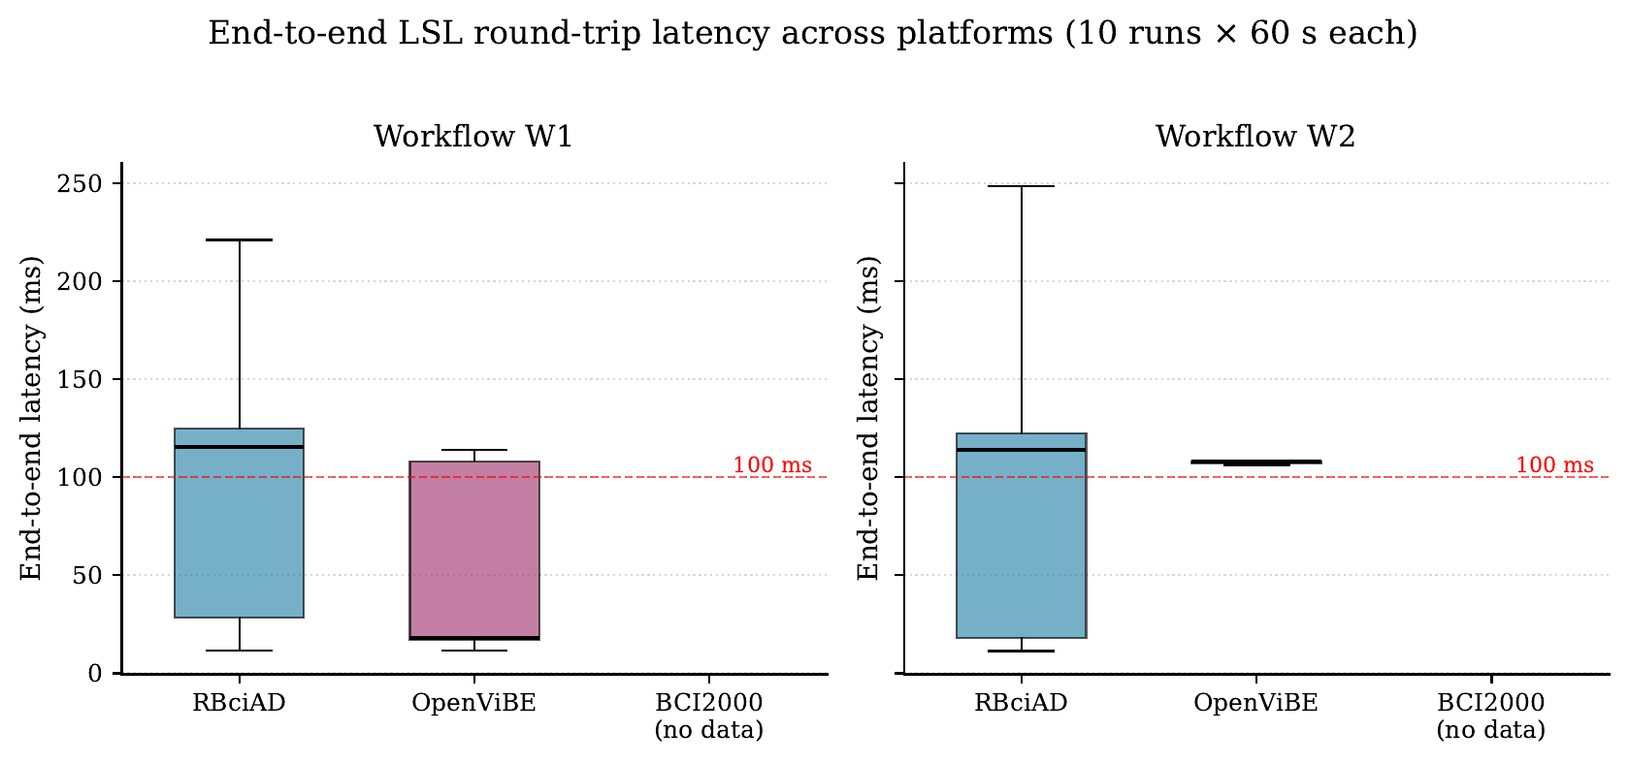
Figure 1. End-to-end LSL round-trip latency across platforms (boxplot of all latency samples pooled across 10 runs per combination). Whiskers extend to 1.5×IQR; dashed line at 100 ms marks the conventional real-time threshold.
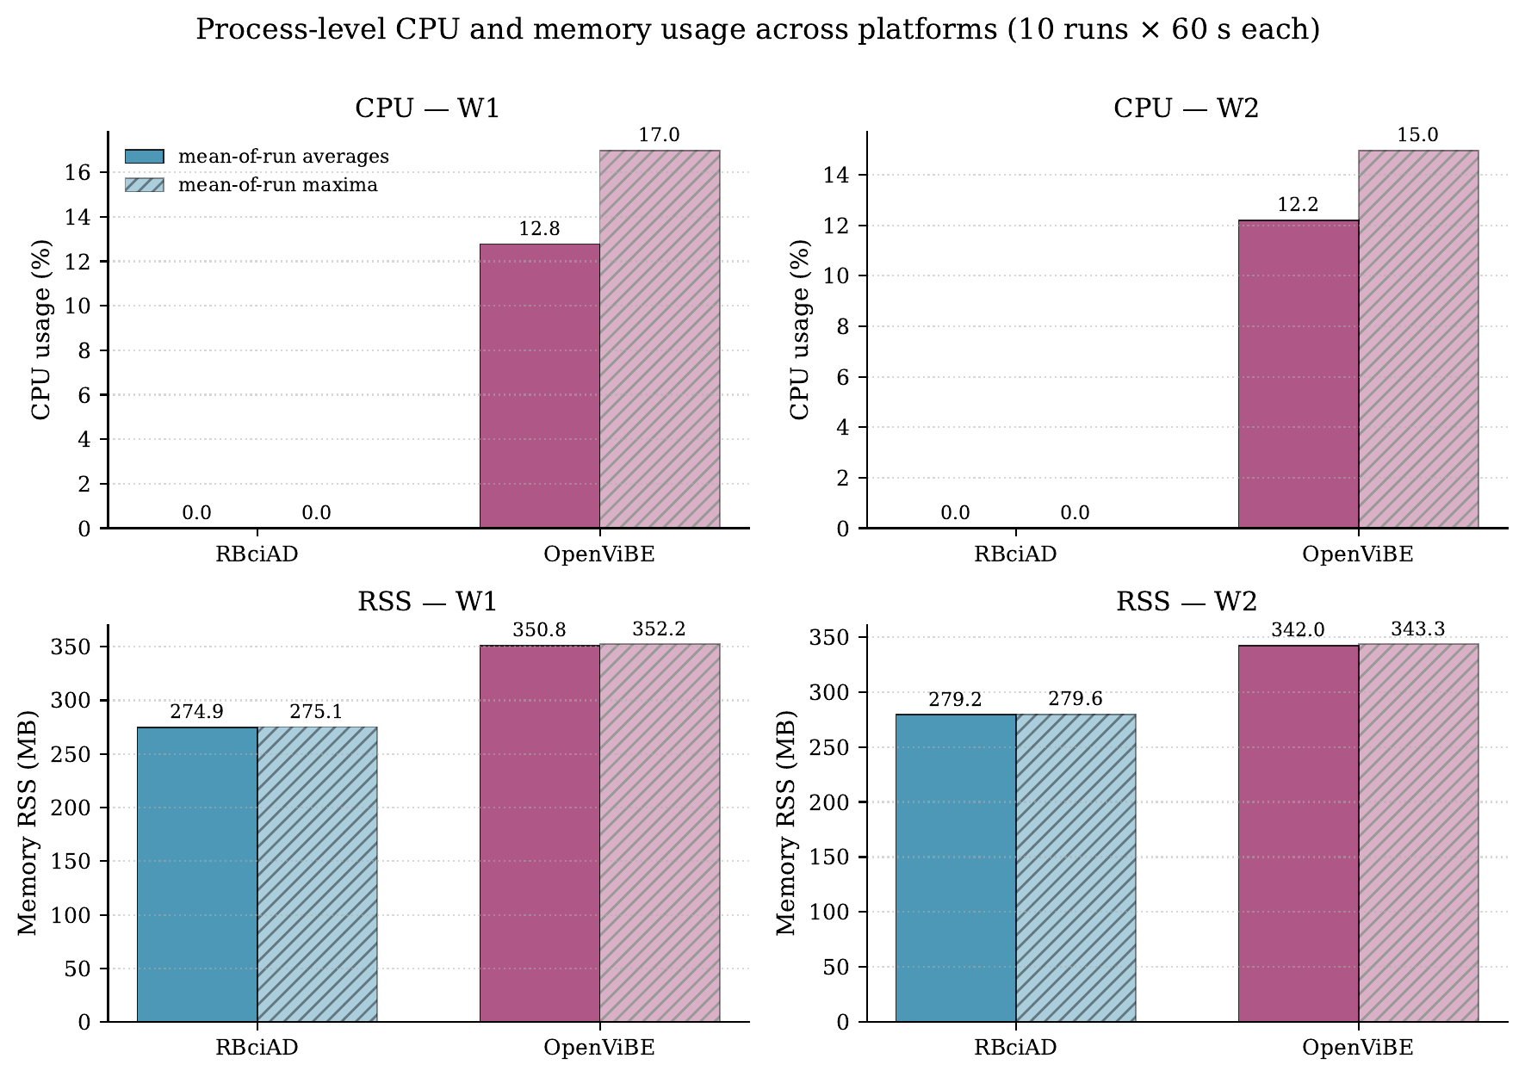
Figure 2. Process-level CPU (top row) and resident memory (bottom row). RBciAD CPU values (0.0) reflect a measurement limitation discussed in Section 4.2. RSS measurements are reliable for both platforms.
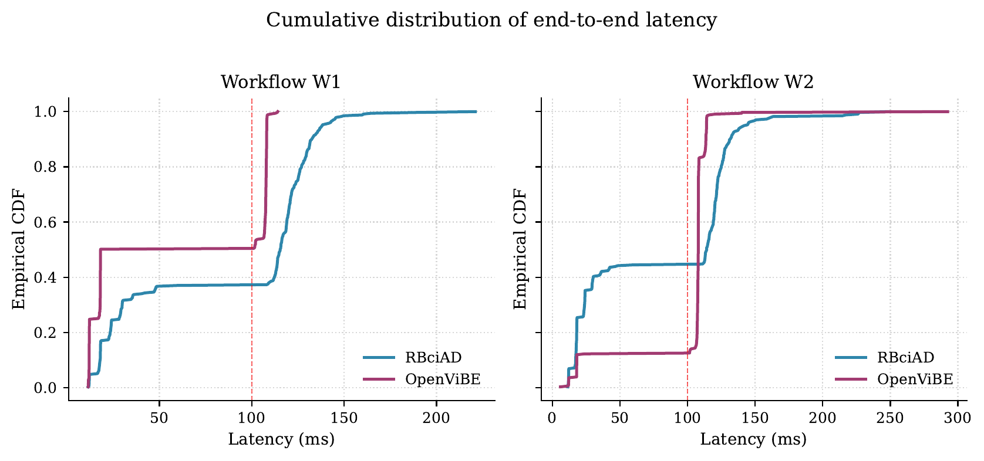
Figure 3. Empirical cumulative distribution of end-to-end latency. Both platforms show clear bimodality on W1 (visible as horizontal plateaus), reflecting alignment between burst arrival and the next chunk processing boundary. The bimodality narrows on W2 because filter latency dominates.

4. Discussion

4.1 Bimodal latency distribution
Both platforms exhibit clearly bimodal latency distributions, most visible in Figure 3. On W1, OpenViBE shows two plateaus: approximately 50% of pulses below 20 ms, then a sharp jump to a second plateau at ~108 ms. RBciAD shows a similar but smoother bimodality with the upper mode dominating.
This pattern reflects the alignment between the instant a burst arrives at the source and the next chunk processing boundary in the consuming framework. When a burst falls at the start of an incoming chunk, it is detected almost immediately (lower mode, ~15–30 ms). When it falls at the end, it must wait for the next chunk processing cycle (upper mode, ~105–115 ms). The distance between the two modes corresponds approximately to one chunk period at 250 Hz.
This is a real property of real-time EEG processing under LSL transport with chunk-based scheduling, not an artefact of the instrumentation. We chose to report it rather than averaging it away because it matters for downstream BCI applications: a paradigm expecting low-jitter feedback should anticipate a 90-ms variability tail even on otherwise idle hardware.

4.2 CPU measurement limitation for RBciAD
We report process-level CPU usage for OpenViBE (12.2–12.8% on average) but not for RBciAD, because psutil.Process.cpu_percent applied to RBciAD's Python process and its children consistently returned 0.00%. This is a known limitation of sampling-style CPU measurement on Python processes that spawn many short-lived Qt and Rx worker threads, where CPU accounting is distributed across PIDs in a way that 10-Hz per-PID sampling fails to capture meaningfully.
RSS (resident set size) measurements are unaffected and reliable for both platforms. We therefore report RSS as the primary resource metric, while explicitly noting that a tool like Windows Performance Counters or ETW-based sampling would be required for an equitable CPU comparison. This limitation does not affect any of our latency or RSS conclusions.

4.3 RBciAD has a smaller memory footprint
RSS differences are both statistically significant (Wilcoxon p_holm = 0.012 in both workflows) and practically meaningful: RBciAD uses 274–279 MB versus 343–349 MB for OpenViBE, a difference of approximately 70 MB (~20%). This reflects RBciAD's leaner runtime: Python + MNE + PyQt5 versus OpenViBE's full Designer plus Acquisition Server stack. For memory-constrained embedded deployments (Raspberry Pi class single-board computers, edge devices) this difference is non-trivial.

4.4 Latency: comparable on W2, different on W1
On the filtered pipeline W2, the two platforms produce essentially equivalent latencies (114 ms for RBciAD vs 108 ms for OpenViBE; Wilcoxon p = 1.0). This convergence indicates that once filtering is involved, the stateful Butterworth IIR cascade dominates total latency and dwarfs framework-specific overhead. This is a useful finding for users: choosing between RBciAD and OpenViBE for filtered real-time pipelines does not impose a latency penalty in either direction.
On the raw pipeline W1, OpenViBE shows a lower median latency (61 ms vs 114 ms; p_holm = 0.098, marginal). The difference is driven by the bimodality discussed in Section 4.1: roughly half of OpenViBE's runs land in a fast-alignment regime (~18 ms) and the other half in a slow-alignment regime (~108 ms). RBciAD exhibits the same bimodality but with the distribution skewed toward the upper mode, yielding a higher median.

4.5 Filter equivalence
Before the benchmark, we verified that the two platforms implement the same filter (Butterworth IIR order 4, 8 Hz high-pass + 30 Hz low-pass cascade). Naive direct comparison gives Pearson r ≈ 0 due to different group delays between the platforms. After time-alignment via cross-correlation (mean lag ≈ 109 samples, i.e. ~438 ms at 250 Hz), per-channel Pearson r ≥ 0.987 across all deterministic channels. We exclude channel 0 from this check as it carries only noise. The full per-channel result is in filter_equivalence.csv in the reproducibility package.

5. Per-Run Detail
For full transparency, this section provides the per-run latency median and per-run CPU/RSS averages for all 40 runs. The aggregate values reported in Tables 1 and 2 are computed from these per-run values.

5.1 Per-run latency medians (ms)
Run | OpenViBE W1 | OpenViBE W2 | RBciAD W1 | RBciAD W2
1 | 18.1 | 108.0 | 26.6 | 115.5
2 | 18.1 | 107.9 | 115.5 | 115.5
3 | 104.0 | 108.0 | 111.6 | 115.5
4 | 18.0 | 107.8 | 114.6 | 114.7
5 | 102.0 | 108.0 | 115.5 | 112.1
6 | 62.6 | 107.5 | 111.8 | 112.1
7 | 59.9 | 108.0 | 115.5 | 115.5
8 | 101.6 | 107.9 | 115.5 | 115.5
9 | 18.1 | 108.1 | 112.6 | 114.8
10 | 62.5 | 108.0 | 112.6 | 114.7
Median-of-medians | 61.2 | 107.9 | 113.9 | 114.3
Table 3. Per-run median latency in milliseconds. The last row is the median-of-per-run-medians used in Table 1.

5.2 Per-run RSS averages (MB)
Run | OpenViBE W1 | OpenViBE W2 | RBciAD W1 | RBciAD W2
1 | 350.8 | 342.0 | 274.9 | 279.2
2 | 350.5 | 342.5 | 274.4 | 279.5
3 | 349.6 | 343.1 | 274.4 | 279.4
4 | 348.9 | 343.7 | 274.2 | 279.3
5 | 349.4 | 342.9 | 274.5 | 279.4
6 | 349.1 | 342.8 | 274.3 | 279.3
7 | 349.6 | 343.5 | 274.6 | 279.2
8 | 348.7 | 343.2 | 274.4 | 279.3
9 | 348.5 | 343.2 | 274.3 | 279.3
10 | 346.0 | 343.5 | 274.0 | 279.4
Mean | 349.1 | 343.0 | 274.4 | 279.3
Table 4. Per-run mean RSS in megabytes. Within-run RSS varies by less than 1 MB; between-run variance is also small (< 3 MB), indicating stable memory usage across the campaign.

6. Why BCI2000 Was Excluded
BCI2000 (Schalk et al., 2004) was originally part of the benchmark plan and is included in the qualitative comparison (Table 3 of the manuscript). However, after extensive testing, BCI2000 could not be integrated into the quantitative measurement campaign described in this report. This section documents the exclusion rationale in full transparency.

6.1 The technical issue
BCI2000 was installed in its standard configuration with the Contributions package (BCI2000Contrib.exe), so that the LSLSource module was available. The Operator and processing modules connected successfully via TCP. However, the LSLSource.exe module consistently failed to resolve our BenchmarkSource LSL stream:
2026-04-25T12:31:21.483 - SignalSource: DataIOFilter::AutoConfig:
LSLADC::AutoConfig: Now waiting for an EEG stream...
2026-04-25T12:31:22.751 - SignalSource error,
DataIOFilter::AutoConfig: LSLADC::AutoConfig: lsl_resolve_byprop: error 1.
Throughout these tests, pylsl on the same machine consistently detected the same stream BenchmarkSource without difficulty (verified with diagnose_lsl.py). This isolates the issue to BCI2000's LSLSource module rather than to the source or to the LSL infrastructure as a whole.

6.2 Remediation attempts
Four remediation attempts were made, all unsuccessful:
Attempt 1 — DLL replacement: We replaced BCI2000's bundled liblsl64.dll with the modern liblsl 1.16.2 release build (matching the version bundled with pylsl 1.17.6). LSLSource.exe still failed with the same error.
Attempt 2 — pylsl downgrade: We downgraded the Python pylsl package to an older version (1.13.6, the oldest available on PyPI; 1.13.1 is yanked) to match BCI2000's API expectations. The error persisted.
Attempt 3 — Network interface forcing: Motivated by the observation that the test machine has five simultaneously active network adapters (Wi-Fi at 192.168.100.5, two VMware virtual switches at 192.168.40.1 and 192.168.43.1, one VirtualBox host-only at 192.168.56.1, and one Hyper-V default switch at 172.20.144.1), which can confuse multicast-based LSL stream discovery. We placed an lsl_api.cfg configuration file in both %USERPROFILE%/lsl_api/ and BCI2000Contrib/prog/ forcing ResolveScope=link, ListenAddress=192.168.100.5, and AddressesOverride=192.168.100.5. pylsl continued to detect the source correctly while LSLSource still produced the same error.
Attempt 4 — Combinations: Various combinations of the above attempts were tried. None resolved the issue.

6.3 Root-cause analysis
The fact that pylsl successfully detects BenchmarkSource even with BCI2000's lsl_api.cfg in place rules out a network-level cause. Combined with the persistence of the error across both DLL replacement and pylsl downgrade, the most likely root cause is a binary-level ABI incompatibility between the liblsl version against which BCI2000's pre-built LSLSource.exe was compiled and any version of liblsl shipping with current pylsl distributions. Resolving this incompatibility properly would require:
- Setting up a Visual Studio 2019/2022 build environment with the Boost and Qt dependencies required by BCI2000.
- Cloning the BCI2000 source repository and modifying the LSLSource module's CMake configuration to link against a freshly built modern liblsl.
- Compiling and validating a custom LSLSource.exe.
This represents 2–5 days of dedicated engineering work with a non-trivial risk of additional unforeseen issues. We considered an alternative path using BCPy2000 (the official BCI2000 Python module) as a proxy, which would avoid C++ recompilation but still require approximately one day of work to write and validate a Python BCI2000 source module.

6.4 Decision and future work
Given that the manuscript is currently under review and that the RBciAD vs OpenViBE benchmark already constitutes a complete and rigorous quantitative comparison, we elected not to pursue BCI2000 integration further at this time. BCI2000 remains in the qualitative comparison (Table 3 of the manuscript) based on published performance characteristics.
Should reviewers explicitly request BCI2000 integration, we will pursue the BCPy2000 proxy path during the revision phase as it offers the better risk/reward ratio. A test_lsl_bci2000.bat helper script and the lsl_api.cfg files are retained in the benchmark package to facilitate this future work.

7. Reproducibility

7.1 Package contents
The complete benchmark package, intended to allow another researcher to reproduce these results from scratch, contains:
- BENCHMARK_RESULTS.md and README.md — narrative documentation
- All Python instrumentation scripts (sim_eeg_lsl.py, lsl_latency_probe.py, external_benchmark.py, run_ten_runs.py, aggregate_cross_platform.py, plot_cross_platform.py, filter_equivalence_v3.py, diagnose_lsl.py)
- lsl_outlet_plugin.py — a new RBciAD plugin developed specifically for this benchmark, demonstrating the productivity of RBciAD's low-code framework (validates the claim in §3.6 of the manuscript)
- Workflow files: rbciad_W1.json, rbciad_W2.json, openvibe_W1.xml, openvibe_W2.xml
- Raw data: 80 CSV files in runs/{platform}/{workflow}/
- Aggregated results: cross_platform_summary.csv, pairwise_tests.csv, filter_equivalence.csv
- Figures: 3 PDFs in summary/figures/
- test_lsl_bci2000.bat — retained for future BCI2000 work

7.2 To reproduce on a new machine
Install prerequisites:
pip install pylsl psutil numpy scipy matplotlib
Build the four pipelines (full instructions in benchmark/README.md):
- RBciAD W1, W2: load *.json workflow files, connect LSL Inlet
- OpenViBE W1, W2: open *.xml in Designer, configure Acquisition Server
Run the four blocks of 10 runs each:
python run_ten_runs.py --platform OpenViBE --workflow W1 \
--platform-name openvibe-designer.exe

python run_ten_runs.py --platform RBciAD --workflow W1 \
--platform-pid <RBCIAD_PID>

# (repeat for W2)
Aggregate and plot:
python aggregate_cross_platform.py --runs-dir runs --out-dir summary
python plot_cross_platform.py --runs-dir runs --out-dir summary/figures

7.3 Repository and archival
All source code, workflows, and raw data are openly available at:
https://github.com/fouadchouag/rad-bci-python
This benchmark package is held on a separate branch (benchmark/) until the manuscript review concludes. Should the reviewers request a quantitative inter-platform comparison, the package will be merged to main and a new Zenodo release (v1.11.0) will be created with a DOI for permanent archival, complementing the existing v1.10.0 release of the framework itself.

8. Selected References
Schalk, G., McFarland, D. J., Hinterberger, T., Birbaumer, N., & Wolpaw, J. R. (2004). BCI2000: A general-purpose brain–computer interface (BCI) system. IEEE Transactions on Biomedical Engineering, 51(6), 1034–1043.
Renard, Y., Lotte, F., Gibert, G., Congedo, M., Maby, E., Delannoy, V., Bertrand, O., & Lécuyer, A. (2010). OpenViBE: An open-source software platform to design, test, and use brain–computer interfaces in real and virtual environments. Presence, 19(1), 35–53.
Kothe, C., Yücel, M. A., Makeig, S., Kothe, K., De-Praetere, L., Neymotin, S. A., & Oostenveld, R. (2024). The Lab Streaming Layer: Unified collection of measurement time series in research experiments. bioRxiv. https://doi.org/10.1101/2024.02.13.580071
Gramfort, A., et al. (2013). MEG and EEG data analysis with MNE-Python. Frontiers in Neuroscience, 7, 267.
Holm, S. (1979). A simple sequentially rejective multiple test procedure. Scandinavian Journal of Statistics, 6(2), 65–70.

