
REPUBLIQUE DU CAMEROUN
Paix-Travail-Patrie

REALIZE

THINK BIG, START SMALL, START NOW
Tel : (237) 620256960/654486985
E-mail : realize.contactus@gmail.com
Website : www.realize.com

REPUBLIC OF CAMEROON
Peace-Work-Fatherland

AFRICAN INSTITUTE OF COMPUTER
SCIENCES-CAMEROON, PAUL BIYA
TECHNOLOGICAL CENTER OF
EXCELLENCE

P.O. Box: 13719 Yaoundé (Cameroon)
Tel : +237 699 796 055 / 657 154 855
E-mail : contact@iaicameroon.com
Website : www.iai.cameroon.com



ACADEMIC INTERNSHIP REPORT

THEME: DESIGN AND IMPLEMENTATION OF A SMART INTERNSHIP MANAGEMENT SYSTEM
CASE STUDY: AICS CAMEROON

In view of obtaining a Higher Technician Diploma (HTD) in computer sciences.
Internship was carried out from the 1st July to 30th September 2026
Option: Software Engineering
Written By:
FOUCHE HAMIDA
Level II student at AICS Cameroon
Under The Supervision of
Academic Supervisor
Professional Supervisor
Mr. TANUE MONETTE
Software engineer at REALIZE Tech

Mr. AGBOR DONALD ANDERSON
Lecturer at AICS CAMEROON

ACADEMIC YEAR
2025-2026

DEDICATION

THIS BOOK IS DEDICATED TO FIFEN’S FAMILLY

ACKNOWLEDGEMENT THIS BOOK IS DEDICATED TO MY FAMILY
FOR THEIR COUNTLESS ENCOURAGEMENT
THROUGHOUT THE ACADEMIC YEAR

THIS BOOK ACKNOWLEDGEMENT MCONTENTY
LIST OF FIGURESLESSLIST OF TABLES
GLOSSARYGHOUABSTRACTADEMIC YEAR

ARESUMEEDGEMENT THIS BOOKGENERAL INTRODUCTIONFAMILY
FOR PART ONE : INSERTION PHASEENT
THRPART TWO: TECHNICAL PHASE

AKLYKH

CONTENTAKLYKH

ACKNOWLEDGEMENTAKLYKH

CONTENTAKLYKH

ACKNOWLEDGEMENTS

Drafting this document would have not been possible without the contribution of some people who took upon themselves to see this work being accomplished. Our gratitude goes to the following people:
- The Resident Representative of IAI-Cameroon, Mr. Armand Claude ABANDA, for his support, words of encouragement and the different advices on how to approach situations.
- The chief executive officer of Realize, Mr. NDELOGAKEH Daniel and his staffs for trusting us by given us the opportunity to serve as interns in their prestigious enterprise.
- Our professional supervisor, Mr. TANUE Monette for his moral support, advice and professional expertise he shared with us.
- Our academic supervisor Mr. AGBOR Donald Anderson for his moral support, effort and advices throughout the academic year.
- To all my teachers of AICS CAMEROON for the knowledge they impacted me with for me to be where I am today.
- The amazing family at REALIZE for their endless love and support during this internship period.
- For my family most especially to my parents for their encouragement, also to my brothers and sister for their love and support.
- To all my classmates and friends at AICS, for their collaborative work, knowledge and idea throughout the academic year.

CONTENT

DEDICATION i
ACKNOWLEDGEMENTS ii
CONTENT iii
LIST OF FIGURES iv
LIST OF TABLES vi
LIST OF ABBREVIATIONS vii
GLOSARY viii
ABSTRACT ix
RESUME x
GENERAL INTRODUCTION 1
PART ONE : INSERTION PHASE 2
INTRODUCTION 4
PART TWO: TECHNICAL PHASE 14
FILE I: EXISTING SYSTEM 16
FILE II: SPECIFICATION BOOK 27
FILE III: ANALYSIS BOOK 42
FILE IV : CONCEPTION PHASE 73
FILE V: REALIZATION PHASE 88
FILE VI: FUNCTIONAL TESTING 101
FILE VII: INSTALLATION AND USER 112
PERSPECTIVE 121
GENERAL CONCLUSION 122
BIBLIOGRAPHY xii
WEBOGRAPHY xiii
REFERENCE xiv
TABLE OF CONTENT xv
ANNEXES xxiv

LIST OF FIGURES

Figure 1: Functional organization of Realize 9
Figure 2: Location of Realize 11
Figure 3: Gantt project 35
Figure 4: UML Diagrams 46
Figure 5: 2TUP Diagrams 49
Figure 6: usecase diagram formalism 51
Figure 7: General usecase diagram 61
Figure 8: specific usecase for manage user account 62
Figure 9: specific usescase for settings configuration 62
Figure 10: specific usecase for manage task 63
Figure 11: specific usecase for manage assigned task 63
Figure 12:manage internship report specifc usecase 64
Figure 13: communication Diagram formalism 64
Figure 14: communication diagram to authenticate 66
Figure 15: communication diagram to upload report 66
Figure 16: communication diagram for AI corrections 67
Figure 17: communication diagram for report analysis 67
Figure 18: formalism of sequence diagram 68
Figure 19: sequence diagram to Authenticate 70
Figure 20: sequence diagram to submit report 71
Figure 21: sequence diagram for AI corrections 72
Figure 22: sequence diagram for report analysis 73
Figure 23: Activity diagram formalism 74
Figure 24: Activity diagram to authenticate 68
Figure 25: Activity diagram to submit report 69
Figure 26: Activity diagram for AI corrections 70
Figure 27: Activity diagram for report analysis 71
Figure 28: n-tier architecture 76
Figure 29: MVC architecture 77
Figure 30: Formalism of class diagram 78
Figure 31:class diagram of InternSmart 80
Figure 32: formalism of state machine diagram 81
Figure 33: student state machine diagram 83
Figure 34: report state machine diagram 84
Figure 35: formalism of package diagram 85
Figure 36: package diagram of InternSmart 86
Figure 37formalism of component diagram 91
Figure 38: component diagram of InternSmart 93
Figure 39: formalism of deployment diagram 94
Figure 40: deployment diagram of InternSmart 95
Figure 41: create account unit test 107
Figure 42: provide account unit test 107
Figure 43: login unit test 108
Figure 44: provide login unit test 108
Figure 45: create task unit test 109
Figure 46: provide task unit test 109
Figure 47: create meeting unit test 110
Figure 48: provide meeting unit test 110

LIST OF TABLES

Table 1: Hardware Resources 10
Table 2: Software Resources 10
Table 3: Study of existing system 20
Table 4: Criticisms of existing system 22
Table 5: Project Planning 34
Table 6: Software Resources(Source Mercurial 2026) 36
Table 7: Hardware Resources(Source Mercurial 2026) 37
Table 8: Human Resources(Source Mercurial 2026) 37
Table 9: Global estimation(Source Mercurial 2026) 38
Table 10: List of Participants 40
Table 11: Differences between UML and Merise 47
Table 12: Elements of a usecase diagram 52
Table 13: System Actors 54
Table 14: Textual description to authenticate 55
Table 15: Textual description for AI correction 57
Table 16: Textual description for plagiarism analysis 59
Table 17: Components of communication diagram 65
Table 18: Component of sequence diagram 69
Table 19: Component of activity diagram 74
Table 20: Component of class diagram 79
Table 21: Component of state machine diagram 82
Table 22: Components of package diagram 85
Table 23: Elements of component diagram 92
Table 24: Elements of deployment diagram 94
Table 25: Technical choice 96

LIST OF ABBREVIATIONS

- 2TUP: Two Track Unified Process
- AICS: African Institute of Computer Science
- API: Application programming interface
- CSS: Cascading style sheets
- JWT: JSON Web Token
- DBMS: Database Management System
- HTTP: Hypertext Transfer Protocol
- MVC: Model View Controller
- AI: Artificial Intelligence
- PDF: Portable Document Format
- UI: User Interface
- ORM: Object Relational Mapping
- UML: Unified Modelling Language

GLOSSARY

- 2TUP (Two Track Unified Process) is a software development methodology that organises the development process into two parallel tracks: the functional track, which focuses on understanding user requirements, and the technical track, which focuses on the system’s technical architecture and implementation.
- API (Application Programming Interface) is a mechanism that allows different software applications or components to communicated and exchange data.
- CSS (Cascading Style Sheet) is a stylesheet language used to control the appearance, layout, and presentation of web pages.
- JWT (JSON Web Token) is a compact token used to securely transmit information between a client and a server, commonly for user authentication.
- DBMS (Database Management System) is a software used to create, store, organize, retrieve, and manage data in the database.
- HTTP (Hypertext Transfer Protocol) is a communication protocol used to transfer information between web clients, such as browsers, and web servers.
- MVC (Model View Controller) is a software architectural pattern that separates an application into three components: Model for data, View for the user interface, and Controller for application logic.
- UML (Unified Modelling Language) is a standardized visual language used to analyze, design, model, and document software systems.
- ORM (Object Relational Mapping) is a technique that allows developers to interact with a relational database using programming-language objects instead of writing database queries directly.

ABSTRACT

The academic internship period is a decisive stage in the training of software engineering students, during which theoretical knowledge is confronted with professional practice. However, the supervision of this period remains largely manual and fragmented in our institutions: reports are drafted and exchanged through disconnected channels, feedback is untraceable, plagiarism between students frequently goes undetected, and physical distance between academic supervisors, professional supervisors, and students often prevents regular follow-up meetings. This dissertation presents the design and implementation of a <<Smart Internship Management System>>, a web-based intelligent platform built to centralize and modernize the academic internship supervision process. The system integrates a live, collaborative document-editing capability that allows students to draft their report directly within the platform, with a manual file upload option retained as a fallback to ensure the platform remains fully operational even if the collaborative service become unavailable. An AI-powered writing assistant helps students identify and correct errors before submission, an internal plagiarism detection module compares each report against previously archived submissions, and a built-in video conferencing module allows supervisors to conduct virtual mentoring sessions without relying on any external application. The platform serves four categories of users students, academic supervisors, professional supervisors, and administrators each interacting with the system through role-specific dashboards and permissions enforced at the level of authentication rather than the interface alone. The system was analyzed and designed using the Unified Modelling Language (UML) coupled with 2TUP methodology, and implemented using React.js and tailwind CSS for the frontend, Node.js with Express.js for the backend, and MySQL database for persistent storage.
Keywords:
- Collaborative Document Editing,
- Artificial Intelligence,
- Plagiarism Detection,
- Video Conferencing.
- Gitsi meet

RESUME

La période de stage académique constitue une étape décisive dans la formation des étudiants en génie logiciel, durant laquelle les connaissances théoriques sont confrontées à la pratique professionnelle. Cependant, l'encadrement de cette période demeure largement manuel et fragmenté dans la plupart des établissements : les rapports sont rédigés et échangés par des canaux disparates, les retours ne sont pas traçables, le plagiat entre étudiants passe souvent inaperçu, et l'éloignement physique entre encadreurs académiques, encadreurs professionnels et étudiants empêche fréquemment un suivi régulier. Ce mémoire présente la conception et mise en œuvre d'un <<Système intelligent de gestion des stage>>, une plateforme web intelligente conçue pour centraliser et moderniser l'ensemble du processus d'encadrement des stages académiques. Le système intègre un outil d'édition collaborative en temps réel permettant à l'étudiant de rédiger son rapport directement au sein de la plateforme, une option de téléversement manuel étant conservée comme solution de secours afin que la plateforme reste pleinement opérationnelle même en cas d'indisponibilité du service collaboratif. Un assistant rédactionnel basé sur l'intelligence artificielle aide l'étudiant à identifier et corriger les erreurs avant la soumission, un module interne de détection de plagiat compare chaque rapport aux soumissions précédemment archivées, et un module de visioconférence intégré permet aux encadreurs de mener des séances de suivi à distance sans recourir à une application externe. La plateforme s'adresse à quatre catégories d'utilisateurs : étudiants, encadreurs académiques, encadreurs professionnels et administrateurs chacun interagissant avec le système à travers des tableaux de bord et des permissions propres à son rôle, appliqués au niveau de l'authentification et non uniquement de l'interface. Le système a été analysé et conçu à l'aide du langage de modélisation unifié (UML) couple avec le 2TUP méthodologie, puis implémenté avec React.js et tailwind CSS pour le frontend, Node.js et Express.js pour le backend, et MySQL pour le stockage persistant.
Mots-clés :
- Édition Collaborative de Documents,
- Intelligence Artificielle,
- Détection de Plagiat

GENERAL INTRODUCTION

Despite the challenges it has faced, the field of computer science has continued to advance over time. In the contemporary era, individuals across the globe are confronted with a multitude of challenges. It is therefore of significant importance to address these issues and meet clients' requirements in a variety of areas of their lives. It is becoming increasingly evident that organisations are reliant on personnels who have undergone rigorous training in the fields of Information Technology and Communication. In light these aforementioned challenges, the Africa Institute of Computer Sciences (AICS), a pioneering institution in the field, has established a three-month internship program for Level 2 students. The program aims to facilitate the application of the skills learnt in school to a professional setting, enhance the abilities of the students, and assist companies in overcoming challenges or facilitating growth. The selected organization for this programme was REALIZE, a company with a primary focus on software development that promotes sustainable development. The project involved the implementation of the "DESIGN AND IMPLEMENTATION OF A SMART INTERNSHIP MANAGEMENT SYSTEM," which was divided into eight main segments.
- The insertion phase, involves introducing the company where the internship was undertaken, documenting the intern's integration into the organization.
- Existing System, here we present the current system in place.
- The specification book outlines the needs of future system users and identifies various constraints and project requirements.
- The analysis phase, involves presenting the chosen analysis method and sketching the first model diagrams of the system to be realized.
- The conception phase focuses on studying analysed systems in detail to identify their real-world components.
- The realization phase, involves implementing and making analysed and conceived system available to users.
- Test of functionalities, in this phase, we will show the various functions or modules of our application and how they operate.
- The user guide, which instructs the users on how to install and use the system.

PART ONE : INSERTION PHASE

Preamble
This section of the report will cover details of how we were welcomed in the Host Company, presentation, organization and brief introduction to our project.

Content

INTRODUCTION
The insertion phase in a company is a period during which we discover our working environment, the staff of the company and other interns. Here, we will begin by discussing our first two weeks in the company, how we were welcomed and how we began adapting to our internship environment, we will proceed by exploring the history of the company, discovering its missions, learning what its major activities are, and witnessing some of its key realizations. We will also get to understand how the company is structured administratively and functionally so that it operates effectively and accomplishes its goals. Furthermore, we will look at the hardware equipment used by the company, and the software resources used in its daily operations. We will then introduce our chosen theme for the internship period, briefly elaborate on it.

I-WELCOME AND INSERTION

a. welcome
The welcoming and integration event took place on 1st July at 8: am. Upon arrival, Mr. Monette delivered an inspiring welcoming speech, greeted us. Having interned at REALIZE this year, this moment felt familiar, though it was refreshing to reconnect with the team. We proceeded with a presentation and a meeting focused on discussing the challenges we faced during the coding test, which was a prerequisite for our internship at the company. The meeting also included an overview of the enterprise's structure, its internal policies, and the specific workstations assigned to each intern. I was able to quickly reorient myself within the company's environment. Mr. Tanue concluded by encouraging us to strive for excellence and offered his support for any issues we might encounter.

b. Integration
After settling into our designated workstations, we were promptly assigned our first task for the day. During the first week, we did every one presentation about a theme. We then engaged in Design thinking, where we were encouraged to thing big, find a problem and give a solution in an empathy way. My previous experience made it easier to contribute and refine these ideas. Subsequently, we were tasked with researching these ideas, as the enterprise valued our initiative and did not impose any themes on us.
In the second week, we were still on presentation reason been that, the main thing is not just to code the application but knowing how to present on it. Furthermore, the week that followed, we entered learning HTML, CSS and JAVASCRIPT the following week. We held a detailed discussion with our professional supervisor about the specification book and its various components, where he outlined what was expected of us in each segment. We also continued developing our project ideas into a concrete plan, benefiting from my previous familiarity with the company's expectations and processes.

II-GENERAL PRESENTATION OF REALIZE

A. History
Realize is a Cameroon based non-governmental tech start-up institute founded by Mr. NDELOGAKEH DANIEL in 2022 which proposes IT solutions and empowers the use on new technologies in Cameroon.

B. Missions, Visions and Activities of Realize

Mission
The mission of Realize mainly relates to the empowerment and perpetuation of technology use. These missions include:
- Designing and realizing mobile-oriented software for companies and individuals;
- Providing training and certifications to improve qualified human resources in many fields of study;
- Taking an active part in the sustainable development of the world through innovative solutions and virtual reality.

Vision
At Realize, we believe that the true potential of every organization and individual can be unlocked through the harmonious fusion of analysis, development, realization, and data analytics.
Our vision propels us forward, guiding us to make a lasting impact on the digital landscape and shape a future where innovation knows no bounds.

Activities
The activities of Realize range from computer sciences, engineering, and training.
They include:
- Conception, realization, and hosting of websites;
- Software development and maintenance ;

- Training in software-related fields;
- Conception and realization of multimedia projects;
- IT consulting, innovation, and IT support.

III-ORGANISATION OF THE COMPANY

ADMINISTRATIVE ORGANIZATION
REALIZE is headed by the Chief Executive Officer (CEO) who manages the day-to-day activities and the implementation of the company’s policies. REALIZE is administratively organized as follows;

General manager
It is the biggest unit in the chain of decision making within the company. It has as mission:
- The good functioning of all the departments.
- Define project strategies.
- Motivate the employees of all services.
- To evaluate the company activities and gives orientations.

Development department
In a way, this is the heart of the company because, almost all the company’s projects are carried out there. This department is responsible for:
- Designing and producing the specification book.
- Respect and enforce the application of standards of the company.
- Design and validate the products created by the development teams.
- Write training content.
- Help desk assistance.
- Innovation.

Financial department
This department manages the accounting, the archives and the functioning of the enterprise at the administrative level. Its missions are:
- Produce financial statement and appendices.
- Produce the tax document required by the tax authorities.
- Produce the cash statements.
- Monitor cash-flow and account.

Communication department
This department is in charge of the following:
- Handles public relations activities, which involve managing the company’s reputation and image;
- Responsible for crafting and delivering messages to external stakeholders such as customers etc.
- It fosters effective communication within the company
- They create and manage content across different platforms and channels

Technical department
This department is in charge of the following:
- Responsible for managing the company’s technological infrastructure, including networks, hardware;
- Play a role in managing and maintaining the company’s data;
- Responsible for implementing and maintaining cybersecurity measures to protect the company’s digital assets from potential threats;
- Interacts with technology vendors and manages relationships with external service providers. Etc.

Software department
This department is in charge of the following:
- Primarily responsible for developing software applications and systems
- Responsible for maintaining and supporting software application throughout their lifecycle
- Evaluation and realization of projects etc.

B. FUNCTIONAL ORGANISATION OF REALIZE
The functional branch of Realize is organized as follows
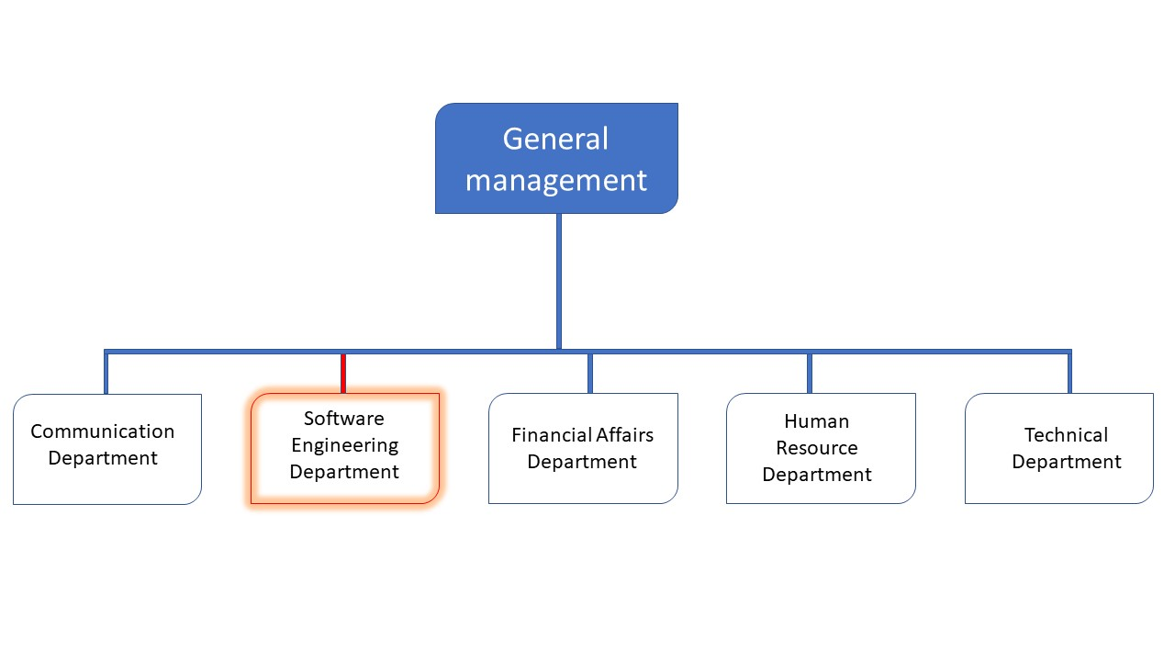

Figure 1: Functional organization of Realize

C. HARDWARE AND SOFTWARE RESOURCES

HARDWARE RESOURCES
Table 1: Hardware Resources
Designation | Features | Observation | Designation | Features
Windows computer | Dell | Good | Windows computer | Dell
Modem | CAMTEL | Excellent | Modem | CAMTEL
LCD screen | HP | Good | LCD screen | HP
Printer | HP | Good | Printer | HP

SOFTWARE RESOURCES
Table 2: Software Resources
Designation | Software
Operating system | Windows, LINUX, MacOS
Design tools | Figma, Canva
Integrated development environment (IDE) | Visual studio code, visual studio
Database management system (DBMS) | Mongo DB, MySQL
Document editor | Microsoft office word
Presentation editor | Microsoft office PowerPoint
Designation | Software

IV-GEOGRAPHICAL LOCATION

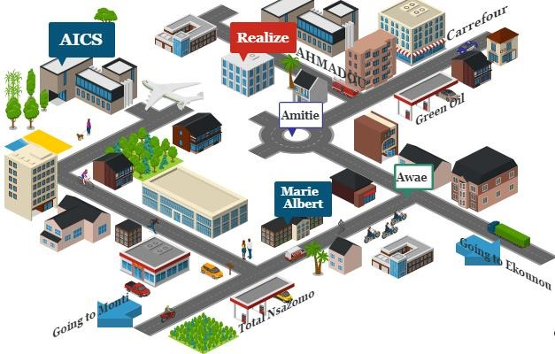
Figure 2: Location of Realize

V-BRIEF PRESENTATION OF PROJECT THEME
At the end of the initial two weeks (insertion period), we received a topic. This project, entitled "Design and Implementation of a smart Internship Management System," which proposes the design and development of a comprehensive web-based platform intended to modernize and centralize the supervision of academic internships. The system covers the complete internship lifecycle from account registration and student-supervisor assignment, through report submission and AI-assisted quality review, to plagiarism verification, supervisor feedback, virtual mentoring sessions, and institutional oversight reporting.

CONCLUSION
Our integration into the company was a pleasurable experience, with friendly and approachable colleagues and a professional supervisor who made us feel welcomed. Their availability and smooth integration into the company's operations were commendable. One of the most valuable takeaways from this phase was the importance of collaboration and discipline, crucial to any successful career. The subsequent phase of this momentous journey involves the project specifications, which must be clear and concise, clearly showing what is needed to extract the most value from this transformative project.

PART TWO: TECHNICAL PHASE

Preamble

This phase will focus precisely on our work and its development that is from the analysis to the testing of our work. We are going to focus on six specific files. These files are going to help us have a global idea of our project and how it is going to function. From the presentation of our theme passing by the analysis and finally making its testing will be presented below.

Content

FILE I : THE EXISTING SYSTEM
FILE II : THE SPECIFICATION BOOK
FILE III : THE ANALYSIS PHASE
FILE IV : CONCEPTION PHASE
FILE : V: REALISATION PHASE
FILE VI : FUNCTIONALITY TESTING
FILE VII : INSTALATION AND USER GUIDE

FILE I : EXISTING SYSTEMFILE I : THE EXISTING SYSTEM
FILE II : THE SPECIFICATION BOOK
FILE III : THE ANALYSIS PHASE
FILE IV : CONCEPTION PHASE
FILE : V REALISATION PHASE
FILE VI : FUNCTIONALITY TESTING
FILE VII : INSTALATION AND USER GUIDE

FILE I: EXISTING SYSTEM

Preamble

The existing system is a document that provides a view of how the current system works, how it carries out its different activities, it equally provides a deep understanding of the system associated to the various limitations and the problems that result from it and we propose the solution.

Content

INTRODUCTION
- PRESENTATION OF THE PROJECT THEME
- STUDY OF THE EXISTING SYSTEM
- CRITICISM OF THE EXISTING SYSTEM
- PROBLEMATIC
- PROPOSE SOLUTION
CONCLUSION

INTRODUCTION
In this part of our report, we will explain our theme. We will also study the current system and identify its strengths and weaknesses. Based on this analysis, we will present the problem statement because understanding this system is a great step in solving the problem we might identified, which is the main challenge or gap that the current system faces. Finally, we will propose a solution that addresses this problem and improves the system.

PRESENTATION OF THE PROJECT THEME
This project, entitled "Design and Implementation of a smart Internship Management System," proposes the design and development of a comprehensive web-based platform intended to modernize and centralize the supervision of academic internships. The system covers the complete internship lifecycle from account registration and student-supervisor assignment, through report submission and AI-assisted quality review, to plagiarism verification, supervisor feedback, virtual mentoring sessions, and institutional oversight reporting.
The platform is designed for three categories of users: students who submit their internship reports and interact with their supervisors; supervisors who evaluate the academic quality of the work; and administrators who manage accounts, timelines, and institutional oversight. Each user category accesses a role-specific interface tailored to their responsibilities within the supervision process.

STUDY OF THE EXISTING SYSTEM
Before presenting our proposed system, we first examined some existing platforms that provide solutions for different aspects of academic and student management. These include Google Classroom, Turnitin, Moodle, Handshake, and Zoom. Each of these systems addresses a specific need, such as course management, plagiarism detection, learning management, career and internship management, or online meetings. However, our school currently does not use these platforms as an integrated solution for managing student internships, supervision, reports, and defense activities. Studying these existing systems therefore helped us identify their useful features, as well as the gaps that our proposed system aims to address.

Table 3: Study of existing system
System | Description | Logo | Country
Google Classroom | A free web-based platform developed by Google for schools, designed to simplify the creation, distribution, and grading of assignments in a paperless environment. It supports document submission, basic feedback, and communication between teachers and students. |  | United States
Moodle | An open-source learning management system founded in 2001, allowing educators to create private online spaces with tools for collaborative learning, course management, document submission, and grade tracking, widely used across higher education institutions. |  | Australia
Turnitin | An internet-based similarity detection and academic integrity service founded in 1998, used by educational institutions to check submitted documents for plagiarism and, more recently, to detect AI-generated text. |  | United States
Handshake | An employment and career platform launched in 2014, primarily used by college students and recent graduates to discover internship and job opportunities, connecting students with employers through institution partnerships rather than supervising the internship period itself. |  | United States
Zoom | A cloud-based video conferencing platform founded in 2011, widely used for remote meetings, online classes, and virtual collaboration across education and business, but operating as a general-purpose communication tool external to any academic supervision workflow. |  | United States
Microsoft word | A word processing application widely used by students and professionals to create, format, edit and print documents. |  | USA

CRITICISM OF THE EXISTING SYSTEM
The observations above reveal a consistent pattern of limitations. The table below summarizes, for each limitation identified, its direct consequence and the solution this project proposes to address it.
Table 4: Criticisms of existing system
System | Limitations | Consequences | Proposed Solution
Google Classroom | No AI-assisted report quality review; no plagiarism comparison specific to internship reports; no integrated video conferencing tied to the supervision workflow. | Supervisors must manually detect writing errors and possible copying, consuming valuable review time; students and supervisors must rely on external tools for remote meetings. | Integration of an AI writing assistant for automatic error detection, an internal plagiarism module, and a built-in WebRTC video conferencing feature directly within the supervision workflow.
Moodle | Generic learning management system not adapted to the internship lifecycle; no distinction between academic and professional supervisor roles; no institutional integrity oversight reporting. | Institutions cannot track internship-specific milestones such as dual supervisor approval or generate consolidated plagiarism reports across a student cohort. | A dedicated internship supervision platform with role-based dashboards for supervisors, and an administrator-level plagiarism oversight report.
Turnitin | Operates as a standalone plagiarism checker disconnected from any centralized internship management workflow; requires manual document upload outside the normal supervision process. | Plagiarism verification becomes an extra manual step that supervisors often skip due to time constraints, allowing copied reports to go undetected in practice. | Plagiarism detection is automatically triggered the moment a report is submitted, with results displayed directly alongside the report in the supervisor's review interface.
Handshake / Symplicity | Focused exclusively on student-company matching and recruitment; no functionality for report submission, supervisor review, or academic integrity monitoring. | Institutions using these platforms still need a separate manual process for the actual supervision and evaluation of the internship period. | A single unified platform covering the complete internship lifecycle from assignment through report submission, review, and virtual mentoring not merely placement.
Microsoft Teams / Zoom | General-purpose video conferencing entirely outside the academic supervision workflow; requires external accounts, shared links, and manual scheduling with no connection to reports or feedback records. | Meetings are disconnected from the student's report and supervision history, and scheduling relies on informal communication with no automated reminders. | A video conferencing module built directly into the platform, allowing supervisors to schedule and launch meetings from the same interface where reports and feedback are managed.
Microsoft word | No integrated internship task assignment, progress monitoring, academic supervision, feedback management, or AI-assisted internship report analysis, which are the key functionalities of internSmart | Microsoft word does not provide a centrilized internship management, progress tracking, supervisor feedback | internSmart integrate an embedded writing workspace for students to draft their report directly with real collaboration with supervisors.

PROBLEMATIC
The management of the academic internship period currently suffers from a profound absence of digital structure and intelligent support. Students draft and submit their reports through informal or disconnected channels with no automated quality verification, meaning supervisors must spend valuable review time correcting basic writing errors rather than evaluating the depth and authenticity of the work itself. The absence of a centralized report archive makes it impossible to verify whether a submitted report was copied from another student's previous work, allowing plagiarism to pass undetected despite not being explicitly authorized. The physical separation between students, academic supervisors, and professional supervisors makes regular in-person meetings difficult, yet no built-in digital meeting channel exists within the supervision process, forcing stakeholders to rely on external tools disconnected from the supervision workflow. From an administrative standpoint, the coordination of hundreds of student-supervisor pairs and the tracking of deadlines are still performed manually, making the entire process error-prone and difficult to scale. The central question this project seeks to answer is therefore the following: how can an intelligent web platform be designed to unify the academic internship supervision process?

PROPOSED SOLUTION
To address the problems identified above, this project proposes the design and implementation of a InternSmart which centralizes the entire supervision process on a single platform.
- The system integrates a self-hosted, Microsoft Word-style collaborative writing workspace built directly into the platform using the open-source Tiptap editor and Yjs synchronization engine, allowing students to draft their internship report in a familiar interface with a strict A4 page format, unlimited storage at no licensing cost, secure read-only visibility for supervisors as the report is written, an integrated grading sidebar, and instant offline PDF export.
- A manual file upload option remains available as a fallback for report submission, ensuring the platform continues to function fully even if the writing workspace becomes unavailable.
- An AI-assisted report review stage allows the student to identify and correct writing and structural errors whether the report was drafted live or uploaded as a file before the report reaches any supervisor.
- An internal plagiarism detection module automatically compares every new submission against all previously submitted reports stored in the system's database, regardless of how the report was submitted.
- A video conferencing module built directly into the platform allows supervisors to schedule and conduct live virtual meetings with their assigned students without relying on any external application.
- Administrative functions account activation, student-supervisor assignment via bulk import, deadline management, and institutional integrity reporting are consolidated into a single administrator dashboard.

CONCLUSION
The study of existing systems shows that, while individually useful tools exist for document sharing, generic academic management, or standalone plagiarism checking, none of them was conceived for the specific demands of academic internship supervision. Each address, at best, a narrow fragment of the process submission, communication, or verification while leaving the remainder to informal, manual, and untraceable practices. Finally, we proposed our solution which is a web application. This step is necessary because we need to understand how the system put in place currently works before we can facilitate or ameliorate the processes been carried out in this system.

FILE II: SPECIFICATION BOOK

Preamble

The Specification book is a document which is been established by the customer needing a particular product and the producer (engineer) who is to create the product, which is to be respected to its fullness during the realization of the product. From this, we obtain the major importance of the specification book.

Content

INTRODUCTION
- CONTEXT AND JUSTIFICATION
- OBJECTIVES OF THE PROJECT
- EXPRESSION OF NEEDS
- PROJECT PLANNING
- ESTIMATED COST OF THE PROJECT
- PROJECT CONSTRAINTS
- DELIVERABLES
CONNCLUSION

INTRODUCTION
The specification book of our reports helps us provide details about our theme, to improve our understanding of it and increase the likelihood of it succeeding. To delimitate the scope of our project, we will specify the context of our theme. From the context, we will list the problems we have identified in our context and that we have decided to address throughout the project. After presenting our solution, we will talk about the objective we have set for the project. In addition, we will explore the needs to which our system will respond both at the functional and non-functional level. We will then look at the estimated financial requirements for our project and establish a plan we will follow to complete our project on time. From here, we will discuss what is expected of us by the end of the project under the project deliverables.

CONTEXT AND JUSTIFICATION

CONTEXT
The academic internship period represents one of the most decisive phases in the training of a software engineering student. It is during this period that the student leaves the theoretical environment of the classroom and confronts real professional challenges within a company. At the end of this experience the student must produce a written report summarizing their work and present it to their supervisors for evaluation.
This transition from theory to practice is essential and valuable. However, the institutions responsible for supervising this process are faced with increasing challenges. The number of students enrolled in internship programs grows every year, and in a single institution hundreds of students may be completing internships simultaneously, each requiring individual supervision from both an academic supervisor representing the university and a professional supervisor representing the host company.
Furthermore, the physical separation between students, academic supervisors at the university, and professional supervisors at the host company often makes regular in-person meetings impossible, leaving supervision irregular and disconnected from the student's day-to-day internship experience. It is within this evolving environment marked by growing student numbers, geographic dispersion, and reliance on informal digital tools that the present project takes shape.

JUSTIFICATIONS
Given the context described above, the choice to design and implement a Smart Task Internship Management System is justified on several grounds. First, the volume of students now completing internships simultaneously has outgrown the manual tools spreadsheets, email, informal messaging that our institution currently rely on, making a centralized digital platform a practical necessity rather than a convenience.
Second, the absence of any automated mechanism to verify the originality of submitted reports exposes institutions to an academic integrity risk that manual supervision alone
cannot reasonably detect, particularly as the number of students grows. A platform capable of automatically comparing submissions against a centralized archive is therefore justified as a safeguard for academic fairness.
Third, the geographic dispersion between academic supervisors, professional supervisors, and students justifies the integration of a built-in virtual meeting capability, since requiring external tools disconnected from the supervision record introduces friction and reduces the frequency of meaningful follow-up.
Fourth, allowing students to draft their report directly within the platform through a self-hosted, Word-style collaborative writing workspace rather than exchanging static files across multiple versions or relying on an external third-party editing service is justified by the need to give supervisors continuous, secure visibility into a student's progress, while keeping report content entirely within the institution's own infrastructure rather than a company the institution does not control. A manual upload fallback remains justified as well, to guarantee report submission is never dependent on a single internal service being available.
Finally, from an engineering education standpoint, this project is justified as an opportunity to apply the complete software engineering lifecycle requirements analysis, UML-based design, implementation, and testing to a real and personally observed institutional problem, reinforcing both the technical and analytical skills expected of a final-year software engineering student.

OBJECTIVES OF THE PROJECT

GENERAL OBJECTIVE
The general objective of this project is to design and implement an intelligent web platform that automates and modernizes the academic internship supervision process by integrating collaborative document drafting, Artificial Intelligence, and video communication technologies.

SPECIFIC OBJECTIVES
- Provide a centralized and secure platform for students to draft, submit, and version internship reports, and for supervisors to review and respond with structured feedback.
- Integrate a live, collaborative document-editing capability allowing students to write their report directly within the platform, with a manual file upload option available as a fallback.
- Automatically export a submitted report to a standard document format and extract its text for automated analysis, regardless of whether it originated from collaborative drafting or manual upload.
- Integrate an AI-powered report quality analysis engine that identifies grammatical errors, structural weaknesses, and missing sections, and proposes concrete corrections.
- Implement an internal plagiarism detection module that compares each new submission against previously submitted reports to identify similarities and potential copying.
- Integrate a video conferencing module allowing supervisors to schedule and conduct live virtual mentoring sessions with their assigned students.
- Provide administrators with tools to activate accounts, assign students to supervisors through bulk import, manage the internship timeline, and generate institutional oversight reports.
- Implement an automated notification system to alert students and supervisors of deadlines, feedback, and scheduled meetings.

EXPRESSION OF NEEDS

FUNCTIONAL NEEDS
- The system must allow students and supervisors to login and have access to their accounts created by an administrator.
- The system must allow students to upload internship reports and receive AI-generated quality feedback before submission to supervisors.
- The system must automatically detect similarities between a submitted report and previously submitted reports.
- The system must allow supervisors to review reports, submit feedback, and approve or request revisions.
- The system must allow supervisors to schedule and conduct live video meetings with students.
- The system must send automated notifications for key events and approaching deadlines.
- The system must allow the administrator to manage users, assignments, and generate integrity oversight reports.

NON FUNCTIONAL NEEDS
- Security: passwords must be encrypted and access must be controlled by role-based authentication.
- Performance: report analysis results should be returned within a reasonable time frame, typically under one minute.
- Usability: the interface must be simple, responsive, and accessible from any modern web browser.
- Reliability: the system must reliably store all submissions, feedback, and meeting records without data loss.
- Scalability: the system must support several hundred simultaneous users without performance degradation.

PROJECT PLANNING

Chronogram of activities
Table 5: Project Planning
PHASE OBJECTIVE OUTPUT DURATION |  |  |  | PERIOD
INSERTION | Collecting  Informations from  Enterprise | Insertion book | 14days | 1st July - 14th  July
EXISTING  SYSTEM | Study of the existing system | Existing System | 4days | 15thJuly - 18st  July
SPECIFICATION  BOOK | The specification of the user needs | Specification Book | 8days | 19rd July -  26th July
ANALYSIS | ANALYSIS | Capture of needs Use case and textual Description  Modeling | 10days | 27th July -  05th August
CONCEPTION | Hardware and Software conception | Conception Book | 15days | 06th August -  20th August
REALIZATION | Realization of the system | Realization Document | 12day | 21thAugust-  1stSeptember
TEST OF FUNCTIONALITIES | Deployment of the system | Testing and  debugging the software | 5days | 2ndSeptember.  06thSeptember
WRITING USER  GUIDE | Instruction on how to use the software and hardware | User Guide | 2days | 07th September  - 9th September
FINALIZING THE REPORT | Final cross check in the report | Report finalisation | 5days | 10th September – 15 September

Gantt Project Planning
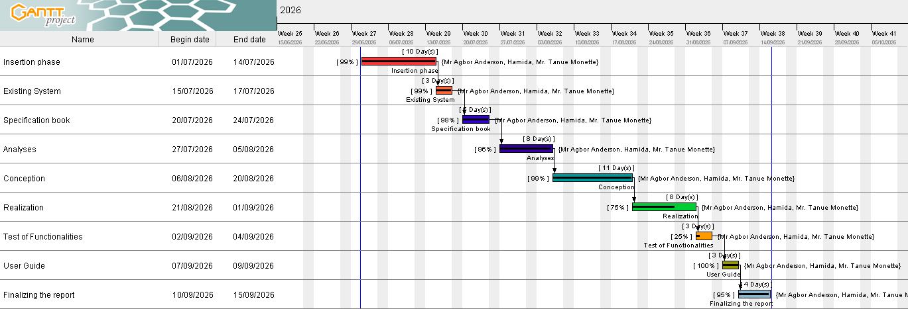
Figure 3: Gantt project

ESTIMATED COST OF PROJECT

Software’s Resources
For the realization of this project, we will need the following software applications:
Table 6: Software Resources(Source Mercurial 2026)
Resources | Designation | Usage | Quantity | Unit Cost  (FCFA)
Microsoft Office  365 | Formatting | Writing of the  report | 1 | 50 000
Google Chrome | Web browser | View web pages | 1 | Freeware
Visual Paradigm  Community  Version | UML Analysis  Tool | For drawing  UML diagrams | 1 | 10 385
Node.js | Programming  Language | Backend logic and data analysis | 1 | Freeware
Express.js  (Library) | Web  Framework | Backend server routing | 1 | freeware
MySQL | Database  Management system | Data Storage  and retrieval | 1 | freeware
TOTAL 1 |  |  | 7 | - 385

Hardware Resources
This includes the material resources used to realize this project. The table below shows a representation of these different materials:
Table 7: Hardware Resources(Source Mercurial 2026)
Hardware Resource | Quantity | UNIT COST (FCFA)
Laptop 8G of RAM, SSD,  Processor 8th Gen Intel(R) Core (TM) i5-8250U CPU @ 1.60GHz 1.80 GHz | 1 | 400 000
Router / Internet Device | 1 | 15 000
Removable Disk | 1 | 40 000
Internet Connection | 1 | 25 000
TOTAL 2 | 4 | 480,000

Human Resources
Table 8: Human Resources(Source Mercurial 2026)
Role | Number Of  Days | Quantity | Cost Per  Day | Total Price  (FCFA)
Project  Manager | 30 | 1 | 40 000 | 1 300 000
Developer | 45 | 1 | 25 000 | 2 250 000
UI/UX  Designer | 20 | 1 | 20 000 | 400 000
Data Analyst | 30 | 1 | 20 000 | 600 000
Tester / QA | 20 | 1 | 20 000 | 450 000
TOTAL 3 |  | 5 |  | 5,000,000

Global Estimation
Table 9: Global estimation(Source Mercurial 2026)
TOTAL 1 | TOTAL 2 | TOTAL 3 | OVERALL TOTAL (FCFA)
60,000 | 380,000 | 5,350,000 | 5,540,385
FIVE MILLION FIVE HUNDRED AND FOURTY THOUSAND THREE HUNDRED AND EIGHT FIVE FCFA

CONSTRAINTS

Project Constraints

Cost Contraints
The fixed budget allocated for the development and deployment of INTERNSMART must be strictly respected to ensure efficient resource management.

Time Contraints
The development and implementation of this system must be completed within a period of three months while ensuring that all predefined objectives are achieved.

Quality Contraints
Within the limits of the fixed budget and timeline, the application must be flexible, reliable, user friendly, and reusable across various devices and environments, ensuring it meets the required standards for a procurement and delivery platform.

List of Participants and Deliverable

List of participants
Table 10: List of Participants
Name | Function | Role
Mr. AGBOR ANDERSON | Lecturer at the African Institute of Computer Sciences. | Academic Supervisor
Mr. TANUE MONNETTE | Full Stack developer at Realize | Professional Supervisor
FOUCHE HAMIDA | Student at AICS Cameroon. | Project Manager,Project Owner, analyst

Deliverables
In project management, any component materializing the result of a realization service is called a deliverable. In the case of our project, the deliverables are: A report composed of the following document:
- The application.
- The user guide.
- The PowerPoint.

CONCLUSION
To conclude, the specification book has permitted us to clearly outline the general and specific objectives of the project, defines it constraints, and identify both functional and nonfunctional needs of the project, lay out the different resources of the project, and finally, the project planning. The end of this document will enable us to easily dive into drafting the analysis document, which will explore the technical aspect in greater depth and ensure that, the project is developed in a structured and coherent manner.

FILE III: ANALYSIS BOOK

Preamble

The main objective of the analysis phase is to capture the user’s need, the delimitation of the field of study and to have a clear understanding of the system in study. To achieve this, we will use UML (Unified Modelling Language) with the 2TUP (2-Track Unified Process) as method applied to UML to analyse the system. We will start by doing a comparison between UML and MERISE, of various unified processes and lastly, we will present the modelling of the solution we propose (Our software).

Content

INTRODUCTION
- METHODOLOGY
- CHOICE OF THE ANALYSIS
CONCLUSION

INTRODUCTION
Analysis involves breaking down a problem into smaller and manageable components to facilitate computer processing. To successfully complete a project, it is crucial to conduct a thorough analysis to meet the objectives outlined in the specification document. The over roll success of a project largely relies on the analysis performed. Consequently, a project that has not been properly analyzed are at high risk of encounting delays, errors and unlikely to yield favourable outcomes or meet the intended goal.

METHODOLOGY

Study of UML

UML
UML (Unified Modelling Language) is a standard notation for the modelling of real-world objects as a first step in developing an object-oriented design methodology. Its notation is derived from three object-oriented design and analysis methodologies: Grady Booch's methodology for describing a set of objects and their relationships, James Rumbaugh's Object Modelling Technique (OMT), Ivar Jacobson's approach which includes a use case methodology. Other ideas also contributed to UML, which was the result of a work effort by Booch, Rumbaugh, Jacobson, and others to combine their ideas, working under the sponsorship of Rational Software. UML captures information about the static and dynamic view of a system. UML 2.5 comprises of 14 diagrams that represent the different views of a system. The 14 diagrams can be subdivided into two, Static or structural and Dynamic diagrams. These diagrams include ;

Static or structural diagrams
    - Class Diagram
    - Object Diagram
    - Component Diagram
    - Deployment Diagram
    - Composite Structure Diagram
    - Package Diagram
    - Profile Diagram

Behavioural or dynamic diagrams
- Use case Diagrams
- Activity Diagram
- State machine Diagram
- Sequence Diagram
- Communication Diagram
- Interaction Diagram
- Timing Diagram
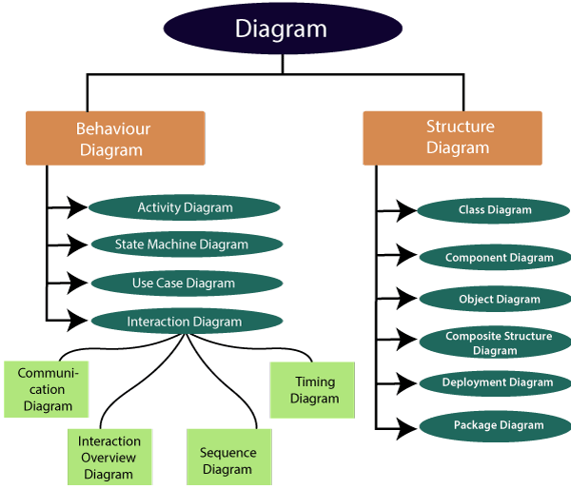
Figure 4: UML Diagrams
https://www.google.com/url?sa=i&url=https%3A%2F%2Fwww.javatpoint.com%2Fumldiagrams)

Table 11: Differences between UML and Merise
MERISE | UML
It stands for Methode d’Etude et de Realisation Informatique pour les Systemes d’Entreprises. | It stands for Unified Modeling Language.
MERISE is a systematic method of analysis and design of information systems. That is, it uses a systems approach. | UML is an object modeling language to which it is necessary to associate an approach to make it a method. This is the case with the 2TUP method, RUP and XP
MERISE proposes to consider the real system from two points:  - A static view (data).  - A dynamic view (treatments).  With the MERISE method, we have a separate study of the data and the treatments. | UML offers a different approach from that of MERISE in that, it combines data and processing. With UML, centralizing data of a type and the associated processing makes it possible to limit the maintenance points in the code and facilitates access to information in the event of software development. In addition, UML describes the dynamics of the information system as a set of operations attached to the objects of the system.
Rational | Object

COMPARATIVE STUDY OF UNIFIED PROCESSES

Unified Process
A Unified Process (UP) is a software development methodology based on UML. It is:
- Iterative: Each iteration is a distinct sequence of activities with a basic plan and evaluation criterion that produces an internal or external output. Either the content of an iteration is improved, or users evaluate the system’s evolution.
- Incremental: An increment is the difference between two released products at the end of two iterations. Each iteration integrates the technical environment to gradually build a final product, giving users tangible results at each step.
- Architecture-Centered: The models derived during the system’s design must be reliable and coherent, ensuring that the architecture supports the project’s growth and stability.
- Driven by use case and requirement: This approach enables a clear definition of users’ needs and priorities, thereby minimizing the risk of project failure.

The Two Track Unified Process (2 TUP)
The Two-Track Unified Process (2TUP) is a development process built on UML. Its main objective is to address the constraints of functional and technical changes imposed on information systems by strengthening controls on development capacities.

Key Characteristics
- Y-Shape life cycle
2TUP proposes a Y-shaped development life cycle that separates the functional aspect from the technical aspect. The merging of these two forms the implementation aspect.
- Three Branches
- Functional Branch: focuses on user requirements and business functionalities.
- Technical Branch : focuses on architecture, infrastructure, and system constraints.
- Realization Branch: the combination of the functional and technical results, where the system is fully realized.

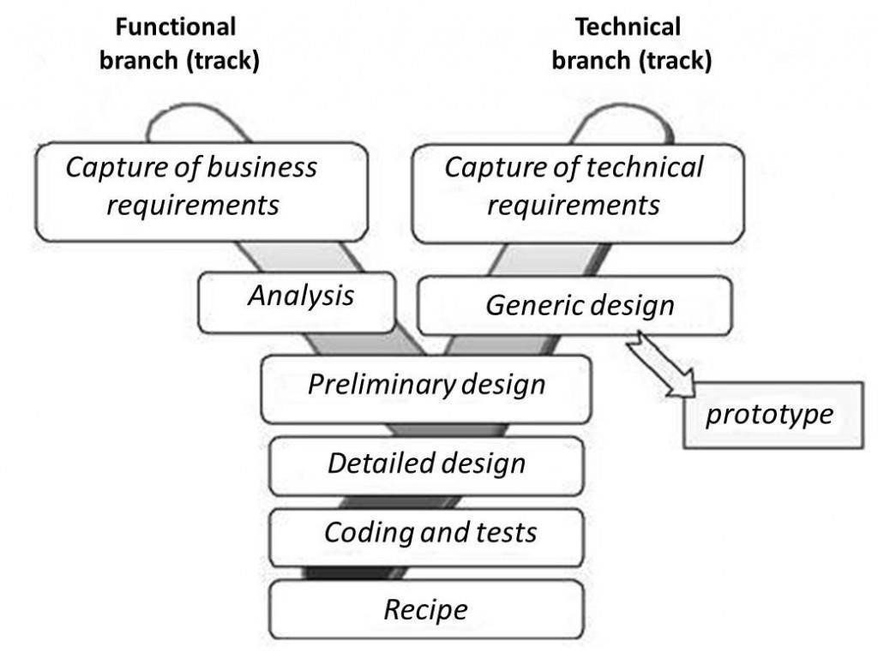
Figure 5: 2TUP Diagrams
(source: https://www.mysciencework.com/omniscience/pervasive-mobile-healthcaresystem-based on-cloud-computing).

The left branch (functional branch)
It captures the functional needs of a system. This ensures the production of software that meets the needs/requirements of the user. The analysis here consists of studying precisely the functional specification in order to obtain an idea of what the system is going to realize, and its result does not depend on any technology.

The right branch (Technical branch)
The technical branch enumerates the technical needs and proposes a generic design validated by a prototype. The technical needs include constraints and choices related to the conception of the system, the tools.

The middle branch (Realization or Implementation branch)
In this branch, we study the preliminary conception, detailed conception, and documentation of the system. The realization branch supports the following:
Preliminary conception: This is the most sensitive step of 2TUP as it is the confluence of the functional and technical branch. It is completed when the deployment model, the operating model, the logical model, interphases and the software configuration model are defined. We have the following diagrams:
- Component Diagram
- Deployment Diagram
- Package Diagram
- Composite Structure Diagram
Detailed conception: This is the detailed design of each feature of the system. We have the following diagrams:
- Class
- . Sequence
- Object
- Timing diagram

Coding and testing: This is the phase where we program the designed features and test the coded features.
The recipe: Also known as, the deliverables is the validation phase of the functions of the developed system.

CHOICE OF THE ANALYSIS

USE CASE DIAGRAM

Definition
Use case diagram shows the functionalities of a system, their interdependencies and how they relate with actors of the system. A use case is a specification of behaviour. The main objectives of the use case diagram are:
- Provide a high-level view of the system.
- Identify the functions of the system.
Use case diagrams are completed with a textual description of each use case that is intended to define the use case in greater details.

Formalism
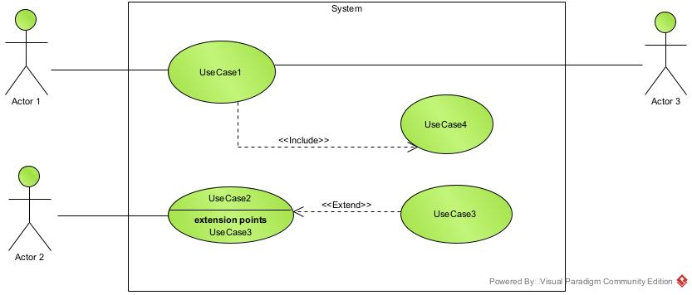
Figure 6: usecase diagram formalism

Elements
Table 12: Elements of a usecase diagram
Elements Notation Description
Actors | 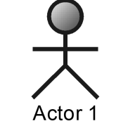 | Represents an entity that directly interacts with the system. The actor is what performs the different possible actions of the system
Use case | 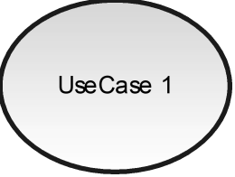 | A use case represents a functionality of the system. It is an action that can be performed by an actor.
Association | 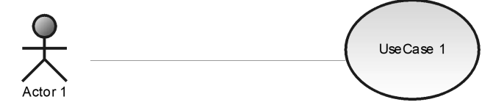 | it indicates that an actor takes part in a use Case.
Include | 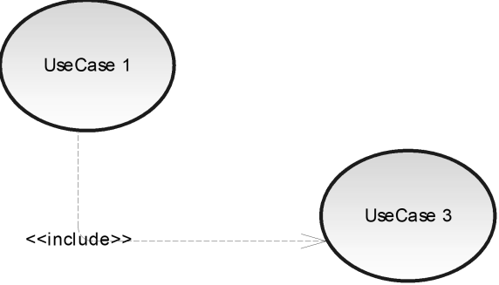 | An inclusion denotes that an included action must be performed before the including action can be performed.
Extend | 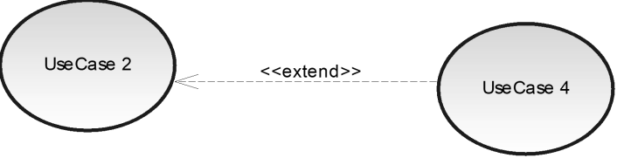 | An extension denotes that an extending action may be performed while an extended action is being performed.
Generalization | 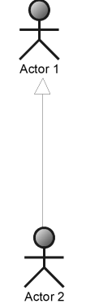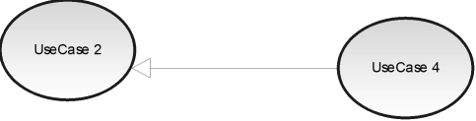 | This shows that an actor or a use case is a kind of another abstract or concrete actors can be defined and later specialized using generalization relationship.
System | 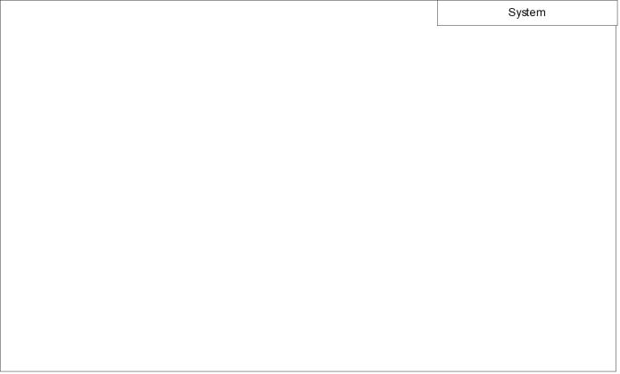 | It is a container of use cases which interact with external  actors

System Actors
The Internship Management System involves four principal actors, each interacting with the platform according to clearly defined roles and permissions.
Table 13: System Actors
Actor | Role Description
Student | Login on the platform, submits internship reports, works with the AI writing assistant to correct errors, sends reports to supervisors, receives feedback, and participates in scheduled virtual mentoring sessions.
Academic Supervisor | Login on the platform, reviews submitted reports along with the AI analysis, submits academic feedback, approves or requests revisions, and schedules virtual mentoring sessions with assigned students.
Professional Supervisor | Login on the platform, reviews submitted reports along with the AI analysis, submits professional feedback, approves or requests revisions, and schedules virtual mentoring sessions with assigned students.
Administrator | Activates registered accounts, assigns students to their academic and professional supervisors, manages the internship timeline, and generates institutional plagiarism oversight reports.

TEXTUAL DESCRIPTION OF SOME USECASES
The textual description is a simple text that describes how a use case can be performed in a more precise and understandable way following a chronological order. We will present in the following lines the textual description of some use cases.
Table 14: Textual description to authenticate
Title | Use Case <<Authenticate>>
Summary | The user wants to authenticates
Actor | Interns, supervisors, Admin
Version | 1.0
Precondition | The application is launched and the user has an active account on the platform
Trigger | The user clicks on the login button
Nominal Scenario | 1. System displays the login form  2. User fill and submit the form  3. The system verifies the form conformity  4. The system sends a login query to the database  5. The database execute the login query and send the response  6. The system displays a success message
Alternative Scenario (invalid credentials) | 7. If in step 3 of the nominal scenario, the user enters wrong credentials  8. The system displays an error message and returns to step 2 of the nominal scenario
Alternative Scenario (if user does not exist) | 9. The system displays an error message and returns to step 1 of the nominal scenario
Exception Scenario | The system stops unexpectedly
Post-condition of success | The user has access to his/her dashboard
Post-condition of failure | The user doesn’t have access to his/her dashboard
The non-functional requirement | Entering the password must not be visible on the screen

Table 15: Textual description for AI correction
Title | Use Case <<AI Corrections>>
Summary | The student wants to have his/her internship report automatically reviewed by the AI assistant in order to identify and correct grammatical errors, structural weaknesses and missing sections before sending it to the supervisors.
Actor | Intern
Version | 1.0
Precondition | The intern is authenticated on the platform and has a report drafted or uploaded on the system.
Trigger | The intern clicks on the "Submit for AI Review" button.
Nominal Scenario | 1. System retrieves the content of the report drafted or uploaded by the intern  2. System extracts the plain text of the report  3. The system sends the extracted text to the AI service for analysis  4. The AI service analyses the text and detects grammatical errors, structural weaknesses and missing sections  5. The AI service returns the list of errors, suggestions and the quality score to the system  6. The system saves the analysis result in the database  7. The system displays the highlighted errors and suggestions to the intern
Alternative Scenario (no error found) | 7. If in step 5 of the nominal scenario, the AI service finds no error in the report  8. The system displays a message informing the intern that the report meets the expected quality standard
Alternative Scenario (report edited) | 9. If the intern edits the report following the suggestions  10. The intern can resubmit the corrected report for a new AI review, and the nominal scenario restarts from step 1
Exception Scenario | The AI service is unreachable or does not respond within the expected time, and the system displays an error message asking the intern to try again later.
Post-condition of success | The report analysis is saved, and the intern can view the highlighted errors and the proposed corrections.
Post-condition of failure | No analysis is saved, and the intern is notified that the AI review could not be completed.
The non-functional requirement | The AI analysis result must be returned to the intern within a reasonable time, and the content of the report must not be altered without the intern's action.

Table 16: Textual description for plagiarism analysis
Title | Use Case <<Plagiarism Analysis>>
Summary | The system wants to verify the originality of a submitted report by comparing it against previously submitted reports stored in the institution's archive, in order to detect similarities and possible cases of plagiarism.
Actor | Academic Supervisor
Version | 1.0
Precondition | The intern has submitted a report, and the text of the report has been successfully extracted by the system.
Trigger | The report submission automatically triggers the plagiarism verification process.
Nominal Scenario | 1. System retrieves the extracted text of the newly submitted report  2. The system retrieves the archive of previously submitted reports from the database  3. The system compares the new report against each archived report  4. The system calculates a similarity percentage for the report  5. The system compares the similarity percentage against the defined threshold  6. The system saves the plagiarism analysis result in the database  7. The system displays the similarity percentage to the supervisors
Alternative Scenario (similarity above threshold) | 8. If in step 5 of the nominal scenario, the similarity percentage exceeds the defined threshold  9. The system flags the report as "on hold" and blocks the grading process  10. The system notifies the administrator and the supervisors for manual review
Alternative Scenario (no archive available) | 11. If in step 2 of the nominal scenario, no previous report exists in the archive  12. The system records a similarity percentage of zero and proceeds to step 6 of the nominal scenario
Exception Scenario | The comparison process fails due to a system error, and the report is marked as "pending verification" until the analysis can be run again.
Post-condition of success | The similarity percentage is calculated, saved, and made visible to the academic and professional supervisors.
Post-condition of failure | No similarity percentage is generated, and the report remains marked as pending verification.
The non-functional requirement | The comparison must cover the full archive of previously submitted reports, and the calculated similarity percentage must be accurate and reproducible for the same input.

General use case Diagram
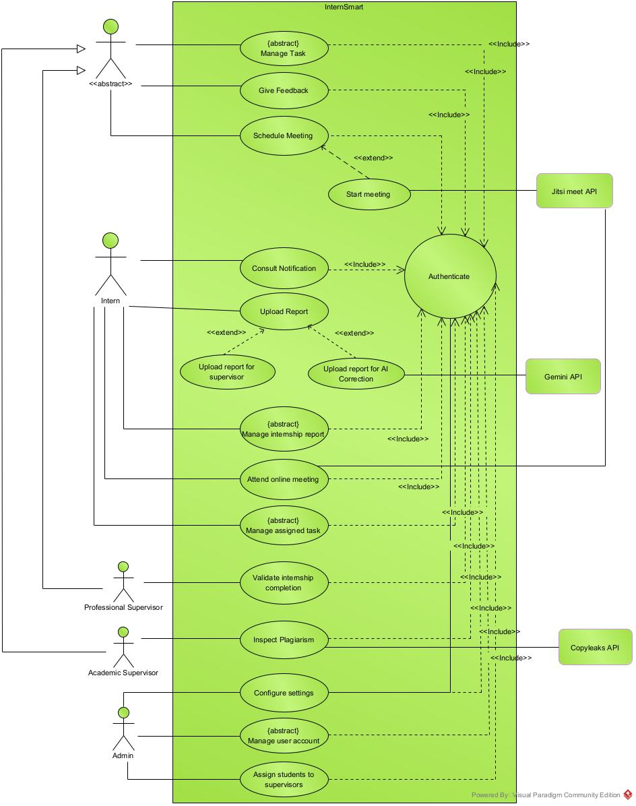
Figure 7: General usecase diagram

Manage User Account Specific use case
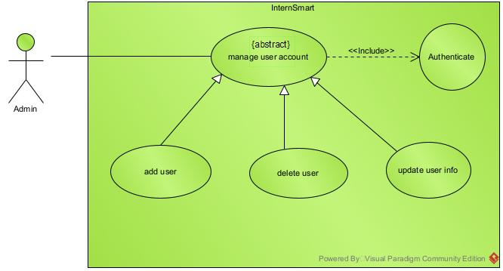
Figure 8: specific usecase for manage user account

Configure Settings Specific use case
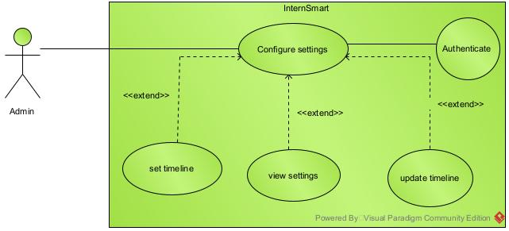
Figure 9: specific usescase for settings configuration

Manage Task specific use case
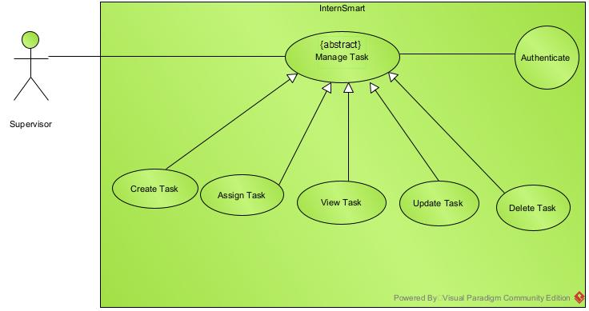
Figure 10: specific usecase for manage task

Manage assigned task specific use case
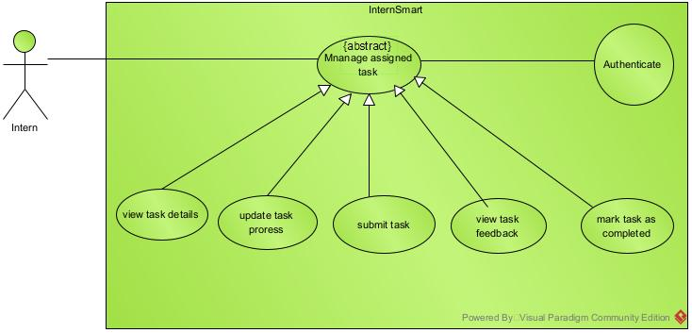
Figure 11: specific usecase for manage assigned task

Manage internship report specific use case
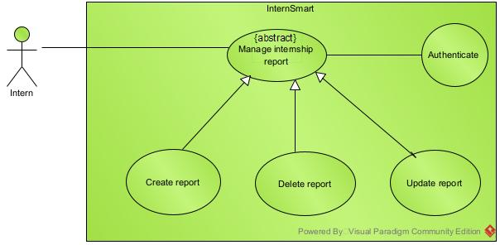
Figure 12:manage internship report specifc usecase

B. COMMUNICATION DIAGRAM

Definition
In UML, a communication diagram shows the interactions between the objects or roles associated with lifelines and the messages that pass between lifelines. They describe both the static structure and the dynamic behavior of a system. It is a simplified version of a Collaboration Diagram introduced in UML 2.0.

Formalism
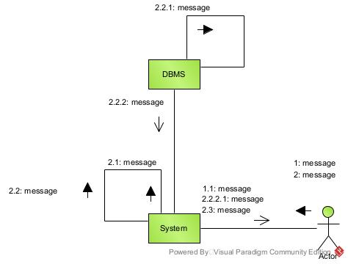
Figure 13: communication Diagram formalism

Components of a communication diagram
Table 17: Components of communication diagram
ELEMENT | NOTATION DESCRIPTION
Message | 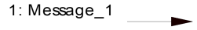 | Designs a particular Communication between lifelines.
Connectors |  | It represents the relationships that exist between lifelines
Dependency | 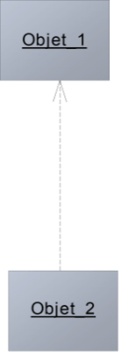 | A dependency is a relationship that signifies a single or a set of model elements for their  specification
Life line | 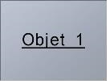 | An object represents an individual participant in the interaction conversation.

Authentication communication diagram
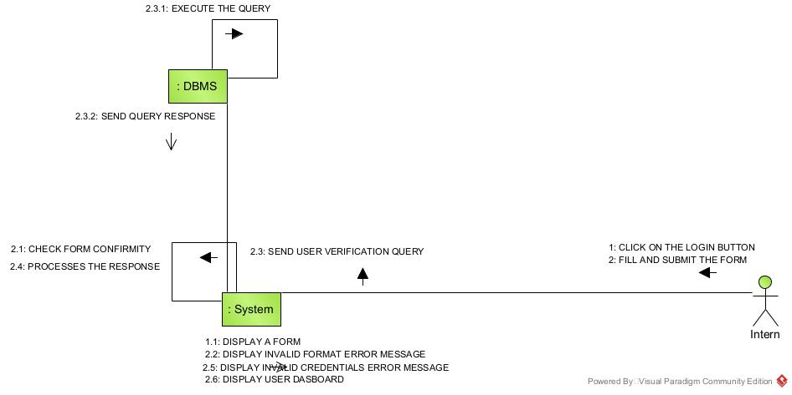
Figure 14: communication diagram to authenticate

Upload Report Communication Diagram
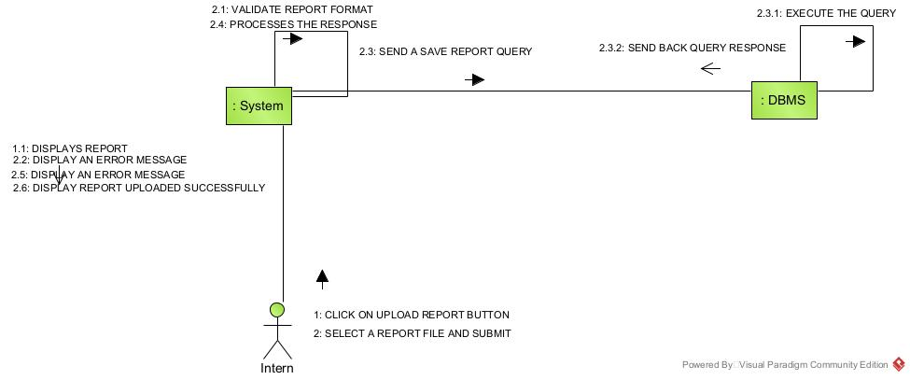
Figure 15: communication diagram to upload report

AI corrections communication diagram
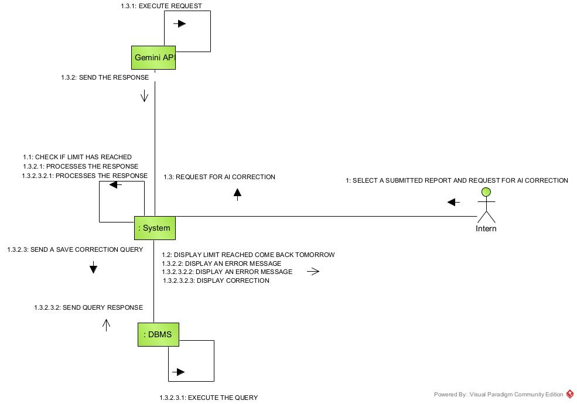
Figure 16: communication diagram for AI corrections

Plagiarism analysis communication diagram
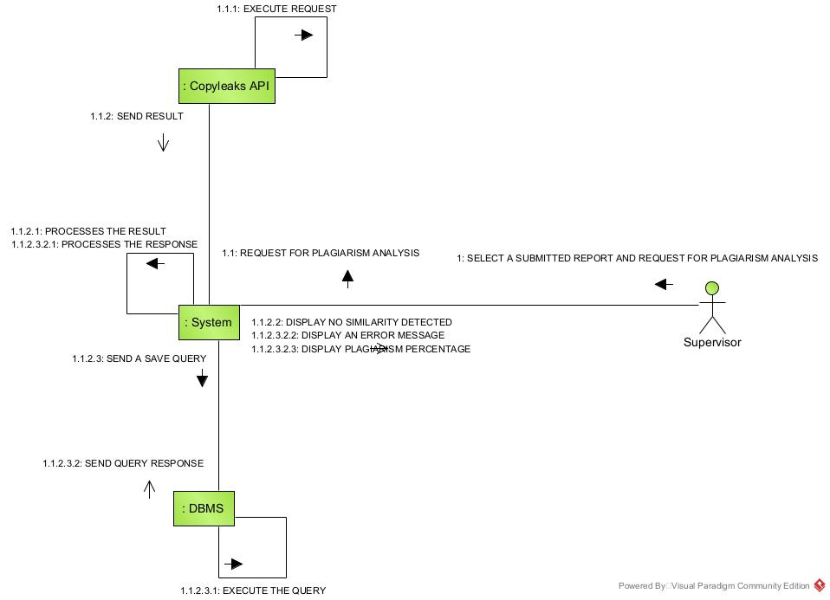
Figure 17: communication diagram for report analysis

C. SEQUENCE DIAGRAM

Definition
A sequence diagram in UML (Unified Modelling Language) is a type of interaction diagram that shows the sequence of events or interactions between objects or components in a system. It illustrates how objects communicate with each other. These can help to predict how a system will behave and to discover responsibilities a class may need to have in the process of modelling a new system.

Formalism
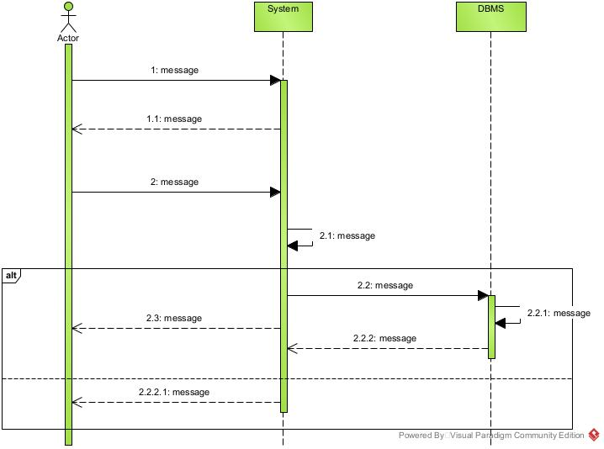
Figure 18: formalism of sequence diagram

Components of a Sequence Diagram
Table 18: Component of sequence diagram
ELEMENTS | NOTATION | DESCRIPTION
Lifeline | 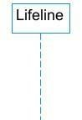 | An individual participant in a sequence diagram, it is position at the top of the diagram.
Combined fragment | 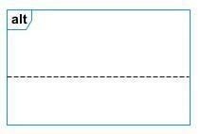 | It represents a choice of behavior in which at most one operand will be chosen.
Messages | 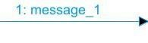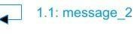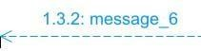 | These are arrows, which shows the direction of message flow. We have the synchronous, the asynchronous and the selfmessages.
Activation | 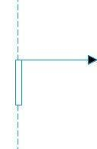 | It describes the time period in which an operation is performed by an element.

Authentication sequence Diagram
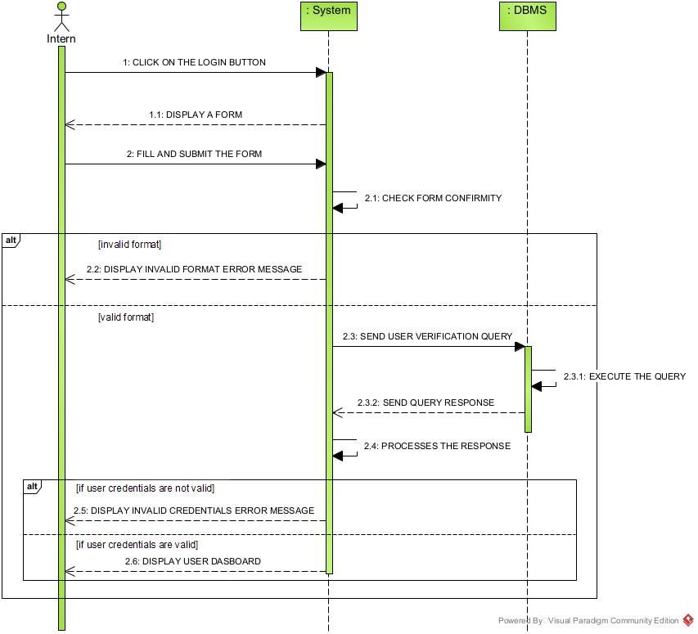
Figure 19: sequence diagram to Authenticate

Submit report sequence diagram

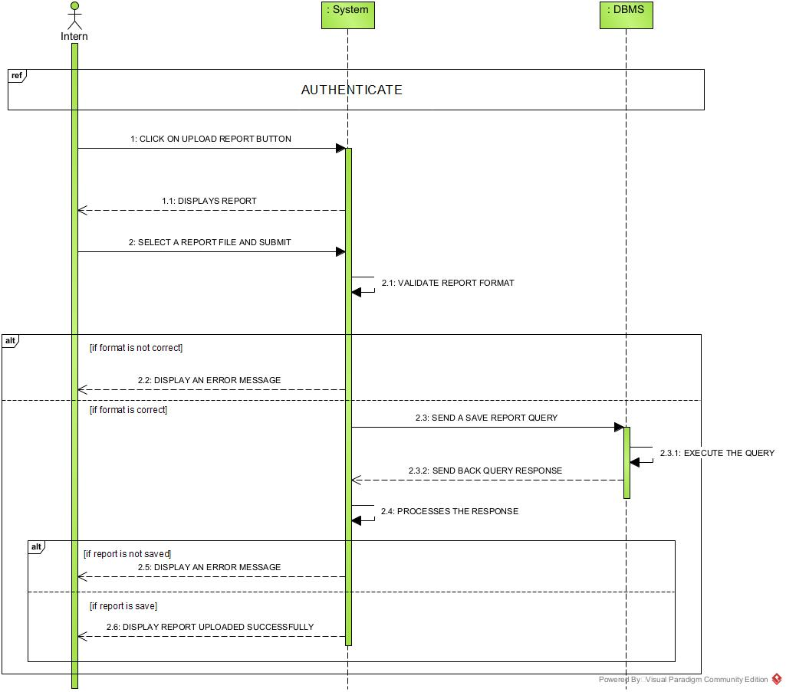
Figure 20: sequence diagram to submit report

AI corrections sequence diagram
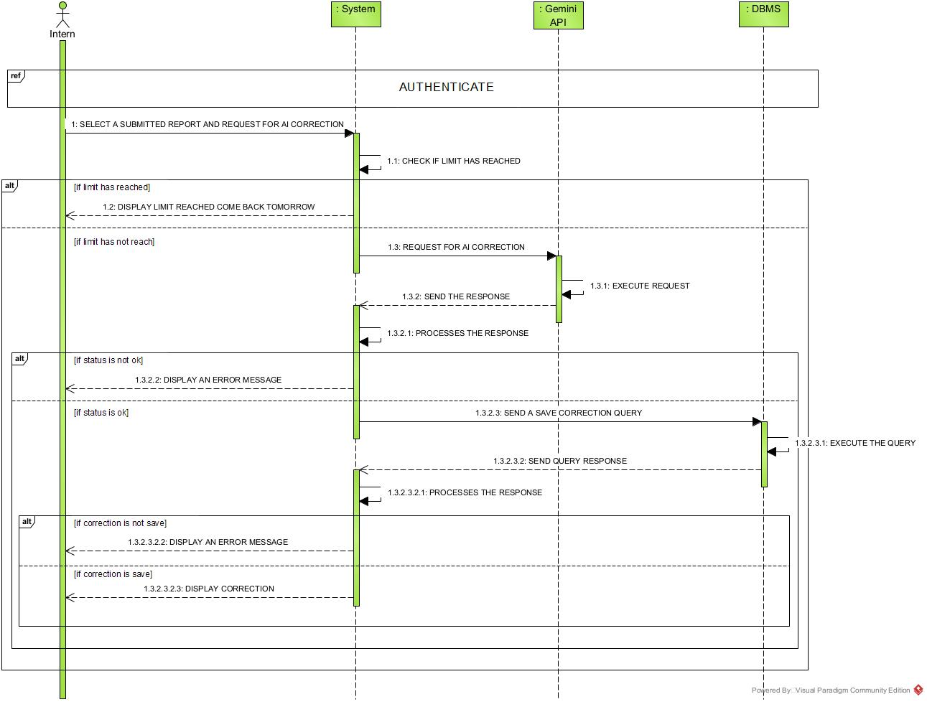
Figure 21: sequence diagram for AI corrections

Plagiarism analysis sequence diagram
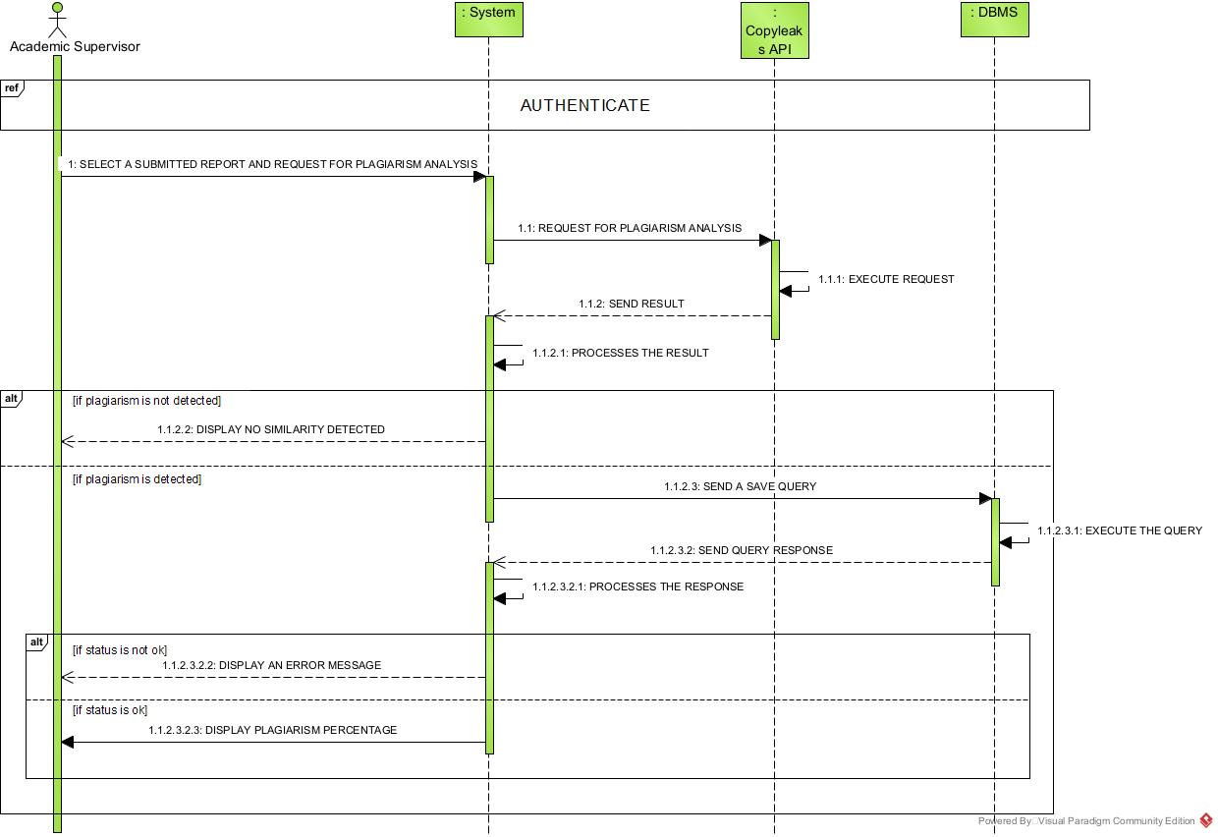
Figure 22: sequence diagram for report analysis

D. ACTIVITY DIAGRAM

Definition
An activity diagram is a graphical representation of workflows that show the steps needed in the realization of a process; showing the details from a start point to an end through all decisions and actions that can possible be performed. Activity diagrams are intended to model both the computational and organizational process. They flow can be sequential, branched or concurrent.

Formalism
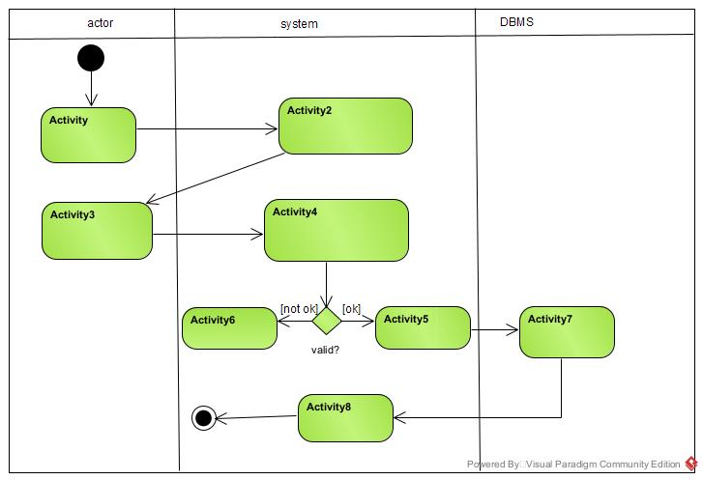
Figure 23: Activity diagram formalism

Component of an activity diagram
Table 19: Component of activity diagram
Element Diagramatic Representations |  | Description
Activity | 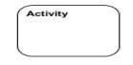 | Used to represent a set of actions.
Action | 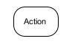 | Represent a task to be performed.
Activity edge |  | A directed connection between two activity nodes through which tokens may flow
Initial node |  | Shows the beginning of an activity or set of actions.
Final node | 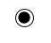 | Stops all controls and object flows in an activity.
Object node | 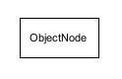 | Represents an object connected to a series of object flows.
Décision node | 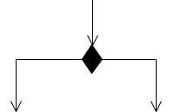 | Represents a test condition that slits an incoming activity edge into opposite outgoing activity edges.
Merge node | 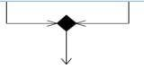 | Reunite different decision paths created using a decision node.
Fork node | 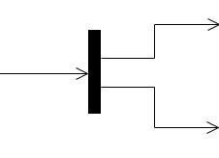 | Slit’s behavior into parallel or concurrent flows of activities (or actions).
Join node | 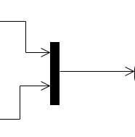 | Unites a set of parallel or concurrent flows of activities or actions.
Swimlane and partition | 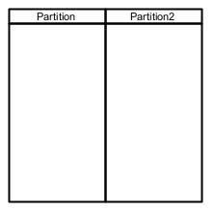 | A way of grouping activities performed by the same actor in an activity diagram or to group actions in the  same. thread

Authentication Activity Diagram
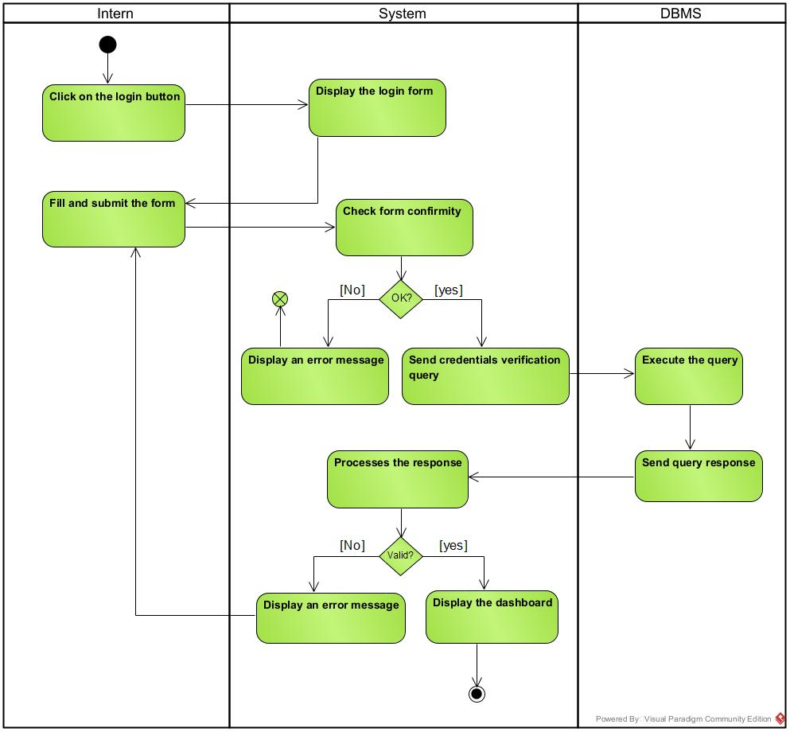
Figure 24: Activity diagram to authenticate

submit Report Activity Diagram
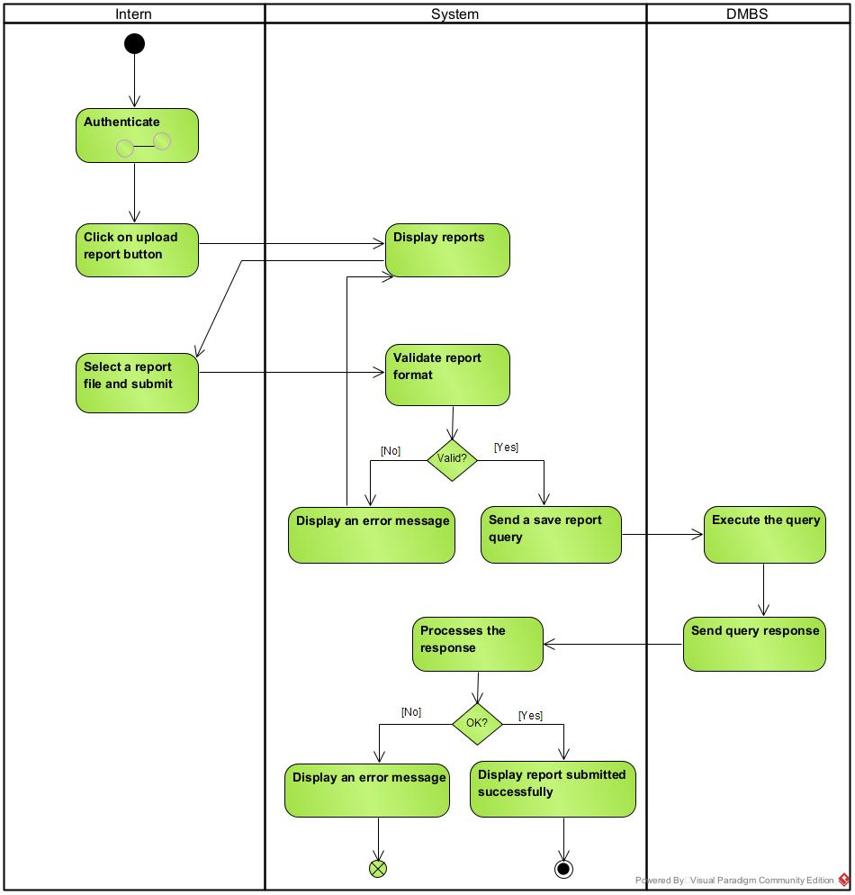
Figure 25: Activity diagram to submit report

AI Correction Activity Diagram
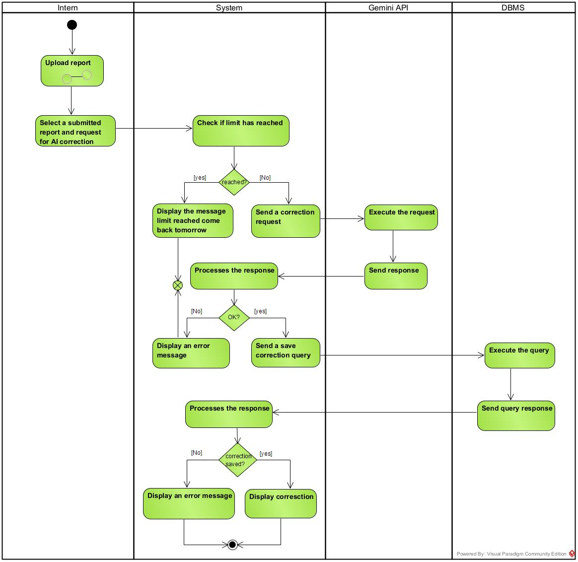
Figure 26: Activity diagram for AI corrections

Analyse report Activity diagram
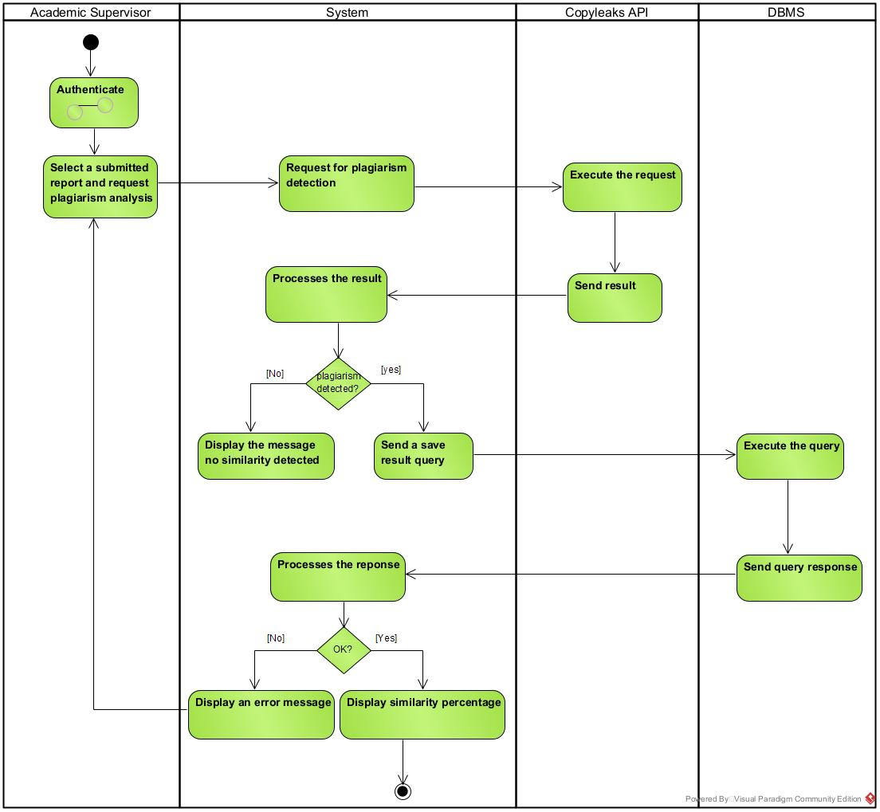
Figure 27: Activity diagram for report analysis

CONCLUSION
In the analysis phase, we chose a software development process and modelling language, after which we explained the functional need of our system, we saw the use case diagram which shows the relationship between the actors and use case (the action the actor can perform on the system),we saw the communication diagram which represents the architecture of the system based on object oriented programming, we saw the sequence diagram which represents the flow of messages between elements in the system, and lastly the activity diagram which shows the workflow of our system. We will now move to the conception phase in which we will present the technical branch of our system together with related diagrams.

FILE IV : CONCEPTION PHASE

Preamble

The conception phase is the part of the document that shows the link between the analysis and the realization phases. It is the continuation of the Analysis phase, which represent the technical aspect used in modelling our system.

Content

INTRODUCTION
- CAPTURE OF THE TECHNICAL NEED
- CLASS DIAGRAM
- STATE MACHINE DIAGRAM
- PACKAGE DIAGRAM
CONCLUSION

INTRODUCTION
The conceptual phase will describe in details the necessary specifications, features and operations that will satisfy the functioning requirements of the proposed system as modelled in the analysis phase. This phase is meant to identify and consider essential components (hardware /or software), structure (network capabilities), processes and procedures for the system to accomplish it objectives. We will look at some diagrams such as the component diagram, package diagram, communication diagram, class diagram and the object diagram.

I. CAPTURE OF THE TECHNICAL NEED

PHYSICAL ARCHITECTURE
When designing an application, it is essential to first understand the architecture that will support it before moving further into development. The physical architecture defines how the different components of the system will be deployed and interact in the real environment. Its choice depends on several factors such as the expected number of users, the volume of data to be handled, performance requirements, and the level of security needed. A well-defined physical architecture ensures that the system is scalable, reliable, and capable of supporting both current and future demands.

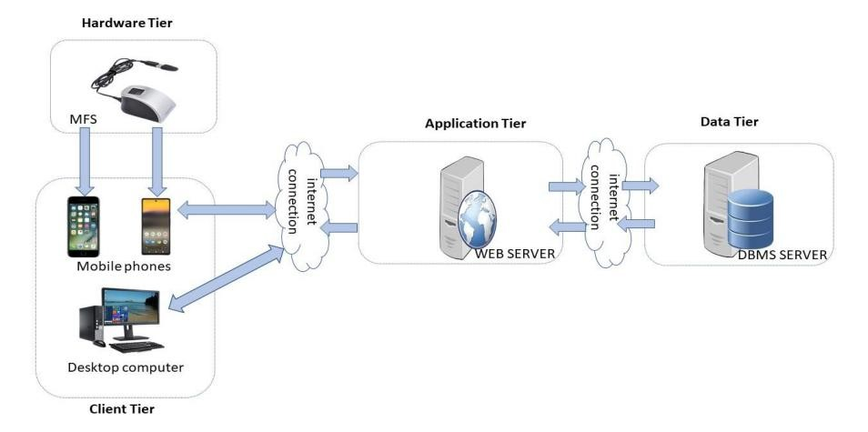
Figure 28: n-tier architecture
(Source: https://www.pinterest.es/pin/752241943987565648/)

B. LOGICAL ARCHITECTURE
Our data analysis tool follows the Model-View-Controller (MVC) design pattern, which separates application concerns into three interconnected components:

Model
The Model is responsible for managing the application’s data and business logic. It ensures data consistency, validates inputs, and exposes methods for querying or updating the stored information.

View
The View presents information to the user and provides a user-friendly interface for interacting with the system. It is only concerned with presentation; it does not perform any business logic or data manipulation.

Controller
The Controller acts as a mediator between the Model and the View. It receives user actions from the View, processes them through the Model, and returns the results for rendering.
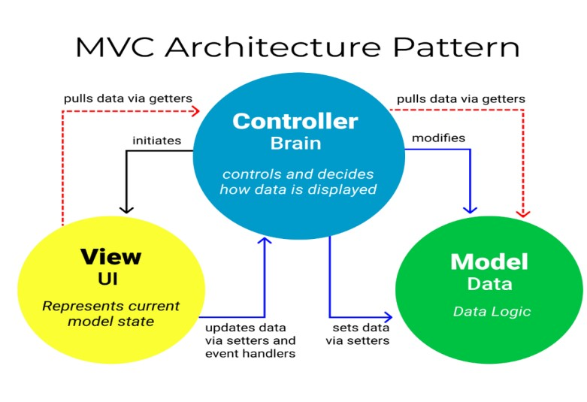
Figure 29: MVC architecture
(source:https://www.freecodecamp.org/news/the-model-view-controller-pattern-mvc-architecture-and-frameworks-explained/ )

II. CLASS DIAGRAM

Definition
A class diagram is a static diagram. It represents the static view of an application. class diagram is not only used for visualizing, describing and documenting different aspect of the system but also for constructing executable code of the software application. Class diagram describes the attribute and operation of a class and constraints imposed on the system. Its purpose is to model the static view of an application.

b. Formalism
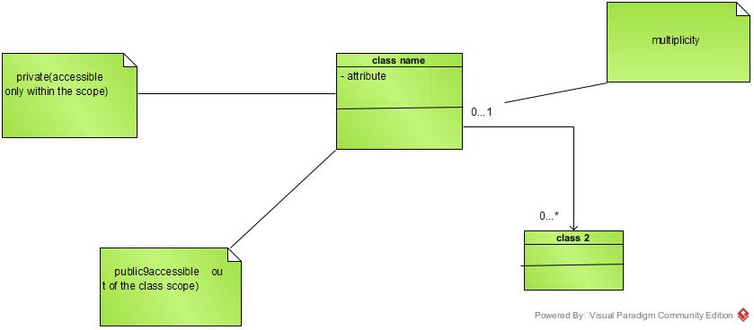
Figure 30: Formalism of class diagram

Components of a class diagram
Table 20: Component of class diagram
Element | Representation | Description
Class | 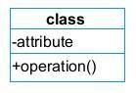 | A class is an element that defines the attributes and behaviours that an object is able to generate
Composition | 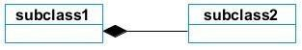 | If a parent of a composite is deleted, usually, all of its parts are deleted with it.
Aggregation |  | If the parent of the aggregate is deleted, usually the children are not deleted.
Dependency | 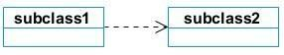 | It existed between two classes, if one changes it may cause the change in the order, but the other way around.
Generalization | 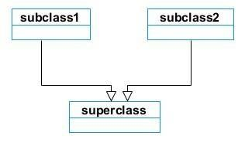 | It is a type of relationship between two classes where one class (child class) inherits the properties of the other class (parent class).
Association | 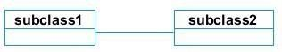 | It is a general type of relationship between elements, it may include cardinality, roles etc.

Class diagram of InternSmart

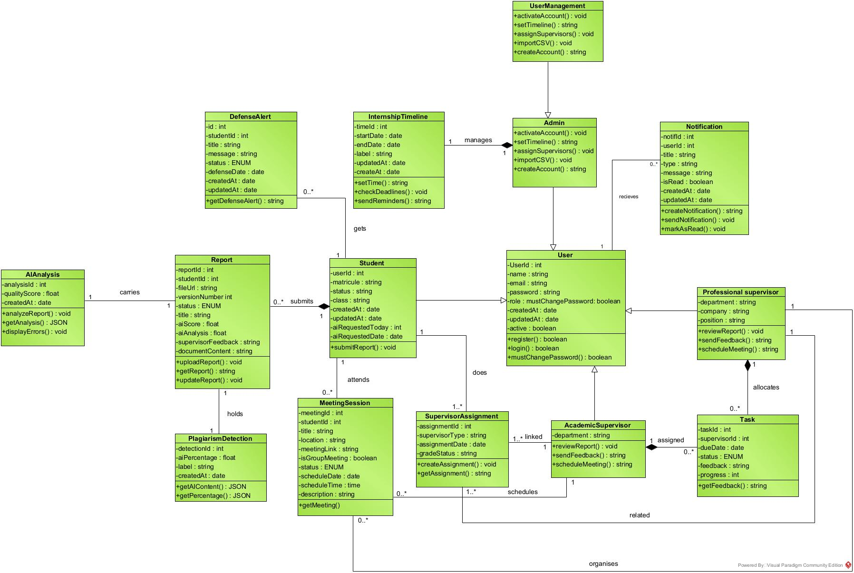
Figure 31:class diagram of InternSmart

III. STATE MACHINE DIAGRAM

Definition
A state machine diagram describes the behavior of a single object in response to a series of events in a system. Also known as the state machine diagram, it models the dynamic flow of control from the state of a particular object within a system.

Formalism
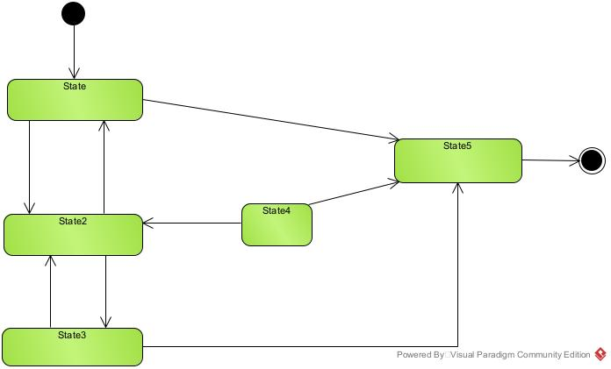
Figure 32: formalism of state machine diagram

Components of a state machine diagram
Table 21: Component of state machine diagram
Elément | Notation | Description
State | 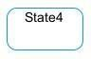 | Models a situation during which a certain invariant condition holds.
First (Initial) State |  | It represents a default vertex, that is, a source for a single transaction to the default or composite state.
Final State |  | A state specifying that the enclosing region is complete.
Transition | 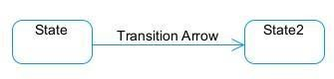 | A direction relation between a source and a target vertex.
Choice pseudo State |  | A diamond symbol that indicates a dynamic condition with branched potential results
Terminate | 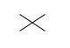 | Implies that the execution of a state by means of it context is terminated.
Diagram Overview | 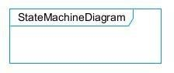 | A placeholder for the linked states in a state machine diagram.

Student State Machine diagram

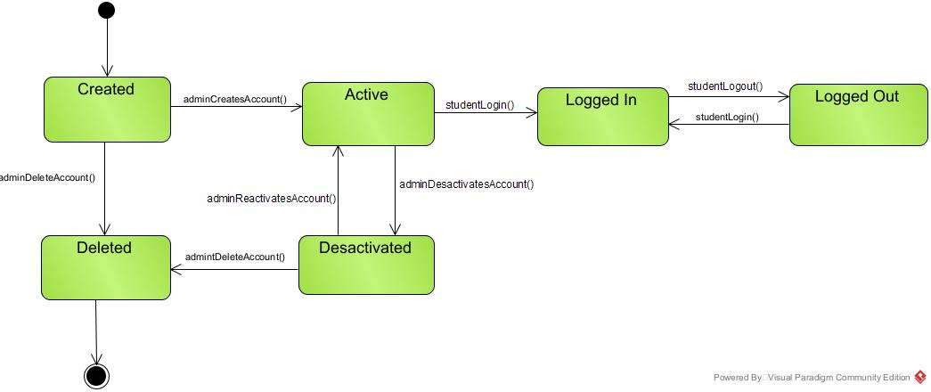
Figure 33: student state machine diagram

Report state machine diagram
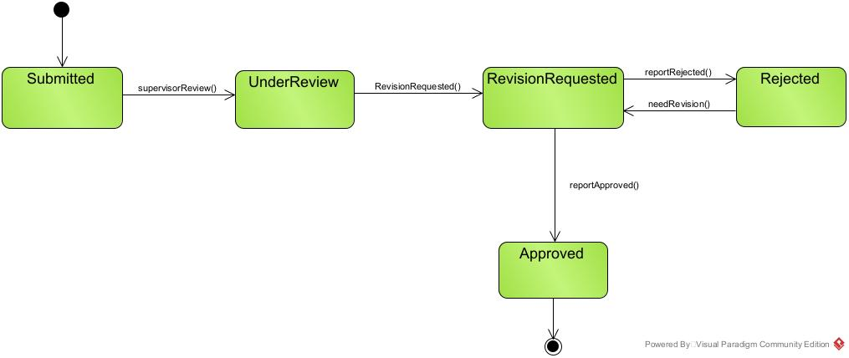
Figure 34: report state machine diagram

IV. PACKAGE DIAGRAM

Definition
A package diagram is a structural diagram used to show the organisation and arrangement of various model element in the form of packages. It groups related UML element such as classes, diagrams, or even other packages into cohesive units.

Formalism
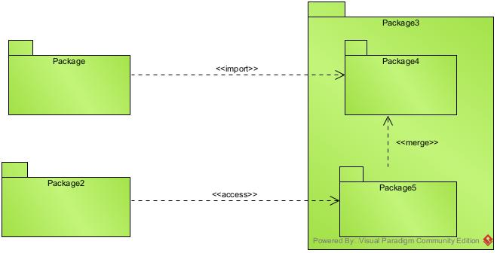
Figure 35: formalism of package diagram

Components of a package diagram
Table 22: Components of package diagram
Name | Representation | Description
Package | 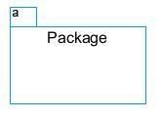 | A package is a namespace use to group related elements; it is a mechanism used to group elements into a better structure in a system.
Package import | 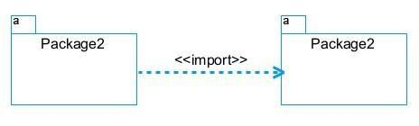 | A relationship Indicate that, functionality has been imported from one package to another.
Package Access | 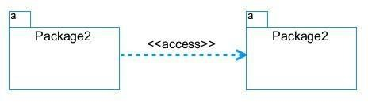 | A relationship Indicates that one package requires assistance from the function of another package.
Package merge | 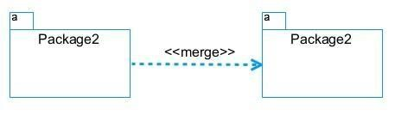 | It is a relationship which shows that, the functionality of two packages are combines to a single function.

Package diagram of InternSmart
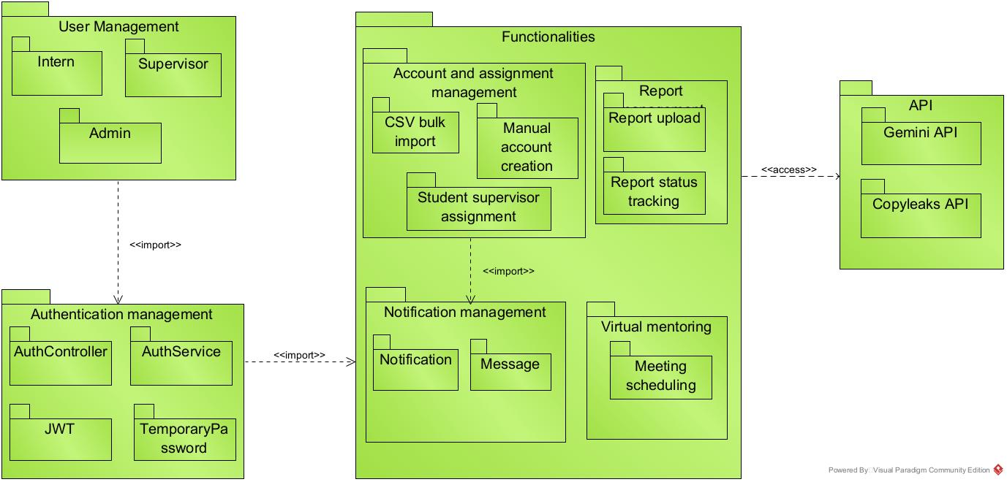
Figure 36: package diagram of InternSmart

CONCLUSION
In the conception phase, we set the stage for a successful project through the creation of key diagrams such as class diagrams, state machine diagrams, and package diagrams. This phase facilitates a shared understanding among stakeholders, identifies and mitigates potential risks and issues, and establishes a robust architectural foundation for implementation. We finished this phase by looking at interaction between the various aspects and actors of our system. The next phase of our report is the realization phase where we will look at aspects concerning the implementation of our system.

FILE V: REALIZATION PHASE

Preamble

The conception phase will permit us to present in an orderly manner the components necessary for the good functioning of our software and the architecture used for the proposed solution. It bridges the gap between the analysis phase and the realization phase

Content overview

INTRODUCTION
- PRELIMINARY CONCEPT
- TECHNICAL CHOICE
CONCLUSION

INTRODUCTION
Here in the realization phase, we will concentrate on building or implementing our solution, based on the different analysis and conception that we had carried out, which will help to facilitate our work. This phase is as critical as the practical application of our plan determine the success of the over roll system. We are going to look at the relationship that exist between the entities of the entity relational diagram. Furthermore, we will see the choices of technologies used for the implementation of our system.

PRELIMINARY CONCEPTION

A. Component Diagram

Definition
Component diagrams are used to model the physical aspect of a system. Now the question is what are these physical aspects? They are element such as executables, libraries, files, document etc. Which reside in a node. The component diagram does not describes the functionality of the system but it describes the component used to make those functionalities.

Formalism

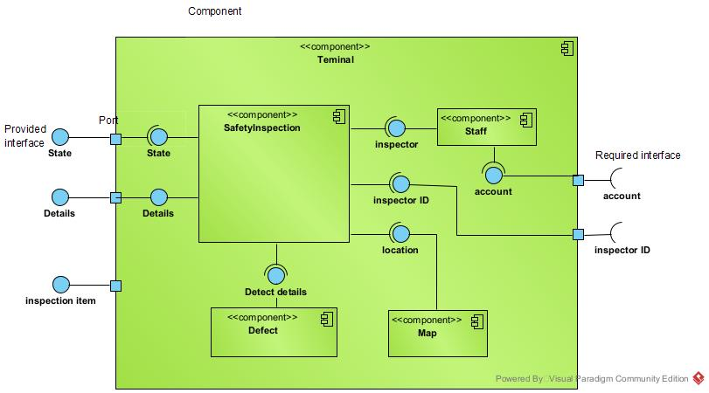
Figure 37formalism of component diagram

Elements of a component diagram
Table 23: Elements of component diagram
NAME | REPRESENTATION | DESCRIPTION
A component | 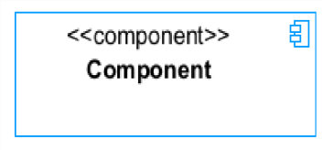  FILE VI : FUNCTIONAL TESTING | A component is an abstract logical unit block of a system.it is represented as a rectangle with smaller rectangle in the upper right corner which saves as it icon for recognition.
Dependency | 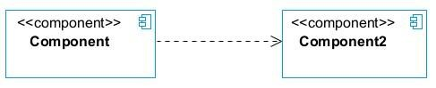 | Dependency is a directed relationship, which is used to show that some components are dependent on others for their correct functioning.
interface | 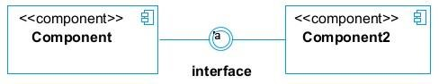 | An interface is a circle or a semicircle attached to a stick which looks like a lollipop. It describes groups of operations provided or required by components.
port | 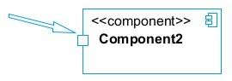 | A port (represented by a small square at the end of a required or provided interface) is used when the components delegate the interfaces to an internal class.

InternSmart component Diagram
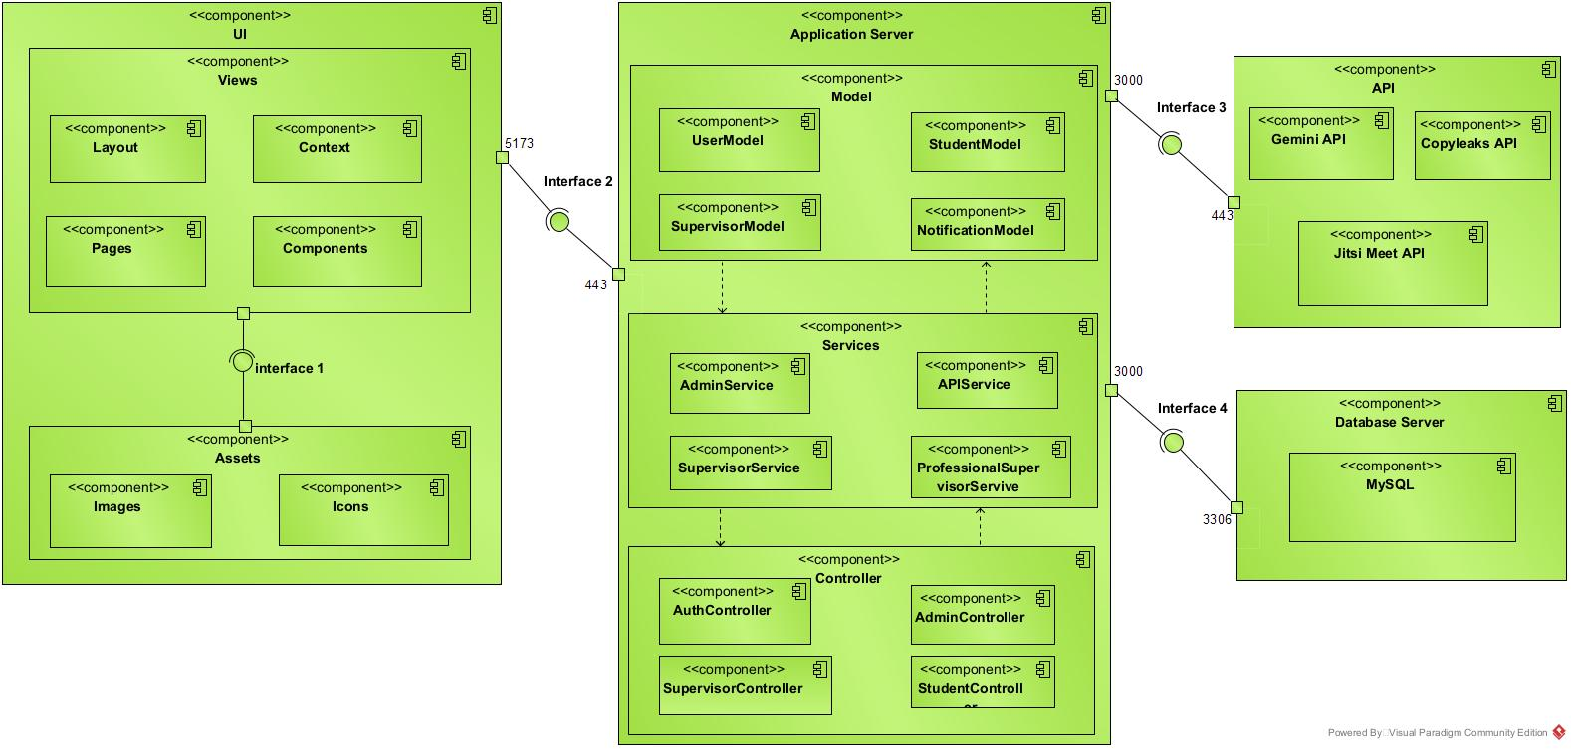
Figure 38: component diagram of InternSmart

B. Deployment Diagram

a) Definition:
Consists of nodes. Nodes are nothing but physical hardware used to deploy the application Deployment diagram is a structural diagram used to visualize the topology of the physical components of a system, where the software is deployed. They consist of nodes and their relationship. It is related to the component diagram because the components are deployed up using the deployment diagram. A deployment diagram

b) Formalism

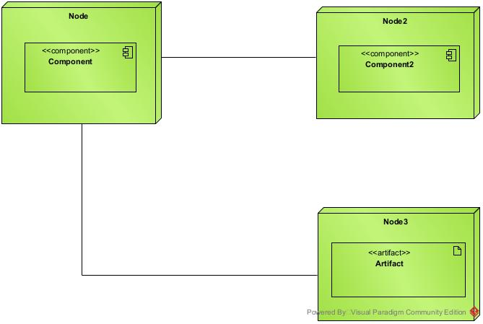
Figure 39: formalism of deployment diagram

c) Elements of Deployment Diagram
Table 24: Elements of deployment diagram
Element | Representation | Description
Node | 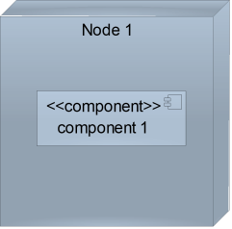 | It is a hardware used to deploy the application
Artifact | 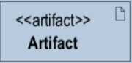 | An artifact is a major product, which is produced or used during the development of a software. E.g diagrams, data models, setup scripts
Component | 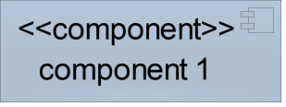 | It represents a modular part of a system that encapsulates its content and whose manifestation is replaceable within it environment.
Association | association | An association helps to connect two nodes together which permits them to communicate together

d) InternSmart Deployment Diagram

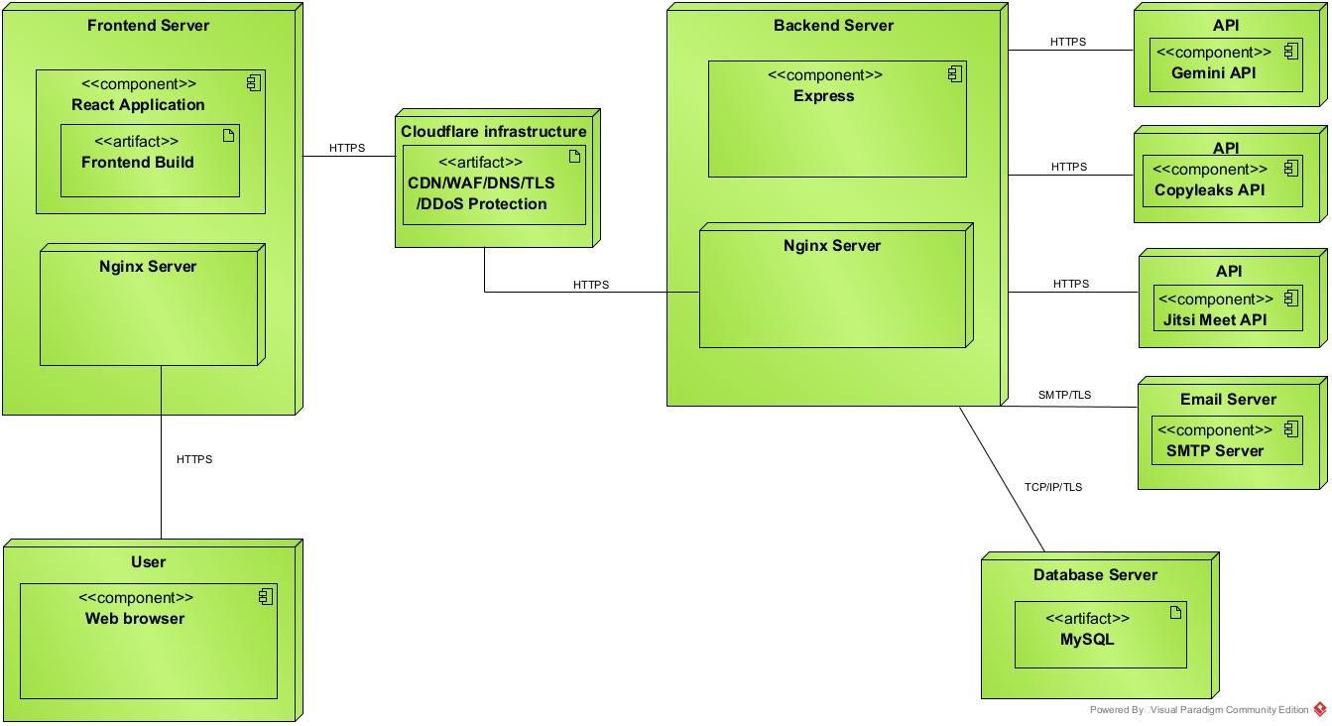
Figure 40: deployment diagram of InternSmart

TECHNICAL CHOICE
Table 25: Technical choice
Software | Role | Reason for use | Image
OS  WINDOWS  11 | The operating system  required to run the  software is the one on  which we have worked. | Windows 10 has a user-friendly interface that is  familiar to many users, making it easy to navigate and use | 
Visual  Paradigm | The software engineering  workshop was used for  solution modelling. We  utilized this tool for  modelling the various  diagrams of our system | Supports multiple modelling languages and methodologies,  making it suitable for various project requirements and enabling teams to adapt to different development processes. | 
GitHub | It is a website and cloud  service that helps  developers store and  manage their code. | Git allows developers to track  changes, revert to previous  versions, and maintain a  history of modifications,  ensuring that no work is lost  and enabling easy recovery. | 
Mocha | It is anAPI Testing Tool | Used to test RESTAPIs,  validate requests and  responses,debug endpoints,  and verify backend  functionality before  integrating with the frontend. | 
Visual studio  code | Visual Studio Code is a  lightweight, open-source  code editor developed by  Microsoft, supporting  multiple programming  languages. Using for the  writing of application  code. | . Combines tools for version  control, debugging, and  terminal access in one  interface, improving  efficiency and reducing the  need for multiple  applications. | 
Framework  react Js | A popular JavaScript  library for building UI. It  provides a component-  based approach and allows for efficient rendering and state management. Used for building the front | Promotes the creation of Reusable components, which  enhances code  maintainability and allows for easier updates and testing. | 
MS Word | MS Word is a widely used word-processing  application that allows  users to create, edit, and  format text documents.  Using in-application report  creation. | Offers extensive options for  formatting text, images, and  layouts, enabling the creation  of professional quality  documents. | 
MS  PowerPoint | MS PowerPoint is a  presentation software that  allows users to create  dynamic slideshows  comprising text, images,  videos, and animations.  Able us to create  slideshow presentations  for application. | Its intuitive interface and  templates make it easy for  users to create professional  presentations quickly,  regardless of their technical  skill level. | 
Node Js | AJavaScript runtime for  building fast and scalable  backend applications. | Enables real-time interactions  and seamless integration with  frontend via APIs. | 
Express Js | A minimalist web  framework for Node.js. | Facilitates API development  and backend routing. | 
Chrome | Google Chrome is a fast,  secure, and user-friendly  web browser developed by Google. Used to test our application UI | Chrome is optimized for fast  page loading and efficient  resource management,  providing a smooth browsing  experience. | 
Gmail  SMTP | Google's email server  protocol. | Enables sending automated  emails (e.g., registration,  updates, approvals). | 
Gantt  Project | Gantt Project is a free,  open-source project  management tool that  allows users to create  Gantt charts for planning  and scheduling projects. | Allows users to assign tasks,  set deadlines, and manage  resources effectively,  facilitating better project  coordination and efficiency. | 
MySQL | A relational database management system | Allows flexible storage of users and project data with easy flexibility | 

CONCLUSION
During our realization phase, we successfully developed and implemented our application. To achieve this, we utilized our analysis and conception phase. We also created deployment and component diagrams, which illustrate the modules, files, and assets, as well, as how different elements interact with each other within our system. Our next step is to move onto the functionalities testing phase, where we will assess the efficacy of the various modules present in our app for different users

FILE VI: FUNCTIONAL TESTING

Preamble

In this phase, we will present the various functionalities of our application.

Content overview

INTRODUCTION
- APPLICATION FUNCTIONALITIES
- TESTS SHOWCASE
CONCLUSION

INTRODUCTION
Functional testing is a systematic process that focuses on verifying whether a software application performs according to its defined requirements. It is carried out across different stages of the development lifecycle to ensure that each component delivers its intended functionality and contributes to the overall performance of the system. The primary objective of this approach is to detect and correct defects or inconsistencies early, thereby improving reliability, user satisfaction, and software quality.

I. Application Functionalities
The functionalities of InternSmart are organized below by functional concern, reflecting the actual architecture of the system rather than a simple listing per user role.

Authentication and Access Control
- Secure login using email and password, with no self-registration option.
- Role-based redirection determined by the account's stored role, not by user selection.
- Password hashing and secure credential storage.
- Forced password reset on first login for newly created accounts.
- Role-based route protection enforced on both frontend and backend.

Account and Assignment Management
- Bulk account creation and supervisor assignment through CSV import.
- Manual, single-entry account creation for individual cases.
- Automatic detection and reuse of existing supervisor accounts across multiple students.
- Import error detection and reporting for invalid or conflicting rows.
- Internship status tracking per student (active, completed, withdrawn, on hold).

Report Management
- Report upload and version submission.
- Report status tracking through the review lifecycle.
- Version history accessible to the student and both supervisors.

AI-Assisted Review
- Automated writing quality analysis of submitted reports.
- Suggested corrections presented to the student prior to supervisor review.
- AI feedback kept advisory only, with all final decisions made by human supervisors.

Plagiarism Detection
- Automatic comparison of each submission against the institution's archive of previously submitted reports.
- Similarity scoring and threshold-based flagging.

Evaluation and Grading
- Separate, weighted grading fields for academic supervisor and professional supervisor evaluation.
- Automatic calculation of the combined weighted final score.
- Supervisor feedback recorded and accessible through the supervisor profile view.

Collaborative Report Drafting
- Self-hosted, Word-style writing workspace built with the open-source Tiptap editor and Yjs real-time synchronization engine.
- Strict A4 page formatting for institutional document consistency.
- Unlimited document storage with no third-party licensing cost.
- Secure, read-only visibility for supervisors into a student's report as it is being written.
- Integrated grading sidebar displayed alongside the document for direct supervisor annotation.
- Instant, offline-capable PDF export at any stage of drafting.
- Manual file upload option available as a fallback submission method.
- Automatic export of the finalized document for AI analysis and archival.

Virtual Mentoring
- Supervisor-initiated meeting scheduling with date, time, and agenda.
- Integrated vidéo Conferencing session.
- Post-meeting notes attached to the student's supervision record.

Notification System
- Real-time in-app notifications for key events.
- Email notifications for account creation, meeting scheduling, and deadline reminders.
- Notification linkage back to the originating record (e.g. a meeting notification linking directly to that meeting).

Administration and Institutional Oversight
- Institutional dashboard displaying cohort-wide submission and approval progress.
- Consolidated plagiarism oversight report across the full student population.
- Internship timeline and deadline configuration.

II. Test Showcase
Create User account
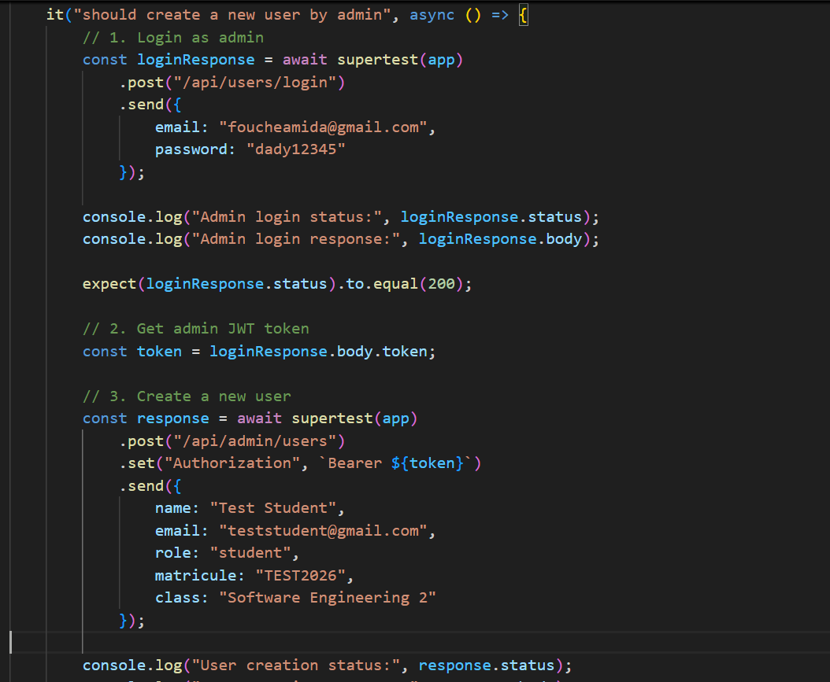
Figure 41: create account unit test

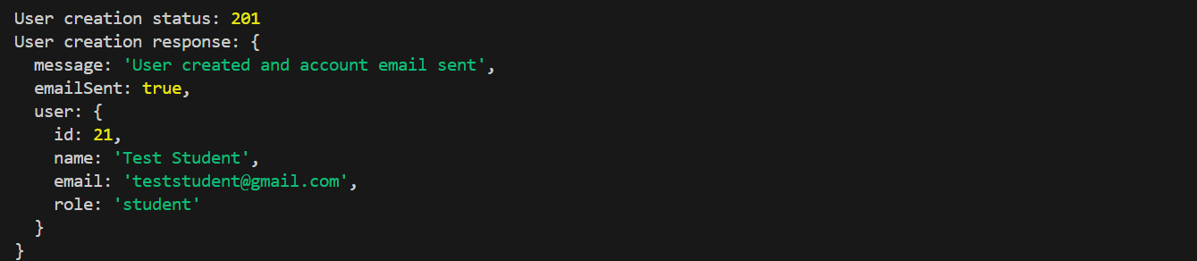
Figure 42: provide account unit test

User Login
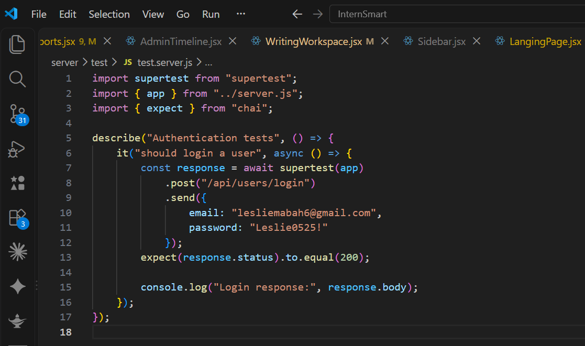
Figure 43: login unit test
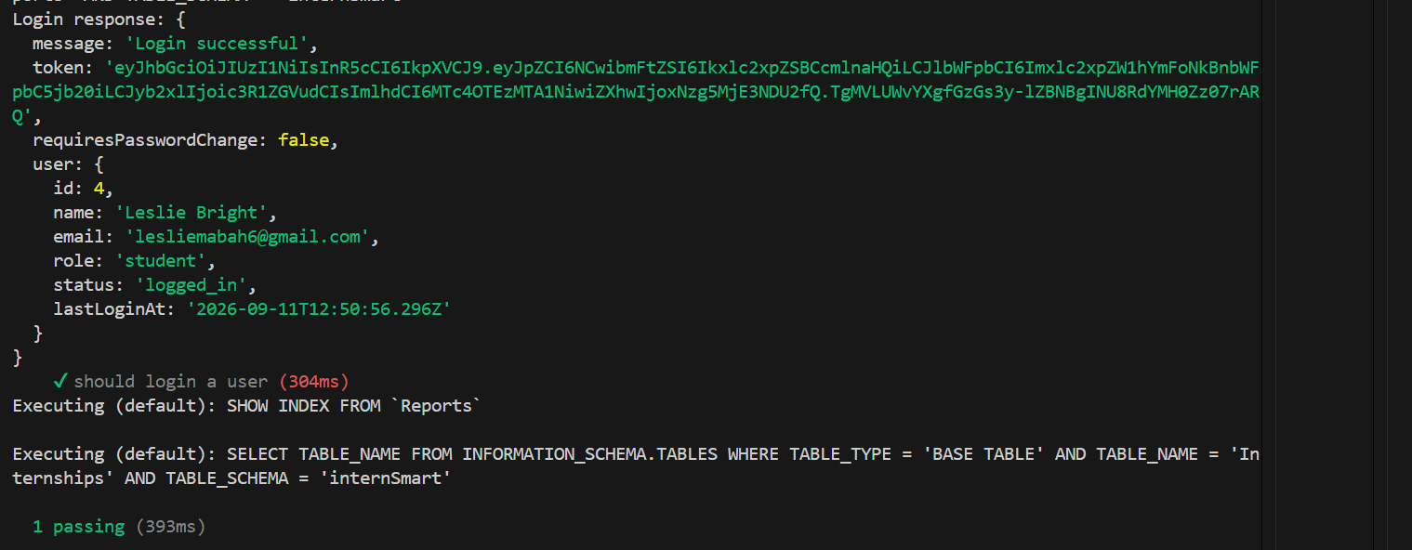
Figure 44: provide login unit test

Create Task
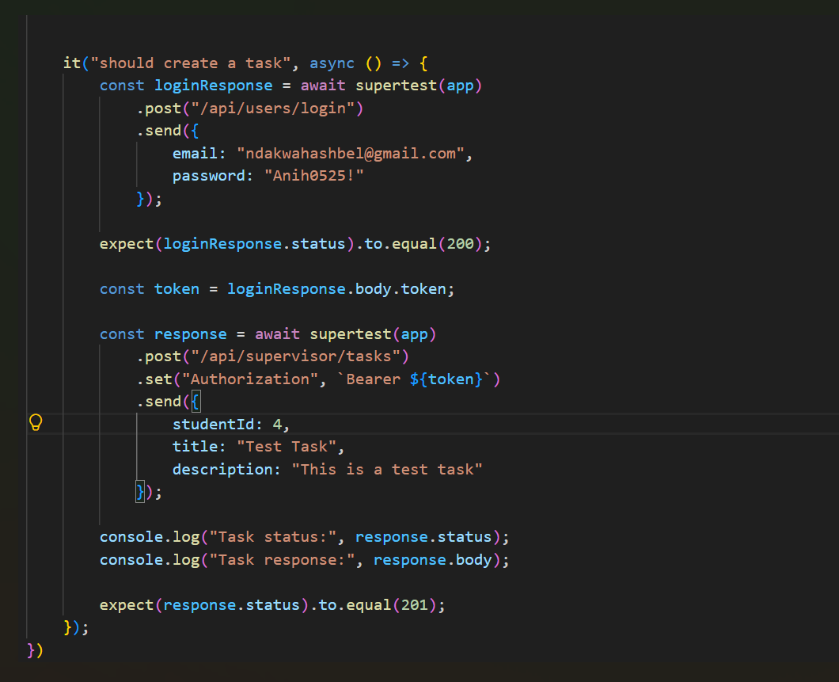
Figure 45: create task unit test
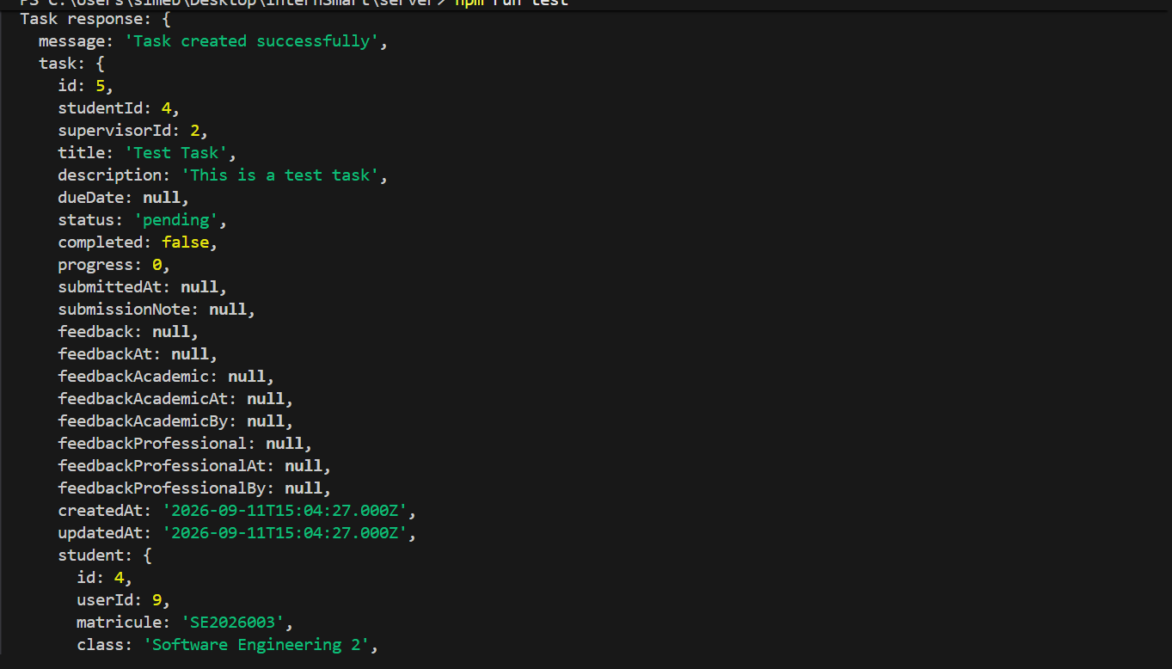
Figure 46: provide task unit test

Create Meeting
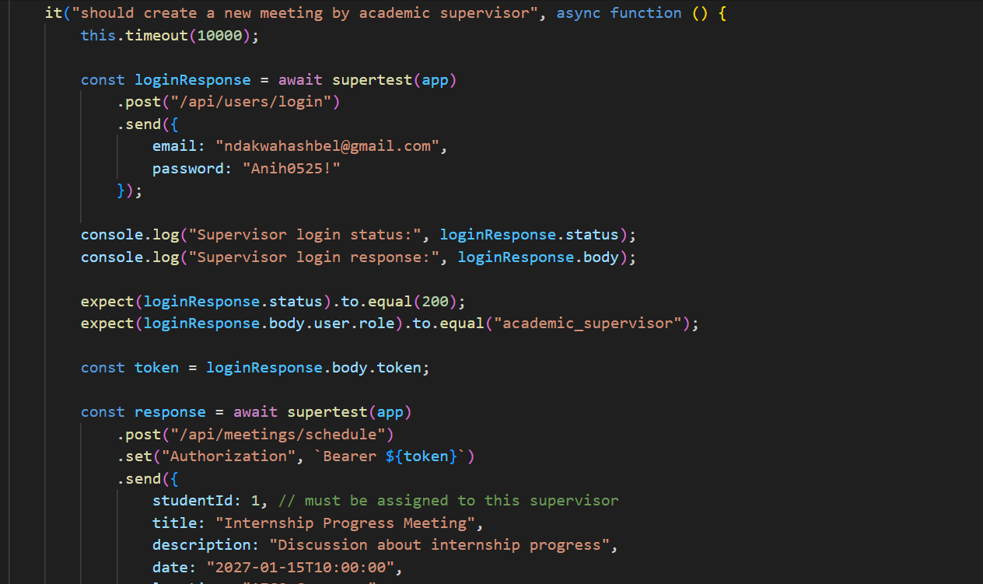
Figure 47: create meeting unit test

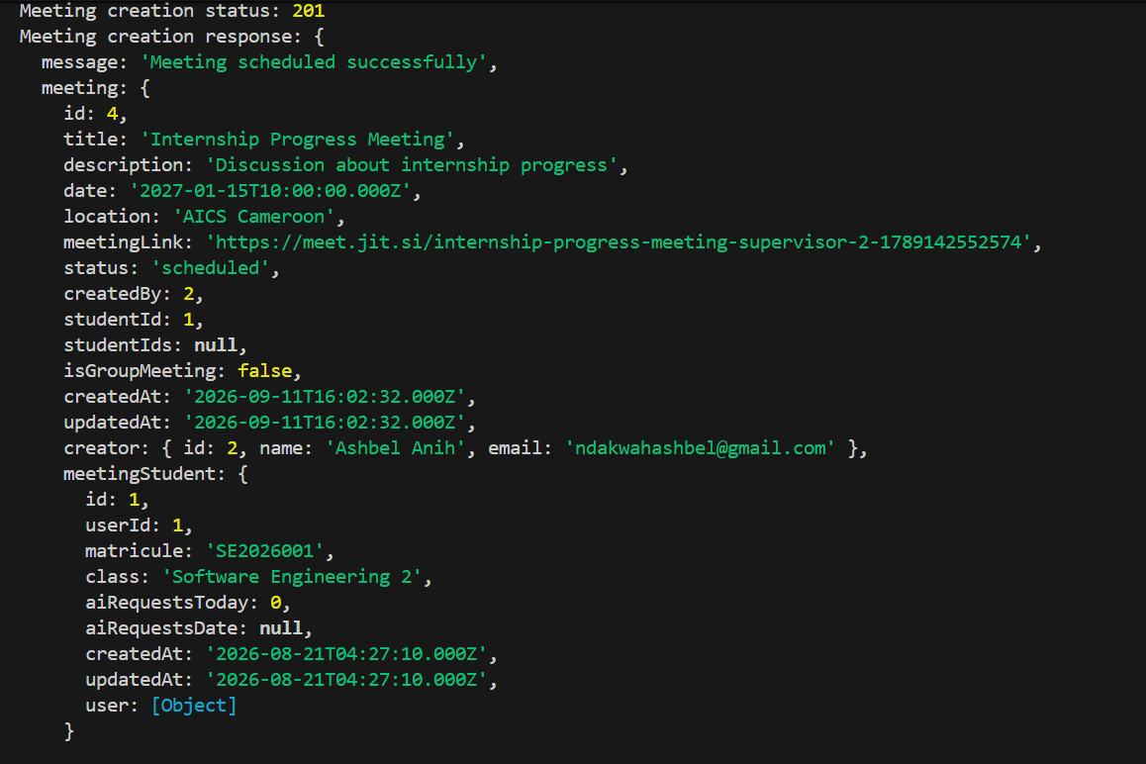
Figure 48: provide meeting unit test

CONCLUSION
Testing is an integral part of the software development life cycle and is performed to verify the correctness, reliability, and robustness of the implementation functionality. The functionality and testing phase are therefore a critical stage in software development where the implemented features are validated, and any issue are identified and resolve.

FILE VII: INSTALLATION AND USER GUIDE

Preamble

The purpose of the user guide is to provide users of our platform with step-by-step instructions on how to install and use the system.

Content overview

INTRODUCTION
- INSTALLATION
- USER GUIDE
CONCLUSION

INTRODUCTION
This phase represents the final part of our project. Here, we will detail the system requirements, outline the installation process, and explain how to access and navigate the platform’s features. All this in a systematic manner to facilitate the setting up of the platform for the first-time users. The steps of different processes will be accompanied by images. After we will showcase our application by presenting it various screens and functionalities.

Installation of the application

Prerequisites
Before installing the application, ensure that your system meets the following requirement.

General Requirement:
- Node.js (version 22 or above) download from nodejs.org
- Npm (comes with node.js)
- Visual studio code or any other preferred text editor/IDE
- MySQL
- Git for version control (install from git-scm.com)

Backend setup:
- Install dependencies; npm install
- Set up your database.
- Start MySQL
- Start the backend server; npm start

Frontend setup (react.js):
- Install dependencies; npm install
- Run the application using; npm run dev

II. User Guide

Login form
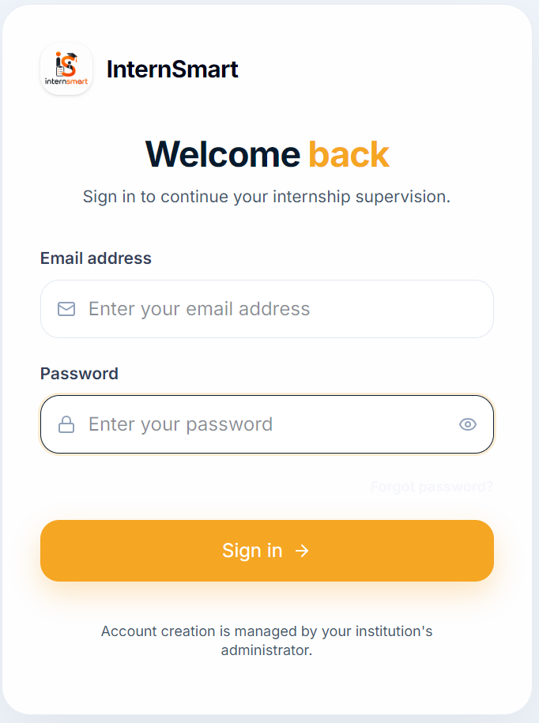

Student Dashboards
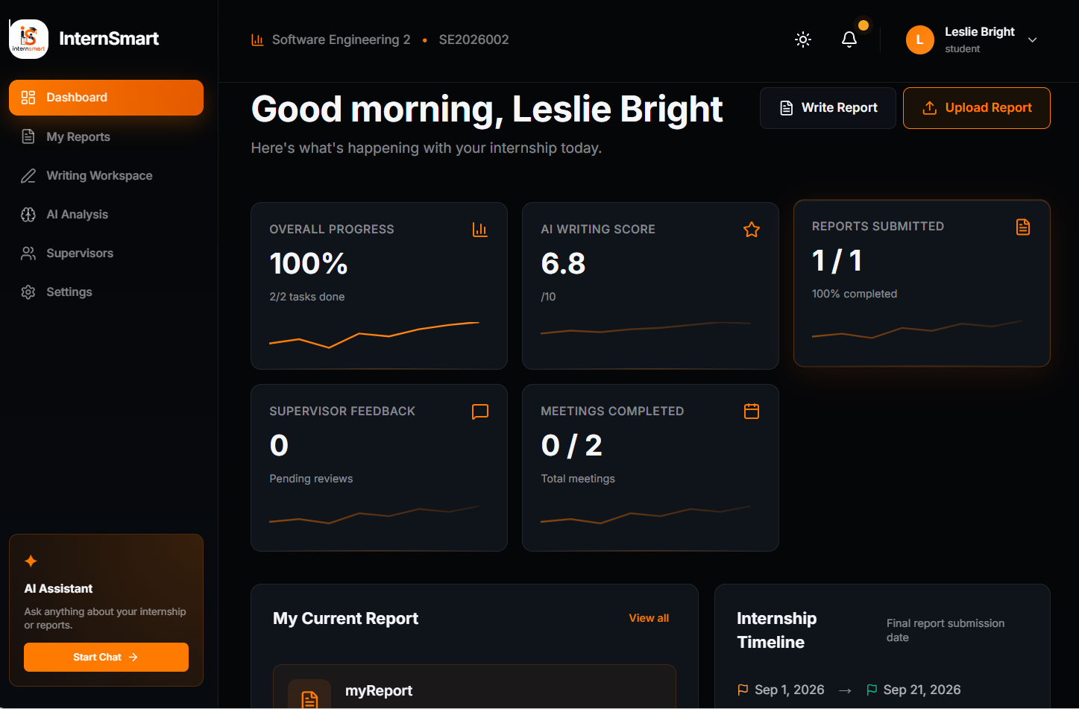

Report Page
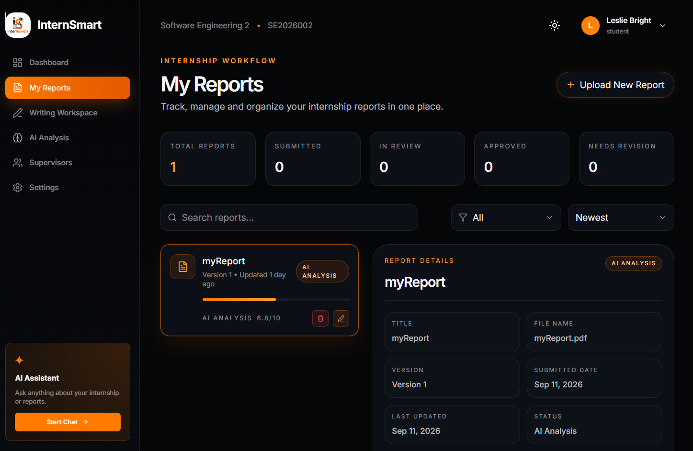

Academic Supervisor Dashboard
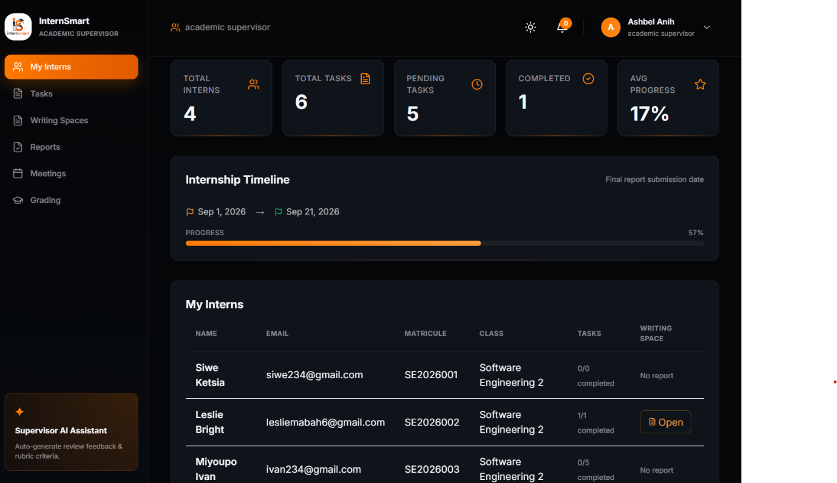

Professional Supervisor
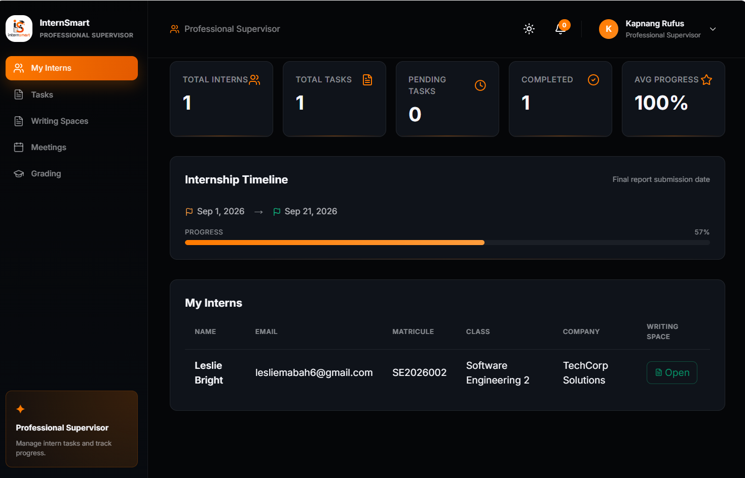

Admin Dashboard
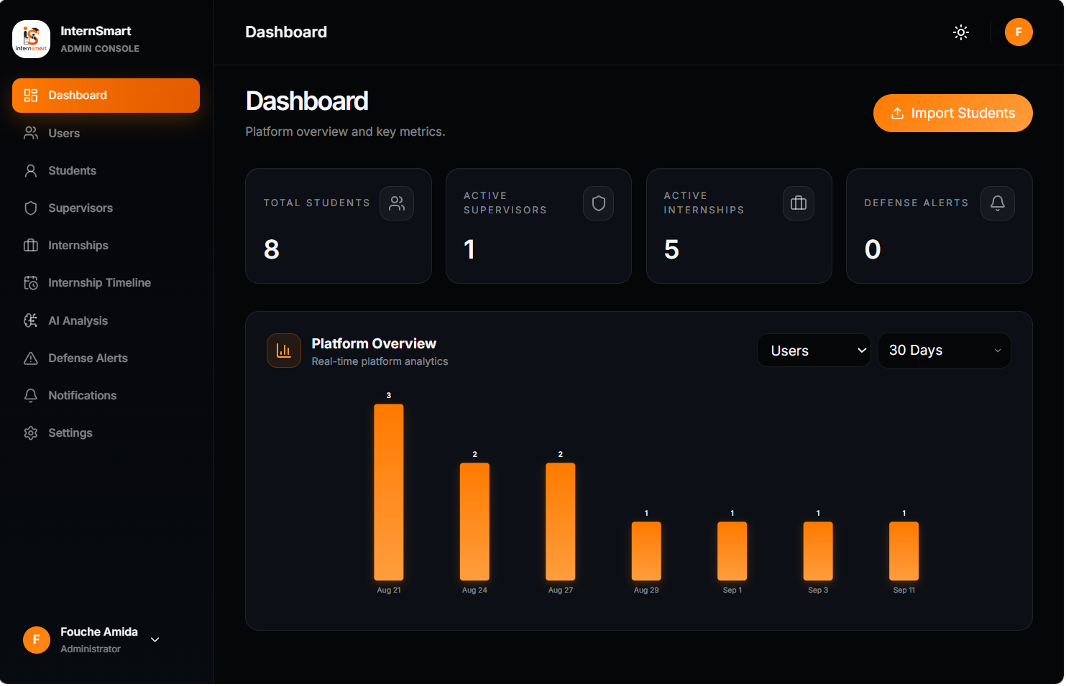

CONCLUSION
Having put in place the platform, it was not sufficient on its own, as we also needed to provide a comprehensive manual to guide its various users. For this reason, we presented the different tools require installation along with clear instruction on how they should be set up in order to run the application smoothly, beyond the installation, we also outline how users can effectively interact with the platform once the environment is ready. This ensures not only a successful deployment but also a seamless adoption of the system by end users.

PERSPECTIVE

While the current version of the Internship Management System addresses the core challenges identified in this dissertation, several enhancements could extend its capabilities in future iterations:
- Integration of an external plagiarism detection service to complement the internal comparison mechanism with web-based source checking.
- Development of a native mobile application to improve accessibility for students and supervisors on the move.
- Support for multilingual interfaces to accommodate institution’s linguistic contexts.
- Implement attendance monitoring and timetable management.

GENERAL CONCLUSION

ANNEXES

Having reached the end of our project and internship at REALIZE, we can affirm that this experience has been highly enriching, both academically and professionally. It enabled us to discover the realities of the professional environment, strengthen our technical skills, improve our ability to work in a team, and develop important qualities such as responsibility, adaptability, problem-solving, and time management. The project undertaken during this internship focused on “THE DESIGN AND IMPLEMENTATION OF A SMART INTERNSHIP MANAGEMENT SYSTEM”, entitled “InternSmart”. The main objective was to provide a centralized digital platform for managing students’ internship-related activities, particularly task assignment and monitoring, academic supervision, internship report preparation, report submission, and AI-assisted report evaluation. The system also integrates user and access management, dashboards, and online supervision meetings in order to facilitate communication and improve the overall monitoring of internship activities. To achieve these objectives, we began by studying the existing system, identifying its limitations, gathering the requirements, and defining the functional and non-functional needs of the proposed solution. We then analyzed and modelled the system using the Unified Modelling Language (UML) methodology before proceeding to its implementation. The application was developed using React.js for the front end and Node.js with Express.js for the back end. Sequelize and MySQL were used for database management, while authentication mechanisms and role-based access control were implemented to protect the system and ensure that each user accesses the functionalities appropriate to their role. Artificial intelligence was also integrated to assist in reviewing internship reports and identifying possible structural, language, and academic issues. The implementation of InternSmart represents a significant step toward improving the organization, monitoring, and documentation of internship activities at AICS CAMEROON. However, the time dedicated for the put in place of the solution was not sufficient to produce a good solution. Nevertheless, some perspectives are to be implemented to make the solution usable and optimal.

BIBLIOGRAPHY

BIBLIOGRAPHY

- Mercurial 2026.
- Fowler, Martin. A Brief Guide to the Standard Object Modelling Language. Addison Wesley 3rd edition 2003
- Booch, G., Rumbaugh, J., & Jacobson, I. (2005). The Unified Modelling Language User Guide (2nd ed.). Addison-Wesley.
- Pressman, R. S., & Maxim, B. R. (2019). Software Engineering: A Practitioner's Approach (9th ed.). McGraw-Hill Education.
- Meta Open Source. (n.d.). React Documentation. React. Retrieved September 08, 2026, from React official documentation⁠.
- OpenJS Foundation. (n.d.). Node.js Documentation. Node.js. Retrieved September 13, 2026, from Node.js official documentation⁠.
- Express.js. (n.d.). Express Documentation. Retrieved September 20, 2026, from Express.js official documentation⁠.
- Sequelize. (n.d.). Sequelize Documentation: Version 6. Retrieved September 10, 2026, from Sequelize v6 documentation⁠.
- Object Management Group. (2017). OMG Unified Modelling Language (OMG UML), Version 2.5.1. Retrieved September 15, 2026, from UML 2.5.1 Specification⁠.
- Google. (n.d.). Gemini API Documentation. Google AI for Developers. Retrieved September 12, 2026, from Gemini API Documentation⁠.
- Russell, S., & Norvig, P. (2021). Artificial Intelligence: A Modern Approach (4th ed.). Pearson.
- Mocha. (n.d.). Mocha Documentation. Retrieved September 04, 2026, from Mocha Documentation⁠.

WEBOGRAPHY

WEBOGRAPHY

- Object Management Group (OMG). Unified Modelling Language (UML) Specification, Version 2.5.1. Retrieved from https://www.omg.org/spec/UML/
- Visual Paradigm. UML Diagram Tutorials. Retrieved from https://www.visual-paradigm.com/guide/
- React. React Documentation. Retrieved from https://react.dev/
- Tailwind CSS. Tailwind CSS Documentation. Retrieved from https://tailwindcss.com/docs
- Axios. Axios Documentation. Retrieved from https://axios-http.com/docs/intro
- Node.js. Node.js Documentation. Retrieved from https://nodejs.org/en/docs/
- Express.js. Express.js Documentation. Retrieved from https://expressjs.com/
- Sequelize Documentation ORM for Node.js. Retrieved from https://sequelize.org/docs/v6/
- MySQL. MySQL 8.0 Reference Manual. Retrieved from https://dev.mysql.com/doc/refman/8.0/en/
- Copyleaks documentation. Retrieve from https://docs.copyleaks.com
- Visual Studio Code Marketplace. REST Client Extension. Retrieved from https://marketplace.visualstudio.com/items?itemName=humao.rest-client
- Google AI for Developers Gemini API Documentation. Available at: https://ai.google.dev/docs Accessed during development.
- MDN Web Docs, WebRTC API. Available at: https://developer.mozilla.org/en-US/docs/Web/API/WebRTC_API. Accessed during development.
- Socket.io Documentation. Available at: https://socket.io/docs. Accessed during development.
- JSON Web Tokens (JWT) Introduction. Available at: https://jwt.io/introduction. Accessed during development.
- node-cron Documentation. Available at: https://www.npmjs.com/package/node-cron. Accessed during development.

REFERENCE

TABLE OF CONTENT

Contents
DEDICATION i
ACKNOWLEDGEMENTS ii
CONTENT iii
LIST OF FIGURES iv
LIST OF TABLES vi
LIST OF ABBREVIATIONS vii
GLOSARY viii
ABSTRACT ix
RESUME x
GENERAL INTRODUCTION 1
PART ONE : INSERTION PHASE 2
Preamble 3
Content 3
INTRODUCTION 4
I-WELCOME AND INSERTION 5
a. welcome 5
b. Integration 5
II-GENERAL PRESENTATION OF REALIZE 6
A. History 6
B. Missions, Visions and Activities of Realize 6
1. Mission 6
2. Vision 6
3. Activities 6
III-ORGANISATION OF THE COMPANY 7
A. ADMINISTRATIVE ORGANIZATION 7
i General manager 7
ii Development department 7
iii Financial department 8
iv Communication department 8
v Technical department 8
vi Software department 9
B. FUNCTIONAL ORGANISATION OF REALIZE 9
C. HARDWARE AND SOFWARE RESOURCES 10
IV-GEOGRAPHICAL LOCATION 11
V-BRIEF PRESENTATION OF PROJECT THEME 12
CONCLUSION 13
PART TWO: TECHNICAL PHASE 14
FILE I: EXISTING SYSTEM 16
Preamble 17
Content 17
INTRODUCTION 18
I. PRESENTATION OF THE PROJECT THEME 19
II. STUDY OF THE EXISTING SYSTEM 19
III. CRITICISM OF THE EXISTING SYSTEM 22
IV. PROBLEMATIC 24
V. PROPOSED SOLUTION 25
CONCLUSION 26
FILE II: SPECIFICATION BOOK 27
Preamble 28
Content 28
INTRODUCTION 29
I. CONTEXT AND JUSTIFICATION 30
A. CONTEXT 30
B. JUSTIFICATIONS 30
II. OBJECTIVES OF THE PROJECT 32
A. GENERAL OBJECTIVE 32
B. SPECIFIC OBJECTIVES 32
III. EXPRESSION OF NEEDS 33
A. FUNCTIONAL NEEDS 33
B. NON FUNCTIONAL NEEDS 33
IV. PROJECT PLANNING 34
A. Chronogram of activities 34
B. Gantt Project Planning 35
V. ESTIMATED COST OF PROJECT 36
A. Software’s Resources 36
B. Hardware Resources 37
C. Human Resources 37
D. Global Estimation 38
VI. CONSTRAINTS 39
A. Project Contraints 39
i. Cost Contraints 39
ii. Time Contraints 39
iii. Quality Contraints 39
B. List of Participants and Deliverable 40
1. List of participants 40
2. Deliverables 40
CONCLUSION 41
FILE III: ANALYSIS BOOK 42
Preamble 43
Content 43
INTRODUCTION 44
I. METHODOLOGY 45
A. STUDY OF UML 45
1. UML 45
2. COMPARATIVE STUDY OF UNIFIED PROCESSES 48
B. The Two Track Unified Process (2 TUP) 48
a. The left branch (functional branch) 50
b. The right branch (Technical branch) 50
c. The middle branch (Realization or Implementation branch) 50
II. CHOICE OF THE ANALYSIS 51
A. USE CASE DIAGRAM 51
a. Definition 51
b. Formalism 51
c. Elements 52
d. System Actors 54
e. TEXTUAL DESCRIPTION OF SOME USECASES 55
f. General use case Diagram 61
g. Manage User Account Specific use case 62
h. Configure Settings Specific use case 62
i. Manage Task specific use case 63
j. Manage assigned task specific use case 63
k. Manage internship report specific use case 64
B. COMMUNICATION DIAGRAM 64
a) Definition 64
c. Components of a communication diagram 65
d. Authentication communication diagram 66
e. Upload Report Communication Diagram 66
f. AI corrections communication diagram 67
g. Plagiarism analysis communication diagram 67
C. SEQUENCE DIAGRAM 68
a) Definition 68
b) Formalism 68
c) Components of a Sequence Diagram 69
d) Authentication sequence Diagram 70
e) Submit report sequence diagram 71
f) AI corrections sequence diagram 72
g) Plagiarism analysis sequence diagram 73
D. ACTIVITY DIAGRAM 73
a) Definition 73
b) Formalism 74
c) Component of an activity diagram 74
d) Authentication Activity Diagram 68
e) submit Report Activity Diagram 69
f) AI Correction Activity Diagram 70
g) Analyse report Activity diagram 71
CONCLUSION 72
FILE IV : CONCEPTION PHASE 73
Preamble 74
Content 74
INTRODUCTION 75
I. CAPTURE OF THE TECHNICAL NEED 76
A. PHYSICAL ARCHITECTURE 76
B. LOGICAL ARCHITECTURE 77
Model 77
View 77
Controller 77
II. CLASS DIAGRAM 78
a Definition 78
b. Formalism 78
a. Components of a class diagram 79
b. Class diagram of InternSmart 80
III. STATE MACHINE DIAGRAM 81
a) Definition 81
b) Formalism 81
c) Components of a state machine diagram 82
d) Student State Machine diagram 83
e) Report state machine diagram 84
IV. PACKAGE DIAGRAM 84
a) Definition 84
b) Formalism 85
c) Components of a package diagram 85
d) Package diagram of InternSmart 86
CONCLUSION 87
FILE V: REALIZATION PHASE 88
INTRODUCTION 90
I. PRELEMINARY CONCEPTION 91
A. Component Diagram 91
a) Definition 91
b) Formalism 91
c) Elements of a component diagram 92
d) InternSmart component Diagram 93
B. Deployment Diagram 93
a) Definition: 93
b) Formalism 93
c) Elements of Deployment Diagram 94
d) InternSmart Deployment Diagram 95
e) TECHNICAL CHOICE 96
CONCLUSION 100
FILE VI: FUNCTIONAL TESTING 101
Preamble 102
Content overview 102
INTRODUCTION 103
I. Application Functionalities 104
Authentication and Access Control 104
Account and Assignment Management 104
Report Management 104
AI-Assisted Review 104
Plagiarism Detection 105
Evaluation and Grading 105
Virtual Mentoring 105
Notification System 106
Administration and Institutional Oversight 106
II. Test Showcase 107
CONCLUSION 111
FILE VII: INSTALLATION AND USER 112
Preamble 113
Content overview 113
INTRODUCTION 114
I. Installation of the application 115
A. Prerequisites 115
II. User Guide 116
A. Login form 116
B. Student Dashboards 117
C. Report Page 117
D. Academic Supervisor Dashboard 118
E. Professional Supervisor 118
F. Admin Dashboard 119
CONCLUSION 120
PERSPECTIVE 121
GENERAL CONCLUSION 122
BIBLIOGRAPHY xii
WEBOGRAPHY xiii
REFERENCE xiv
TABLE OF CONTENT xv
ANNEXES xxiv

ANNEXES

