Jonathan Atena Green

CS-477-A

Dr. April Kontostathis

6-10-2015

Artificial Intelligence Project Proposal: SAMM machine learning engine.

Introduction:

In recent years there has been a resurgence of interest in the potential of learning models that are built for computers, artificial neural networks. Inspired by the way the neural networks form pathways and connections in the human brain, artificial neural networks make it possible for a computer to learn. As an application of neural networks I will implement a machine learning artificial intelligence that harnesses the power of neural networks and supervised learning. The Similar Animal Matching Machine, or SAMM, is an artificial intelligence that is capable of using supervised learning to identify patterns of objects within images and associate many different images with the same subject. As the user guides SAMM and limits the scope of a search, SAMM learns what features are important to distinguish similar animals from others. The purpose of designing SAMM is to associate animals (subjects) within their respective images to a database of other animals that are classified as the same animal.

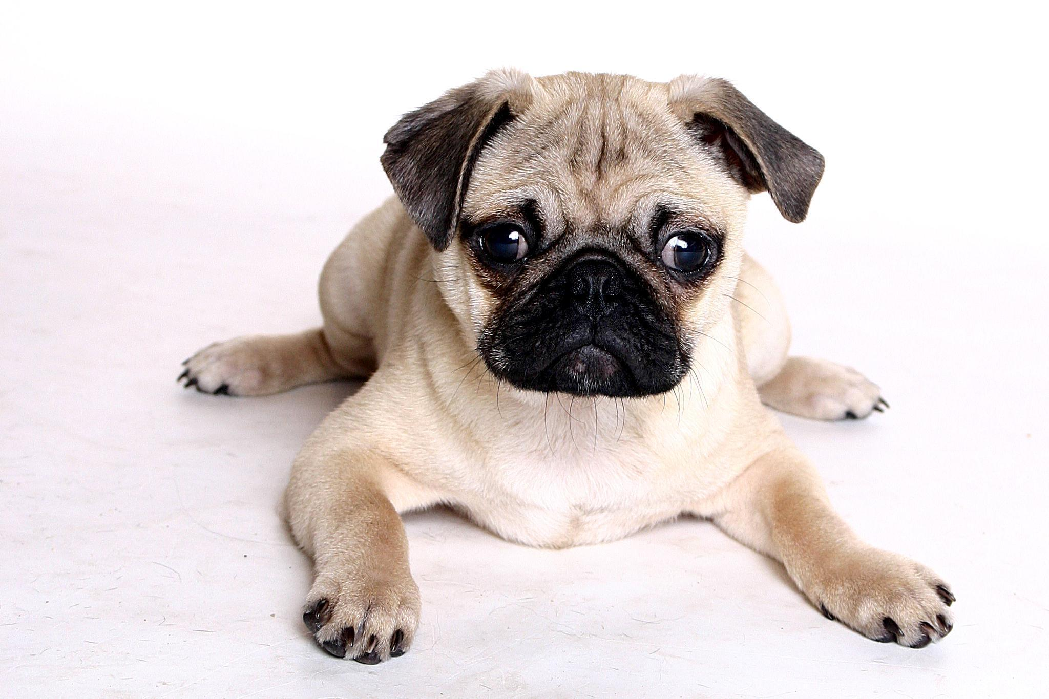

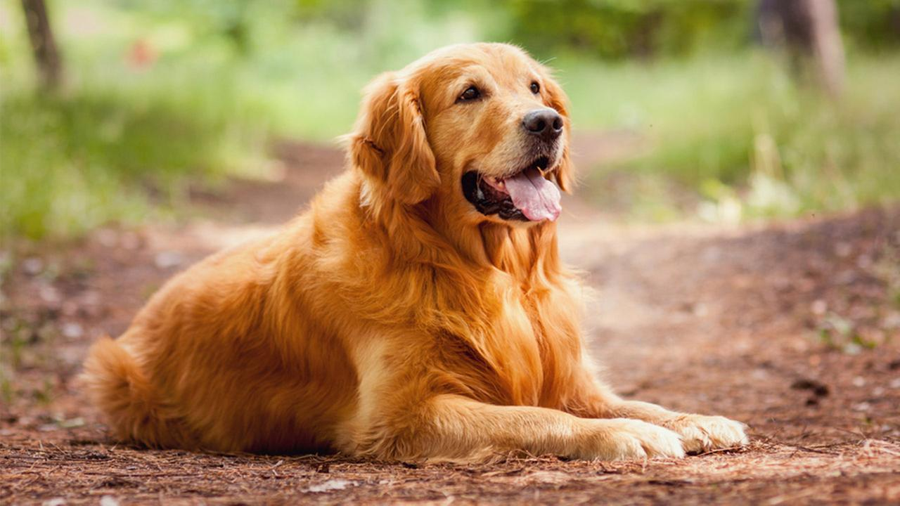

Figure 1. SAMM image association. *The animals of the images above show dogs with different features. The first dog is a pug with a costume, while the second dog is a pug without a costume. The ability to distinguish the first pug from the second, and furthermore the golden retriever from the pugs, is one of the tasks of SAMM.*

The applications of SAMM are numerous and underpin many of the modern technologies we depend on. Self-driving cars rely on a 360° camera in order to navigate roads in relation to all objects in its immediate vicinity. Deep learning allows the vehicle to interpret its surrounds so that it can execute an action, such as accelerate or turn on a turn-signal. Facial recognition software has security features that can protect sensitive information and restrict access to users by comparing facial images with an authorized face. Current AI research in natural language processing is utilizing supervised learning to improve their AI's vocabulary by feeding it hundreds of thousands of related images.

The choice in developing SAMM as a research application are manifold. First, there are inherent complications in the task of image recognition, as can be seen in Figure 1. Although it is not difficult for a human to distinguish the pug in the first and second images from the golden retriever, which has an entirely different palette of features (coat color, size, shape), SAMM may be challenged in distinguishing breeds of dogs without supervision (unsupervised or semi-supervised learning). Furthermore, it is difficult for the untrained SAMM to distinguish between the first pug in costume and the second pug, as the first is dressed as a seal and has different features than the second. Developing an algorithm that

SAMM Supervised Learning Algorithm -

There are several algorithms available that are used for supervised learning. Algorithms used for supervised learning include:

* Decision trees
* Discriminant analysis
* Support vector machine (SVM)
* Naive Bayes
* Nearest neighbor
* Ensembles

References

1. K. Barnard, P. Duygulu, N. de Fritas, D. Forsyth, D. Blei, and M. I. Jordon. Matching words and pictures. *JMLR*, 3:1107-1135, 2003.
2. G. Carneiro and N. Vasconcelos. Supervised semantic image annotation. SVCL, 2004.
3. D. Ciresan, U. Meier, and J. Schmidhuber. Multi-column deep neural networks for image classification. *Technical Report No. IDSIA-04-12*, 2012.
4. P. Duygulu, K. Bernard, J.F.G. de Freitas and D. A. Forsyth. Object recognition as machine translation: Learning a lexicon for a fixed image vocabulary. *ECCV,* vol 2, 97-112, 2002.
5. A. Prest, C. Schmid, and V. Ferrari. Weakly supervised learning of interactions between humans and objects. *IEEE*, 2012, 34(3): 601-614.
6. A. Teichman and S. Thrun. Tracking-based semi-supervised learning.
7. J. Weston, F. Ratle, H. Mobahi, and R. Collobert. Deep learning via semi-supervised embedding. Chapter in *Neural Networks: Tricks of the Trade*,vol 7700 in Lecture Notes in Computer Science, 639-655.