**Ex01c :**

When changing in property file INFO to DEBUG :

* Info : displays only INFO ;
* DEBUG : displays DEBUG & INFO.

This displays 2 times more lines.

**Ex01d :**

Corrected version of the code :

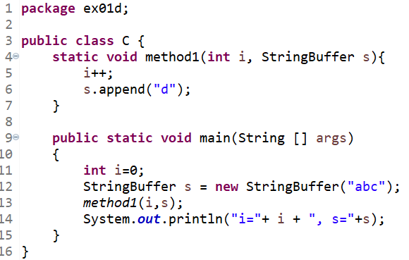

**Ex01e :**

The m method is the one called from A class.

The OOP type of implementation is a multilevel inheritance.

**Ex01F :**

The result of toString is displayed even that method isn’t called.

Because system.out.println() can only display string, it automatically found the toString method and ran it. If we change the toString() method to toString1() for example, then the memory location of the class is displayed.

**Lab2 :**

ZipEntry, ZipFile are included in the java language because they are basics operation useful for manipulating files.

It is interesting to use InputBufferedStream and OutputBufferedStream to use less memory and improve code performance.

The Reader/Writer class hierarchy is character-oriented, and the Input Stream/Output Stream class hierarchy is byte-oriented.

List text network protocols :

- Text based protocol

- Plain text protocol