INTRODUCTION
All rights reserved. Exotel Techcom Pvt. Ltd. &#xA9; 2015
INDIA&#x2019;S LEADING
CLOUD
TELEPHONY
SERVICE
All ...

INTRODUCTION
All rights reserved. Exotel Techcom Pvt. Ltd. &#xA9; 2015All rights reserved. Exotel Techcom Pvt. Ltd. &#xA9;...

Some of our 200+ Customers

 

Don&#x2019;t let any of this happen

 

Don&#x2019;t do this &#x2013; Don&#x2019;t confuse your
customer

 

Call Details

 

Analytics

 

INTRODUCTION
All rights reserved. Exotel Techcom Pvt. Ltd. &#xA9; 2015
Some interesting numbers
Over 18,000 companies
regi...

INTRODUCTION
All rights reserved. Exotel Techcom Pvt. Ltd. &#xA9; 2015
Exotel is India&#x2019;s leading cloud telephony co...

INTRODUCTION
All rights reserved. Exotel Techcom Pvt. Ltd. &#xA9; 2015
Example &#x2013; 1: Distributed order taking system...

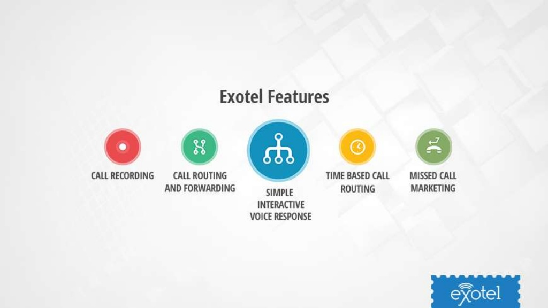

INTRODUCTION
All rights reserved. Exotel Techcom Pvt. Ltd. &#xA9; 2015
How Exotel works
salesforce
Target
Execute
Sales
On...

INTRODUCTION
All rights reserved. Exotel Techcom Pvt. Ltd. &#xA9; 2015
Companies most commonly use Exotel for
A SINGLE NUM...

INTRODUCTION
All rights reserved. Exotel Techcom Pvt. Ltd. &#xA9; 2015
Companies most commonly use Exotel for
A SINGLE NUM...