The role of corporate eLearning in the Next Generation of ERP

Hossein Akhlaghpour,
Chief Technology Officer
ObjectJ Canada Inc.
hossein@objectj.com

As the Internet continues to impact business models, it has catalyzed a connection between the customer and the corporate human resources infrastructure by translating improvements in the performance of each employee into a much shorter service lifecycle to the end users. The next generation of Enterprise Resource Planning (ERP) systems is designed to not only connect the customers’ feedback directly to the appraisal of each employee but also customize and plan their job training accordingly. It performs such a complex task by the integration of Customer Relation Management (CRM) and eLearning systems. In this talk we will go over the evolution of ERP systems and present architectures that are the base for the next generation of ERP systems.

Keywords: Enterprise Resource Planning, ERP, Supply Chain Management, SCM, SAP, Customer Relationship Management, CRM, eLearning, Business Process Management, BPM, workflow

One of the considerable challenges facing most businesses is the effective management of resources. This is particularly pertinent to human capital, considered the most expensive type of resource in today’s industry. Any business that can manage its human resources most efficiently establishes a considerable advantage over its competitors. Of course the streamlining of human resource management is somewhat of a daunting task, becoming proportionally more challenging with respect to the size of the business, and often involving coordination among the many facets of the business.

The complexity of this task has generated the need for a dedicated industry referred to as Enterprise Resource Planning (ERP). The goal of ERP is the integration of all departments and functions across a company onto a single computer system that can serve all those different departments' particular needs by managing and planning their resources. ERP strives for an ambitious goal, so ambitious in fact that hardly any system can truly claim to fully realize it.

Initially, ERP was developed as an extension to Supply Chain Management (SCM) systems. SCM intended to improve many business processes by interlacing production with the supply, inventory, and finance systems. SCM were deemed quite successful, increasing profit margins and shortening the production lifecycle. But overtime, as SCM was unable to keep up with the ever growing needs of the industry, ERP took over, attempting to unify the enterprise under a single, monolithic system. By merging the many divisions of the enterprise (e.g. Accounting, Purchasing, Human Resources, and Payroll), ERP not only handles the internal affairs of each segment, but it also integrates the processes of the disparate divisions.

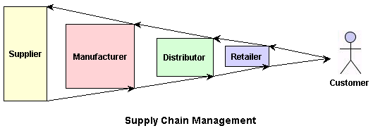

Although presently no ERP system can truly claim to offer complete integration, adopting systems that can even partially meet this claim is a challenging job. Setting up a conventional ERP system in a company usually amounts to tens or hundreds of millions of dollars, in addition to a few years of transition and immense amount of training, all without a guarantee that the system will ultimately perform as promised.
The system itself is not solely responsible for such lackluster potential, as most often failure is a direct result of people’s resistance to change. Simply put, people tend to accept more habitual methodologies as opposed to those that are more contemporary or modern (i.e. software systems).

However, even if the system is received with open arms, it still doesn’t guarantee a significant return on investment. The real value of an ERP system is the extent to which it improves the way a company does business, and more specifically, the degree to which it integrates all divisions or departments under one customizable system. If a company uses an ERP system to improve the way it takes orders, manufactures goods, ships its products, and bills its customers, it obtains value from the system. On the other hand, if the company simply deploys the system without changing the way its people do their jobs, it may not see any value at all—indeed, and the new system could slow down the business in that it replaces a system to which everyone is accustomed. This point illuminates the largest hidden cost of an ERP system: Training. Training is the unanimous choice of experienced ERP implementers for the most underestimated budget item. Training expenses are invariably high because employees almost always have to learn a new set of processes when deploying a new ERP system. To complicate matters more, external training companies may not be able to help since they are not familiar with the particular ways a company does business. It is therefore in the best interest of a company to prepare a curriculum that identifies and explains the different business processes that will be affected by the ERP system.
The next generation of ERP systems is poised to address many of these issues. These systems will be influenced considerably by two major events:
  - The shift of major industry groups from manufacturing to service-based commerce.
  - The birth of the Internet and the standardization of e-commerce protocols congruent amongst many industries.
These paradigm shifts became evident as manufacturing industries lost their market share to service-based industries during the 80s and 90s. Correspondingly, related segments of ERP systems such as SCM, dominated by IBM, lost market share to the service oriented segments of ERP, particularly those that dealt with Human Resources, dominated by such companies as PeopleSoft.
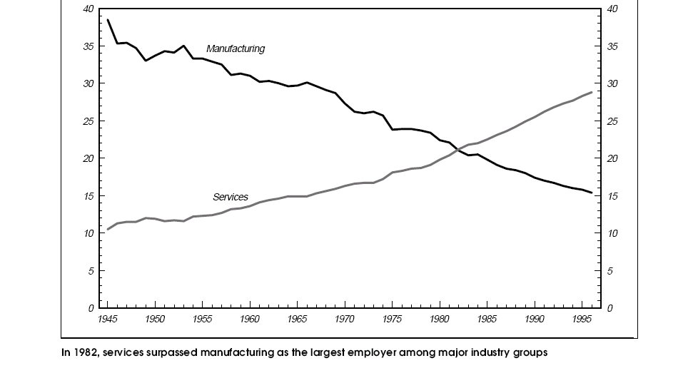
At the same time web-enablement of enterprise systems became the de-facto standard across most industries. This trend was applicable to ERP systems as well, but it proved to be a challenging endeavor, causing ERP systems to lag behind in their migration towards the web. Of the major players in the ERP industry, SAP is ahead of all others in terms of complying with Internet standards (including the adoption of Web Services standard), a fact that has helped SAP to attain the top market share.

$ bn | Total market | % Share
SAP | 2.95 | 16.86
People Soft | 1.00 | 5.71
Oracle | 0.92 | 5.26
McKesson | 0.85 | 4.86
J D Edwards | 0.62 | 3.54
Misys | 0.49 | 2.80
BaaN | 0.48 | 2.74
GEAC | 0.46 | 2.63
JBA | 0.37 | 2.11
System Software Associates | 0.24 | 1.37
Others | 9.12 | 52.11
Total | 17.50 | 100.00
Source IDC
Figures include 1998 license and maintenance revenues
The Top 10

This combined proliferation of service-based commerce and the Internet during the last decade has given birth to a new breed of customer oriented web-based systems referred to as Customer Relationship Management (CRM) systems. The goal of CRM systems is to combine technology and human resources in order to attain insight into the behavior and value of customers. Naturally, these systems rely heavily on the web, for no other medium can provide such a vast and uniform access to customers. While the web facilitates the acquirement of customer information, a greater need lies in translating this information into business guidelines. This is where ERP systems come into play, so much so that the integration of ERP and CRM systems is the feature du jour of most ERP vendors. In the same way that SCM systems revolutionized manufacturing, ERP systems have the potential to optimize service industries by streamlining the management of resources to better serve the customer.
But unfortunately this potential has not been fully realized. In fact there is an important factor that is to be accounted for: a web-based ERP system integrated with CRM is much larger and more complex than traditional ERP systems and thus requires a much higher learning curve. The mere fact that the new generation of ERP is web-based presents a plethora of issues, most predominately due to the volatility that characterizes the ever-changing standards and protocols of the web. This trait of the web translates into more dynamic ERP systems that are enhanced and evolved constantly to meet the business needs of the industry. Unfortunately this compounds the problem that has plagued ERP systems since their inception: training. In order to cope with this issue, the ERP industry has turned to eLearning – the use of network technologies to create, foster, deliver, and facilitate learning, anytime and anywhere. ERP and eLearning are a good much in that eLearning functionality can be easily and coherently embedded within a web-enabled ERP system. An ERP system, for example, can be extended to contain a user guide, technical documentation, assessment features, and even a virtual laboratory. By integrating with eLearning, ERP vendors can reduce training cost significantly, thereby diminishing the largest hidden cost of ERP application.
Integration of CRM and eLearning is a challenging task, but one that will enable ERP systems to:
- Capture and analyze customer behavior, disseminating analysis across the enterprise so as to enhance and improve the applicable business processes.
- Foster an enriched learning environment that not only enables employees to master the ERP system, but also improves the way business is enacted by enhancing customer relations.
- Appraise employee-customer relationships, gauging customer feedback in order to improve business processes.
By implementing these functionalities, an ERP system improves the synergy between the enterprise and its customers by alleviating the two major obstacles of ERP deployment: training and employee resistance to change. In order to achieve these goals, an ERP system must be able to handle Business Process Management (BPM). A BPM system breaks down the enterprise into a series of related business processes, with each process representing a sequence of tasks. Business analysts design each process through a user-friendly interface that also enables event handling, the mechanism used by one business process to trigger other business processes. The subsystem that manages and invokes these events is generally referred to as a workflow system. By containing an integrated workflow system, the next generation of ERP systems can handle complex relationships, such as the one between customer’s related processes and processes in other departments (e.g. inventory, finance, and shipping). The system will allow an employee to view such a process in a user-friendly graphical interface and to track the movement of every participant of that process. Ideally the employee can then connect directly to the eLearning subsystem so as to customize and deploy sample workflow schemes and therefore attain the most optimal configuration.
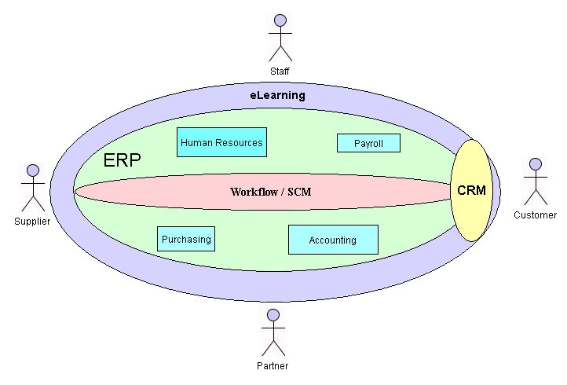
Major components of the next generation of ERP Systems

Conclusion
The future of ERP systems promises to facilitate business process improvements, promoting active involvement of every employee in understanding and enhancing these processes. In short, these systems will elevate employees by promoting each employee from performing a single repetitive task to managing business processes that involve multiple tasks. This not only increases employee productivity, but also helps the bottom line by streamlining business processes.

References:

- The ABCs of ERP: http://www.cio.com/research/erp/edit/erpbasics.html

- An Introduction to Supply Chain Management: http://silmaril.smeal.psu.edu/misc/supply_chain_intro.html

- The hidden cost of Enterprise Software: http://www.cio.com/archive/enterprise/011598_erp.html
- The services industry in the good versus bad jobs debate: http://www.bls.gov/opub/mlr/1998/02/art3full.pdf
- An Introduction to ERP: http://www.indiainfoline.com/cyva/erp/ar01.html
- What is CRM?
http://www.cio.com/research/crm/edit/crmabc.html
- CRM Integration: http://www.ebizq.net/topics/crm_int/features/2336.html
- Monolithic ERP Gives Way to BPM Infrastructure: http://www.intelligenterp.com/feature/2003/01/0301feat2_1.shtml

- The Workflow Reference Model: http://www.wfmc.org/standards/docs/tc003v11.pdf

The ABCs of ERP: http://www.cio.com/research/erp/edit/erpbasics.html
An Introduction to Supply Chain Management: http://silmaril.smeal.psu.edu/misc/supply_chain_intro.html
The hidden cost of Enterprise Software: http://www.cio.com/archive/enterprise/011598_erp.html
The services industry in the good versus bad jobs debate: http://www.bls.gov/opub/mlr/1998/02/art3full.pdf
An Introduction to ERP: http://www.indiainfoline.com/cyva/erp/ar01.html
What is CRM? http://www.cio.com/research/crm/edit/crmabc.html
CRM Integration: http://www.ebizq.net/topics/crm_int/features/2336.html
Monolithic ERP Gives Way to BPM Infrastructure: http://www.intelligenterp.com/feature/2003/01/0301feat2_1.shtml
The Workflow Reference Model: http://www.wfmc.org/standards/docs/tc003v11.pdf

