PBL as an eLearning Pedagogy

Hossein Akhlaghpour: Chief Technology Officer, ObjectJ Inc.
Saeed Akhlaghpour: MBA Dept, Sharif University of Technology
Mahmoud Mortazavi: eLearning Specialist, ObjectJ Inc.

Abstract:

Problem based learning (PBL) is a known pedagogy (educational method) characterized by the use of real or imaginary problems as a context for students to learn problem-solving skills and acquire knowledge about the underlying sciences.

In this article we review the main obstacles that PBL advocates have been challenging with, and investigate how eLearning as a new platform may address those problems. At the same time we see how PBL can emerge as a natural choice of pedagogy for eLearning to make it a complementary paradigm to the conventional learning in certain industries including medical education.

We review a mechanism of how eLearning can be applied to medical diagnostic and look at a real case that such a mechanism is applied for learning the diagnostic of SARS.

Introduction:

The science of Pedagogy talks about the different educational methods that are used to present learning materials to students. One can enumerate methods such as:

- Teacher Directed Approach
- Problem Based Learning (PBL)
- Investigative Case Based Learning (ICBL)
- Goal Based Learning

There are also many overlaps among these methods. For example it is not easy to differentiate between case based learning and problem based learning in many cases.

Among these we focus on the Problem Based Learning or so called PBL. This is a method that emphasizes on the use of real or imaginary problems as a context for students to learn problem-solving skills and acquire knowledge about the underlying sciences.

On the other hand in recent years we are witnessing the birth of a new technology (infrastructure and tools) for learning called electronic learning or eLearning. eLearning has a specific characteristic that makes it different from other distance learning including the computer based learning and that is the use of Internet as a mean of transferring content to students or communicating between different parties involved in the learning process. What Internet provides is the following characteristics:

- Having access to the largest community of the world and that is Internet users
- Internet provides two-way communication protocol and not only content is accessible to every Internet user but their feedback and interactions are accessible to us. That makes it much more valuable than a media such as book, Newspaper or TV.
- It includes one of the best security protocols of accessing information. Meaning you can access who can access what part of information and be sure that unauthorized access is prohibited or at least monitored.
- There has been a body of standards that is developed and accepted worldwide. These standards include the format of content, the protocols of communications and the methods of accessing information. This gives the content providers and educational institutes a firm framework to work with.

We try to address the problems that PBL methods deals with, and show how one can apply such a method in eLearning. We see how these two educational method and technology may compensate each other deficiencies and provide a true complementary paradigm to the conventional learning.

Problem Based Learning (Pro & Con)

PBL mainly consists of the following steps:

- Problem (Case) Gathering: Gather problems (or create mock problems) that its resolution students have to get the familiar with the targeted science or technology.
- Underlying Science: Acquire the required knowledge to resolve the problem
- Problem Formulation: Develop multiple competing hypotheses to solve the problem
- Prioritization: Assign probability and importance to each hypothesis and select the most popular one.
- Strategy: Develop a strategy of how to examine the chosen hypothesis. This includes measuring and recording its result of every steps of examination
- Analyze the resultant data to measure the overall success of the hypothesis and the related resolution strategy.
- Feedback: Return the feedback to the system and if it doesn’t meet the expectation try the next probable hypothesis.
- Conclusion: Reach to the conclusion of the best solution to the problem

It starts by offering a case to students. Once students have read a case together, they complete a brief but carefully structured case analysis discussion, which allows students a way to identify their own questions and prior knowledge. Students are next encouraged to explore questions derived from the case through extended science investigations. These investigations may take place in lab or field, or in a computational space using simulations, models or other tools. The investigations may be student or faculty initiated. They may be full-blown individual projects or they may be brief analyses by the whole class of data set from a published paper. Situating learning in a realistically complex context, followed by related investigations provides students with a more meaningful experience of science and scientific research.

Through this method the student not only learns the underlying science but also he learns how to use it in solving a problem. In a way the skill of solving the problem may be even more important than the related science, as one can always find the references to relearn the science but there is not an easy way to learn that skill.

Examples of available cases that are being used for PBL in Biology & Geosciences can be found on the LifeLines website (http://www.bioquest.org/lifelines) include situations ranging from the problem of excess caffeine in the Willamette River leading to reduction in the salmon harvest, to sewage treatment in the arctic, to identifying snakes and their venoms to provide appropriate treatment for a snakebite, to conducting nucleic acid alignment procedures to identify unknown samples from whale meat vendors in Asia. These rich societal contexts are both multidisciplinary and motivational. They are written about people grappling with questions that scientific inquiry can help illuminate.

However as you can see developing a curriculum that covers all of above steps is a daunting task. We try to list some of the obstacles that advocates of PBL are challenging with:

- Developing a PBL curriculum is not an easy job and requires specialists that are trained and has experienced in this field. While conventional learning can be done by any graduate with some preliminary training.
- It is very time consuming as one needs to layout the whole scenario and makes the material ready for students.
- Often the raw data that are needed to use for examining the hypothesis either are not easy to find or are not complete. Therefore sometimes the data are hand made and doesn’t represent the real data.
- It is often stressful for both students and instructors, because of its complexity and the discipline to follow the steps
- Some research suggests that PBL curricula cover about 80% of what might be accomplished in a conventional curriculum in the same period

We can see that the above reasons make the initial cost of a PBL curriculum high. To reduce this cost we need to have an infrastructure that

- Help us to maximize reusability of a curriculum
- Easy access to a large repository of raw data
- Easy access to the previous experience of building up similar cases and their corresponding hypotheses.
- Easy method of searching through the body of underlying science to acquire specific knowledge
- Develop a community of PBL advocates and publicize its achievement (lobbying the PBL methodology among the scholars)

eLearning (Pro & Con)

There is not a definite list of eLearning components. Some consider eLearning as any learning material that is presented in Internet. With this definition a simple web site may be called eLearning content and some went far enough that include large applications such as eCommerce as one of the eLearning components:
However we can list the following as the essential parts of any eLearning package:

Assessment
Tool
Authoring
Tool
Virtual
Classroom
Learning Management System
Content
Management System

- Learning Management System (LMS): Presents the learning materials to students while maintaining the full security of such an access (authenticity of material and authorization of students). LMS is also responsible to track student progress and create all sort of reports related to his education
- Authoring Tool: Learning materials has to be in specific formats to be presentable in Internet and at the same time should follow certain eLearning standards (such as SCORM) to be able to communicate with LMS (pluggable to LMS). Author of eLearning materials needs a tool designed to develop contents with such a standards. Such a tool is called Authoring tool
- Content Management System (CMS): A tool to manage the content provided for eLearning. By management we mean categorizing that content such that one can easily find the relevant content by navigating through its classification or by searching through the content using a search engine. (Recent eLearning tools combine LMS with CMS functionality and call it CLMS)
- Assessment Tool: LMS can be used to track student progress in taking the courses or performing their homework, however without real exams one cannot track what a student has really grasped. Performing an online exam similar to the conventional exam requires specific tool that is designed for such a purpose and that is called Assessment Tool. Instructors use Assessment Tool to design the exam materials (variety of questions, such as multiple answered quizzes, etc.) and then define a specific exam (including it’s duration, number of questions, type of questions, passing score, validation period, etc.). Once the exam is ready, students can take the exam and monitor their scores.
- Virtual Classroom: Often in eLearning you require direct & live interaction between students and their instructor, meaning we need a Virtual Classroom that resembles the real classroom. In Virtual Classroom an instructor can present the materials to his students in real time and students can participate in the class by asking questions through the use of voice/text chat or share their feedbacks via sharing specific applications such as a whiteboard. Virtual Classroom can also be used for students to collaborate with each other or even held a brainstorm session.


Progress
Report
Content
Author
Student
Live
Content
Instructor
Progress
Report

Even though eLearning with all of these tools cannot bring the full experience of the conventional learning, it removes the physical and time barriers on learning and provides learning opportunities that we may never have in the conventional one. However one of the main challenges that eLearning advocates tackle with, is to attract students such that they stay all of the way though their eLearning courses. Making an interactive and attractive course is often very expensive.

Complementary Solutions

eLearning is a collection of tools and infrastructure. With only tools you cannot develop a curriculum. You also need pedagogy. Pedagogy determines the layout of your presentation, the way and order to present the material, or in short, how to use the tools to develop the curriculum. We often use pedagogy implicitly. Anytime you derive a syllabus for a course or put together the materials to compile a course, you are using pedagogy. Often you use “Teacher Directed Approach” where teacher present a learning path to student and every student follows the same path. Even though there have been attempts to apply “Student Directed Approach” pedagogies that emphasizes more on the role of student to define his learning path, they are mostly limited to the experimental cases and because of their high cost and lack of resources have not been publicized.

With the introduction of eLearning we have the opportunity to alter the course of learning based on the student profile. In a way you can develop an adaptive pedagogy. For example based on the student’s answers you can redirect him to an advance topic or force him to retake a basic one. Therefore the same course may present differently for different students. Most importantly such a customization can be done with almost no cost (some initial cost that once it breaks down for each case, it becomes negligible). As a result we can say “eLearning makes adaptive learning affordable”.

Problem based learning is a special case of adaptive learning where the students are given the opportunity to choose their learning path by applying different models to solve the problem. This selection process is a combination of
- collaboration between students
- examining different hypothesis
- and guidance by the instructor.

We claim that eLearning tools can be designed to embrace PBL as an affordable pedagogy and the resultant courses will be attractive for students. In a way each side’s strengthen covers the other side’s weakness

Let’s review what the requirements for such an eLearning package are:

Feature | eLearning tool | Example
Access to the raw data used for examining the hypothesis | CMS | Patient medical history
Define forms that record the result of each examination step | Assessment Tool | How the model predict patient diagnostics
Define the navigation from one course to the other (search through course materials) | LMS + Authoring tool + CMS | What might be the cause of low blood pressure (looking at the related course and resources)
Discussion board to discuss hypothesis suitability | LMS | Is this disease passed by animal?
Record student progress in examining the hypothesis | LMS | Let’s look at what others have done in this regard
When a new case arrives, retrieve those cases similar to the new one, and classify by based on the set of similar cases | CMS | Let’s look at similar cases
Have a brainstorm session with other students and instructor (text-video chat, white board, document sharing) | Virtual Classroom | This is a controversial conclusion. Let’s discuss about it.

Once a PBL curriculum has been developed, there will be so much interaction between
- student and the course
- different students (collaboration)
- and instructor and the students (guidance)

That student naturally stays with the course all the way to see the result. The course is not dictated to the student, it is made by the student through its participation. Student feels some sort of ownership for the course and gets credits for his work.

Case Study:

National Taiwan University has developed a virtual medical school (VMS) as the platform of eLearning center. This system integrates collaborative and self-directed learning environment by virtual group, classroom and library, and automatically converts valuable clinical case from Hospital Information System (HIS) database into virtual patient by online authoring tools for problem-based e-learning. This is a process to remove the real name of the patients such that the resultant records are complied with medical security constraints like HIPAA.

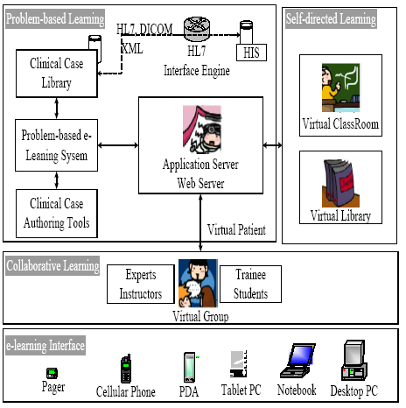

VMS complies with the following eLearning and medical standards to connect to Electronic Medical Record (EMR) system in the hospital:

- SCORM 1.2 (Shared Courseware Object Reference Mode)
- HL7 v2.4 (Health Level 7)
- CDA v1.0 (Clinical Document Architecture)

National Taiwan University uses such a system to apply PBL for medical diagnostic and for the first case they have chosen SARS disease. The idea is to utilize the countless, valuable actual cases stored in the database of HIS as teaching material.

The patient data include:
- History: Chief Complaint, Present Illness, Past History, Family History, Development, and Drug History.
- Physical Exam: General Condition, Skin, Head, Eyes, Ears, Nose, Mouth, Neck, Chest, Abdomen, Urinary, Muscle, and Nerve.
- Laboratory: Blood Routine, Biochemistry, Microbiology, Serology, Immunology, EKG, and Medical Image.
- Differential Diagnosis: List of the possible diagnoses and related reference material; and further search references for these diagnoses.
- Treatment and Management: The treatment, management, further follow-up and prognoses of each possible diagnosis.

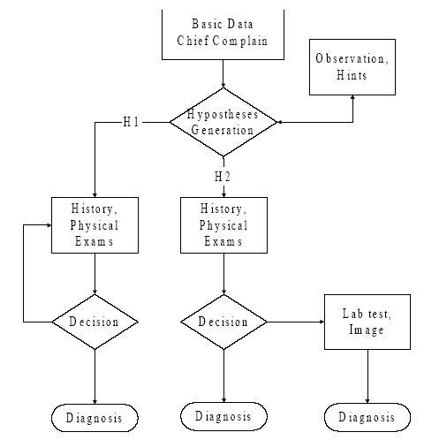

Students are presented with a clinical problem (e.g., a patient with SARS), and, in a series of steps, they discuss possible mechanisms and causes, develop hypotheses and strategies to test the hypotheses, are presented with further information, and use this new information to refine their hypotheses, finally reaching a conclusion.

Problem-based Learning compartment provides a virtual patient system by conglomerating several subsystems:
- Clinical Case Library (CCL) contains the valuable teaching cases selected by medical expert.
- HIS provides the raw materials compatible with HL7 and DICOM standards, along with interface engine that uploads these materials to the CCL as instructed by the clinical instructors.
- Collaborates with CCL and authoring tools to provide a platform for the revision of education materials.
- Application Server integrates with a web-based interface for both the students and the instructors.

The specific student had learned eight steps to find the SARS diagnosis. He spent half of whole learning time to understand the subjective information of the patient and then spent a little time for observation and diagnosis.

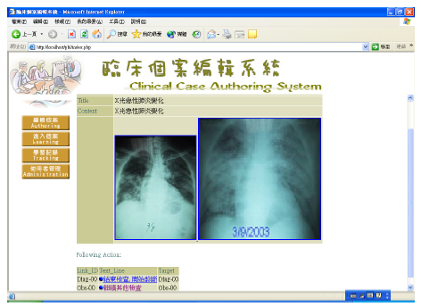
Clinical Case Authoring – SARS Patient Image Data
Conclusion:

Even though Problem based Learning has been introduced for many years, due to the cost and lack of resources it has not been used widely. We believe with the birth of eLearning we have the opportunity to look at this method one more time and design eLearning tools specifically to apply PBL as eLearning pedagogy. Applying PBL may create new paradigm to introduce eLearning as a real complementary and alternative means to the conventional learning.

References:

A Problem-based e-Learning Prototype System for Clinical Medical Education:
http://cmbi.bjmu.edu.cn/news/report/ 2004/medinfo2004/pdffiles/papers/TOC.pdf

BioQuest Notes: http://www.bioquest.org/lifelines

Total eLearning Solution: http://www.objectj.com/public/symphony.html

MedicCaseML - A new instrument in web-based medical education
http://www.medicmed.de/downloads/mediccaseml_paper_amee_300802.pdf
Pedagogy and Online Learning: An Interview with Ron Oliver: http://www.learnscope.anta.gov.au/learnscope/golearn.asp?Category=18&DocumentId=5545

Pedagogy: http://www.bath.ac.uk/e-learning/pedagogy.htm
Pedagogical Designs for E-Learning: http://mettleweb.unimelb.edu.au/guide/pedagog.html

