### Project Description

### App 1 - Cat in the Hat:

### Steps to complete this app:

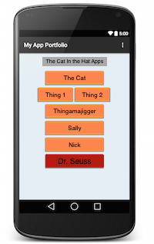

1. Download Android studio
2. Create a new project in Android Studio using the 'application with blank activity' template.
3. Add a button for each app:
   * The Cat
   * Thing 1
   * Thing 2
   * Thingamajigger
   * Sally
   * Nick
   * Dr. Seuss
4. add an onClickListener for each button or write an onClick method
5. Launch a toast from the methods you created in the last step

Design the UI however you wish!

## Colors and Styles

When designing your layout for the project, you may enjoy customizing the style and color of your buttons and changing the layout. If you are interested in learning about colors you can use, take a look at the material design [color page](http://www.google.com/design/spec/style/color.html), from Google.

If you'd like your app to look udacious, feel free to use #F08C35 to match the orange buttons on our site.