### Project Description

### Spotify Streamer, Stage 1: Implementation Guide

# Stage 1: Overview

This document should be used as a guide and development plan for Stage 1 of the Spotify Streamer app. It breaks down the build process into smaller, concrete milestones, and provides technical guidance on specific tasks.

## Evaluation

Stage 1 is evaluated against the [following rubric](https://docs.google.com/document/d/1Q7b2dIt18r2pXqDhE_TsgZ5UkfzbybkGlmKfyoqpegc/pub?embedded=true).

# User Experience Design

This guide will provide UI mock-ups (or mocks) to establish a baseline for Spotify Streamer’s core user experience. Your job is to implement these same experiences, although you’re free to customize the visual design to make it your own.

Note: In a real world situation, such mocks are generally provided by a designer or design team. But, in some cases, an individual developer creates their own mocks.

The main purpose of these mocks is to communicate and establish the visual and interactive experience of the app.

## 

## 

## Phone Interaction Flow

## Search for an artist and display results

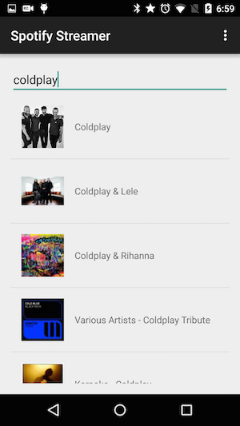

2. Then display the top tracks for a selected artist.

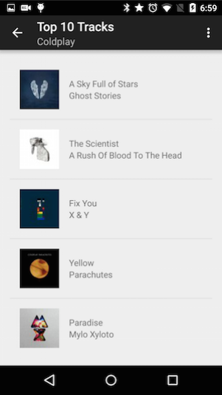

3. When a user selects a track, the track should start playing in a player UI

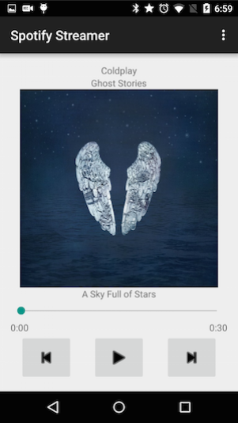

## 

# Project Setup: Configure Your Project to Use Two Important Libraries

This project will utilize two key Android libraries, which we’ve included to reduce unnecessary extra work and help you focus on applying your app development skills.

1. [Picasso](http://square.github.io/picasso/) - A powerful library that will handle image loading and caching on your behalf
2. [Spotify-Web-Api-Wrapper](https://github.com/kaaes/spotify-web-api-android) - A clever Java wrapper for the Spotify Web API that provides java methods that map directly to [Web API endpoints.](https://developer.spotify.com/web-api/endpoint-reference/) In other words, this wrapper handles making the HTTP request to a desired API endpoint, and deserializes the JSON response so you don’t need to write any parsing code by hand. When you need to make a particular Web API call, you simply call the corresponding method in the library and act on the return data, already converted to Java objects that you can interact with programmatically.

## Library Configuration Instructions

### Picasso

In your app/build.gradle file, add:

repositories {

mavenCentral()

}

Next, add **compile 'com.squareup.picasso:picasso:2.5.2'** to your dependencies block.

### Spotify Wrapper

Compile a new jar from the most recent git clone of the [Spotify Web API repository on GitHub](https://github.com/kaaes/spotify-web-api-android). See the [README](https://github.com/kaaes/spotify-web-api-android/blob/master/README.md) for how to compile the source. Snippet from the README:

This project is built using [Gradle](https://gradle.org/):

1. Clone the repository: git clone **https://github.com/kaaes/spotify-web-api-android.git**
2. Build: **./gradlew** jar
3. Grab the jar and put it in your project. It can be found in **build/libs/spotify-web-api-android-0.1.0.jar**

In order to install the jar file place it into your Android Project under:

**<PROJECT_ROOT>/apps/libs directory**

and then add the following statements to your build.gradle dependencies:

compile 'com.squareup.retrofit:retrofit:1.9.0' // Uses this to create RESTful Requests

compile 'com.squareup.okhttp:okhttp:2.2.0' // Uses this to create HTTP connections

Note: These dependencies are specifically used by the spotify wrapper and you do not need to use them directly. Also don’t worry if you don’t completely understand these lines. You’ll learn more gradle and how it works with Android Studio later in other courses.

If you are having trouble, you can also download the [**spotify-web-api-android-0.1.0.jar**](https://github.com/kaaes/spotify-web-api-android/releases/download/0.1/spotify-web-api-android-0.1.0.jar) from the [releases page](https://github.com/kaaes/spotify-web-api-android/releases), though be advised that, as of May 2015, the most recent build was from November 2014, and thus may be a stale build.

## 

# 

# 

### Build the UI: Search for an Artist, then Return Their Top Tracks

## Task 1: UI to Search for an Artist

Design and build the layout for an Activity that allows the user to search for an artist and then return the results in a ListView.

**Corner case:** If no artists are found, display a toast stating this or write a similar message to the layout.

Note: You should design two layouts:

1. For the artist search activity 2. For an individual artist search result

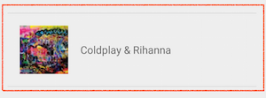

**Guidance:**

* See [Lesson 1](https://www.udacity.com/course/viewer#!/c-ud853/l-1395568821/m-1647298624) of Developing Android Apps for support on building UI layouts. For extra polish, check out [this section](https://www.udacity.com/course/viewer#!/c-ud853/l-1623168625/e-1667758574/m-1605670991) of Lesson 5.

## Task 2: UI to Display the top 10 tracks for a selected artist

Design and build the layout for an Activity that displays the top tracks for a select artist.

Note: You should design two layouts:

1. 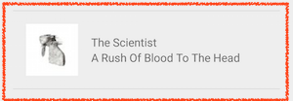For the Activity that will display the tracks in a ListView 2. For an individual an individual track (thumbnail, album, track)

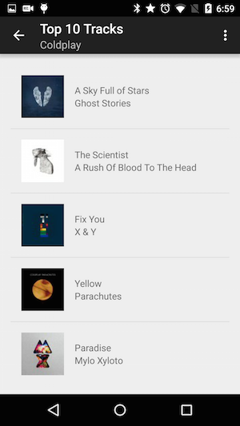

## Task 3: Query the Spotify Web API

### Overview

For the two user interface flows described in tasks 1 & 2, you will need to fetch artist and track data from the Spotify Web API to populate your list views. As mentioned earlier, you will use the [Spotify-Web-Api-Wrapper](https://github.com/kaaes/spotify-web-api-android) to simplify this task since it handles making the HTTP request and deserializing the JSON response for you. You will be able to extract the artist and track metadata you need directly as java objects.

You will issue the following requests to the Spotify Web API:

For task 1, you will need to request artist data via the [**Search for an Item**](https://developer.spotify.com/web-api/search-item/)web endpoint.

* Be sure to restrict the search to artists only by including the item type=”artist”.
* For each artist result you should extract the following data:
  + artist name
  + SpotifyId* - This is **required** by the **Get an Artist’s Top Tracks** query which will use afterwards.
  + artist thumbnail image

For task 2, you will need to request track data via the [**Get an Artist’s Top Tracks**](https://developer.spotify.com/web-api/get-artists-top-tracks/) web endpoint.

* Specify a country code for the search.
* For each track result you should extract the following data:
  + track name
  + album name
  + Album art thumbnail ( large (640px for Now Playing screen) and small (200px for list items). If the image size does not exist in the API response, you are free to choose whatever size is available.)
  + preview url* - This is an HTTP url that you use to stream audio

**Programming Notes:**

* Populate the ListView using a ListView Adapter.
* Fetch data from Spotify in the background using AsyncTask and The Spotify Web API Wrapper

### Additional Guidance

**Mapping Web API Queries to the Spotify Wrapper Java API**

**Important Note**: Before you write any code using the Web API wrapper, it is important that you familiarize yourself with how the the Spotify Web API works via HTTP.

By doing this exercise, you will not only understand what the wrapper library is doing for you but you’ll be able to fully understand the request’s parameters as well the JSON response that will be returned.

**How do I manually test the Web API via HTTP?**

You can do this by submitting test HTTP requests using [Spotify’s web console](https://developer.spotify.com/web-api/console/get-search-item/#complete) or any other REST client of your choice. (@ Udacity, we like clients like [PAW](https://luckymarmot.com/paw) or [POSTMAN](https://chrome.google.com/webstore/detail/postman-rest-client-packa/fhbjgbiflinjbdggehcddcbncdddomop))

Once you’re comfortable with the structure of the necessary API requests (and their corresponding responses) in raw form, you can easily implement the same request sequence in Java using the Spotify Wrapper.

Here’s a more detailed example:

A Search for “Beyonce” looks like this on the Web Console

<https://developer.spotify.com/web-api/console/get-search-item/#complete>

Maps to the [following Java method](https://github.com/kaaes/spotify-web-api-android/blob/master/src/main/java/kaaes/spotify/webapi/android/SpotifyService.java#L1338) in the Web API Wrapper

|  |  |
| --- | --- |
|  |  |
|  | * Get Spotify catalog information about artists that match a keyword string. |
|  | * |
|  | * @param q The search query's keywords (and optional field filters and operators), for example "roadhouse+blues" |
|  | * @return A paginated list of results |
|  | * @see <a href="https://developer.spotify.com/web-api/search-item/">Search for an Item</a> |
|  | */ |
|  | @GET("/search?type=artist") |
|  | public ArtistsPager searchArtists(@Query("q") String q); |

You can familiarize yourself with the specific Object types such as ArtistsPager using [their definitions in code here.](https://github.com/kaaes/spotify-web-api-android/tree/master/src/main/java/kaaes/spotify/webapi/android/models)

**Using Picasso To Fetch Images and Load Them Into Views**

You can use Picasso to easily load album art thumbnails into your views using:

[Picasso.with(context).load("http://i.imgur.com/DvpvklR.png").into(imageView);](http://square.github.io/picasso/)

Picasso will handle properly caching the images.