Rook-ceph storage cluster configure in kubernetes cluster

Requirements:

1. 3 server (one master + 2 worker node)
2. each 100Gb disk attach to worker node.

How to install kubernetes cluster via ansible (Ubuntu Machine)

# sudo apt update
# sudo apt install ansible
# sudo apt install sshpass

1. ansible.cfg

[defaults]
inventory=hosts
host_key_checking=false
stdout_callback=unixy

2. hosts

master-server ansible_host=xxx.xxx.xxx.xxx ansible_user=username ansible_ssh_pass=xxxxxxxxxxxxx
node-server1 ansible_host=xxx.xxx.xxx.xxx ansible_user=username ansible_ssh_pass=xxxxxxxxxxxxx
node-server2 ansible_host=xxx.xxx.xxx.xxx ansible_user=username ansible_ssh_pass=xxxxxxxxxxxxx

3. daemon.json.j2

{
"exec-opts": ["native.cgroupdriver=systemd"],
"log-driver": "json-file",
"log-opts": {
"max-size": "100m"
},
"storage-driver": "overlay2"
}
4. token.sh.j2

#!/bin/bash
sudo {{ _token.stdout }}

5. kubernetes.yml

---
- hosts: all
vars:
- token: "{{_token.stdout_lines }}"
tasks:
- name: Run the equivalent of "apt-get update" as a separate step
apt:
update_cache: yes
become: true
- name: Install packeges apt-transport-https
apt:
name: "{{ item }}"
state: present
loop:
- apt-transport-https
- ca-certificates
- curl
- software-properties-common
become: true
- name: Add an Apt signing key
apt_key:
url: "{{item}}"
state: present
loop:
- https://download.docker.com/linux/ubuntu/gpg
- https://packages.cloud.google.com/apt/doc/apt-key.gpg
become: true
- name: add repositary
apt_repository:
repo: "{{item}}"
state: present
loop:
- deb https://apt.kubernetes.io/ kubernetes-xenial main
- "deb [arch=amd64] https://download.docker.com/linux/ubuntu {{ansible_distribution_release}} stable"
become: true
- name: install packages
apt:
name: "{{item}}"
state: present
update_cache: yes
loop:
- kubelet
- kubeadm
- kubectl
- docker-ce=18.06.2~ce~3-0~ubuntu
become: true
- name: added docker daemon systemd
template:
src: ./daemon.json.j2
dest: /etc/docker/daemon.json
become: true
- name: create the directory
file:
path: /etc/systemd/system/docker.service.d
state: directory
become: true
- name: restart the docker deamon service
systemd:
name: docker
state: restarted
enabled: yes
daemon_reload: yes
become: true
- name: restart kubelet
systemd:
name: kubelet
state: restarted
enabled: yes
become: true
- name: get ipaddress details
shell: hostname -I | awk '{print $1}'
register: _ips
when: inventory_hostname == "master-server"
become: true
- name: initiate master node
shell: sudo kubeadm init --apiserver-advertise-address {{ _ips.stdout }} --pod-network-cidr=192.168.0.0/16
when: inventory_hostname == "master-server"
- name: create the directory in ansible user
file:
path: .kube
state: directory
when: inventory_hostname == "master-server"
- name: copy the file into ansible user home directory under
copy:
src: /etc/kubernetes/admin.conf
dest: .kube/config
owner: "{{ansible_user}}"
group: "{{ansible_user}}"
remote_src: yes
become: true
when: inventory_hostname == "master-server"
- name: export kubectl version
shell: kubectl version | base64 | tr -d "\n"
register: _versions
when: inventory_hostname == "master-server"
- name: download overlay network over internet
get_url:
url: "https://cloud.weave.works/k8s/net?k8s-version={{_versions.stdout}}"
dest: "{{ansible_user_dir}}/wavenet.yml"
when: inventory_hostname == "master-server"
- name: execute wavenet yml file
shell: "kubectl apply -f {{ansible_user_dir}}/wavenet.yml"
when: inventory_hostname == "master-server"
- name: create token to add worker node to k8s
shell: sudo kubeadm token create --print-join-command
when: inventory_hostname == "master-server"
register: _token
- name: get token id from master
template:
src: ./token.sh.j2
dest: "{{ansible_user_dir}}/token.sh"
when: inventory_hostname != "master-server"
- name: fetch token id to ansible server
fetch:
src: "{{ansible_user_dir}}/token.sh"
dest: ./
flat: yes
fail_on_missing: yes
when: inventory_hostname != "master-server"
- name: token move to worker nodes
copy:
src: ./token.sh
dest: "{{ansible_user_dir}}/"
remote_src: no
when: inventory_hostname != "master-server"
- name: to add node into kubernetes cluster
shell: "bash {{ansible_user_dir}}/token.sh"
when: inventory_hostname != "master-server"
- name: node add execution take some few seconds
pause:
minutes: 2
# ansible-playbook kubernetes.yml

login into master node as ansible username

$ kubectl get nodes
$ kubectl get all

Note: verify the all nodes are working fine.

Rook

Rook is an open source cloud-native storage orchestrator, providing the platform, framework, and support for a diverse set of storage solutions to natively integrate with cloud-native environments.
Rook turns storage software into self-managing, self-scaling, and self-healing storage services. It does this by automating deployment, bootstrapping, configuration, provisioning, scaling, upgrading, migration, disaster recovery, monitoring, and resource management. Rook uses the facilities provided by the underlying cloud-native container management, scheduling and orchestration platform to perform its duties.

Configure Ceph


important parameters:

1. cluster (refer cluster.yml)
1. monitor
2. mgr
3. osd

Pre-Requirement

→ 2 server attached with above 100Gb

installation process from official github (master node)

$ git clone https://github.com/rook/rook.git
$ cd rook/cluster/examples/kubernetes/ceph
$ kubectl apply -f common.yaml
$ kubectl apply -f operator.yaml

need to change configuration parameters in cluster.yaml file:

42 mon:
43 count: 2
44 allowMultiplePerNode: true

154 useAllNodes: false
155 useAllDevices: true
156 deviceFilter:
157 config:

165 nodes:
166 - name: "node-server1" # → hostname
167 devices: # specific devices to use for storage can be specified for each node
168 - name: "sdd" # → external attached disk name
169 - name: "node-server2" # → hostname
170 devices: # specific devices to use for storage can be specified for each node
171 - name: "sdd" # → external attached disk name

Note:

hostname get command

$ kubectl get nodes

external disk name get details:

$ lsblk (important note: this disk don’t have child disks like I.e sdd1,sdd2)

or

$ kubectl apply -f cluster.yaml

after 10 min

$ kubectl apply -f csi/rbd/storageclass.yaml
$ kubectl apply -f toolbox.yaml

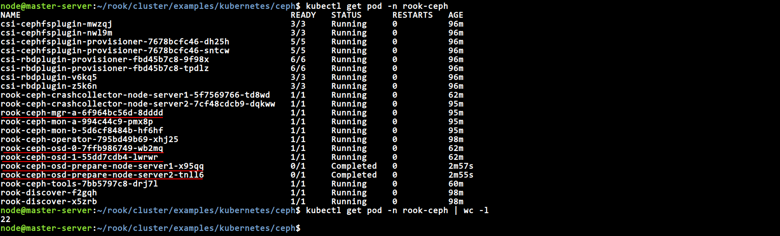
after login into

$ kubectl exec -ti rook-ceph-tools-7bb5797c8-drj7l -n rook-ceph bash

# ceph status

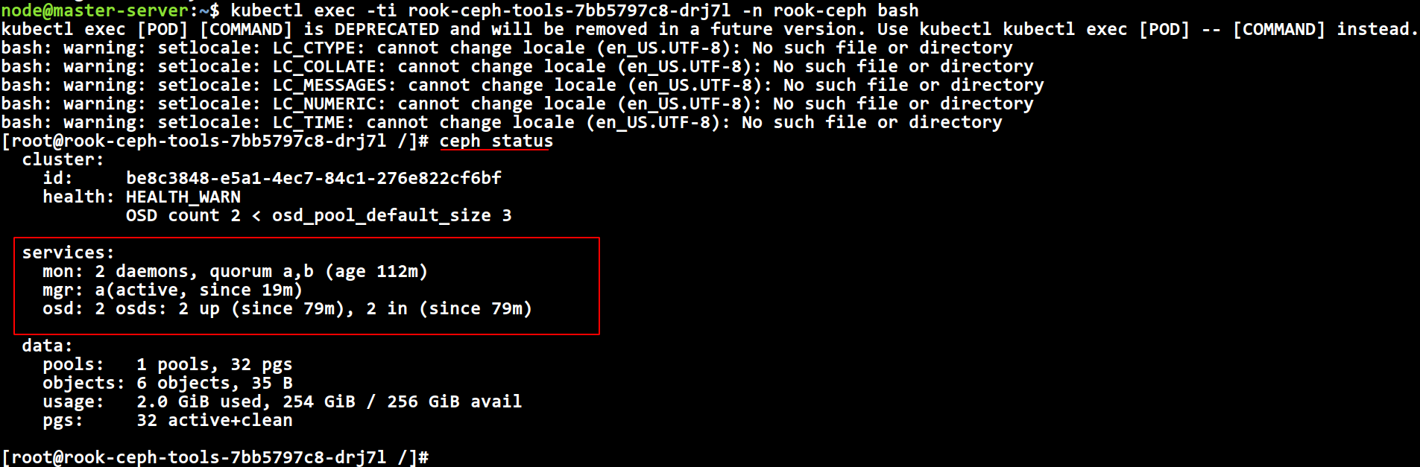
# ceph osd tree

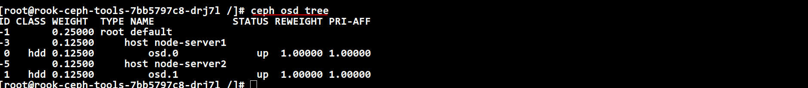
# ceph osd status

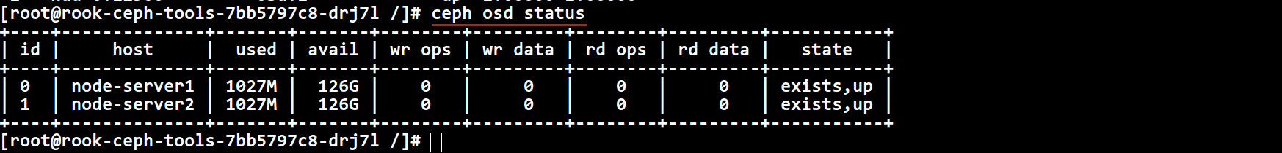
# ceph osd df

# ceph osd utilization
refer this link: https://rook.io/docs/rook/v1.2/ceph-osd-mgmt.html

Create pvc

$ kubectl apply -f csi/rbd/pvc.yaml

now I able to create pvc from rook-ceph storage

common issues:

→ https://rook.io/docs/rook/v1.0/ceph-common-issues.html#osd-pods-are-not-created-on-my-devices
→ https://rook.io/docs/rook/v1.0/ceph-common-issues.html#osd-pods-are-failing-to-start

