Create service account in google cloud

Requirements:

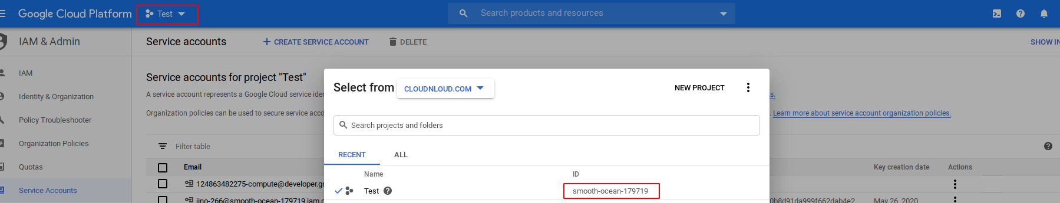

project name and project id

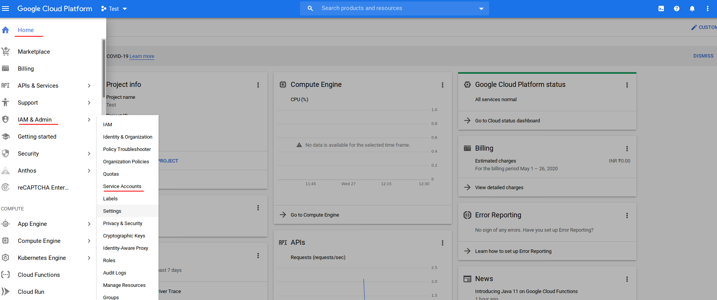

Home → IAM → Service Account →

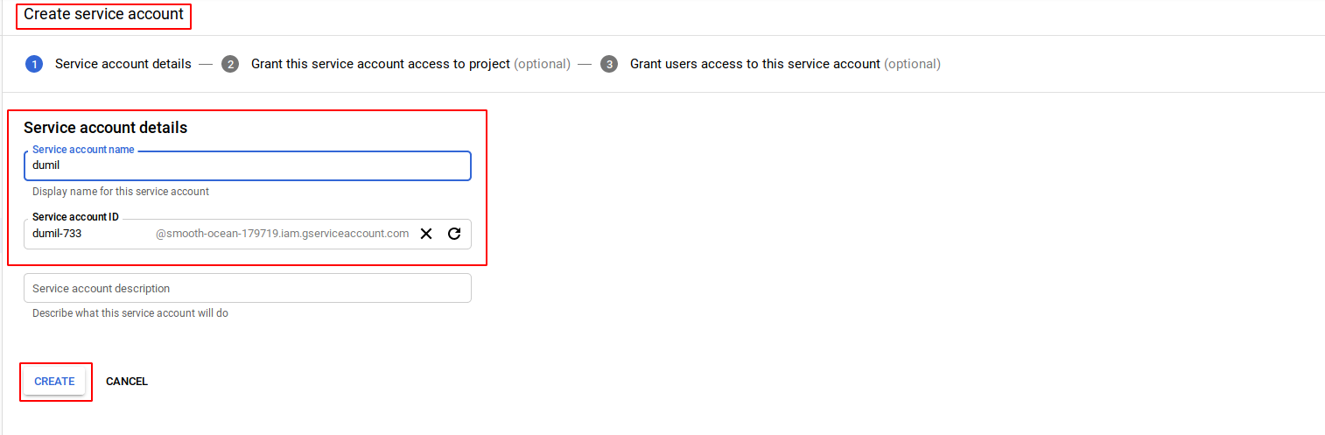

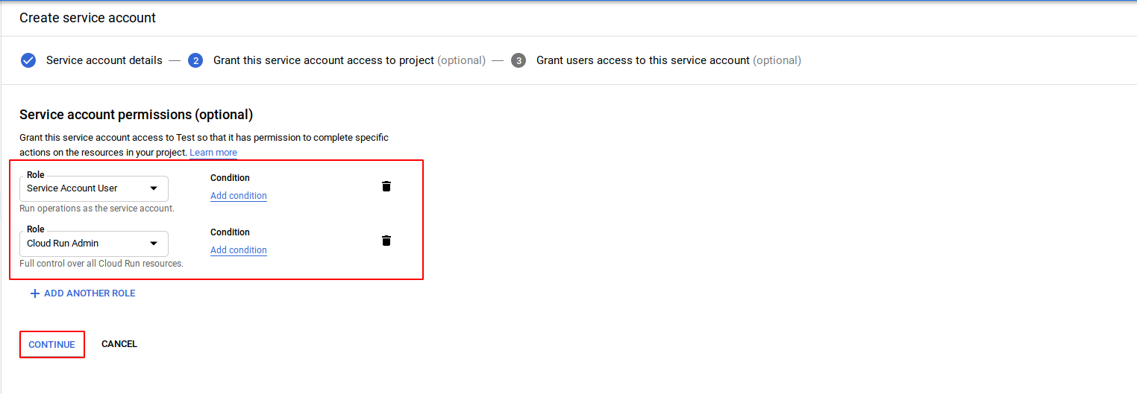
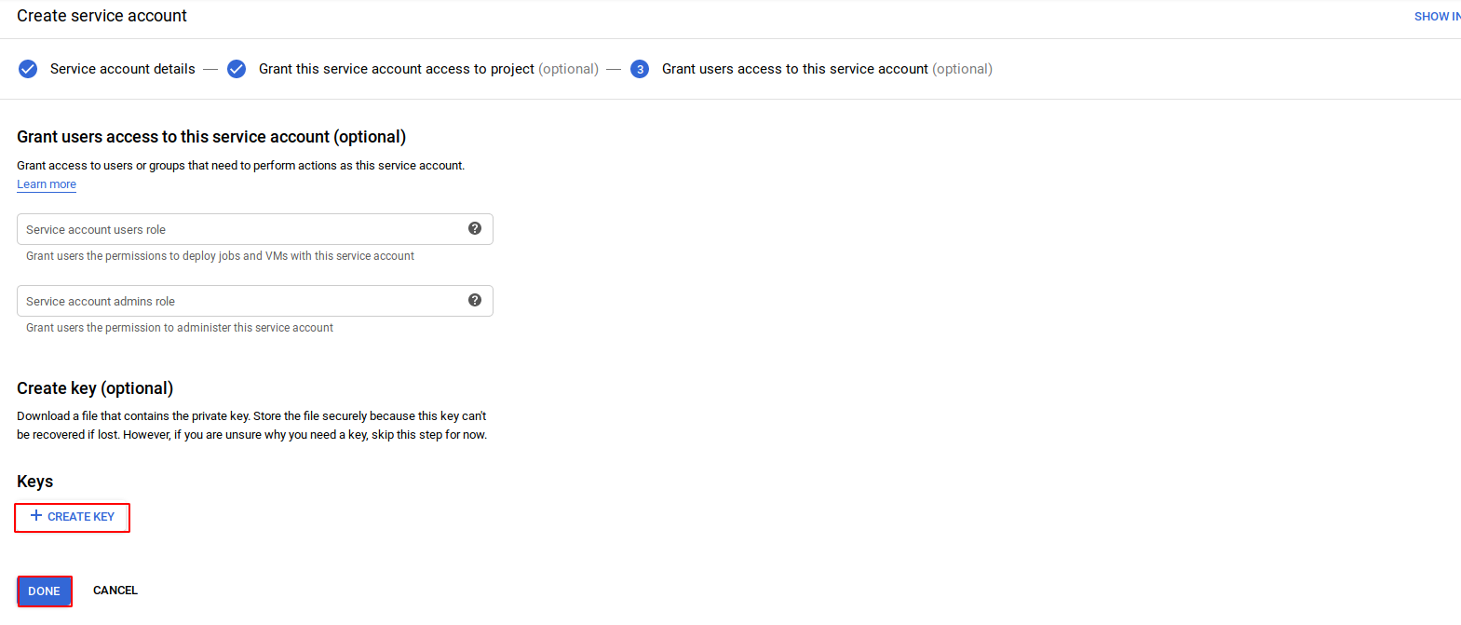
Save the json file into particular location

Execution:

# gcloud auth activate-service-account --key-file ~/Downloads/smooth-19-2cced1abedfc.json
# gcloud config set project smooth-ocean-179719
# gcloud config set run/region us-central1
# gcloud run deploy jino –image=gcr.io/my/image --platform managed

