PROJECT ORCA
Fixed-Wing eVTOL Reconnaissance UAV

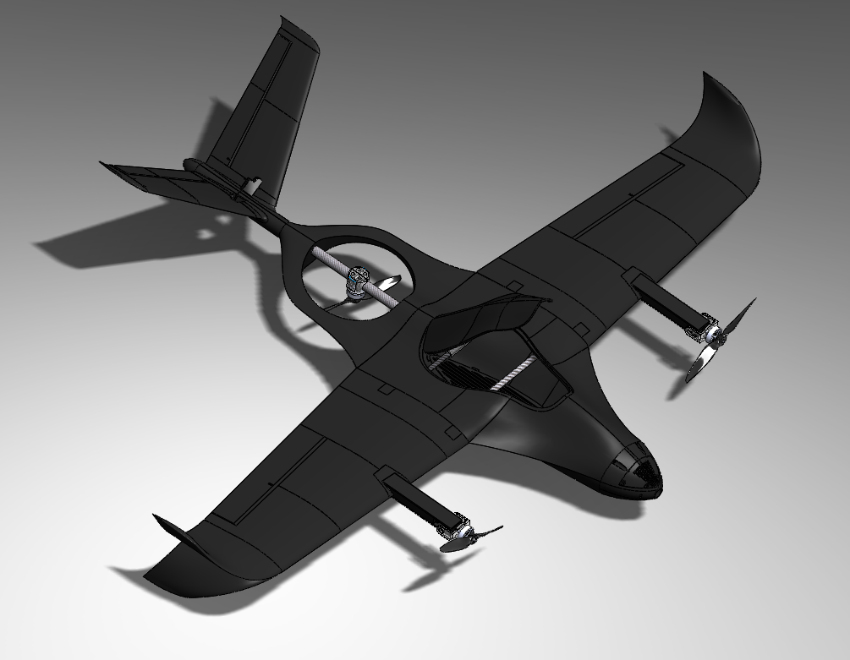

AEM 404 · Senior Capstone Design
The University of Alabama · Department of Aerospace Engineering & Mechanics
Spring 2026

Chief Engineer & CFD/Aerodynamics Lead: Fourie van Rooyen
Faculty Advisor: Dr. Jinwei Shen

Executive Summary

Project ORCA is a fixed-wing electric Vertical Takeoff and Landing (eVTOL) tiltrotor UAV developed as a University of Alabama AEM 404 Senior Capstone project. The aircraft is designed for reconnaissance, surveillance, and intelligence-gathering missions, combining vertical takeoff and landing capability with aerodynamically efficient fixed-wing cruise. Built on a Flightory Stallion V2 airframe platform, ORCA integrates a three-motor tiltrotor quadplane configuration running ArduPlane QuadPlane firmware.

The program advanced through a full NASA NPR 7123.1D-aligned design lifecycle: Mission Concept Review (MCR), Preliminary Design Review (PDR), Critical Design Review (CDR), Test Readiness Review (TRR), and Flight Readiness Review (FRR). Two flight-test campaigns were conducted in April 2026 at a UA-approved outdoor UAV test area. The aircraft achieved stable VTOL hover, completed one successful full transition cycle (VTOL → cruise → VTOL), and generated significant flight log data enabling in-depth post-flight analysis.

Key Results
✓ Stable VTOL hover demonstrated — 5–10 min total accumulated hover time
✓ First successful VTOL→cruise→VTOL transition cycle completed
✓ Full ANSYS CFD simulation at cruise (17 m/s): L/D ≈ 10.5–11.2, C_L = 0.58 at α = 4°
✓ ANSYS FEA structural validation: FoS ≥ 2.0 on primary structure
✓ ArduPlane QuadPlane firmware configured, tuned, and flight-validated
✓ FAA Part 107 compliant design throughout — MTOW ≤ 5 kg

Team & Project Overview

Team Structure
Chief Engineer / CFD Lead | Fourie van Rooyen
Project Manager / GNC Lead | Matthew Cotting
Propulsion & Power / Safety Officer | Cohen McNabb
Structures Lead / CFO | Coralie Lallier
CAD Lead / Electronics Lead | Colin Thomasma
Technical Writer / Systems Lead | Eliel Smith
Pilot / Outreach Liaison | Keelan O'Doherty
Faculty Advisor | Dr. Jinwei Shen

Mission Objectives
The ORCA UAV was designed to accomplish the following primary objectives:
- Provide ≥ 30 minutes endurance at 17 m/s cruise, with ≥ 10 minutes hover capability
- Operate fully autonomously with waypoint navigation, VTOL transition, and return-to-home
- Carry modular payloads up to 2.0 kg including thermal/IR/EO imaging systems
- Launch and recover without a runway using vertical lift rotors
- Maintain full FAA Part 107 compliance (MTOW ≤ 55 lb, ≤ 400 ft AGL, LOS operation)

Vehicle Configuration Summary
Configuration | Fixed-wing with distributed VTOL lift rotors (tiltrotor tricopter)
Airframe Platform | Flightory Stallion V2
Wingspan | 1.33 m
Length | ~1.0 m
MTOW | ≤ 5 kg
Cruise Speed | 17 m/s (≈ 38 mph)
Target Endurance | 60 minutes cruise
VTOL Hover Time | 5–10 minutes at MTOW
Payload Capacity | ≤ 2.0 kg modular EO/IR/night-vision
Propulsion | 3× Thobby F60 tiltrotor motors + rear hover motor
Flight Controller | Matek F405-Wing V2 — ArduPlane QuadPlane firmware
Power System | 6S LiPo (Zeee 6S 5200 mAh)
Construction | 3D-printed ABS / LW-PLA + carbon fiber reinforcement
Regulatory Compliance | FAA Part 107

Aerodynamics & CFD Analysis

Airfoil Selection
The ORCA wing uses the Eppler E205 airfoil, selected for its high lift-to-drag ratio at low Reynolds numbers (Re ≈ 2.3×10⁵), predictable stall behavior, moderate pitching moment, and proven UAV performance record. The wing uses a high-aspect-ratio planform (AR ≈ 4.5) to maximize endurance efficiency.

Aerodynamic Coefficients
Lift Curve Slope | a ≈ 0.088 /deg (≈ 5.0 rad⁻¹)
Cruise C_L (α = 4°) | 0.58
Zero-Lift Drag (C_Do) | 0.028
Oswald Efficiency (e) | 0.78
Aspect Ratio (AR) | 4.5
Predicted Cruise L/D | 10.5–11.2
Stall Onset (α_stall) | ~10.5°–11.2°
Cruise Margin to Stall | >50% (cruise α ≈ 4°)

Full 3-D ANSYS Fluent CFD Simulation
A full 3-D CFD analysis was conducted in ANSYS Fluent 2025 R2 at cruise conditions (V∞ = 17 m/s) across angles of attack from 0° to 10°. The simulation used a viscous k-ω SST turbulence model with a fully resolved boundary layer mesh. Results confirm smooth, attached flow at cruise, strong upper-surface suction consistent with efficient lift generation, and no adverse pressure gradients at operating conditions.

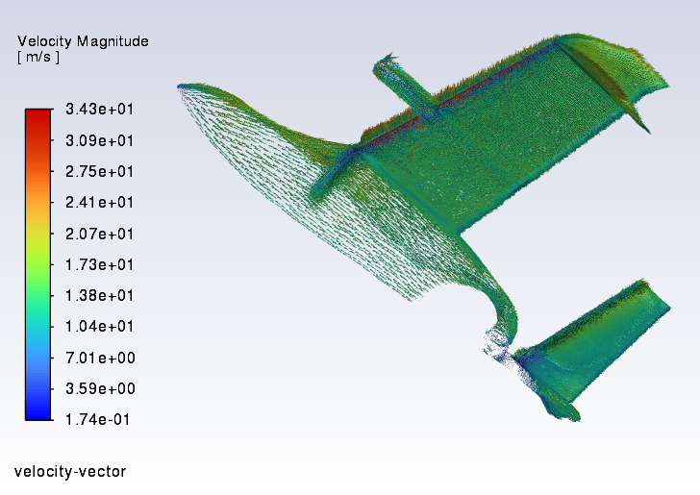  Fig. 1 — Velocity vectors colored by magnitude at cruise (α = 4°) | 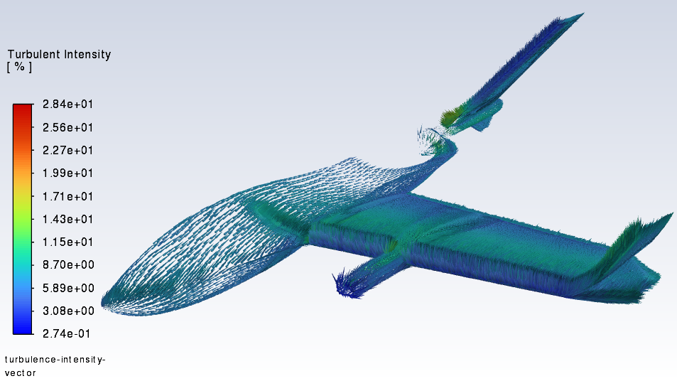  Fig. 2 — Turbulent intensity vectors at cruise conditions

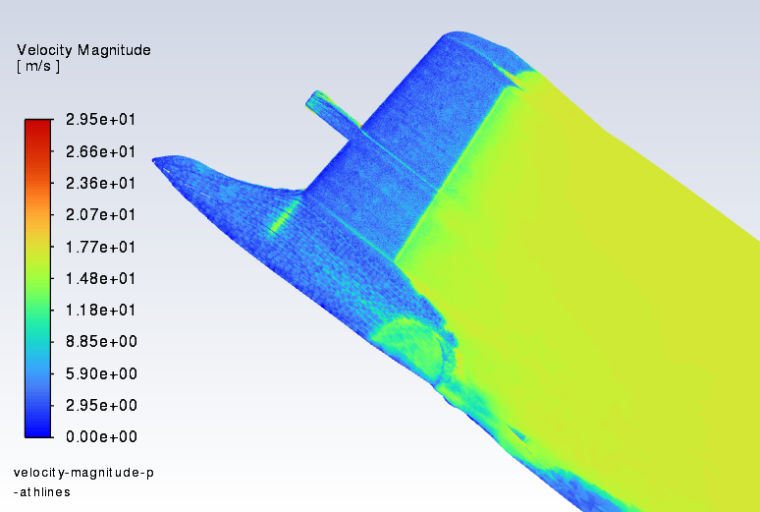
Fig. 3 — Velocity magnitude flow pathlines — isometric view showing acceleration over lifting surfaces

CFD Force/Moment Table at 17 m/s
AoA (°) | Lift (N) | Drag (N) | Moment (N·m) | C_L | C_D | C_M
0° | 11.09 | 2.89 | 1.54 | 0.154 | 0.0401 | 0.0216
2° | 29.59 | 0.48 | 8.44 | 0.394 | 0.0352 | 0.0597
4° | 43.65 | 4.32 | 6.82 | 0.581 | 0.0575 | 0.0918
6° | 47.77 | 8.24 | 7.10 | 0.636 | 0.1097 | 0.0956
8° | 54.67 | 12.14 | 8.38 | 0.728 | 0.1617 | 0.1128
10° | 51.62 | 16.44 | 7.89 | 0.688 | 0.2189 | 0.1061

Table 1 — Full-plane CFD simulation results at V∞ = 17 m/s (ANSYS Fluent 2025 R2)

Structures & Finite Element Analysis

Structural Design Philosophy
The ORCA structural architecture uses a multi-material 3D-printed approach balancing weight, strength, and manufacturability. The design philosophy centers on lightweight thin-walled shells with internal ribs and spars, continuous load paths through all structural members, modular replaceability of all major assemblies, and composite reinforcement in high-load regions.

Material Selection
Primary Structure (motor mounts, brackets) | ABS — 30–35 MPa tensile, 1.8–2.2 GPa modulus, Tg ~105°C
Airframe Skins, Wings, Fuselage | LW-PLA-HT — ultra-lightweight, ~25 MPa tensile, Tg 65–70°C
Wing Spars & Motor Arms | Carbon fiber tubes — high stiffness-to-weight, bending resistance
High-stress joints | Epoxy & fiber tape — delamination and crack prevention
Infill Strategy (most parts) | 7% infill — crush-tested superior to 10% (29.7 lbf vs. 17.8 lbf failure)
Motor mounts infill | ≥ 25% — higher density required for thrust loads

ANSYS FEA Results
Structural finite element analysis was conducted in ANSYS Mechanical 2025 R2 covering three primary load cases: cruise aerodynamic loads, VTOL hover thrust loads, and gust loading at 15 kt.

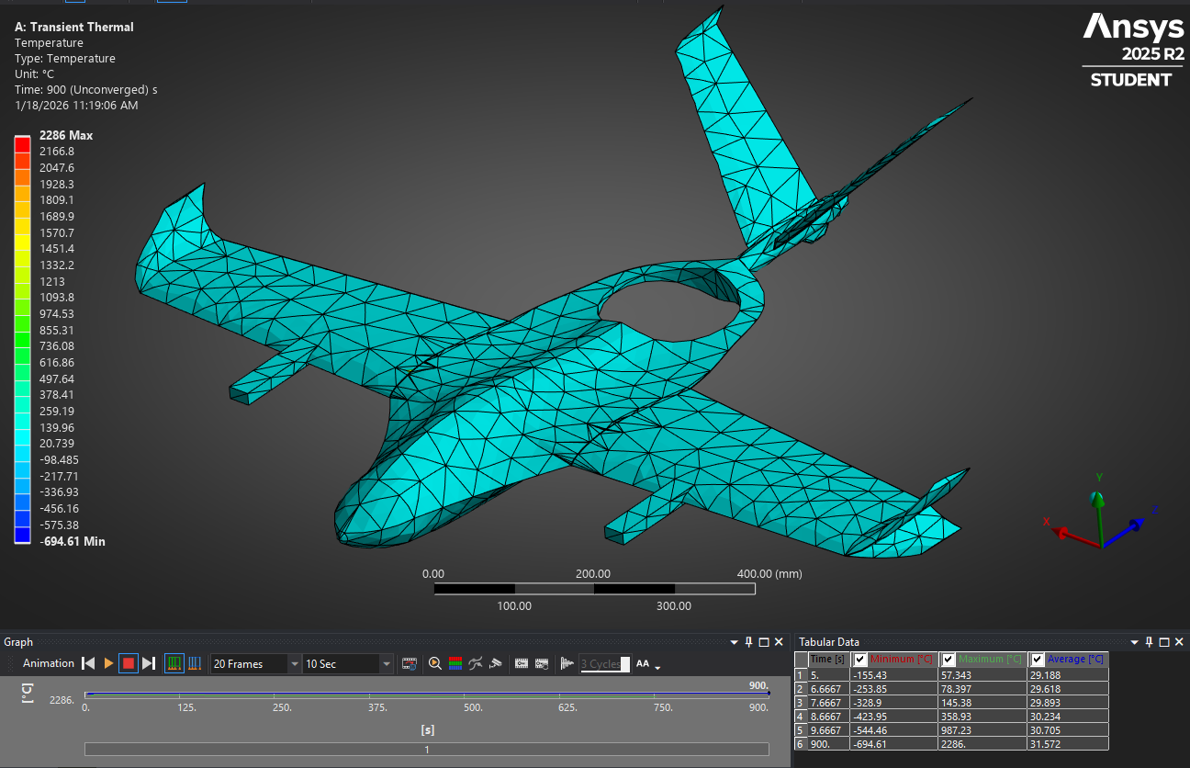
Fig. 4 — ANSYS Transient Thermal simulation of ORCA airframe (temperature distribution, 900 s exposure)

Wing max von Mises stress | < 18 MPa — FoS: 2.1–2.4
Wing tip deflection (15 kt gust) | 4–6 mm — acceptable for UAV class
Fuselage stress at motor mounts | 22–26 MPa — FoS ≥ 1.6
VTOL arm peak stress | ~19 MPa — FoS ≈ 1.6 with carbon reinforcement
Global structural FoS | ≥ 2.0 on primary structure (meets CDR requirement)
Landing/handling load peak | 28–32 MPa — mitigated by reinforced belly skin

Stability, Control & GNC

Static Stability
The ORCA design satisfies required stability margins in all axes across three flight regimes: VTOL hover, transition, and fixed-wing cruise.

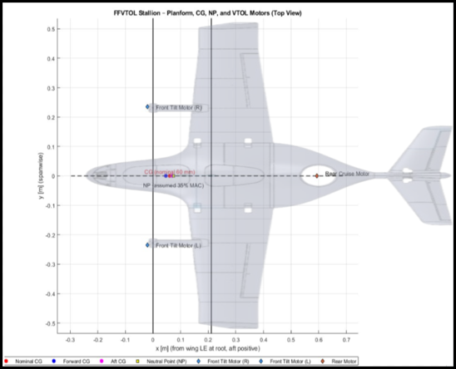
Fig. 5 — Static stability diagram: CG, NP, and VTOL motor positions relative to airframe planform

Longitudinal stability (C_mα) | ≈ −0.043 /deg — Stable (C_mα < 0)
Static margin | 8–10% MAC (target: 5–15%)
Directional stability (C_nβ) | > 0 — Stable
Roll stability (C_lβ) | < 0 — Wing-leveling
CG empty airframe | ~23% MAC
CG with full payload | ~29% MAC
VTOL CG alignment error | < 3 mm (acceptable)

Dynamic Stability Modes
Phugoid Mode | Period ~30–40 s, ζ ~0.05–0.12 (lightly damped, normal for small UAVs)
Short Period Mode | Period ~0.3–0.6 s, ζ ~0.35–0.45 (strongly stable)
Dutch Roll | ζ ≈ 0.2–0.3 — mitigated by yaw-damping autopilot gains
Roll Mode | Fast, strongly damped (ζ > 0.5)
Spiral Mode | Slightly divergent — slow and manageable with autopilot

Transition Control Logic
VTOL-to-cruise transition uses a cubic blend scheduling function λ(s) = 3s² − 2s³ where s is normalized transition time. This provides smooth thrust handoff, prevents step changes in angle of attack, and eliminates undesirable oscillations. Key ArduPlane QuadPlane parameters:

Q_TILT_MAX | 45° — maximum tilt angle for transition
Q_TILT_RATE_UP | 15°/s — motor tilt rate
Q_TRANSITION_MS | 7000 ms — transition smoothing duration
AIRSPEED_MIN | 12 m/s — minimum speed for fixed-wing transition gate
AIRSPEED_MAX | 25 m/s — cruise speed limit
Q_M_BAT_VOLT_MAX/MIN | 16.8 V / 13.2 V — battery voltage compensation

GNC Architecture
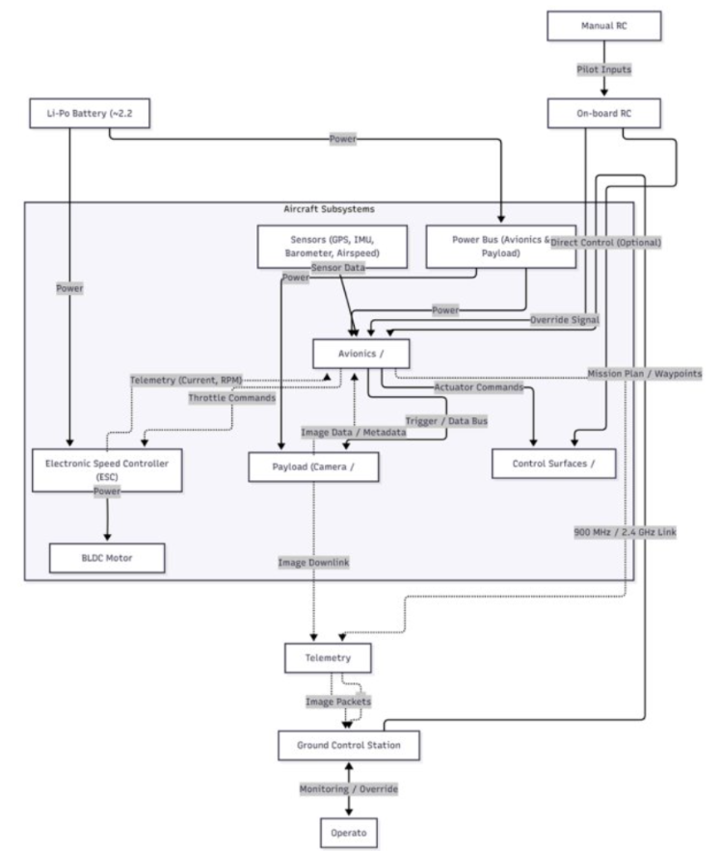
Fig. 6 — ORCA avionics and GNC system block diagram

Propulsion System

Architecture
ORCA uses a distributed electric propulsion system with three Thobby F60 tiltrotor motors configured as a tricopter quadplane. Two front motors tilt from vertical (VTOL) to horizontal (cruise) via servo-actuated mounts, while a fixed rear motor provides supplemental hover thrust and is disabled in cruise. All motors are driven by BLHeli32 ESCs over DSHOT600 protocol.

VTOL Motors | 3× Thobby F60 — 1750 KV class, matched to 7×4.5" props
ESC Protocol | DSHOT600 — BLHeli32
VTOL T/W Ratio | 1.41 at MTOW (5 kg) — exceeds EDS minimum of 1.3
Hover Power (estimated) | 1,650–2,300 W total
Cruise Motor | 7" high-efficiency propeller — rear-mounted
Cruise Power Draw | 180–220 W at 17 m/s
Cruise Propeller Efficiency | η_prop ≈ 0.75
Battery | Zeee 6S 5200 mAh LiPo
Estimated Cruise Endurance | 35–65 min (analysis basis)
Tilt Servo Controller | PCA9685 I²C expander (TIM8 conflict workaround)

Wiring & Power Distribution
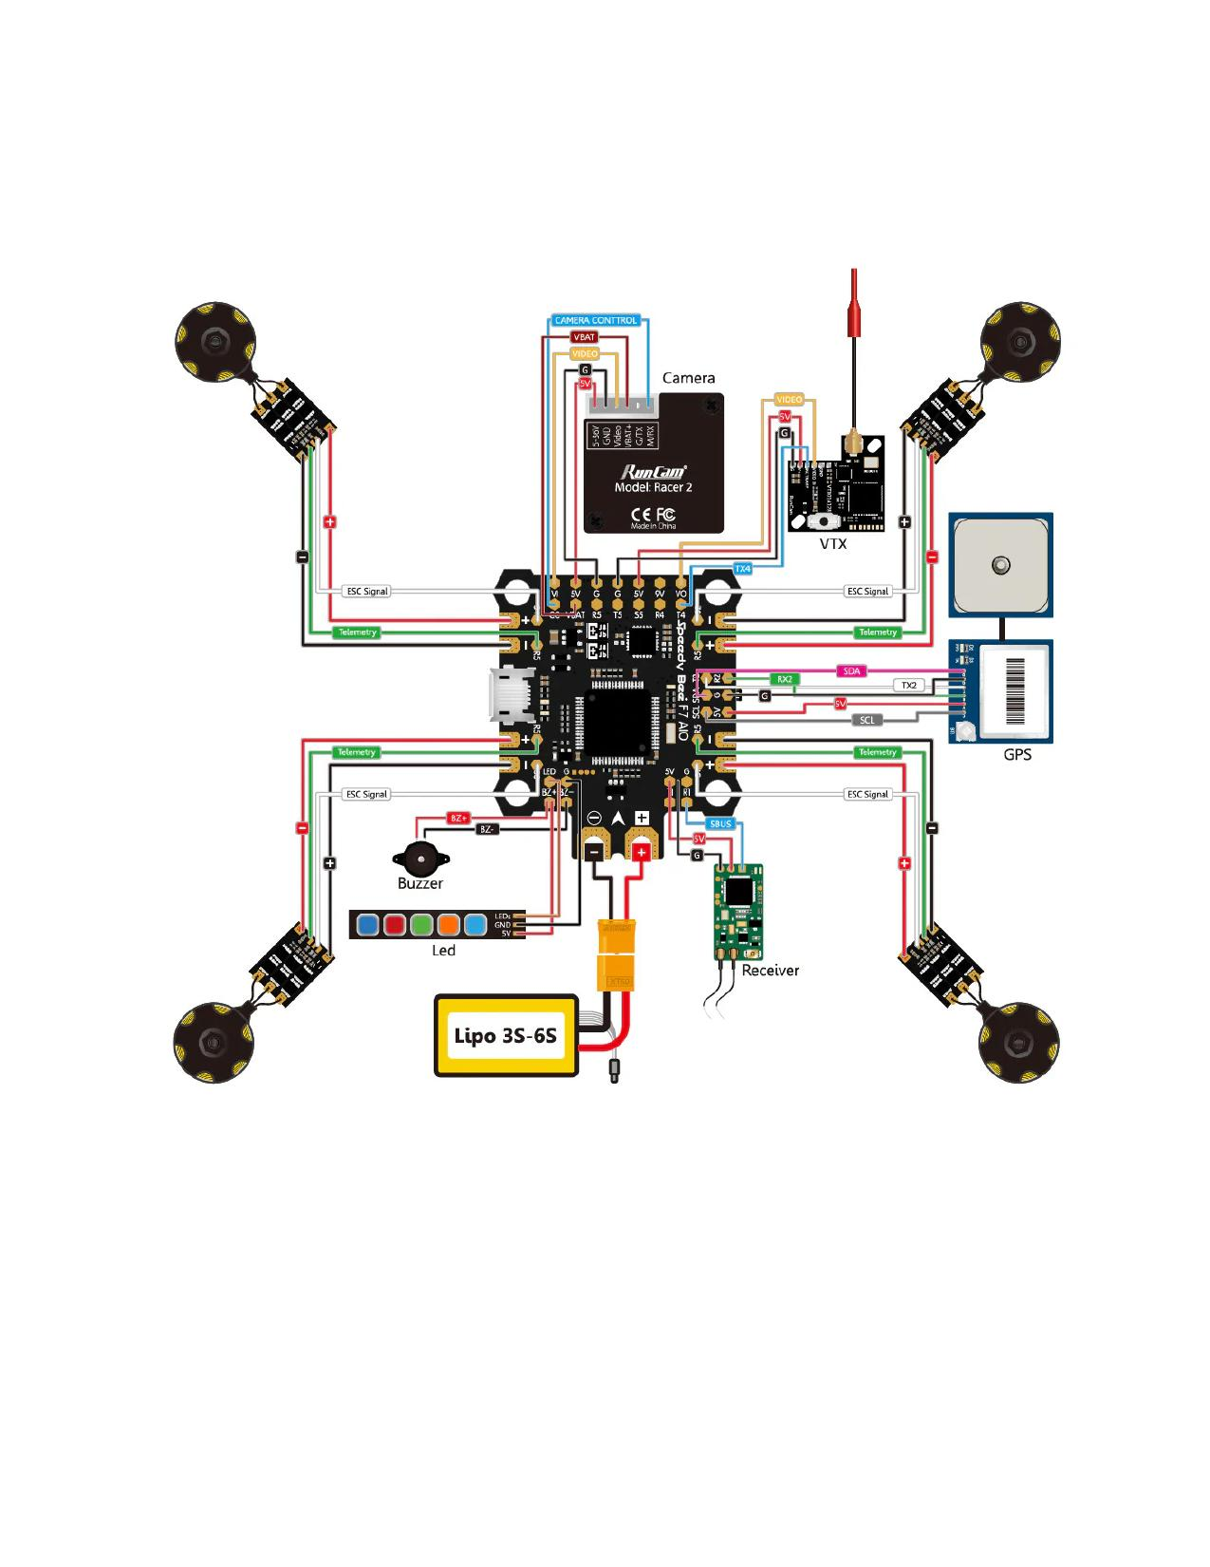
Fig. 7 — ORCA electronics wiring diagram — flight controller, ESCs, GPS, receiver, and payload

Physical Build & Manufacturing

Airframe Assembly
The ORCA airframe was manufactured entirely using FDM 3D printing on Bambu P1S and university Cube printers. The fuselage was printed in 3–4 modular segments and bonded using ABS-compatible epoxy with alignment pins. Wing panels use 7% gyroid infill LW-PLA-HT skins with ABS ribs and carbon fiber primary spars.

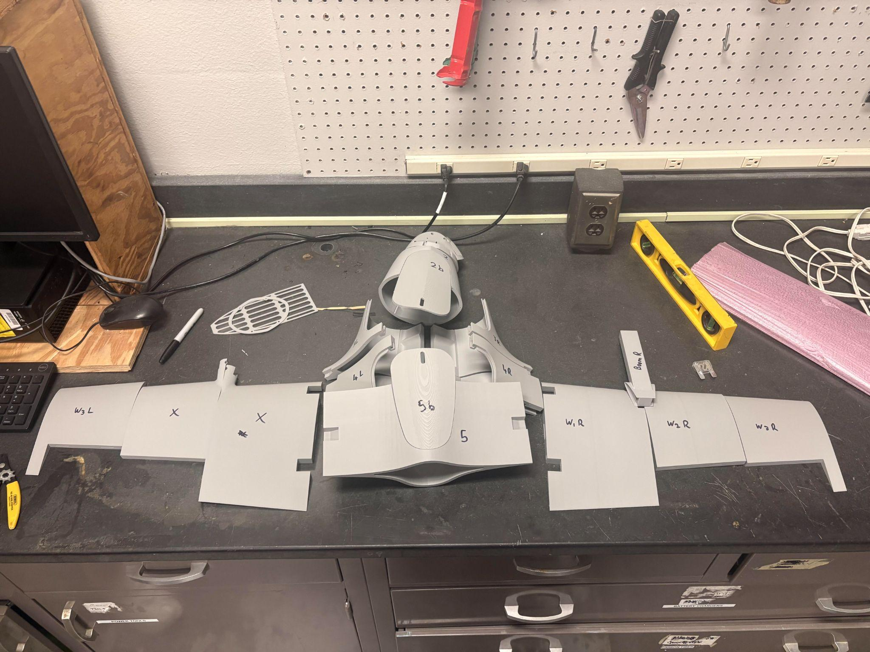
Fig. 8 — ORCA airframe laid out for pre-flight inspection — fuselage, wings, and VTOL boom assemblies

Manufacturing Parameters
Wing panels (LW-PLA-HT) | 7% gyroid infill, nozzle 230–240°C, bed 50–60°C
Motor mounts (ABS) | 25% infill, nozzle 240–250°C, bed 95–110°C
Fuselage (LW-PLA-HT) | 3–4 segments, 7% infill, carbon longeron inserts
VTOL arms (LW-PLA-HT) | Carbon rod embedded during print pause
Total print time estimate | ~60–65 hours across all components
Total material (ABS) | ~400–600 g
Total material (LW-PLA) | ~1,500–2,000 g

Flight Test Campaign & Results

Campaign Overview
Two flight-test sessions were conducted at a UA-approved outdoor UAV test area in April 2026. The campaign followed an incremental five-phase test plan (bench testing, integrated ground tests, VTOL hover, fixed-wing cruise, transition). The campaign is characterized as two distinct campaigns separated by a mid-program rebuild.

Session | Regime | Outcome | Key Observation
1A | VTOL Hover (QLOITER) | Crash (controlled) | FC commanded climb to match GPS home-altitude reference; kill switch at ~2.5 m AGL
— | Rebuild | — | Replace 2× front servos, 2× front motor mounts, rear motor, rear motor mount; epoxy fuselage and wingtips
2A | VTOL Hover (QSTABILIZE) | Met | Stable hover — 5–10 min total; less overcorrection than Session 1A
2B | Transition Cycle 1 | Met ✓ | VTOL→cruise→VTOL; aircraft swooped low during forward transition, recovered and returned
2C | Transition Attempt 2 | Terminal crash | Lateral gust during tilt; UV-softened PLA booms; control overcorrection; terminal impact

Table 2 — High-level flight-test log summary (April 2026)

Session 2B: First Successful Transition
Session 2B represents the program's primary flight achievement. The aircraft was initiated from stable QSTABILIZE hover, transitioned to FBWA, executed the tilt sequence to 45°, accelerated to cruise airspeed, and then reversed the sequence to return to hover and land. The full VTOL→cruise→VTOL cycle was completed, validating the transition control logic and QuadPlane firmware configuration. Partway through transition, the aircraft pitched nose-down and descended, but recovered in response to aft stick input and completed its forward pass.

Root Cause Analysis — Session 2C Terminal Crash
Primary Failure Factors
(1) UV-induced thermal softening of PLA boom arms — glass transition Tg ~60°C exceeded in direct sunlight
(2) Compliant structure reduced GNC corrective authority — control law demands more, structure flexes more, diverges
(3) Default ArduPlane PID gains untuned to this airframe — gains assumed rigid-body dynamics, airframe was softened
(4) Cumulative fatigue from Session 1A impact — reduced structural reserve on rebuilt airframe

Quantitative Performance vs. CDR Predictions
Hover T/W ratio | CDR: 1.41 — Observed: Confirmed (adequate hover at MTOW)
Hover stability (±3°) | CDR: Met — Session 2A: Met in calm wind
Transition completion | CDR: Planned — Session 2B: Achieved (first cycle)
Cruise endurance | CDR: 35–65 min — Status: Not verified (program terminated)
Structural failure | CDR risk accepted — Root cause: UV/heat PLA degradation

Lessons Learned & Recommendations

Design Recommendations
- Replace PLA boom arms with PETG or fiber-reinforced ASA — UV and heat resistance critical for outdoor operations
- Perform formal PID tuning on-airframe before transition testing — default ArduPlane gains insufficient for this configuration
- Establish EKF convergence verification procedure before committing to altitude-hold modes (QLOITER)
- Add GPS home-altitude pre-arm check and altitude offset correction to preflight checklist
- Structural FEA should model UV-degraded material properties for worst-case outdoor analysis

Operational Improvements
- Tethered hover testing prior to free flight — would have revealed PID gain issues at lower risk
- Separate hover validation day from transition testing day — avoid stacking risk in single test window
- Dedicate time to formal PID autotuning using ArduPilot's onboard autotune function
- Apply UV-resistant coating or use ASA for all sun-exposed structural components

What Was Validated
Confirmed Technical Achievements
✓ QuadPlane firmware configuration with tiltrotor tricopter geometry — operational
✓ TIM8 timer conflict resolved via PCA9685 I²C expander — DSHOT and PWM coexistence confirmed
✓ VTOL hover stability in QSTABILIZE — adequate for test program
✓ Transition control logic functional — successful VTOL↔cruise cycle demonstrated
✓ Full CDR design cycle completed — 3D CFD, FEA, stability analysis, EDS compliance
✓ FAA Part 107 operations maintained throughout — no third-party property or personnel affected

Appendix: Engineering Design Specifications

EDS Compliance Summary
Requirement | CDR Status | Verification Method
60 min cruise endurance | On Track | Analysis & flight test
5–10 min hover | On Track | Thrust/power testing
2 kg payload | On Track | Mass budget & structural analysis
VTOL capability (< 5×5 m area) | On Track | Power/RPM → hover model
FAA Part 107 compliance | Met | Documentation
Stability ±3° | On Track | GNC tuning
CG within 23–33% MAC | Met | CAD & mass properties
Manufacturing requirements | Met | Printability analysis
Structural FoS ≥ 2 | Met | ANSYS FEA
T/W ≥ 1.3 (VTOL) | Met | Thrust stand testing (1.41 achieved)

This document was prepared as a portfolio artifact summarizing Project ORCA (AEM 404 Senior Capstone, University of Alabama, Spring 2026). It consolidates deliverables spanning the Mission Concept Review through the Post-Flight Analysis Report.

