**MEMO Number UMBC-CMPE451-S25-ASL2-Verification-&-Validation**

**DATE: *May 19, 2025***

**TO: *Dr. LaBerge***

**FROM: *Bardan Kafle, Rajjya Paudyal, Joaquin Calilao, Ali Ahmed (ASL-2)***

**SUBJECT: Verification & Validation Report**

**1. Introduction & Summary**

The ASL-2 project is a real-time American Sign Language (ASL) interpretation device that is designed to bridge communication between the deaf community and non-sign language users in point-of-sale (POS) environments. The system captures ASL gestures, processes them, and translates them into text to display. The text is also converted into speech using text-to-speech technology to adapt to fast moving store environments.

**2. System Design and Implementation**

The final design of the ASL translator device consists of a Raspberry Pi which is housed in a custom enclosure that includes an embedded display, a speaker and a camera. The camera is responsible for capturing sign language hand gestures, which are analyzed in real-time using a machine learning model. The inferred translation is both displayed on the real-time display or can be converted to speech. The figures below show the fully-assembled ASL interpreter device, including both its hardware and software components.

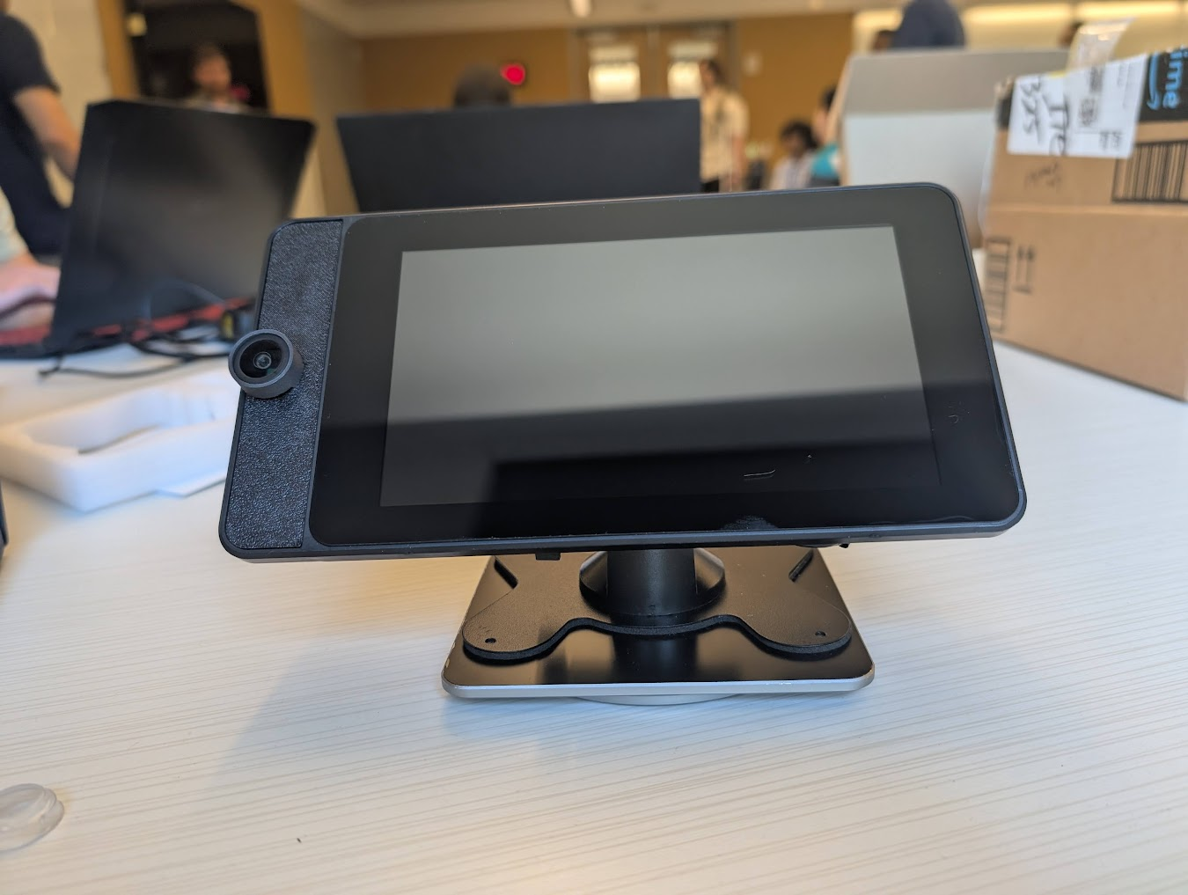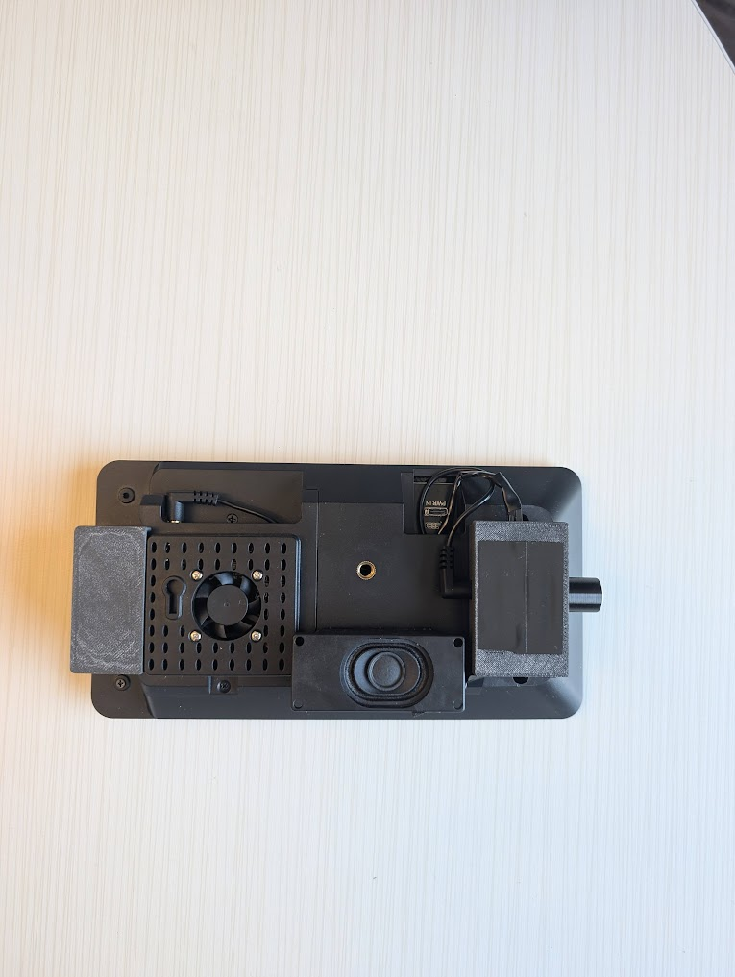

**FIGURE 1: ASL DEVICE FRONT FIGURE 2: ASL DEVICE BACK**

**3. Referenced Documents**

| Document ID | Document |
| --- | --- |
| REF_DOC_1 | ACME ASL [Guidelines](https://docs.google.com/document/u/2/d/1wSZlfibUaOJhgA19wxk85Uw88gpaRCJk/edit) |
| REF_DOC_2 | System Requirements [Specification](https://docs.google.com/document/u/2/d/1qziqTngsOIZSMGbaYiJy8MLGLOEsXitu/edit) |

**4. Verification & Validation**

The overall approach to verification & validation was through simulated POS interactions. Because access to a real POS scenario was not possible, the testing was done in a lab environment where the components of the device went through scenarios that tested the overall effectiveness of its interpretation of gestures. The following requirements were specified in REF_DOC_2, which derived from REF_DOC_1.

| Req ID | Description | Test Method | Result |
| --- | --- | --- | --- |
| FUNC_REQ_1 | Translate ASL to English | Text Output Observation | PASS |
| FUNC_REQ_2 | Standalone device for POS use | Observation | PASS |
| FUNC_REQ_3 | Output both text and sound | Observation of TTS and Display Output | PASS |
| FUNC_REQ_4 | Recognize signs in various lighting conditions | Dataset test with different lighting conditions | PASS* |
| FUNC_REQ_5 | Recognize users with various skin tones | Dataset testing with different hands | PASS* |
| FUNC_REQ_6 | Processing done with an embedded microprocessor | Hardware inspection | PASS |
| FUNC_REQ_7 | Displayed on embedded screen | Hardware inspection | PASS |
| FUNC_REQ_8 | Output audio through an embedded speaker | Hardware inspection + audio validation | PASS |
| PERF_REQ_1 | Recognize A-Z, 0-9, 10 basic signs | Dataset test | PASS* |
| PERF_REQ_2 | Translate with <5s delay | Manual Timing | PASS* |
| PERF_REQ_3 | Translate with >=80% accuracy | Dataset Test | PASS* |
| PERF_REQ_4 | Recognize gestures within 3 feet | Distance testing | PASS* |

**5. Discussion**

FUNC_REQ_4:

The ASL device was tested thoroughly with all signs and with both hands. It was tested in both high brightness and low brightness environments, with a PASS being considered as greater than 80% accuracy for both scenarios (PERF_REQ_3). The results can be seen below in Tables 1 & 2.

FUNC_REQ_5:

The ASL device was not formally tested with various skin colors. This requirement is met by Google’s Mediapipe Hands framework, which is implemented to detect signs in the software of the device. Skin color does impact the ability for Mediapipe to detect the user’s hands and there may be a few inconsistencies but the group had no issues, therefore we considered this a PASS.

PERF_REQ_1:

The ASL device recognized all signs that were required to be detected. The list of all signs that are recognized are represented in Table 1. In the best case scenario, each sign can be detected (therefore the requirement was a PASS) but there may be inconsistencies based on lighting and other environmental factors.

PERF_REQ_2:

The timing requirement of the ASL device was tested by executing each sign and measuring how long it took the software to display the translation to the display. The average was lower than the 5 second delay threshold (when removing the outliers), therefore, the requirement was considered a PASS. The POS environment may add to the overall delay depending on how difficult it is for MediaPipe to detect hand positions.

PERF_REQ_3:

Overall accuracy testing of the ASL device is presented in Tables 1 & 2. In each scenario, the accuracy surpassed 80%, therefore, it fulfilled the requirement and was considered a PASS.

PERF_REQ_4:

The ASL device was exclusively tested with the user 2-3 feet away from the device, therefore, since the accuracy measurements are met, this requirement receives a PASS.

**[THIS SPACE INTENTIONALLY LEFT BLANK]**

**TABLE 1: HIGH BRIGHTNESS AREA TEST TABLE 2: LOW BRIGHTNESS AREA TEST**

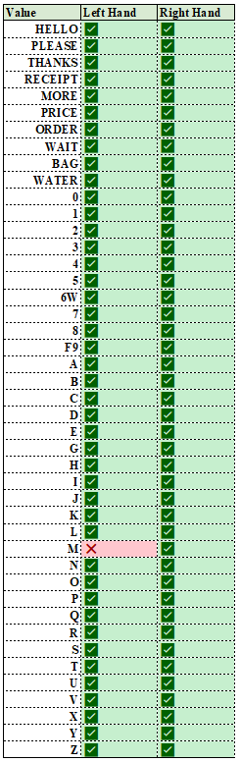 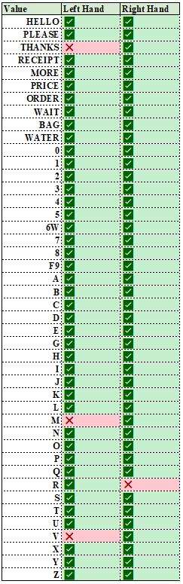

**Accuracy: 98.86% Accuracy: 95.45%**

**TABLE 3: TIMING TEST**

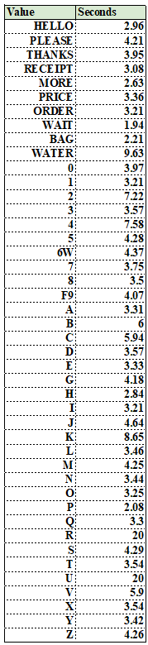

**Timing Average: 4.84s**

**(Inconclusive signs were timed as 20 seconds)**