|  |  |
| --- | --- |
| **HOSPITAL MANAGEMENT SYSTEM.** | **KING SAUD UNIVERSITY**  **COLLEGE OF COMPUTER AND INFORMATION SCIENCES**  **DEPARTMENT OF SOFTWARE ENGINEERING**  **Course Code / Title:** SWE-381 /Applications Development  **Instructor:** Dr. Mashael Maashi  **Semester / Year:** Spring 2019  **Section No#:** 46440  **Date:** 24 Jan 2019  **Due date**: **Monday, 8th of Apr 2019**  PROJECT GROUP MEMBERS:  Name: Alia Saud AlSheha ID: 437200766  Name: Abeer Abdulaziz AlHarran ID:437201752  Name: Fouz Ali AlRubaie ID:437200482  Name: Hussa Saud AlQuraishi ID:437200828  Name: Hadeel Ahmad AlDosari ID:437200200 |
|  |  |

**Table of Contents:**

Work Distribution 2

Issues Faced By Team Members 3

Filenames And Their Purposes 4

Main Functionalities Screenshots 6

Entity Relationship Diagram (ERD) 10

Pages Architecture Diagram 11

**Work Distribution:**

|  |  |  |  |  |  |
| --- | --- | --- | --- | --- | --- |
| Functions | Alia | Abeer | Fouz | Hussa | Hadeel |
| Doctor: | | | | | |
| Sign in/Sign out. |  | **✓** |  |  |  |
| Request laboratory test. | **✓** |  |  |  |  |
| Issue subscription to Pharmacy. | **✓** |  |  |  |  |
| View laboratory results. |  |  |  |  | **✓** |
| Access and view the patient medical file. | **✓** |  |  |  | **✓** |
| Search for a specific patient. | **✓** |  |  |  |  |
| Patient: | | | | | |
| Sign in/Sign out. |  | **✓** |  |  |  |
| Update the account information. |  |  | **✓** |  |  |
| Request for an appointment for a specific doctor. |  |  | **✓** | **✓** |  |
| Change/ cancel a booked appointment. |  |  | **✓** |  |  |
| Search for a specific doctor. |  |  |  | **✓** |  |
| Request for a medical report. |  |  |  | **✓** |  |
| View his/ her medical report. |  |  |  | **✓** |  |
| View the list of doctors in each specialty. |  | **✓** |  |  |  |
| View the history of appointments to him/her previously visited. |  | **✓** |  |  |  |

**ISSUED FACED BY TEAM MEMBERS:**

First, we had a problem to have a time to work that’s suitable for all group members, so we had to stay in university after our lectures to late hours. Secondly, we had other projects for other courses to work on, so we make a schedule to distribute the tasks and organize our time between the projects. Finally, lack of experience and knowledge made working in the database part a demanding task.

**FILE NAMES AND THEIR PURPOSES:**

|  |  |
| --- | --- |
| File Name | Purpose |
| index.php | The home page for Ibn Sina Hospital that view the hospital services and information’s, Also, it provides a field to log in either as doctor or as a patient. |
| DoctorPage.php | The home page for the doctor after he/she singed in, it contains the main functionality that the doctor can do such as Appointment calendar, Patients list, Request a Test…. etc. |
| AllPatients.php | This page is for Doctor’s Patients list, contains information about the patients such as name, file number, age...etc. Also, it has a search bar to search in the list. |
| ReqTest.php | This page is for Request a test from the laboratory, it contains a form that will be filled with the required information by the doctor to send it to the laboratory. |
| ReqMedicine.php | This page is for Request a medicine from the pharmacy, it contains a form that will be filled with the required information by the doctor to send it to the pharmacy. |
| medReport.php | this page is for view and request a medical report, it contains information such as doctor's name, medicine's name and another details. |
| searchDbyName.php | this page is for view all doctors, it contains information such as doctor’s name, office number, phone number and the clinic where he works. |
| Appointmentform.php | This page allow patient to request a new appointment by choose date , time, clinic and doctor name . |
| Patientinfo.php | This page display patient's information such as file number, name, city, phone number, gender and age. |
| patientPage.php | this page is the main page for patient, the patient can access other pages to control or mange his account. |
| appointmentOfPatient.php | this page shows all appointments also allow patient to change or delete any appointment. |
| MedcFile.php | The doctor can view the patient's condition such as: drugs, doses, previous tests and their results. |
| Resultpage.php | The results of the tests that were performed and their results are presented wih a clarification of the situation, whether it is nature or not, with the date of analysis and time  . |

**MAIN FUNCTIONALITIES SCREENSHOTS:**

* Sign in/Sign out.

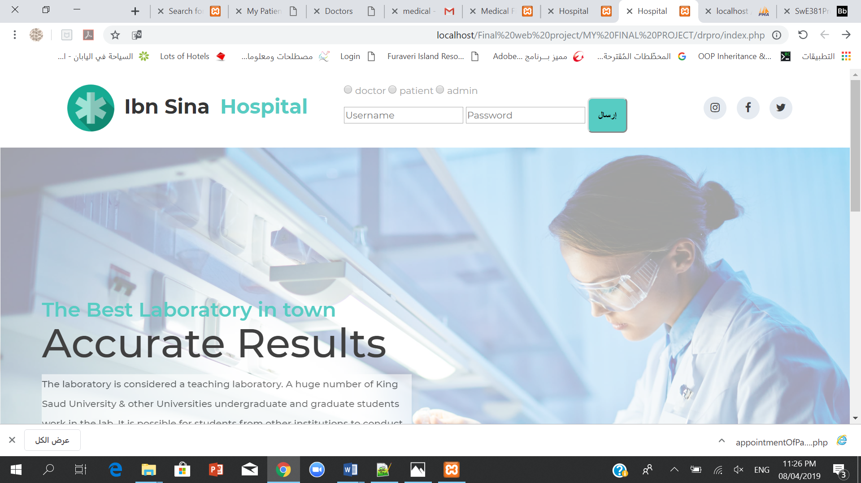

***Doctor:***

* Request laboratory test.
* Issue subscription to Pharmacy.
* View laboratory results.
* Access and view the patient medical file.
* Search for a specific patient.

***Patient:***

*homepage:

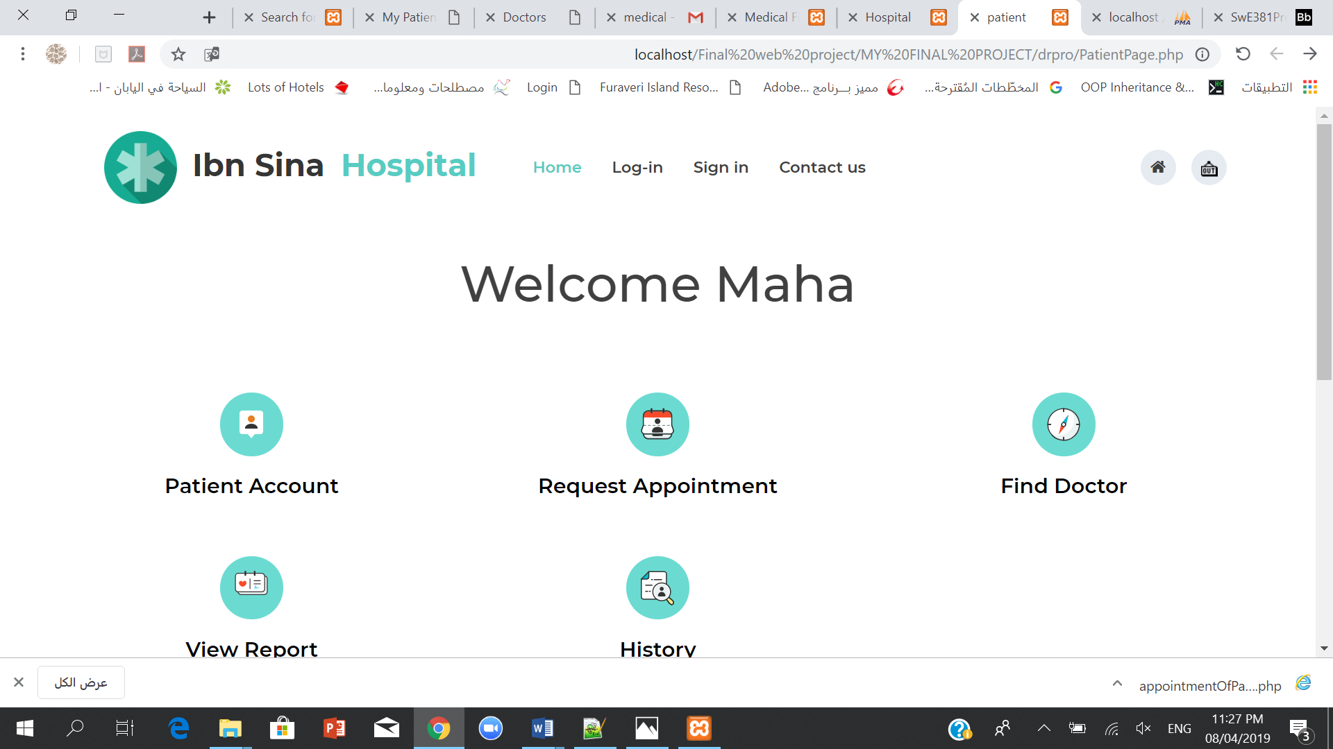

* Update the account information.

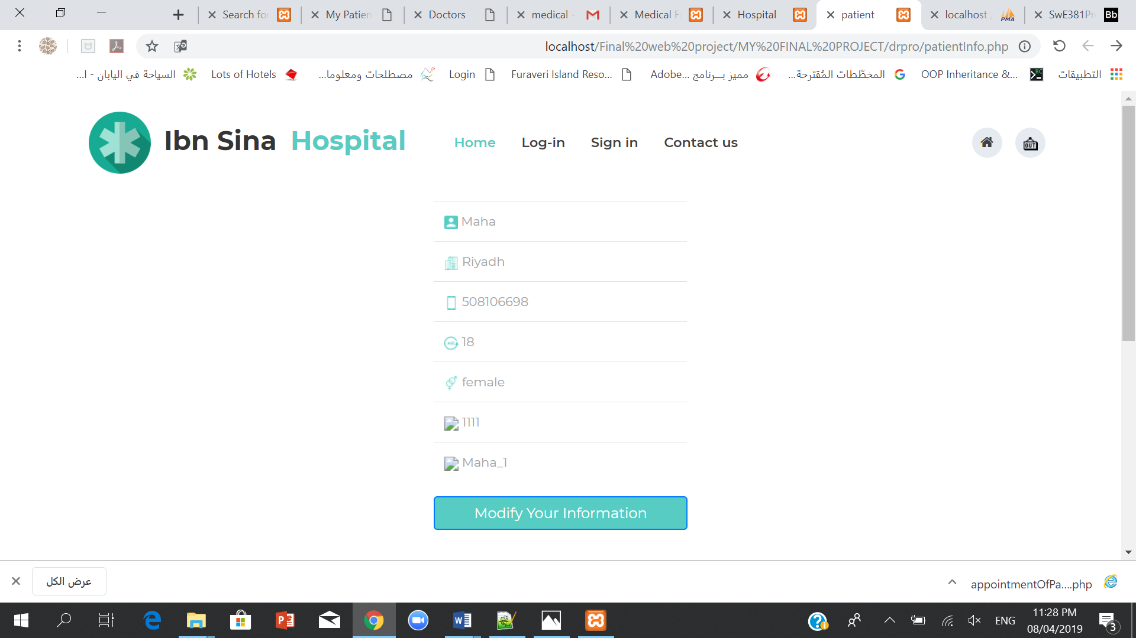

* Request for an appointment for a specific doctor.
* Change/ cancel a booked appointment.
* Search for a specific doctor.
* 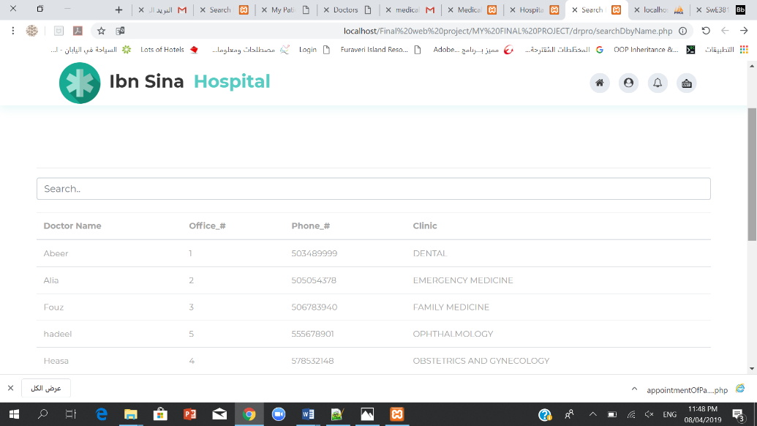
* Request for a medical report.

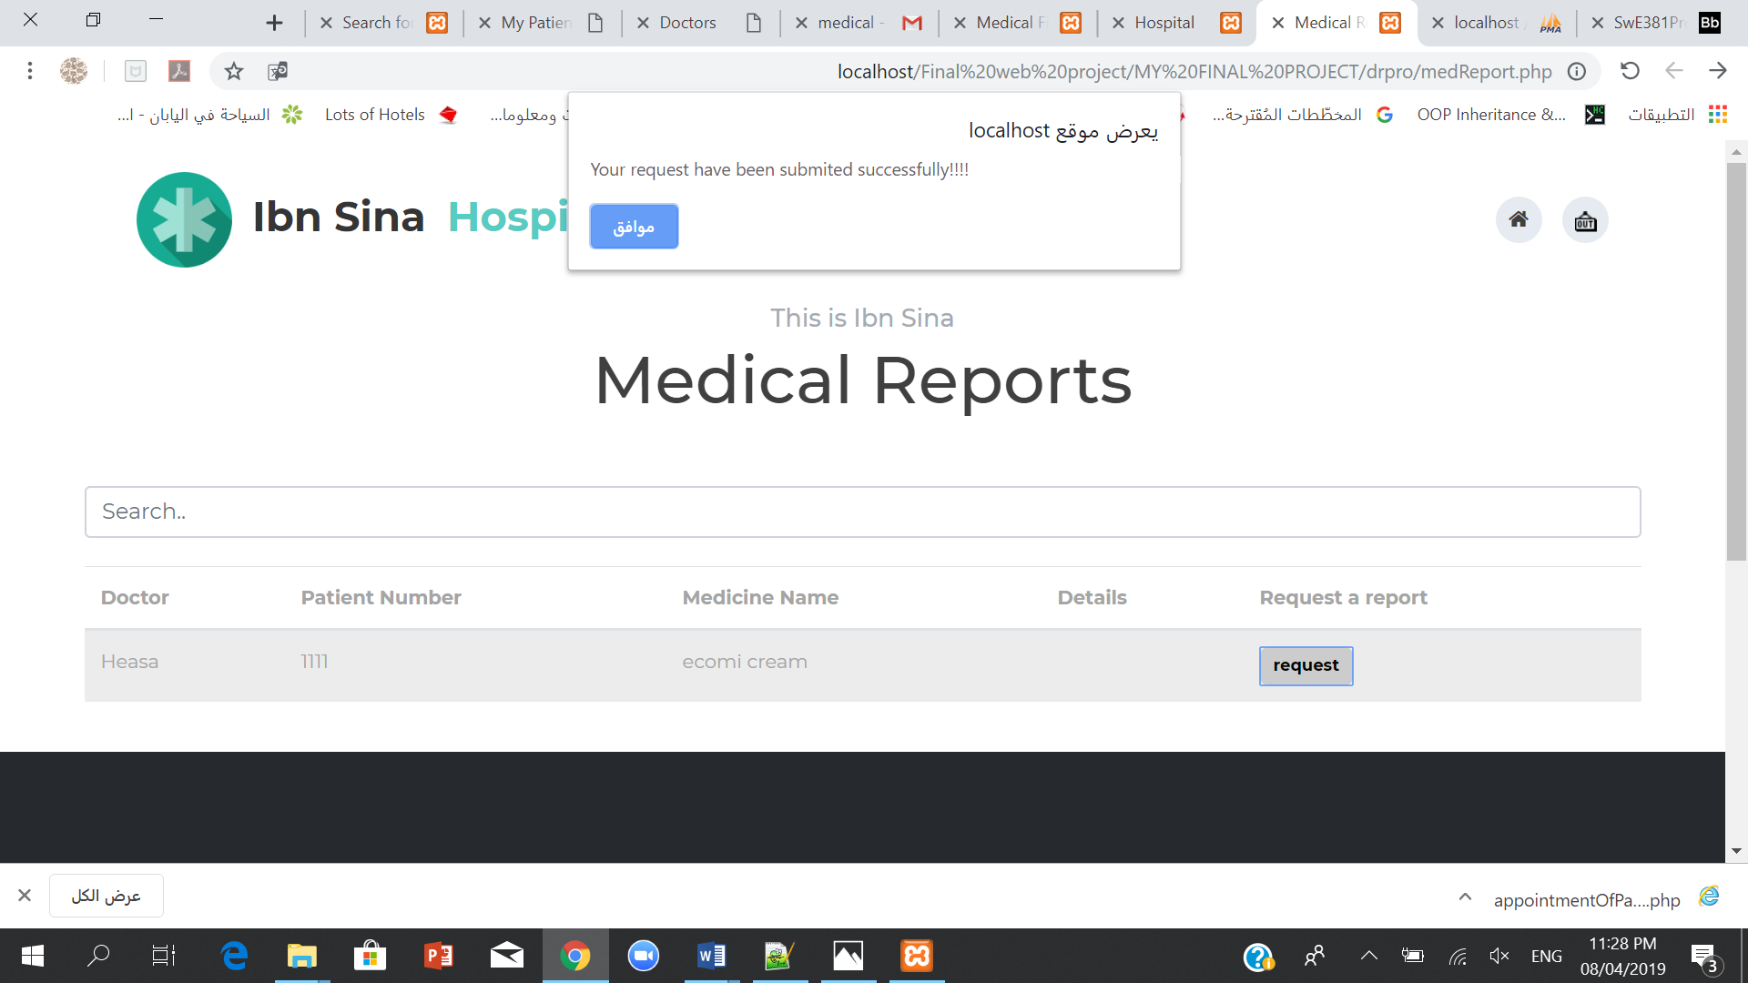

* View his/ her medical report.

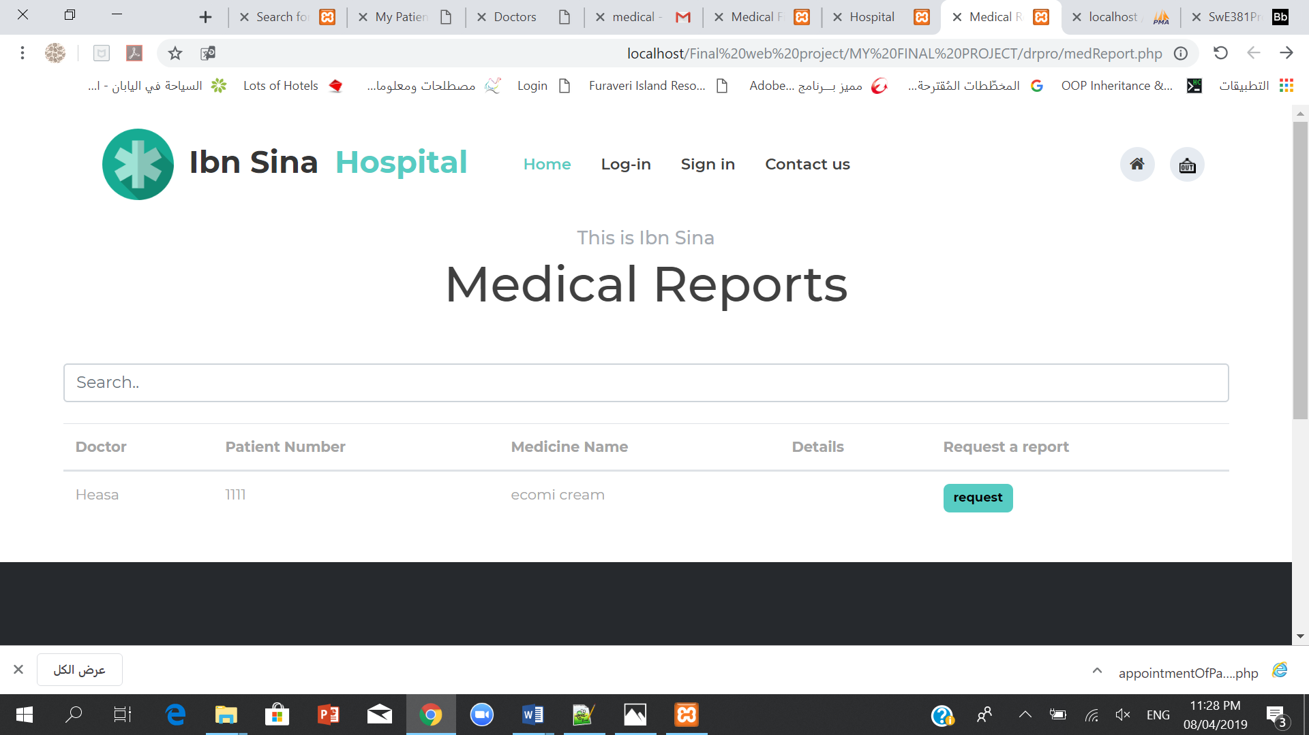

* View the list of doctors in each specialty.
* View the history of appointments to him/her previously visited.

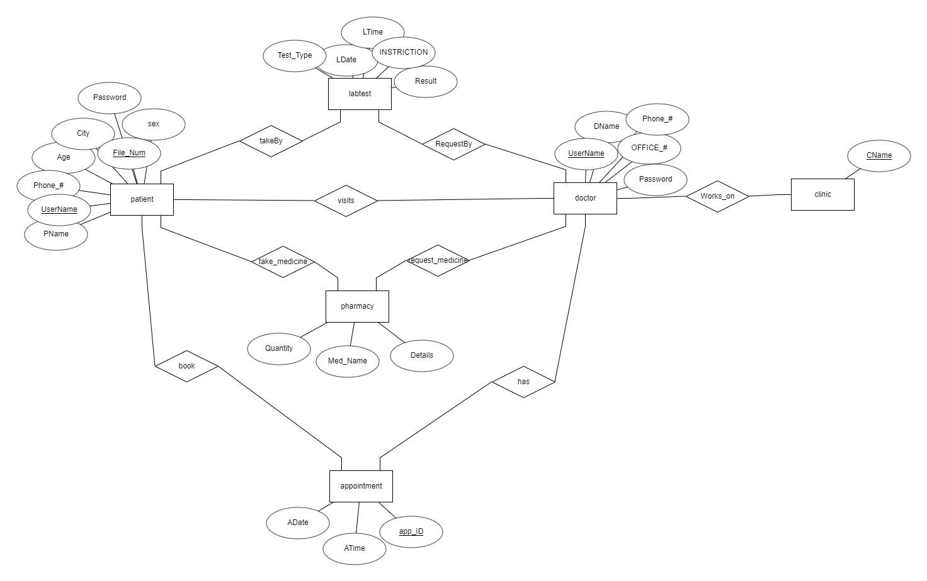**ENTITY RELATIONSHIP DIAGRAM (ERD):**

**PAGES ARCHITECTURE DIAGRAM:**

