Semantic Model Health
Nov 6, 2026 · @Fowzan
Semantic Model Health gives every Power BI semantic model in your Fabric workspaces a health score from 0 to 100, shows what is pulling it down and how to fix it, and installs itself from one notebook.

What it does
It turns hundreds of best-practice warnings into one grade per model and a short list of what to fix first.
Most teams publish more models than they can review. Slow, fragile or oversized models only surface when users complain. Microsoft's Best Practice Analyzer can find the issues, but it returns long lists that nobody has time to read.
Semantic Model Health checks every model every day and gives you:
Report page | What you see
Semantic Model Health | Score and grade per model, the five area scores, the weakest area, the top issues and one quick win
What's hurting the score | Every issue ranked by points lost, the exact tables, columns and measures behind it, how to fix it, effort and impact
Memory and Structure | Model size, the heaviest tables and columns, hidden auto date tables, relationships to review
Scores are kept each day, so you can see whether a model is getting better or worse after a change.

How it works
One notebook does all the work, and the report reads its results directly, so there is nothing to refresh and no password stored anywhere.
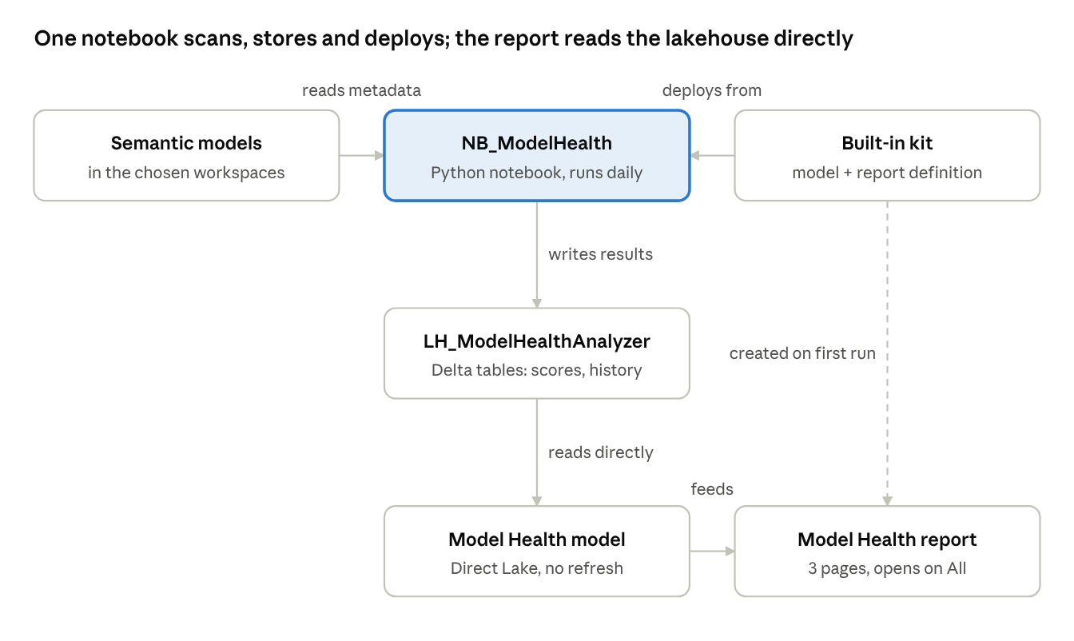
Model Health architecture · one notebook, one lakehouse, one report
The notebook reads each model's metadata, writes scores to its lakehouse, and on the first run creates the Direct Lake model and the report from the kit stored inside it.

How the score works
Every model starts at 100 and loses points for each broken best-practice rule; serious problems cost more than tidiness issues.
- Each broken rule costs points. Error (can give wrong results): 10 points. Warning (slow or hard to maintain): 4 points. Tip (formatting, descriptions): 1 point.
- Repeats cost more, up to a limit. Broken once costs the base points, about 10 times costs double, 100 times or more costs triple, never more. One habit repeated everywhere can't sink an otherwise good model.
- Five areas, each out of 100. Performance, DAX, Error prevention, Maintenance and Formatting each lose the points of their own rules.
- One overall score. Performance counts 30%, DAX 25%, Error prevention 20%, Maintenance 15%, Formatting 10%.
- A grade. A from 90, B from 80, C from 65, D from 50, F below 50.
Worked example:
Area | What was found | Points lost | Area score
Performance | 12 calculated columns + auto date tables (Warnings) | 12.3 | 87.7
DAX | 3 divisions without DIVIDE (Warning) | 5.9 | 94.1
Error prevention | 1 serious issue (Error) | 10.0 | 90.0
Maintenance | 40 objects without a description (Tip) | 2.6 | 97.4
Formatting | 200 number columns without a format (Tip) | 3.0 | 97.0
Overall: 92.1, grade A. Note that 200 formatting tips cost 3 points while one serious issue cost 10.

Get started
Installing takes about five minutes and needs no settings changed.
- Open a workspace on Fabric capacity (F2 or higher, Premium or Trial).
- Import the notebook: Import → Notebook → From this computer.
- Open it and click Run all.
- Open the Model Health report in the same workspace.
From then on it runs every morning on its own. To check more workspaces than the one it sits in, list them in the notebook's settings, or use all of them at once.

Questions people ask
Question | Answer
Does it read our data? | No. It reads the model's structure, DAX, sizes and refresh history, never the rows in your tables.
Does it change our models? | No. It only reads them. It creates its own lakehouse, model, report and schedule, nothing else.
Are passwords stored? | No. It runs as the signed-in user and asks Fabric for a short-lived sign-in each time.
What does it cost to run? | A small Python session: about a minute per changed model. Unchanged models are skipped, so a daily run is short.
What do I need? | Fabric or Premium capacity and Contributor access to the workspaces you want checked.
Can I change the weights? | Yes, in the notebook's settings; the report uses the same numbers.
Where do the rules come from? | Microsoft's Best Practice Analyzer, through the open-source Semantic Link Labs library.

What's coming next
Next step | What it adds
Safe fixes | Apply low-risk fixes (formats, hidden keys, descriptions) after a backup, with a preview and a re-score
Alerts | Tell a model's owner when it drops a grade or a refresh fails
Usage ranking | Put the most-used models first
Your own rules | Add team-specific rules and weights

