
OSHMI
Open Substation HMI
Operation Manual
Version 3.0
© 2014 Ricardo L. Olsen

Objective
This manual is intended to be a guide to operators of the HMI system.

Introduction
The HMI provides the operators a friendly interface with single-line (aka one-line) diagrams (SLD) where can be shown measurements and equipment states and alarms.
The commands are available by clicking the related supervised state or measurement. Example to command a circuit breaker, click the breaker state on the screen.
There are browser based viewers for Screens, Events (real time and historic), Tabular, Alarms, Historic Curves, Trending (real time).

Main features
Redundant mode of operation, dual server – “n” clients (a x86 server can be also a client).
Unlimited clients, monitors and viewers.
No arbitrary limit for the number of points (limited only by memory and performance).
Fast and easy configuration.
IEC60870-5-104 and ICCP protocol drivers.
Developed mostly with open source web technologies and tools: SVG, HTML5, Javascript, PHP, Lua, QT, SQLite, Nginx.
Server software runs on x86 Windows and Linux (experimental) machines. The client web interface can be accessed by modern IOS (IPad/IPhone), Android and Mac OS devices or by any other platform with an HTML5 browser.
Screen Viewer: full-graphics, vector based, lossless zoom (SVG).
Events Viewer: millisecond resolution; can operate with field time tags or local time tags; 2 stage acknowledgement/elimination; historical mode.
Tabular Viewer: point list shown filtered by substation and bay.
Alarms Viewer: displays the unacknowledged and persistent alarms of the system.
Trend Viewer: follow measurements plot in real time.
Curves Viewer: historical measurement plot.
Distinct treatment for simple digital states, alarms and pure events (protection).
Range check for analog values (max e min with hysteresis).
Calculation of points.

Basic HMI Operation

OSHMI PC Interface
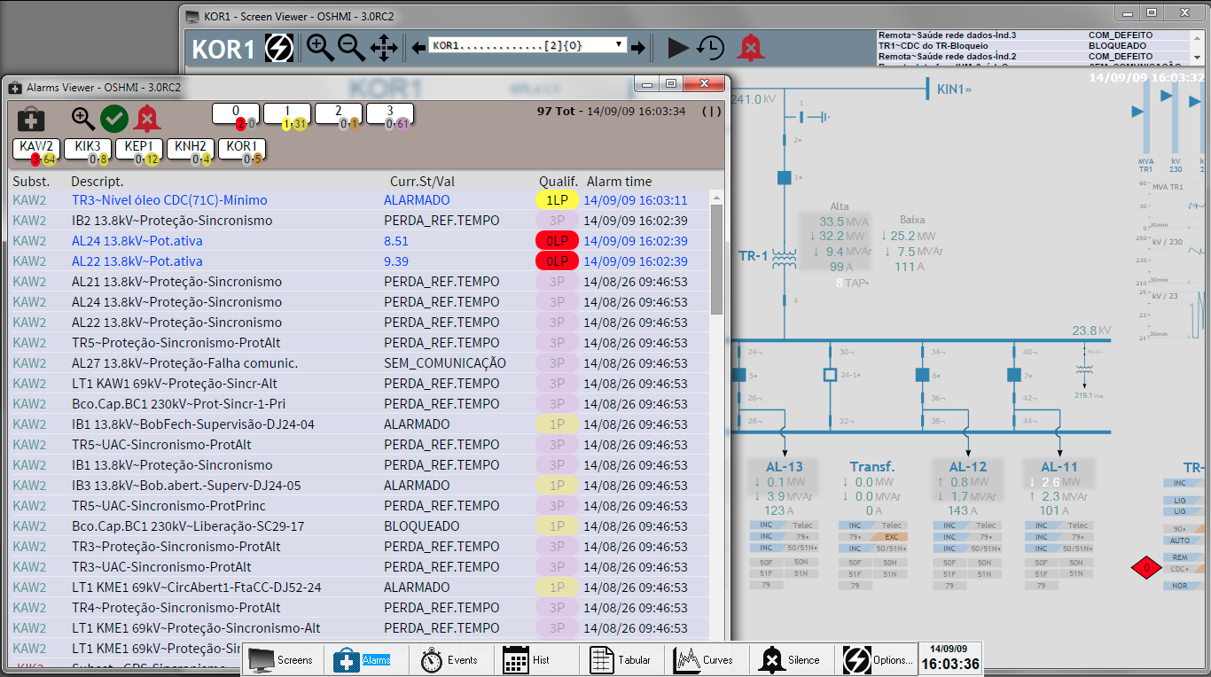

HMI Shell
The HMIShell is the launcher for the OSHMI viewers. It can replace the Windows Standard Shell (Windows Explorer).
It is designed to be unobtrusive, using a minimum of the screen space.
Its position is fixed by the system administrator and cannot be further moved by normal operators.
When not utilized it becomes transparent and shrinks (optional) to show only the date and time. When the mouse moves over it, it then grows and becomes opaque.
Description of the buttons of the HMIShell:
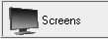 Screen: presents a list of the available screens in a popup menu.
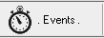 Events: real time events.
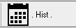 Historical: historical events.
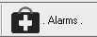 Alarms: list of unacknowledged alarms plus persistent alarms.
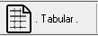 Tabular: list of points by substation and bays.
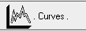 Curves: historical plot of analog measurements.
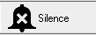 Silence: silence the alarm beep.
The “Options” button is used to access the following dialog:
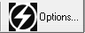 Options: options menu (logout, turnoff, restart, adm. login, etc,).
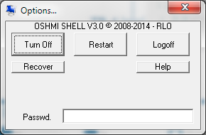
Turn Off – turns off the computer.
Restart – restarts the system.
Logoff – operating system user logoff.
Help – shows this operation manual.
Recover – emergency recover options.

Screen Viewer
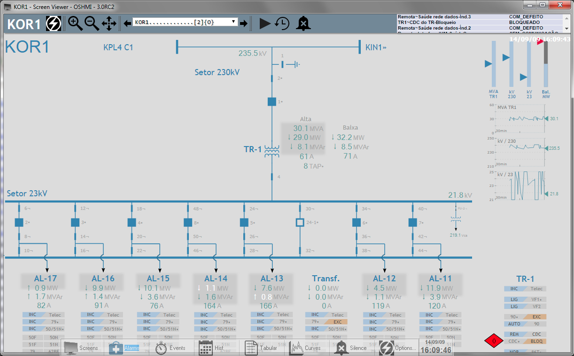
Screen Viewer elements:
- Title bar
Presents the screen name, and the OSHMI version.
- Graphic screen
Displays the SVG drawing with animated SCADA objects.
- Zoom and pan controls
 Zoom in, zoom out and pan controls with the mouse.
- Screen list
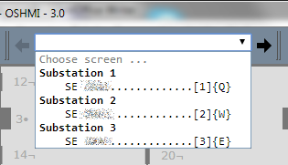 Accesses the list of screens and shows its keyboard shortcuts.
- Time of the last data update
In the upper right corner, in white, it's shown the time of the last data update. It must be almost the current time updated at each 5 seconds (default period). If this time stops to update the Screen Viewer is frozen or the server is not responding so the systems needs to be restarted.
- Slideshow
 Starts to cycle the list of screens (10 seconds per screen by default).
- Time machine
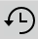 Feeds the screen with historical data.
- Alarm beep silence button
 Silences the current alarm beep.

Screen Navigation
Can be accomplished with the mouse using the Screen Viewer menu, the previous and next screen buttons aside the menu, the Screen list from the HMIShell and links placed inside the SVG screens.
The keyboard shortcuts to screens are:
[1] – first screen from menu
[2] – second screen from menu
...
[9] – ninth screen from menu
[0] – tenth screen from menu
[<] = [ , ] - previous screen from menu
[>] = [ . ] - next screen from menu
{A-Z} – Alphabetic character configured as a shortcut to the screen (char between { }).

Acknowledgement of alarmed objects
Alarmed objects (blinking objects) can be acknowledged individually using the [Control]+Click of the mouse or also by simply clicking the object (point access).

Point Qualifiers
Point qualifiers are chars used to represent special quality and states attributes of a point, they appear in the:
- Tabular Viewer, [Qualif] column.
- Event Viewer, [Qualif] column.
- Point Access Dialog [Qualifier], unabridged form.

The qualifier chars and its descriptions are :
A = Annotation: indicates that the point does have an annotation;
C = Calculated: the point is the result of a calculation;
F = Failed value, invalid, not topic, not updated or bad value;
I = Inhibited alarm, will not register alarm;
K = Command, the point does have one associated command;
L = Unacknowledged alarm;
P = Persistent alarm (acknowledged but still present);
M = Manual, the point is not supervised, the value is manually entered;
S = Substituted: the supervised value was substituted by a manually entered value;
T = Time imprecise: the event possibly does have an imprecise time tag.
U = Analog point frozen, the value is not changing for some time.
X = The point value was never updated.
Y = Interlocked command, the point does have its command interlocked by the value of another point.

Point Info Dialog
To open the Point Info (faceplate) dialog of a supervised point, just click the desired object in the Screen Viewer or he respective line in the Tabular/Alarms/Events Viewers (SHIFT+CLICK). This act will acknowledge any alarm present of the point.
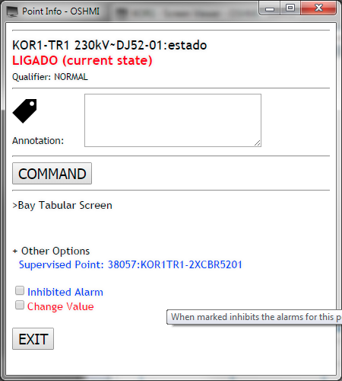  Digital Point Info Dialog | 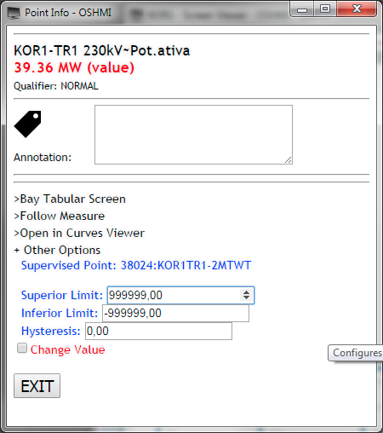  Analog Point Info Dialog

Fields of the Point Info dialog for digital (D) and analog (A) points:
Substation/Description (A/D): substation, bay and information description.
Value (A): value of a measurement.
Current State (D): textual description of the current state of a point.
Qualifier (A/D): list of point qualifiers.
Annotation (A/D): text annotation associated to a point. Every annotation automatically blocks the command of a point. The command can be unblocked checking the “Unblock Command” checkbox. The act of unblocking a command automatically removes the text annotation.
Command (A/D): allows access to the command dialog of the associated command point. If the point does have an activated interlock point, the command will be blocked and can't be unblocked until the interlock point is deactivated.
Bay Tabular Screen (A/D): opens the tabular screen filtered by the substation and bay of the current point.
Follow Measure (A): trace a measure with a real time plot of its values (Trend Viewer).
Open in Curves Viewer(A): opens the current point in the historical Curves Viewer for the current day.
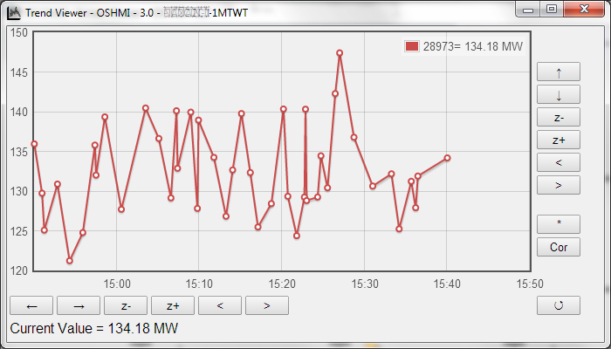“Follow Measure” opens the Trend Viewer.
+ Other Options (click to show the following additional options):
Supervised Point(A/D): number and id (tag) of the point.
Normal State (D): shows the considered normal state of a point, can be changed by the operator in some cases.
Inhibited Alarm (D): allows inhibiting the point alarms, a card will be shown aside the linked object.
Change Value (A/D): enter manually the value of a point (only in simulation mode).
Inferior Limit (A): values for the point below it will generate an alarm.
Superior Limit (A): values for the point exceeding it will generate an alarm.
Hysteresis (A): defines a minimal variation for the value to change the alarmed state.
Exit (A/D): closes the dialog.

Command Dialog
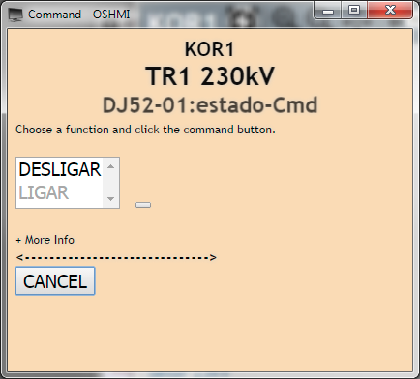  Command Dialog | 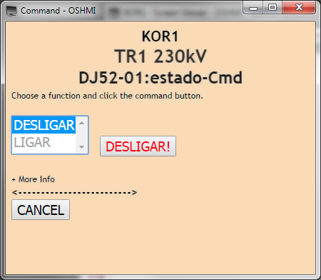  Command Dialog

To reach the command dialog, first open the Point Info Dialog by clicking the desired object to be commanded, then click the “COMMAND” button.
To send a command, choose the desired function like ON or OFF, CLOSE or OPEN..., then click on the command button (this button will present the function text and an exclamation symbol when the function is chosen).
The Command Dialog does have a timeout that will close it after some time to avoid accidental commands.

Events Viewer
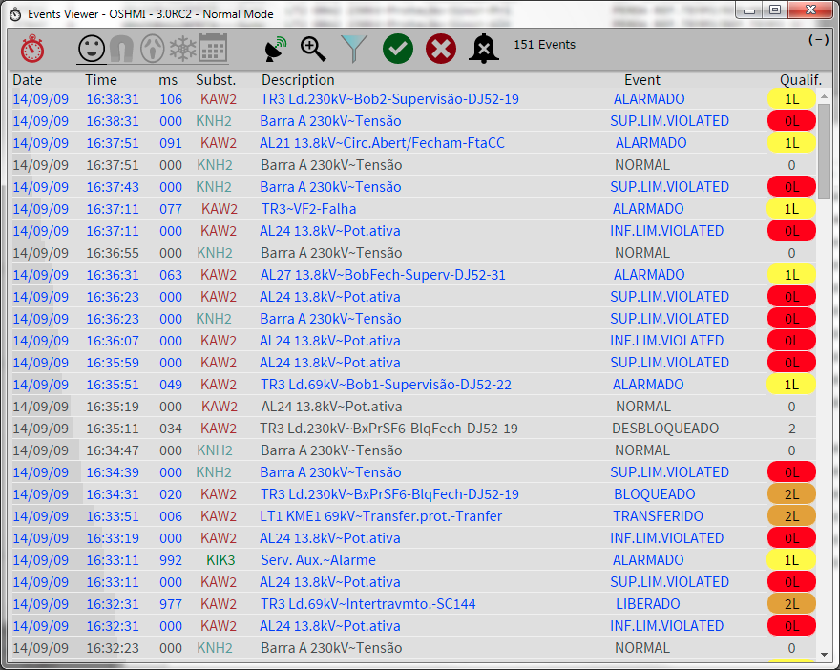
New events when not yet acknowledged appear with blue text and after acknowledged the color of the text change to gray.
Individual acknowledge of events is attained with a simple click in the desired line. A second click eliminates the event from list in the next list update.
The “Point Info Dialog” can be opened with a [SHIFT]+CLICK.

Columns of the events table:
Date, Time, ms: time tag of the event.
Subst.: substation of origin of the point.
Point#: point number, normally hidden, to show click the clock icon. 
ID: point ID (tag), normally hidden, to show click the clock icon.
Description: describes the bay and information the point represents.
Event: text message for the current state of the point (ON or OFF, OPENED or CLOSED, ...).
Qualif: list of point qualifiers and the number of priority. When selected the Aggregated or the Panic Mode, will be presented the number of aggregated events for a point after a plus signal, ex: 0L+4 means that there are more 4 events aggregated not shown for a point.

Toolbar options:
Modes of operation indicators/selectors:
 Normal Mode (shortcut [1]): shows all events.
Aggregated Mode (shortcut [2]): shows just one (the last) event for each point.
 Panic Mode (shortcut [3]): also aggregates events, pure events are shown only the ON state and for point that have a defined alarmed state it's not show events for the normal state. Events for points below a configured (default 1) priority are also not shown.
 Frozen Mode (shortcut [4]): freezes the list to help the reading of the list.
 Historical Mode (shortcut [5]): queries old archived events.
For the Historical Mode there are the following options:
Date: date to query events.
Initial Time: initial time for the events.
Filter: optionally can filter events by the point ID (tag).
There is a limit (default=5000) for the number of events returned by each query. Each execution automatically fills the “Initial Time” field with the time of the last event of the last query. The excess of events will be indicated by the presence of “...” at the last line.
 Indicates (and allows choosing if configured) what time tag will be shown: the field time tag or the time of arrival of the event at the HMI. The green wave icon represents the field GPS synced time tag with millisecond resolution. The red receptor icon represents the time tag as detected by the HMI when the event arrives coming from the protocol driver, in this case the millisecond time will always be set to zero. When the icon is dimmed, the mode is set fixed in the configuration and cannot be changed by the operator.
 Eliminates all events from the list (shortcut: [F2]). They will be archived and can be consulted with the “Historical Mode”.
 Acknowledges all events from the list (shortcut: [F8])].
 Silences the alarm beep (shortcut: [F9]) until next alarm.
Shows info about qualifiers. Click to show the columns point# and ID.
 Filter by substation. Allows choosing what substations to display events. Mark the substations to show events. If none is marked, all events will be shown. The icon is dimmed when there are no substations selected.
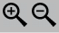 Changes the text font size.

Tabular Viewer
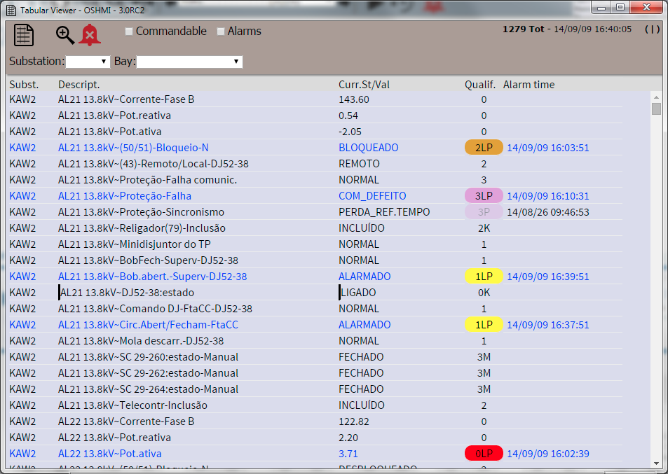
This viewer presents all points of a substation or a bay in a table form. The list boxes “Substation” and “Bay” can be used to filter the list. Also the “Filter (ID)” text box can be used to enter manually a filter by the ID (tag). Also the check boxes “[ ]Commandable” and “[ ]Alarms” can be used to restrict the list to points with an associated command and alarmed points respectively.
The “Point Access Dialog” can be opened by a [CLICK] or [SHIFT]+CLICK on the desired line.
An alarmed, not acknowledged, point is represented by the blue text and the light color of the qualifier box.
A persistent acknowledged alarm is represented by the dark grayed text and the dimmed color of the qualifier box.
A point with no alarm is represented by the grayed text and no colored box in the qualifier field.
The alarm of a point can be acknowledged by a [CONTROL]+CLICK.

The column fields are:
Point#: point number, normally hidden, to show click the table icon. 
ID: point ID (tag), normally hidden, to show click the table icon.
Subst.: substation name.
Description: describes the bay and information of a point.
Curr. St/Val: current state or value of a point.
Qualif: priority number and list of qualifiers.
Last alm. time: date/time of the last alarm detected of a point.

Toolbar options:
Controls the text font size.
Silences the alarm beep (shortcut: [F9]) until next alarm.

Alarms Viewer
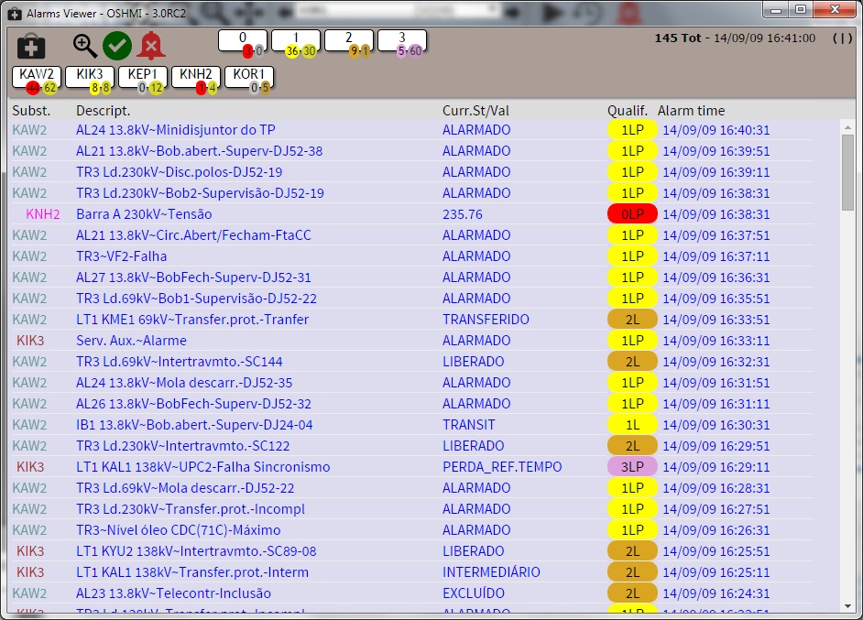
This viewer presents the current alarms of the system in the order they were detected by the system, i. e. the time shown is the local time, not the time sent by the RTU (this time can be viewed in the Events Viewer).
The “Point Access Dialog” can be opened by a [SHIFT]+CLICK on the desired line.
An alarmed, not acknowledged, point is represented by the blue text and the light color of the qualifier box.
A persistent acknowledged alarm is represented by the dark grayed text and the dimmed color of the qualifier box.
A point with no alarm will be removed from this list.
The alarm of a point can be acknowledged by a [CLICK] or [CONTROL]+CLICK.

The column fields are:
Point#: point number, normally hidden, to show click the table icon. 
ID: point ID (tag), normally hidden, to show click the table icon.
Subst.: substation name.
Description: describes the bay and information of a point.
Curr. St/Val: current state or value of a point.
Qualif: priority number and list of qualifiers.
Last alm. time: date/time of the last alarm detected of a point.

Toolbar options:
Controls the text font size.

Acknowledges all alarms (shortcut [F8]).
Silences the current audible alarm beep (shortcut [F9]).
On mouse over, presents information about the point qualifiers. Clickto show/hide the Point# and ID columns.

Alarm priority statistics display/filter
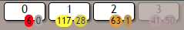
For each used priority (0-9) this display presents the totals of acknowledged (number in a bright color ellipsis, at left) and unacknowledged (number in a dimmed color ellipsis, at right) alarms. The color of the ellipsis is the color of the highest priority of it's alarms. To filter out alarms of undesired priorities, just click it's respective display, it's color will be dimmed. To restore the filtered out alarms just click again the desired display.

Substation alarms statistics display/filter
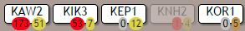
For substation this display presents the totals of acknowledged (number in a bright color ellipsis, at left) and unacknowledged (number in a dimmed color ellipsis, at right) alarms. The color of the ellipsis is the color of the highest priority of it's alarms. To filter out alarms of undesired substations, just click it's respective display, it's color will be dimmed. To restore the filtered out alarms just click again the desired display.

The default colors for priorities are:
- Priority 0 (zero, the highest priority): red;
- Priority 1 (one): yellow;
- Priority 2 (two): orange;
- Priority 3 (three) purple.
- Priority 4-9: can be used, but is not present in the example files.

Curves Viewer (Historical)
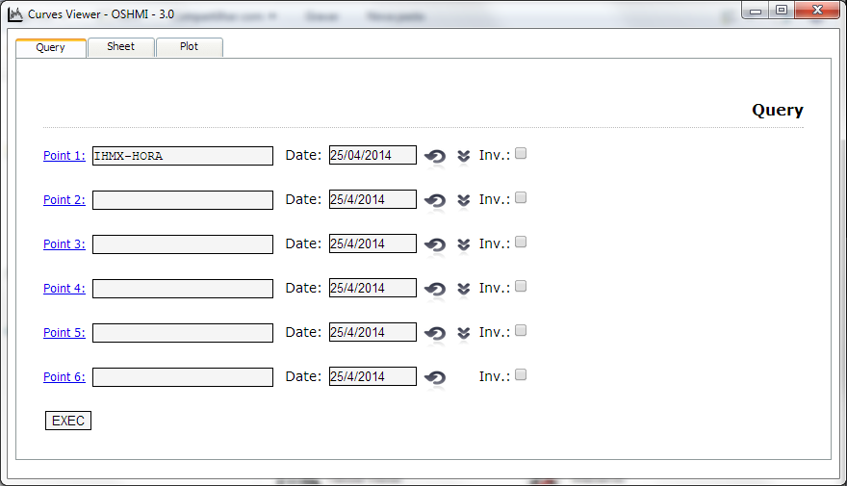
This viewer can be used to recover past point data in table and graphic form.
Type the point number(s) or ID('s) to consult in the “Point 1-6” fields, select the desired dates and click “Exec”. Typing the ID will activate the “suggest as you type” function that shows a list options based on the type text.
This button selects the current date.
This button copies the selected date to the fields below.
The check box “Inv.” allows inverting the plot of a measurement. This does not affect the table values, just the plotted curve.
After executed a query, two new tabs are created, one for the Sheet and one for the Plot.

Keyboard Shortcuts
KEY | FUNCTION |  | KEY | FUNCTION
[F2] | Eliminate all (EVE) |  | [1] | Normal mode(EVE)  Alarms(TAB)  1st. Screen(SCR)
[F3] | Find (BROWSER) |  | [2] | Aggregated mode(EVE)  Commandable (TAB)  2nd Screen(SCR)
[F5] | Page reload  w/ [CTRL]:cache bypass |  | [3] | Panic mode(EVE)  3rd Screen(SCR)
[F8] | Ack all (EVE) |  | [4] | Freezed mode(EVE)  4th Screen(SCR)
[F9] | Silence beep |  | [5] | Historical mode (EVE)  5th Screen(SCR)
[F11] | Full screen  (BROWSER) |  | [6] | Current date(HEV)  6th Screen(SCR)
Mouse over measurement | Measurement plot  (SCR) |  | [7] | Initial time reset(HEV)  7th Screen(SCR)
Mouse over  screen link | Preview linked  screen(SCR) |  | [8] | Erase filter(HEV)  8th Screen(SCR)
 |  |  | [9] | 9th Screen(SCR)
[SHIFT]+[ENTER] | Page Snapshot to save or print (SCR) |  | [0] | Ack top event(EVE)  10th Screen(SCR)
[SHIFT]+[BACKSP] | Show linked points  (SCR) |  | Num[+]  Num[9] | More zoom (SCR)  Bigger text font(TAB/EVE)
Mouse CLICK | Point info dialog(TAB)  Point info dialog(SCR)  Ack event(1st time),  erase event (2nd time)(EVE) |  | Num[-]  Num[3] | Less zoom (SCR)  Smaller text font(TAB/EVE)
Mouse  [CTRL]+CLICK | Ack alarm  (All Viewers) |  | [→]  Num[6] | Move drawing right  w/ SHIFT:next linked object  w/ CTRL:next controllable obj.  (SCR)
Mouse  [SHIFT]+DRAG | Move drawing  (SCR) |  | [←]  Num[4] | Move drawing left  c/SHIFT:previous linked object  c/CTRL:previous controllable obj.  (SCR)
Enter | Point info dialog (SCR) |  | [↑]  Num[8] | Move drawing up  (SCR)
Mouse  [SHIFT]+CLICK | Point info dialog(EVE/TAB) |  | [↓]  Num[2] | Move drawing down  (SCR)
Mouse roll | Change zoom (SCR) |  | Num[5]  [Home] | Zoom and pan reset(SCR)
 |  |  | Num[*] | Hide/show toolbar (SCR)
Legend | SCR=Screen Viewer  EVE=Events Viewer |  |  | TAB=Tabular Viewer  HEV=Historical Events

