2025-2029
Restigouche River Watershed Management Council Inc.
Adopted xx/xx/2025
Revision 05/02/2025
Strategic plan
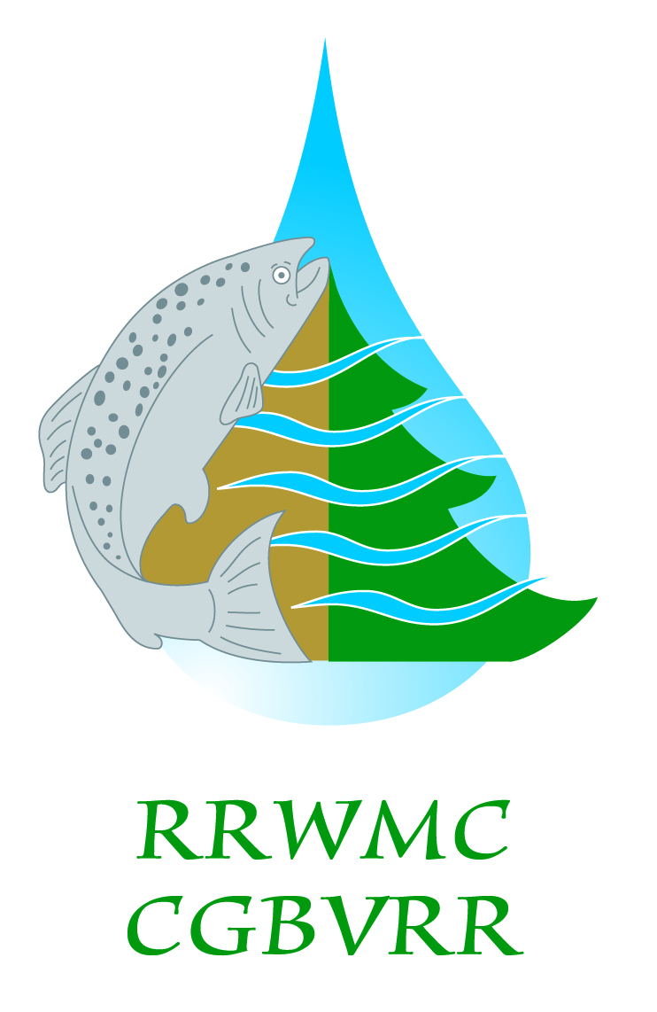
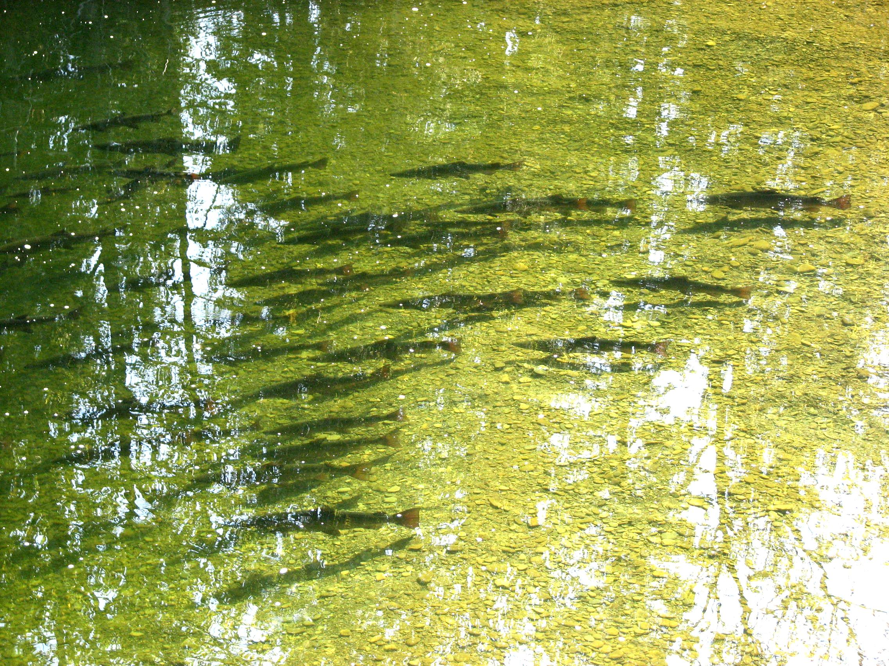

Organizational Description

The Restigouche River is historically renowned for producing an abundance of large Atlantic salmon which supported Aboriginal communities for thousands of years, European settlers during the 1800s, and a major local commercial fishery up to the early 1970s. The current management program for the Restigouche salmon is restrictive by necessity because of low stock abundance and management of the resource is cumbersome because of the involvement of five governments, many private interests and non-profit organizations. These concerns, along with increasing conflicts with other interests within the watershed (e.g., forestry, agricultural and mining industries, other recreational users), plus a growing interest in localizing management decisions for the salmon resource, lead a group of us representing the local Aboriginal and recreational salmon fishing interests to form a new salmon management organization, the Restigouche River Watershed Management Council (RRWMC).
The Restigouche River Watershed Management Council is incorporated as a non-profit organization created in 2002. Founding members were the Listuguj Mi’gmaq Government, the Ristigouche Salmon Club, the Eel River Bar First Nation, the Corporation de Gestion des Rivières Matapédia et Patapédia and former Fraser Lodge now known as Kedgwick Salmon Club. Membership to the Council is open to all organizations, whether incorporated or not, who in the opinion of its Board of Directors have objects and purposes similar to those of the Council. The affairs of the Council will be managed by a Board of Directors elected by the members of the Council.
The Restigouche River Watershed is an interprovincial watershed of 12,877sq kilometers and includes the five major tributaries of Matapedia, Patapedia, Kedgwick, Little Main Restigouche and Upsalquitch rivers.
Being involved in many programs, projects and partnerships, the RRWMC have increased his implication and participation on salmon issues. This strategic plan outlines a blueprint for the growth and development of the RRWMC for 2025-2029.

Mission Statement

Our goal is to ensure protection, conservation and restoration of the Restigouche River Atlantic salmon population for the benefit of all – particularly those participating or otherwise involved in the salmon fisheries and the local communities.

Vision Statement
A healthy abundance of the Restigouche Atlantic salmon.

The main objectives are:
- To protect and restore the stocks and their habitat;
- To improve the scientific knowledge to manage the stocks to sustainability;
- To involve the local interests through education and awareness campaigns in order to involve the public at large in the decision-making processes in regards to management decisions.

Secondary objectives
- To increase social and economic benefits from salmon abundance for all communities;
- To maintain stability of the organization finances so it can maintain its mission into the future

Goals and Strategies
To achieve the RRWMC mission and ultimately realize the vision of the organization, the work of the RRWMC is divided among four major areas. They fall under the 15 strategic intentions outlined below:
Strategy # 1: To develop and deliver a robust community outreach and education program
Intention | Action
Continue the participation of the RRWMC on the identified committees. | Being involved with the NBSC, OBVMR, the NB Watershed Caucus and the group FORCE active in the Madawaska/Restigouche area.
Enhance the visibility of the organisation based on our actions and accomplishments. | -Re-design the Website  -Continue to use the Facebook page to promote our accomplishments and activities  -Update our website www.restigouche.org to include fact sheets of the projects and keep the «news» section up to date.
Attain higher visibility in the media. | Regularly produce press releases, interviews and videos.
Educate the public on the importance of the rivers and the salmon. | -Create school activities within projects.  -Participate in conferences every year to promote our work.
Broaden and strengthen the public participation and increase the information transfer to members. | -Organize public sessions including conference on various topics in each watershed area (Listuguj, Eel River Bar First Nation, Campbellton, Matapedia, Causapscal, Upsalquitch, Kedgwick)  -Produce and send a newsletter to all members at least yearly.  - hold the Annual General Meeting with as many participants as possible.
Participate in annual events and conferences to promote the visibility of the council | Attend (and present if possible) the RRWMC at:  - the Fédération Québécoise pour le Saumon Atlantique and Atlantic Salmon Conservation Fondation congresses and symposiums  - other workshops and conferences related to salmon

Strategy # 2: To represent the salmon interest group
Intention | Action
Foster communication and partnership among Restigouche Salmon stakeholders and First Nations | Set Board of directors meeting dates for all year at a minimum of 1 meeting every 4 months
Foster and coordinate actions related to existing committees. | Continuation of at least these two sub-committees :  - WaterShade  DNRED, licensees, GINU, OBVMR, etc;  - Protection  MFFP, DFO, DNRED, LMG, ERB.
Develop a plan of action to promote coordination and communication between stakeholders, particularly in regards to science matters. | -Review and evaluate the memorandum of understanding and redefine the objectives for all committees’ members through an initial meeting hosted by the Council.  - The science committee members that will be invited  DFO, MFFP, DNRED, LMG, ERB, GINU, ASF, CGRMP, OBVMR;  -Establish the requirements to satisfy all participants’ needs and present a new framework that delineate how science coordination through the science committee will be delivered on the Restigouche watershed and reported to the Council.

Strategy# 3: To maintain the financial health of the organization and its efficiency
Intentions: | Action
Streamline the number of programs in the budget and perform more projects. | -Maintain a good relationships with existing foundations in order to deliver existing programs  (siltation reduction, beaver dam breaching, habitat restoration and protection);  -Organize regular on-going fund raising and apply for subventions on behalf of Council to favor projects related to protection, outreach, research, stock monitoring and habitat restoration, etc.
Maximize every dollar to accomplish the most beneficial returns as per organization’s mission. | Identify partners that will contribute financially or in-kind to projects to enhance project proposals and accomplish more.
Enhance contract and subvention budgeting to include administration fees within it. | Devise funding, contracts and subventions by dedicating 10-15% of founding into overhead and general office related costs.

Strategy # 4: Be involved in projects and programs that are effective to protection, conservation, stock assessment, research and habitat restoration of the rivers and the salmon
Intentions | Action

Prioritize projects to ensure that our efforts comply with the organization’s mission. | Use the project’s decision matrix to identify projects to be submitted to different programs.
Orientate our work to favor partnership with our local partners. | Favor the involvement of other RRWMC’s members in each of the projects, especially First Nations.
Ensure a concerted approach to reduce duplication of programs among partners. | Allocate effort and projects so all five major tributaries benefit from the RRWMC work.

APPENDIX A – SWOT ANALYSIS
SWOT analysis – Restigouche River Watershed Management Council
 | HELPFUL + | HARMFUL -
 | Strengths | Weaknesses
 | - Multi-sector representatives and public at large on the board of directors  - Recognition of the role of the RRWMC by the governments (MOU)  - Partnerships with First Nation, Forest companies, municipalities , other environmental groups and stakeholders  - Contacts in all level of Government , local and national organizations  - Recent funding program success and actual financial health; some flexibility of action  - Staff expertise  - Collaborative model to carry out projects  - Human resources and equipment within the RRWMC and partners (FN-OBVMR-CGRMP, etc.) | - Mid to long term uncertainty in relation to funding and no core funding specifically related to the mission  - Projects to fit programs reduce the availability of money for long term planning and organization development  - Funding programs oriented management does not release enough money for administration tasks, increase the paperwork and complicates the cash flow availability  - Volunteer and public participation insufficient  - Recreational issues are complicated to manage (i.e. users conflict)  - Education, communication and awareness programs are time consuming  - Pressure from land use and other activities on the territory does not align with conservation efforts requirements
 | Opportunities | Threats
 | - Private donation funding campaign to raise money for specific projects  - First Nation science crews and rangers potential availability  - Promoting past works and projects to raise funds and increase the support  - Visibility of past projects to prepare communication and involve the community  - The presence of other environmental groups is low in the NB Restigouche area, possibility to fill the gap and accomplish more environmental projects | - Cutbacks in the government agencies reduce the external support for all issues (protection, fish and boating, research, monitoring) and consequently increase the task for the RRWMC and local partners  - Dependant of Government decisions and existence top-down structure for environmental protection and fisheries management policies  - External factors influence Atlantic salmon population within the Restigouche river system (invasive species and climate change for instance)

APPENDIX B –ORGANIZATION CHART (2025)

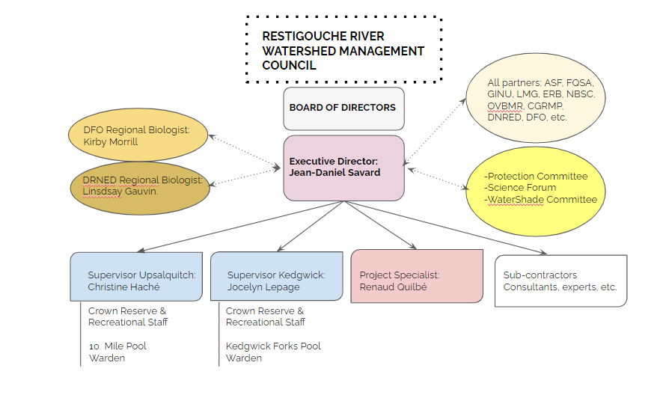

APPENDIX C – Membership

Restigouche River Watershed Council Members

Voting Members:

- Acadian Timber
- Association des Agriculteurs/Agricultrices du Restigouche Ouest
- Association des Pêcheurs & Chasseurs Baie des Chaleurs
- AV Cell Group
- Camp Managers
- Charlo Salmonid Enhancement Centre
- Communauté Régionale de Campbellton
- Corporation de Gestion des Rivières Matapédia et Patapédia (CGRMP)
- Eco-Tourism representatives
- Eel River Bar First Nation Government
- Gespe’gewa’gi Institute of Natural Understanding (GINU)
- Guides
- Groupe Savoie
- Kedgwick Salmon Club
- J. D. Irving Limited
- Listuguj Mi’gmaq First Nation Government
- New Brunswick Aboriginal Peoples Council (NBAPC)
- Organisme Bassin Versant Matapédia Ristigouche (OBVMR)
- Restigouche Trapers Association
- Restigouche Salmon Club
- Village de Bois-Joli
- Village de Kedgwick
- Ville de Baie-des-Hérons
- Ville de St-Quentin

Ex-Officio Members:

- Atlantic Salmon Federation (ASF)
- Department of Fisheries and Oceans Canada (DFO)
- Fédération Québécoise pour le Saumon Atlantique (FQSA)
- Ministère des Forêts de la Faune et des Parcs du Québec (MFFPQ)
- New-Brunswick Department of Natural Resources and Energy (NBDNRE)
- New-Brunswick Department of Tourism and Heritage
- New Brunswick Wildlife Federation (NBWF)
- New-Brunswick Salmon Council (NBSC)

To be invited if possible:

- Municipalité de Ristigouche Sud-Est (to be confirmed)
- Municipalité de Matapédia (to be confirmed)
- Municipalité de St-Alexis-de-Matapédia (to be confirmed)
- Municipalité de St-Francois-d’Assise (to be confirmed)
- Municipalité de L’Ascenscion-de-Patapédia (to be confirmed)
- Municipalité de St-André-de-Restigouche (to be confirmed)
- Municipalité de Causapscal (to be confirmed)
- Municipalité d’Amqui (to be confirmed)
- Municipalité de compté Matapédia (to be confirmed)
- Municipalité de compté d’Avignon (to be confirmed)

APPENDIX D – Board of directors constituency
Board of Directors composition (18 directors)

 |  | Seat
APPPOINTED (7) | Corporation Gestion Rivières Matapédia et Patapédia (CGRMP)
APPPOINTED (7) | Restigouche Salmon Club
APPPOINTED (7) | Gespe'gewa’gi Institute of Natural Understanding (GINU)
APPPOINTED (7) | Listuguj Mi'gmaq Government (LMG)
APPPOINTED (7) | Eel River Bar First Nation
APPPOINTED (7) | Kedgwick Salmon Club
APPPOINTED (7) | Restigouche River Camp Owners Association (RCOA)
ELECTED AT THE AGM (11) | Organisation below Patapédia
ELECTED AT THE AGM (11) | Public at large (4)
ELECTED AT THE AGM (11) | Camp managers
ELECTED AT THE AGM (11) | Guides
ELECTED AT THE AGM (11) | Organisation above Patapédia River
ELECTED AT THE AGM (11) | Municipalities
ELECTED AT THE AGM (11) | Ecotourism group
ELECTED AT THE AGM (11) | Industry

APPENDIX E – PROJECT DECISION MATRIX
Project selection matrix / decision making process
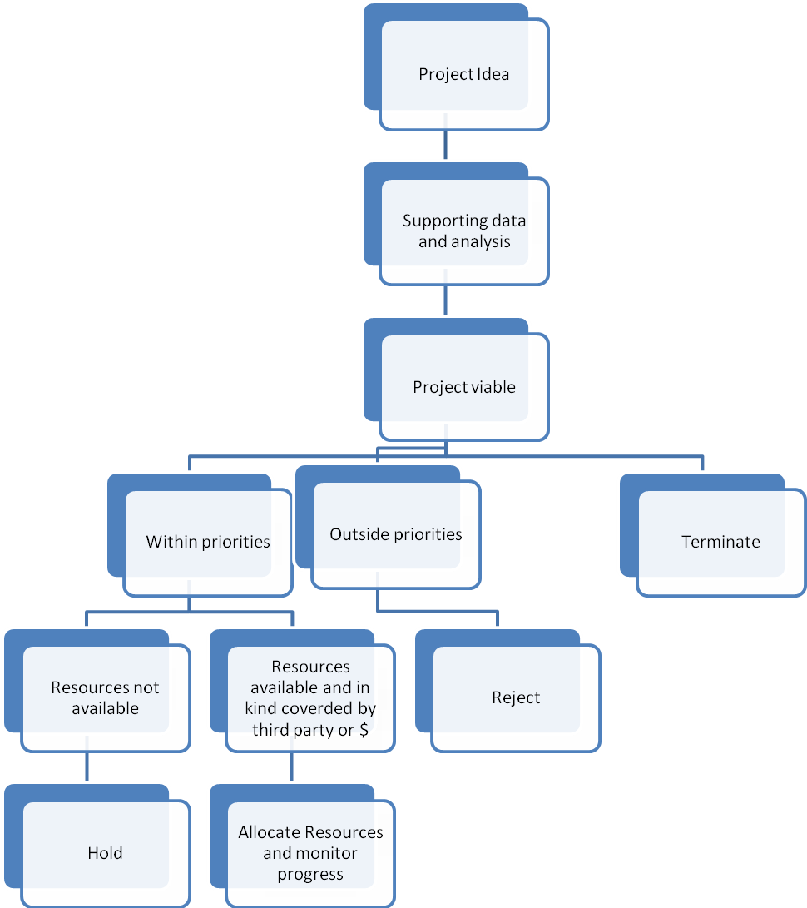

APPENDIX F – PRIORITIES

Pyramid of Priorities
