FSVMPCZR_UI

Release Note

***December 7, 2017***

***Version: v2.0.9***

### Contents

1. Release Summary 2

1.1. Important Notes 2

1.2. Release information 2

1.3. Change List 2

1.4. Known Issues 2

1.5. MD5 of Release Files 2

1.6. Virus Scan 3

2. History 3

# Release Summary

## Important Notes

The major target of V2.0.9 is the fifth version for FSVMPCZR_UI. This version has fixed part of issues.

## Release information

|  |  |
| --- | --- |
| **Type** | **Description** |
| Release Git tag | V2.0.9 |
| FW | ZHJ_III_IRv1_3R  ZHJ_III_MTv0_7R.hex  ZHJ_III_VMCv1_6R.hex |
| APK Information | app_name: FSVMPCZR_UI_V2.0.9.apk app_icon: @mipmap/ ic_launcher.png Release filename: FSVMPCZR_UI_V2.0.9.apk |

## Change List

**New change for V2.0.9**

1. Add right case temperature  
2. Modify IR and Motor instruction  
3. Upload the Apk version number to the server

## Known Issues

* no

## MD5 of Release Files

Target file: FSVMPCZR_UI_V2.0.9apk  
 MD5: 5a48f957bea4603dc892cbb93dcac726

## Virus Scan

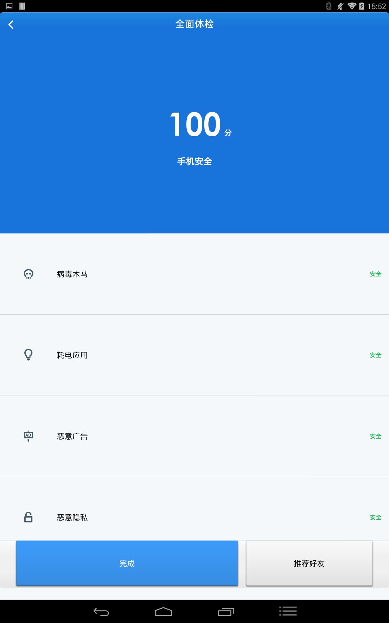

# History

V2.0.3

1. Modify update time to 10 minute

2. Modify balance display

3. Fix bug：download success when the parameter reqAnswer is null

V2.0.4

1.When get connected with VMC, you can not login

V2.0.5

1.When get connected with VMC, you can not login

2.Solve the problem of abnormal display of UI

V2.0.6

1. Solve the problem of generating two dimensional code when the equipment is out of order

V2.0.7

1. Modify the message when the refund fails   
2. After IR test,delay of 10 seconds to exit  
3. Fix bug:Video playing exception in the synchronization page