Project 8 - Buoy Data Generator

Requirements

The Buoy data generator will generate new, randomised data based on the CSV file specifications of existing NDBC Buoy data files which are in CSV file format. The existing NDBC Buoy data files have previously been converted over from NetCDF file format to CSV file format using a separate program called NetCDF_to_csv.py which is currently a Python program run via the command-line.

**User Requirements Story:**

A user has existing NDBC buoy data from the year 2020 and wants to generate 7 variations of simulated data the years 2022 through to 2025. The user should:

1. Run/Start the Buoy Data Generator application

NOTE: the program will automatically search for and load config.yaml in the root folder

1. Either input manually or use the up/down arrow keys to show the number 7 in the “instances” field and click the button “apply” to its left.

NOTE: 7 windows will pop up with dialogue and interactable boxes and buttons.

1. Use the checkboxes and radio buttons to enter the environment behaviour desired  
    OR  
   Click the button marked “load as…” then navigate and select the 2020 CSV file from the file manager prompt.

NOTE: this will grey out the radio buttons until you press the “Clear” button besides the “load as…” button.

1. Click ‘Run All’ to run the data generation process based on the selected configuration file  
    OR  
   Click ‘Run’ on each instance window.
2. Navigate to the root folder and the user will now see 7 respective csv files which contain the recently generated data.

**Application Requirements:**

**Main window:**

* Needs to have---…

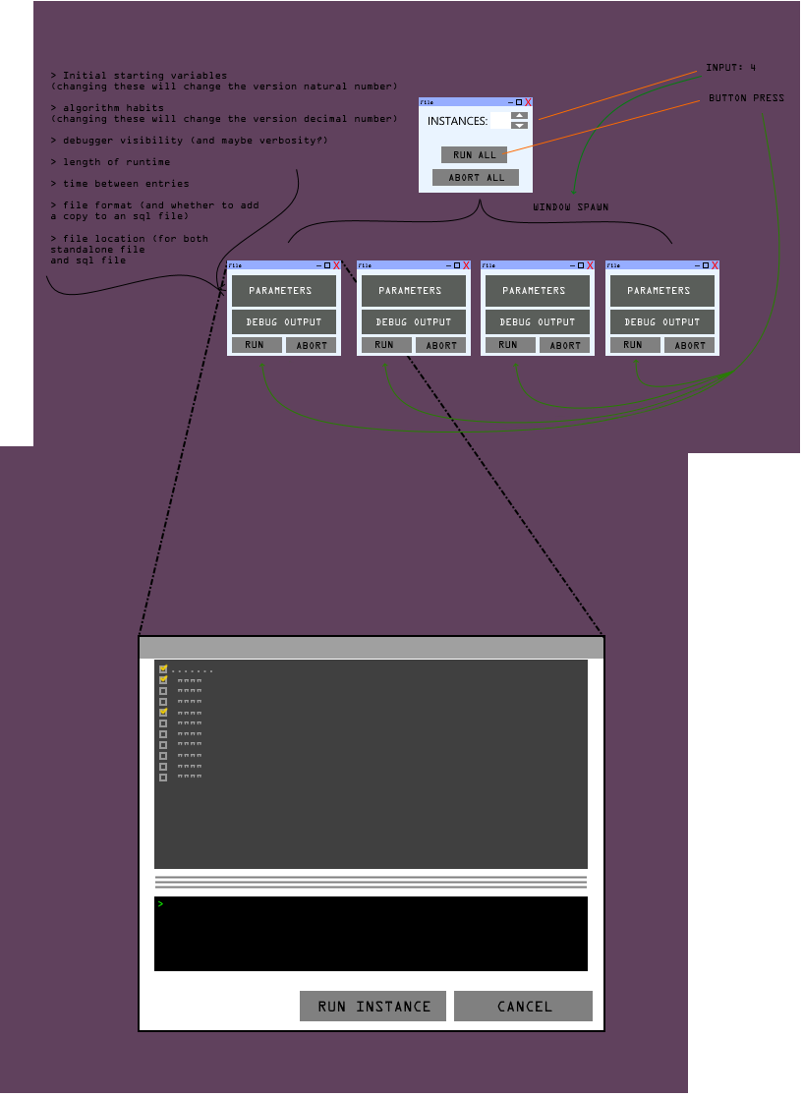

**Configuration File Requirements:**

|  |  |
| --- | --- |
| **---** | **DESCRIPTION:** |
| Theme: |  |
| Background: 0x555555 |  |
| Forground: 0x888888 |  |
| Highlights: 0xaaaaaa |  |
| text: 0xdddddd |  |
| Dimensions: |  |
| X: null |  |
| Y: null |  |
| Position: |  |
| X: null |  |
| Y: null |  |
| Defaults: |  |
| Dark theme: True |  |
| History: null |  |
| BASE_FOLDER: C:/Users/afox/Downloads/cmanwx |  |
| BASIS_YEAR: '2020' |  |
| BASIS_MONTH: '01' |  |
| CSV_FOLDER: 'csv' | Input data is in: BASE_FOLDER/year/month/csv/... |
| MAX_FILES_TO_RUN: 1000 | The maximum number of files/buoys to generate data |
| OUTPUT_YEARS: |  |
| [2022, 2023, 2024, 2025] | List of the years desired for the output sim data |
| OUTPUT_MONTHS: |  |
| [1, 2, 3, 4, 5, 6, 7, 8, 9, 10, 11, 12] | List of the months desired for the output sim data |
| MonthLength: |  |
| [0,31,28,31,30,31,30,31,31,30,31,30,31] |  |
| Statscolumns: |  |
| - FieldName | Name of the field |
| - DataType | Type of the field (int, float, string, datetime) |
| - Min | Numerical minimum |
| - Max | Numerical maximum |
| - Mean | Numerical average (mean) |
| - StdDev | Standard deviation |
| - Median | Field median value |
| - Mode | Most likely/common value of this field |
| - NumValues | Total number of values (including nulls) |
| - NumNulls | Number of null values |
| - NumUnique | Number of unique values for this field |
| - AutoCorr | Field self-correlation |
| - FFT | Data periodicity (hrs) |
| - Distrib | Distribution (discrete only) |

frequency of the data

any mandatory fields