目录

Part 1必考题 3

Work or studies 3

Home/accommodation 4

Hometown (The area you live in) 5

Part 1 6

新题 6

Hats/caps 6

Borrowing/lending 6

Websites 6

保留题 6

Street market 6

Cars 7

Computers 7

Feeling bored 7

Evening time 7

Mobile phone 7

Taking photos 8

Advertisement 8

Dream 8

Emails 8

Lost and found 8

Old buildings 9

Mirrors 9

Talents 9

Your favourite item at home 9

Swimming 9

Watch 10

Part 2 10

地点类 10

安静的地方 10

重要河流/湖泊 11

⽂化之地 12

别人的房间 13

理想房屋 14

看到野生动物的地方 15

拥挤地方 16

公园/花园 17

喜欢和亲友去的地方 19

人物类 19

工作中的积极建议 19

你的国家的名人 19

有趣的邻居 19

想要共事的家人 19

提高 注意力 19

喜欢做手工的人 19

读书迷 19

医疗人士 19

给建议的人 19

固执己见的人 19

老友又见 19

物品类 20

传统节日的食物 20

弄丢贵重物品 20

获奖 20

改变世界的发明 20

传统产品 20

丢东西的经历 20

事件类 20

积极改变 20

一次非常忙碌的经历 20

帮助小孩 20

想参加的比赛 20

花费甚少的外出日 20

保健方式 20

让你惊讶的事情 20

庆祝过的活动 20

用手机做重要事情 21

节约时间的方法/改变 21

喜欢一起聊天的朋友 21

交通拥堵 21

# Part 1必考题

## Work or studies

1. ***Do you work or are you a student?***

I’m working as a software engineer in a vehicle company. My major work is to create AI program which helps the vehicles to drive autonomously

1. ***Why did you choose to do that type of work (or that job)?***

Well, the main reason is that I learnt AI and autonomous driving in both college and graduate school for like 10 years, so this work is a perfect match with my knowledge and expertise. In addition, the vehicle companies give pretty generous offer for the AI engineers, so the salary also attracts me to do this job

1. ***Do you like your job?***

Definitely yes. You know, autonomous driving is one of the most challenging and interesting working in information industry, and I could fully apply what I have learnt in school about programming and math in the projects. Also, having my code running on thousands of vehicles gives me a great feeling of satisfaction, because I can directly feel the value of my work as they are turned into real products.

1. ***Is it very interesting?***

Same as above

1. ***Do you miss being a student?***

No, because my last memory in school is as a PHD student. I suffered great academic pressure in that time, as I had to publish several decent academic transaction papers in order to graduate, and that was really difficult. Also, the economic pressure made me depressed because the salary allocated to a PHD student was very low, and I could barely feed myself. That’s why some people call PHD as Permanent Head Disease, because it could really make people crazy, and I don’t want to live like that again.

1. ***What technology do you use at work***

Well programming for sure, as I need to write down the code to order the autonomous vehicle to conduct an operation like turning left or going forward, so I need to write hundreds of codes every day. Another important technology I use is deep learning, which is blackened by a lot of math, and it gives the power of intelligence to the vehicles to recognize the traffic lights, the vehicles and other obstacles by itself.

1. ***Who helps you the most? And how?***

In my work, our principal scientist helps me the most. He is a researcher with a lot of industrial experience in AI, and he is familiar with the state-of-the-art technology in deep learning. He often tells me the best way of constructing the deep learning network in order to achieve the best performance of AI. Without his help, I will waste of time in investigating the related information.

## Home/accommodation

1. ***Do you live in a house or a flat?***

I am living in a three-bedroom apartment. I mean, most people in Shanghai live in an apartment, because we have a large population, and there are very few houses in urban area in Shanghai. Living in buildings that are closer to work is the ideal option.

1. ***Can you describe the place where you live?***

I am living in Shanghai. I bet you have heard about it, as it’s the largest city in China, with the population of more 25 million. It is also the center of China in the field of industry, logistic and economy.

1. ***How long have you lived there?***

I was born in Shanghai 35 years ago, so I have lived here for about 30 years, as I went abroad to get my PHD degree in Tokyo for 5 years.

1. ***Please describe the room you live in?***

I have a small room about 10 square meters in size. There is a queen bed, a desk, my gaming chair, and that’s about it. It does not have a walk-in closet due to its small size. Oh, and there isn’t any poster or mirror because my mom does not allow me to hang anything on the wall.

1. ***What part of your home do you like the most?***

Definitely the living room. We just upgraded our TV to a 75 inch 8k OLED TV which cost us

thousands of dollars. And there’s a gaming console, a Xbox, so sometimes I invite some friends to play video games together in the living room, and we can sit in our comfy leather couch.

1. ***Who do you live with?***

Although I’m 35, I’m still living with my parents, because the rental fee is too high downtown where I work. The good point is that I don’t need to pay for housing and food, but the problem is my mother is controlling everything, like when I should go to bed or to get up.

1. ***What room does your family spend most of the time in?***
2. ***See 5.***
3. ***What do you usually do in your flat?***
4. ***See 5.***
5. ***What kinds of accommodation do you live in?***
6. ***See 1.***
7. ***Do you plan to live there for a long time?***
8. ***See 6.***
9. ***Do you prefer living in a house or a flat***
10. ***Are the transport facilities to your home very good***
11. ***What kind of house or flat do you want to live in in the future***
12. ***What's your favorite room in your apartment/house***
13. ***What makes you feel pleasant in your home***
14. ***What's the difference between where you are living now and where you***
15. ***lived in the past***
16. ***Do you think it is important to live in a comfortable environment***

## Hometown (The area you live in)

1. ***Where is your hometown?***
2. ***Is that a big city or a small place?***
3. ***Do you like your hometown?***
4. ***What do you like (most) about your hometown?***
5. ***Is there anything you dislike about it?***
6. ***How long have you been living there?***
7. ***Do you like living there?***
8. ***Do you think you will continue living there for a long time?***
9. ***Please describe your hometown a little.***
10. ***What's your hometown famous for?***
11. ***Did you learn about the history of your hometown at school?***
12. ***Do you like the area that you live in?***
13. ***Where do you like to go in that area?***
14. ***Do you know any famous people in your area?***
15. ***What are some changes in the area recently?***
16. ***Do you know any of your neighbors?***

# Part 1

## 新题

## Hats/caps

1. ***Is wearing hats popular in your country?***
2. ***Where do you like to buy hats?***
3. ***What kinds of hats do you have?***

## Borrowing/lending

1. ***Have you borrowed books from others?***
2. ***Have you ever borrowed money from others?***
3. ***Do you like to lend things to others?***
4. ***How do you feel when people don't return things they borrowed from***

***you***

## Websites

1. ***What kinds of websites do you usually use?***
2. ***Are there any changes about the websites you usually use?***
3. ***What is your favorite website?***
4. ***What kinds of websites are popular in your country?***

## 保留题

## Street market

1. ***What do people usually buy on the street market?***
2. ***Do you prefer to go shopping in the shopping mall or on the street market?***
3. ***When was the last time you went to a street market?***
4. ***Are there many street markets in China?***

## Cars

1. ***Did you enjoy traveling by car when you were a kid?***
2. ***What types of cars do you like?***
3. ***Do you prefer to be a driver or a passenger?***
4. ***What do you usually do when there is a traffic jam?***

## Computers

1. ***In what conditions would you use a computer?***
2. ***When was the first time you used a computer?***
3. ***What would your life be like without computers?***
4. ***In what conditions would it be difficult for you to use a computer?***

## Feeling bored

1. ***Do you often feel bored***
2. ***When would you feel bored***
3. ***What do you do when you feel bored***
4. ***Do you think childhood is boring or adulthood is boring***

## Evening time

1. Do you like morning or evening time
2. What do you usually do in the evening
3. What did you do in the evening when you were little? Why?
4. Are there any differences between what you do in the evening now and what you did in the past?

## Mobile phone

1. ***What was your first mobile phone?***
2. ***Do you often use your mobile phone for texting or calls***
3. ***Will you buy a new one in the future?***
4. ***How has your mobile phone changed your life?***

## Taking photos

1. ***Do you like taking photos?***
2. ***Do you like taking selfies***
3. ***What is your favourite family photo?***
4. ***Do you want to improve your photography skills?***

## Advertisement

1. ***Are you interested in watching TV advertisements or internet***

***advertisements?***

1. ***What kinds of advertisements do you dislike?***
2. ***Do you share advertisements with others?***
3. ***Do you want to work in advertising in the future?***

## Dream

1. ***Do you often remember your dreams?***
2. ***What do you usually dream about?***
3. ***Are you interested in other’s dreams?***
4. ***Do you want to make your dreams come true?***

## Emails

1. ***Do you often send emails?***
2. ***When would you send emails to others?***
3. ***Is sending emails popular in China?***
4. ***Do you think sending emails will be more or less popular in the future?***

## Lost and found

1. ***What will you do if you find something lost by others?***
2. ***Do you report to the police when finding something lost by others? Why?***
3. ***Have you ever lost things?***
4. ***Will you post on social media if you lose your item?***

## Old buildings

1. ***Have you ever seen some old buildings in the city??***
2. ***Do you think we should preserve old buildings in cities??***
3. ***Do you prefer living in an old building or a modern house?***
4. ***Are there any old buildings you want to see in the future? Why?***

## Mirrors

1. ***Do you like looking at yourself in the mirror? How often?***
2. ***Have you ever bought mirrors?***
3. ***Do you usually take a mirror with you?***
4. ***Would you use mirrors to decorate your room?***

## Talents

1. ***Do you have a talent, or something you are good at?***
2. ***Was it mastered recently or when you were young***
3. ***Do you think your talent can be useful for your future work? Why***
4. ***Do you think anyone in your family has the same talent***

## Your favourite item at home

1. ***What is the thing you like the most in your home??***
2. ***Why do you like it?***
3. ***What makes your home more comfortable?***
4. ***What is the view like around the place where you live***

## Swimming

1. ***Do you like swimming??***
2. ***Is it difficult to learn how to swim?***
3. ***Where do people in your country like to go swimming?***
4. ***What's the difference between swimming in the pool and swimming in***

***the sea?***

## Watch

1. ***Do you wear a watch?***
2. ***Have you ever got a watch as a gift?***
3. ***Why do some people wear expensive watches?***
4. ***Do you think it is important to wear a watch? Why?***

# Part 2

## 地点类

### 安静的地方

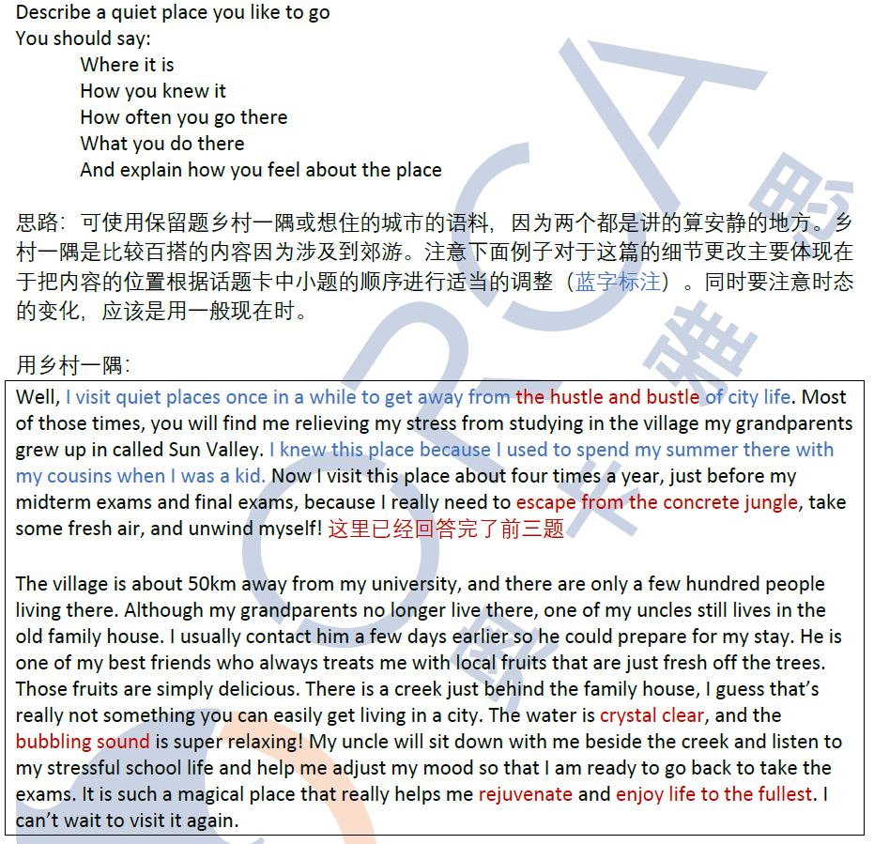

1. Is it easy to find quiet places in your country? Why?
2. Why do old people prefer to live in quiet places?
3. Why are there more noises made at home now than in the past?
4. Why do some people like to use noise as background sound when they are

working or studying?

### 重要河流/湖泊

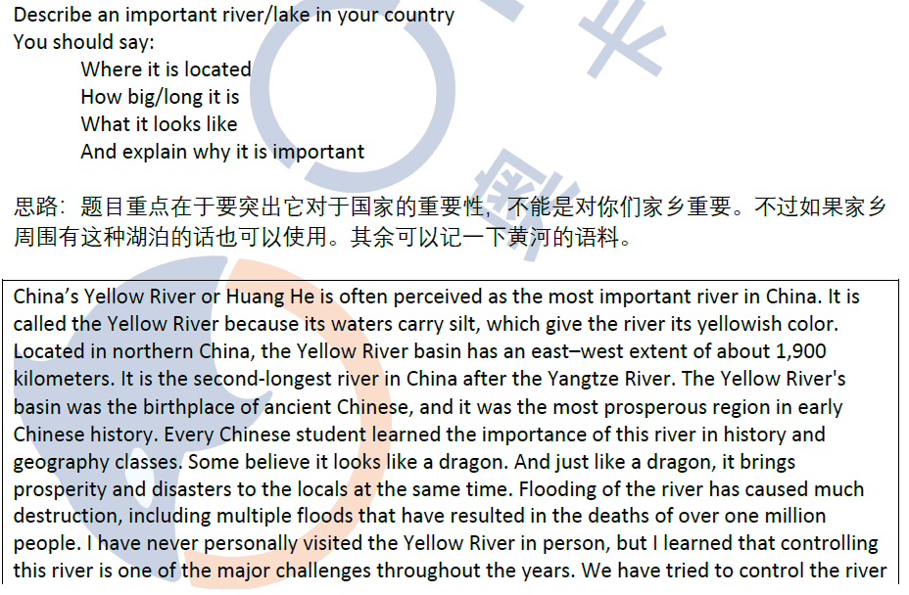



1. How can rivers/lakes benefit local people?
2. Do you think rivers/lakes attract tourists?
3. How do rivers/lakes affect local tourism?
4. Are rivers/lakes good for transport? Why?

### ⽂化之地

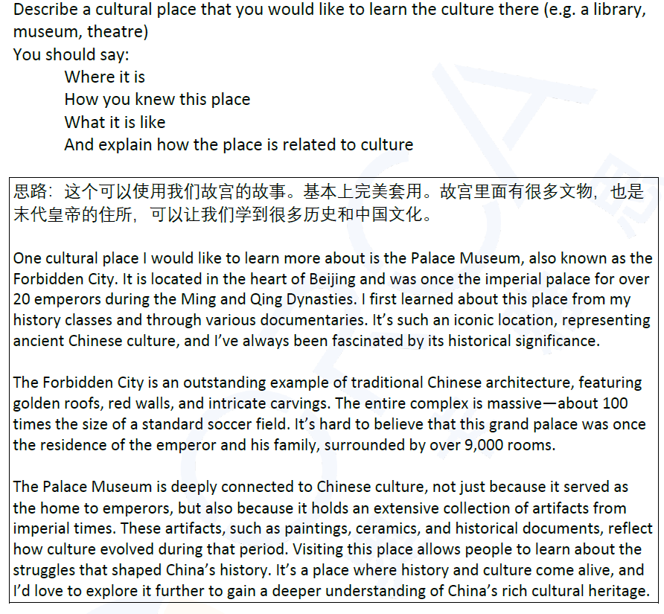

Part 3

1. How does the internet affect culture?
2. How is a culture formed?
3. What kind of culture is popular among young people?
4. How do young people learn different cultures?
5. Which is more important in terms of culture, literature or music?
6. Does the culture of the past have an impact on today's culture?

### 别人的房间

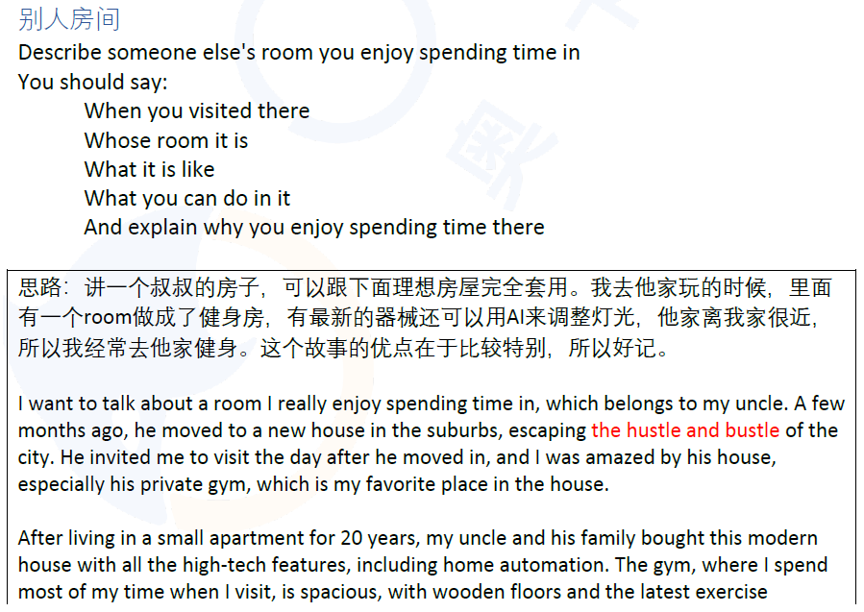

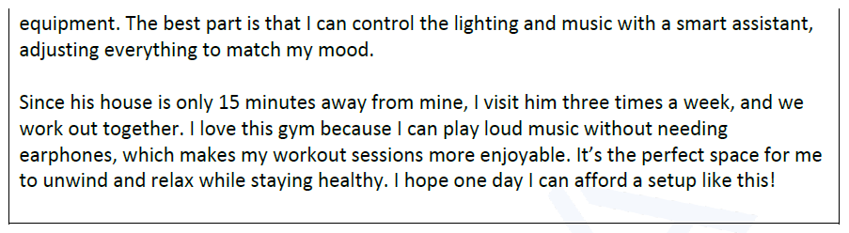

1. ***Do you like to invite your friends to your home?***
2. ***Do most people visit other people's houses during the Spring Festival?***
3. ***Why do people often take gifts with them when they visit others' homes?***
4. ***What are the most enjoyable parts of having a meal together with your***

***family?***

1. ***Who likes to stay at home more, young people or old people?***
2. ***Do you think old people will be able to keep up with the pace of technology***

***in 50 years?***

### 理想房屋

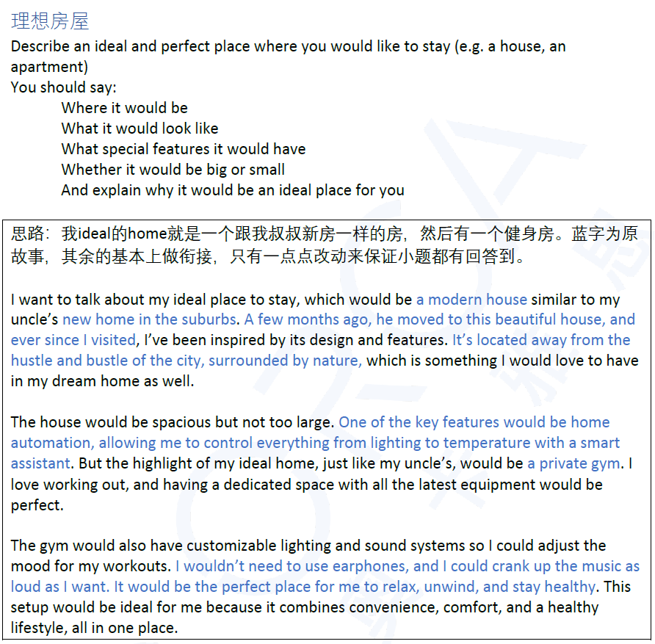

1. ***What are apartments like in your country***
2. ***Why are apartments popular in some places while not in other places?***
3. ***What would people normally consider when they rent or buy a house or an***

***apartment?***

1. ***Do different people have different preferences for houses or apartments?***
2. ***Why do some people choose to live in the city center?***
3. ***What do you think buildings will be like in the future?***

### 看到野生动物的地方

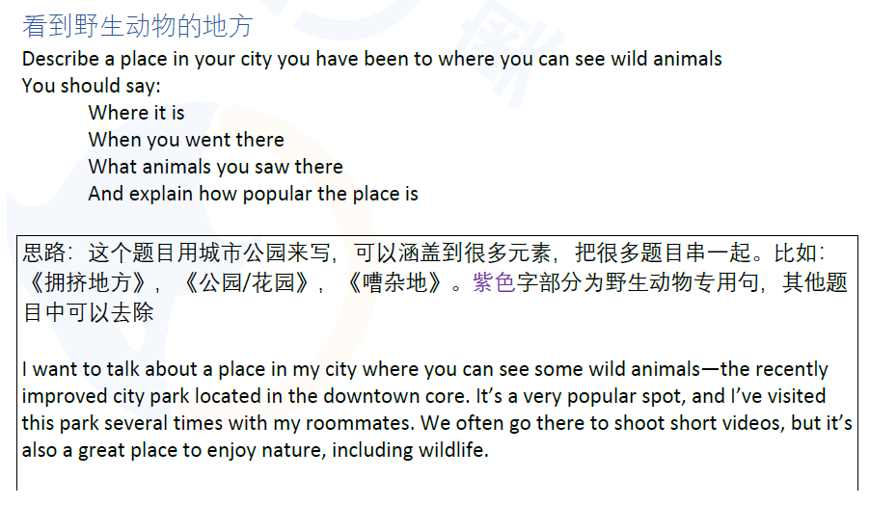

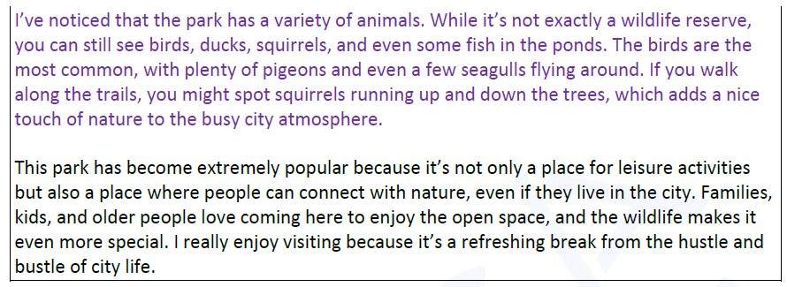

1. ***Why are most children interested in wild animals?***
2. ***Should parents take their children to see wild animals?***
3. ***Are wild animals easy to spot in your country?***
4. ***Are there many documentaries about wildlife in your country?***
5. ***What impacts does only seeing wild animals in zoos have on children's***

***understanding of these animals?***

1. ***Which is the better way to see wildlife, watching documentaries or going***

***into the wild?***

### 拥挤地方

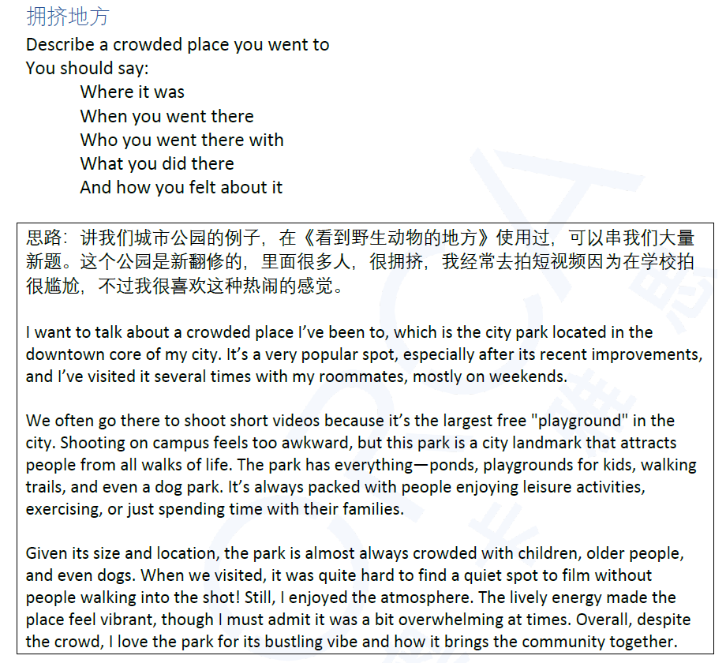

1. ***Which cities are overcrowded in your country?***
2. ***Will there be more or less green space in cities in the future?***
3. ***Will people use bikes more or less in cities in the future?***
4. ***Why do people go to crowded places?***
5. ***Do you think there are some people who enjoy crowded places?***
6. ***Do you think it is a good trend to have more big cities?***

### 公园/花园

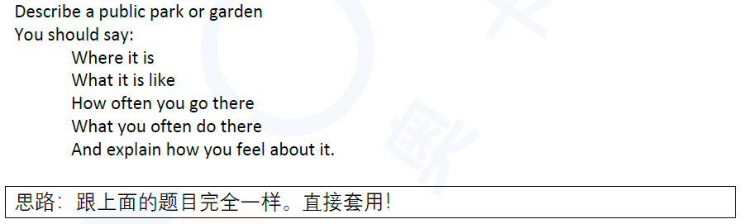

1. ***Is it necessary to have public parks in cities?***
2. ***What facilities are needed in a park?***
3. ***What are the differences between a garden and a natural area?***
4. ***Why do people like to visit tourist attractions?***
5. ***What tourist attractions are popular in China?***
6. ***How can we encourage young people to go to parks more often?***

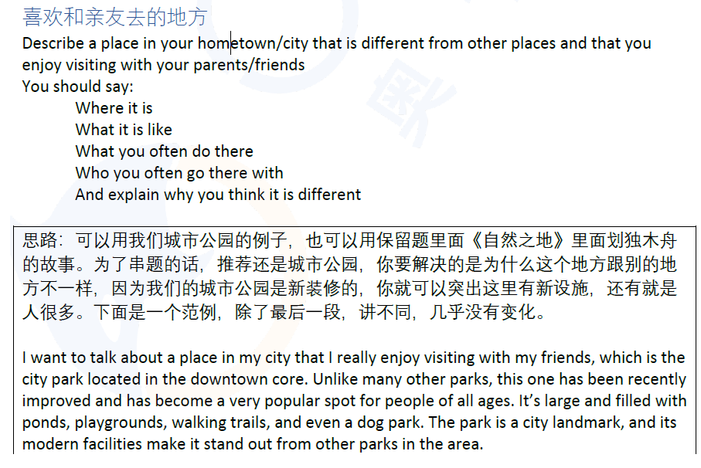

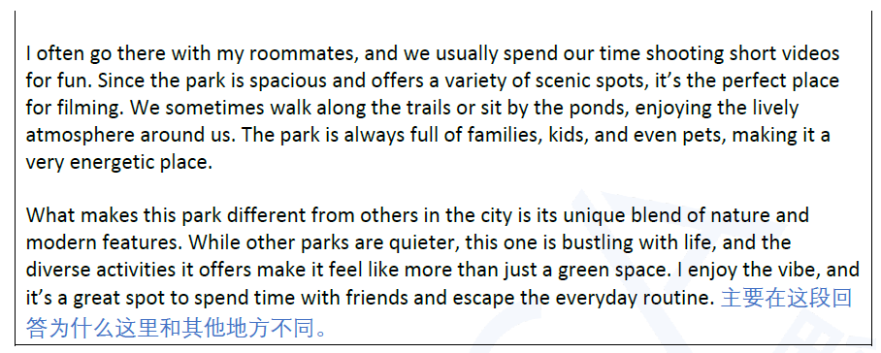

1. ***What are the differences between big cities and small cities?***
2. ***Where do people in your hometown like to go?***
3. ***What are the differences between the places young people like to go and***

***the places old people like to go?***

1. ***What do young people like to do in their leisure time?***
2. ***Why are some attractions not suitable for people to live in?***
3. ***What factors attract people to go to visit other places ither than their***

***hometown?***

## 人物类

### 工作中的积极建议

### 你的国家的名人

### 有趣的邻居

### 想要共事的家人

### 提高 注意力

### 喜欢做手工的人

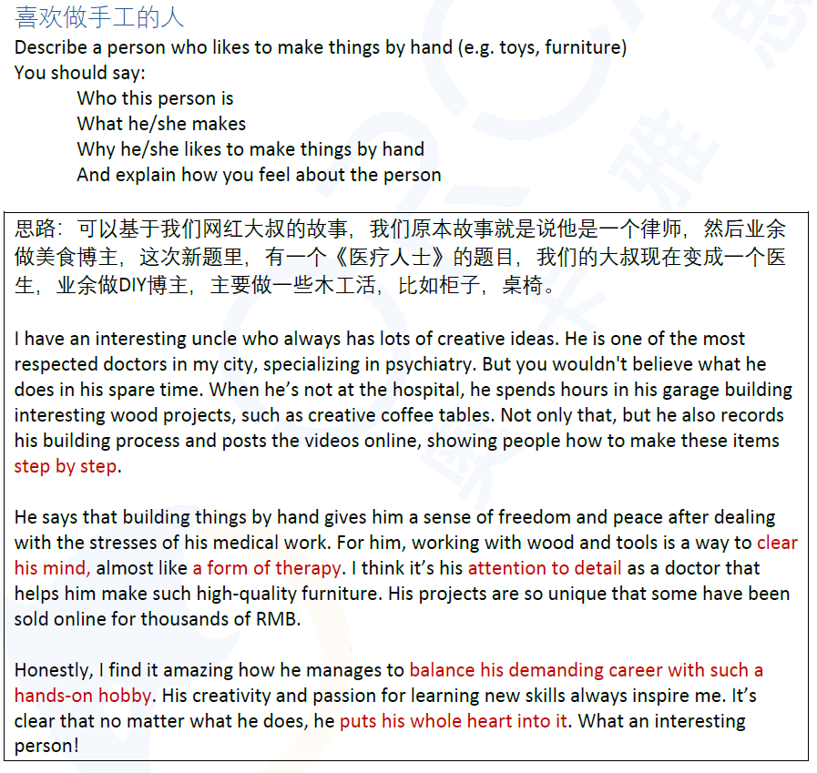

1. ***Are traditional handicrafts important to tourism?***
2. ***What are the benefits for students to learn to make things by hand?***
3. ***Why do many children like to make things by hand?***
4. ***Are there any traditional handicrafts in your hometown?***
5. ***Is it reasonable to charge a high price for handmade things?***
6. ***How does modern technology change the handicraft industry?***

### 读书迷

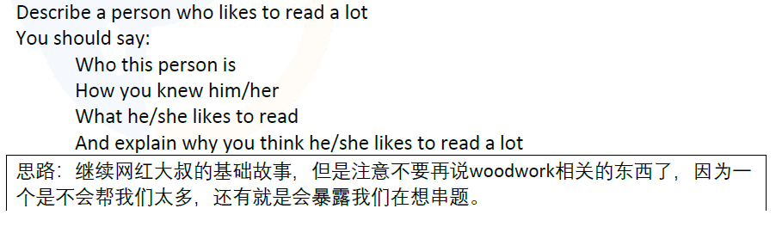

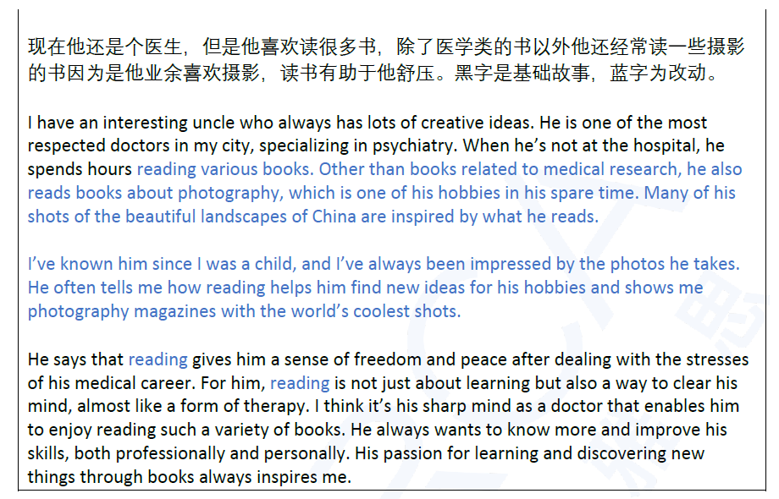

1. ***Why are many people so keen on reading?***
2. ***Do you think parents should help their children develop the reading habit from an early age?***
3. ***Is reading for fun or for work?***
4. ***What reading topics are popular in your country?***
5. ***What are the differences between paper books and movies?***
6. ***Do you think people of all ages need to read?***

### 医疗人士

### 给建议的人

### 固执己见的人

### 老友又见

## 物品类

### 传统节日的食物

### 弄丢贵重物品

### 获奖

### 改变世界的发明

### 传统产品

### 丢东西的经历

## 事件类

### 积极改变

### 一次非常忙碌的经历

### 帮助小孩

### 想参加的比赛

### 花费甚少的外出日

### 保健方式

### 让你惊讶的事情

### 庆祝过的活动

### 用手机做重要事情

### 节约时间的方法/改变

### 喜欢一起聊天的朋友

### 交通拥堵