ФГБОУ ВО «Сочинский государственный университет» Инженерно-экологический факультет Кафедра Прикладной информатики

Отчёт:

О выполнении лабораторной работы №5

по дисциплине «Технологии программирования»

Выполнил: Студент 2 курса, группы 20-ПИ-2 Воронин Елизар

Проверил: проф. кафедры инф. техн., д.т.н. Попов Дмитрий Иванович

Дата: 08.12.21

 Сочи 2021

**Создать учебные примеры (программы 1–4) и разобрать принцип их работы. Поместить примеры работы программ и их коды с комментариями в отчет.**

**Программа 1**

**using** System**;**

**using** System**.**IO**;**

**namespace** Pudge

**{**

class Program

**{**

staticvoid Main**(**string**[]** args**)**

**{**

byte**[]** data **=new**byte**[**10**];**

FileStream fs **=new** FileStream**(**"FileStreamTest.txt"**,**

FileMode**.**OpenOrCreate**);**

**if(**fs**.**Length **==**0**)**

**{**

Console**.**WriteLine**(**"Writing Data..."**);**

**for(**short i **=**0**;** i **<**10**;** i**++)**

data**[**i**]=(**byte**)**i**;**

fs**.**Write**(**data**,**0**,**10**);**

**}**

**else**

**{**

fs**.**Seek**(-**5**,** SeekOrigin**.**End**);**

int count **=** fs**.**Read**(**data**,**0**,**10**);**

**for(**int i **=**0**;** i **<** count**;** i**++)** Console**.**WriteLine**(**data**[**i**]);**

**}**

fs**.**Close**();**

**}**

**}**

**}**



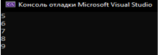

**Программа 2**

**using** System**;**

**using** System**.**IO**;**

**namespace** Pudge

**{**

class Program

**{**

staticvoid Main**(**string**[]** args**)**

**{**

FileStream fs **=new** FileStream**(**"BinaryTest.bin"**,** FileMode**.**OpenOrCreate**);**

**if(**fs**.**Length **==**0**)**

**{**

Console**.**WriteLine**(**"Writing Data..."**);**

BinaryWriter w **=new** BinaryWriter**(**fs**);**

**for(**short i **=**0**;** i **<**10**;** i**++)** w**.**Write**(**i**);**

w**.**Close**();**

**}**

**else**

**{**

BinaryReader r **=new** BinaryReader**(**fs**);**

**for(**int i **=**0**;** i **<**10**;** i**++)** Console**.**WriteLine**(**r**.**ReadInt16**());**

r**.**Close**();**

**}**

fs**.**Close**();**

**}**

**}**

**}**



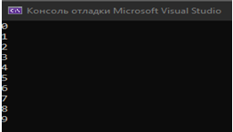

**Программа 3**

**using** System**;**

**using** System**.**IO**;**

**namespace** Pudge

**{**

class Program

**{**

staticvoid Main**(**string**[]** args**)**

**{**

FileStream fs **=new** FileStream**(**"TextTest.txt"**,** FileMode**.**OpenOrCreate**);**

**if(**fs**.**Length **==**0**)**

**{**

Console**.**WriteLine**(**"Writing Data..."**);**

StreamWriter sw **=new** StreamWriter**(**fs**);**

sw**.**Write**(**100**);**

sw**.**WriteLine**(**" One Hundred"**);**

sw**.**WriteLine**(**"End of File"**);**

sw**.**Close**();**

**}**

**else**

**{**

String text**;**

StreamReader sr **=new** StreamReader**(**fs**);**

text **=** sr**.**ReadLine**();**

**while(**text **!=null)**

**{**

Console**.**WriteLine**(**text**);** text **=** sr**.**ReadLine**();**

**}**

sr**.**Close**();**

**}**

fs**.**Close**();**

**}**

**}**

**}**



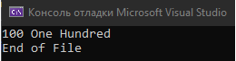

**Программа 4**

**using** System**;**

**using** System**.**IO**;**

**namespace** Pudge

**{**

class Program

**{**

staticvoid Main**(**string**[]** args**)**

**{**

File**.**Delete**(**"file2.txt"**);**

StreamWriter sw **=** System**.**IO**.**File**.**CreateText**(**"file.txt"**);**

sw**.**Write**(**"Пусть каждый день твой будет светлым, "**);**

sw**.**WriteLine**(**"приятным, радостным и щедрым!"**);**

sw**.**Close**();**

File**.**Move**(**"file.txt"**,**"file2.txt"**);**

FileInfo fileInfo **=new** FileInfo**(**"file2.txt"**);**

Console**.**WriteLine**(**"File {0} is {1} bytes in length, created on {2}"**,**

fileInfo**.**FullName**,** fileInfo**.**Length**,** fileInfo**.**CreationTime**);**

Console**.**WriteLine**(**""**);**

StreamReader sr **=** fileInfo**.**OpenText**();**

String s **=** sr**.**ReadLine**();**

**while(**s **!=null)**

**{**

Console**.**WriteLine**(**s**);** s **=** sr**.**ReadLine**();**

**}**

sr**.**Close**();**

**}**

**}**

**}**



**Создать текстовый редактор NotepadC#, добавив недостающие пункты меню и функции.**

**Программа 5**

**Form1.cs**

**using** System**;**

**using** System**.**Collections**.**Generic**;**

**using** System**.**ComponentModel**;**

**using** System**.**Data**;**

**using** System**.**Drawing**;**

**using** System**.**Linq**;**

**using** System**.**Text**;**

**using** System**.**Threading**.**Tasks**;**

**using** System**.**Windows**.**Forms**;**

**namespace** Gadget

**{**

**publicpartial**class Frmmain **:** Form

**{**

**private**int openDoc**;**

**public** Frmmain**()**

**{**

InitializeComponent**();**

**}**

**private**void fileToolStripMenuItem_Click**(object** sender**,** EventArgs e**)**

**{**

**}**

**private**void theToolStripMenuItem_Click**(object** sender**,** EventArgs e**)**

**{**

**this.**LayoutMdi**(**MdiLayout**.**TileHorizontal**);**

**}**

**private**void theVertkalToolStripMenuItem_Click**(object** sender**,** EventArgs e**)**

**{**

**this.**LayoutMdi**(**MdiLayout**.**TileVertical**);**

**}**

**private**void arrangeIconsToolStripMenuItem_Click**(object** sender**,** EventArgs e**)**

**{**

**this.**LayoutMdi**(**MdiLayout**.**ArrangeIcons**);**

**}**

**private**void Frmmain_Load**(object** sender**,** EventArgs e**)**

**{**

**}**

**private**void mnuNew_Click**(object** sender**,** EventArgs e**)**

**{**

blank frm **=new** blank**();**

frm**.**DocName **=**"Документ "**+++**openDoc**;**

frm**.**Text **=** frm**.**DocName**;** frm**.**MdiParent **=this;**

frm**.**Show**();**

**}**

**private**void mnuWindow_Click**(object** sender**,** EventArgs e**)**

**{**

**}**

**private**void mnuCascade_Click**(object** sender**,** EventArgs e**)**

**{**

**this.**LayoutMdi**(**MdiLayout**.**Cascade**);**

**}**

**private**void mnuCut_Click**(object** sender**,** EventArgs e**)**

**{**

blank frm **=(**blank**)(this.**ActiveMdiChild**);**

frm**.**Cut**();**

**}**

**private**void mnuCopy_Click**(object** sender**,** EventArgs e**)**

**{**

blank frm **=(**blank**)(this.**ActiveMdiChild**);**

frm**.**Copy**();**

**}**

**private**void mnuPaste_Click**(object** sender**,** EventArgs e**)**

**{**

blank frm **=(**blank**)(this.**ActiveMdiChild**);**

frm**.**Paste**();**

**}**

**private**void deleteToolStripMenuItem_Click**(object** sender**,** EventArgs e**)**

**{**

blank frm **=(**blank**)(this.**ActiveMdiChild**);**

frm**.**Delete**();**

**}**

**private**void mnuSelectAll_Click**(object** sender**,** EventArgs e**)**

**{**

blank frm **=(**blank**)(this.**ActiveMdiChild**);**

frm**.**SelectAll**();**

**}**

**private**void blackToolStripMenuItem_Click**(object** sender**,** EventArgs e**)**

**{**

blank frm **=(**blank**)(this.**ActiveMdiChild**);**

frm**.**FontColor**(**"Black"**);**

**}**

**private**void grayToolStripMenuItem_Click**(object** sender**,** EventArgs e**)**

**{**

blank frm **=(**blank**)(this.**ActiveMdiChild**);**

frm**.**FontColor**(**"Gray"**);**

**}**

**private**void greenToolStripMenuItem_Click**(object** sender**,** EventArgs e**)**

**{**

blank frm **=(**blank**)(this.**ActiveMdiChild**);**

frm**.**FontColor**(**"Green"**);**

**}**

**private**void blueToolStripMenuItem_Click**(object** sender**,** EventArgs e**)**

**{**

blank frm **=(**blank**)(this.**ActiveMdiChild**);**

frm**.**FontColor**(**"Blue"**);**

**}**

**private**void timesNewRomanToolStripMenuItem_Click**(object** sender**,** EventArgs e**)**

**{**

blank frm **=(**blank**)(this.**ActiveMdiChild**);**

frm**.**fonts**(**"TimesNewRoman"**);**

**}**

**private**void arialToolStripMenuItem_Click**(object** sender**,** EventArgs e**)**

**{**

blank frm **=(**blank**)(this.**ActiveMdiChild**);**

frm**.**fonts**(**"Arial"**);**

**}**

**private**void calibriToolStripMenuItem_Click**(object** sender**,** EventArgs e**)**

**{**

blank frm **=(**blank**)(this.**ActiveMdiChild**);**

frm**.**fonts**(**"Calibri"**);**

**}**

**private**void pinkToolStripMenuItem_Click**(object** sender**,** EventArgs e**)**

**{**

blank frm **=(**blank**)(this.**ActiveMdiChild**);**

frm**.**FontColor**(**"Pink"**);**

**}**

**private**void orangeToolStripMenuItem_Click**(object** sender**,** EventArgs e**)**

**{**

blank frm **=(**blank**)(this.**ActiveMdiChild**);**

frm**.**FontColor**(**"Orange"**);**

**}**

**private**void mnuOpen_Click**(object** sender**,** EventArgs e**)**

**{**

mnuSave**.**Enabled **=true;**

openFileDialog1**.**Filter **=**"Text Files (*.txt)|*.txt|All Files(*.*)|*.*"**;**

**if(**openFileDialog1**.**ShowDialog**()==** DialogResult**.**OK**)**

**{**

blank frm **=new** blank**();** frm**.**Open**(**openFileDialog1**.**FileName**);**

frm**.**MdiParent **=this;**

frm**.**DocName **=** openFileDialog1**.**FileName**;**

frm**.**Text **=** frm**.**DocName**;**

frm**.**Show**();**

**}**

**}**

**private**void mnuSave_Click**(object** sender**,** EventArgs e**)**

**{**

mnuSave**.**Enabled **=false;**

saveFileDialog1**.**Filter **=**"Text Files (*.txt)|*.txt|All Files(*.*)|*.*"**;**

**if(**saveFileDialog1**.**ShowDialog**()==** DialogResult**.**OK**)**

**{**

blank frm **=(**blank**)(this.**ActiveMdiChild**);**

frm**.**Save**(**saveFileDialog1**.**FileName**);** frm**.**MdiParent **=this;**

frm**.**DocName **=** saveFileDialog1**.**FileName**;** frm**.**Text **=** frm**.**DocName**;**

**}**

**{**

blank frm **=(**blank**)(this.**ActiveMdiChild**);**

frm**.**Save**(**frm**.**DocName**);**

frm**.**IsSaved **=true;**

**}**

**}**

**private**void mnuSaveAs_Click**(object** sender**,** EventArgs e**)**

**{**

mnuSave**.**Enabled **=true;**

saveFileDialog1**.**Filter **=**"Text Files (*.txt)|*.txt|All Files(*.*)|*.*"**;**

**if(**saveFileDialog1**.**ShowDialog**()==** DialogResult**.**OK**)**

**{**

blank frm **=(**blank**)(this.**ActiveMdiChild**);**

frm**.**Save**(**saveFileDialog1**.**FileName**);** frm**.**MdiParent **=this;**

frm**.**DocName **=** saveFileDialog1**.**FileName**;** frm**.**Text **=** frm**.**DocName**;**

frm**.**IsSaved **=true;**

**}**

**}**

**}**

**}**

**blank.h.cs**

**using** System**;**

**using** System**.**Collections**.**Generic**;**

**using** System**.**ComponentModel**;**

**using** System**.**Data**;**

**using** System**.**Drawing**;**

**using** System**.**Linq**;**

**using** System**.**Text**;**

**using** System**.**Threading**.**Tasks**;**

**using** System**.**Windows**.**Forms**;**

**using** System**.**IO**;**

**namespace** Gadget

**{**

**publicpartial**class blank **:** Form

**{**

**public**bool IsSaved **=false;**

**public** String DocName**;**

**private** String BufferText**;**

**public** blank**()**

**{**

InitializeComponent**();**

**}**

**public**void font**(**string fontRR**)**

**{**

richTextBox1**.**SelectionFont **=new** Font**(**fontRR**,**9**);**

**}**

**public**void FontColor**(**string FontColorRR**)**

**{**

**switch(**FontColorRR**)**

**{**

**case(**"Black"**):** richTextBox1**.**SelectionColor **=** System**.**Drawing**.**Color**.**Black**;break;**

**case(**"Green"**):** richTextBox1**.**SelectionColor **=** System**.**Drawing**.**Color**.**Green**;break;**

**case(**"Gray"**):** richTextBox1**.**SelectionColor **=** System**.**Drawing**.**Color**.**Gray**;break;**

**case(**"Blue"**):** richTextBox1**.**SelectionColor **=** System**.**Drawing**.**Color**.**Blue**;break;**

**case(**"Pink"**):** richTextBox1**.**SelectionColor **=** System**.**Drawing**.**Color**.**Pink**;break;**

**case(**"Orange"**):** richTextBox1**.**SelectionColor **=** System**.**Drawing**.**Color**.**Orange**;break;**

**}**

**}**

**public**void fonts**(**string fontSS**)**

**{**

richTextBox1**.**SelectionFont **=new** Font**(**fontSS**,**14**);**

**}**

**public**void Cut**()**

**{**

**this.**BufferText **=** richTextBox1**.**SelectedText**;**

richTextBox1**.**SelectedText **=**""**;**

**}**

**public**void Copy**()**

**{**

**this.**BufferText **=** richTextBox1**.**SelectedText**;**

**}**

**public**void Paste**()**

**{**

richTextBox1**.**SelectedText **=this.**BufferText**;**

**}**

**public**void SelectAll**()**

**{**

richTextBox1**.**SelectAll**();**

**}**

**public**void Delete**()**

**{**

richTextBox1**.**SelectedText **=**""**;**

**this.**BufferText **=**""**;**

**}**

**private**void richTextBox1_TextChanged**(object** sender**,** EventArgs e**)**

**{**

**}**

**private**void copyToolStripMenuItem_Click**(object** sender**,** EventArgs e**)**

**{**

**}**

**private**void cmnuCut_Click**(object** sender**,** EventArgs e**)**

**{**

Cut**();**

**}**

**private**void cmnuCopy_Click**(object** sender**,** EventArgs e**)**

**{**

Copy**();**

**}**

**private**void cmnuPaste_Click**(object** sender**,** EventArgs e**)**

**{**

Paste**();**

**}**

**private**void cmnuDelete_Click**(object** sender**,** EventArgs e**)**

**{**

Delete**();**

**}**

**private**void cmnuSelectAll_Click**(object** sender**,** EventArgs e**)**

**{**

SelectAll**();**

**}**

**public**void Open**(**String OpenFileName**)**

**{**

**if(**OpenFileName **==null){return;}**

**else**

**{**

StreamReader sr **=new** StreamReader**(**OpenFileName**);**

richTextBox1**.**Text **=** sr**.**ReadToEnd**();** sr**.**Close**();**

DocName **=** OpenFileName**;**

**}**

**}**

**public**void Save**(**String SaveFileName**)**

**{**

**if(**SaveFileName **==null){return;}**

**else**

**{**

StreamWriter sw **=new** StreamWriter**(**SaveFileName**);**

sw**.**WriteLine**(**richTextBox1**.**Text**);** sw**.**Close**();**

DocName **=** SaveFileName**;**

**}**

**}**

**private**void blank_FormClosed**(object** sender**,** FormClosedEventArgs e**)**

**{**

**if(**IsSaved **==true)**

**if(**MessageBox**.**Show**(**"Do you want save changes in "

**+this.**DocName **+**"?"**,**"Message"**,** MessageBoxButtons**.**YesNo**,**

MessageBoxIcon**.**Question**)==** DialogResult**.**Yes**)**

**{**

**this.**Save**(this.**DocName**);**

**}**

**}**

**}**

**}**

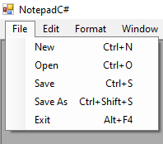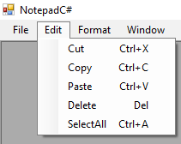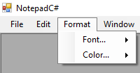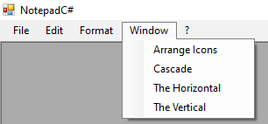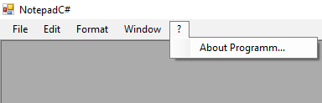

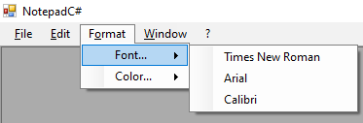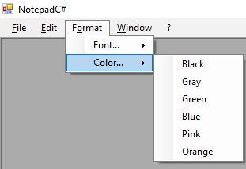

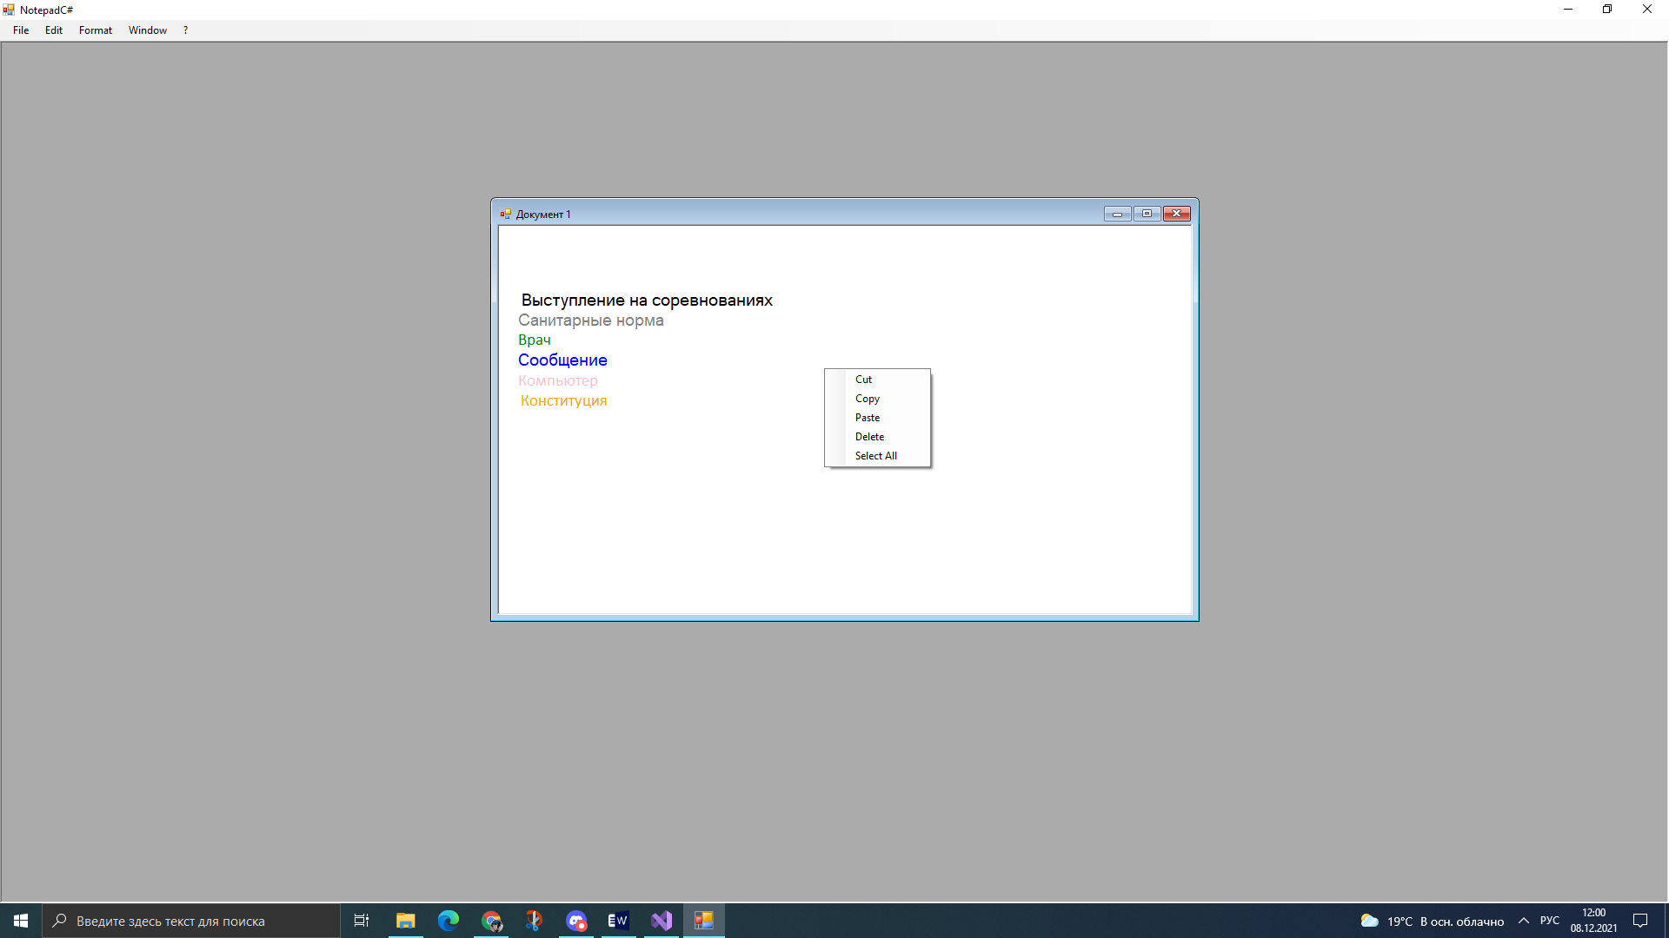

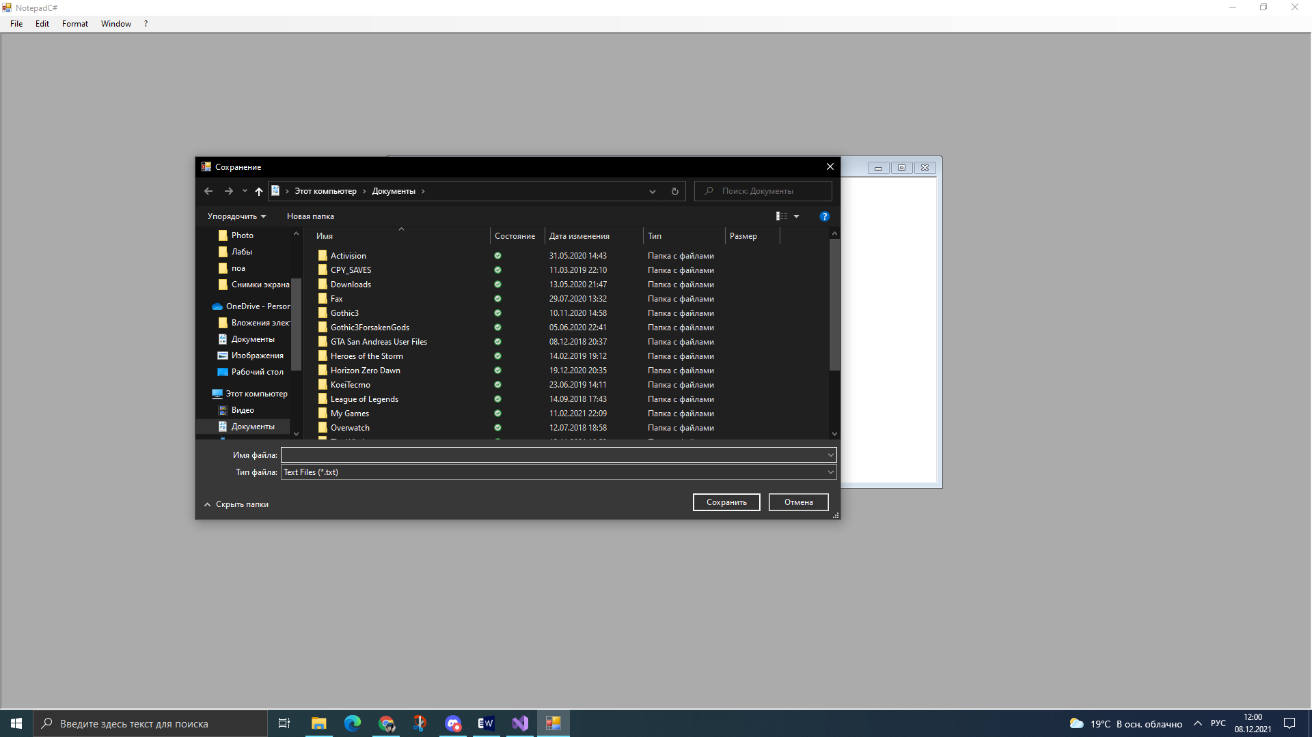

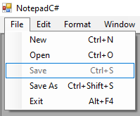

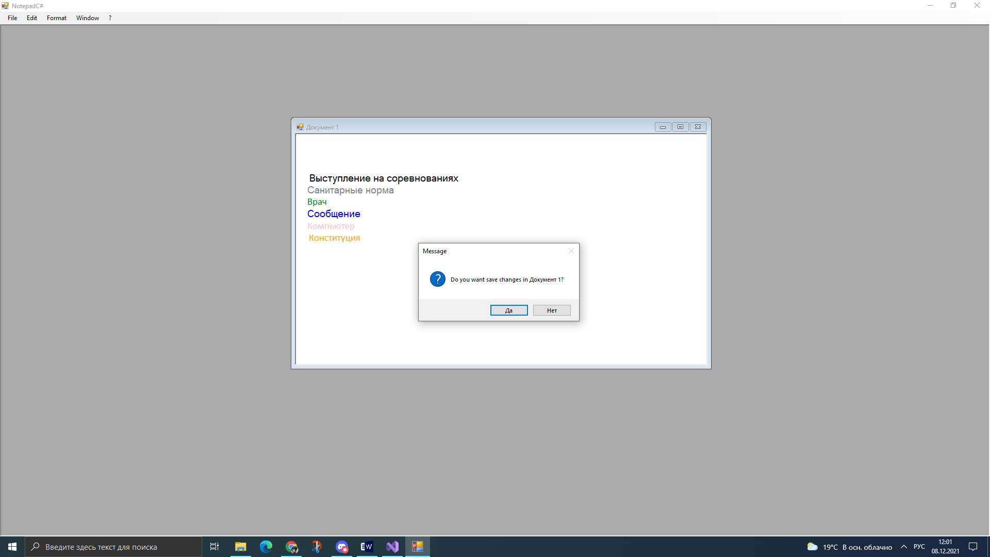

**Диалоговые окна**

**Программа 6**

**using** System**;**

**using** System**.**Collections**.**Generic**;**

**using** System**.**ComponentModel**;**

**using** System**.**Data**;**

**using** System**.**Drawing**;**

**using** System**.**Linq**;**

**using** System**.**Text**;**

**using** System**.**Threading**.**Tasks**;**

**using** System**.**Windows**.**Forms**;**

**using** System**.**IO**;**

**namespace** TextEditor

**{**

**publicpartial**class Form1 **:** Form

**{**

**public** Form1**()**

**{**

InitializeComponent**();**

**}**

**private**void opnemToolStripMenuItem_Click**(object** sender**,** EventArgs e**)**

**{**

openFileDialog1**.**ShowDialog**();**

String fileName **=** openFileDialog1**.**FileName**;**

FileStream filestream **=** File**.**Open**(**fileName**,** FileMode**.**Open**,** FileAccess**.**Read**);**

**if(**filestream **!=null)**

**{**

StreamReader streamreader **=new** StreamReader**(**filestream**);**

txfflox**.**Text **=** streamreader**.**ReadToEnd**();**

filestream**.**Close**();**

**}**

**}**

**private**void mnuSave_Click**(object** sender**,** EventArgs e**)**

**{**

saveFileDialog1**.**ShowDialog**();**

String fileName **=** saveFileDialog1**.**FileName**;**

FileStream filestream **=** File**.**Open**(**fileName**,** FileMode**.**Create**,**

FileAccess**.**Write**);**

**if(**filestream **!=null)**

**{**

StreamWriter streamwriter **=new** StreamWriter**(**filestream**);**

streamwriter**.**Write**(**txfflox**.**Text**);**

streamwriter**.**Flush**();**

filestream**.**Close**();**

**}**

**}**

**}**

**}**

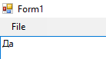

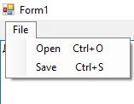

**Программа 7**

using System;

using System.Collections.Generic;

using System.ComponentModel;

using System.Data;

using System.Drawing;

using System.Linq;

using System.Text;

using System.Threading.Tasks;

using System.Windows.Forms;

using System.IO;

namespace IO

{

publicpartialclassForm1 : Form

{

publicForm1()

{

InitializeComponent();

}

privatevoid Form1_Load(object sender, EventArgs e)

{

}

privatevoid sdaToolStripMenuItem_Click(object sender, EventArgs e)

{

}

privatevoid name_Click(object sender, EventArgs e)

{

}

privatevoid surname_Click(object sender, EventArgs e)

{

}

privatevoid usename_Click(object sender, EventArgs e)

{

}

privatevoid email_Click(object sender, EventArgs e)

{

}

privatevoid gender_Click(object sender, EventArgs e)

{

}

privatevoid textName_TextChanged(object sender, EventArgs e)

{

}

privatevoid textDateofBirth_TextChanged(object sender, EventArgs e)

{

}

privatevoid textSurname_TextChanged(object sender, EventArgs e)

{

}

privatevoid textUsename_TextChanged(object sender, EventArgs e)

{

}

privatevoid textEmail_TextChanged(object sender, EventArgs e)

{

}

privatevoid textGender_TextChanged(object sender, EventArgs e)

{

}

privatevoid mnuSave_Click(object sender, EventArgs e)

{

saveFileDialog1.ShowDialog();

String fileName = saveFileDialog1.FileName;

FileStream filestream = File.Open(fileName, FileMode.Create, FileAccess.Write);

}

privatevoid pictureBox1_Click(object sender, EventArgs e)

{

}

public Image Photo // добавление фото

{

get { return pictureBox1.Image; }

set { pictureBox1.Image = value; }

}

privatevoid button_Click(object sender, EventArgs e)

{

OpenFileDialog ofd = new OpenFileDialog();

ofd.Filter = "Image Files(*.BMP;*.JPG;*.PNG)|*.BMP;*.JPG;*.PNG|All files (*.*)|*.*";

if (ofd.ShowDialog() == DialogResult.OK)

pictureBox1.Image = new Bitmap(ofd.FileName);

}

privatevoid saveFileDialog1_FileOk(object sender, CancelEventArgs e)

{

}

privatevoid openFileDialog1_FileOk(object sender, CancelEventArgs e)

{

}

}

}

