
GNU is an extensive collection of free software, which can be used as an operating system or can be used in parts with other operating systems. The use of the completed GNU tools led to the family of operating systems popularly known as Linux. Most of GNU is licensed under the GNU Project's own General Public License.


FSF The Free Software Foundation is a 501 non-profit organization founded by Richard Stallman on October 4, 1985, to support the free software movement, which promotes the universal freedom to study distribute, create, and modify computer software,

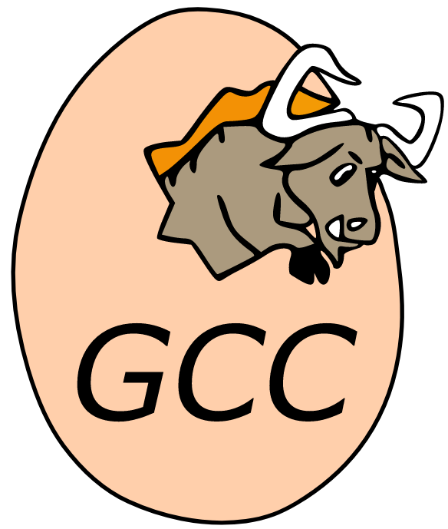
GCC The GNU Compiler Collection is an optimizing compiler produced by the GNU Project supporting various programming languages, hardware architectures and operating systems. The Free Software Foundation distributes GCC as free software under the GNU General Public License.

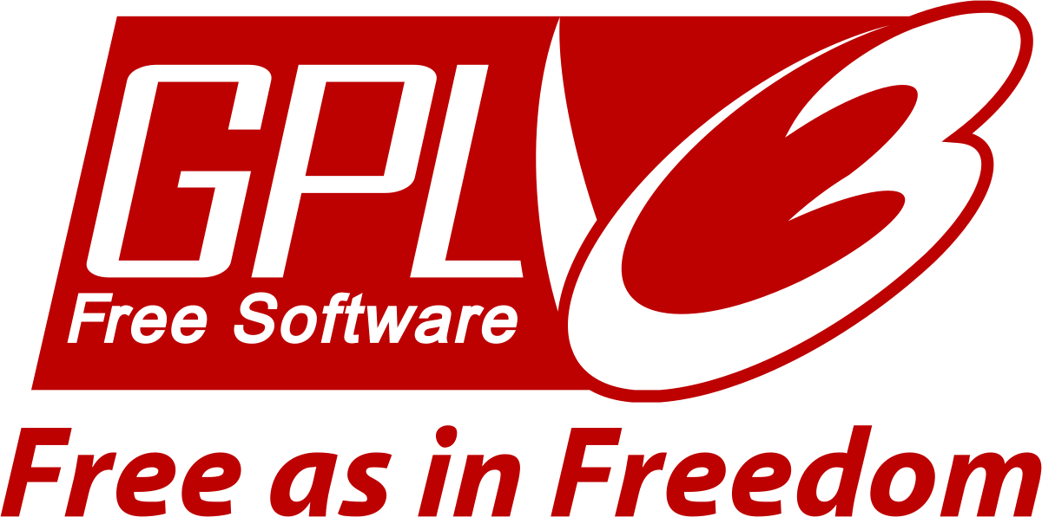
GPL The GNU General Public License is a series of widely used free software licenses that guarantee end users the four freedoms to run, study, share, and modify the software.

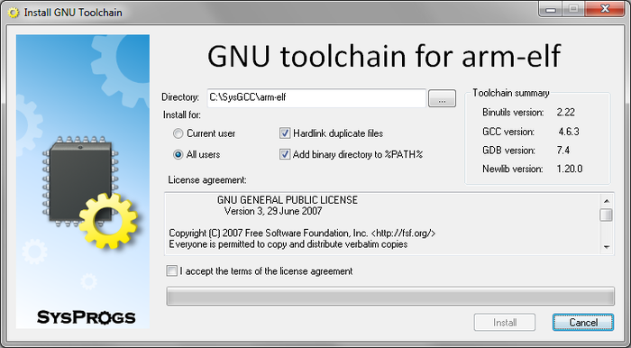
The GNU toolchain is a broad collection of programming tools produced by the GNU Project. These tools form a toolchain used for developing software applications and operating systems. The GNU toolchain plays a vital role in development of Linux, some BSD systems, and software for embedded systems.


The Berkeley Software Distribution or Berkeley Standard Distribution is a discontinued operating system based on Research Unix, developed and distributed by the Computer Systems Research Group at the University of California, Berkeley.

AT&T Inc. (originally the American Telephone and Telegraph Company) is an American multinational conglomerate holding company that is Delaware-registered[5] but headquartered at Whitacre Tower in Downtown Dallas, Texas.[6] It is the world's largest telecommunications company and the largest[7] provider of mobile telephone services in the U.S.

