NDG Introduction to Linux I - Chapter 15 Hardware Configuration

Objectives

This chapter will cover the following exam objectives:
101.1: Determine and configure hardware settings v2
Weight: 2
Candidates should be able to determine and configure fundamental system hardware.
Key Knowledge Areas:
- Enable and disable integrated peripherals.
Section 15.3
- Differentiate between the various types of mass storage devices.
Section 15.2.4
- Determine hardware resources for devices.
Section 15.4
- Tools and utilities to list various hardware information (e.g. lsusb, lspci, etc.).
Section 15.5
- Tools and utilities to manipulate USB devices.
Section 15.5
- Conceptual understanding of sysfs, udev and dbus.
Section 15.6

Key Terms

/dev/
Hardware devices are made available through special files under the /dev directory.
Section 15.6

/proc/
The process information pseudo-filesystem
Section 15.6
/sys/
The mount point for sysfs providing a set of virtual files by exporting information about various kernel subsystems, hardware devices and associated device drivers from the kernel's device model to user space.
Section 15.6

lsmod
Prints the contents of the /proc/modules file
Section 15.7

lspci
Prints detailed information about all PCI buses and devices in the system
Section 15.5

lsusb
Prints detailed information about all USB buses and devices in the system
Section 15.5

modprobe
Used to add a loadable kernel module (LKM) to the Linux kernel or to remove an LKM from the kernel
Section 15.7

swap space
Used when the amount of physical memory (RAM) is full. If the system needs more memory resources and the RAM is full, inactive pages in memory are moved to the swap space.
Section 15.2.2

15.1 Introduction
Understanding how to view and configure computer system hardware is a critical skill for a Linux administrator. Even though some hardware may not require any configuration, an administrator can benefit from understanding the function of that hardware when attempting to diagnose any problems. The usage of virtualization and virtual machines does not lessen the need to understand hardware, as the concept of hardware still exists in the virtual machine environment, and virtualization environments run on physical hardware

15.2 Core Hardware
Components that are essential to operate a computer are considered core hardware. Every system should include a central processing unit, random access memory, and some kind of firmware. This module will define these components and demonstrate commands and files that can be used to view core hardware information in the terminal. Other hardware that is essential for a complete system includes some type of persistent storage device like a mechanical hard drive or solid-state drive (SSD), a method of controlling the device, either remotely, or by using a display device/monitor, a keyboard, and a mouse. Most systems also include one or more networking devices, possibly a sound device, and ports for connecting external devices.

15.2.1 Central Processing Unit
The central processing unit (CPU) is the brain of the computer, where the instructions to perform calculations or manipulate data are processed. There are numerous types of CPUs that are able to work with Linux, but the most common is the 64-bit x86_64 type, and decreasingly, the 32-bit x86 type. Both of these types of CPUs are backward compatible with the CPU used in the first IBM Personal Computer (PC), the Intel 8088 CPU.
Knowing the type and capability of a system’s CPU is essential to knowing what software can be installed on it, and how it will perform. There are several ways to gather information about the type of CPU in a system. We will focus on determining this information from an already-installed Linux system.
A prime location for CPU information is the firmware settings. Viewing the contents of the /proc/cpuinfo file will display extremely detailed information, including the model name, speed in MHz, and specific features available in a list of flags.
The uname command is a valuable tool for quickly determining system information from the command line. Running the uname command with no parameters yields only the kernel name as shown below:
sysadmin@localhost:~$ uname
Linux

The uname command has access to the files in the /proc and /sys directories which can display a lot of organized information about your system. Running uname with the -a option will show the following information (in order of appearance):

Information | Option | Example
Kernel name | -s | Linux
Nodename | -n | localhost
Kernel release | -r | 4.4.0-72-generic
Kernel version | -v | #93~14.04.1-Ubuntu SMP Fri Mar 31 15:05:15 UTC 2017
Machine hardware | -m | x86_64
Processor | -p | x86_64
Hardware platform | -i | x86_64
Operating System | -o | GNU/Linux

sysadmin@localhost:~$ uname -a
Linux localhost 4.4.0-72-generic #93~14.04.1-Ubuntu SMP Fri Mar 31 15:05:15 UTC
2017 x86_64 x86_64 x86_64 GNU/Linux
Each item can be display individually with the corresponding option. For a less detailed summary of the CPUs in your system, execute the uname -p command:
sysadmin@localhost:~$ uname -p
x86_64
Another way to get more detailed information than the uname command can give you is to run the lscpu command. Much of the information the lscpu command returns is out of the scope of this objective but can be very useful in determining the hardware’s capabilities.
sysadmin@localhost:~$ lscpu
Architecture: x86_64
CPU op-mode(s): 32-bit, 64-bit
Byte Order: Little Endian
CPU(s): 8
On-line CPU(s) list: 0-7
Thread(s) per core: 1
Core(s) per socket: 4
Socket(s): 2
NUMA node(s): 1
Vendor ID: GenuineIntel
CPU family: 6
Model: 44
Stepping: 2
CPU MHz: 2394.000
BogoMIPS: 4788.00
Hypervisor vendor: VMware
Virtualization type: full
L1d cache: 32K
L1i cache: 32K
L2 cache: 256K
L3 cache: 12288K
NUMA node0 CPU(s): 0-7

15.2.2 Random Access Memory
The random access memory (RAM) of a system is used to temporarily store data and instructions for the operating system and the programs that are executing. When the IBM PC debuted in 1981, it was able to access 1 MiB of memory, of which 640 KiB was RAM, and 384 KiB was for the system ROM.
The maximum amount of memory that can be used with a 32-bit processor is 4 GiB, whereas a 64-bit processor can theoretically use 16 EiB of memory. In reality, many 32-bit systems may actually be limited to using 3 GiB of memory, and the hardware doesn't exist yet to be able to use the maximum amount of memory on a 64-bit system.
From a practical perspective, if a system doesn't currently have at least 1 GiB of RAM, then it may not be able to use the graphical user interface (GUI) with Linux. When using only the command line interface (CLI), the memory requirements are much less.

Consider This
Unit | Abbreviation | Value (Bytes)
kibibyte | KiB | 1024
mebibyte | MiB | 10242 = 1,048,576
gibibyte | GiB | 10243 = 1,073,741,824
tebibyte | TiB | 10244 = 1,099,511,627,776
exbibyte | EiB | 10246 = 1,152,921,504,606,846,976

A typical desktop in the year 2019 has 16 GiB of RAM. That is more than 26000 times the amount of RAM in a fully loaded IBM PC in the year 1981!

Normally a system will have enough RAM to conduct its normal operations, run a few services, and maybe applications. If a system doesn't have sufficient RAM for the processes you are executing on it, then it will use virtual memory, called swap space in Linux. Swap space is hard drive space that is temporarily used to hold data that exceeds the amount of RAM available. When the system begins to run low on memory, it will "swap out" data that is least in demand at that moment, so that RAM space can free up for something that is currently in demand (typically a new process). If the system is using swap space constantly, then it will perform poorly in comparison to a system that doesn't; an increase in performance could be obtained if more RAM were added to the system.
Swap space comes in two types; a swapfile that would reside on an existing filesystem, or a swap partition, which is a section of a disk that is dedicated to swap and is formatted with the swap filesystem. A swap partition is an essential part of a properly configured Linux system and yields the best performance for swap operations. Swap files have the overhead of being on an existing filesystem and should be used sparingly, and only if absolutely necessary.
The amount of RAM in a system can be viewed in the firmware settings. For a very detailed breakdown of how much memory a system has and how it is being used, view the /proc/meminfo file:

sysadmin@localhost:~$ cat /proc/meminfo
MemTotal: 132014640 kB
MemFree: 67439868 kB
MemAvailable: 99487364 kB
Buffers: 2116936 kB
Cached: 27429740 kB
SwapCached: 40 kB
Active: 14409408 kB
Inactive: 23724500 kB
Active(anon): 8400252 kB
Inactive(anon): 191680 kB
Active(file): 6009156 kB
Inactive(file): 23532820 kB
Unevictable: 0 kB
Mlocked: 0 kB
SwapTotal: 134196220 kB
SwapFree: 134195752 kB
Output Omitted...

For a quick summary of RAM memory and swap space, execute the free command:

sysadmin@localhost:~$ free
total used free shared buff/cache available
Mem: 128920 35120 89205 2 4594 93190
Swap: 131050 140 130910
The output above shows this system contains about 128 MiB of RAM memory; almost all of it is used. Very little memory is free because the system configures any unused memory for buffers and caches, which are temporary data stores, to speed up the system.
Despite having so little free RAM, notice that the swap space of about 131 MiB has not been used at all; although if a heavy demand for memory (due to an additional load of processes) were placed on this system, then this swap space is available and would likely be used.
Another notable bit of information from this output is that the swap space that has been configured is about twice as large as the amount of RAM. For systems with smaller amounts of RAM (under 16-32 GiB), it is common to configure the swap space to be twice the size of the amount of RAM.

15.2.3 Firmware
Firmware is software that has been written to non-volatile memory such as read-only memory (ROM) or flash memory. There are several types of firmware that may be present in a computer system. On each device that provides services to a system (like a network interface card or a graphics display), there is typically a ROM chip that contains firmware for the device.
The motherboard firmware contains the code that allows the integrated components of the system to work together. This firmware tests the components upon startup, identifies and initializes these components, and attempts to find a bootloader to load an operating system.

Note
Bootloaders will be covered in greater detail later in the course.

Originally, this firmware was known as the Basic Input/Output System (BIOS), System ROM, or ROM BIOS. BIOS is used to provide basic services, called input and output services before an operating system is loaded, so the user may provide input through the keyboard or see output on a monitor even before the bootloader or an operating system is executed.
Recently, computer manufacturers have begun to replace the traditional BIOS with something called the Unified Extensible Firmware Interface (UEFI); however, the functions of UEFI appear so similar to BIOS that many people still refer to the system firmware as BIOS.
Both UEFI-based systems and BIOS-based systems provide a proprietary menu program that allows integrated devices to be enabled or disabled. The firmware that is included varies with each system vendor, so, unfortunately, there is no standard way to start this program or standard menu item for enabling or disabling devices.
Entering the program that will allow adjustments to the firmware settings typically requires that a designated key is pressed immediately after turning the system on. Many systems use a function key like F2 or F12, while others might use the Esc or Del keys to start the firmware settings program. When a computer is powered on, messages typically appear on the splash screen indicating the appropriate key to press. If the correct key is not displayed on the splash screen, it may be necessary to refer to vendor documentation.
‌⁠​​⁠​If a system has UEFI firmware, then it may be more challenging to boot the Linux operating system due to a feature called Secure Boot. If Secure Boot is enabled, then the bootloader must be cryptographically signed by a digital key that is recognized by the firmware. If the bootloader is not properly signed, then booting may still be possible by disabling Secure Boot in the firmware settings, in favor of the Compatibility Support Module (CSM).
Not only can the firmware settings be used to enable or disable Secure Boot, settings can also be changed that will affect which devices, and in what order, the firmware will look for a bootable device. The firmware settings can even be used to affect the use of external devices like keyboards.
As advancements in integration of peripherals have occurred, more components have been placed on-board, meaning they are embedded into the motherboard of a system. These integrated peripherals can be managed through firmware as well. Historically, a peripheral was added to the system by inserting a card on the peripherals bus, such as a video card or networking card. Then the peripheral had to be manipulated either via physical jumper or switch settings to properly use the right memory location and IRQ or Interrupt Request number. All of this is typically pre-configured on systems that have integrated peripherals, by the manufacturer, typically with no need for the computer’s user to be involved.
Commonly, server systems may be configured to run headless, that is without a keyboard, mouse, or monitor. Typically, the BIOS will prevent a computer from booting without a keyboard present. It may be necessary to change the firmware settings to disable this feature for headless systems.

15.2.4 Mass Storage Devices
Although Linux doesn't strictly require a mass storage device, most systems will include one or more of such devices. The most common mass storage device is the mechanical hard disk (or fixed disk). These types of disks come with a variety of interfaces or ways that they connect to the computer system.
There are quite a few mass storage interfaces that are still in use today:
- The Small Computer System Interface (SCSI) is one of the oldest and requires a SCSI controller in the system to control one or more disk drives that connect to it.
- The Integrated Drive Electronics (IDE) or Parallel Advanced Technology Attachment (PATA) type interface includes the controller directly on each drive and was very popular for hard disks through the 1990s. This type is still used for some optical drive devices today.
- The most common interface used for internal mass storage devices today is the Serial Advanced Technology Attachment (SATA) type. Each SATA drive is connected directly to the system board by a cable. To configure the primary SATA drive, connect it with a cable to the connector of the system board that is designated as the primary port.
- For external drives, the Universal Serial Bus (USB) interface is the most common, but there are other standards such as FireWire and Thunderbolt.

Note
Data storage devices use either serial or parallel interfaces. The S in SCSI, in SATA, and in USB all stand for the word serial. That is why they appear as /dev/sda1 meaning Device Serial Drive A partition 1.
The df -h command can be used to determine which type of drive is being used in a Linux based computer.

sysadmin@localhost:~$ df -h
Filesystem Size Used Avail Use% Mounted on
/dev/sda9 58G 7.7G 49G 14% /
tmpfs 7.9G 0 7.9G 0% /dev
shm 64M 0 64M 0% /dev/shm
/dev/sda9 58G 7.7G 49G 14% /etc/hosts

The df command is covered in greater detail later in the course.

15.3 Plug and Play
In addition to the core hardware, there are many other components, commonly known as peripherals, that may be used with the computer system. It is important to know if a peripheral requires that the power to the computer system be turned off at the time it is connected, or if the peripheral may be connected while the computer system is on. If the power to the computer system is on and the peripheral requires that the power be turned off, connecting the device may result in damage to the peripheral, ‌⁠​​⁠​ the computer system, or both.
Devices that are supposed to be connected when the power is off are known as coldplug devices. Devices that can be connected when the power is on are known as hotplug devices. In order to "plug and play", or plug in a device while the system is powered on and have it work, the device, the interface, the driver, and the operating system all must support hotplugging for that device.

Consider This
Typically, USB devices are hot pluggable. This means that the USB device will be auto-recognized by the running operating system, so you don't have to do anything for the system to “see” the device; just plug it in, and the USB drivers will see it, auto-configure, and connect it properly.

15.4 Hardware Resources
In order for a device to work correctly, certain resources must be allocated to it. Originally, PCs had very limited resources that had to be manually managed; the administrator would have to set jumpers or switches on the devices to configure them for the resources that they would use. This was problematic, as a mistake might create a situation where one resource was being allocated to more than one device, resulting in one or both devices not working. In some cases, improper allocation of resources could even result in a non-functional system.
Not only are more resources available today, but they are also automatically allocated and managed by the operating system instead of manually by the administrator.
There are four types of hardware resources that devices use to communicate with the system. As some of these resources refer to input and output, part of their name may be abbreviated as IO. The four resources are: IO ports, IO memory, interrupt requests (IRQ), and direct memory access (DMA) channels:

IO Ports - Memory addresses that allow for communication with hardware devices. The current system addresses in use can be viewed by executing the following command:
sysadmin@localhost:~$ cat /proc/ioports
0000-0cf7 : PCI Bus 0000:00
0000-001f : dma1
0020-0021 : pic1
0040-0043 : timer0
0050-0053 : timer1
0060-0060 : keyboard
0064-0064 : keyboard
Output Omitted...
IO Memory - A section or location that acts much like the RAM that is presented to the processor via the system bus. These are used to pass and store data as well as for access to devices on the system. IO memory information can be viewed by executing the following command:
sysadmin@localhost:~$ cat /proc/iomem
00010000-0009ffff : System RAM
000a0000-000bffff : PCI Bus 0000:00
000c0000-000c7fff : Video ROM
000c8000-000cdfff : Adapter ROM
000f0000-000fffff : System ROM
00100000-be777fff : System RAM
06000000-0680bdb2 : Kernel code
0680bdb3-06f45abf : Kernel data
Output Omitted...
Interrupt Requests (IRQ) - An interrupt is a hardware signal that pauses or stops a running program so that the interrupt handler can switch to running another program, or send and receive data. There are a set of commonly-defined interrupts called IRQ’s that map to common interfaces, such as the system timer, keyboard controller, serial and parallel ports, and floppy controllers. The /proc/irq directory contains configuration information for each IRQ on the system.
Direct Memory Access (DMA) - A method by which particular hardware items in the system can directly access RAM, without going through the CPU. This speeds up access, as the CPU would otherwise be fully tasked during such access, making it unavailable for other tasks for the duration. DMA information can be viewed by executing the following command:
sysadmin@localhost:~$ cat /proc/dma
4: cascade
Note that, with the exception of interrupt requests, these resources cannot be shared between devices. Also, keep in mind that administrators rarely need to view this data on modern Linux systems as the configuration of devices is almost always transparent and automatic.

15.5 Viewing Hardware
Viewing the details of what hardware is attached (including peripherals attached via USB, etc.) or contained in a running Linux system is important to successfully troubleshoot problems that may occur during boot up and day-to-day operations.

Consider This
Modern computers typically use the Peripheral Component Interconnect Express (PCIe) bus to connect components inside the computer. For example, video, sound, network, and disk controllers are normally found on the PCIe bus.

A bus is not only used to refer to actual physical connections, but also software components designed to connect programs and certain communications protocols. Components are attached with a type of bus and communicate through it at high rates of speed.
Buses can be alternatively grouped into internal and external bus types. Internal buses are considered to be inside the actual computer, while external or “expansion” buses are used to attach external devices to the computer. Good examples of internal buses are the aforementioned PCIe bus, the older Industry Standard Architecture (ISA) bus, and the very popular Small Computer Systems Interface (SCSI) bus. An example of an external or expansion bus type would be the most universally available Universal Serial Bus (USB) bus.
Bridges connect the various buses on a system to each other and allow for cross bus communications when necessary.
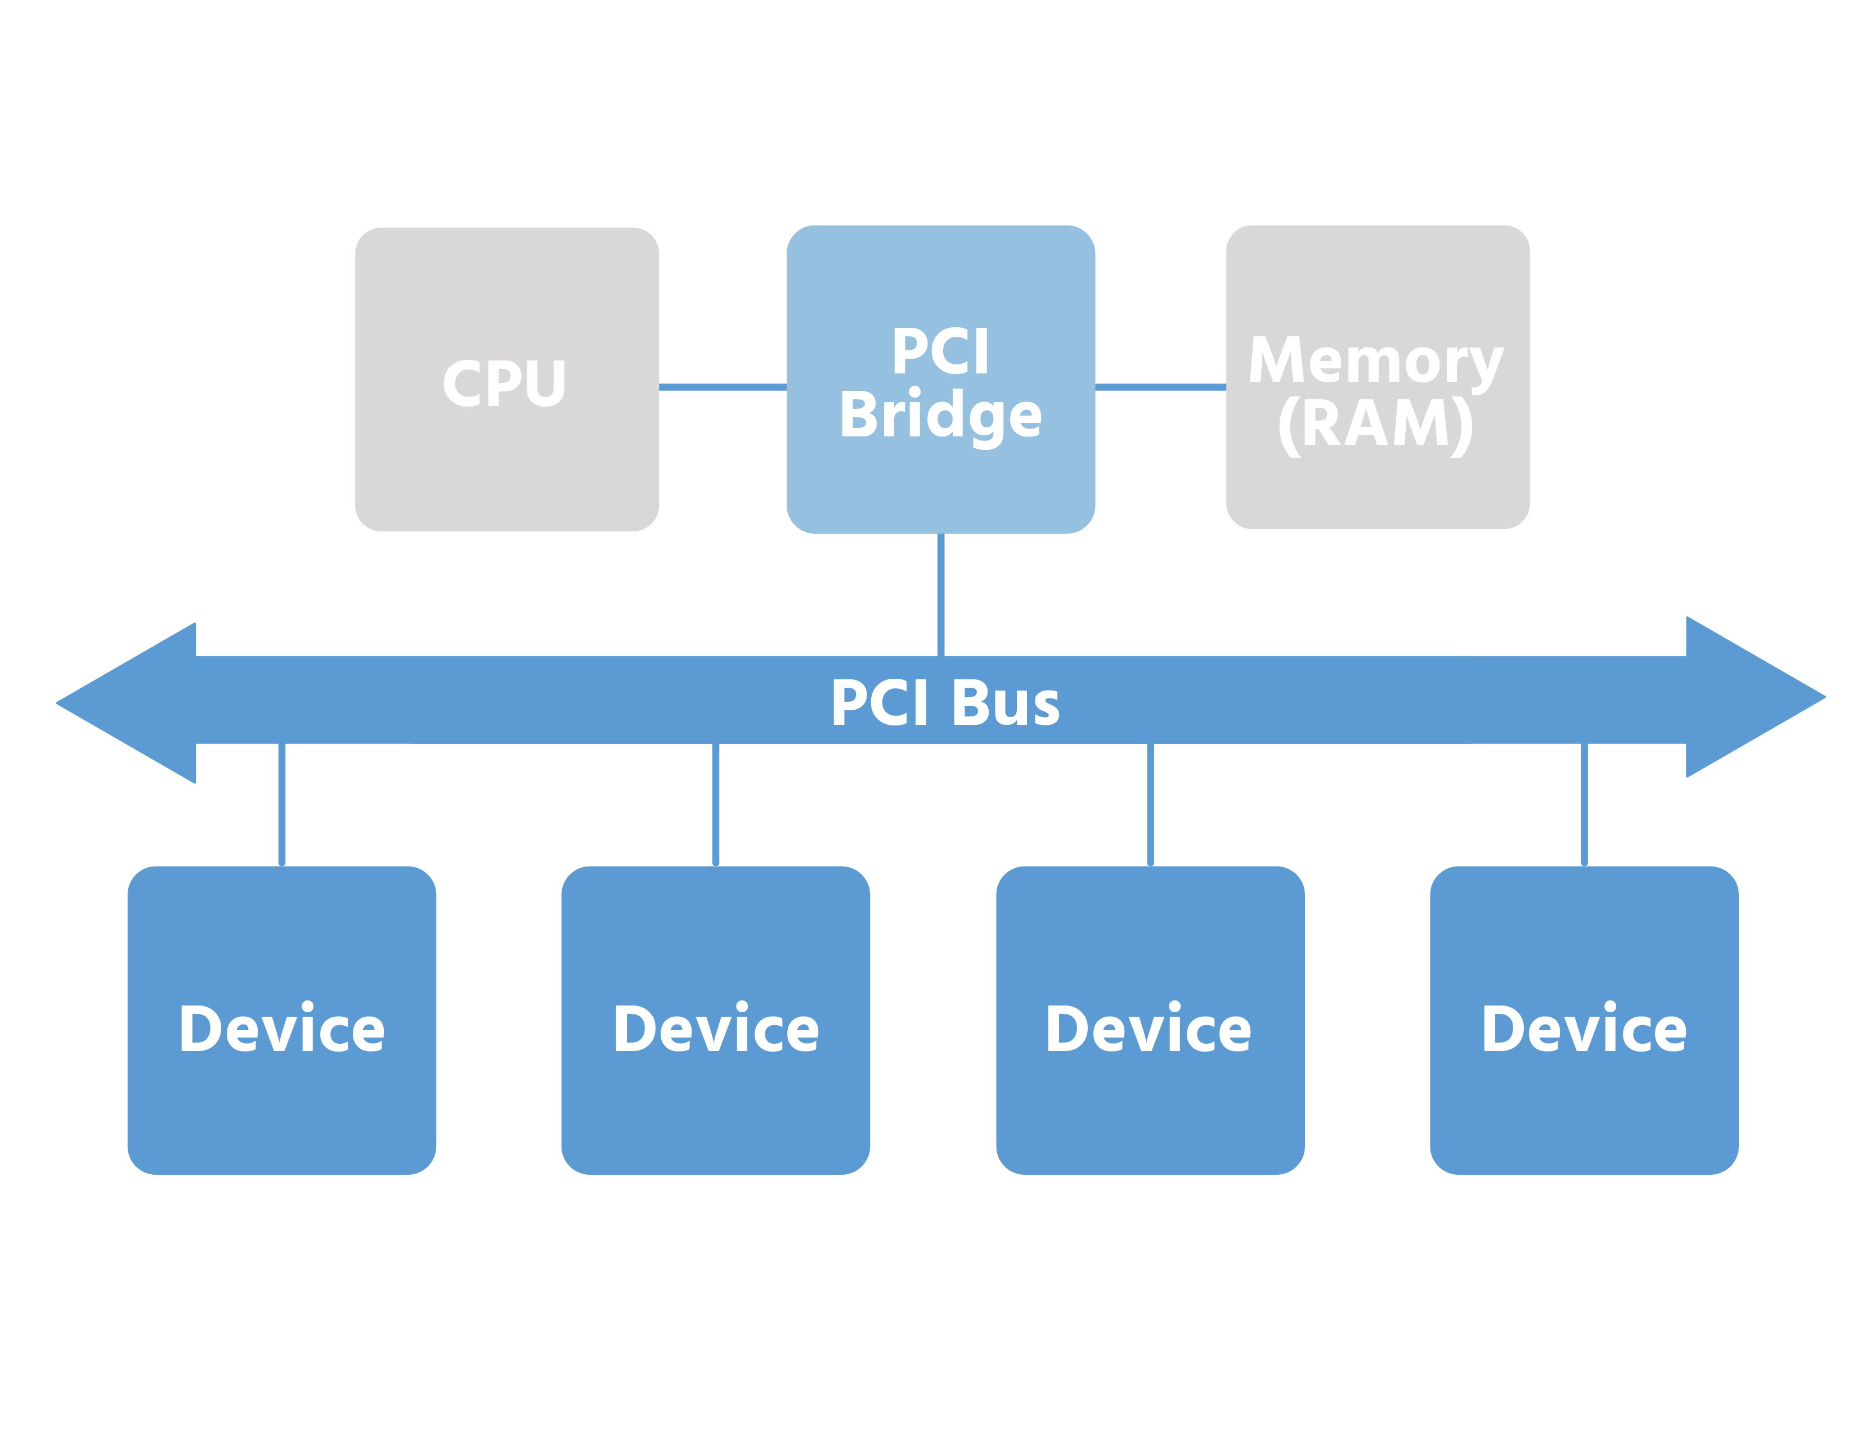

While there are files and directories in the /proc and /sys directories that contain hardware information, users can run various commands to view the multiple aspects of the hardware that makes up or is attached to the system.
First among these is the lspci command, designed to show the user the PCI buses and devices attached to them.
In the output of the command below you will see the various bridges listed; those are connections between the different buses on the system, interconnecting them with each other.
Additionally, users can view the USB controller, Ethernet, sound, and other video and peripheral connection buses and controllers.

sysadmin@localhost:~$ lspci
00:00.0 Host bridge: Intel Corporation 5520 I/O Hub to ESI Port (rev 13)
00:01.0 PCI bridge: Intel Corporation 5520/5500/X58 I/O Hub PCI Express Root Por
t 1 (rev 13)
00:03.0 PCI bridge: Intel Corporation 5520/5500/X58 I/O Hub PCI Express Root Por
t 3 (rev 13)
00:04.0 PCI bridge: Intel Corporation 5520/X58 I/O Hub PCI Express Root Port 4 (
rev 13)
00:05.0 PCI bridge: Intel Corporation 5520/X58 I/O Hub PCI Express Root Port 5 (
rev 13)
00:06.0 PCI bridge: Intel Corporation 5520/X58 I/O Hub PCI Express Root Port 6 (
rev 13)
00:07.0 PCI bridge: Intel Corporation 5520/5500/X58 I/O Hub PCI Express Root Por
t 7 (rev 13)
00:09.0 PCI bridge: Intel Corporation 7500/5520/5500/X58 I/O Hub PCI Express Roo
t Port 9 (rev 13)
00:14.0 PIC: Intel Corporation 7500/5520/5500/X58 I/O Hub System Management Regi
sters (rev 13)
00:14.1 PIC: Intel Corporation 7500/5520/5500/X58 I/O Hub GPIO and Scratch Pad
Registers (rev 13)
For viewing external devices, the lsusb command will show those that are specifically connected to the Universal Serial Bus (USB).
sysadmin@localhost:~$ lsusb
Bus 002 Device 006: ID 0624:0249 Avocent Corp. Virtual Keyboard/Mouse
Bus 002 Device 001: ID 1d6b:0002 Linux Foundation 2.0 root hub
Bus 006 Device 001: ID 1d6b:0001 Linux Foundation 1.1 root hub
Bus 005 Device 003: ID 0624:0248 Avocent Corp. Virtual Hub
Bus 005 Device 001: ID 1d6b:0001 Linux Foundation 1.1 root hub
Bus 001 Device 002: ID 0424:2514 Standard Microsystems Corp. USB 2.0 Hub
Bus 001 Device 001: ID 1d6b:0002 Linux Foundation 2.0 root hub
Bus 004 Device 001: ID 1d6b:0001 Linux Foundation 1.1 root hub
Bus 003 Device 001: ID 1d6b:0001 Linux Foundation 1.1 root hub
Another tool for viewing details about USB devices connected to the system is the usb-devices command. This is a script, which when executed will display information about the USB device that can otherwise be found in the /sys or /proc directories, including the USB device number, vendor, port and more:
sysadmin@localhost:~$ usb-devices | tail -n 15
S: Manufacturer=Avocent
S: Product=USB Composite Device-0
S: SerialNumber=20120430
C: #Ifs= 2 Cfg#= 1 Atr=c0 MxPwr=2mA
I: If#= 0 Alt= 0 #EPs= 1 Cls=03(HID ) Sub=01 Prot=01 Driver=usbhid
I: If#= 1 Alt= 0 #EPs= 1 Cls=03(HID ) Sub=01 Prot=02 Driver=usbhid

T: Bus=06 Lev=00 Prnt=00 Port=00 Cnt=00 Dev#= 1 Spd=12 MxCh= 2
D: Ver= 1.10 Cls=09(hub ) Sub=00 Prot=00 MxPS=64 #Cfgs= 1
P: Vendor=1d6b ProdID=0001 Rev=04.04
S: Manufacturer=Linux 4.4.0-72-generic uhci_hcd
S: Product=UHCI Host Controller
S: SerialNumber=0000:00:1d.1
C: #Ifs= 1 Cfg#= 1 Atr=e0 MxPwr=0mA
I: If#= 0 Alt= 0 #EPs= 1 Cls=09(hub ) Sub=00 Prot=00 Driver=hub
If the user requires more information than the lspci and lsusb commands show normally, simply append a -v option to either command and a great deal more information will be shown; taking the output from one line per item to a stanza-based output where each item is shown with multiple details.
To demonstrate, the output of the lspci -v command below displays only a single screen of output. The complete output would be 350+ lines long!

sysadmin@localhost:~$ lspci -v
00:00.0 Host bridge: Intel Corporation 5520 I/O Hub to ESI Port (rev 13)
Subsystem: Dell 5520 I/O Hub to ESI Port
Flags: fast devsel, IRQ 15
Capabilities: <access denied>
lspci: Unable to load libkmod resources: error -12

00:01.0 PCI bridge: Intel Corporation 5520/5500/X58 I/O Hub PCI Express
Root Port 1 (rev 13) (prog-if 00 [Normal decode])
Flags: bus master, fast devsel, latency 0, IRQ 25
Bus: primary=00, secondary=01, subordinate=01, sec-latency=0
Memory behind bridge: d6000000-d9ffffff
Capabilities: <access denied>
Kernel driver in use: pcieport

00:03.0 PCI bridge: Intel Corporation 5520/5500/X58 I/O Hub PCI Express
Root Port 3 (rev 13) (prog-if 00 [Normal decode])
Flags: bus master, fast devsel, latency 0, IRQ 26
Bus: primary=00, secondary=02, subordinate=02, sec-latency=0
Memory behind bridge: da000000-ddffffff
Finally, if a user has an issue with a component and is able to see that component mentioned in the lspci -v output, they can get more information about the malfunctioning component by referring to the multiple digit vendor and device code that prefaces the stanza for each device.
For example, to get more information about the IDE interface from the machine above, the user can run the lspci command with the -v and -s options followed by the vendor and device code as a parameter. The -s option will allow for a domain to be specified which will display information solely about devices in that domain:
sysadmin@localhost:~$ lspci -v -s 00:07.0
00:07.0 PCI bridge: Intel Corporation 5520/5500/X58 I/O Hub PCI Express
Root Port 7 (rev 13) (prog-if 00 [Normal decode])
Flags: bus master, fast devsel, latency 0, IRQ 30
Bus: primary=00, secondary=06, subordinate=06, sec-latency=0
Capabilities: <access denied>
Kernel driver in use: pcieport
lspci: Unable to load libkmod resources: error -12
To isolate the details of a specific USB device, find the vendor and device code in the output of the lsusb command, then use the lsusb command again, this time with the -v and -d options to get the isolated details of a device. The -d option will allow for a vendor or product ID to be specified, which will only display devices with that number. For example, to show details about Device 003, use the following command:
sysadmin@localhost:~$ lsusb -v -d 0624:0248 | less
Bus 005 Device 003: ID 0624:0248 Avocent Corp. Virtual Hub
Device Descriptor:
bLength 18
bDescriptorType 1
bcdUSB 1.10
bDeviceClass 0 (Defined at Interface level)
bDeviceSubClass 0
bDeviceProtocol 0
bMaxPacketSize0 64
idVendor 0x0624 Avocent Corp.
idProduct 0x0248 Virtual Hub
bcdDevice 0.00
iManufacturer 1
iProduct 2
iSerial 3
bNumConfigurations 1
Configuration Descriptor:
bLength 9
bDescriptorType 2
wTotalLength 59
bNumInterfaces 2
bConfigurationValue 1
:

Note
Type the Q key to exit the less command.

15.6 Hardware Subsystems
Linux distributions are more capable than ever, particularly in the area of device management. Devices built into the computer system are typically not removable unless the system is shut down and power disconnected for safety.
The concept of hotplugging - plugging devices into a port on a Linux system and having the running system automatically recognize the device correctly, then possibly run a program or execute a set of actions - works extremely well in modern Linux distributions due to a trio of device management tools.
The trio of device management tools starts with udev, a device management subsystem that manages the /dev directory and will automatically create and destroy node points (references to a device) for devices that are attached to the system, or subsequently removed.
To accomplish this, the udev subsystem maintains a pseudo-filesystem mounted as the /dev directory. The files in the /dev directory represent devices currently connected to the system. When the Linux kernel detects a device being connected, the udev daemon is used to create a device file (or node) in the /dev directory. If the device is removed, the udev daemon then removes the device node in the /dev directory.

Consider This
Older Unix systems tended to create all possible device nodes in /dev, just in case they were needed; udev only creates and maintains nodes for devices currently connected. This keeps the directory nice and neat and clean, easy to troubleshoot, and to determine what’s actually present and attached to the system.
Configuration files in the /etc/udev/rules.d directory are used to define rules that assign specific ownerships, permissions, and persistent names to these device files. These files allow a user to configure how udev handles the devices it manages.
The second part of the device management trio is the sysfs subsystem, which is another in-memory filesystem that consists of directories and text files that contain values about the kernel’s operation and configuration.
The sysfs subsystem is typically mounted as the /sys subdirectory. The /sys directory and sysfs exist because there is a need to provide information about the kernel, its attributes, and contents to users via programs such as ps, top, and other programs that provide information to the regular user through command line output. To view the contents of the /sys directory on the system, use the following command:

sysadmin@localhost:~$ ls /sys
block class devices fs kernel power
bus dev firmware hypervisor module

Modern systems (kernels 2.5 and beyond) use sysfs to express kernel information into the /sys directory because the procfs subsystem (and the /proc directory) had become increasingly busy and cluttered. Like the /sys directory, the /proc directory contains information about the system hardware, including devices and the kernel. However, as an ever-larger set of kernel subsystems started using the /proc directory to express their structures and expose kernel information for the system user to access, the /proc directory became busy and somewhat jumbled in nature, like a closet that has too many items packed into it. In comparison, the /sys directory structure forces a certain austerity and cleanliness by design, as the rules for using the /sys directory are “one item per file” and no more.
This allows for a much neater and easier to understand expression of kernel objects and their attributes, and allows for easier documentation and programming.
For example, in the /proc directory, you can use the tree command to show a hierarchical tree of the files and directories that are contained there. However, the listing will be many pages long, so using the less command will be of great benefit in scrolling up and down and looking at the output.

sysadmin@localhost:~$ tree /proc | less
/proc
|-- 1
| |-- attr
| | |-- current
| | |-- exec
| | |-- fscreate
| | |-- keycreate
| | |-- prev
| | `-- sockcreate
| |-- autogroup
| |-- auxv
| |-- cgroup
| |-- clear_refs
| |-- cmdline
| |-- comm
| |-- coredump_filter
| |-- cpuset
| |-- cwd -> [Error\ reading\ symbolic\ link\ information]
| |-- environ
| |-- exe -> [Error\ reading\ symbolic\ link\ information]
| |-- fd [error opening dir]
| |-- fdinfo [error opening dir]
| |-- gid_map
:

Many of the files in the /proc directory will contain more than a single value, whereas the files in the /sys directory are designed to be simpler and contain a single text value, making them more predictable and easier to use.
Finally, the last of the trinity of device management tools is the Hardware Abstraction Layer (HAL) daemon, (aka hald). As the kernel detects a device, it puts the information about the device into the appropriate files in the /sys directory. The hald is responsible for discovering and maintaining a list of connected devices and their attributes by monitoring the files in the /sys directory.
To view the list of devices and their attributes that have been stored by hald, execute the lshal command. The lshal command's output will likely contain thousands of lines of text. To see information about specific devices, make use of the grep command, as shown in the following example:

Note
The following example may not match the output in our virtual environment.

sysadmin@localhost:~$ lshal | grep cdrom | grep true
storage.cdrom.dvd = true (bool)
storage.cdrom.mrw = true (bool)
storage.cdrom.mrw_w = true (bool)
storage.cdrom.support_media_changed = true (bool)
storage.cdrom.support_multisession = true (bool)

Consider This
Since 2011, hald has been deprecated by many of the leading Linux distributions and has been eliminated from recent releases. In its place, the udev subsystem has been expanded, along with integrating Systemd. Keep in mind that hald may still be used on legacy systems, so questions related to it may still be on the exam.

Finally, when programs want information about devices, they are able to query hald by using D-Bus.

D-Bus is a method of allowing inter-process communications, primarily the communications between components in the Linux Desktop environments, KDE and GNOME. Without D-Bus, desktop environments will communicate between components with many separate processes, each requiring its own one-to-one communication with other components. This produces a confusing communications environment and can contribute to inefficiency and a lack of reliability and instability in the graphics subsystem.
D-Bus is a software bus that allows individual and groups of processes to communicate on a single virtual bus or channel, a feature called Interprocess Communication (IPC).

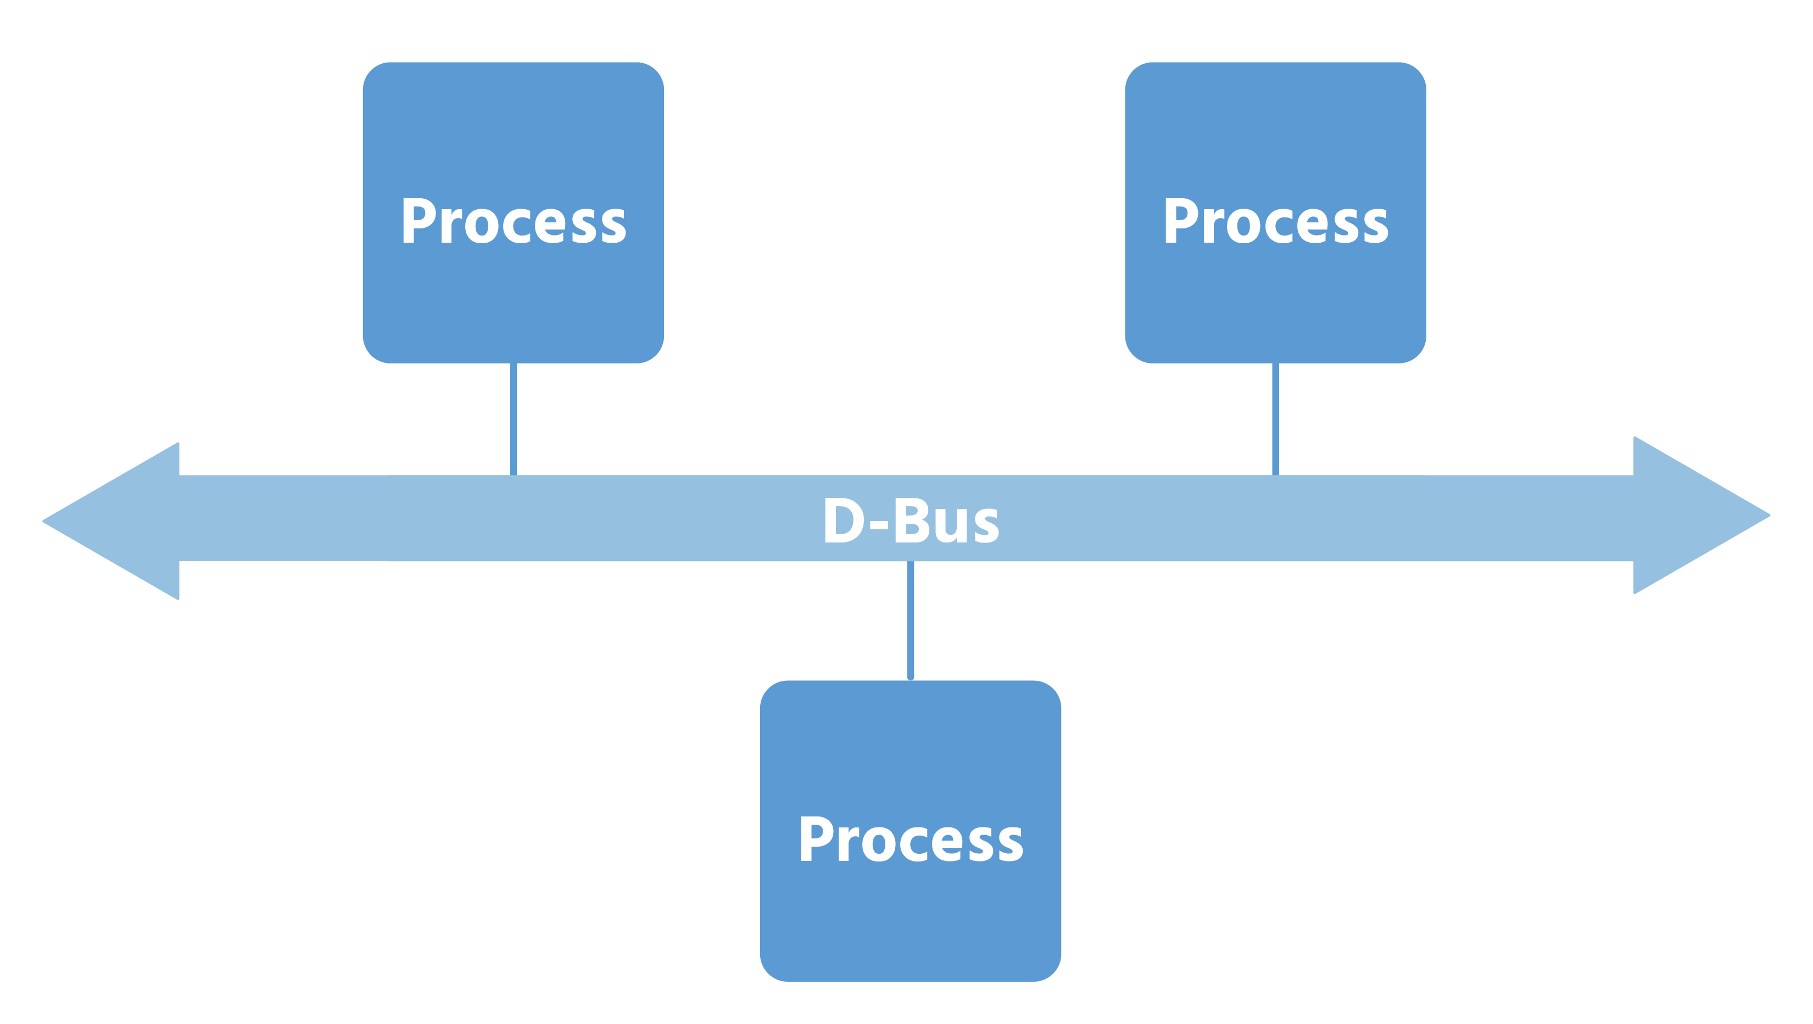

D-Bus operates with an overall system bus that is available to all the processes on the system, whether they are system or user-related processes. Additionally, there is a session bus for each of the logged-in users for the processes that are connected to that user’s desktop session.
Programs can also register themselves with D-bus to receive notifications from hald when specific types of hardware events occur. When the state of a hardware device changes, hald uses D-Bus to send notifications to those programs that have been registered for that type of hardware event.
Systemd typically uses udev for its device management tasks. The job of udev is to let your computer know of device events, among other tasks. A user will likely not have to deal with udev directly unless there are archaic or odd devices that need to be made available and manual configuration to be done.
Udev can manage any device that shows a link in the /dev directory when attached to the system, which udev is able to do through scripts known most commonly as udev rules. At their simplest, a udev rule is something that performs an action when a device is inserted, such as a thumb drive.
For the majority of devices, the kernel will know exactly what to do already. For example, if you plug in a USB thumb drive, the kernel will likely mount it to one of the available spots in the /dev/sd* devices directory. If it does, you can access and use it, depending on its format and other compatibility settings.
Udev can detect when a device has been attached or removed. Udev rules can establish custom actions that are taken when these events occur.
Writing udev rules is beyond the scope of this course; however, you can use the udevadm command to view the pertinent information that would allow you to directly specify a device within a udev rule when it’s attached, and then execute specific actions on that device.
There are two ways to do this:
- When a device is inserted.
- When you want to query a device that is either already attached or is built-in to the system, such as the main storage device (the /dev/sda device for example.)
To watch what happens when a device is inserted or attached, run the following command:
sysadmin@localhost:~$ udevadm monitor
monitor will print the received events for:
UDEV: the event udev sends out after rule processing
KERNEL - the kernel uevent
To query an already-attached device for the necessary information, execute the command below:
sysadmin@localhost:~$ udevadm info /dev/sda
P: /devices/pci0000:00/0000:00:07.1/ata1/host0/target0:0:0/0:0:0:0/block/sda
N: sda
S: disk/by-id/ata-VMware_Virtual_IDE_Hard_Drive_00000000000000000001
S: disk/by-id/wwn-0x5000c2947bd39bdb
S: disk/by-path/pci-0000:00:07.1-ata-1
E: DEVLINKS=/dev/disk/by-id/wwn-0x5000c2947bd39bdb /dev/disk/by-path/pci-0000:00:07.1-ata-1 /dev/disk/by-id/ata-VMware_Virtual_IDE_Hard_Drive_00000000000000000001
E: DEVNAME=/dev/sda
E: DEVPATH=/devices/pci0000:00/0000:00:07.1/ata1/host0/target0:0:0/0:0:0:0/block/sda
E: DEVTYPE=disk
The two preceding commands and a short study of the udev man pages about rules will inform beginners and system administrators on how to create custom rules for devices.

15.7 Kernel Modules
In addition to detecting devices, the Linux kernel may load software called kernel modules to support the device. Some devices are so common that the software to support them is normally compiled into the kernel itself, for example, the software for the CPU. Other devices that are not as common will have modules that are only loaded if the device is detected, for example, a specific network card.
The kernel module may even load additional software such as firmware from a file or from the device itself. One concern of some users is that these firmware files may contain code that is not open source, meaning there is no way for a user to know what the code does exactly because it is proprietary and not shared with the public. If the kernel loads "non-free" code, then the kernel is considered to be "tainted" as the code of the kernel itself is free.
Kernel modules can be used for more than supporting devices; since modules are simply software that is able to run within the kernel, they are able to be used for virtually anything. Some common uses besides device drivers include filesystems modules, networking protocols modules, and cryptographic algorithms modules.

To view the list of loaded kernel modules, use the lsmod command:

sysadmin@localhost:~$ lsmod
Module Size Used by
af_packet_diag 16384 0
netlink_diag 16384 0
dccp_diag 16384 0
dccp 73728 1 dccp_diag
udp_diag 16384 0
unix_diag 16384 0
tcp_diag 16384 0
inet_diag 20480 3 tcp_diag,dccp_diag,udp_diag
xt_nat 16384 700
xt_tcpudp 16384 718
Output Omitted...

The columns of data in the output above are:
Module
dccp 73728 1 dccp_diag
The name of the loaded module.
Size
dccp 73728 1 dccp_diag
The size in bytes of the module.
Used by
dccp 73728 1 dccp_diag
Indicates how many "things" depend on the current module being loaded. These "things" could include other modules, processes, or other features (such as a filesystem being mounted).
dccp 73728 1 dccp_diag
Shows the name of the module that depends on the current module.
It may be the case that you need to find modules based on the name, size, or dependencies. To filter the output of the lsmod command to only show specific modules, use the grep command:

Note
The following examples may not match the output in the virtual environment.

sysadmin@localhost:~$ lsmod | grep ext4
ext4 465245 2
crc16 12503 1 ext4
mbcache 17476 1 ext4
jbd2 82480 1 ext4
The output above shows the modules that work together to support the ext4 filesystem. In other words, the ext4 filesystem depends on these modules.
Additionally, you can get more details about a module by using the modinfo command. For example, to learn more about the snd kernel module, execute the following command:
sysadmin@localhost:~$ modinfo snd
filename: /lib/modules/3.13.0-35-generic/kernel/sound/core/snd.ko
alias: char-major-116-*
license: GPL
description: Advanced Linux Sound Architecture driver for soundcards.
author: Jaroslav Kysela <perex@perex.cz>
license: GPL
description: Jack detection support for ALSA
author: Mark Brown <broonie@opensource.wolfsonmicro.com>
srcversion: 0EBCEABF53FC967306ED228
depends: soundcore
intree: Y
vermagic: 3.13.0-35-generic SMP mod_unload modversions
signer: Magrathea: Glacier signing key
sig_key: B1:41:4A:E9:6C:1B:0E:BB:7C:14:1F:A4:05:C1:F6:C9:8E:8A:66:F0
sig_hashalgo: sha512
parm: debug:Debug level (0 = disable) (int)
parm: slots:Module names assigned to the slots. (array of charp)
parm: major:Major # for sound driver. (int)
parm: cards_limit:Count of auto-loadable soundcards. (int)
To get a list of all available modules, use the modprobe -l command:
sysadmin@localhost:~$ modprobe -l | head
kernel/arch/x86/kernel/cpu/mcheck/mce-inject.ko
kernel/arch/x86/kernel/cpu/cpufreq/powernow-k8.ko
kernel/arch/x86/kernel/cpu/cpufreq/mperf.ko
kernel/arch/x86/kernel/cpu/cpufreq/acpi-cpufreq.ko
kernel/arch/x86/kernel/cpu/cpufreq/pcc-cpufreq.ko
kernel/arch/x86/kernel/cpu/cpufreq/p4-clockmod.ko
kernel/arch/x86/kernel/test_nx.ko
kernel/arch/x86/kernel/microcode.ko
kernel/arch/x86/crypto/aes-i586.ko
kernel/arch/x86/crypto/twofish-i586.ko
Normally, kernel modules are loaded automatically by the kernel. To load a module manually, execute the modprobe command with the name of the module.

For example, to load the ext4 module, execute the modprobe ext4 command. Note that if the module is loaded successfully, there is no output to this command. A quick use of the lsmod command will show if the module was loaded properly.

One nice feature of the modprobe command is that it will automatically load all dependency modules, so in the case of loading the ext4 module, it would automatically load the crc16, mbcache, and jdb2 modules.

The modprobe command can also be used to remove modules from memory with the -r option. Executing the modprobe -r ext4 command would remove the ext4 module from memory, and it will automatically remove the crc16, mbcache, and jdb2 modules from memory as long there was nothing else that depended upon them:

sysadmin@localhost:~$ lsmod | grep ext4
ext4 465245 2
crc16 12503 1 ext4
mbcache 17476 1 ext4
jbd2 82480 1 ext4
sysadmin@localhost:~$ modprobe -r ext4
sysadmin@localhost:~$ lsmod | grep ext4

