NDG Introduction to Linux I - Chapter 6: Finding Files

Objectives

This chapter will cover the following exam objectives:
103.3: Perform basic file management v2
Weight: 4
Candidates should be able to use the basic Linux commands to manage files and directories.
Key Knowledge Areas:
Using find to locate and act on files based on type, size, or time.
Section 6.3.2
104.7: Find system files and place files in the correct location v2
Weight: 2
Candidates should be thoroughly familiar with the Filesystem Hierarchy Standard (FHS), including typical file locations and directory classifications.
Key Knowledge Areas:
Understand the correct locations of files under the FHS.
Section 6.2
Find files and commands on a Linux system.
Section 6.3
Know the location and purpose of important file and directories as defined in the FHS.
Section 6.2

Key Terms

c/etc/updatedb.conf
A configuration file for the updatedb utility. In some implementations, updatedb.conf is a shell script that allows more flexibility in defining variables
Section 6.3.1

find
Command used to search for files in a directory hierarchy. find searches the directory tree rooted at each given file name by evaluating the given the expression from left to right.
Section 6.3.2

locate
Command used to search for files by name. locate reads one or more databases prepared by the updatedb utility and writes file names matching at least one of the PATTERNs to standard output.
Section 6.3.1

type
Command that indicates how a name would be interpreted if used as a command. When using the type utility, the path to the command will be displayed.
Section 6.3.5

updatedb
The updatedb utility creates or updates a database to be used by the locate utility.
Section 6.3.1

whereis
Command that is used to locate source/binary and manuals sections for specified rules. This will locate binary, source, and manual pages for a command.
Section 6.3.3

which
Command that returns the pathnames of the files, or links, which would be executed in the current environment. It does this by searching the PATH for executables matching the names of the arguments.
Section 6.3.4

Content

6.1 Introduction
In Linux, everything is considered a file. Files are used to store data such as text, graphics, and programs. Directories are a type of file used to store other files. This chapter will cover how to find files, which requires knowledge about the Linux directory structure, typically called a filesystem and the filesystem standards supported by the Linux Foundation; the
Filesystem Hierarchy Standard (FHS). You will also learn about how to find files and commands within the Linux filesystem from the command line.

6.2 Filesystem Hierarchy Standard
The open source licensing of many Linux components makes it possible for anyone to create their own distribution. Most people start with a well-known distribution, make modifications, and release a fork of the original.
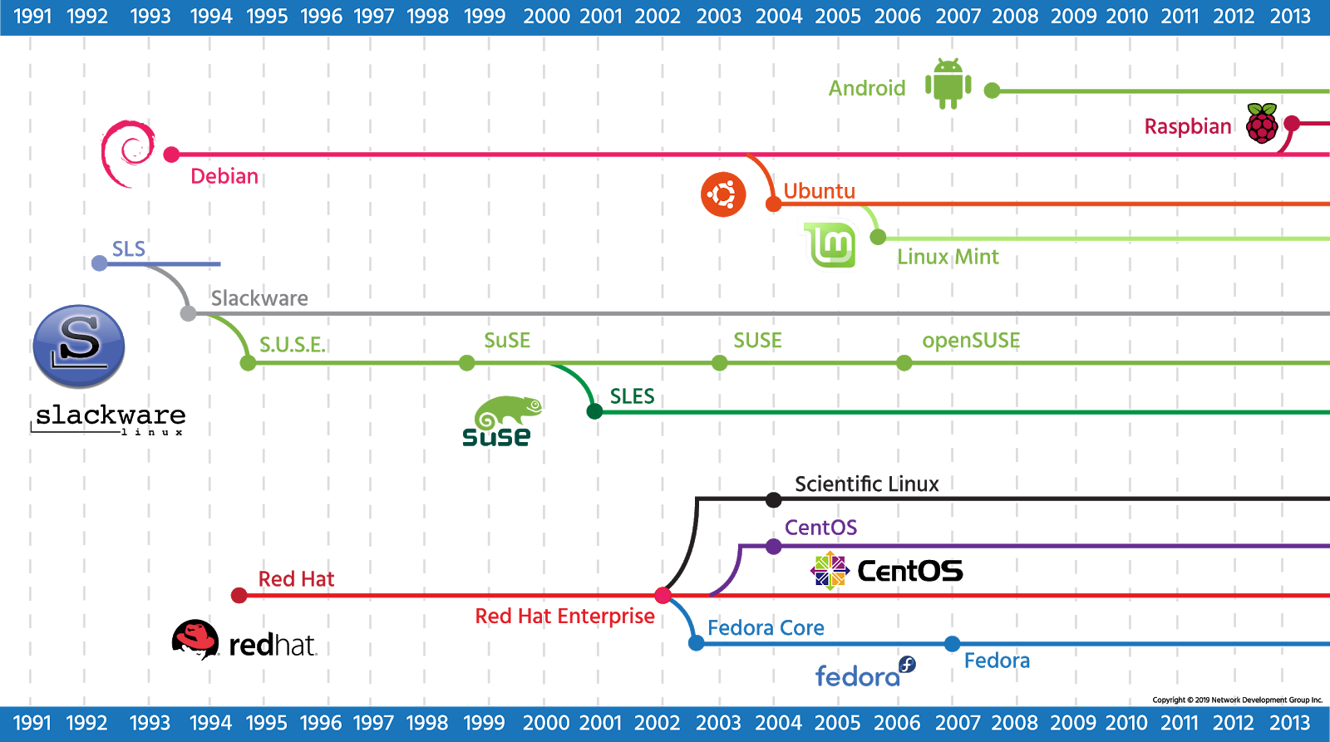

Consider This
An illustration containing many more of the distributions and their origins can be found at http://futurist.se/gldt/wp-content/uploads/12.02/gldt1202.svg.

Since there are so many Linux distributions, it would be expected that numerous people would change the names of the files and folders, eventually making the distributions incompatible. This makes a basic agreement necessary concerning the naming and location of important system files and directories.

The Filesystem Hierarchy Standard (FHS) is an agreement to standardize the names and locations of directories and their content for use within most Linux filesystems. It helps to know what directories to expect to find, and what files one should expect to find in them. More importantly, it allows programmers to write programs that will be able to work across a wide variety of systems that conform to this standard.
During the development of the first series of this standard from 1994 to 1995, it was known as the Filesystem Standard (FSSTND). When the second series was started in 1997, it was renamed to the Filesystem Hierarchy Standard (FHS). The final 2.3 version of this second series of this FHS standard was published in 2004 at http://refspecs.linuxfoundation.org/fhs.shtml. In 2011, a draft version of the third series of this standard was published at http://www.linuxbase.org/betaspecs/fhs/fhs.html.
The Linux file structure is best visualized as an upside-down tree, with directories and files branching out from the top-level root / directory. While the actual standard details many more directories than listed below, the image and table highlight some of the most important ones to know.

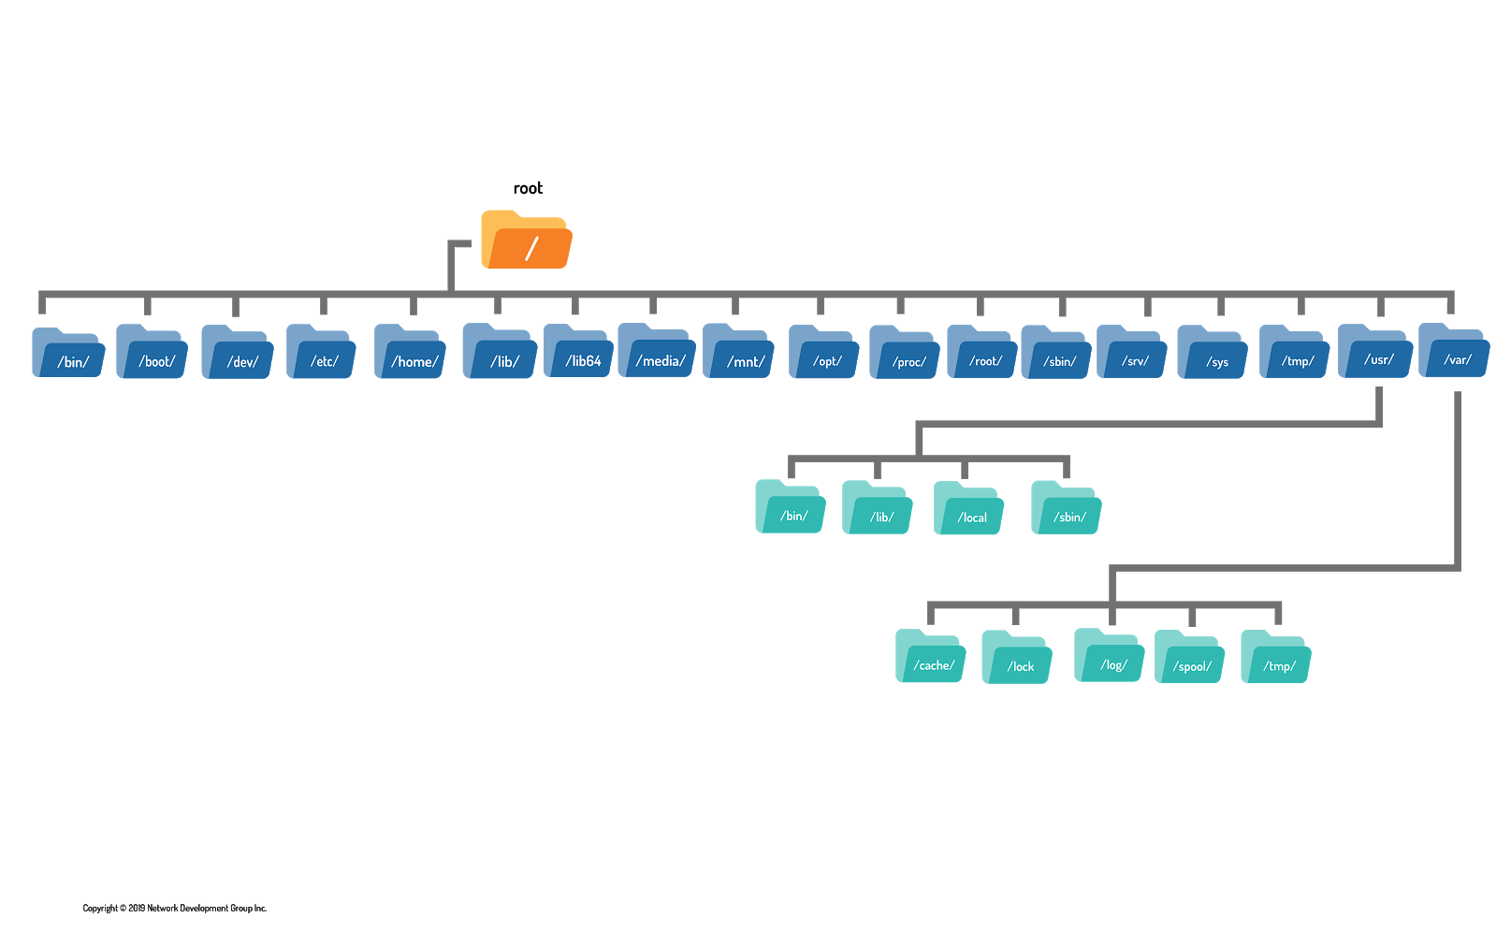

Directory | Purpose
/ | The root of the primary filesystem hierarchy.
/bin | Contains essential user binary executables.
/boot | Contains the kernel and bootloader files.
/dev | Populated with files representing attached devices.
/etc | Configuration files specific to the host.
/home | Common location for user home directories.
/lib | Essential libraries to support /bin and /sbin executables.
/mnt | Used to attach (mountpoint) external storage devices
/opt | Optional third-party add-on software.
/root | Home directory for the root user.
/sbin | Contains system or administrative binary executables.
/srv | May contain data provided by system services.
/tmp | Location for creating temporary files.
/usr | The root of the secondary filesystem hierarchy.
/usr/bin | Contains the majority of the user commands.
/usr/include | Header files for compiling C-based software.
/usr/lib | Shared libraries to support /usr/bin and /usr/sbin.
/usr/local | The root of the third filesystem hierarchy for local software.
/usr/sbin | Non-vital system or administrative executables.
/usr/share | This directory contains subdirectories with specific application data, that can be shared among different architectures of the same OS.
/usr/share/dict | Contains the word lists used by spell checkers
/usr/share/doc | Documentation for software packages.
/usr/share/info | Information pages for software packages.
/usr/share/locale | Locale information.
/usr/share/man | Location for man pages.
/usr/share/nls | Native language support files.

Vendors of Linux distributions have continued to make some changes, even though a new version of the standard has not been published in over ten years. Two notable new additions include the /run directory and the /sys directory. The /run directory is being considered for use in the forthcoming FHS versions to contain volatile data that changes at runtime. Previously, this data was supposed to be stored under the /var/run directory, but due to the unavailability of this directory at boot time, this data can become scattered in other places, such as hidden files in the /dev directory.
The /sys directory in some traditional UNIX systems was used to hold files related to the kernel. In modern Linux systems, the /sys directory is used to mount the sysfs pseudo-filesystem. This filesystem is used to export information about kernel objects and their relationships to each other. The kernel objects are represented by directories, and the files that they contain are named for the attributes of those objects. The contents of the files represent the value for that attribute. Symbolic links are used to represent relationships between objects.
Another notable change that some Linux distributions are making is the conversion of the /bin, /sbin and /lib directories into symbolic links which point to /usr/bin, /usr/sbin and /usr/lib, respectively. All user executables are now in the /usr/bin directory, administrator executables are now in the /usr/sbin directory, and the libraries to support all these executables are now in the /usr/lib directory.

Note
A symbolic link, also called a soft link, is simply a file that points to another file.
Links will be covered in greater detail later in the course.

The merger of the /bin, /sbin and /lib directories into the /usr/bin, /usr/sbin and /usr/lib directories has been somewhat controversial. Many administrators are comfortable with the long-standing subdivisions of these files into different directories.
Because of the way that UNIX booted, the /bin, /sbin and /lib directories had to be part of the root filesystem as they contain critical boot executables. Some developers now argue that the reason for having them split is no longer valid. In early versions of UNIX, the developers had two filesystems of about 1.5 MiB each on two separate disks for the root filesystem and the /usr filesystem. As the root filesystem started to become full, the developers decided to move some of the executable files that were in the /bin and /sbin directories that were not essential to booting the system into the corresponding directories /usr/bin and /usr/sbin (in the separate /usr filesystem).

The FHS standard categorizes each system directory in a couple of ways for security purposes:

Shareable / Unshareable
Shareable files can be stored on one host and used on others. For instance, /var/www is often used as the root directory of a web server, which shares files with other hosts. Another example is the user home directories.
Unshareable files should not be shared between hosts. These include process states in the /var/run directory and the /boot directory.

Variable / Static
Static files generally do not change, including library files and documentation pages. An example is the info pages located at /usr/share/info.
Variable files normally change during the execution of programs. The /var/run directory contains files that are both variable and unshareable.

The table below summarizes the main distinctions between file types:

 | Shareable | Unshareable
Static | /usr  /opt | /etc  /boot
Variable | /var/mail  /var/spool/news | /var/run  /var/lock

6.3 Finding Files and Commands
Most operating systems allow users to search for specific files in the filesystem. A GUI typically provides a search tool that makes it possible to find files and applications. However, there are a few commands available for searching files and commands from the CLI. Both the locate and find commands are useful for searching for a file within the filesystem. While both commands perform similar tasks, each does so by using a different technique, with its own distinct advantages and disadvantages.

6.3.1 locate Command
Of the two main search commands, the locate command can be described as fast, but always potentially out-of-date. Its speed comes from the fact that the locate command searches a database that contains the location of the files on the filesystem, but that database needs to be updated to be accurate.
locate [OPTION]... PATTERN...
In its simplest form, the locate command accepts a search string as an argument. For example, to find a file named passwd, use the following command:
sysadmin@localhost:~$ locate passwd
/etc/passwd
/etc/passwd-
/etc/pam.d/chpasswd
/etc/pam.d/passwd
/etc/security/opasswd
/usr/bin/gpasswd
/usr/bin/passwd
/usr/lib/tmpfiles.d/passwd.conf
/usr/sbin/chgpasswd
/usr/sbin/chpasswd
/usr/sbin/update-passwd
/usr/share/base-passwd
/usr/share/base-passwd/group.master
/usr/share/base-passwd/passwd.master
/usr/share/doc/base-passwd
/usr/share/doc/passwd
/usr/share/doc/base-passwd/README
/usr/share/doc/base-passwd/changelog.gz
/usr/share/doc/base-passwd/copyright
/usr/share/doc/base-passwd/users-and-groups.html
/usr/share/doc/base-passwd/users-and-groups.txt.gz
/usr/share/doc/passwd/NEWS.Debian.gz
A few things to consider when using the locate command:
- The locate command will only return results of files that the current user would normally have access to.
- The locate command will display all files that have the search term anywhere in the file name. For example, the search term passwd would match both /etc/passwd and /etc/thishaspasswdinit.
- Like most things in Linux, the locate command is case sensitive. For example, the search term passwd would not match a file named /etc/PASSWD. To have the locate command not be case sensitive, use the -i option.

Note
The locate command accepts the -r option to use regular expressions in the search pattern which provides a more powerful way to search for files.
Regular expressions will be covered in greater detail later in the course.
The locate command is dependent on a database. This database can be updated manually by an administrator using the updatedb command, though typically this command is run automatically every day through cron, a system scheduling service that runs commands on a particular recurring schedule.
When executed, the updatedb command creates a database of all files that it finds on the computer for quick searching. This command can only be executed by a user with administrative access, which can be achieved using the sudo command:
sysadmin@localhost:~$ sudo updatedb
[sudo] password for sysadmin:
Note
The sudo command allows users to execute commands using the privileges of another user. The sudo command is the preferred way to run commands with escalated privileges, and the root user is assumed by default.
The sudo command circumvents the need to login as root; this is bad practice because all commands are executed with root privileges. This is seldom necessary and increases the risk that potentially dangerous commands may be executed as root, even though root privileges were not required or desired.
Accordingly, some Linux distributions now prevent root logins entirely and require sudo to escalate privileges. The system administrator must specifically authorize each user that can use the sudo command and must specify which user(s) they can impersonate. For Linux system administrators, sudo plays a vital role and is among the most frequently-used commands.
The updatedb command can be told not to search a particular name, path, or filesystem by changing the corresponding line in its configuration file, /etc/updatedb.conf. Below is an example of the default file in its entirety:
sysadmin@localhost:~$ cat /etc/updatedb.conf
PRUNE_BIND_MOUNTS="yes"
# PRUNENAMES=".git .bzr .hg .svn"
PRUNEPATHS="/tmp /var/spool /media /var/lib/os-prober /var/lib/ceph /home/.ecryp
tfs /var/lib/schroot"

PRUNEFS="NFS nfs nfs4 rpc_pipefs afs binfmt_misc proc smbfs autofs iso9660 ncpfs
coda devpts ftpfs devfs devtmpfs fuse.mfs shfs sysfs cifs lustre tmpfs usbfs ud
f fuse.glusterfs fuse.sshfs curlftpfs ceph fuse.ceph fuse.rozofs ecryptfs fusesm
b"
The /etc/updatedb.conf file can be edited as the root user. Any name, path, or filesystem that is listed in the file on the appropriate line will not be added to the database. Any line starting with the # symbol will be ignored since it is commented out.
Since the locate command works with a database, it is able to work very quickly even on a system with hundreds of thousands of files. However, if you want to use the locate command to search for a file that was created very recently, it will fail to find the file if the database hasn't been updated since the file creation.
Likewise, the database may contain outdated information about files that might have existed in the very recent past, so the command will report them incorrectly as still existing.
The following example demonstrates the consequences that arise when the database is not updated in real time:

1. A new file called lostfile isn't initially found by the locate command.
sysadmin@localhost:~$ touch lostfile
sysadmin@localhost:~$ locate lostfile
2. After the database is updated by the updatedb command, the locate command can find the lostfile file.
sysadmin@localhost:~$ sudo updatedb
[sudo] password for sysadmin:
sysadmin@localhost:~$ locate lostfile
/home/sysadmin/lostfile
3. After the lostfile file has been deleted, the locate command will still report that the file exists.
sysadmin@localhost:~$ rm lostfile
sysadmin@localhost:~$ locate lostfile
/home/sysadmin/lostfile

6.3.2 find Command
If you want to search for files that are currently in the filesystem, then you should use the find command. The find command is slower than the locate command because it searches directories in real time; however, it doesn't suffer from problems associated with an outdated database.
The find command expects a directory as the first argument. This will be the starting point of the search. The find command will search this directory and all of its subdirectories. If no directory is specified, then the find command will start the search at the current directory.
find [OPTIONS]... [starting-point...] [expression / (criteria)]

Note that the period . character refers to the current directory in the following example, but the current directory could also be referred to using the ./ notation. The find command uses the -name option to search for files by name, in this case, the Downloads directory.

sysadmin@localhost:~$ find . -name Download
sysadmin@localhost:~$ find . -name Downloads
./Downloads
sysadmin@localhost:~$ find . -name Dow*
./Downloads
sysadmin@localhost:~$ find . -name 'Do*'
./Documents
./Downloads
The first search yielded no results because the string must match the exact name of the file, not just part of the name. The third command demonstrates that globbing can be used, and the fourth command demonstrates multiple matches (notice that single quotes were added so that the find command will interpret the glob, rather than the shell).
If the search for the Downloads directory was conducted from the root / directory, many errors would arise:
sysadmin@localhost:~$ find / -name Downloads
find: '/var/lib/apt/lists/partial': Permission denied
find: '/var/cache/ldconfig': Permission denied
find: '/var/cache/apt/archives/partial': Permission denied
find: '/var/spool/rsyslog': Permission denied
find: '/var/spool/cron/crontabs': Permission denied
find: '/etc/ssl/private': Permission denied
find: '/root': Permission denied
Output Omitted...
These errors can be ignored for now, but just be aware that errors like these are typical when either a regular user is attempting to search root-only areas, or when the root user is attempting to search areas that are dedicated to the system’s processes.
The find command also offers many options for searching files, unlike the locate command which searches only for files based on file name. The following table illustrates some of the more commonly used criteria:
⁠⁠
Example | Meaning
-iname LOSTFILE | Case insensitive search by name.
-mtime -3 | Files modified less than three days ago.
-mmin -10 | Files modified less than ten minutes ago.
-size +1M | Files larger than one megabyte.
-user joe | Files owned by the user joe.
-nouser | Files not owned by any user.
-empty | Files that are empty.
-type d | Files that are directory files.
-maxdepth 1 | Do not use recursion to enter subdirectories; only search the primary directory.
If multiple criteria are specified, then all criteria must match as the find command automatically assumes a logical AND condition between criteria, meaning all of the conditions must be met. This could be explicitly stated by using the -a option between criteria. For example, the Downloads directory must also be owned by the sysadmin user in order for the find command to produce a result in the following example:
sysadmin@localhost:~$ find . -user sysadmin -a -name Downloads
./Downloads
Logical OR conditions can be specified between criteria with the -o option, meaning at least one of the conditions must be true. The following output lists files that are either named Downloads or owned by the sysadmin user.
sysadmin@localhost:~$ find . -user sysadmin -o -name Downloads
.
./Public
./Downloads
./Pictures
./Videos
./.selected_editor
./.profile
./.bash_logout
...
Logical groupings of criteria can also be specified using parentheses. Be careful to precede the parentheses with a backslash or to use single quotes around them so that the shell doesn't attempt to interpret them as special characters. Also, as mentioned previously, use quotes around any globs that the find command should interpret instead of the shell, as shown in the following example:
sys@lhost:~$ find . -iname 'desk*' -o \( -name Downloads -a -user sysadmin \)
./Desktop
./Downloads
In plain text, the find command in the preceding example will return files in the current directory, with the non-case sensitive name starting with desk OR files with the exact name Downloads owned by the sysadmin user.
By default, the find command simply prints the names of the files that it finds. To generate output showing additional file details, similar to the ls -l command, you can specify the -ls option:
sys@lhost:~$ find . -iname 'desk*' -ls -o \( -name Downloads -a -user ubuntu -ls \)
15871 4 drwxrwxr-x 2 ubuntu ubuntu 4096 Nov 18 13:24 ./Downloads
15869 4 drwxrwxr-x 2 ubuntu ubuntu 4096 Nov 18 13:24 ./Desktop
Note that the -ls option must be added after specifying the find criteria, otherwise a list of all files in the starting point will be shown (this is a common mistake, that is also made in the NDG material).
To make the output exactly like the output of the ls -l command, use the -exec option to execute ls -l on each file found. For example:
sysadmin@localhost:~$ find -name 'Documents' -exec ls -l {} \;
total 1100
drwxr-xr-x 5 sysadmin sysadmin 4096 Mar 8 19:10 School
drwxr-xr-x 2 sysadmin sysadmin 4096 Mar 8 19:10 Work
-rw-r--r-- 1 sysadmin sysadmin 39 Mar 8 19:10 adjectives.txt
-rw-r--r-- 1 sysadmin sysadmin 90 Mar 8 19:10 alpha-first.txt
-rw-r--r-- 1 sysadmin sysadmin 106 Mar 8 19:10 alpha-second.txt
-rw-r--r-- 1 sysadmin sysadmin 195 Mar 8 19:10 alpha-third.txt
...
The previous example tells the find command to execute the ls -l command for each file found. The pair of curly braces {} is a placeholder for the name of each file found; note that there is no space between them. The \; is an escaped semicolon that is added between each command so that multiple commands may be executed in series.
In order to make the find command confirm the execution of the command for each file found, use the action option -ok instead of the -exec option:
sysadmin@localhost:~$ touch one two three
sysadmin@localhost:~$ find . -mmin -2 -ok rm {} \;
< rm ... . > ? n
< rm ... ./one > ? y
< rm ... ./two > ? y
< rm ... ./three > ? y
The command above tells the find command to execute the rm command for files that were modified less than two minutes ago. Did you notice how the first file that the rm command tried to remove was the current directory (represented by the period. character)? That is enough reason not to use the -exec option because the rm command would have tried to remove the current directory.

sysadmin@localhost:~$ find . -mmin -2 -ok touch {}.bak \;
< touch ... . > ?
< touch ... ./two > ? y
< touch ... ./three > ? y
< touch ... ./one > ? y

sysadmin@localhost:~$ find . -mmin -5
.
./two
./three.bak
./one.bak
./two.bak
./three
./one

There will be situations where it’s useful to find a file or set of files depending on their age, or when they were last modified, such as all files that have been changed since a given time (such as the last backup). The modification time -mtime option to the find command provides the ability to give time as criteria for a search.
First, a word about how the find command uses times is relevant here. When looking for files modified within the period of a day, such as 3 days ago, you would use -mtime 3, but if you are looking for files that have changed anytime between 3 days ago and now, you would use -mtime -3. If you are looking to find files older than 3 days, you would use -mtime +3.

Option | Function
-mtime N | Files modified N*24 hours ago.
-mtime -N | Files modified less than N*24 hours ago.
-mtime +N | Files modified more than N*24 hours ago.

To summarize, a number without a + or - means exactly N days ago, a number with a - means anytime between N days ago and NOW, and a number with a + means N days ago or more.
For example, if you backup every seven days, use the following command to backup all files that are 3 days or less old:
sysadmin@localhost:~$ find /tmp -mtime -3
/tmp
The above command starts in the /tmp directory and finds all files that have been modified in the last three 24-hour periods, or 72 hours.

The find command is less exact by default than you might want it to be. When using numbers of days with the -atime, -ctime or -mtime operators, the days refer to 24-hour blocks. Therefore, you may think that you are searching to find all files that occurred between now and your last backup by referring to that day, but depending on the time of day, you may not have found all of the files.

Since the find command’s time operators are effectively tied to 24-hour blocks or days, you can use a reference file to make certain you have found all files that occurred precisely since your last backup.

To find all files that are newer than your last backup, find out the date and time of that backup, and create a reference file with that date/time so you can use it with the find -newer command. For example, if the backup was done at precisely 2300 (11:00 PM) on the 1st of March, 2020, you can create a reference file with that exact date and time with the following command:

sysadmin@localhost:~$ touch -t 202003012300 /tmp/reference_file

Now that we have a file that mirrors precisely the date and time of our last backup, we can search for all files in the /home directory that might have been created or modified since the last backup date with the following command:

sysadmin@localhost:~$ find /home -newer /tmp/reference_file
/home
/home/sysadmin
/home/sysadmin/Templates
/home/sysadmin/Downloads
/home/sysadmin/Music
/home/sysadmin/.selected_editor
/home/sysadmin/Documents
/home/sysadmin/Documents/alpha-third.txt
/home/sysadmin/Documents/spelling.txt
/home/sysadmin/Documents/profile.txt
/home/sysadmin/Documents/numbers.txt
/home/sysadmin/Documents/animals.txt
/home/sysadmin/Documents/hidden.txt
/home/sysadmin/Documents/people.csv
/home/sysadmin/Documents/alpha.txt
...

Note
The output will vary, depending on what your system includes for users and what they have been doing, but typically at least the current user’s .bash_history file will appear as having been changed.

The find command also allows the use of friendly notation to find files that are larger or smaller than a particular size. Trying to find files that are above 1 Kilobyte on a busy system is like searching for the word “the” on Google; so much output is returned it’s essentially useless. When searching for files of a given size, or those that are smaller or larger than a given size, try to restrict the search to the smallest valid set of directories and files possible.
For example, to find all files that are smaller than 1 Kilobyte in the /etc directory, you would use:
sysadmin@localhost:~$ find /etc -size -1k
/etc/.pwd.lock
/etc/security/opasswd
/etc/apparmor.d/local/sbin.dhclient
/etc/apparmor.d/local/usr.sbin.rsyslogd
/etc/apparmor.d/local/usr.sbin.named
/etc/apparmor.d/local/usr.bin.man
find: '/etc/ssl/private': Permission denied
/etc/newt/palette.original

If the files are smaller than 1 Kilobyte, they will be listed as output. You can also use the -size option to find all files on the system that are 1 Megabyte or more with the command:
sysadmin@localhost:~$ find / -size +1M
find: '/proc/tty/driver': Permission denied
find: '/proc/1/task/1/fd': Permission denied
find: '/proc/1/task/1/fdinfo': Permission denied
find: '/proc/1/task/1/ns': Permission denied
find: '/proc/1/fd': Permission denied
find: '/proc/1/map_files': Permission denied
find: '/proc/1/fdinfo': Permission denied
find: '/proc/1/ns': Permission denied
...
Consider This
The -size option rounds up, to ensure that the find command will display the results you want.
For example, if you have three files, one less than 512 Kilobytes in size, one above 512 Kilobytes but less than 1024 Kilobytes in size, and one that is above 1024 Kilobytes in size, the -size option will not show anything for the output of -size -1M, since it rounds down to 0.
The output of -size -512K would show only the file that is 512K or less, and if you run the -size +512K command, the output would show both the file that is 512K or more and the file that is 1024K or more. You may wish to experiment with this option so you know what to expect.

The find command can also help you find files by specifying a file type, such as regular file, directory, and more, using the -type option. The table below shows all the different types of files you can find using the -type option:

Symbol | File Type
b | Block (i.e., disks, storage)
c | Character (i.e., keyboards, scanners, mice)
d | Directory (directory files)
p | Named pipes (Allows for communication between processes)
f | Regular file (i.e., scripts, text files, graphics)
s | Sockets (Allows for communication between processes)

To demonstrate, in order to search only for directories under the /home directory, you could use the following command:

sysadmin@localhost:~$ find /home/sysadmin -type d
/home/sysadmin
/home/sysadmin/Desktop
/home/sysadmin/Templates
/home/sysadmin/Documents
/home/sysadmin/Documents/Work
/home/sysadmin/Documents/School
/home/sysadmin/Documents/School/Engineering
/home/sysadmin/Documents/School/Art
/home/sysadmin/Documents/School/Math
/home/sysadmin/Music
/home/sysadmin/Public
/home/sysadmin/Pictures
/home/sysadmin/Videos
/home/sysadmin/Downloads
/home/sysadmin/.cache

The command above will search the /home/sysadmin directory tree structure and filter out all results except for files that are the specified directory type.

Consider This
To limit the search to just a single level below the /home directory, the -maxdepth option to the find command can be used. The -maxdepth option can be set to almost any numeric value. For example, a depth of 1 will show the top-level directories in the /home/sysadmin directory:

sysadmin@localhost:~$ find /home/sysadmin -type d -maxdepth 1

6.3.3 whereis Command
There are many commands available to the operating system, and it is sometimes useful to know where they are. The whereis command can be used to search your PATH for the binary. It is also capable of searching for the man page, and source files for any given command.
whereis [OPTION]... NAME...
The echo command can be used to determine which directories are in the PATH:
sysadmin@localhost:~$ echo $PATH
/home/sysadmin/bin:/usr/local/sbin:/usr/local/bin:/usr/sbin:/usr/bin:/sbin:/bin:/usr/games:/usr/local/games
To find out where the grep command is located, use whereis without any options:
sysadmin@localhost:~$ whereis grep
grep: /bin/grep /usr/share/man/man1/grep.1.gz /usr/share/info/grep.info.gz
The output of the whereis command returns three directories. The first is where the grep command is located, in the /bin/grep directory. There is also a path given for the man page of the grep command at /usr/share/man/man1/grep.1.gz and another path for the info page at /usr/share/info/grep.info.gz. Without an option, the whereis command provides all three pieces of information.
To view the location of the binary separate from the man page and info page, use the -b and -m options respectively:
sysadmin@localhost:~$ whereis -b grep
grep: /bin/grep
sysadmin@localhost:~$ whereis -m grep
grep: /usr/share/man/man1/grep.1.gz /usr/share/info/grep.info.gz
The -s option can be used to find source code that has been installed for a given command. In the case of grep, only the binary is currently installed:
sysadmin@localhost:~$ whereis -s grep
grep:
Notice that no results are returned because the source code for the grep command is not installed.
The -u can be used to identify commands that have an unusual entry for the requested attribute. An entry is unusual if it has no entries, or more than one entry. For example, the following lists commands in /bin with unusual documentation entries.
sysadmin@localhost:~$ cd /bin
sysadmin@localhost:/bin$ whereis -m -u *
dir: /usr/share/man/man1/dir.1.gz /usr/share/info/dir /usr/share/info/dir.old
grep: /usr/share/man/man1/grep.1.gz /usr/share/info/grep.info.gz
gzip: /usr/share/man/man1/gzip.1.gz /usr/share/info/gzip.info.gz
hostname: /usr/share/man/man7/hostname.7.gz /usr/share/man/man5/hostname.5.gz /u
sr/share/man/man1/hostname.1.gz
ip: /usr/share/man/man7/ip.7.gz /usr/share/man/man8/ip.8.gz
nano: /usr/share/man/man1/nano.1.gz /usr/share/info/nano.info.gz
sed: /usr/share/man/man1/sed.1.gz /usr/share/info/sed.info.gz
sysadmin@localhost:/bin$ cd
sysadmin@localhost:~$
Note: The –u is incorrectly described in the NDG material.
In the previous example, the asterisk * character is used to consider every file in the current directory.
The example below identifies a specific command that does not have a man page:
sysadmin@localhost:~$ whereis type
This means that there is no man page for the type command:
sysadmin@localhost:~$ man type
No manual entry for type
If the same example is repeated for the ls command, there will be no output because ls has a man page.
sysadmin@localhost:~$ whereis ls
ls: /bin/ls /usr/share/man/man1/ls.1.gz
In the example below, no output is generated for ls – since it has a normal entry of one man page. However, output is generated for ip since it has two man page entries.
sysadmin@localhost:/$ whereis -m -u ls
sysadmin@localhost:/$ whereis -m -u ip
ip: /usr/share/man/man8/ip.8.gz /usr/share/man/man7/ip.7.gz
To limit the search to a specific path or paths, capitalized options can be used. The -B option searches for binaries, the -M option for manuals and documentation, and the -S option for sources. The -f option must be used to indicate the end of the path list and the beginning of the search term.

whereis [OPTION]... [-BMS directory… -f] name...

sysadmin@localhost:~$ whereis -B /home/sysadmin/ -f Desktop
Desktop: /home/sysadmin//Desktop
This type of searching, however, may be best left to the find command, as it allows for more specific criteria to be used in a search.

6.3.4 which Command
Sometimes the whereis command returns more than one result on a command. In this case, an administrator would want to know which command is being used.
which [-a] FILENAME...
The bash command is an example that normally yields two results:
sysadmin@localhost:~$ whereis -b bash
bash: /bin/bash /etc/bash.bashrc
To find out which bash result is the real command, in other words, the result that is used when executing the command, use the which command:
sysadmin@localhost:~$ which bash
/bin/bash
The -a option can be used with the which command to locate multiple executable files. This would be useful to know if an executable script was inserted maliciously to override an existing command.
sysadmin@localhost:~$ which -a ping
/bin/ping
By using the which command, an administrator can be fairly certain that the only executable running by the name of the ping command is located in the /bin directory.

6.3.5 type Command
The type command can be used to determine information about various commands.
type [OPTION]... NAME...

Some commands originate from a specific file:
sysadmin@localhost:~$ type which
which is /usr/bin/which
This output would be similar to the output of the which command:
sysadmin@localhost:~$ which which
/usr/bin/which
The type command can also identify commands that are built into the Bash (or other) shell:
sysadmin@localhost:~$ type echo
echo is a shell builtin
This output is significantly different than the output of the which command:
sysadmin@localhost:~$ which echo
/bin/echo

Using the -a option, the type command can also reveal the path of another command:
sysadmin@localhost:~$ type -a echo
echo is a shell builtin
echo is /bin/echo
The type command can also identify aliases to other commands:
sysadmin@localhost:~$ type ll
ll is aliased to `ls -alF'
sysadmin@localhost:~$ type ls
ls is aliased to `ls --color=auto'
The output of these commands indicates that ll is an alias for ls -alF, and even ls is an alias for ls --color=auto. Again, the output is significantly different than the which command:
sysadmin@localhost:~$ which ll
sysadmin@localhost:~$ which ls
/bin/ls

The type command supports other options, and can lookup multiple commands simultaneously. To display only a single word describing the echo, ll, and which commands, use the -t option:
sysadmin@localhost:~$ type -t echo ll which
builtin
alias
file

