Lesson 1

/etc/passwd file

Traditionally, the /etc/passwd file is used to keep track of every registered user that has access to a system.
The location where the system stores the default shell for user accounts is the /etc/passwd file.

The /etc/passwd file is a colon-separated file that contains the following information:
  - User name
  - Encrypted password
  - User ID number (UID)
  - User's group ID number (GID)
  - Full name of the user (GECOS)
  - User home directory
  - Login shell

/bin
/bin is a standard subdirectory of the root directory in Unix-like operating systems that contains the executable (i.e., ready to run) programs that must be available in order to attain minimal functionality for the purposes of booting (i.e., starting) and repairing a system.

/sbin
/sbin is a standard subdirectory of the root directory in Linux and other Unix-like operating systems that contains executable (i.e., ready to run) programs.

Lesson 3

There are two types of initialization files: global initialization files that affect all users on the system and local initialization files that are specific to an individual user.

The global configuration files are located in the /etc directory. Local configuration files are stored in the user's home directory.

Each shell uses different initialization files.
Additionally, most shells execute different initialization files when the shell is started via the login process (called a login shell).
Versus when a shell is started by a terminal (called a non-login shell or an interactive shell).
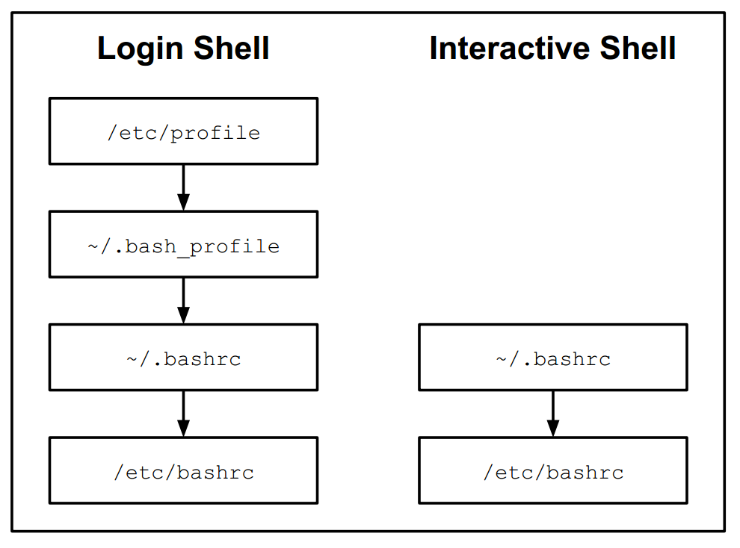

/bin
This directory contains executable programs which are needed in single user mode and to bring the system up or repair it.

/sbin
Like /bin, this directory holds commands needed to boot the system, but which are usually not executed by normal users.

/usr/bin
This is the primary directory for executable programs. Most programs exe cuted by normal users which are not needed for booting or for repairing the.

/usr/sbin
This directory contains program binaries for system administration which are not essential for the boot process, for mounting /usr, or for system

/usr/local/bin
Normally empty, but may have commands that have been compiled from local sources.

/usr/local/sbin
Normally empty, but may have administrative commands that have been compiled from local sources.

/home/sysadmin/bin
A directory for the current user sysadmin to place programs. Typically used by users who create their own scripts.

/etc/profile

This file can only be modified by the administrator and will be executed by every user who logs in. Administrators use this file to create key environment variables, display messages to users as they log in, and set key system values.

In addition to the setting environmental items the /etc/profile will execute the scripts within /etc/profile.d/*.sh

~/.bash_profile or ~/.profile or ~/.bash_login
Each user has their own .bash_profile file in their home directory.
The purpose of this file is the same as the /etc/profile file, but having this their own tastes.
This file is typically used to create customized environment variables.

~/.bashrc
Each user has their own .bashrc file in their home directory. The purpose of this file is to generate items that need to be created for each shell, such as local variables and aliases.
/etc/bashrc or /etc/bash.bashrc
Is the system wide version of ~/.bashrc. This file may affect every user on the system.
Only the administrator can modify this file. Like the ~/.bashrc file, the purpose of this file is to generate items that need to be created for each shell, such as local variables and aliases.

.bash_profile VS .bashrc
bash_profile is executed for login shells, while .bashrc is executed for interactive non-login shells.
When you login (type username and password) via console, either sitting at the machine, or remotely via ssh: .bash_profile is executed to configure your shell before the initial command prompt.
But, if you’ve already logged into your machine and open a new terminal window (xterm) then .bashrc is executed before the window command prompt. .bashrc is also run when you start a new bash instance by typing /bin/bash in a terminal.

~/.bash_logout or /etc/bash_logout
Upon logout, the commands in ~/.bash_logout are executed, which can for instance clear the terminal.

/etc/skel

Is the directory used by useradd to create the default settings in a new user's home directory. The files from the /etc/skel directory are automatically copied into the new user's home directory.
As an administrator, you can modify the files in the /etc/skel directory to provide custom features to new users.

~/.bash_history
(file) Stores the history of commands you’ve run in your user account.

/etc/inputrc
Inputrc deals with the mapping of the keyboard for certain situations. This file is the start-up file used by readline, the input related library used by bash and most other shells.
Default mode is emacs (a popular Linux editor)

~/.inputrc Override the global settings of /etc/inputrc

.bashrc vs .bash_profile (better explanation):
- The primary thing to understand is that the rc files are for all shell invocations while the profiles are strictly for interactive shells.
- An interactive shell is where you (end user) types the command while an non-interactive shell is when shells are launched by other programs such as a script with #!/bin/bash as SHEBANG value
- By default ~/.bashrc is executed as part of ~/.bash_profile to load the alias function
- Now if I comment out the part which executes .bashrc inside ~/.bash_profile, let's check the outcome:

File | Description
/etc/profile | This is the system-wide initialization file executed during login. It usually contains environment variables, including an initial PATH, and startup programs.
/etc/bashrc | This is another system-wide initialization file that may be executed by a user’s .bashrc for each bash shell launched. It usually contains functions and aliases.
~/.bash_profile | If this file exists, it is executed automatically after /etc/profile during login
~/.bash_login | If .bash_profile doesn’t exist, this file is executed automatically during login
~/.profile | If neither .bash_profile nor .bash_login exists, this file is executed automatically during login. This is the default in Debian-based distributions, such as Ubuntu. Note that this is the original Bourne shell configuration file
~/.bashrc | This file is executed when a non-interactive bash shell starts, i.e., a new terminal window in X. This file is often referred to in the bash interactive scripts, such as ~/.bash_profile
~/.bash_logout | This file is executed automatically during logout

