Lesson 19 & 20 Designing and Createing Partitions

$ fdisk Is a dialog-driven program for creation and manipulation of partition tables.

-u, --units[=unit]
When listing partition tables, show sizes in 'sectors' or in 'cylinders'.

-l, --list [ optioalDevice… ]
List the partition tables for the specified devices and then exit.

-c option disables the warning regarding compatibility issues with the MS-DOS operating system.

In interactive mode :
m = menu , d =delete, n =ew partition , p =print, t = change partion type, w =write, q =quit

$ sfdisk
sfdisk is a script-oriented tool for partitioning any block device.
It runsin interactive mode if executed on a terminal.

$ cfdisk
Provides basic partitioning functionality with a user-friendly interface. If you need advanced features, use fdisk instead.

$ gdisk Interactive GUID partition table (GPT) manipulator.

GPT fdisk (aka gdisk) is a text-mode menu-driven program for creation and manipulation of partition tables.
It will automatically convert an old-style Master Boot Record (MBR) partition table or BSD disklabel stored without an MBR carrier partition to the newer Globally Unique Identifier (GUID) Partition Table (GPT) format, or will load a GUID partition table.

The o command allows you to create a new GPT partition table. This will erase all partitions on the disk
The v command allows you to verify the disk
$ sgdisk & $ cgdisk
Similar to sfdisk and cfdisk.

If when writing changes, an error appear (especially on older Linux distributions) run either the partprobe or kpartx command.

$ partprobe Inform the OS of partition table changes.
$ kpartx Create device maps from partition tables.

$ parted & gparted
GNU parted is another partitioning tool. Unlike fdisk and gdisk, GNU Parted allows for non-destructive changes to the partition table, such as resizing partitions and the filesystems within them.
Two applications are provided; parted which is a CLI tool, and GParted which is a GUI application.

Parted Cli useful commands:
help - to view a list of commands
print - print partition table
mkpart - create partition
rm - delete partition
Save changes: not required (partitions are written to disk immediately).

$ lsblk
Lists information about all available or the specified block devices. The lsblk command reads the sysfs filesystem and udev db to gather information.

$ add-apt-repository
Is a script which adds an external APT repository to either /etc/apt/sources.list or a file in /etc/apt/sources.list.d/ or removes an already existing repository.

-r, --remove Remove the specified repository.
Logical volume manager (LVM)
Introduces an extra layer between the physical disks and the file system allowing file systems to be :
- Resized and moved easily and online without system downtime.
- Using discontinuous space on disk
- Meaningful names to volumes, rather than the usual cryptic device names.
- Span multiple physical disks
- And also offers advanced features like snapshotting, striping, and mirroring.

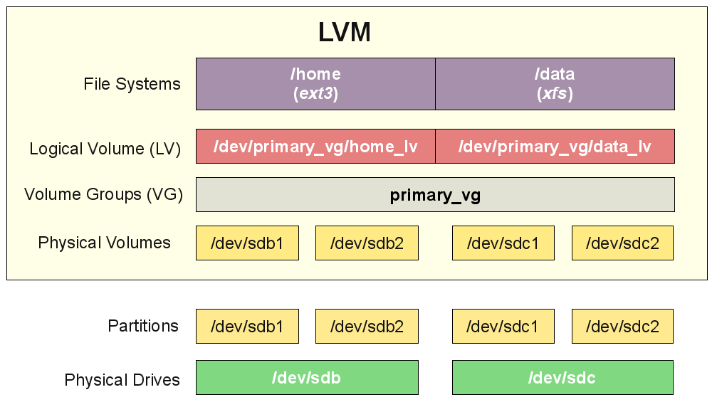
$ sudo apt install lvm2
Implementing LVM involves four main steps:
- Attach physical storage devices to the system.
- Use pvcreate to convert the physical devices into physical volumes, which will allocate them for inclusion in LVM.
- Use vgcreate to incorporate the physical volumes into a volume group. This acts as a single device, which can then be partitioned.
- Use lvcreate to create logical volumes of the desired size using the volume group device.

- vgextend adds one or more PVs to a VG. This increases the space available for LVs in the VG.
Ex:
$ sudo pvceate /dev/sdb
$ sudo pvceate /dev/sdc
$ sudo pvceate /dev/sdd

$sudo vgcreate vol1 /dev/sdb /dev/sdc /dev/sdd

$sudo lvcreate -L 15G -n logical_vol1 vol1
$sudo lvcreate -L 5G -n logical_vol2 vol1

The above command has resulted in:
/dev/vol1/logical_vol1 & /dev/vol1/logical_vol2

–L option is used to specify the size of the logical volume
–n option is used to give the volume a name

$ mkfs Build a Linux filesystem.
In actuality, mkfs is a front-end for the various file system builders (mkfs.fstype) available under Linux.
The filesystem-specific builder is searched for in many directories, like perhaps /sbin, /sbin/fs, /sbin/fs.d, /etc/fs, /etc

-t, --type Specify the type of file system to be built. If not specified, he default file system type (currently ext2) is used.

Ex: $ mkfs -t ext2 /dev/sdb1

In this case, the mkfs command would end up calling the mke2fs command, which is capable of creating ext2, ext3, and ext4 type filesystems.

Ex: $ mkfs -t vfat /dev/sdb1

While this will call mkdosfs to create vfat type filesystems.

$ mke2fs Create an ext2/ext3/ext4 file system.
-b Specifies the block size of the filesystem.
-N Specifies the number of inodes.
-m Specifies what percentage of the filesystem is reserved for system use.

$ mkdosfs Is used to create an MS-DOS filesystem under Linux on a device (usually a disk partition).

The mkfs command will create the appropriate filesystems for all, except ISO 9660 and Universal Disc Format.

ISO 9660 is the format used in CD-ROM discs. Created by $ mkisofs command.
Universal Disc Format is used in DVDs and is created by $ mkudffs command.

exFAT (Extended File Allocation Table)
Is a proprietary, lightweight filesystem created by Microsoft in 2006 for use with flash memory storage systems such as SD cards and USB drives.
It was designed to replace FAT32.
Most Linux distributions do not support exFAT by default.

Enabling exFAT support depends on the distribution you are using. In the
case of Debian based systems:

$ sudo add-apt-repository universe
$ sudo apt update
$ sudo apt install exfat-fuse exfat-utils

Red Hat based systems:
$ sudo yum install epel-release
$ sudo yum install exfat-utils fuse fuse-exfat

$ add-apt-repository Adds a repository into the /etc/apt/sources.list or /etc/apt/sources.list.d or removes an existing one.

Btrfs (B-Tree Filesystem) is a Linux filesystem created by Oracle.

Some features are:

Copy-On-Write
Btrfs is a copy-on-write (COW) system. When a file is modified, the new data does not over-write the old file, rather the new data alone is saved to another location on disk.
This allows quick file versioning, and aids in recovery after power loss.

Snapshots
Btrfs creates space-efficient snapshots. When a snapshot is created, no data is copied – the snapshot simply becomes the original data.
As more data is added, only the changes since the last snapshot are saved. This saves space whilst still retaining snapshot capability.

Subvolumes
This allows for LVM-style flexibility without using LVM – the features are built-in to Btrfs.

Compression
Btrfs can create compressed volumes. This saves space, at the expense of some system performance.

Swap Space

Swap partition - It is set to type 82 on MBR disks or 8200 on GPT disks.

Swap file - An empty file of a fixed size is created & designated as swap
space.

Creating a Swap Partition:

Method1: Create a partition with type 82 if using fdisk, or 8200 if using gdisk.

Method2: Format the partition as swap using mkswap:
Ex: $ mkswap /dev/sda3

Enable the swap partition using the swapon command. Ex: $ swapon /dev/sda3

to Label a swap: $ sudo mkswap -L rockSwap /dev/sdc6
Creating a Swap File:

Create a large file using the dd command. In this case, a 100MB file is
created. This is full of binary zero values from the /dev/zero file:

$ sudo dd if=/dev/zero of=/var/extraswap bs=1M count=100

Format the file as swap space using mkswap:

$ sudo mkdswap /var/extraswap

Enable the file as current swap space using swapon:

$ sudo swapon /var/extraswap

$ swapon –s Will show currently used swap space.

Note that swapon only temporarily enables swap space.
To make the swap space permanently available, it must be mounted.

