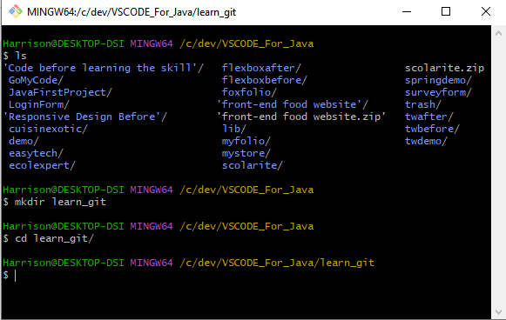

Figure 1: Create a folder Change into the folder

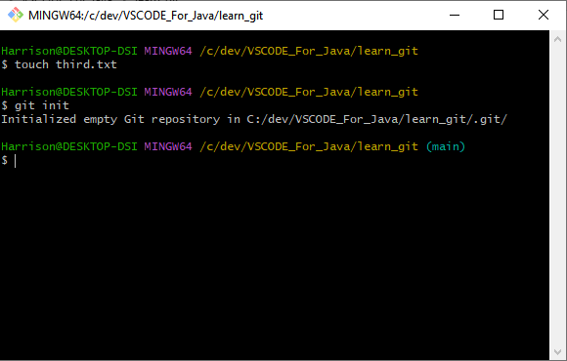

Figure 2: Create Third.txt file & Initialize empty git repository

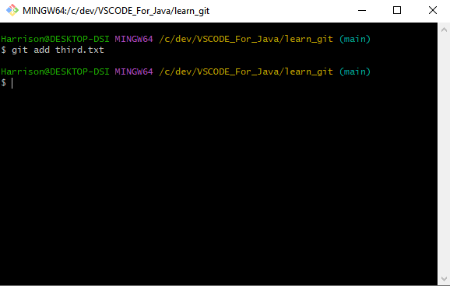

Figure 3: Adding third.txt to the staging area.

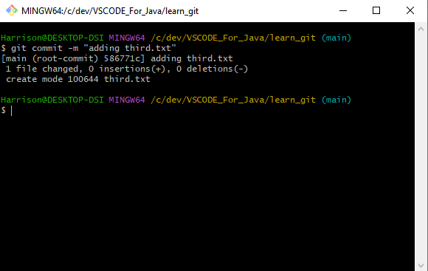

Figure 4: Commit with the message "adding third.txt".

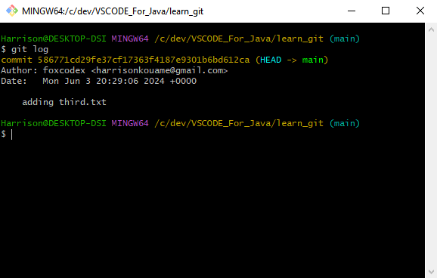

Figure 5: Checking out the commit with git log.

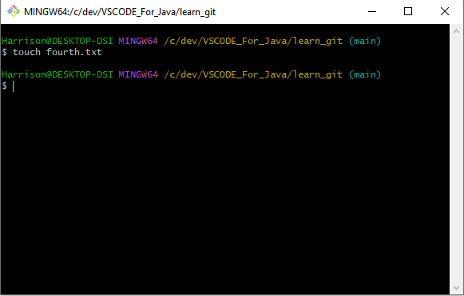

Figure 6: Create another file called fourth.txt.

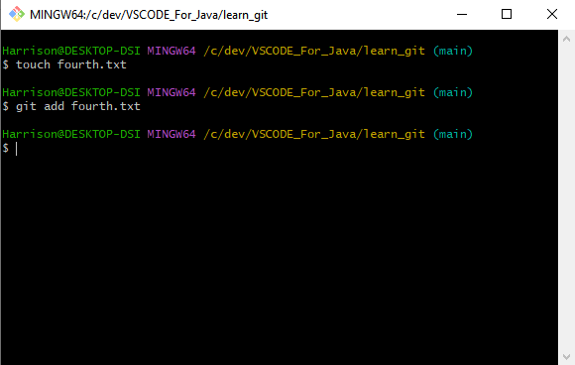

Figure 7: Add fourth.txt to the staging area.

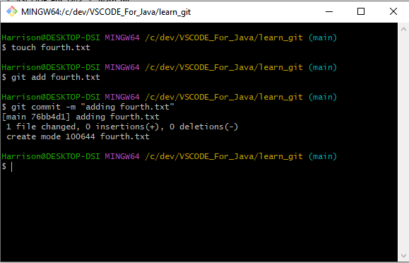

Figure 8: Commit with the message "adding fourth.txt"

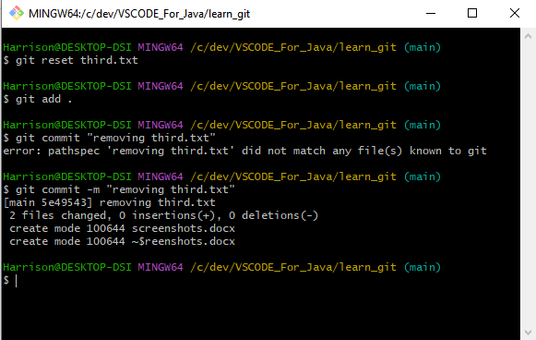

Figure 9: Remove the third.txt file / Add change / Commit

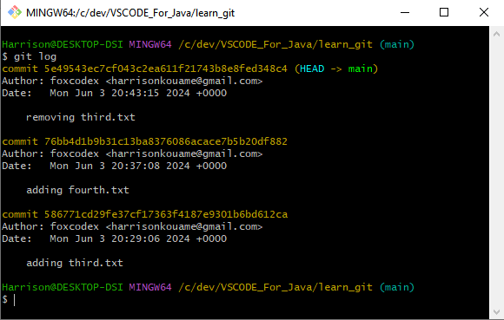

Figure 10: Checking out the commit using git log

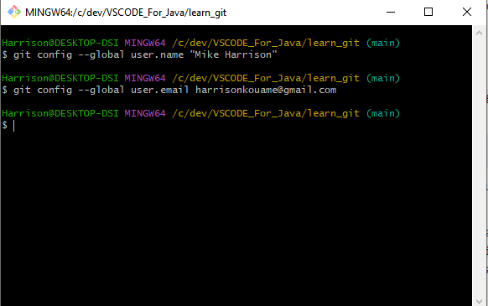

Figure 11: Changing the globals settings

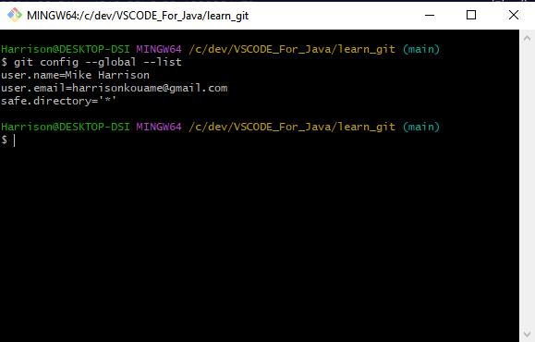

Figure 12: List all the global configuration