Name: HaoxuanGu

Student Number: 20100200

Title: Recipe Sharing Web Application  
Supervisor: Micheal Mcmahon

Description:

The "Development of Recipes Application" project embarked by Haoxuan Gu, under the supervision of Micheal McMahon at South East Technological University, represents a pivotal step towards innovating how contemporary Chinese society engages with cooking. In an era where material well-being enhances, the quest for discovering, trying, and sharing a variety of cuisines has become a significant source of joy for many. This project targets the existing gap in the market for a user-centric, efficient, and engaging platform for recipe sharing, propelled by the challenges posed by the prevalent complexity, intrusive advertisements, and poor user experience on current platforms.

Moreover, the project draws motivation from the increasing concerns over food safety in takeaways and restaurants in China. These concerns have led to a growing preference for home-cooked meals, underscoring the necessity for an application that not only facilitates recipe sharing but also educates users on cooking methods, thereby promoting healthier and safer eating habits.

The "Development of Recipes Application" is engineered using React, Express, and MongoDB, chosen for their efficiency and suitability in creating scalable, interactive web applications. The application boasts features that are thoughtfully designed to cater to the needs of both culinary novices and aficionados. These features include recipe browsing, which allows users to filter recipes based on ingredients, cuisine types, and cooking difficulty levels; recipe posting, enabling users to share their culinary creations along with detailed ingredients lists, step-by-step instructions, and photos; social interaction functionalities, fostering a sense of community by allowing users to follow others, like, and comment on recipes; personalized recommendations, tailored according to a user’s browsing history and preferences; and comprehensive user management, enabling profile edits and management of posts and following lists.

The guiding principles for this project revolve around creating an exceptional User Interface (UI), implementing functions efficiently, and ensuring a clear and organized database structure. The aim is to craft an online environment where users can seamlessly discover, share, and exchange recipes. Beyond mere recipe content, the platform envisages facilitating an exchange of cooking skills and consulting on healthy diet knowledge, thus enriching the user's diet, health, and overall quality of life.

The project’s methodology embraced agile development after evaluating various development methodologies. Agile development, characterized by its iterative nature and flexibility, was deemed most appropriate given the project’s need for rapid prototyping and accommodating new learning curves associated with the integration of novel technologies and skills. This methodology enabled the swift implementation of basic functionalities, thereby reducing initial development pressure and allowing more time for refinement and optimization.

The technical feasibility phase of the project was meticulously conducted, evaluating the chosen technologies and frameworks to ensure they met the project’s objectives. A detailed system architecture was laid out, illustrating how technologies like React for the frontend and Express along with MongoDB for the backend and database were integrated to realize the envisioned application.

During the design phase, detailed design elements were defined using use case diagrams, BPMN flowcharts, and database descriptions. This phase underscored the project’s commitment to a NoSQL database approach, enabling flexible and scalable data management solutions. The implementation phase saw the realization of critical features such as user registration, login, and recipe management, setting a solid foundation for future enhancements.

In summary, the "Development of Recipes Application" project addresses a significant need within the context of Chinese society’s shifting dietary habits and concerns over food safety. By leveraging cutting-edge web development technologies and an agile development approach, the project aims to deliver a comprehensive, engaging, and user-friendly recipe-sharing platform. This platform is not just a repository of recipes; it is envisioned as a vibrant community where users can engage, learn, and share their passion for cooking, thus fostering healthier eating practices and a richer culinary culture.

Picture:

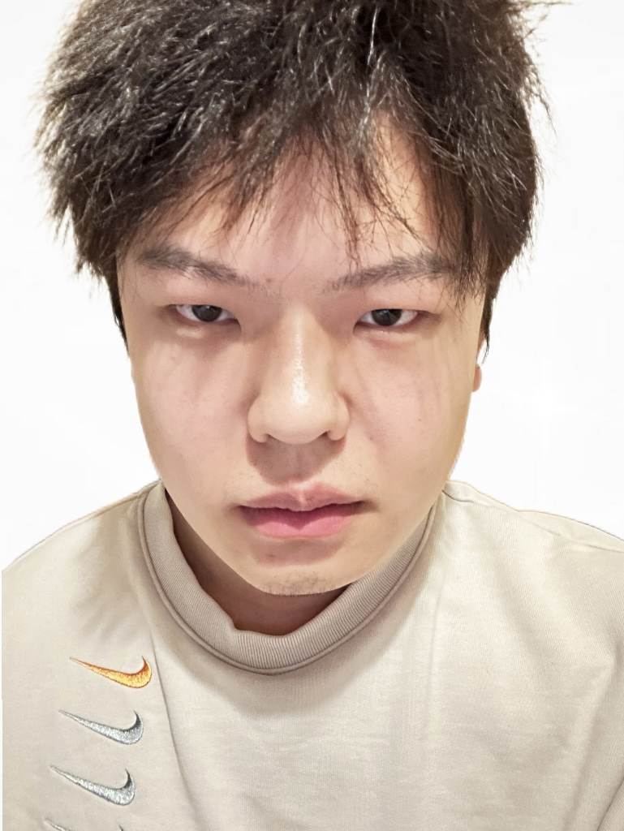

Github Url: https://github.com/foxeatbread/Fyp.git

Poster:

