Olympic Database System

Our group is going to make a database system for the Winter Olympic games 2018 Pyeong Chang. This will include all the sports and games held in the Olympics and the teams will be joining from all over globe. Different countries which are a part of the Olympic Games. Federation will be sending their best people to participate in the games. We will be accumulating all the information in our Database like the events, the sponsors, the organisers, etc. The ER Diagram is given below.

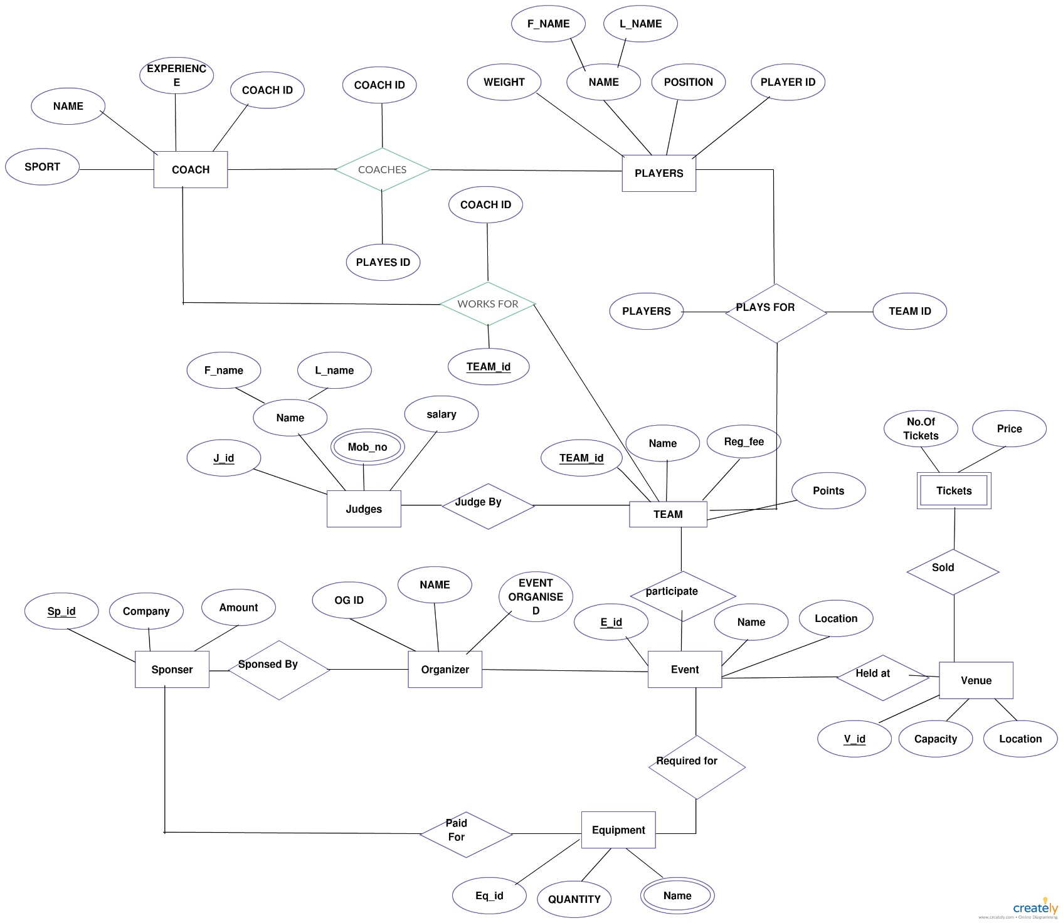

The ER diagram explains how the different entities of the database are connected to each other. We can see that the Coach is related to the players and the team in the diagram. They work for the teams and coach the players. The judges judge the teams and the teams participate in the events and win medals. These Olympics are held and all the countries from different parts send their best of the best participants to win these medals. The organisers organise the events which are sponsored by the different sponsors. Different equipment are used in the events which are held in the different venues constructed specially for these events and games. People from different places to witness the Olympic.

We have managed to compile the whole Database in an SQL query language. The code for the SQL language is also givens.

The group Members are :-

Dhruva Agarwal (U101116FCS177)

Kenneth Prabhakaran (U101116FCS275)

Ajinkya Bedekar (U101116FCS183)

Biren Sharma (U101116FCS246)