CWatM Testing Framework Documentation

Purpose
A comprehensive pytest-based testing framework for the CWatM (Community Water Model) hydrological modeling system. This module provides automated testing capabilities for multiple model configurations, scenarios, and validation workflows including testing different settings files for different resolutions, different basins and different input and output options in order to make sure that CWatM is properly running after each change.
Folder: pytest
Program: test_cwatm3.py
Requirement: libraries pytest and pytest-html
Optional: pip install pytest-codecov
Execute:
pytest test_cwatm3.py --html=C:/work/CWATM/report1.html
--settingsfile=test_py_cwatm2.txt --cwatm=C:/work/CWATM/run_cwatm.py
Where:
--html=C:/work/CWATM/report1.html: results of test are written into this HTML file
--settingsfile=test_py_cwatm2.txt: settings file to tell which tests are executed
--cwatm=C:/work/CWATM/run_cwatm.py: executable of CWatM

Test Types and Execution Modes
The framework supports different test execution modes based on keywords in the settings file path:
"error": Tests expected failure scenarios with quiet mode execution
"calibration": Runs calibration workflow with meteorological data loading and warm-start functionality
"checkmap": Validates model configuration without full execution - configuration validation only
Default mode: Performs standard model run with full execution and result validation

Configuration File Structure
The test configuration file uses a structured format to define test scenarios:
base_setting: Path to the base configuration template
name: Test scenario identifier and description
runtest: Enable/disable specific test groups (TRUE/FALSE)
test_value: Enable discharge value validation
path_*: System paths for different components (system, root, init, output, maps, meteo)
header: Test title for reporting
description: Detailed test description
set_save: Output filename for the generated settings file
changes: Parameter modifications in "parameter = value" format
adds: Additional configuration lines to append
last_value: Expected discharge value for validation

Testing Workflow
CWatM can be run with different resolutions, different basins, and different options. Each testing scenario uses a settings template and varies different options during the test. The framework follows this workflow:
1. Parse command line arguments for settings file and CWatM executable paths
2. Read and parse the test configuration file to extract test scenarios
3. For each enabled test scenario:
a. Generate modified settings files with parameter changes
b. Execute CWatM with the appropriate test mode
c. Validate results based on test type
d. Record success/failure status
4. Generate comprehensive HTML test report with pytest

Code Quality and Standards
The test_cwatm3.py module has been enhanced with:
PEP 8 Compliance: Code formatted according to Python PEP 8 standards with 120-character line limit
Comprehensive Documentation: All functions documented using numpydoc format with detailed parameter descriptions
Preserved Functionality: All original variable names, function names, and comments maintained
Enhanced Readability: Improved code structure and formatting for better maintainability

Usage Examples
Basic execution with HTML reporting:
pytest test_cwatm3.py --html=pytest_report_cwatm.html --settingsfile=__cwatm_pytests_settings.ini --cwatm=../run_cwatm.py
Extended execution with code coverage:
pytest test_cwatm3.py --html=pytest_report_cwatm.html --cov=cwatm --cov-report=xml --settingsfile=__cwatm_pytests_settings.ini --cwatm=../run_cwatm.py
The framework provides robust validation for CWatM hydrological model testing across multiple scenarios, ensuring model reliability and consistency across different configurations and use cases.

Files and folders:
output: Folder for CWatM testing results e.g. output/rhine
init: Folder for CWatM warm-start files
settings: Folder with settings templates and created settings files e.g.
Settings/30min/global_30min/settings_global_30min.ini
metaNetcdf.xml: xml file with metadata for NetCDF files
test_cwatm3.py, conftest.py, pytest.ini: Program files
test_py_cwatm1.txt,.. Settings files

Testing CWatM
CWatM can be run with different resolutions, different basins, and different options. Each testing e.g. for the Rhine basin 30 arcmin is using a settings template and varies different options during the test. Examples for tests are given below, but other tests can be included. Tests are executed using the template settings file as a start and then tests are repeated using different options.

Results
Results of the testing are written into the report.html (--html=C:/work/CWATM/report1.html)
This report shows an overview of passed, failed and skipped test and the details of each test.
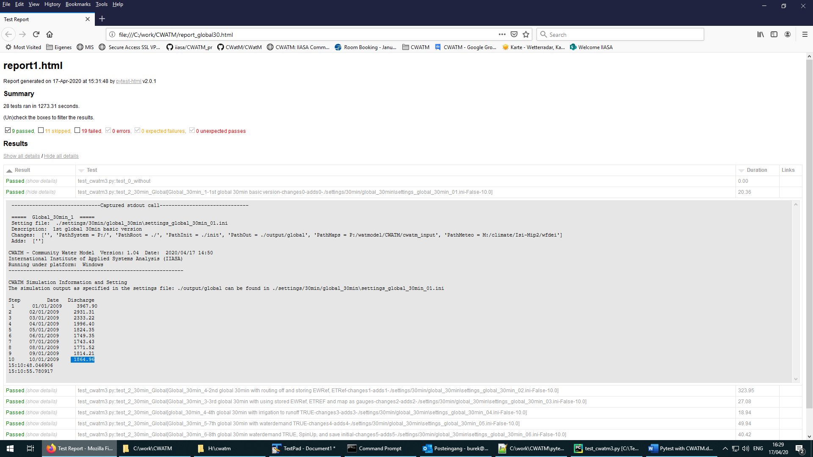
Figure 1: Screenshot of a test report page

Examples for tests:

1 test mask
1.1 mask as .tif
1.2 mask as box
1.3 mask as outlet lon/lat of a basin
2 test gauges
2.1 as list
2.2 as map
3 Options
3.1 includeIrrigation = True
3.2 preferentialFlow = True
3.3 CapillarRise = True
3.4 includeRunoffConcentration = True
3.5 includeWaterBodies = True => 3.1 - 3.5 together
3.6 includeWaterDemand = True
3.7 calc_evaporation = True - store OUT_MAP_Daily = ETRef, EWRef before!
3.8 includeRouting = False (some more calc_environflow = True, inflow = True, waterquality = True
4 Timing
4.1 more than 1 year
4.2 with SpinUp
4.3 save initital
4.4 load initial
5 outputs
5.1 with tss output for daily, monthly, yearly
5.2. with map output for daily, monthly, yearly
5.3 with some 'exotic output

Settingsfile for pytest

This part explains different parts of the settingsfile for pytest e.g. test_py_cwatm2.txt
Mind the ; for separating the changes of the settingsfile (each separated part with a ; is a change in the settingsfile)

# True is the tests for this section should be done
runtest: Rhine_30min True -> if this is set to True, test will be executed, otherwise test is skip
runtest: global_30min False
runtest: Rhine_5min False
runtest: global_5min False

# True is test should compare last discharge with given number, False is test should look for -no error-
test_value: False
-> if this is set to False, a check is done if CWatM runs the settingsfile without error
-> if this is set to True, a check is done by comparing the last discharge value with a value in the pytest
settingsfile

# 30 min versions
# Rhine
base_setting: ./settings/30min/rhine_30min/settings_rhine_30min.ini
- this is the path to the template CWatM settingsfile. This template file will be modified and executed
name: Rhine_30min
- Name of the test

path_system: P:/
path_root: ./
path_init: ./init
path_out: ./output/rhine
path_maps: P:/watmodel/CWATM/cwatm_input
path_meteo: M:/climate/Isi-Mip2/wfdei
- Main paths of the CWatM settingsfile can be changed here
- For the next test only these paths have to be included which have changed since the last test

# 1st Rhine 30min -> first sub test
header: Rhine_30min_1 -> name of the test
description: 1st Rhine 30min basic version
set_save: settings_rhine_30min_01.ini
-> name of the changed settings file, this file is added in the template settingsfile folder
changes: -> changes of the CWatM settingsfile, here: no changes
adds: -> add to the CWatM settingsfile, here: no adds
last_value: 4.22 -> last value of discharge to check against if test_value=True

….

# 7th setup Rhine -> sub test no. 7
header: Rhine_30min_7
description: 7th Rhine 30min with waterdemand TRUE
set_save: settings_rhine_30min_07.ini
changes: calc_evaporation = False; includeIrrigation = True; preferentialFlow = True; CapillarRise = True;
includeRunoffConcentration = True; includeWaterBodies = True; includeWaterDemand = True; StepEnd = 40
adds: OUT_TSS_Daily = discharge
last_value: 443.03

….

# -----------------------------
# Global -> next test
base_setting: ./settings/30min/global_30min/settings_global_30min.ini
name: global_30min
path_out: ./output/global

# 1st global 30min
header: Global_30min_1
description: 1st global 30min basic version
set_save: settings_global_30min_01.ini
changes:
adds:
last_value: 1864.96

Updating the settingsfile for tests

- Either you create a new settings file than you need this header

# True is the tests for this section should be done
runtest: Rhine_30min True
runtest: global_30min True

# True is the tests for this section should be done
runtest: XXXX_XXmin True

# True is test should compare last discharge with given number, False is test should look for -no error- execution of run
test_value: False

# ---------------------
# xx arcmin versions
# Basin xxx
base_setting: ./settings/XXmin/basin_XXmin/settings_XXXX_XXmin.ini
name: XXXX_XXmin
path_system: P:/
path_root: ./
path_init: ./init
path_out: ./output/XXXX
path_maps: P:/watmodel/CWATM/XXXXXXXXX
path_meteo: XXXXX

# 1st XXXX XXmin
header: XXXX_XXmin_1
description: 1st XXXX XXmin basic version
set_save: settings_XXXX_XXmin_01.ini
changes:
adds:
last_value: XXXX
# 2nd setup XXXXX
header: XXXX_XXmin_2
description: 2nd XXXX XXmin with box as mask and basic outputs
set_save: settings_XXXXX_XXmin_02.ini
changes: MaskMap = 14 12 0.5 5.0 52.0
adds: OUT_TSS_Daily = discharge; OUT_MAP_Daily = discharge
last_value: XXXX

….

- Or you add the tests to an existing ones:
- Add runtest: XXXX_XXmin True below the existing runtest
- Add tests at the bottom

Settingsfile for CWatM

The template for settingsfile for CWatM can be as individual as needed for specific region, resolutions, options and outputs.
Only the file path sections should contain these keys (key values are changed in the settings file for pytest)
#-------------------------------------------------------
[FILE_PATHS]
#-------------------------------------------------------
PathSystem = P:/
PathRoot = $(PathSystem)
PathOut = $(PathRoot)/output/
PathInit = $(PathRoot)/init/
PathMaps = $(PathSystem)/watmodel/CWATM/cwatm_input
PathWaterdemand = $(PathMaps)/landsurface/waterDemand
PathMeteo = $(PathSystem)

Executing in PyCharm

- Load test_cwatm3.py in Pycharm
- Open Add configuration (right corner)
- Look for templates Python test / pytest
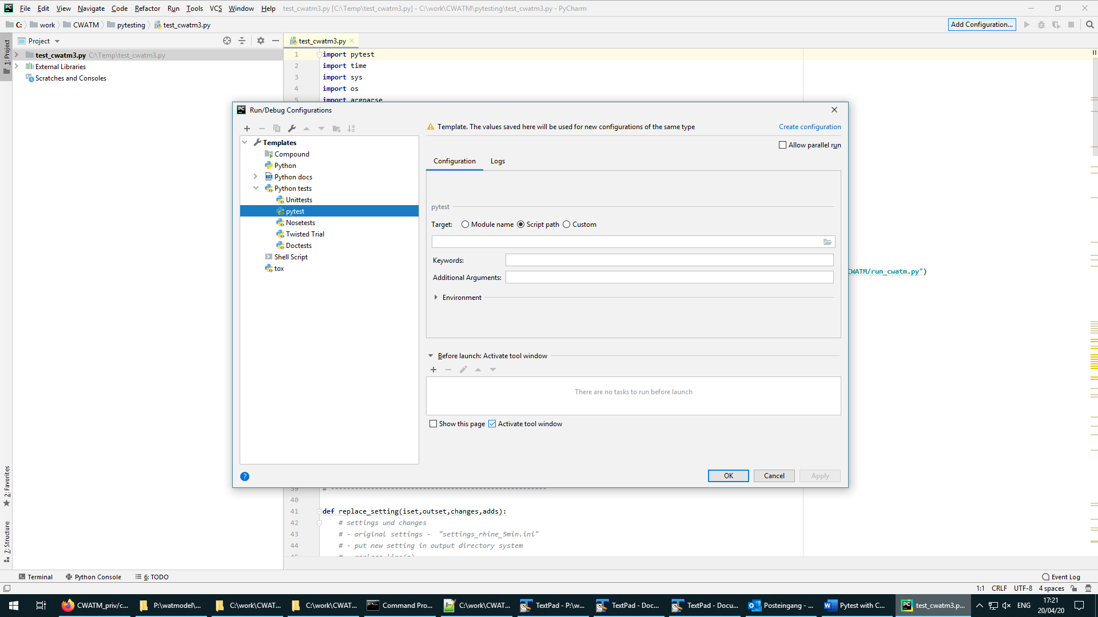
- Insert in Script path:
e.g.: C:/work/CWATM/pytesting/test_cwatm3.py
- Insert in Additional Arguments:
e.g.: --html=report1.html --settingsfile=test_py_cwatm2.txt --cwatm=C:/work/CWATM/run_cwatm.py
- Right corner of the window: click on set configuration set
- Run pytest in test_cwatm3.py (right corner)
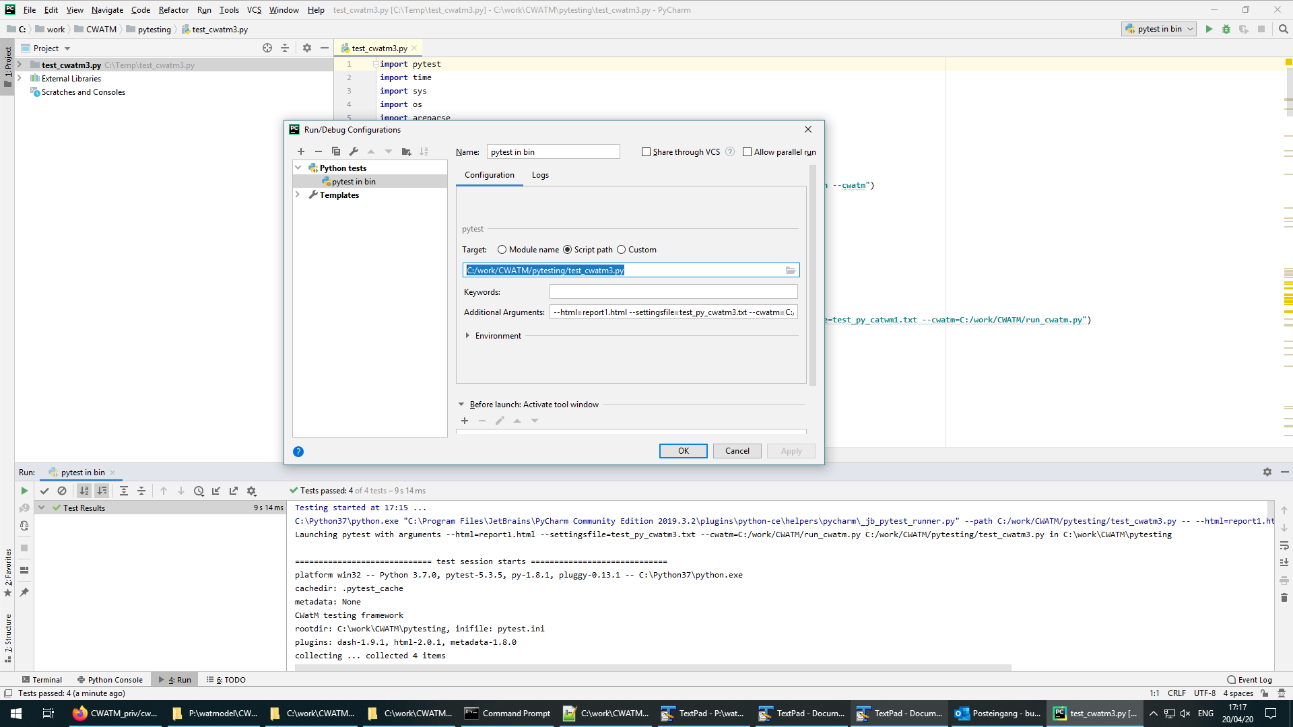

Model Structure

Framework Architecture
The testing framework consists of several key components:
Command Line Interface: Dynamic argument parsing for flexible CWatM integration
Configuration Parser: Reads structured test configuration files with multiple test scenarios
Settings File Generator: Creates modified configuration files for each test variation
Test Execution Engine: Handles different test types (normal, calibration, checkmap, error testing)
Reporting System: Integration with pytest HTML reporting for comprehensive test results

Key Functions Documentation
replace_setting(iset, outset, changes, adds)
Create a modified configuration file with parameter changes and additions. Reads an original settings file, replaces specified parameter lines, and adds new configuration lines to create a new settings file for testing.

cwatm(info, model)
Execute CWatM model tests with different configurations and settings. Runs the CWatM hydrological model with specified settings and validates execution based on the test type (normal run, calibration, checkmap, or error testing).

test_cwatm_without_settings(info)
Test CWatM library import and basic functionality without settings file. Validates that the CWatM module can be imported and its usage function executes successfully without requiring a settings file.

test_cwatm(info, model)
Parameterized test function for CWatM model execution with various configurations. This is the main test function that executes all configured CWatM test scenarios using pytest parameterization.

