SOFTWARE REQUIREMENTS
SPECIFICATION
Smart Parking Platform
WE ARE $oftware ¢orp.
Prepared by: Carlo Sosa
Version: 2.0
Date: October 15, 2026
Course: CIS 4374 / TLIM 3355
Status: Week 7 Project Update

This SRS is an initial project draft and is expected to be refined and expanded throughout the semester.

Document Purpose and Basis
This Software Requirements Specification (SRS) defines the initial requirements for the Smart Parking Platform. Its structure follows the SRS format presented in Lecture 2: Introduction, Overall Description, Functional Requirements, Non-Functional Requirements, and Use Cases. The assigned semester project establishes the core capabilities of the platform, including real-time parking availability, maps, reservations, digital payments, notifications, operator tools, analytics, and third-party navigation integration. Additional draft requirements in this version reflect initial project research and requirements elicitation and may be refined as stakeholder analysis continues.

1. Introduction

1.1 Purpose
The purpose of this document is to define the initial functional and non-functional requirements for a Smart Parking Platform developed by the fictitious software development company WE ARE $oftware ¢orp. The SRS provides a shared starting point for stakeholders, project management, development teams, quality assurance, and parking operators.

1.2 Scope
The Smart Parking Platform will help drivers locate, reserve, navigate to, use, and pay for parking spaces at participating parking facilities. The platform will be available through web and mobile applications and will provide parking availability information, an interactive map, reservation and payment capabilities, parking-session information, notifications, and reservation history. Parking operators will receive administrative tools for monitoring occupancy and reviewing parking analytics.
The initial design direction also explores a simple driver experience that can support different facility workflows. Draft features include showing a driver's parked vehicle and parking location on a map, a parking-time countdown, push/SMS notifications, QR-based onboarding for first-time users, first-use instructions, and an in-application Help feature.

1.3 Initial Out of Scope Items
The project materials do not yet define a complete list of out-of-scope items. This section will be refined during the semester. For Version 2.0, the project does not assume ownership of physical garage construction, parking enforcement personnel, or third-party mapping/payment infrastructure. The platform will integrate with external services where required.

2. Overall Description

2.1 User Groups
User / Stakeholder | Primary Interaction
Drivers and Vehicle Owners | Locate parking, reserve spaces, pay, navigate, monitor parking time, and manage parking history.
Mobile Application Users | Use the mobile experience for parking discovery, navigation, payment, notifications, and help.
Parking Facility Operators | Monitor occupancy, manage parking information, and review operational analytics.
City Transportation Departments | Stakeholders concerned with parking operations, compliance, congestion, and city requirements.
System Administrators | Maintain platform configuration, access, integrations, and system operations.
Finance and Billing Personnel | Support payment, billing, receipt, and transaction-related processes.
Third-Party Payment Providers | Process authorized digital parking transactions.

2.2 System Environment
The platform is planned as a web-based and mobile software system. It will depend on internet connectivity and external services such as mapping/navigation and payment providers. Participating parking facilities may use different entry, exit, identification, and payment technologies; compatibility requirements will be refined as the project progresses.

2.3 Project Constraints
- Fixed semester timeline.
- Dependence on third-party services and APIs.
- Compliance with security and privacy requirements.
- Compliance with applicable city ordinances and laws.
- Theoretical development budget and resources are unlimited for the semester project.

2.4 Assumptions
- Users accessing real-time parking, maps, payments, and notifications will have internet access.
- Participating parking operators will provide the data or integrations required to report parking availability.
- Third-party mapping/navigation and payment services will provide interfaces that can be integrated with the platform.
- A parking facility may support space-level identification, zone-level identification, or facility-level availability; the interface should accommodate these differences.
- Notification delivery through SMS or mobile push services depends on external communication services and user permission.

3. Functional Requirements
ID | Requirement | Specification
FR-01 | User Registration and Authentication | The system shall allow users to register and securely authenticate.
FR-02 | Parking Search | The system shall allow users to search for participating parking locations.
FR-03 | Real-Time Availability | The system shall display real-time parking availability when availability data is provided by a participating facility.
FR-04 | Interactive Map | The system shall display participating parking locations on an interactive map.
FR-05 | Parking Reservation | The system shall allow users to reserve available parking when reservations are supported by the selected facility.
FR-06 | Digital Payment | The system shall allow users to pay for parking digitally through an integrated payment provider.
FR-07 | Navigation Assistance | The system shall provide navigation assistance to the selected parking location through an external mapping/navigation service.
FR-08 | Reservation History and Receipts | The system shall allow users to view reservation history and parking receipts.
FR-09 | Parking Session Countdown | The system shall display the remaining time for a time-limited active parking session.
FR-10 | Parking Notifications | The system shall notify users about relevant parking events, including approaching session expiration.
FR-11 | Push and SMS Delivery | The system shall support mobile push notifications and SMS notifications when enabled by the user and supported by the service.
FR-12 | Parked Vehicle Location | The system shall display the location of the user's parked vehicle using available facility/location data.
FR-13 | Parking Spot or Zone Display | The system shall display the user's assigned or recorded parking space, level, zone, or facility location when that information is available.
FR-14 | QR Onboarding | The system shall support QR codes that direct new users to the appropriate application download or web onboarding experience.
FR-15 | First-Time Instructions | The system shall provide first-time users with a short onboarding experience explaining core parking functions.
FR-16 | Help Feature | The system shall provide an accessible Help feature covering common parking, reservation, payment, account, and navigation questions.
FR-17 | Operator Dashboard | The system shall provide an administrative dashboard for authorized parking operators.
FR-18 | Occupancy Reporting and Analytics | The system shall provide parking operators with occupancy reporting and analytics based on available facility data.
FR-19 | Notifications and Alerts for Operators | The system shall support operational alerts or notifications for authorized parking operators when defined by later requirements.
FR-20 | External Service Integration | The system shall integrate with required third-party mapping/navigation and payment services.

4. Non-Functional Requirements
The semester project materials identify security/privacy compliance and third-party dependencies but do not provide numerical performance, uptime, or capacity targets. The following Version 2.0 requirements are therefore intentionally high-level and should be made measurable as stakeholder and technical requirements are refined.
ID | Category | Draft Requirement
NFR-01 | Usability | The user interface shall emphasize a simple, understandable parking workflow for both first-time and returning users.
NFR-02 | Security | The system shall protect user authentication, payment-related information, and administrative access using appropriate security controls.
NFR-03 | Privacy | The system shall handle personal, vehicle, location, and transaction information in accordance with applicable privacy requirements.
NFR-04 | Compatibility | The platform shall support web and mobile access and shall be designed to integrate with participating facilities and approved third-party services.
NFR-05 | Reliability | The system shall preserve accurate parking-session, reservation, and transaction records during normal operation.
NFR-06 | Maintainability | The system shall be organized so that integrations, facility configurations, and requirements can be updated as the platform evolves.
NFR-07 | Accessibility | User-facing workflows and Help content should be designed to support accessible use; specific accessibility standards will be defined in a later version.
NFR-08 | Compliance | The system shall support compliance with applicable security/privacy requirements, city ordinances, and laws identified for participating locations.

5. Use Cases
The following use cases are the initial Version 2.0 set. They use the class format of Title, Actor, Precondition, Steps, and Postcondition. They are expected to grow and be refined during the semester.

UC-01: Register User Account
Actor: Driver
Precondition: The user has access to the Smart Parking Platform and is not currently registered.
Steps:
- The user selects the option to create an account.
- The system requests the required account information.
- The user enters the required information.
- The system validates the submitted information.
- The system creates the user account and confirms registration.
Postcondition: A user account is created and can be used for future parking activity.

UC-02: Authenticate User
Actor: Registered Driver
Precondition: The user has an existing account.
Steps:
- The user opens the login screen.
- The user enters authentication credentials.
- The system validates the credentials.
- The system grants access to the user's account.
Postcondition: The authenticated user can access account-based parking features.

UC-03: Locate Available Parking
Actor: Driver
Precondition: The user has access to the platform and the platform can access participating facility information.
Steps:
- The user enters a destination or opens the parking map.
- The system identifies participating parking facilities near the requested area.
- The system retrieves available parking information when provided by each facility.
- The system displays parking locations and available capacity information.
- The user selects a parking facility for additional details.
Postcondition: The user has identified a parking facility and may continue to reservation or navigation.

UC-04: View Parking Facility on Interactive Map
Actor: Driver
Precondition: At least one participating parking facility is available for display.
Steps:
- The user opens the interactive map.
- The system displays participating parking locations.
- The user selects a facility marker.
- The system displays available facility information such as availability, parking options, and location details.
Postcondition: The user can evaluate a parking location before selecting it.

UC-05: Reserve Parking
Actor: Driver
Precondition: The selected facility supports reservations and an eligible parking option is available.
Steps:
- The user selects a parking facility.
- The user selects an available reservation option.
- The system displays reservation details and applicable charges.
- The user confirms the reservation.
- The system records the reservation and provides confirmation.
Postcondition: The parking reservation is stored in the user's account.

UC-06: Pay for Parking
Actor: Driver
Precondition: The user has a payable parking session or reservation and a supported payment provider is available.
Steps:
- The system displays the amount due.
- The user selects or enters an approved payment method.
- The system submits the transaction to the payment provider.
- The payment provider returns the transaction result.
- The system confirms successful payment and creates a receipt.
Postcondition: The parking transaction is recorded and a receipt is available.

UC-07: Navigate to Parking Facility
Actor: Driver
Precondition: The user has selected a parking facility and a supported mapping/navigation service is available.
Steps:
- The user selects Navigate.
- The system sends the selected parking destination to the mapping/navigation integration.
- The navigation service displays the route.
- The user follows navigation to the parking facility.
Postcondition: The user is provided directions to the selected parking location.

UC-08: QR Code First-Time Onboarding
Actor: New Driver
Precondition: The user is at a participating parking location displaying a Smart Parking Platform QR code.
Steps:
- The user scans the QR code with a mobile device.
- The QR code directs the user to the appropriate web landing page or application download.
- The system presents a brief explanation of the parking process.
- The user opens or installs the application as needed.
- The system presents first-time onboarding instructions.
Postcondition: The new user reaches the platform and understands the basic steps required to park.

UC-09: Add or Select Vehicle
Actor: Driver
Precondition: The user has access to the platform.
Steps:
- The user opens vehicle information.
- The user enters or selects vehicle information required by the participating facility.
- The system validates required fields.
- The system stores or associates the vehicle with the current parking activity.
Postcondition: A vehicle is associated with the user's parking activity.

UC-10: Start or Confirm Parking Session
Actor: Driver
Precondition: The user has arrived at a participating facility and has completed any required facility entry or payment steps.
Steps:
- The system receives or records the parking session start information.
- The system associates the session with the user or vehicle when applicable.
- The system displays the active parking session.
- The system displays relevant time, location, and payment information.
Postcondition: An active parking session is available for the user to monitor.

UC-11: View Parking Time Countdown
Actor: Driver
Precondition: The user has an active time-limited parking session.
Steps:
- The user opens the active parking session.
- The system determines the remaining paid or reserved time.
- The system displays the remaining parking time.
- The displayed countdown updates as the session progresses.
Postcondition: The user can see how much parking time remains.

UC-12: Receive Parking Expiration Notification
Actor: Driver
Precondition: The user has an active time-limited parking session and has enabled an available notification method.
Steps:
- The system monitors the active session end time.
- The session reaches a configured notification threshold.
- The system generates an expiration warning.
- The system sends the warning through an enabled push or SMS channel.
- The user receives the parking-time warning.
Postcondition: The user is informed that the parking session is approaching expiration.

UC-13: Locate Parked Vehicle
Actor: Driver
Precondition: The user's parking location has been recorded or is available from the participating facility.
Steps:
- The user selects Find My Car or opens the active parking session.
- The system retrieves the recorded parking location.
- The system displays the vehicle location on the parking map.
- When available, the system displays the garage, level, zone, or parking-space information.
Postcondition: The user receives information that helps them return to the parked vehicle.

UC-14: Extend Parking Session
Actor: Driver
Precondition: The user has an active parking session and the facility permits remote extension.
Steps:
- The user selects the option to extend parking.
- The system displays available extension options and charges.
- The user selects additional time and confirms.
- The system processes any required additional payment.
- The system updates the session end time and confirmation.
Postcondition: The parking session is extended when permitted by the facility.

UC-15: View Reservation History and Receipts
Actor: Registered Driver
Precondition: The user is authenticated and has previous reservations or transactions.
Steps:
- The user opens parking history.
- The system retrieves the user's recorded reservations and transactions.
- The system displays the history.
- The user selects an item.
- The system displays the reservation details or receipt.
Postcondition: The user can review previous parking activity and payment records.

UC-16: Access Help
Actor: Driver
Precondition: The user has access to the platform.
Steps:
- The user selects Help.
- The system displays help categories for common topics such as parking, reservations, payment, account access, and navigation.
- The user selects a topic or searches for assistance.
- The system displays relevant help information.
Postcondition: The user receives guidance for the selected issue.

UC-17: Monitor Parking Occupancy
Actor: Parking Facility Operator
Precondition: The operator is authenticated and authorized to access a participating facility.
Steps:
- The operator opens the administrative dashboard.
- The system retrieves available occupancy information for the facility.
- The system displays current occupancy and availability information.
- The operator reviews the facility status.
Postcondition: The operator can monitor current parking utilization.

UC-18: View Occupancy Analytics
Actor: Parking Facility Operator
Precondition: The operator is authenticated and sufficient facility data has been collected.
Steps:
- The operator opens the analytics area.
- The operator selects the facility and available reporting period.
- The system processes the available parking data.
- The system displays occupancy and utilization information.
Postcondition: The operator can review parking utilization information to support operational decisions.

6. Requirements Traceability - Initial View
This initial traceability view connects major project capabilities to the Version 2.0 functional requirements and use cases. It is intentionally lightweight and can be expanded later.
Capability | Functional Requirement(s) | Use Case(s)
Real-time parking availability | FR-03 | UC-03, UC-17
Interactive parking map | FR-04 | UC-03, UC-04, UC-13
Parking reservations | FR-05 | UC-05
Digital payments | FR-06 | UC-06, UC-14
Navigation integration | FR-07, FR-20 | UC-07
History and receipts | FR-08 | UC-15
Notifications | FR-10, FR-11 | UC-12
Operator dashboard | FR-17 | UC-17
Occupancy analytics | FR-18 | UC-18
QR/first-time experience | FR-14, FR-15, FR-16 | UC-08, UC-16
Parking countdown / find vehicle | FR-09, FR-12, FR-13 | UC-11, UC-13

7. Open Items for Future Versions
- Define measurable performance, capacity, and availability targets.
- Refine security, privacy, accessibility, and legal/compliance requirements.
- Determine detailed workflows for facilities using QR, ticket, license-plate recognition, gated, or other parking technologies.
- Define operator configuration capabilities, pricing rules, refunds, and exception handling.
- Refine notification timing and user communication preferences.
- Expand stakeholder analysis and requirements elicitation.
- Add exception/alternate flows and acceptance criteria to use cases as the SRS matures.
- Confirm technical requirements for mapping, payment, SMS, push notification, and facility integrations.

7.1 Week 7 Project-Wide Review
The Week 7 review reconciles project-management artifacts developed since project kickoff. The SRS, use cases, WBS, schedule, backlog, Sprint materials, risk register, communication plan, roles, resource and cost plan, and RACI matrix are treated as connected project baselines rather than isolated homework deliverables.
SRS and User Stories / Use Cases: Reviewed against the current Smart Parking Platform scope, including authentication, parking discovery, reservations, payments, navigation, notifications, operator tools, and third-party integrations.
WBS and Timeline: Reviewed for alignment with the current workstreams and nine-month planning horizon. Schedule dependencies should continue to be refined as Sprint work progresses.
Backlog and Sprints: Jira remains the working source for backlog and Sprint status. Current screenshots should replace earlier planning screenshots when the board changes.
Risks and Communication: The risk register and recurring meeting cadence remain active management tools. Risk probability, impact, ownership, response, and status should be updated as project conditions change.
Roles and Cost Plan: The project uses six cross-functional roles with percentage allocations. Labor is based on Houston-area salary assumptions, with a nine-month bottom-up project budget of approximately $176,927 including contingency.
RACI Matrix: Responsibilities are aligned to the six project roles using Responsible, Accountable, Consulted, and Informed assignments, with one accountable role for each major deliverable.

8. Version History
Version | Date | Status | Summary
1.0 | 09/10/2026 | Initial Draft | Project kickoff SRS with initial requirements and 18 use cases.
2.0 | 10/15/2026 | Week 7 Update | Project-wide update aligning SRS, planning artifacts, risks, roles, cost plan, and RACI.

Smart Parking Platform
Work Breakdown Structure (WBS)
Carlo Sosa | CIS 4374| Homework 2
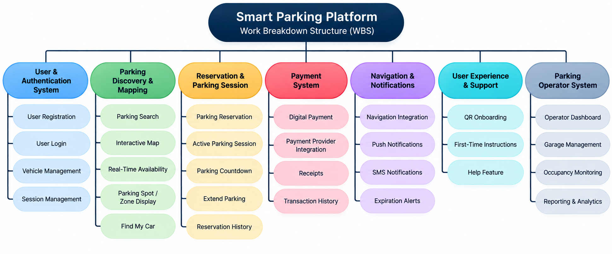
Figure 1. Smart Parking Platform Work Breakdown Structure

Smart Parking Platform Gantt Chart
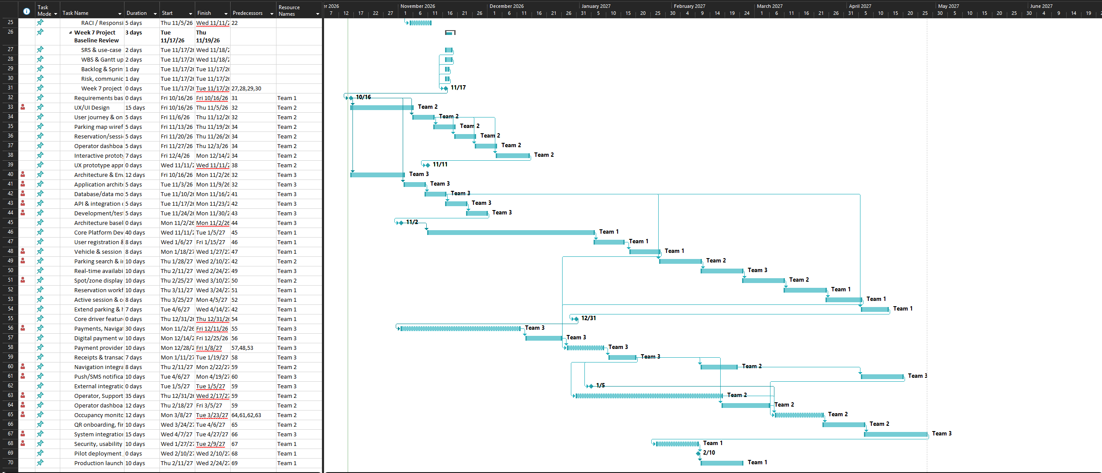
Figure 2. Smart Parking Platform Gantt Chart
Sprint 1 Planning and Scrum Board
Sprint 1 was planned in Jira using selected items from the Smart Parking Platform product backlog. The sprint focuses on establishing the initial application foundation, including authentication, database and API development, and initial user-facing interfaces.
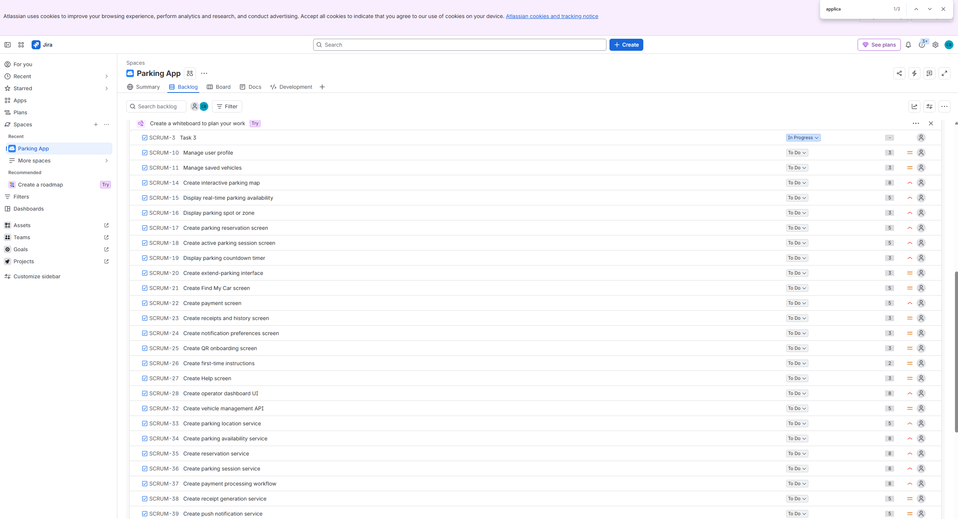
Figure 3. Smart Parking Platform Backlog
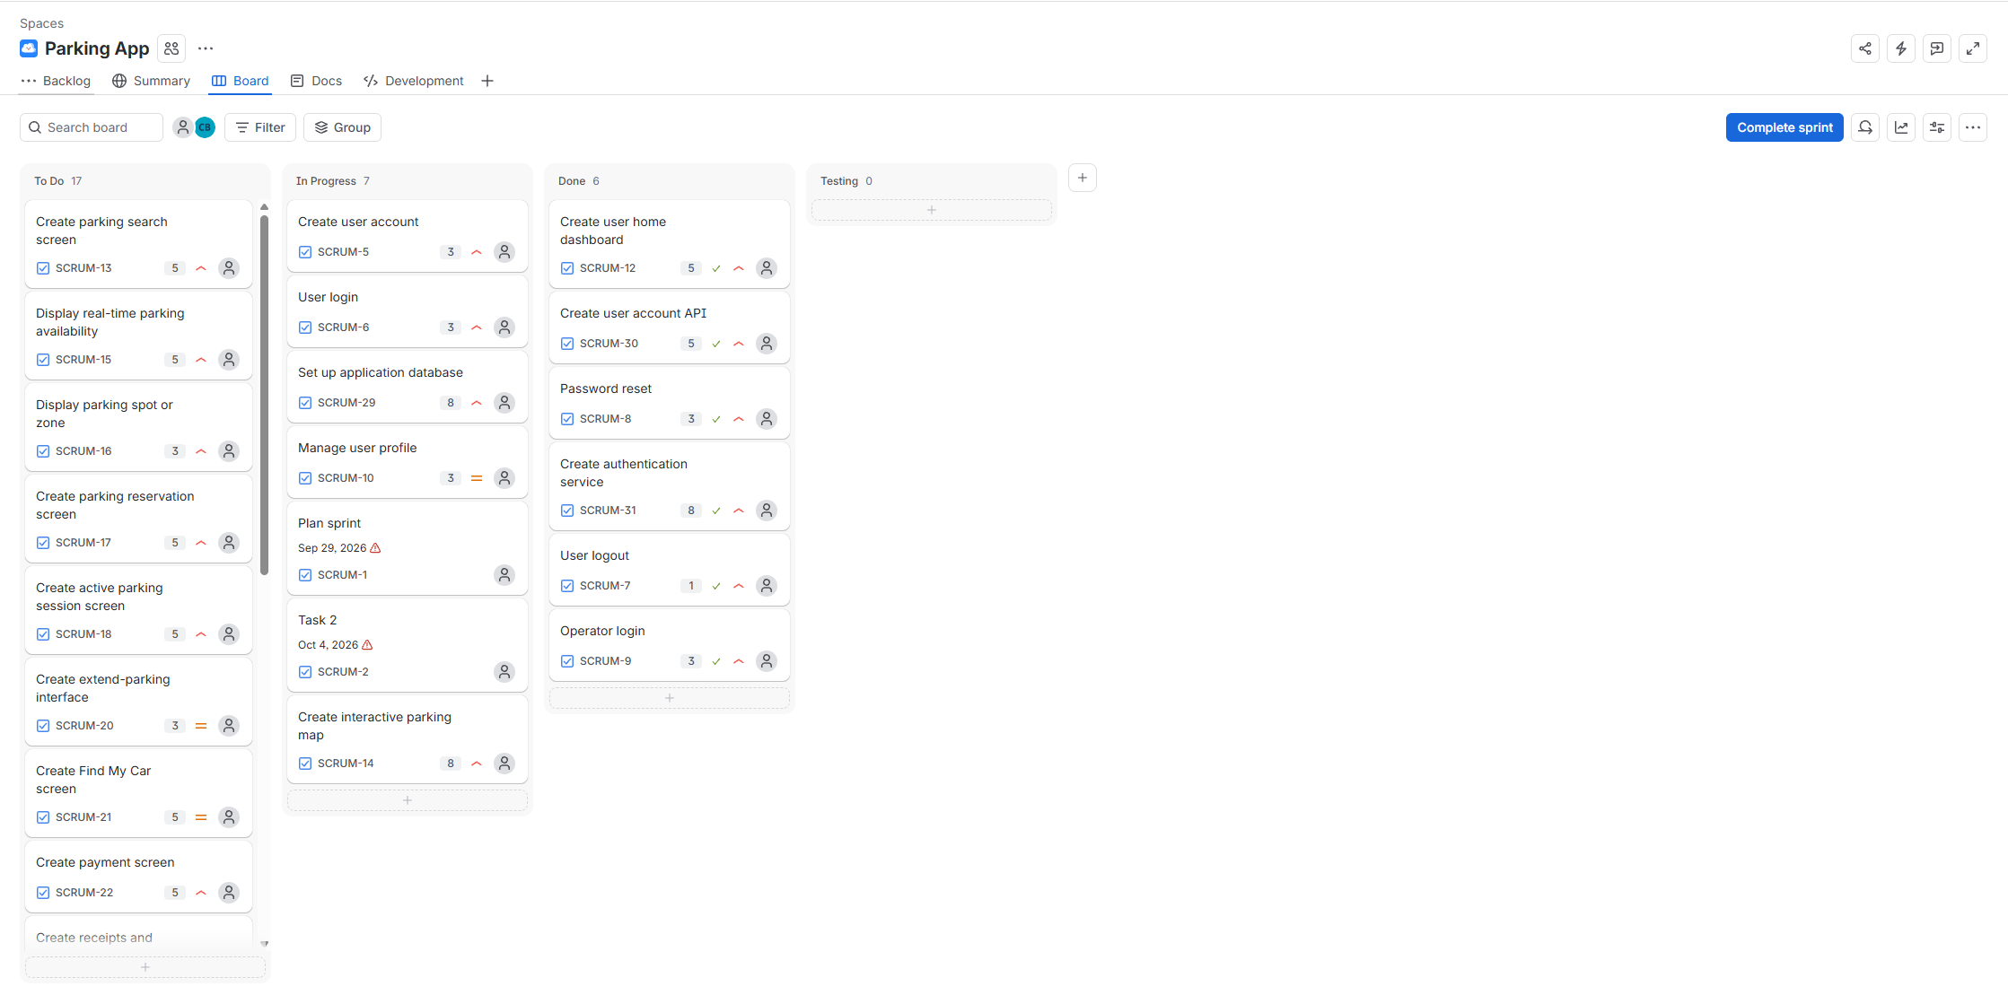
Figure 3.1 Smart Parking Platform Sprint 1 Scrum Board

Risk Management and Communication Plan
CIS 4374 / TLIM 3355
Weekly Project Deliverable 4

1. Risk Management Plan
The Smart Parking Platform risk management plan helps identify uncertain events that could affect project objectives. Risks are grouped into four categories used in the course: technical, schedule, financial, and people. The project team will assess probability and impact, select an appropriate response strategy, assign ownership, and review open risks throughout the project.

1.1 Risk Identification by Category
Category | ID | Risk
Technical | T-01 | Parking availability API or external integration becomes unavailable or unreliable.
Technical | T-02 | Payment provider integration fails or does not process transactions correctly.
Technical | T-03 | Map or navigation integration returns inaccurate location information.
Technical | T-04 | Authentication or user-data security vulnerability is discovered.
Schedule | S-01 | Third-party API integration takes longer than planned.
Schedule | S-02 | Testing identifies defects that require additional rework.
Schedule | S-03 | Dependencies between Teams 1, 2, and 3 delay downstream work.
Schedule | S-04 | Sprint work items require more effort than originally estimated.
Financial | F-01 | Third-party API or service costs exceed the project estimate.
Financial | F-02 | Cloud hosting or database usage costs exceed the project estimate.
Financial | F-03 | Payment processing fees are higher than expected.
Financial | F-04 | Defect correction and rework increase development costs.
People | P-01 | A team member becomes unavailable during a critical project period.
People | P-02 | The team lacks sufficient experience with a required technology or integration.
People | P-03 | Poor communication between teams causes duplicate work or rework.
People | P-04 | Conflicting priorities or unclear responsibilities delay assigned work.

1.2 Risk Register
The register below tracks priority project risks. Probability and impact use the qualitative levels presented in class, and response strategies use Avoid, Mitigate, Transfer, or Accept.
ID | Category | Description | Probability | Impact | Owner | Response | Status / Notes
R-01 | Technical | Parking availability API/integration becomes unavailable. | Moderate | Major | Team 3 | Mitigate | Open - Monitoring. API reliability and fallback handling remain part of integration planning.
R-02 | Technical | Payment provider integration fails or transactions are rejected. | Low | Major | Team 3 | Mitigate | Open - Mitigation planned. Payment integration will be tested in a controlled environment.
R-03 | Technical | Map/location data is inaccurate. | Moderate | Moderate | Team 2 | Mitigate | Open - Monitoring. Location results will be validated and user confirmation retained.
R-04 | Technical | Authentication or user-data security vulnerability is discovered. | Low | Catastrophic | Team 1 | Mitigate | Open - Mitigation planned. Secure authentication practices and security testing remain required.
R-05 | Schedule | API integration takes longer than scheduled. | Moderate | Major | Team 3 | Mitigate | Open - Monitoring. API dependencies are tracked in the updated schedule and will be reviewed as integration begins.
R-06 | Schedule | Testing reveals defects requiring rework. | Moderate | Moderate | Team 3 | Mitigate | Open - Monitoring. Incremental testing and rework time remain included in the project approach.
R-07 | Schedule | Cross-team dependencies delay Sprint work. | Moderate | Moderate | Team 1 | Mitigate | Open - Monitoring. Cross-team blockers will be reviewed through recurring coordination meetings.
R-08 | Schedule | Sprint estimates are too optimistic. | Moderate | Minor | Team 1 | Accept / Mitigate | Open - Monitoring. Sprint estimates will be compared with actual effort and adjusted in future sprints.
R-09 | Financial | Third-party service/API costs exceed estimates. | Low | Moderate | Project Manager | Mitigate | Open - Monitoring. Third-party service usage and pricing will be reviewed against the current cost plan.
R-10 | Financial | Cloud/database costs exceed estimates. | Low | Moderate | Team 3 | Mitigate | Open - Monitoring. Cloud/database usage will be reviewed against the current cost plan.
R-11 | People | A team member becomes unavailable. | Low | Major | Project Manager | Mitigate | Open - Monitoring. Shared documentation and project knowledge remain the primary mitigation.
R-12 | People | Poor communication between teams causes rework. | Moderate | Moderate | All Teams | Mitigate | Open - Mitigation active. Jira and recurring cross-team status meetings are being used to reduce rework.

2. Communication Plan
The communication plan defines how the three project teams coordinate work, surface blockers, review risks, and report progress to stakeholders. Communication is tailored to the audience: development teams receive task-level information, while stakeholder updates focus on progress, risks, milestones, and next steps.
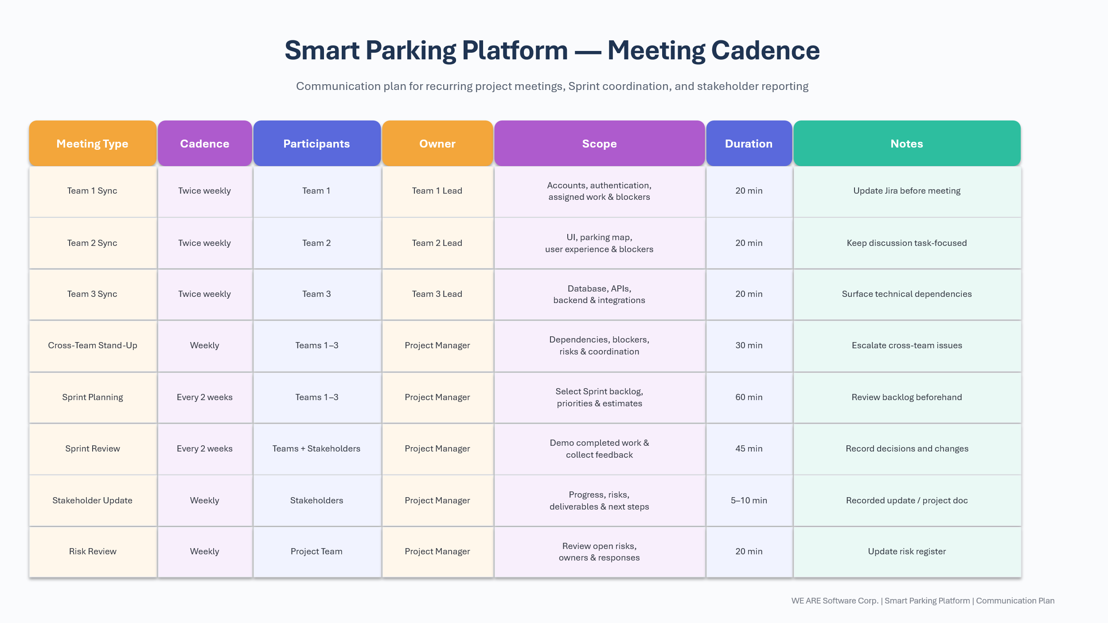

2.1 Reporting Methods
- Jira Scrum Board: Tracks Sprint work through To Do, In Progress, and Done.
- Risk Register: Tracks risk probability, impact, ownership, response strategy, and current status.
- Weekly Stakeholder Video: Provides a concise summary of completed work, current risks, and upcoming work.
- Project Document: Maintains the formal project record, including the WBS, Gantt chart, Scrum planning, risks, and communication plan.

3. Weekly Review Approach
Risk and communication information will be reviewed as the project progresses. New risks will be added to the register, existing risks will be updated when probability or impact changes, and communication cadence may be adjusted if the needs of the project teams or stakeholders change.

Roles, Resource, Cost Plan & RACI Matrix
CIS 4374 / TLIM 3355
Weekly Project Deliverable 5

1. Roles & Resources
The Smart Parking Platform uses a small cross-functional project team organized around the existing Team 1, Team 2, and Team 3 workstreams. The following fictional staffing assumptions identify each role, assigned team, skill level, project allocation, and primary responsibility.

Role | Fictional Name | Team | Skill Level | Allocation | Primary Responsibility
Project Manager | Alex Morgan | Project | Senior | 25% | Planning, schedule, budget, risks, and stakeholder communication
Business Analyst / Product Owner | Jord Lei | Project | Intermediate | 20% | Requirements, use cases, backlog, and acceptance criteria
Full-Stack Developer | Marcus Reed | Team 1 | Intermediate | 50% | User accounts, authentication, reservations, and parking sessions
UX/UI Developer | Sophia Nguyen | Team 2 | Intermediate | 40% | User interface, parking map, onboarding, and operator UI
Backend/API Developer | Daniel Brooks | Team 3 | Advanced | 50% | Database, APIs, payments, and parking-system integrations
QA / Tester | Emily Carter | Cross-Team | Intermediate | 25% | Test cases, integration testing, and defect verification

Skill-Level Assumptions
Senior: Capable of independently managing project-level decisions, coordination, and stakeholder communication.
Advanced: Strong technical experience and capable of handling complex integrations independently.
Intermediate: Capable of completing assigned work independently with occasional guidance.
Allocation assumption: The allocation percentage represents the share of each resource's available work capacity assigned to the Smart Parking Platform.

2. Resource Plan
The resource plan uses a nine-month planning horizon. Estimated hours are based on approximately 160 available work hours per month multiplied by the resource's project allocation.

Role | Name | Annual Salary Assumption | FTE % | Est. Hours | Hourly Equivalent | Project Cost
Project Manager | Alex Morgan | $110,000 | 25% | 360 | $52.88 | $19,038
Business Analyst / Product Owner | Jordan Lee | $115,000 | 20% | 288 | $55.29 | $15,923
Full-Stack Developer | Marcus Reed | $117,500 | 50% | 720 | $56.49 | $40,673
UX/UI Developer | Sophia Nguyen | $85,000 | 40% | 576 | $40.87 | $23,538
Backend/API Developer | Daniel Brooks | $122,500 | 50% | 720 | $58.89 | $42,404
QA / Software Tester | Emily Carter | $70,000 | 25% | 360 | $33.65 | $12,115
TOTAL |  |  |  | 3,024 |  | $153,692

Labor Cost Assumption: Annual salary assumptions use the Houston-area midpoint estimates supplied for comparable software roles. Annual salaries are converted to hourly equivalents using 2,080 working hours per year. Project labor cost includes only the estimated hours allocated to the Smart Parking Platform.

Example calculation: Marcus Reed: 160 hours/month × 9 months × 50% allocation = 720 project hours; 720 × $56.49/hour = $40,673.

3. Bottom-Up Cost Plan
A bottom-up estimate is used because the project already has defined roles, workstreams, requirements, and planned deliverables. Labor is estimated from resource hours and hourly rates, while infrastructure, tools, and third-party services are estimated separately.
Item | Category | Qty / Months | Unit Cost | Duration | Total | Notes
Project Team Labor | Labor | 3,024 hrs | Houston salary equivalents | 9 mo. | $153,692 | Derived from annual salary assumptions
Cloud Hosting & Database | Infrastructure | 9 months | $300/mo. | 9 mo. | $2,700 | Application, database, storage, and testing
Development / Design Tools | Tools | 1 project | $1,200 | N/A | $1,200 | Development and design licenses
Mapping / Navigation API | Third-party API | 9 months | $150/mo. | 9 mo. | $1,350 | Map and navigation services
SMS / Notification Services | Third-party API | 9 months | $100/mo. | 9 mo. | $900 | SMS and notification usage
Security / Testing Tools | Tools | 1 project | $1,000 | N/A | $1,000 | Security and application testing
SUBTOTAL |  |  |  |  | $160,842
Contingency | Reserve | 10% | Applied to subtotal | N/A | $16,084 | Planning reserve for project uncertainty
PROJECT BUDGET |  |  |  |  | $176,927

4. Budgeted Monthly Cash Flow
The monthly cash flow distributes the same $176,927 project budget across the nine-month project lifecycle. Higher labor spending is planned during core development and integration, while planning and closure months require fewer labor hours.
Month | Primary Phase | Labor | Other Costs | Contingency | Monthly Budget
Month 1 | Planning & Requirements | $10,758 | $1,500 | $1,226 | $13,484
Month 2 | UX & Architecture | $13,832 | $800 | $1,463 | $16,096
Month 3 | Core Development | $18,443 | $650 | $1,909 | $21,002
Month 4 | Core Development | $19,980 | $650 | $2,063 | $22,693
Month 5 | Integration | $22,285 | $650 | $2,294 | $25,229
Month 6 | Integration | $22,285 | $650 | $2,294 | $25,229
Month 7 | Operator / QA | $19,212 | $650 | $1,986 | $21,848
Month 8 | Testing / Pilot | $16,138 | $650 | $1,679 | $18,466
Month 9 | Deployment / Closure | $10,758 | $950 | $1,171 | $12,879
TOTAL |  | $153,692 | $7,150 | $16,084 | $176,927

5. RACI Matrix
The RACI matrix assigns responsibility for major Smart Parking Platform deliverables. Each row has one accountable role. R = Responsible, A = Accountable, C = Consulted, and I = Informed.
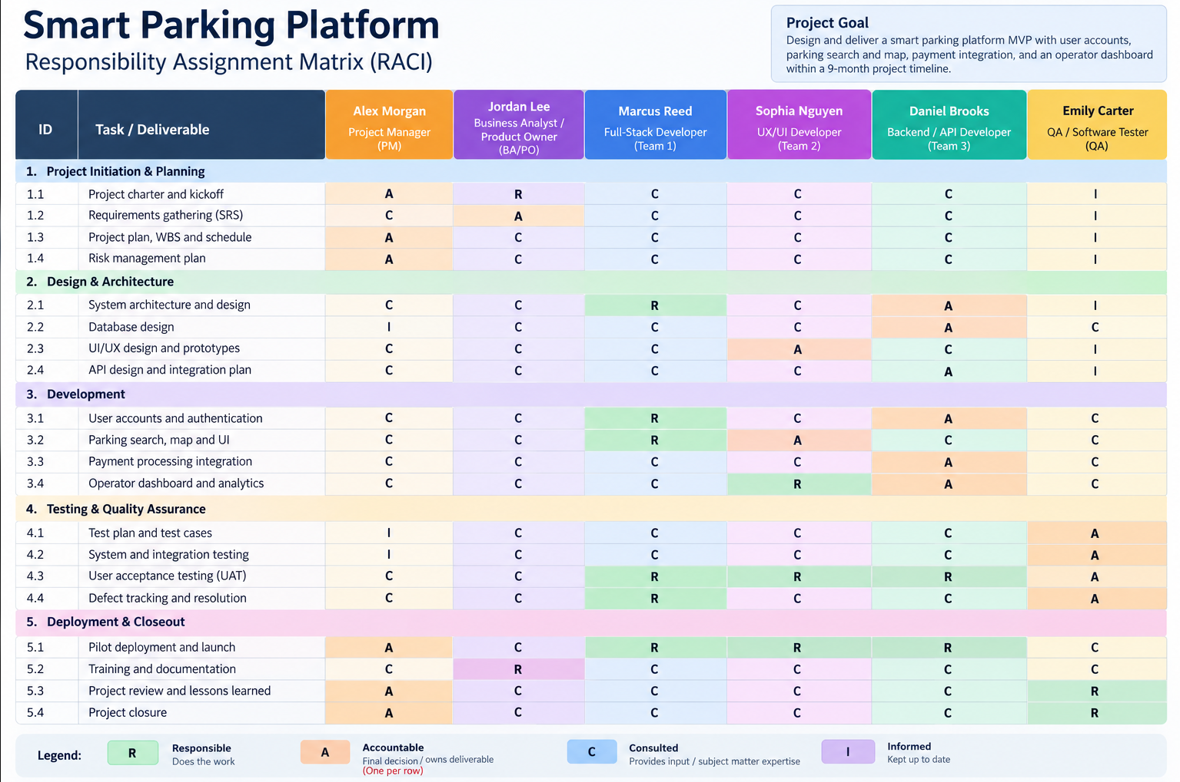

Week 8 – Managing Teams & Stakeholders
Stakeholder Analysis and Charters. The Week 8 update establishes the project stakeholder Power–Interest Grid and formalizes the Team Charter and Project Charter. WE ARE Software Corp. is the owner and self-funder of the Smart Parking Platform, while parking facility operators participate as customers and onboarding partners. Professor Otto is included as a high-power stakeholder who should be kept satisfied.
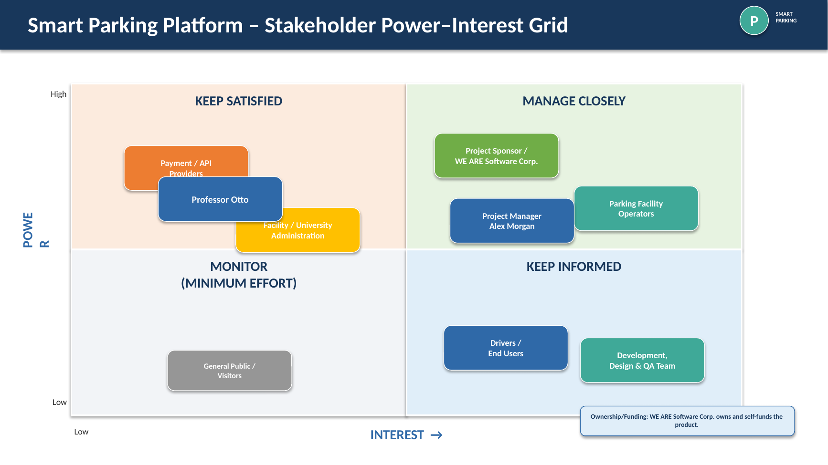
Figure 4. Smart Parking Platform Stakeholder Power–Interest Grid

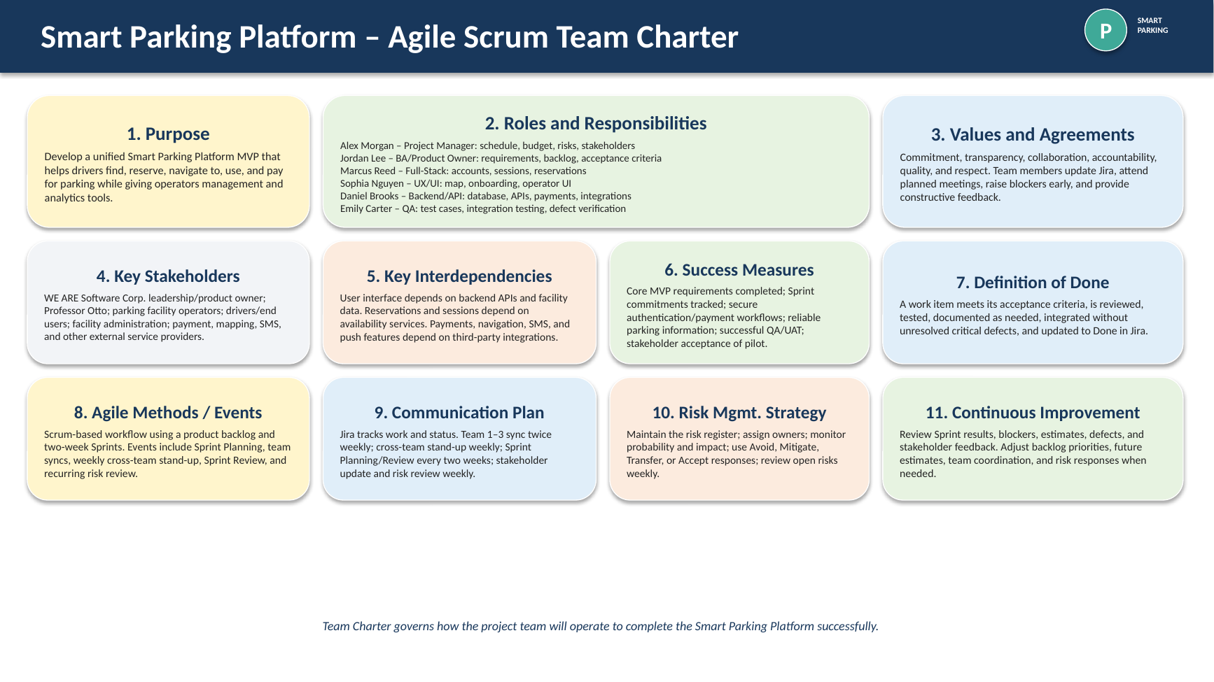
Figure 5. Smart Parking Platform Agile Scrum Team Charter

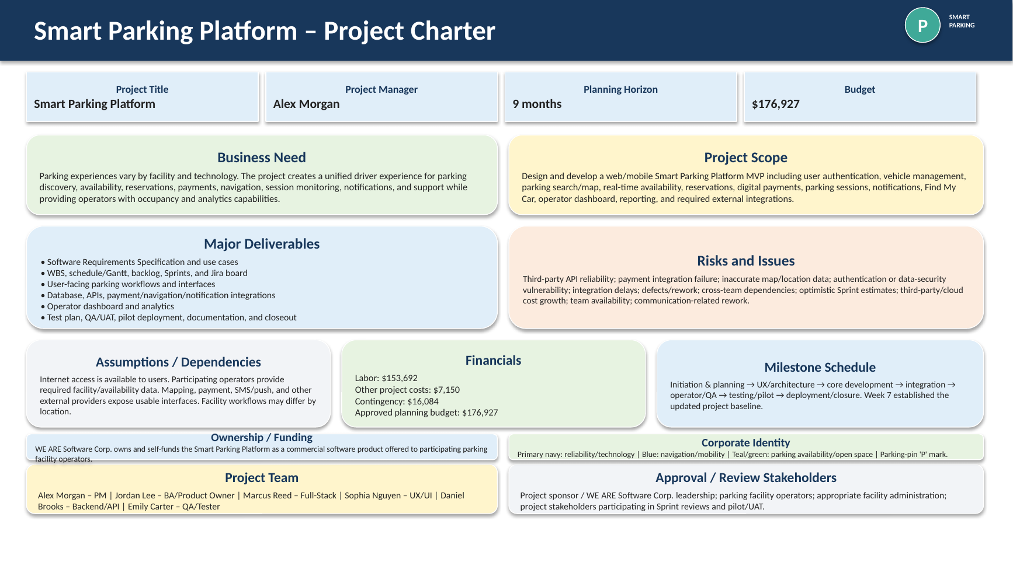
Figure 6. Smart Parking Platform Project Charter

